

Policing The Nighttime Economy and Anti-Social Hours

Benjamin Quint

2134474

BSc Degree Apprenticeship Professional Policing Practice

7524 Words

Acknowledgements:

Being the first person in my family to go through a university degree all whilst being a full time police officer has been one of the most challenging things I have ever had to do in my entire life, especially given the fact that due to COVID-19 it forced me to leave secondary school with no exam experience and little to no academic background whatsoever finishing on a predicted grade basis only.
First and foremost, I would like to thank my mother and father for their continuous support and efforts of encouragement to complete this degree over the last three years, particularly when it got so challenging, I wanted to just quit and kept telling myself that I was not good enough. Secondly, I would like to express thanks to my closest family members including all my grandparents whose support has also not gone unnoticed, I look forward to having you all present on my graduation day, a day that I was not sure whether I would see.
Thanks also goes out to my supervisors and team within South Wales Police over the last three years for their never-ending understanding and compassion for my struggles with this degree, and the physical, emotional and mental support they have given me.
I would also like to thank Stephanie Brown who has supervised my dissertation and whose guidance has been invaluable.

DECLARATION

This work has not previously been accepted in substance for any degree and is not being concurrently submitted in candidature for any degree.
Signed: B. Quint Date: 01/04/2025

STATEMENT 1

This dissertation is being submitted in partial fulfilment of the requirements for the degree of BA.
Signed: B. Quint Date: 01/04/2025

STATEMENT 2

This dissertation is the result of my own independent work/investigation, except where otherwise stated. Other sources are acknowledged by footnotes giving explicit references. A bibliography is appended.
Signed: B. Quint Date: 01/04/2025

STATEMENT 3

I hereby give consent for my dissertation, if accepted, to be available for photocopying and for interlibrary loan, and for the title and summary to be made available to outside organisations.
Signed: B. Quint Date: 01/04/2025

STATEMENT 4

I hereby give consent for my dissertation, if accepted, to be available on the university’s IT system to those who have consent to use the system.
Signed: B. Quint Date: 01/04/2025

Abstract:

My essential aim and emphasis for my dissertation was to gather and examine the perspectives of serving police officers on working night shifts and policing the nighttime economy (NTE). I aimed to gain a thorough understanding of the issues and challenges that officers face during these hours, as well as to assess how the police force manages the resources and equipment at their disposal during hours when other services may be unable to assist, in order to determine whether it meets the needs and expectations of the public.
To collect these thoughts and viewpoints from serving police officers, a questionnaire was developed and distributed, beginning with demographic questions to demonstrate that the questionnaire was sent to a diverse group of police officers of various ranks, duties, and service periods. A series of precise questions were asked throughout the questionnaire, covering the challenges officers face and allowing them to go into greater detail about what changes they would like to see made to make policing during anti-social hours and the nighttime economy easier. A total of 18 officers based in the Western BCU of South Wales Police participated in the questionnaire.
A critical analysis of existing literature has been conducted on the overall topic of night shift working and NTE policing particularly looking at the effects it has on the general well-being of officers, and the way it impacts their work life balance.

Table of Contents:

Chapter 1 – Introduction………………………………………………………………………………6

– Background………………………………………………………………………………………….6

– Aims and Objectives…………………………………………………………………………….6

Chapter 2 – Literature Review………………………………………………………………………7

2.1 – Introduction to Literature Review………………………………………………………...7

2.2 – Literature Review………………………………………………………………………………...7

2.3 – Conclusion of Literature Review…………………………………………………………11

Chapter 3 – Research Methodology………………………………………………………..12

3.1 – Introduction to Research Methodology……………………………………………..12

3.2 – Sampling……………………………………………………………………………………………12

3.3 – Research Approach……………………………………………………………………………12

3.4 – Data Collection………………………………………………………………………………….12

3.5 – Limitations………………………………………………………………………………………..13

3.6 – Reliability………………………………………………………………………………………….13

3.7 – Ethical Considerations……………………………………………………………………….13

3.8 – Conclusion…………………………………………………………………………………………14

Chapter 4 – Analysis of Results……………………………………………………………….15

4.1 – Introduction to Analysis of Results…………………………………………………….15

4.2 – Demographic Questions……………………………………………………………………15

4.3 – Questions relating to the participants individual roles………………………17

4.4 – Questions covering views on night shifts and NTE policing……………….18

4.5 – Conclusion……………………………………………………………………………………….21

Bibliography………………………………………………………………………………………….22

Chapter 1 – Introduction

1.1 - Background
The association between police officers working night shifts and the night-time economy is a complicated and multifaceted subject that has received growing attention in academic research and is a topic discussed frequently by police forces across the United Kingdom. The night-time economy, which often marks itself by an increase in social activities such as nightlife and entertainment, presents unique issues for police officers who work these hours to maintain order and safeguard the public. There is drive due to scrutiny for officers to always be paying close attention to people who are most vulnerable because of alcohol and drugs, especially after hours, when crime rates and public safety issues tend to fluctuate. Police officers, as major characters in preserving order and public safety, play an important role in addressing these issues. However, the implications of night shift work on police officers' performance, well-being, and interactions have not been extensively explored, especially in terms of direct input from the officers themselves within the United Kingdom, specifically those of South Wales Police.

1.2 – Aims and Objectives
This study attempts to fill the vacancy by looking into the experiences and perspectives of police officers working night shifts and the night-time economy. Drawing on current literature, the study focusses on crucial problems such as the effects of night shifts on an officer's tiredness, mental health, and decision-making processes, as well as the operational demands of police in areas with increased crime. The literature also discusses the larger social consequences of a thriving nighttime economy, as well as how police presence might impact public safety results, the general atmosphere of busy High Streets and "party streets", and the need of maintaining positive working relationships with other partner agencies.
In order to develop an enhanced understanding of the issue, this study goes beyond theoretical analysis and incorporates primary data acquired directly from serving police officers within South Wales Police via a carefully developed questionnaire that employs both qualitative and quantitative research methodologies. This study enables a thorough examination of how officers perceive the problems provided by working night shifts and the night-time economy. It investigates how night shift duties affect how they work and how they adjust to the specific dynamics of policing during these hours. This dissertation intends to add to the discussions on the relationship between police, shift patterns, and the socioeconomic landscape of the night-time economy by including both theoretical ideas and primary research data.
The primary aim of this dissertation is to provide an answer as to how do police officers find working night shifts and the nighttime economy. The dissertation will then branch off to explore wider key objectives such as analysing whether officers feel supported during their duties which is a continually discussed subject within contemporary policing in the UK. The dissertation will also explore if more serious crime occurs at night and how the police respond during these hours with the resources they have at the time. The nighttime economy element of policing will also be covered specifically on the contribution of drink and drugs to crime within the nighttime economy.

Chapter 2 – Literature Review

2.1 - Introduction to Literature Review:
This dissertation delves into how police forces and its officers cope with working night shifts when faced with the ever-growing demand of modern-day policing, in a time where police forces are more scrutinised than ever before. I will also be exploring the challenges that officers face during these hours based on how night shifts effect their personal lives and general health/well-being. Furthermore, I will be looking at nighttime economy-based policing where incidents are often made additionally complex based on intoxication levels from alcohol and drugs plus impact factors that come with busy high streets and ‘party’ tailored environments. For clarity and impartiality, I will mostly articulate to night shift duties in the United Kingdom, although I have compiled research on worldwide policing circumstances to accompany this. My research is necessary and justified as it assists me in providing a background on my chosen topics and creates a clear foundation for me to fill in the gaps tailored towards the specific topics I have mentioned above for police officers of the modern day within the United Kingdom. I can use the research I have conducted to compare to my findings in the questionnaire completed in the latter section of my dissertation.

2.2 - Literature Review:
Modern day policing, whether for police forces in the United Kingdom or in other nations throughout the world, becomes increasingly complicated as officers and staff members are exposed to a wide range of working environments and scenarios. Unconsciously, police officers leave home for work without knowing what they will encounter that shift, putting their lives and health at risk every time they walk out the door. The police, as is well known, work around the clock, every day of the year. This as we know includes night shift workers. Night shift work and police work during anti-social hours are becoming increasingly demanding; there are numerous factors contributing to this increase in demand, including an increase in calls from the public requiring the police, officer personal workloads, general resourcing, and both social and economic factors.
Moran (2024) discusses the overall demand and crime levels during nighttime hours in an article where she evaluates who is at risk during night but covered that crime during the nighttime hours are more “commonplace” and of a more serious nature compared to crime that occurs during regular daytime hours.
According to studies conducted by the Crime Survey for England and Wales (CSEW, 2015) in March of 2015, published in the Office for National Statistics, it was found that during the nighttime hours is where 57% of serious and violent crime occurred. This includes offences of robbery, domestic abuse, assault and sexual offences. Given these statistics and the demand becoming more evident that experiencing crimes like this, especially during nighttime hours can have a detrimental effect on their health and wellbeing.
Fatigue during night shifts is probably the biggest challenge for police forces across the world during these shifts. Police officers are human beings and also experience tiredness and fatigue, a study conducted by Mendoza (2011) discusses the effect that night shifts have on police officers and when discussing fatigue, says that not only does it affect the officer there and then but over time, and doing night shifts over their years of service, will have impacts on mental and physical health which in turn will result in a lack of proficiency the officer can deliver to the public when dealing with an array of incidents and scenarios. Fatigue as we know it affects almost everything a person does including alertness, communication skills,
reaction skills and decision-making skills which to a police officer are imperative, non-negotiable skills to have and on some occasions, the ability to use these skills efficiently, and in a timely manner could mean the difference between life and death. By lacking these skills can result in officers becoming more prone to receiving complaints and undergoing disciplinary proceedings, further damaging their well-being. It is not to be forgotten about that police forces have policies in place to allow officers a certain amount of rest between shifts. In South Wales Police, all officers are required to have a minimum of eleven hours of resting period between shifts. The NHS advises that adults need 7-9 hours of sleep per day, however, added that this can vary based on age, gender and personal circumstances (NHS, n.d) which for police officers will always be the case based on working shift patterns. There are even occasions which happens more often than not, where officers will not finish at their scheduled finish time due to potentially dealing with an incident late on in the shift that requires action. It would make sense that should an officer finish two hours late after their schedule time they would be entitled to start their next shift later to rest more but this unfortunately is not always possible.
Driving vehicles is also a crucial element to being a police officers and for those officers who have received training, will be required to drive at a much higher standard comparted to basic drivers as they are required to respond to emergency calls utilising exemptions which would include driving faster than the speed limit, overtaking, contravening traffic lights etc. With an officer being fatigued on a night shift, this can result in drowsiness which is extremely dangerous for the officer, his colleagues and the public/other road users. A study conducted by Martin and Buckley (2024) looked at statistics surrounding driving whilst drowsy/fatigued. Their findings stated that between 2017 and 2021, there were just shy of 30,000 fatalities involving a fatigued driver with most of these fatalities occurring between midnight and dawn. It is also between those times that police officers are most involved in vehicle collisions, Mendoza added that during these hours, makes up 50% of all police vehicle collisions.
Senjo (2011) elaborated on police officers working under fatigue and focused on the topic of measures to be brought in to assist officers on getting more rest time and being less fatigued. One focal point of his discussion was that of overtime. It is common for police officers to be called in early or brought in off rest days to work should demand be greater than that of police resources. A Police Chief that was interviewed by Senjo stated that they would always count on officers to come in should they be required, regardless of the notice they were given, and remained to say that officers are more than happy to do it based on the overtime rate of pay which is a minimum of time and a half. Senjo then discussed this and asked the same Police Chief if he thinks it reduces officer fatigue, and the Police Chief says that he has faith in his officers to recognise if it is too much for them and has measures in place to prevent the over working of officers.
Thankfully, as times have changed, and employers have begun to see the importance of a good work-life balance and there are methods in place, particularly within police forces to ensure that officers have a health work-life balance. Working night shifts immediately effect a work/life balance and it is unavoidable given the nature of the roles police officers are meant to do. Despite how individual officers feel about working night shifts, in some way or another it would have affected their personal lives or the lives of family and friends around them. The Metropolitan Police (2011) released a document under the Freedom of Information Act in light of their work/life balance policy for their officers and staff. This outlined maternity leave, paid leave, career breaks, leave for carers and other measures for a healthier working balance. They also highlighted services available to officers for counselling and trauma care which can be important to prevent home and work lives colliding which can have a detrimental effect on an officer and the service they can provide. A study was carried out by Cheung and Chi-mei Li (2022) where they moderated the effects of night shifts on police officers and the factors that come with it and impact on their work-family balance. The study was carried out on 793 police officers based in Hong Kong, China. They firstly discuss the effects of night shifts for police officers, and adding strength to what was found by Mendoza, highlighting that night shifts are likely to “provoke hazards and diminish the worker’s alertness”. They went on to explore the effect it has on family life and proposed that shift autonomy has a positive effect and makes a work/life balance easier to manage for all officers. It is important in this area of discussion to understand what the term shift autonomy means, as it ties in with discussing a positive working environment which as also discussed, creates a healthier work life balance. Autonomy is a wide expression and differs depending on career, role and team environments. But in fundamental terms, it is defined as the capacity for workers to express themselves and self-assess decision making about how they prioritise and conduct their tasks while meeting their employer's expectations (Caldas, 2024). Specifically, to police officers, having autonomy on shift plays a significant part in a police officer’s role, especially those who work night shifts.
Night shifts are challenging for some officers, and this will be discussed later on in the dissertation, but by having shift autonomy, role satisfaction within officers will increase as they would have more control over their time and what they choose to do with it, which predominantly makes them feel more valued as a member of a shift/organisation. Night shifts can feel a lot longer and “drag” when there is a lack of task and time management, further inflicting unnecessary stress on police officers. Jensen, et al (2016, p.1280-1292) conducted research on male police officers, analysing how their hormones are affected upon working a series of consecutive night shifts. It was found that stress, lack of sleep and self-satisfaction within the role are highest when completing night shifts, reduce vital hormones including melatonin, cortisol and testosterone. Autonomy is demonstrated in their research findings to reduce this.
Moving forward, I will now analyse and discuss research surrounding police officers who as part of their duties work and collaborate as part of nighttime economy (NTE) based policing. Most importantly, I will be looking at the issues police officers are faced with during after dark based work including resourcing, partner agencies etc and I will also explore the effectiveness of police forces when it comes to managing crime associated with NTE policing such as alcohol and drug related offences, anti-social behaviour, assaults and sexual offences. In the United Kingdom, night-time economy policing refers to police's stance and techniques for managing and ensuring public safety during the evening and night hours, particularly in locations with significant levels of nightlife activity. This includes cities and towns with large audiences in bars, clubs, restaurants, and other places, which can lead to greater risks of alcohol consumption, violence, anti-social behaviour, and other crime-related occurrences. The purpose of night-time economy policing is to strike a balance between enjoying nightlife and protecting the public's safety and welfare (Welsh Government, 2018).
With the definition above taken into consideration, it would be fair to say that alcohol consumption is one of the main contributing factors to issues and crime that police officers are faced with whilst working during nighttime economy events and hours. A charity has conducted research and stated that in the United Kingdom, alcohol is a working part in crime and is involved in 39% of violent crimes in England and 49% in Wales (Alcohol Change UK, n.d). These figures alone were based around general policing responses, not tailored towards night shifts or NTE based policing. Hadfield, Lister and Traynor (2009, p. 465-485) wrote about police responses to nighttime economy within England and Wales. Their research suggests that the presence of alcohol is likely to be more prominent within the incident’s officers deal with, but they do not have any new data or statistics to prove this. In their research, they also discussed and highlighted the complex dynamics of nightlife areas where licensed premises including bars, night clubs, etc) are strategically placed in areas within mainstream cities, drawing the attention of a more youth-oriented culture which is centred around alcohol consumption. The areas of which these establishments are placed into, are seen as economic drivers which on its own seems positive when thinking about growing a cities economy and making it more available to younger adults and party goers, however, they can often create contested and very busy spaces allowing room for disorder which poses as a challenge and a risk for police officers working night time economy duties at that time.
On the topic of busy high streets and party centred locations, police officers around the United Kingdom at some point would’ve had to undertake nighttime economy duties (also known as After Dark duties) in order to maintain a safe yet enjoyable environment for drinkers and party goers to enjoy themselves. These duties do not come without their risks, some more significant than others. What may be a simple issue during regular policing duties is often heightened and made more complex based on involved persons being under the influence of alcohol and/or drugs which more often or not affects people’s behaviour and decision making which has previously been outlined by Hadfield, Lister and Traynor (2009). A police officer published in a blog discussing is experiences working nighttime economy shifts and as a result of his experiences, went on to be one of the United Kingdom’s first Alcohol Harm Reduction officers within his force. Urwin (2021) shared that upon being tasked to work NTE duties, he would see a dramatic change in the way members of the public would interact with him and other officers, often appearing more controversial and quite frankly abusive. Which he states was all through the alcohol more often than not. He also explained that he was referred to hospital several times after being assaulted by intoxicated members of the public but just “accepted it as part of the job” and stated that alcohol is an aggravating factor, not to be mistaken for a mitigating factor.
Given the risks identified with policing the night time economy above, particularly with modern day policing and the heightened risk towards officers with some covered previously, CCTV (closed circuit television) has become a massive contributor to detecting crime in night time economy locations resulting in prompt response from an array of multi-agency services but it is also an invaluable tool when it comes to protecting victims and leading to the successful arrest and punishing of those who have offended. Brands, et al (2015) has produced a study that delves into the relationship between CCTV/surveillance, policing and the general public’s perception when it comes to their safety in the nighttime economy which over time has seen a dramatic increase in police presence and CCTV. The study found that the visible presence of police working collaboratively with door staff/bouncers is what significantly enhances perceived public safety and CCTV is just an extra on top. However, the effects of these interventions on safety are both broad and relational. Additionally, it was said that police officers are often perceived positively as friends of the public, which increases perceptions of safety. Which is contrary to what was said by Urwin who has served as a police officer and states that police are less respected than ever.
Because nighttime economy-based policing is located in the busier areas of towns and cities, and police visibility and presence is one of the many priorities identified for maintaining order and safety, this requires officers to be on foot and constantly mobile for the duration of their shift. Particularly within the United Kingdom, weather is unpredictable all year round where officer working nighttime economy duties are expected to be prepared and undertake their tour of duty regardless of environmental factors and weather conditions. This also includes always wearing the correct personal protective equipment (PPE). Hudson et al (2025) discussed the uniform issues that are faced within policing; however, their research was based around that of mounted officers and not frontline roles including those who partake in nighttime economy based policing. In their research, they aimed to assess whether or not the issued uniform was fit for purpose, and if the officers felt comfortable. The general consensus of this study was that the officers would “just make do” with what they have as it is their only option. Which was scrutinised. Similar to the position I find myself in now, the research also found that there is very little research and literature on the general comfort of police PPE, specifically body armour as they are referring to but has found that the majority of officers who wear body armour find it to be ill fitting and significantly reduces their mobility. To put this into a nighttime economy scenario, officers are continually mobile and need to have constant awareness and require to be able to react quickly to any hazards they may encounter, even when they are least expecting it. Not to mention officers are sometimes required to run from one location to another to deal with an incident they may witness or have reported, as they do not always have a vehicle whilst conducting nighttime economy patrol. It is clear that some work needs to be done to provide officers with more comfortable body armour.
In addition to the research discussed above, Dempsey (2013) in similar opinion conducted his own research specifically on body armour within the police and his research found that the weight of body armour over a period of time can have negative physiological effects on officers which in turn affects the ability for the officers to achieve optimum performance within their roles, decreasing the public’s trust within the police and their ability to respond. From a safety perspective, uncomfortable body armour can have greater impacts on the general safety of a police officer. This is as it may encourage an officer to stop wearing body armour in order to just be comfortable or to have a cooler body temperature. On nighttime economy duties when drink and drugs become aggravating factors, alongside people having more access to things like glasses and bottles the officer’s chance of sustaining more serious injuries that ranges from punches to stab and slash wounds.

2.3 - Conclusion of Literature Review:
In conclusion, the literature on the effects of night shifts on police officers and policing the nighttime economy highlights a complex interplay of physical, mental, and emotional challenges that significantly affect officers' well-being and effectiveness alongside their families and personal lives too. While night shifts are a necessary component of policing within the United Kingdom, that corresponds directly to active nightlife also, the evidence indicates that they come with heightened risks of fatigue, stress, and burnout regardless of role or department.
Research consistently shows that sleep deprivation, common in night shift work, can impair cognitive functions, decision-making, and physical response times, all of which are crucial for effective policing and for maintaining but also increasing the trust of the public. Despite the protective role that police officers play in ensuring public safety during these hours, the study of their experiences reveals that the emotional and physical costs of working night shifts including nighttime economy based events are substantial. With the main question being such a broad one, it is important to ask these demographic questions as the question is answered on personal experience, and the characteristics sought in a demographic question.

Chapter 3 – Research Methodology

3.1 - Introduction to Research Method:
In this chapter of the dissertation, will be detailed the research methodology acquired to research the prime question: “How do you find working during anti-social hours and the nighttime economy?” In order to understand exactly what the effect of night shifts and nighttime economy policing have on individual officers, regardless of role and individual circumstances, an extensive questionnaire has been made available to serving police officers within South Wales Police, predominantly within the Western BCU of the force to be able to express via these questions how they are affected by these types of duties.

3.2 - Sampling:
The questionnaire following being sent out will be received by police officers employed within South Wales Police. No specific department will be targeted, neither will rank nor service length. All officers who complete the survey would have a direct involvement in contributing and protecting the communities of South Wales. Whether this be frontline officers answering 999 calls and attending an incident, dealing with it there and then at an incidents most heightened state, all the way up to investigative officers who specialise in the latter investigation of an incident. The common theme is that they have all had to participate in night shifts or nighttime economy duties, and taking their personal roles and skillsets into consideration will provide a more vast and diverse answer to the question.

3.3 - Research Approach:
The questionnaire asks a variety of questions including demographic questions at the beginning establishing information such as age, gender, role, length of service etc. With the main question being such a broad one, it is important to ask these demographic questions as answers provided are that of personal experience. For example, these shifts may affect male police officers different to female officers and those with longer service etc. This survey aims to establish an opinion of all serving officers in a frontline role, thereby providing more data to critically analyse and reflect upon.

3.4 - Data Collection:
The questionnaire has been developed in order to gather the opinions of participating officers currently serving in a frontline role within South Wales Police. All officers participating in the questionnaire undertake night shifts and nighttime economy-based duties. The only factor that changes is the frequency of these shifts, as some roles/departments would carry out these duties more than others. As a whole, the questionnaire will be completed by those who have carried out these duties over their career and will carry on doing these duties whose opinions contribute significantly to the documentation and authenticity of this dissertation.
Following the completion of the questionnaire by participating officers, qualitive and quantitative methods will be adopted, and the responses analysed. The data will be collected, and the results will be visible in pie charts which provide clear reading. Furthermore, through the use of pie charts, the opinions and data collected will not only illustrate the pertinent opinions of serving officers who carry out these duties, but it will also clearly highlight the areas in which officers feel the least supported, with the option for officers to add free text to highlight which areas of these duties require improvement, allowing for qualitative research methods to be accomplished.

3.5 - Limitations:
Where there are no substantial constraints on police officers completing this questionnaire, there is a possibility of a narrow variety of viewpoints. For example, this questionnaire was designed and modified for active, front line police officers in a variety of roles. They are responding from a professional standpoint, and the opinions of the general public, who may have been affected or had personal experiences with police officers on night shifts and nighttime economy duties, have not been considered, resulting in police officers lacking a broader understanding of how it may or may not affect members of the community.
Another potential limitation is that of personal bias. Police officers will feel differently about working night shifts and nighttime economy based policing, and have a vast amount of experiences with these shifts both positive and negative. Current personal issues that have occurred can also lead to bias. For example, should an officer be completing this questionnaire directly after a night shift or after nighttime economy duties, where they did not have a positive experience on that shift alone, their answers will most likely heavily reflect their negative views from that shift rather than focussing on the bigger picture, and the shifts they have worked on in their career thus far.

3.6 - Reliability:
The answers and opinions of those officers who participate in this questionnaire will be based off a appreciable amount of experiences working night shifts and night time economy based duties. As it is commonly known, all frontline officers undergo night shifts in some respect or another as it is part of their role. These participants will be able to give unique, and personal first-hand insights which enables the questionnaire to be answered with the most true and accurate responses for that given time. Given the nature of the police officers’ role, and the contribution of both personal and commercial values, police officers prove to be reliable and trustworthy sources. It would be almost impossible to gain valuable and accurate opinions on night shifts and nighttime economy policing if anyone other than the officers themselves who carry out these duties participated instead.

3.7 - Ethical Considerations:
With police officers being the recipients of this questionnaire, the following points ensure the integrity of the process and allows the police officers to answer the questions anonymously. This enables the identity of the officer to be protected, providing a sense of security that honest opinions are accepted and that their answers are based of genuine feelings and experiences, allowing them to express these opinions and feelings without fear of repercussion or controversy. The questionnaire is also completely voluntary, and officers are aware they are under no obligation to participate. The questionnaire was formulated into a link that was distributed amongst serving officers within South Wales Police only. This ensures a streamlined and smooth process. The officers have been informed that they can share the questionnaire with other colleagues should they wish to participate, further promoting diversity in the answers provided in the questionnaire from participants. Participants who receive the questionnaire from their colleagues are also aware that their answers remain anonymous.

3.8 - Conclusion:
In conclusion, the research methodology utilised for this questionnaire sent to police officers has been formulated with care and attention has been given to maintaining professionalism with focus to ethical standards and reliability. Even with the limitations considered which could potentially impact on the findings, this method appears to be the most appropriate and effective as clear, unbiased questions have been asked throughout. This method allows for both quantitative and qualitative research, which allows for further research to be conducted, and other key areas of interest identified.
A safe environment has been adopted allowing the officers to participate anonymously on a completely voluntary basis. The questionnaire is justified and proportionate as it is focused on police officers who partake in night shifts and nighttime economy duties as part of their role within South Wales Police who’s answers and opinions will be diverse and able to provide the most up to date findings based on personal experience only and not speculation or thoughts. The mix of quantitative and qualitative approaches allow for the comparison of statistics which will show clearly the similarities between the opinions of officers, followed by an option for officers to say what they feel needs to be improved or what they are in need of, further expanding on their answer.

Chapter 4 – Analysis of Results

4.1 – Introduction to Analysis of Results:
The previous chapter of this dissertation proposed the research methodology that was sent out to serving police officers in a variety of roles by utilising a questionnaire as the focal data collection method. This chapter explores and compares the answers police officers have provided in order to establish up to date and accurate opinions of those whose opinions provide the best insight to answering the main question of the dissertation. This questionnaire has been made available to serving police officers within South Wales Police and sent out via workplace email. 18 police officers of various roles, departments and ranks have participated in the survey throughout the Western BCU sector. A total of 16 multiple choice questions were included within the questionnaire and a free text box at the end of the questionnaire for officers to offer their own opinions around the subject, encouraging quantitative methods of research.
In order to formulate the questionnaire, ‘Google Forms’ was utilised in order to layout the questions ensuring ease of reading and navigation for those answering the questions. It also populates clear statistics which allows for easy comparison and analysis of the targets outlined desired to be completed through means of this dissertation.

Questionnaire Findings/Results:

4.2 – Demographic Questions:

The first question proposed within the questionnaire, was asking participants their age. As found within the review of literature, night shifts and night time economy duties affect persons individually based on their personal circumstances as well as organisational/career circumstances. In the questionnaire, 38.9% of participants were between 27 and 35 years old. The Home Office (2025) included within the Police Workforce statistics that most serving police officers within England and Wales were between 26-40 years of age, making up 45.4% of the numbers. Continuing with the questionnaire, 22.2% of participants were between 23 and 27, a further 22.2% were between 35 and 40. 11.1% were 40 years old plus and 5.6% made up the smallest amount of participants who were aged between 18 and 23.

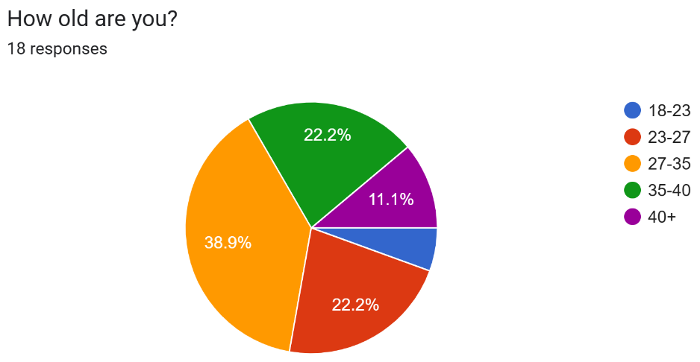

The next question asked was the gender of the participating police officers. 61.1% of participants identified as males, followed by 38.9% identifying as female. There was a third option where officers could identify as non-binary however, no participants provided this answer.

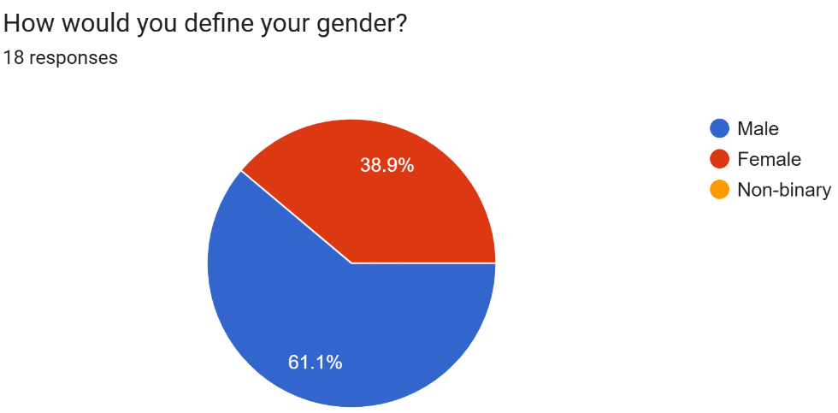

Wiggett (2020) conducted research to explore the dramatic change in service profile of police forces across the United Kingdom. He stated that “a quarter of all police officers in England & Wales now have less than five years service”. In relation to the service length of officers that participated in this questionnaire, the findings showed that the majority of officers (making up 44.4%) had between two and three years of service which supports Wiggett’s research indicating that officers within the modern era of policing are younger and have less service time. 22.2% of participants have ten years or more worth of service who’s opinions for the rest of the questionnaire will be able to provide answers based on their years of experience working night shifts and the night time economy. It will give these officers the opportunity to reflect on their whole years of service and hopefully provide insight into how these duites may or may not have developed over the years as policing evolves. 16.7% of participants hold between three and five years of service, followed by a further 16.7% with between five and ten years as a warranted officers.

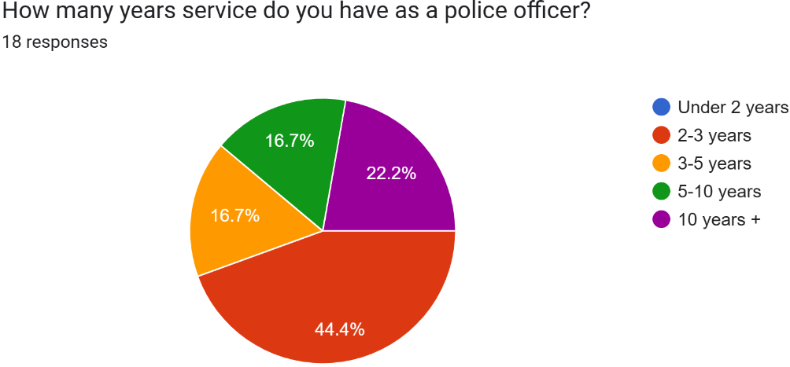

4.3 - Questions Relating to the Participants Individual Roles

It is at this point in the questionnaire that officers are questioned as to their individual role within South Wales Police. Firstly, participants were asked about which department of policing they work in. 66.7% of the officers work on response which is the most frontline and under appreciated role of policing. With response being the most popular department of those participants, is going to attract many opinions in relation to night shift working as these shifts are standard within their duties. 11.1% of participants work as part of an investigative role which may include the Criminal Investigation Department (CID), Rape Investigation Team (RIT) and Major Crime. Whereas night shifts are not as frequent for those on response duties, there are occassions where night shifts are intergrated within their roles, which can give an insight on how night shifts affect those who are prioritising investigations and evidence gathering. A further 11.1% of officers stated they were in a specialist role which may include custody duties, roads policing, firearms, traffic. Similarly to those in the investigative roles, specialist roles naturally carry more risk to the incidents they attend and the duties they carry out, further broadening the experience of night shifts. Two particiapnts then stated they worked within Neigbourhood Policing and within the Hub. For neighbourhood officers, their insight on night time economy duties will be extremely valuable as not only do they work after dark duties more frequently than any other role within South Wales Police, they actually pre-plan the events and are a working part in the execution of night time economy duties.
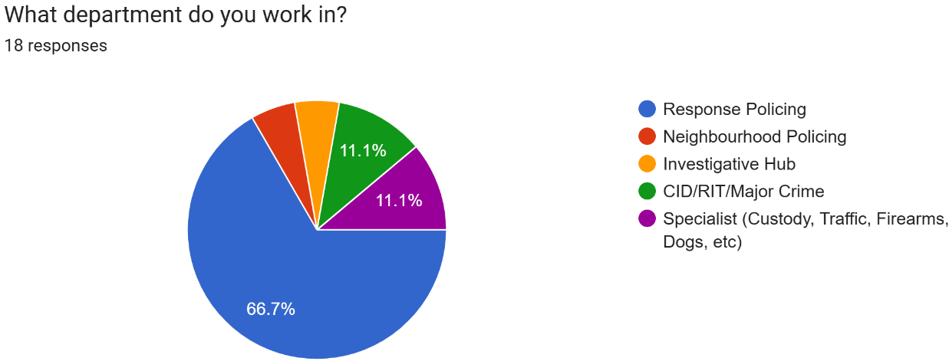

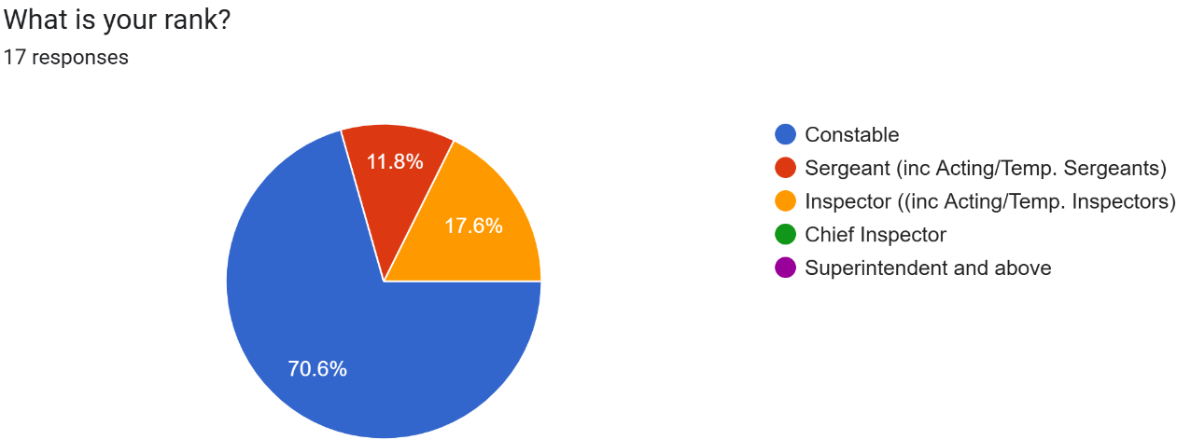
The next question proposed to officers was asking about the rank they currently hold. 70.6% of participants confirmed themselves to hold the rank of Police Constable, with 17.6% of participants being an Inspector and 11.8% holding the rank of Sergeant. No participants were the rank of Chief Inspector or above. By obtaining the ranks of the participants, it will provide data on how night shifts change and play out for those in leadership roles aswell as those of a Police Constable. One partipant chose not to answer this question.

Moving forward, officers were now asked whether or not they work night shifts as part of their regular duties. Police forces vary across the UK and the world when it comes to night shift working. Some police forces will have designated night shift officers such as West Yorkshire Police (n.d) who say that their officers who work night shifts “will not exceed an average of eight hours in any 24-hour period over a four-week cycle”. Whereas South Wales Police response officers will work two night shifts from 2200hrs-0700hrs at the end of a shift set before going onto four consecutive rest days (South Wales Police, 2025). 72.2% participants answered that night shifts form part of their regular duties. Additionally, 22.2% answered that they work nights occasioanlly through either cancelled or changed shifts, or overtime.
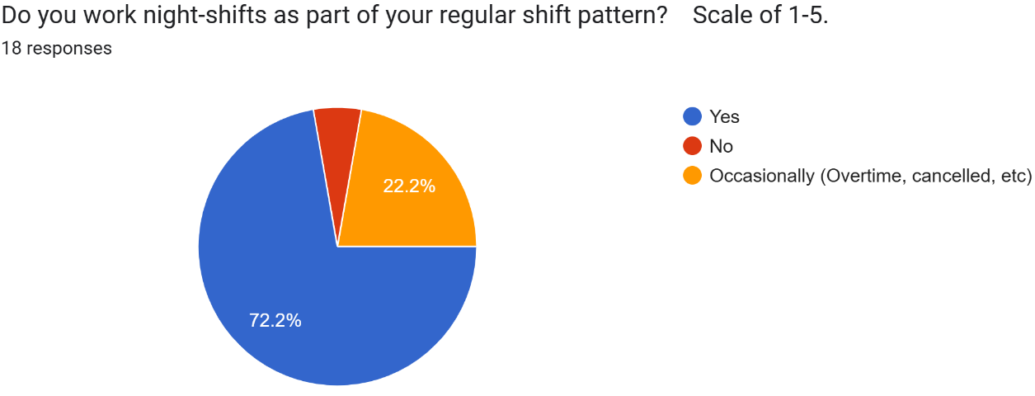

4.4 – Questions Covering Views on Night Shifts and Night Time Economy Policing

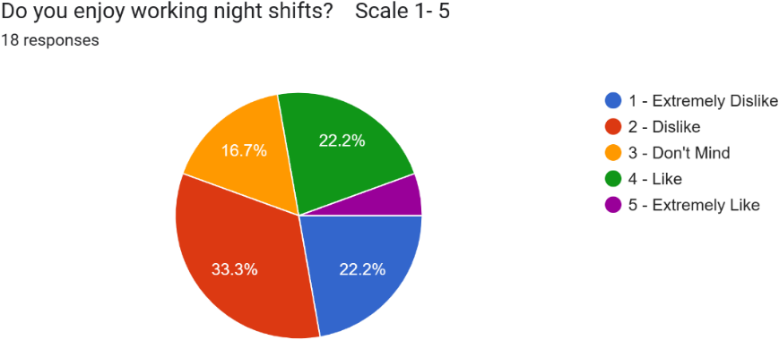
Following asking the officers the above questions to learn firstly about who they are, what they do and whether or not night shifts form part of their regular duties, the following questions will relate to their opinions and generating mixed views and opinions based off the personal experiences and honest feelings of those officers participating in the questionnaire. The particiaptns were asked the broad question of whether or not they enjoy night shifts. The participants were given a Scale of 1 – 5 with 1 being they extremely dislike working night shifts and 5 being they extremely like working night shifts. 33.3% of those who answered stated that they dislike working night shifts. This was followed by 22.2% of those who said they extremely dislike working night shifts and 16.7% do not mind working night shifts. Only one participant (making up 5.6%) stated they extremely like working night shfits and a further 22.2% stated they like working night shifts. These results are not suprising given the risks identified with working night shifts, and the overall effect it can have on a police officer. Adding to the effects gathered during the literature review, the BBC (2024) conducted their own research and in similar findings, found that working night shifts can have detromental effects on a person’s health over time that are both biological and psychosocial effects including caridovascular disorders, increased accidents, stress increase, heightened risk of cancer and diabetes.

The next questions within the questionnaire was asking the officers whether or not there is enough resources to support them through night shifts and whether or not night shifts impact negatively on their family lives as a result of these issues. One of the big key issues rasied around modern day policing within the United Kingdom is resourcing issues. A study was conducted by Kassem and Erken (2024) where twenty six police officers were interviewed about contemporary issues within policing. The common finding with the interviews was the officers expressing issues surrounding resourcing. One of the officers in Kassem and Erken’s study talked about night shifts having a part to play in the lack of resourcing. He said that “recruitment and retention are massive issues due to job demand and night shifts which contribute to low morale”. He went on to say that the extremely low resourcing issues across the United Kingdom are to do with the lack of support from the government including salary problems made even more difficult by the modern day cost of living crisis. To summarise his research, it was clear in his findings that there are simply not enough resources working in the police full stop but for night shifts, it is made even more complicated due to certain departments only operating during the day as there is lack of funding to put on night shift staff. Similar results were seen in the questionnaire sent out as part of this dissertation. 61.1% of officers participating said that there is a lack of resources available during the night shift. On the contrary, 33.3% of officers stated that they do feel there are adequate resources in place during the night shift. One participant did not have an opinion on the matter and stated they were unsure, making up 5.6%. It was then asked if night shifts then have a negative impact on the family lives of participating officers. Sadly, 72.2% of officers stated that it does have a negative impact and 27.8% stated that their family life is not affected negatively. It is evident from these two questions that more needs to be done to upscale resourcing to take some strain off night shift officers in which will adequately result in a better service to the public and more prompt response times whilst also gives the officer a better work life balance and contributes to the health of themselves and their families .
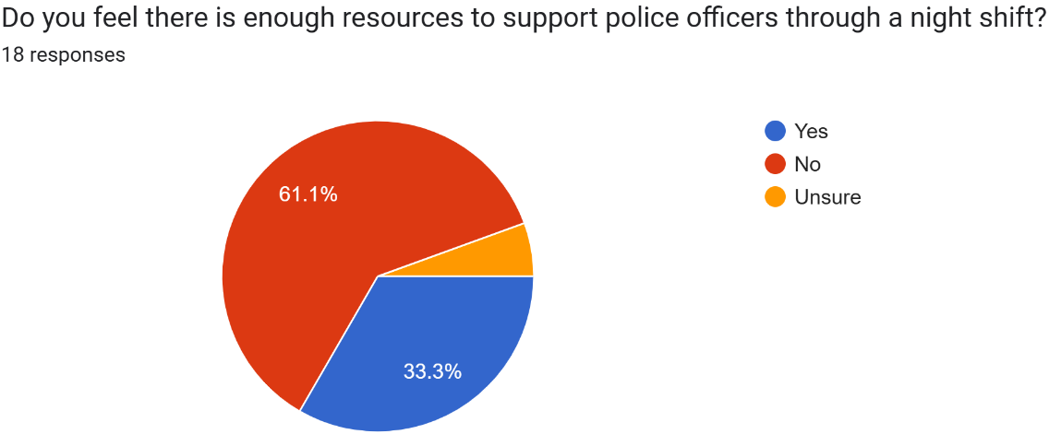

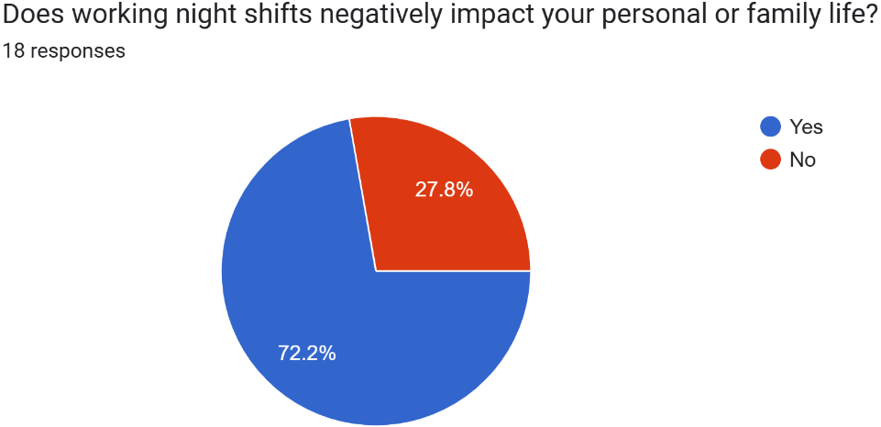

Moving on, to analyse the data that relates to policng the night time economy, the participants were asked how often they participate in night time economy duties. 38.9% of the officers participating said that they are a resource for night time economy duties up to three times a year, 33.8% stated that they carry out NTE duties three to five times in a six month period and then 27.8% answered stating that they work NTE between one and three times a month. As previously discussed, the roles of the individual officers depend on how often they carry out these duties. Neighbourhood policing officers and response officers would work NTE more than any other role. The partiicpants were then asked whether or alcohol and drug use is the main influence in incidents that occur on NTE. A staggering 94.4% of officers answered yes, in agreement with the fact that alcohol and drug use is an aggravating factor in all incidents dealt with during this specific duty. In corrospondance with this, Lister (2009) wrote in an article he produced on the NTE that between 1998 and 2001, Manchester city centre saw a surge of 225% in realtion to assaults within night time economy as a direct result of alcohol and controlled drugs.
Lister also highlighted the importantce of partner agency collaboration when it comes to maintaining a safe night time economy. In Cardiff, there is a large scale effort by South Wales Police that goes into their night time economy. This includes the deployment of a safety bus for those who are modt vulnerable, collaboration with St. Johns Ambulance who work a similar tour of duty to the officers, responding to various medical issues including concerns around alcohol poisoning and drug misuse (South Wales Police, 2023)
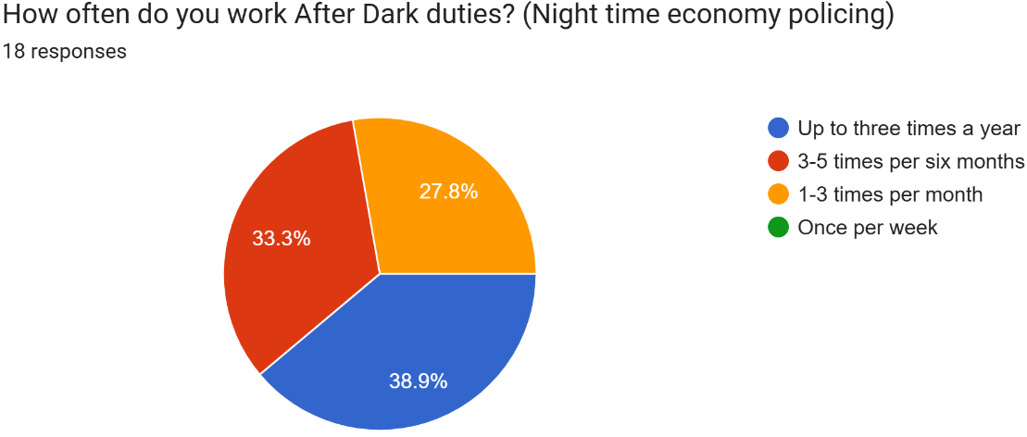

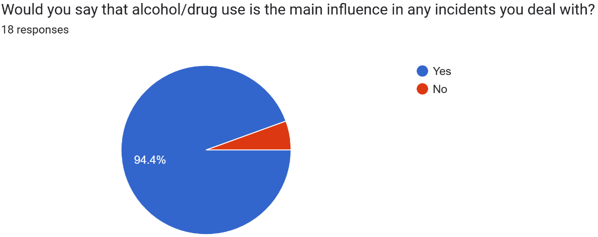

4.5 – Conclusion

Throughout this questionnaire, officers have had the oppourtunity to voice their opinions on some key issues identified in past literature. By obtaining these opinions from current serving officers within South Wales Police, it offers a valuable insight into issues experienced first hand surrounding police work during night shifts and the night time economy. Almost all officers that undertook this survey from Police Constables upto Inspector, still actively work night shifts and night time economy duties as part of their standard duties, granted some officers do it more frequently than others. One of the major issues which was common across the board from all officers was that resourcing is an issue. In relation to the qualatitve method of research, a few participating officers have outlined concerns surrounding the equipment police officers have at their disposal throughout both night shifts and night time economy duties.
In the questionnare, four responses surrounding torches and uniform/equipment were highlighted as an issue. Officers said that some specialist department get much better quality uniform where at night keeps them a lot warmer whereas the officers on response had uniform and jackets that feel extremely cheaply made leading to officers becoming prone to colder and wetter weather conditions, which naturally would be even harder to work with during a night shift. One officer described the standard issue high visibility jackets as “cumbersome and unpracticable”. Torches are argubly a police officer’s most valuable tool. Whether it being used outside in the dark looking for a missing person, or being used to search a dimly lit property for evidence. It is clear that officers are in need of better equipment and this was common throughout the varied officers opinions during the questionnaire.
Overall, the general feelings towards night shifts for the most part appear negative. However, it seems this is because police officers are not being supported as best they can be, particularly when it comes to uniform and equipment issued to them as outlined above. Should changes be made in relation to these issues, officers would feel far more valued and looked after which in turn will promote a positive morale and shift autonomy.
Relating to working the night time economy, alcohol and drug use played a significant role within the incidents officers were dealing with during these shifts. After paying close attention and analysing previous research on the night time economy, alcohol use and even drug use is going to extremely difficult if not impossible to stop the use completely based on the environment and the demographics of audience the night time economy is most used by.

Bibliography:
Alcohol Change UK. (n.d). Focus on alcohol-related crime and disorder. [Online]. Alcohol Change UK. Last Updated: n.d. Available at: https://alcoholchange.org.uk/policy/the-alcohol-charter/what-is-the-alcohol-charter/focus-on-alcohol [Accessed 31 March 2025].
BBC. (2024). Shift Working and Night Shifts. [Online]. BBC. Last Updated: 21 March 2024. Available at: https://www.bbc.co.uk/safety/resources/aztopics/shift-working-and-night-shifts [Accessed 3 April 2025].
Brands, J., Van Aalst, I., & Schwanen, T. (2015). Safety, surveillance and policing in the night-time economy:(Re) turning to numbers. Geoforum, 62, 24-37.
Caldas, M. (2024). Autonomy in the Workplace: Why It Matters and How to Foster It. [Online]. The Muse. Last Updated: 16 December 2024. Available at: https://www.themuse.com/advice/autonomy-in-the-workplace [Accessed 31 March 2025].
Cheung, C. K., & Chi-mei Li, J. (2022). Moderating the harmful effects of police nightshift work on work–family balance by adjusting shift autonomy. Journal of Comparative Family Studies, 53(3), 305-330.
CSEW. (2016). Overview of violent crime and sexual offences. [Online]. CSEW. Last Updated: 11 February 2016. Available at: https://www.ons.gov.uk/peoplepopulationandcommunity/crimeandjustice/compendium/focusonviolentcrimean [Accessed 24 March 2025].
Dempsey, P. (2013). Impact of police body armour and equipment on mobility. Applied Ergonomics. 44(6), pp.957-961. [Online]. Available at: https://www.sciencedirect.com/science/article/abs/pii/S0003687013000677 [Accessed 1 April 2025].
Hadfield, P., Lister, S., & Traynor, P. (2009). ‘This town’sa different town today’ Policing and regulating the night-time economy. Criminology & criminal justice, 9(4), 465-485.
Home Office. (2025). Police workforce, England and Wales: 31 March 2024. [Online]. GOV.UK. Last Updated: 19 March 2025. Available at: https://www.gov.uk/government/statistics/police-workforce-england-and-wales-31-march-2024/police-wor [Accessed 3 April 2025].
Hudson, S. et al. (2025) ‘‘We just make do’: the use, comfort and functionality of personal protective equipment in the UK mounted police’, Ergonomics, pp. 1–12.
Jensen, M. A., Hansen, Å. M., Kristiansen, J., Nabe-Nielsen, K., & Garde, A. H. (2016). Changes in the diurnal rhythms of cortisol, melatonin, and testosterone after 2, 4, and 7 consecutive night shifts in male police officers. Chronobiology international, 33(9), 1280-1292.
Kassem, R and Erken, E. (2024). In their own words: Police officers’ insights on identifying and overcoming contemporary policing challenges. International Review of Administrative Sciences. 0(0). [Online]. Available at: https://journals.sagepub.com/doi/10.1177/00208523241256029 [Accessed 3 April 2025].
Lister, S. (2009). Policing the night-time economy. [Online]. The Police Foundation. Last Updated: March 2009. Available at: https://www.police-foundation.org.uk/wp-content/uploads/2017/06/ideas_night_time_economy.pdf [Accessed 3 April 2025].
Martin, S and Buckley, A. (2024). Drowsy driving statistics and facts 2024. [Online]. Bankrate. Last Updated: 12 December 2024. Available at: https://www.bankrate.com/insurance/car/drowsy-driving-statistics/ [Accessed 24 March 2025].
Mendoza, M. L. (2011). The effects of night shift work on police officers. Travis County Sheriff’s Office Austin, Texas.
Moran, G. (2024). Who is more likely to be attacked at night UK?. [Online]. NCESC. Last Updated: 27 June 2024. Available at: https://www.ncesc.com/geographic-pedia/who-is-more-likely-to-be-attacked-at-night-uk/#:~:text=Accord [Accessed 24 March 2025].
NHS. (n.d). Sleep problems. [Online]. NHS. Last Updated: n.d. Available at: https://www.nhs.uk/every-mind-matters/mental-health-issues/sleep/ [Accessed 24 March 2025].
Senjo, S. R. (2011). Dangerous fatigue conditions: a study of police work and law enforcement administration. Police Practice and Research: An International Journal, 12(3), 235-252.
South Wales Police. (2025). POLICE CONSTABLE ENTRY PROGRAMME (PCEP). [Online]. South Wales Police Jobs. Last Updated: 4 February 2025. Available at: https://policejobswales.tal.net/vx/mobile-0/appcentre-SouthWales/brand-0/candidate/so/pm/6/pl/15/opp [Accessed 3 April 2025].
South Wales Police. (August 2023). Cardiff City Centre Night-time economy policing overview August 2023. [Online]. Cardiff Modern Gov. Last Updated: August 2023. Available at: https://cardiff.moderngov.co.uk/documents/s73728/Item%204%20-%20Appendix%20F.pdf [Accessed 3 April 2025].
The Metropolitan Police. (July 2011). Work Life Balance - Equality Impact Assessment. [Online]. The Metropolitan Police. Last Updated: July 2011. Available at: https://www.met.police.uk/SysSiteAssets/foi-media/metropolitan-police/policies/work-life-balance---e [Accessed 24 March 2025].
Urwin, M. (2021). Alcohol and crime: how drinking impacts policing. [Online]. Alcohol Health Alliance. Last Updated: 20 July 2021. Available at: https://ahauk.org/how-drinking-impacts-policing/ [Accessed 1 April 2025].
Welsh Government. (2018). A Framework for Managing the Night Time Economy in Wales. [Online]. Public Health Wales. Last Updated: 2018. Available at: https://phw.nhs.wales/services-and-teams/policy-and-international-health-who-collaborating-centre-on [Accessed 31 March 2025].
West Yorkshire Police. (n.d). Shift Working and Working Time – Police Staff. [Online]. West Yorkshire Police. Last Updated: n.d. Available at: https://www.westyorkshire.police.uk/sites/default/files/2023-09/shift_working_and_working_time_-_pol [Accessed 3 April 2025].
Wiggett, I. (2020). Younger in service, less experienced: The dramatic change in the UK’s police service profile over the past five years. [Online]. Policing Insight. Last Updated: 7 September 2020. Available at: https://policinginsight.com/feature/analysis/younger-in-service-less-experienced-the-dramatic-change [Accessed 3 April 2025].

