Build, deploy, configure, and manage a Type 2 Hypervisor platform based Virtualised network
Author: Morgan Combstock
Network Operating Systems and Services (ACCA5023)
School of Applied Computing
Wales Institute of Science and Art
01/03/23 Date of Submission

Abstract
…

Table of Contents
Contents
1. Task 1 4
1.1 Introduction 4
1.2 Mandatory Team Submission Details 4
1.3 Building of a virtual Network (Screenshots) 5
VM Creation and Operating Systems 5
Virtual Network Configurations 5
1.4 Install Critical Network Services (Screenshots) 9
Task 2 18
2.1. Question i 18
2.2 Question ii 18
2.3 Question iii 18
2.4 Question iv 19
2.5 Question v 19
2.6 Collaborative Working Reflection 19
3. References 20

Task 1

Introduction
The Purpose of this Task is to work as a team on the practical aspect of building, configuring, managing and deploying a virtual network. This involves downloading VM Box and creating and configuring servers and clients using specific Type 2 Hypervisor management software. This forms the building blocks of configuring the network, then allowing suitable services and features to be utilised.

Mandatory Team Submission Details
Name of the Team: DMTJ
Team Members:
Student Name | Student ID
Dave Cornelius | 2023506
David Corner | 1809784
Dylan Thomas | 2014801
Morgan Combstock | 2014028
Team Evaluation (Self Evaluate your Team)
 | Student 1 | Student 2 |  | Student 3 |  | Student 4 |  | Student 5
Student 1 | X |  | 5 |  | 5 |  | 5 |  | X
Student 2 | 5 |  | X |  | 5 |  | 5 |  | X
Student 3 | 5 |  | 5 |  | X |  | 5 |  | X
Student 4 | 5 |  | 5 |  | 5 |  | X |  | X
Rate your Teams Contribution with a scale of 1 to 5 (1 No Contribution and 5 Excellent Contribution)
Add your comments on Team Evaluation: (Justify your evaluation)
Student 1:
Dave had a good share in helping to manage the workload. He added some annotations to the screenshots and provided technical help when the virtual machines were not communicating properly.
Student 2:
David was a good team member. He was involved each week at the tutorial sessions and he contributed to annotations to screenshots and he was willing to offer suggestions when asked.
Student 3:
Dylan took a strong lead. He suggested using a teams group chat to manage the project, he completed a lot of annotations and he prompted all in the team to complete their tasks in a timely manner.

Building of a virtual Network (Screenshots)

VM Creation and Operating Systems
Figure – Initial Client and Server creation within VM Box
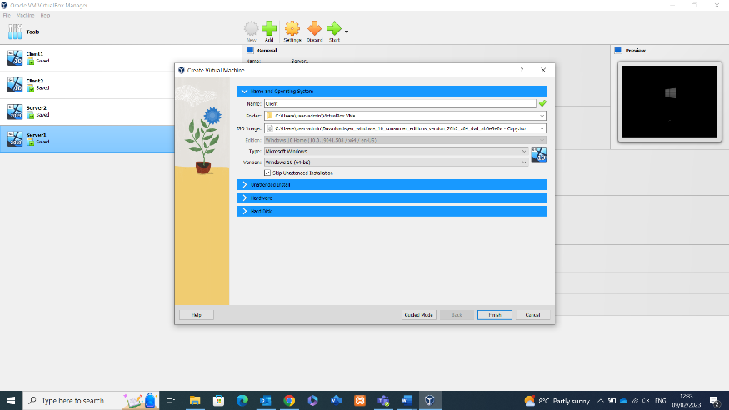
Having downloaded and Installed VM box, and the associated files provided for the VM examples, VM Box can now be loaded up. It is now possible to create the two clients and two servers as required. The above screenshot shows the VM box Manager screen, when selecting the Add button, selecting the relevant File and ISO Image allows the creation of clients and servers. Once this is done, select finish and repeat to reach the point above with the required clients and servers.

Virtual Network Configurations
Once the VM’s are created and Window’s 10 Operating System is installed, the configuration of the virtual network can begin.
Figure – Network configuration of Server
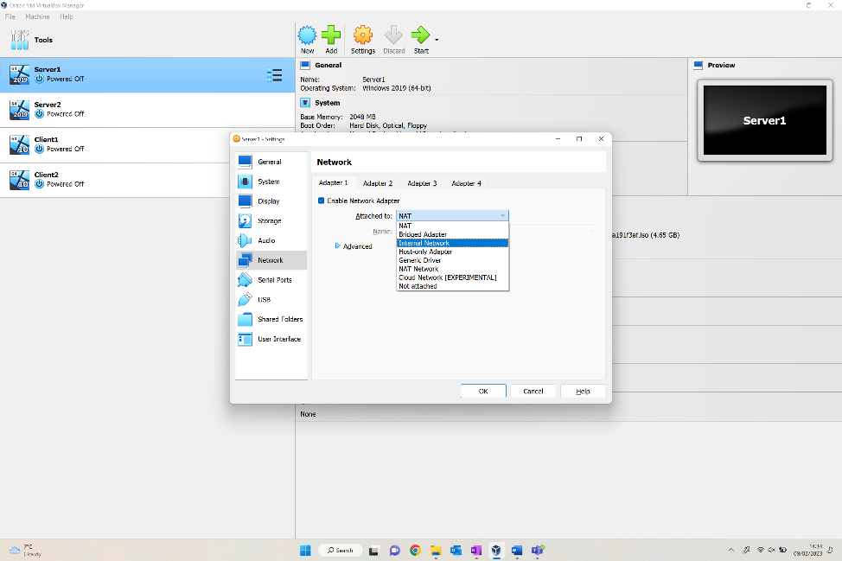
The above shows the selection of the first server, navigating to Networks tab it allows the end user to select the enable network adapter, thus allowing selection of what network it’s attached to (Internal) in this case. This creates a switch for the network.

Figure – Accessing Control Panel of VM
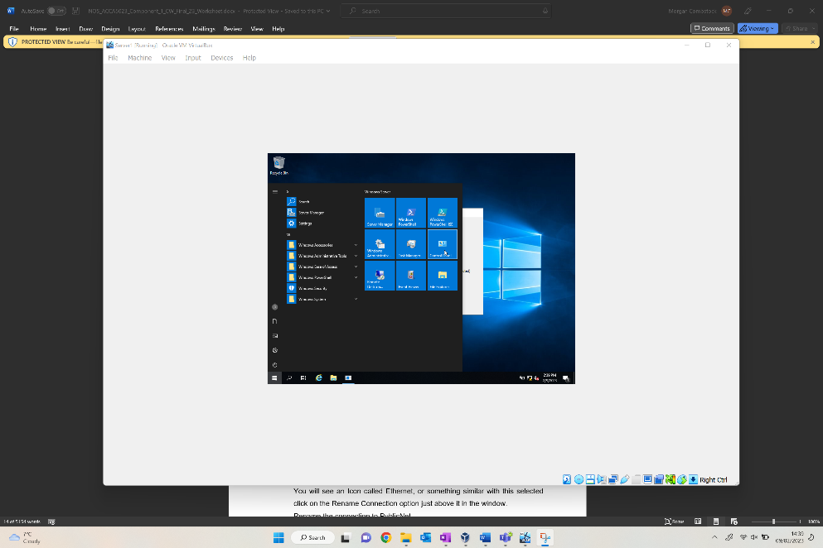
Following the network amendments, booting up Server1 allows the user to select the Windows Start section, then the control panel as seen above to access the Network Status and Tasks section. By doing this, you will be able to amend the change adapter settings.

Figure – Amending Adaptor Settings within Network Status
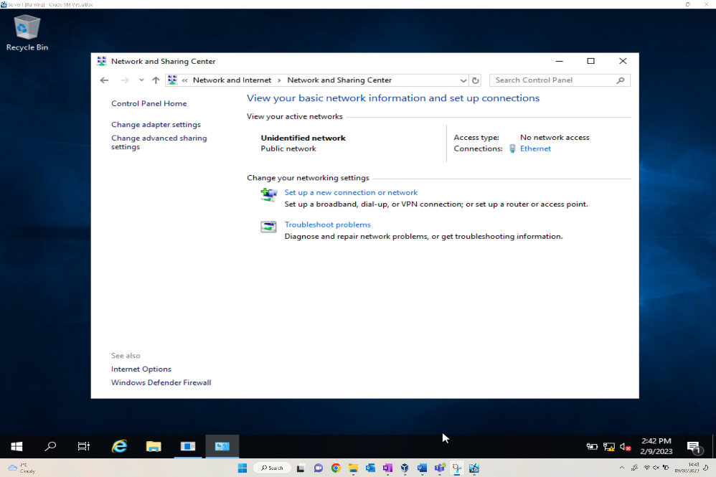
The above shows the options provided for the Network and sharing centre after navigating via the Network and Internet section of the control panel. The Ethernet hyperlink found to the right of the screen allows amendments to be made to the ethernet adaptor properties, along with changing the IPv4 specification.

Figure – Amending IPv4 within ethernet adaptor properties
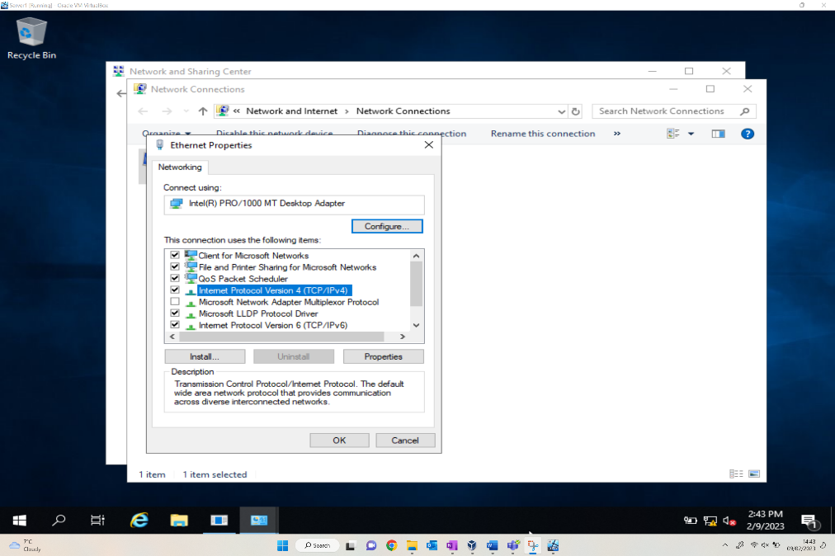
The connection has been renamed PublicNet as requested, which could be seen behind the Ethernet Properties window. The above shows the ethernet properties screen, where the Internet Protocol Version 4 option should be selected and amended.

Figure – Assigning manual IPv4 address and auto assigning Subnet mask within PublicNet
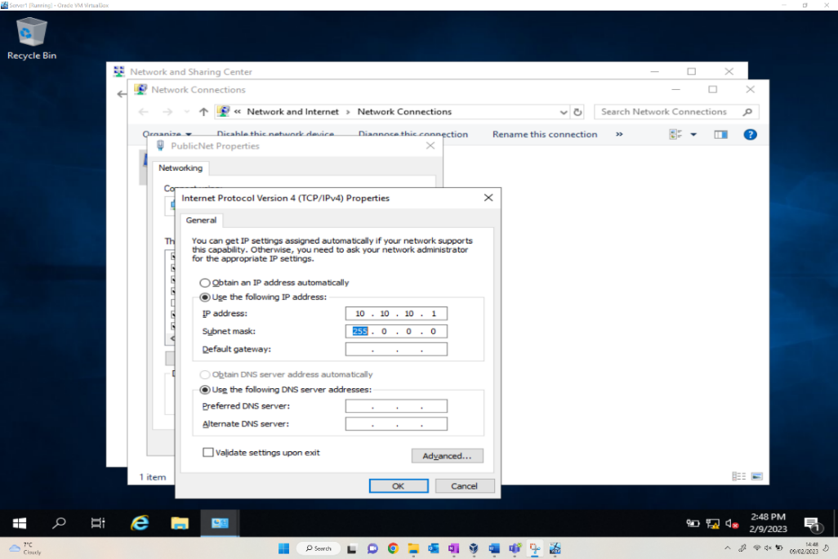
After accessing the Internet Protocol Version 4 window, the user can manually amend the IP address as required, this has been changed to 10.10.10.1 which is the address specified in the Trial Network Config diagram. The subnet mask has been auto assigned.

This process is then repeated to create the second connection for PrivateNet1. This involves the similar steps documented above, beginning by selecting Server1 and the Adapter 2 tab, this then creates the second connection which is now visible, seen in the next figure.
This connection has been named PrivateNet1 as required in the network specification document. Once the network connection has been renamed, like the first network connection the IPv4 address can be assigned, along with an auto populated subnet. The subnet should be a different one to the other adaptor.

Figure – Client1 connection to PrivateNet1
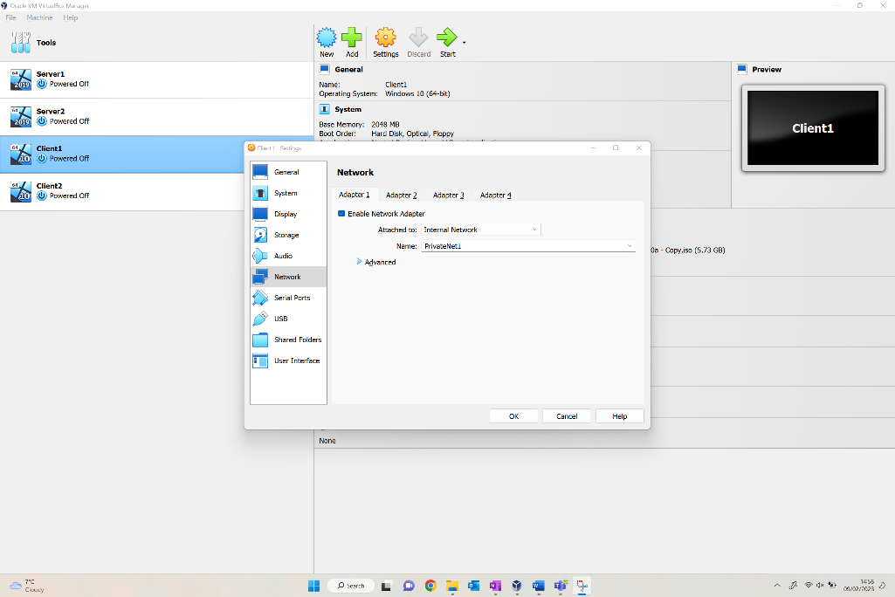
Now that both Public and PrivateNet1 connections have been configured, the Clients can now be connected to the relevant Networks. The above figure shows the Network options for Client1, the Adapter attachment has been amended to Internal Network, and the network selection is PrivateNet1.

Figure – Client2 PrivateNet2 IP Address
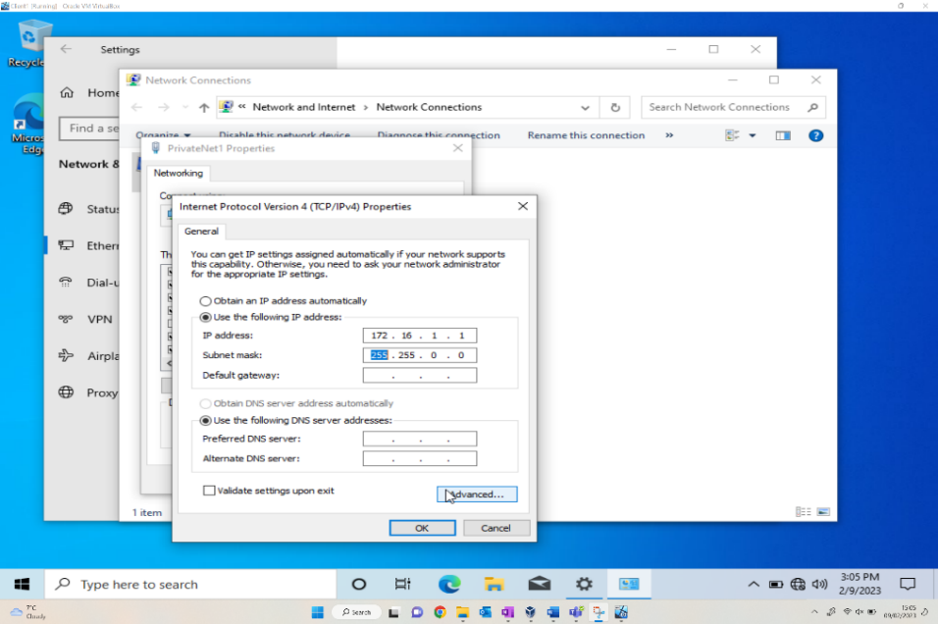
Like the previous processes for the servers, the Ethernet within Client 1 is renamed, then the client is manually assigned with the IPv4 address of PrivateNet1 172.16.1.1 as per the Trial Network Config diagram, subnet mask again automatically allocated.

Install Critical Network Services (Screenshots)

Pre-Requisite
Figure – Server 1 Firewall Turned Off
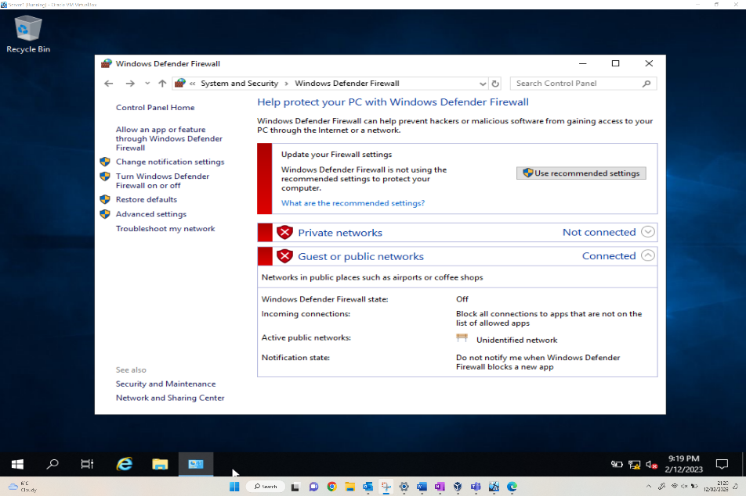
As a pre-requisite to the next task, there needs to be verification that there’s no DNS setup, and that the Firewall is turned off. The above screen allows the user to customize the settings of each network, both the private and public network firewall settings.
This screenshot confirms that the Server1 Firewalls have now been turned off, showing as Not connected in the private networks section specifically.
Figure – Confirmation of Rename
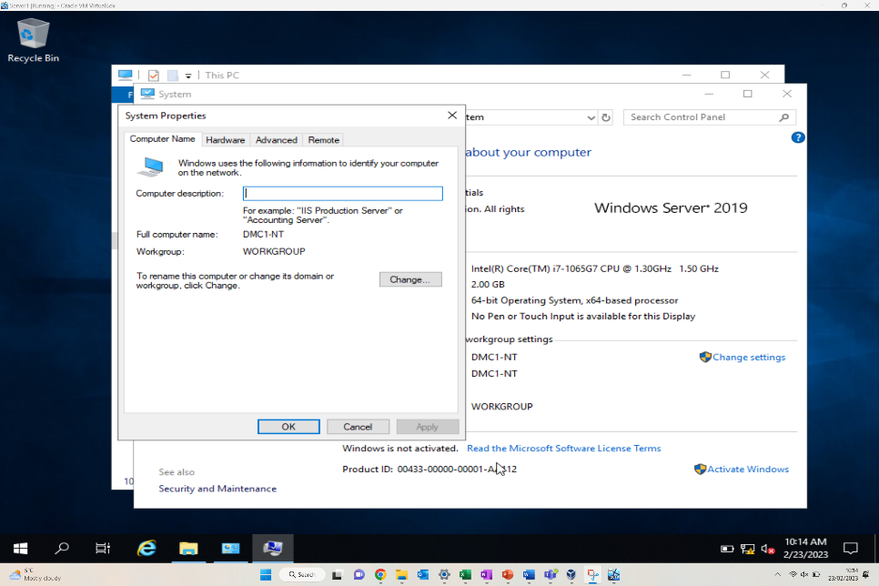
The above screenshot evidences the renaming of server 1, following the instructions provided via the worksheet the computer name has been amended to DMC1-NT. Following this action, a system restart was required.

Deploying Active Directory as a role or feature based installation.

For the roles to be installed on the required server, this is all handled within the ‘Server manager’ application on the server OS. To launch Server Manager the user will need to search for it within the start menu and search for it within there. Once Server Manager is open select ‘Manage > Add Roles and Features’, where the following window will be displayed, when the user is at this point, it is required to select ‘next’ to proceed through the Add role wizard.
Figure – Server Management Dashboard to add Features
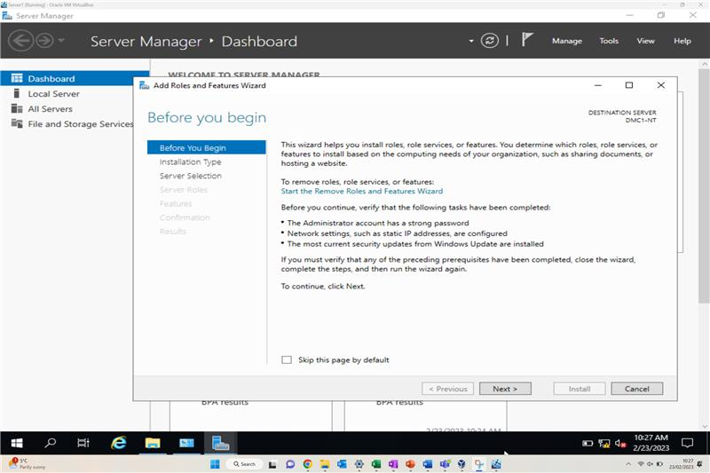
The next window that will appear is to select the destination server, this allows the user to select a different server to install the roles, in this example the destination will be set to the local server the add roles and features wizard is currently running on, so just click ‘next’ to proceed.
Figure – Selection of Renamed Server
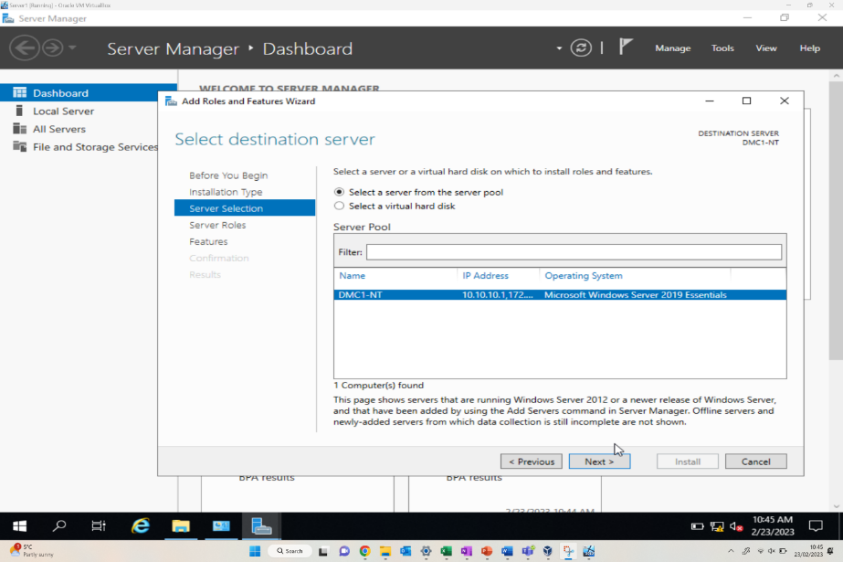
The next window that is presented is to ‘select server roles’, within here it give the user the ability to install any ‘out the box’ features which are disabled by default as part of the Windows Server OS. As part of this example Active Directory requires installing on the server host so selecting the checkbox next to ‘Active Directory Domain Services’ then clicking ‘next’ will allow the installation to commence.
Figure – Adding Active Directory Domain Services
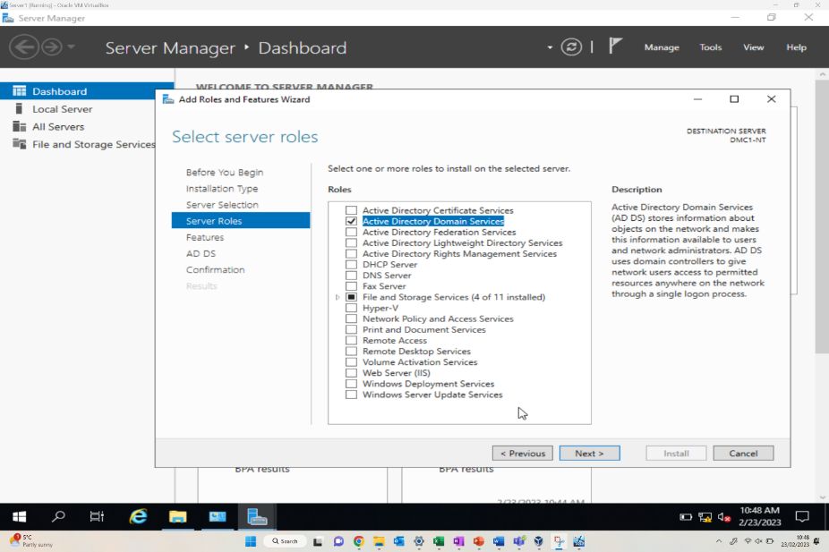
Role installation progression can be monitored through the status ‘flag’ within server manager.
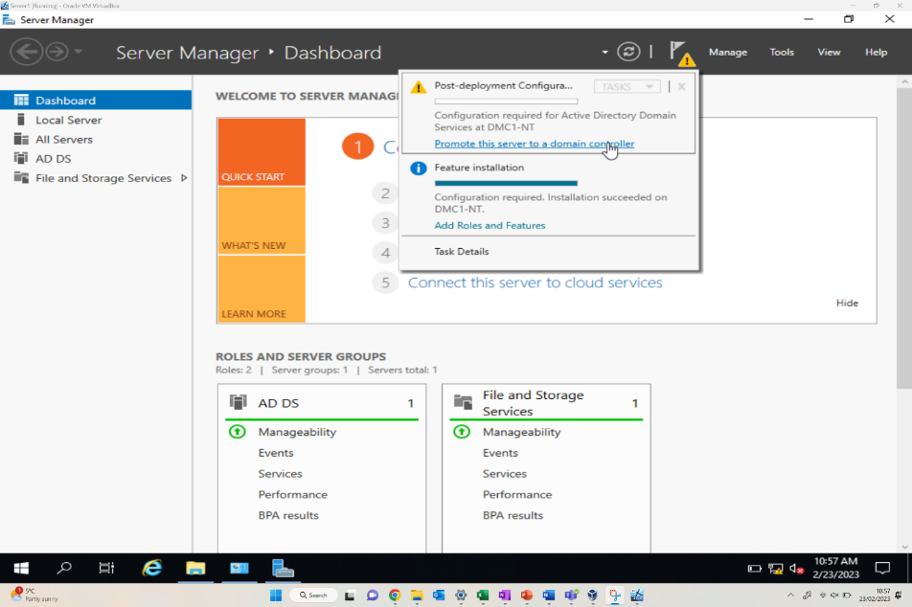

Creating user account objects using Active Directory Users and Computers snap-in console
Search for ‘Active directory users and computers’ in the start menu of the server, this will then open the MMC snap-in console with the AD configurations within there, like the following:
Figure – Verification of DMC1-NT Server
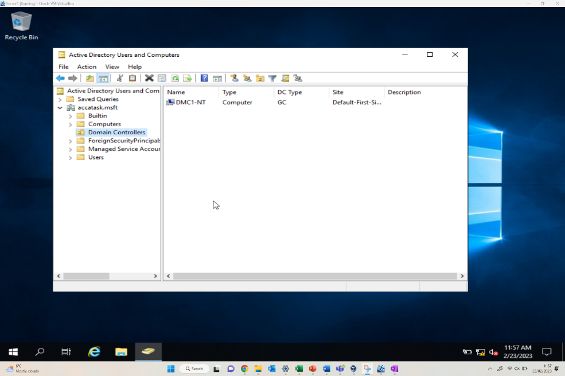
To create a new user object right-click on the ‘users’ container within the left-hand pane and select ‘New > User’, here the new user account creation window will appear, here the user's information such as first and last name, logon names all require entering to create the domain account

Figure – Creation of user “Morgan Combstock”
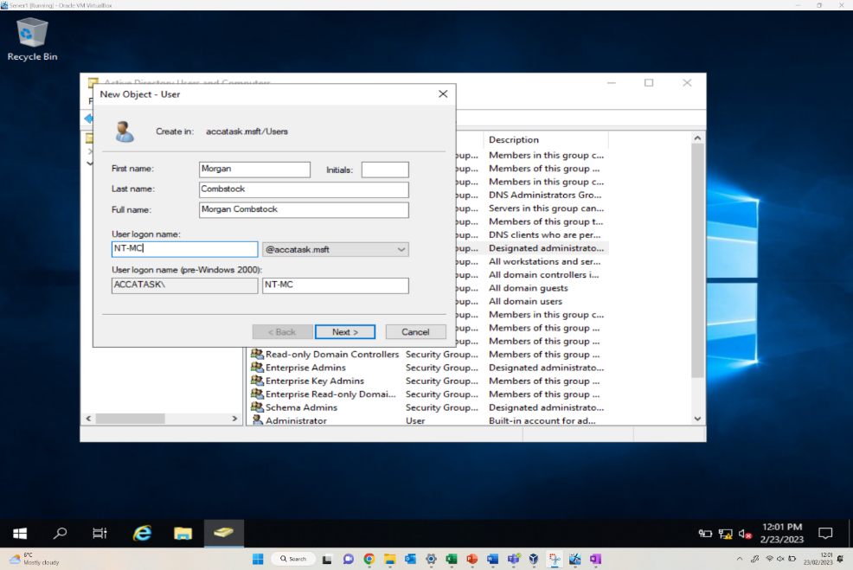
Once the user details have been inputted, simply select ‘next’ to create a password for the account and to select any additional functions on the account, i.e., set password to never expire, user must change password at next logon etc.
Figure – Adding Password for user Accessibility
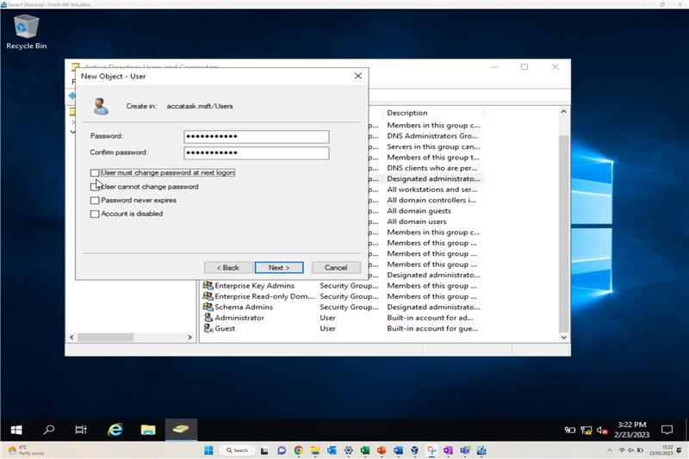
Once the user has been created and password assigned, the user then needs to be added to a domain admin group, whether this is with admin accessibility rights or just general user with lesser network accessibility.

Object Attributes of Interest

Once the Active Directory users and account objects have been created, further object attributes of interest can be created. Various attributes can be implemented to optimise the Active Directory management capability. This includes imposing limitations on restricted user groups, or enforcement of user activities upon the network.
Figure – New user in user membership domain
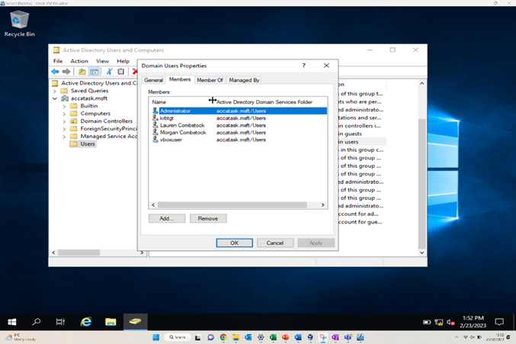
The above figure shows the addition of new users into the user membership. Various users can then be added, including an administrator user, or even group to separate those who need/should have higher levels of access and influence on the network compared to those who should only have restricted access.
Figure – Restriction of Login hours for specified User
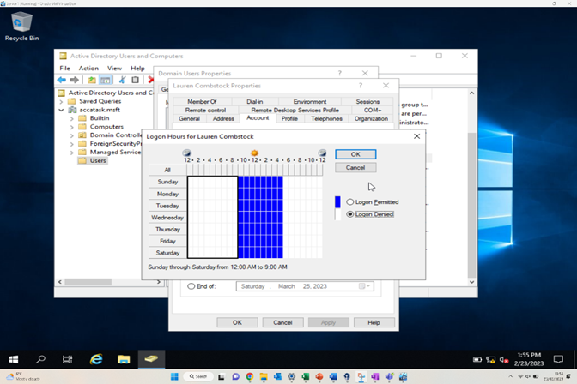
Other restrictions can be imposed, the above is an example of restricting the access hours of a generic user of the network. The user ‘Lauren Combstock’ has had the hours of permitted access to 9am – 5pm, meaning the user will be unable to log in to the network in times outside the permitted access.

Adjoining the Domains and Testing user logins

Figure – WC1-NT successful Domain connection
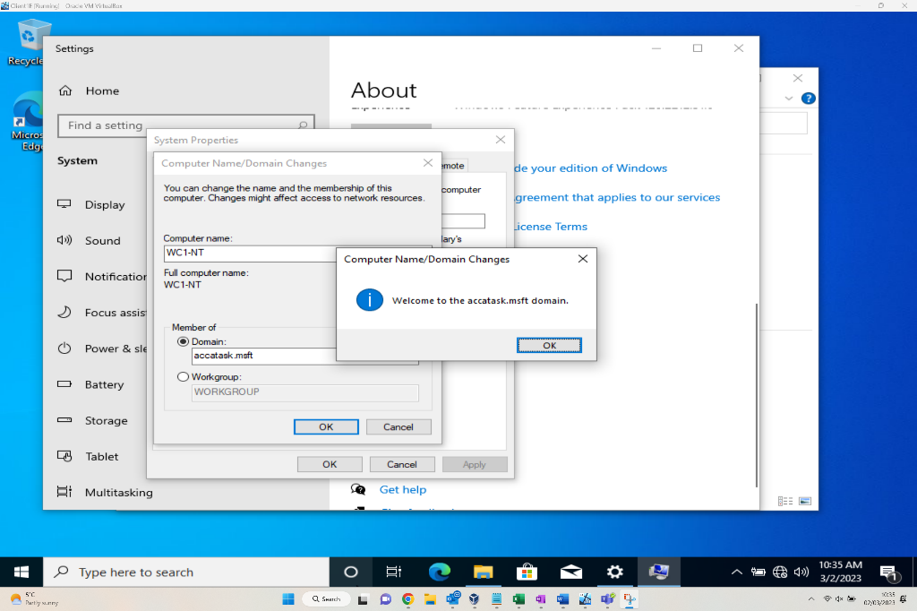
The above figure demonstrates the computer WC1-NT being connected to accatask.msft domain successfully. This is accessed via the system properties window within the control panel.
Figure – Morgan Combstock home screen prior to Log out
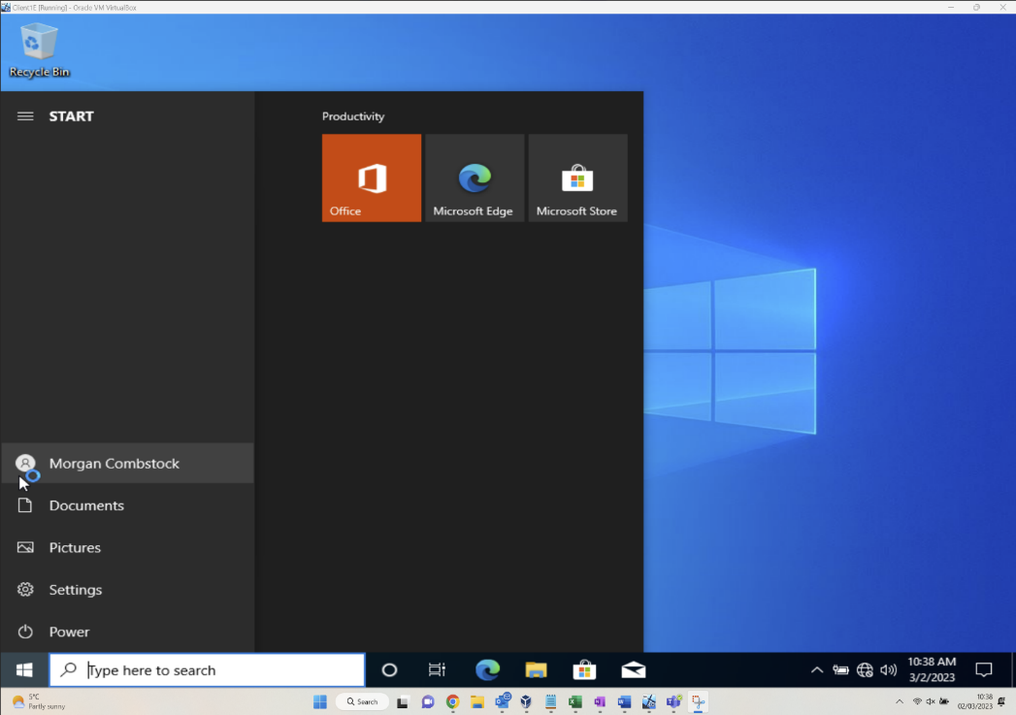
This above figure shows a completed login by the user “Morgan Combstock” after successful authentication of domain credentials. The user is now successfully connected following the completion of all the previous steps in setting up the network.
Figure – Access denied for user without domain access
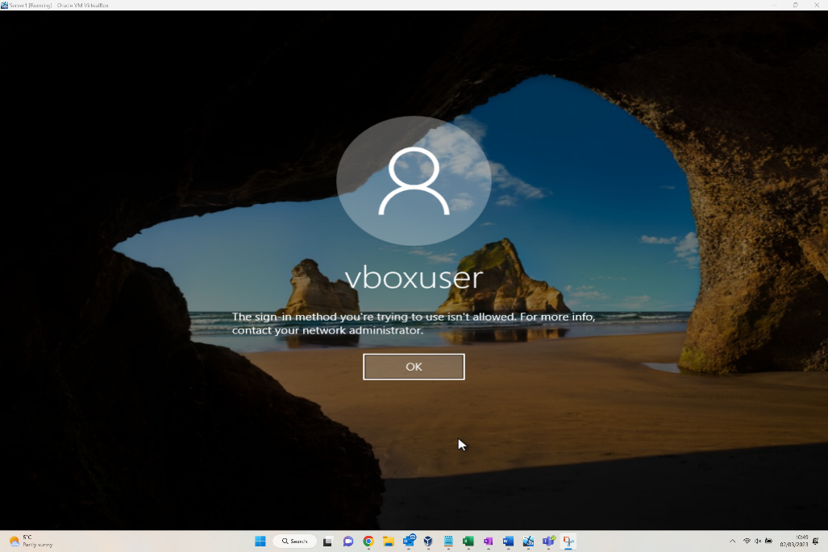
Having showcased a successful login in the previous figure, the above examples a user who now attempts to login using non-domain credentials. This shows that when a user attempts to do this, they are denied access to the domain as intended.

2. Task 2

2.1. Question i
Justify the reason why Type 2 Hypervisors is used in the above practical task? Give scenarios where Type 1 Hypervisors could be used. Identify benefits and drawbacks of Type 1 and Type 2 Hypervisors.
A type 2 hypervisor runs on top of an existing computer’s operating system [1]. This means installing a hypervisor program which allows a user to run multiple virtual machines from a single device. The practical task we carried out was well suited to a type 2 hypervisor as it allowed us to quickly and easily provision 4 virtual machines using different images; two Windows Server 2019 and two Windows 10 Enterprise Edition. A Type 1 hypervisor however, runs directly on the underlying computer’s physical hardware, interacting directly with its CPU, memory, and physical storage; it effectively functions as an operating system [2].
A type 1 hypervisor is more efficient as they are not operating through an operating system. They are also more secure as they there is no intermediary program that could be compromised. For these reasons, a type one hypervisor may be used by a large organisation so that they can benefit from these two features.

2.2 Question ii
DHCP - explain what it is, how it works (illustrations) and its significance.
DHCP stands for dynamic host configuration protocol. DHCP is a client/server protocol that automatically provides an IP address to host machines [3]. This allows a client machine to access the network and request an IP address to be assigned. In a home network, this may not be considered vital as there may be only a few client devices and so static or manual IP assignment isn’t an issue. In enterprise organisations however, many devices could be connected to a network and these all need assignments. DHCP can also operate on a lease basis. This is the temporary assignment of an IP address to a device on the network [4]. This allows an IP address to be used by a device and then reallocated once that device disconnects from the network.

2.3 Question iii
“Active Directory is a distributed database that stores objects in a hierarchical, structured, and secure format”: Justify AD’s technology with illustrations and adequate evidence.
Active Directory simplifies life for administrators and end users while enhancing security for organizations [5]. Active Directory allows a network domain to be administered by a server machine assigned as a domain controller. Other machines in the domain group may be able to access the domain and use the resources rather than users having to access the same physical asset. Active Directory allows for the roles of user and administrator which limits configuration settings which users can view and or access.

2.4 Question iv
Give an in-detail description about the different terminologies and its purposes (like (not limited to) Ping, Server Management, Firewall, PAE/NX, OOBE etc) you came across during this worksheet. Compare your list of terminologies in the aspect of their operations/functionality with other Network Operating Systems. (For example: If you select Windows Firewall and describe the operations/functionality of Windows Server 2019 Firewall, you have to compare these features with the operations/functionality of other Network Operating Systems like Linux, Mac)
During this task, we were required to send a ping to verify that the machines were connected, configure firewalls to allow communication and administer active directory to control permissions within the domain group.
Ping is a command or function that can be executed within the command line. This sends a packet of data to the specified IP address or domain name and measures the response time. As mentioned above, this can be used to determine whether or not two machines are connected via a network. Ping functions largely the same in other operating systems but in some cases, more options are available.
Server management, in the context of this task, was primarily carried out by manually assigning the IP addresses to each network connector and configuring active directory. This meant we could set up the ping to test connectivity and also allowed us to control who could make changes on the domain controller.

Question v
Write a brief reflection on the tasks completed in this worksheet. (Not more than 250 words)
Completing the tasks in the above worksheet gave me a greater understanding of how a network operates. In creating the multiple machines and networks, I had to configure the network adaptors, IP addresses and the subnets so that each machine could interact with the other machine(s) in the network. The task also introduced me to local domain based active directory. I am familiar with Azure Active Directory which can be used at an enterprise level, but it is useful to understand how a domain can be controlled and administered by active directory on a sever machine.
We did encounter an error at one stage whereby a virtual machine running Windows 10 Home edition is unable to be added to a domain. We verified this by checking on Microsoft help pages. To fix the issue, we had to create a new virtual machine running a Windows 10 Enterprise image and re-configure within the network.

2.6 Collaborative Working Reflection
Working as a group or team is something that I do day in, day out in my employment. This has meant that, for this group project, I felt I had a strong footing from the off. Dylan took a strong lead within the team suggesting that we use Microsoft Teams to engage with one another and centralise the document we would use for screenshots and annotations. Dave and David were both present each week in class and active on Microsoft teams providing suggestions, further annotations and more technical/troubleshooting support when the solution did not seem to be functioning.
All team members worked well in their given roles and supported one another. This has been a successful team exercise.

3. References

[1] | S. J. Bigelow, “What's the difference between Type 1 vs. Type 2 hypervisor?,” TechTarget, 13 01 2021. [Online]. Available: https://www.techtarget.com/searchitoperations/tip/Whats-the-difference-between-Type-1-vs-Type-2-hypervisor#:~:text=The%20main%20difference%20between%20Type,cons%20and%20specific%20use%20cases.. [Accessed 09 03 2023].
[2] | IBM, “Hypervisors,” IBM, 2023. [Online]. Available: https://www.ibm.com/topics/hypervisors. [Accessed 09 03 2023].
[3] | Microsoft, “Dynamic Host Configuration Protocol (DHCP),” 29 07 2021. [Online]. Available: https://learn.microsoft.com/en-us/windows-server/networking/technologies/dhcp/dhcp-top. [Accessed 09 03 2023].
[4] | Efficient IP, “What is DHCP Lease?,” 2023. [Online]. Available: https://www.efficientip.com/glossary/dhcp-lease. [Accessed 09 03 2023].
[5] | Quest, “What is Active Directory?,” Quest, 2023. [Online]. Available: https://www.quest.com/solutions/active-directory/what-is-active-directory.aspx#:~:text=Active%20Directory%20(AD)%20is%20a,who's%20allowed%20to%20do%20what.. [Accessed 09 03 2023].

