WING ON’S FINANCIAL ANALYSIS

Student Name: KEUNG Nga Yee Teresa
Student Number: 1922108

DR. KATHERINE MO
UNIVERSITY OF WALES

17 August 2020

Executive Summary
This paper gives a detailed financial study of Wing On, a leading retail company in Hong Kong. This paper commences with the basic knowledge regarding Wing On, such as the history of the organization, goods and services, corporate principles and ethics of the firm, and the general market place. The report also addresses the condition of the market, covering past success and possible viewpoints. The paper then presents a business overview, addressing the structure and makeup of the market, development, opportunities, and risks, and potential outlook. When this groundwork is set, the paper will include a detailed comparison to Wing On's market research; to give an overview of their financial strengths and disadvantages, and their general business-level results. Ultimately, this paper ends with Wing On's value-based financial review, which provides proposals for better business efficiency. This paper will provide a precise overview of the entire industry and the retail selling business, as well as an in-depth awareness of the financial status of Wing On and its present market place.

Table of Contents
WING ON’S FINANCIAL ANALYSIS 1
1. INTRODUCTION 4
1.1 Company Background 4
1.2 Wing On products and services 4
1.3 Industry Outlook 4
2. FINANCIAL STATEMENTS ANALYSIS 6
2.1 General Discussion of Wing On financial statements 6
2.2 Financial Ratios 7
3. STRENGTHS AND WEAKNESSES ANALYSIS 8
3.1 Financial Ratio to Industry Analysis 8
4. INVESTMENT APPRAISAL ANALYSIS. 16
5. WINGON'S CORPORATE GOVERNANCE ASSESSMENT 19
5.1 Suggestions for improvement 20
6. RECOMMENDATIONS ON VALUE-BASED FINANCIAL ANALYSIS 22
6.1 Strategy for Increasing the Company's Value 22
7. REFERENCES……………………………………………………………………………..…23
8. APPENDICES………………………………………………………………………………...24

INTRODUCTION

Company Background
Wing On Company International Limited was founded in December 1991 and is registered on the Hong Kong Stock Exchange (stock code: 289). The core company interests comprise the Wing On Department Stores and the Hong Kong and international industrial property portfolios ("WING ON", 2020).

Wing On products and services
Retail Shop Division
The Wing On Department Stores (Hong Kong) Limited is a company owned entirely by the Wing On Company International Limited. Wing On Department Stores was founded in 1907 and is among Hong Kong 's biggest department stores. Managing retail stores in Hong Kong with a gross selling floor space of about 315,000 square feet, Wing On Department Stores provides its consumers a vast array of premium products originating locally and abroad, accompanied by professional customer support ("WING ON", 2020).
Investments in real estate
The country operates a diversified portfolio of commercial property investments in Hong Kong, the United States, and Australia, as among the business units. The Group's real estate investments in Hong Kong include the Wing On Center in Sheung Wan, a section of Tsimshatsui East's Wing On Plaza, and the largest share of Yaumatei 's Wing On Kowloon Centre. Such assets grant Wing On Department Stores premium commercial space for renting purposes as well as shop sites. Abroad, the company operates key office locations in Sydney, Australia, as well as The Halbouty Center in Houston, Texas, United States. The real estate in Sydney is regarded as being among the best and most contemporary landmark commercial buildings in Australia ("WING ON", 2020).

Industry Outlook
Nature of the Industry
Organizations in this industry offer a large variety of items, including food and clothing to appliances, kitchen goods, and office equipment, to customers and companies. Costco, Kroger, and Target (all headquartered in the US), and also Aldi (Germany), Carrefour (France), Schwarz (Germany), and Tesco (UK) are other big corporations in the retailing industry.
Competition
The internet is changing the retail industry and growing customer access, despite traditional retailers losing market share to online operators. Also, markets once thought to be fairly free from online competition, for example, the grocery and automotive components retail, face growing pressure from e-retailers (particularly Amazon) and reinventing their business activities as a reaction. Overall, U.S. e-commerce revenues were reported at $453.5 billion in 2017 (8.9 percent of overall retail revenue), a 16 percent rise from 2016. According to Forrester, e-commerce is projected to rise to 17 percent of US retail revenue by 2022 (CBRE , 2020).
Research comparison company information
For purposes of this study, a comparison is done between Wing On and two other top Chinese retailers: The Sincere Company and Lifestyle.
Sincere Department Store is a Sincere Company Limited retail store and among Hong Kong's largest department stores. Until 1949, its central presence was in Shanghai, together with Wing On.
Lifestyle International Holdings Limited, an enterprise that has shares in a number of subsidiaries, is a major retailer that has its headquarters and majority of its outlets and operations in Hong Kong. The company is considered a specialist in the management of both middle-end and high-end supermarkets in Hong Kong. The company owns two Hong Kong SOGO retail outlets, namely the finest shop Causeway Bay, Hong Kong's biggest and top rated retail store, and the Tsim Sha Tsui retail outlet. Represented by a single stop shopping experience with unmatched brand value, the Group's retail stores deliver a wide range of different products in a convenient shopping atmosphere, from everyday needs to premium brands and also personalized care facilities, including beauty salons.

FINANCIAL STATEMENTS ANALYSIS

General Discussion of Wing On financial statements
The Annual Reports offer interest details to creditors, shareholders, and executives at companies. The annual statements contain a statement of income, a balance sheet, and a summary of cash flow over different amounts of time. This report focused on yearly results. Usually, annual statements are compiled using Generally Accepted Accounting Principles (GAAP), which are standard guidelines for standardizing accounting procedures. With Wing On during the last three years (2017 – 2019), the accompanying estimates include revenue tax, a balance sheet, and a cash flow condition. In fact, specific interactive descriptions of the details on these sheets are introduced to explain the knowledge in question further. Similarly, an analysis of this information as the following.
Income Statement, Wing On, (in HKD) (APPENDIX A)
CONSOLIDATED STATEMENT OF PROFIT OR LOSS (For the year ended 31 December 2019)
Cash Flow Statement, Wing On, (In Millions of Dollars) (APPENDIX B)
CONSOLIDATED STATEMENT OF PROFIT OR LOSS AND OTHER COMPREHENSIVE INCOME (For the year ended 31 December 2019)
Balance Sheet, Wing On, (In Millions of Dollars) (APPENDIX C)
CONSOLIDATED STATEMENT OF FINANCIAL POSITION (At 31 December 2019)
Revenues and costs for Wing On for the last two years are laid out in the income statement. That argument is utilized by creditors and borrowers to assess the company's potential for income. The financial statement frequently displays earnings per share, standardizing a company's success metric and enabling investors to associate different firms, such as Wing On, with other related business rivals. The gap in revenue and investments is equal to EBIT. The net profit is what stays after paying for taxation and interest. Wing On received sales of $1.37 billion in 2019 and reported net profits of just $766.8 million, a profit margin of 55.9 percent.
The balance sheet for Wing On during the last two years includes income, liabilities, and owners' equity (net worth). Investors and borrowers use the balance sheet to determine the potential of the company to respond to evolving demands and growth prospects. Capital Management includes a reflection across the last two years of existing and future assets. Liabilities & Capital Analysis offers a statistical illustration of existing and long term liabilities for the last two years, as well as capital. Total assets are derived by summing up the existing and future reserves to a combined value of $21 billion.
The cash flow statement shows funds produced for Wing On during the past two years from working, spending, or funding operations. Investors and borrowers utilize the cash-flow analysis to assess whether cash would be enough to cover obligations and expenses, such as dividends. Cash Flow Process offers a description of the year-end (next year-beginning) operating assets and current income transition from year to year. At the end of 2019, Wing On had gross cash of 2.993 billion dollars. Cash Flow Review offers financial analysis from Wing On's running, acquisition, and financing operations over the last two years. The summation of all three operations produces the total cash flow adjustment equivalent to that of the overall year-on-year increase in cash flow.
Given the complexity of the Financial Statements, Balance Sheets, and Cash Flow Statements, although reasonable, the data given provides minimal information with just essential values, all of which were used to measure the necessary ratios.

Financial Ratios
Common Size Statements
Common size ratios should be used for a three-year analysis of Wing On's income statements and balance sheets. By presenting the items of the financial statements in a specific size scale, uniform metrics are given to help determine any patterns found over time. The income statement values are calculated as a percentage of the total revenue, and the balance sheet values are represented as a percentage of the total assets.
Review of the Income Report
The income statement metrics of Wing On have been very stable over the last three years, from 2017 and 2019. From 2018 and 2019, the gross operational cost of Wing On reduced by about 6.34 percent. Wing On has reported substantial rises in operating income as a consequence of such lower operating expenses. Net income before taxation, though, and income after taxation, fell between 2018 and 2019 (93.02% and 121.56%, respectively). They are due to smaller returns (about 1 billion less) on investment properties in 2019 relative to 2018.
Balance Sheet Analysis
Wing On's balance sheet metrics indicate optimistic patterns from 2018 to 2019. Any interesting developments are as follows: Total Current Assets fell by 7.37 percent. These cuts derive largely from increases in Cash and Short Term Investments; and to some degree, Overall Inventory decreases.
Total Non-Current Assets grew by 40.25 percent between 2018 and 2019, largely as a consequence of higher interest levels on associates, property, plant and machinery, and investment property.
Total Current Liabilities witnessed rising movements from 2018 to 2019 (average of 20.97 percent). Such adjustments were primarily attributed to improvements in lease liabilities, tax payable, and bank loans.
Ultimately, the balance sheet reveals optimistic patterns in the period 2018 to 2019
Cash Flow Analysis
Many analysts see cash flow as maybe the most significant financial leading indicator for business. Figure 2 displays Wing On's Cash Flow Report for the past 3 years, 2017-2019. From 2018 to 2019 the net income diminished.

STRENGTHS AND WEAKNESSES ANALYSIS

Financial Ratio to Industry Analysis
There are other tools available to offer different business financial ratios. Because Wing On is such a broad and diversified business, it can be found within the retailing industry as well as across several sectors and sub-industries. This study incorporates aggregate statistics from a small group of companies that make up a vast portion of the retail sales market. In an attempt to eliminate inconsistencies, Wing On, The Sincere Company, and Lifestyle have the business and company insight data set. The raw data included in these analyzes include three years of the statement of income, balance sheets, and analysis of cash flow (from 2017 to 2019)
The ratios presented are adapted from literature on ratios outlined in the text, Financial Management Theory, and Practice, 12th Edition.
Financial Strength
The financial health of an organization is an indicator of its economic risk. Part of the risk mitigation tests the capacity of a business to fund or pay back the short-term debt. This can be achieved by the usage of properties and can be turned easily into currency. Those properties are known as liquid assets. The following formulas are used to determine liquidity and financial flexibility for business.
Current Ratio – [Current Assets / Current Liabilities]
A current ratio is a liquidity ratio that evaluates the capacity of a firm to meet short-term obligations. A higher ratio is deemed healthier, as it indicates that surplus assets will be used to offset outstanding debt obligations.
TABLE 1: Current Ratios
Company Name | Sincere |  |  | Wing On |  |  | SOGO
Year | 2017 | 2018 | 2019 | 2017 | 2018 | 2019 | 2017 | 2018 | 2019
Current Ratio | 1.77 | 1.05 | 0.67 | 6.85 | 7.74 | 6.87 | 2.67 | 2.07 | 2.15

In general, over the three years, Wing On exhibits an increase followed by a decrease in the current ration. However, the range remains within a specific limit with little variation. Similarly, the current ratio is significantly higher than its competitors. This indicates that Wing On is performing better than its counterparts in the same industry as it has more liquid assets and hence manages its debts better.
Quick Ratio – [(Current Assets – Inventories) / Current Liabilities]
A quick ratio tests the capacity of a corporation, with its most volatile assets, to fulfill its short-term obligations. A higher ratio is deemed healthier as it demonstrates that a company does not rely on inventory to fund short-term debt.

TABLE 2: Quick Ratios
Company Name | Sincere |  |  | Wing On |  |  | SOGO
Year | 2017 | 2018 | 2019 | 2017 | 2018 | 2019 | 2017 | 2018 | 2019
Quick Ratio | 1.42 | 0.82 | 0.47 | 6.68 | 7.50 | 6.70 | 267% | 206% | 215%

Upon analysis of the financial strength ratios of Wing On and the competitors, both the current and quick ratios for Wing On's have been higher than the industry average, which commends its ability to pay short-term obligations.
Asset Management
Asset management ratios for an organization calculate performance in controlling assets for sales generation. Such factors may provide clarity into the inventory and credit control of a business. The equations below are used to measure specific types of asset management.
Days Sales Outstanding (DSO) – [Receivables / (Annual Sales/365)]
The DSO figure gives an indicator of how long it takes to collect payments receivable, relative to a typical regular turnover of unpaid receivables. A lower percentage indicates fewer processing period for deferred receivables and a quicker turnover in cash flow. It has considerable significance to the lending policy of a corporation.
TABLE 3: Days Sales Outstanding Ratios
Company Name | Sincere |  |  | Wing On |  |  | SOGO
Year | 2017 | 2018 | 2019 | 2017 | 2018 | 2019 | 2017 | 2018 | 2019
Day's Sales in Inventory | 164 | 172 | 181 | 54 | 75 | 54 | 6.5 | 14.3 | 15.8
Total Asset Turnover – [Sales / Total Assets]
The asset turnover ratio tests the performance of a company is utilizing its properties to achieve profits or revenues. A bigger total asset turnover is considered to be more desirable. It can also serve to describe a promotional policy. Low-profit margin businesses tend to have large asset turnover, while high profit margin businesses have low asset turnover.
However, it is not a typical for some business models to forego huge assets turnover. This mostly in the case where the business model encourages high enough margins that will cover the cost foregone from higher sales.
TABLE 4: Total Asset Turnover Ratios
Company Name | Sincere |  |  | Wing On |  |  | SOGO
Year | 2017 | 2018 | 2019 | 2017 | 2018 | 2019 | 2017 | 2018 | 2019
Total Assets Turnover | 77.4% | 78.1% | 42.1% | 9.82% | 9.02% | 8.3% | 45.9% | 39.4% | 32%

The total asset turnover rates were below the industry average when evaluating the asset management levels of Wing On and the sector, and the days sales outstanding level was average, despite it not being on either end of the spectrum in all three years. The 3-year data reveals that it takes two to three months for Wing On to accumulate unpaid receivables. The company model for Wing On tends to be concentrated in assets. The total of net assets rose 21.05 percent in 2018 relative to those in 2017. This rise was attributed to higher funding origination rates and is mirrored in the asset management ratios.
Debt Management
Debt management for a business is focused on how it utilizes funding from borrowers as an incentive to work and expand as a corporation. In order to remain afloat or generate better money, borrowing lent funds is often more realistic than locking up certain vital capital. The debt ratio is the percentage of the total assets of a company that are funded by borrowed funds. A small debt level indicates prudent finance with the potential to invest at no major potential cost in the future.
Debt Ratio – [Total Liabilities / Total Assets]
The debt ratio shows what percentage of a company's debt is proportional to its assets. The calculation suggested future threats facing the organization with regard to its debt. A debt ratio greater than 1 means a business has more debt than assets. A debt level of less than 1 means a business has more assets than debt. The debt ratio may be used in combination with the current and quick ratios to help assess the amount of uncertainty for business.
TABLE 5: Debt Ratios
Company Name | Sincere |  |  | Wing On |  |  | SOGO
Year | 2017 | 2018 | 2019 | 2017 | 2018 | 2019 | 2017 | 2018 | 2019
Total Debt Ratio | 0.55 | 0.84 | 0.72 | 0.08 | 0.07 | 0.07 | 0.81 | 0.86 | 0.84

The debt ratios of Wing On's competitors seem to fluctuate from year to year. However, it is common for all the three companies in all the three years that they all have debt ratios less than one. This means that all companies have more assets than liabilities. Wing On has been significantly lower than the industry average for the last three years. Wing On continues to smartly manage debt and maintain a productive balance between debt and assets.
Profitability
The profitability of a business is a metric used to determine its ability to produce profits in comparison to its expenditures and related costs. Getting a higher ratio value compared to the typical market, or the same ratio from a previous time implies the business is safe and less volatile.
Profit Margin on Sale (Net) – [Net Income / Sales]
A higher profit margin on sale implies a business that is more competitive than its rivals and has greater leverage of its expenses. But lower profit margins, in some situations, reflect a price policy. Some businesses as retailers, may be recognized for their low-cost, high-volume approach. A weak net profit margin may sometimes reflect a trade war that lowers income
TABLE 6: Profit Margin Ratios
Company Name | Sincere |  |  | Wing On |  |  | SOGO
Year | 2017 | 2018 | 2019 | 2017 | 2018 | 2019 | 2017 | 2018 | 2019
Net Profit margin | 26% | 43% | 57% | 162% | 116% | 56% | 67% | 39% | 53%
Basic Earning Power – [Earnings Before Interest and Taxes (EBIT) / Total Assets]
The basic ratio of earning power shows how efficient assets are used for earnings production. A higher ratio to the market average suggests that the business is managing its operational costs and assets, while still rising earnings.
TABLE 7: Basic Earnings Ratios
Company Name | Sincere |  |  | Wing On |  |  | SOGO
Year | 2017 | 2018 | 2019 | 2017 | 2018 | 2019 | 2017 | 2018 | 2019
Gross profit margin | 0.96 | 0.96 | 0.50 | 0.60 | 0.68 | 0.69 | 0.57 | 0.74 | 0.75

Return on Total Assets (ROA) – [Net Income / Total Assets]
The return on the total asset ratio reveals how successfully the business turns its assets into net profits. The larger the percentage, the more efficient the business becomes as it generates more profits with less spending.
TABLE 8: Return on Total Assets Ratios
Company Name | Sincere |  |  | Wing On |  |  | SOGO
Year | 2017 | 2018 | 2019 | 2017 | 2018 | 2019 | 2017 | 2018 | 2019
ROA (after tax) (%) | 0.20 | 0.34 | 0.24 | 0.14 | 0.07 | 0.04 | 0.17 | 0.12 | 0.10

Return on Common Equity (ROE) – [Net Income / Common Equity]
The return on the common equity ratio is helpful when evaluating the productivity of previous success of a business, as well as that of certain firms within the sector. This also tests the competitiveness of a company by demonstrating how much income a firm earns from the capital shareholders have spent. Using current resources, a higher ratio indicates improved profit.
TABLE 9: Return on Common Equity Ratios
Company Name | Sincere |  |  | Wing On |  |  | SOGO
Year | 2017 | 2018 | 2019 | 2017 | 2018 | 2019 | 2017 | 2018 | 2019
ROE (after tax)(%) | -0.45 | -2.15 | -0.85 | 0.15 | 0.08 | 0.04 | 0.90 | 0.83 | 0.66

Upon analysis of the profitability ratios of Wing On and the competitors in the industry, Wing On was lagging behind the industry for the majority of the ratios, with the exception of the net profit margins when it outperformed the industry in this indicator. In addition, Wing On's net profit margin jumped by nearly 50 percent between 2018 and 2019, indicating that easing of cost-cutting efforts.
Market Value (Valuation or Risk)
The market valuation ratios of business compare an actual market value, the purchase price, to the book prices derived from the financial report of the corporation. Such ratios enable a firm to determine potential investor efficiency. Such factors can provide investors with a strong risk overview of existing and potential market rankings for the business.
Price/Earnings (P/E) – [Price per Share / Earnings per Share]
A strong price-to-earnings ratio indicates consumers hope to see faster increases in projected earnings. The higher the P/E level, the more happily the consumer is to pay for any dollar in taxable profits. Firms with large P/E ratios can be deemed to be riskier for investment in comparison to companies with lower P/E ratios. A strong P/E ratio implies higher aspirations and greater risk.
TABLE 10: Price/Earnings Ratios
Company Name | Sincere |  |  | Wing On |  |  | SOGO
Year | 2017 | 2018 | 2019 | 2017 | 2018 | 2019 | 2017 | 2018 | 2019
Price-earnings Ratio(Times) | -3.22 | -1.84 | -2.46 | 13.41 | 21.38 | 11.54 | 5.04 | 11.25 | 7.10
Market/Book (M/B) – [Market Price per Share / Book Value per Share]
The book value price per share reflects an enterprise 's overall net assets on a single unit basis. This helps businesses and creditors to equate a business' book prices to the stock price, and to measure valuation gaps. If the amount is over 1 then the stock is undervalued; if it is below 1 the stock is overvalued.
TABLE 11: Market/Book Ratios
Company Name | Sincere |  |  | Wing On |  |  | SOGO
Year | 2017 | 2018 | 2019 | 2017 | 2018 | 2019 | 2017 | 2018 | 2019
Market-to-book ratio | 1.46 | 3.96 | 2.10 | 0.44 | 0.37 | 0.33 | 0.77 | 0.92 | 0.55

Upon analysis of the market value ratios of Wing On and its competitors in the industry, it can be seen that ratios for Wing On have decreased from 2017 to 2019. However, the ratios indicate that Wing On shares are overvalued. However, this is not the case for both its competitors with Sincere being undervalued and Sogo being overvalued. The price-earnings ratios observed in all three years are significantly higher than the competitors seen in the industry, thus making Wing On's outlook better than the industry competitors.

INVESTMENT APPRAISAL ANALYSIS
Due to a lack of availability of a new project plan identified by the company, an assumption is made of a hypothetical project plan. In this paper, the hypothetical plan will be dubbed Project Parkson. Project Parkson involves the addition of a new product. The project will require a one-off investment of 68,574,700. Similarly, once the project has begun, an annual investment of approximately 4.5% of the initial capital is needed. This is under the assumption that the rate of additional investment would be synonymous with the current rate of investment income increase of the Wing On group property investment.
Following input from consumers, the business department has planned the below demand outlook for upcoming years:

Year | 1 | 2 | 3 | 4 | 5
Demand in units | 28000 | 36000 | 44000 | 52000 | 32000

The following information relating to this investment proposal has now been prepared:
Initial investment | 68,574,700
Annual additional investment | 3,085,862
Selling price | $700 per unit
Variable operating cost | $28 per unit
Fixed operating cost | $6000

An assumption is made the price of the product will remain constant throughout the period gain; this will last for the remainder of the life of the product. No residual value or scrap value of equipment is anticipated at the termination of the assessed project period of five years, as development of the stated commodity is supposed to cease. Wing On will utilize a nominal discount rate of 10 percent per annum and an intended return on capital employed of 20 per cent per annum for the project assessment activities.
Calculation of NPV
 | t0 | t1 | t2 | t3 | t4 | t5
Investment | -68,574,700 | -3,085,862 | -3,085,862 | -3,085,860 | -3,085,859 | -3,085,858
Income (W1) |  | 19,600,000 | 25,200,000 | 30,800,000 | 36,400,000 | 22,400,000
Operating costs (W2) |  | -844,000 | -1,068,000 | -1,292,000 | -1,516,000 | -956,000
Net relevant cash flows | -68,574,700 | 15,670,138 | 21,046,138 | 26,422,140 | 31,798,141 | 18,358,142
Discount factor at 10% | 1 | 0.91 | 0.83 | 0.75 | 0.68 | 0.62
PV | -68,574,700 | 14,244,155 | 17,384,110 | 19,843,027 | 21,718,130 | 11,400,406
NPV | 16,015,129
NPV = $16,015,129.06 > 0 therefore accept

Workings
(W1) Calculation of income
 | t1 | t2 | t3 | t4 | t5
Units | 28000 | 36000 | 44000 | 52000 | 32000
Price per unit | 700 | 700 | 700 | 700 | 700
Total income | 19,600,000 | 25,200,000 | 30,800,000 | 36,400,000 | 22,400,000

(W2) Calculation of operating costs
 | t1 | t2 | t3 | t4 | t5
Variable cost | 784,000 | 1,008,000 | 1,232,000 | 1,456,000 | 896,000
Fixed cost | 60,000 | 60,000 | 60,000 | 60,000 | 60,000
Operating costs | 844,000 | 1,068,000 | 1,292,000 | 1,516,000 | 956,000

Calculation of return on capital employed
Calculation of return on capital employed
Total cash inflow = 15,670,138 + 21,046,138 + 26,422,140 + 31,798,141 + 18,358,142 = 113,294,699
Total depreciation and initial investment are same, as there is no scrap value
Total accounting profit 113,294,699 - 68,574,700 = 44,719,999
Average annual accounting profit = $44,719,999/5 = $8,944,000
Initial investment = $68,574,700
Return on capital employed = 100 x 8,944,000/68,574,700 = 13.04%

Calculation of discounted payback
 | t0 | t1 | t2 | t3 | t4 | t5
PV | -68,574,700 | 14,244,155 | 17,384,110 | 19,843,027 | 21,718,130 | 11,400,406
Cumulative PV | -68,574,700 | -54,330,545 | -36,946,435 | -17,103,407 | 4,614,723 | 16,015,129
Discounted payback period = 3 + (17,103,407/ 21,718,130) = 3 + 0.79 = 3.79 years
The investment plan has a favorable net present value (NPV) of $16,015,129.06 and should be approved financially. The outcomes of the other forms of investment appraisal will not change this financial acceptability, as the NPV judgment law would still provide the right investment guidance.
The estimated return on capital invested of 13.04 percent is smaller than the goal return of 20 percent, but the project plan is financially appropriate because it has a positive NPV, because stated earlier. This will be questioned whether Wing On has a 20 percent minimum return on resources employees. It may be an old threshold rate not adjusted for increasing economic circumstances. The discounted payback duration of 3.79 years is a huge portion of the projected existence of the project which is intended to be for five years, a time span that is constrained by technical transition as the details given indicates. It is important to evaluate the vulnerability of the investment plan to shifts in market and cycle movements within the time-span, as an early advent of technical irrelevancy may have a substantial effect on its economic acceptance.
The main measures that a capital budgeting plan should ideally include:
- Identifying the company goals and ensuring that the project objectives are in line with the company goals
- Discovery of alternative programs appropriate for meeting such goals
- Future project assessment. The project should ideally not tie them down from pursuing other profitable ventures
- Having capital outlays in the sector selected
- Analysis of real and expected project effects. Where appropriate, examine deviations from schedule. Monitoring of Plan Rewards. A sensitivity analysis would be best where the key variables could be analyzed for potential risk

WINGON'S CORPORATE GOVERNANCE ASSESSMENT
Fast Retailing enacts corporate governance to maintain good supervision, a flexible and open management system, and progress in the journey to becoming the number one clothing producer and seller in the world. We also placed in effect different steps to guarantee transparency and to enhance the board's supervisory forces. They implemented a group of administrative officers empowered to distinguish decision-taking from corporate management roles. In fact, a number of the board's directors are temporary to improve the transparency and supervisory capability of the board. Corporate Governance Overview the Company has adopted the corporate auditor governance model that gives the Board of Auditors the responsibility to ensure the accountability and enforcement of corporate governance. Around the same period, the board of directors' decision-making responsibilities are assisted by management committees. Separate compliance committees regulate human resource management, corporate social responsibility, transparency, IT procurement, the Code of Conduct for Quick Retailing and professional ethics.
In the financial year ended 31 December 2019, the board has performed the following Corporate Governance responsibilities on its own and by the Nomination Committee, Audit Committee and Remuneration Committee. The Nomination Committee aided the board in evaluating and tracking the Directors and Senior Management preparation and ongoing professional growth. The Audit Committee also helped the board in evaluating the company's conformity with the Corporate Governance Document Code and transparency. The Pay Committee provided proposals on the policies of the Group and the remuneration system of both executives and senior management to the board.

Suggestions for improvement
1. Diversity Rise
Corporate boards are suffering from a significant shortage of diversity. Diversity is needed mainly to encourage a sense of inclusivity of the different races and women. This lack of diversity was widespread as there are several reports that indicate that diversity in the boardroom enhances the efficiency of the business.
Of all the three companies, only one does not have even a single female in its board of directors. The members of the Sincere company's board are all male who may bring up an issue of inclusivity and gender diversity. It may be unclear on the actual gender composition of the entire organization. Still, it may seem to be a biased indicator if an assumption was made that the picture is similar throughout the entire organization.
For Wing On and Lifestyle companies, they each have a single female member in its board of directors. However, if ratios were observed, lifestyle would appear to be more inclusive than Wing On since Wing On has more members on its board.
A new analysis by Credit-Suisse that analyzed businesses across the globe found that better financial efficiency results in higher gender diversity (Credit Suisse, 2012). In net income growth, firms with one or two women on the board outperformed corporations with no women by 4 percent. In the modern world, inclusivity would not only ensure these benefits but could potentially prevent negative outcomes, including reputation risk due to bad publicity or possible litigation.
2. Ensure details in due time
That helps in improved decision-making is timely details. Senior management must provide appropriate input to ensure adequate supervision and guidance on the board. Nonetheless, board members should not be overloaded by the details. Communications between senior management and board are crucial to ensure the board receives sufficient details. If a member of the board demands documents, the senior managers will respond promptly.
All three companies in the analysis seem to have robust measures in place to ensure oversight and transfer of information between the different committees, boards, and executives within the company. However, a key shortcoming in all of the companies' corporate governance models is that the details about the flow of information appear to very complex and full of bureaucracy. This will make the flow of information to take longer, which in turn could lead to further complexities like delays and lengthening in the decision-making processes. A further complication would be the opportunity cost of immediate action in the case of abrupt opportunities.
3. Giving risk reduction a focus
Every board will have appropriate risk monitoring and control program in place. "Risk" isn't restricted to the chance of enforcement. This is a wider concept that encompasses many of the company's threats – for example, financial hazards, climate change, information protection, and other threats in accordance with the provisions of law and regulation. Efficient risk assessment contributes to improved decision-making and clearer judgments on cost-benefit or risk-reward.

RECOMMENDATIONS ON VALUE-BASED FINANCIAL ANALYSIS

Strategy for Increasing the Company's Value
This paper offers Wing On several advices to maximize the profitability of the company. These suggestions for the treatment of Wing On follow here:
Economic Collaborations - Wing On understands the value of mutual collaboration in harnessing the capabilities of stakeholders. In addition to launching its own website, Wing On may recognize the possible benefits of collaborating with an e-commerce company. Getting its e-commerce operations focused on various channels will trigger revenue to grow. However, potential on higher operational costs. An alternative means of addressing the poor profit margins is to work with individuals and companies delivering the cheapest deal.
Services - Focusing attention on sales and pre-sale and after-sales services is the best course of action in the foreseeable future. As Wing On is doing, is advised as there continues to be no major changes in the outlook for the retail services market.

- References
CBRE. (2020). E-commerce retail sales hit $453.5 billion in 2017, as brands invest in omnichannel. Retrieved 2 August 2020, from http://www.cbre.us/real-estate-services/real-estate-industries/retail-services/research-and-insights/us-marketflash-e-commerce-2017.
Credit Suisse (2012). Gender diversity and corporate performance. Retrieved from https://infocus.creditsuisse.com/data/_product_documents/_shop/360145/csri_gender_diversity_and_ corporate_performance.pdf
Lifestyle International Holdings Limited.. Lifestylehk.com.hk. (2020). Retrieved 2 August 2020, from https://www.lifestylehk.com.hk/html/index.php.
The Sincere Company Ltd. Sincere.com.hk. (2020). Retrieved 2 August 2020, from http://www.sincere.com.hk/corporation/indexen
WING ON. Wingon.hk. (2020). Retrieved 2 August 2020, from https://www.wingon.hk/.

- (APPENDIX A)
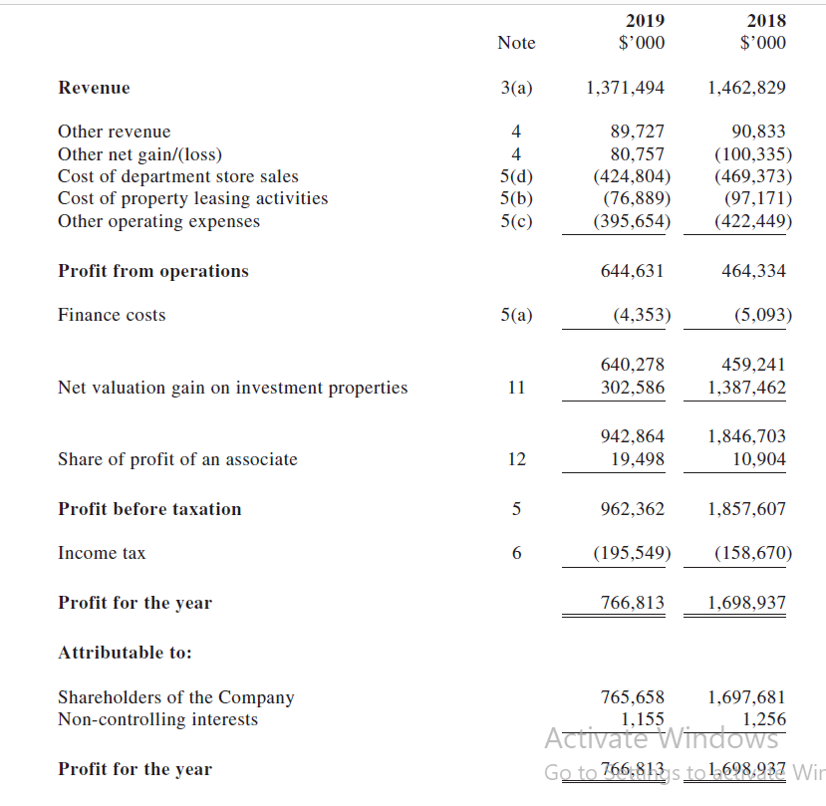

(APPENDIX B)
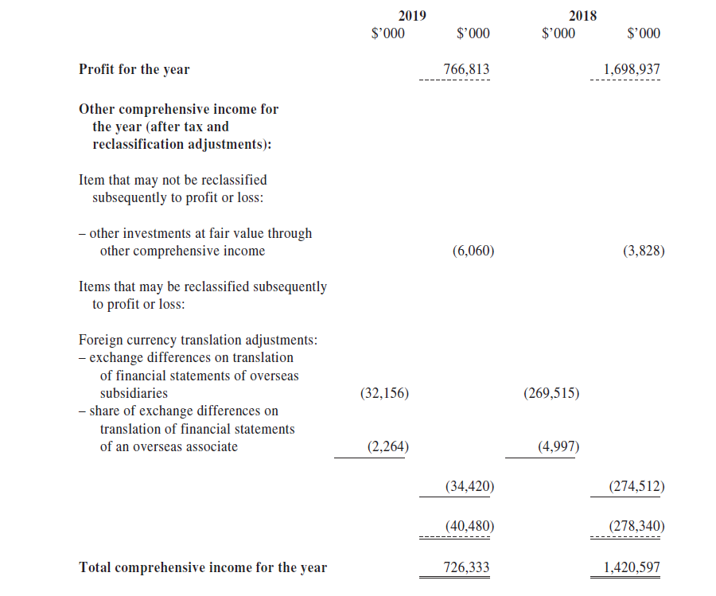

(APPENDIX C)


