Confirmative Praxis

Abstract
Within the realm of my illustrative portfolio, a deliberate emphasis is placed on themes encompassing body positivity, feminism, and the everyday lifestyle. Reflective of my distinctive illustrations, my objective is to construct witty and relatable narratives across the body of work. Rather than striving for a deep intellectual meaning, the intention is to foster accessibility and engagement through being relatable. The work “is what it is”, which offers the viewers an opportunity to resonate with its inherent themes and find their own personal meaning. The digital illustrations within this collection are stylised, detailed, and invite closer examination which unveils intricacies. This deliberate attention to detail enhances the richness of the illustrations which allow the viewers to discover layers of meaning beneath the surface.

Introduction
My illustrations draw inspiration from the three main themes of body positivity, feminism, and the mundane lifestyle. These themes inspired me during my formative days as when I attended exhibitions in galleries, art of this kind resonated the most and empowered me.
In contemporary discourse, three intersecting themes have risen to prominence, each of them echoes the complexity of the human experience.
Body Positivity
Body positivity as a movement, seeks to challenge and dismantle societal norms surrounding body image. At its core, it champions the idea that all bodies are worthy of acceptance, irrespective of size, shape, or appearance. Rooted in the belief that self-love should transcend societal expectations, body positivity endeavours to foster a culture where individuals can embrace and celebrate their bodies for what they are. (Cohen, 2021)
Lizzo is an American singer/rapper who has become highly successful in the music industry in 2019 with her songs about self-acceptance and body positivity. Lizzo is also a plus size woman and regularly shares her struggles with mental health on many social media platforms, along with image posts and TikTok’s of her larger body and the self confidence that she has. Interviewed by Essence magazine, Lizzo explains that she will post risqué images of herself on social media for the whole purpose that she is simply comfortable in her own skin and wants to normalize larger bodies of all types, but especially Black women. (Zavattaro, 2021). In society and social media, many influencers and celebrities that post photos of themselves on social media tend to be petite and slim, which sends a message out to viewers that being petite and slim is supposed to be the “perfect weight”, this hinders people’s relationships with themselves which causes them to become more insecure and unhappy.
This has significantly influenced my work by interweaving a similar message by including slightly larger women with hairy legs and bodies to show bodies come in all shapes and sizes, being beautiful does not necessarily mean petite and hairless.

Feminism
Feminism, a resounding force in societal evolution, advocates for the equal rights and opportunities for all genders. Beyond all waves of feminism in history, contemporary feminism brings a diverse range of perspectives, addressing issues such as reproductive rights, dismantling systemic barriers and gender equality. It is a dynamic and ongoing conversation that seeks to redefine power dynamics, challenge societies stereotypes, and empower individuals a society free from discrimination against gender. (Beasley, 1999)
Florence Given is an artist, mostly active on Instagram. Florence Given released her first book in 2020 Women Don’t Owe You Pretty. The book is about Intersectional Feminism, writing about relationships, body image and self-esteem for women. The book itself contains questions and checklists for the reader to consider. Florence Given also gives advice to readers about recognising being gaslight, racial fetishism and other negative actions towards women. The book is also a guide for readers to know the signs of a toxic relationship. Florence Given also has a conversation with her teenage self, talking and exploring male validation. The book’s title is based on the quote by lexicographer Erin McKean:
“You don’t owe prettiness to anyone. Not to your boyfriend/spouse/partner, not to your co-workers, especially not to random men on the street. You don’t owe it to your mother, you don’t owe it to your children, you don’t owe it to civilisation in general. Prettiness is not a rent you pay for occupying a space marked ‘female’” Erin McKean.
Florence Given is one of the biggest reasons that Feminism is one of the core themes in my illustrations. Reading her book gave me a realisation of what is truly means to be a woman and wanted my illustrations to reflect that. Florence Given is also an artist that likes to push society’s boundaries and get people questioning which is something that resonates with me as an artist and I wanted to portray this in my illustrations.
Mundane
Nestles within these transformative ideologies is the often-overlooked beauty of the mundane. Defined by its everyday nature and simplicity, the mundane is the canvas in which life unfolds. Embracing the mundane is an invitation to appreciate the poetry in everyday routine, finding profound meaning in the seemingly ordinary aspects of life. In our face-paced world, the mundane becomes a haven, offering moments for you to look back on, introspection, and connection to the shared experience of a human being’s life. (Royce, 1984)

Aims
As an illustrator that is mostly committed to drawing for the purpose of creating visual art, I wanted to expand beyond illustrating for prints. Inspired by the transformative potential of digital art, I became enthusiastic about commercialising illustrations into homeware products. The goal is to bring the spirit of female empowerment and inclusivity into people’s homes, fostering an environment where each product created serves as a subtle yet impactful reminder of these values. Furthermore, these illustrations also have a light-hearted humour and I wanted to bring this aspect to homeware also. This was important for me as it reflects my sense of humour and how I look at life which would hopefully give customers a chuckle or a smile on their face. From cushions with bold and empowering imagery, to wallpaper featuring intricate designs of nude women, my vision was to create quirky homeware products which stand out in the room with vibrant colours and cheeky designs. Throughout this project, I aim to contribute to a broader cultural conversation, allowing people to surround themselves with tangible expressions of feminist principles and fill their homes with art that reflects their commitment to equal rights, empowerment, and self-love.

Research and Findings
Polly Nor
Polly Nor stands as a significant source of inspiration throughout my journey as an illustrator and for my project, wielding a distinctive and captivating style that resonated deeply with my illustrative style. Her crude and dark sense of humour injects a refreshing honesty within her work, challenging conventional norms and allowing for a more unique and quirky exploration of complex themes that people go through in their everyday life. Polly Nor digitally illustrates her artwork, in a raw and imperfect way, almost looking like her art has been drawn on Microsoft paint. This gives her overall look raw expression, providing a seamless integration of emotion and commentary. What particularly draws me into Polly Nor’s work is her ability to cover substantial topics without a hint of pretention, navigating through everyday issues with approachable humour. Polly Nor also uses a lot of pastel colours in her illustrations, which amplify the irony of her dark sense of humour which I think is an interesting way of portraying her art. I naturally aim to infuse my illustrations with a similar blend of humour, digital quirkiness, and unapologetic exploration of substantial subjects, creating art that sparks a reaction without losing its accessibility and relatability.
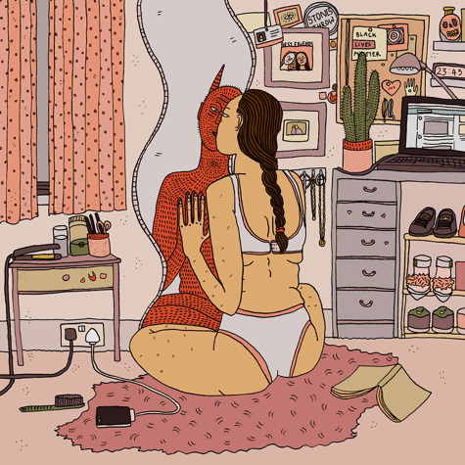
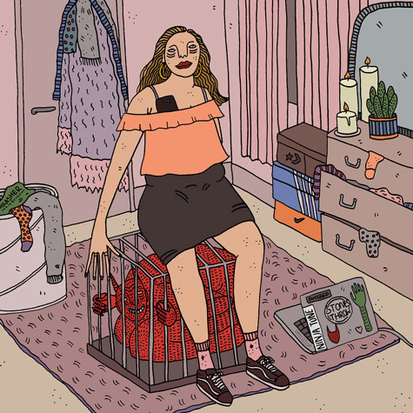

FIGURE (left) 1. Polly Nor. Learned how to hide my crazy. 2016 FIGURE (right) 2. Polly nor Thinking bout you. 2015.
https://www.pollynor.com/Thinking-Bout-You-By-Polly-Nor

Laura Callaghan
Laura Callaghan’s influence on my illustration style is profound, drawn from her remarkable ability to breathe life into each female character with distinct individuality. Her illustrations become a vibrant tapestry of various personalities, each woman having their own unique charm and strength. What inspires me most about Laura Callaghan’s artwork is how she injects humour, often light-hearted and camp energy into her art. Creating a much more uplifting experience when looking at her work. Another factor that appeals to me is her use of mundane subjects in which elevate the ordinary. This invites the viewers to find beauty in the ordinary. Many of her illustrations find women doing many everyday things such as shopping, sleepovers, gardening and sleeping. The meticulous attention to detail in her drawings provides a rich visual tapestry, offering viewers a visual experience with layers of narratives to explore, which is something I personally find very important when it comes to an illustration. The use of colours in her work further enhances the storytelling, with bold and unexpected pairings of colours that add depth and vibrancy to each art composition. Colour is also something important to me for this project as I wanted the aesthetic of the homeware to be just as powerful as the impact of the meaning behind it. I strive to infuse my illustrations with a similar celebration of individuality, humour, and a keen eye for the beauty found within the mundane and the detailed use of colour.
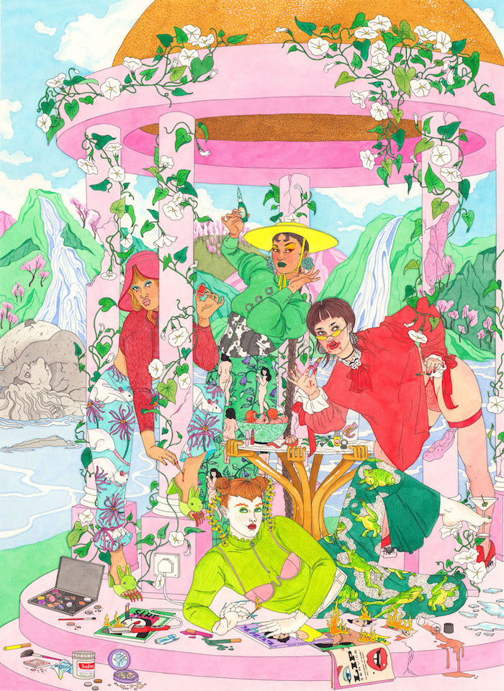

FIGURE 3. Laura Callaghan. Artwork name unknown. Created unknown
https://www.lauracallaghanillustration.com/

Eva Malley
Eva Malley serves as another strong influence on my illustrations, leaving an inedible mark with her bold and expressive use of black lines that give her illustrations a captivating and unmistakable quality. The use of bold lines within her work not only makes her work visually appealing but also imparts a unique and distinguishable character to her artwork, I find profound inspiration in in Eva Malley’s aesthetic choices, drawn to the way that Eva Malley elevates the everyday with her distinctive flair. Her illustrations, prominently featuring women in their day-today lives, echo a relatable uniqueness that inspires my own work. Not only does Eva Malley’s style inspires me an illustrator but her entrepreneurial spirit has help me further develop my project in creating my artwork into commercial products. Eva Malley’s true success is expanding her illustrations into products and starting her own business selling products from phone cases to tote bags. This has encouraged myself into creating my own merchandise, allowing my illustrations to reach a wider audience and become a big part of people’s daily life.
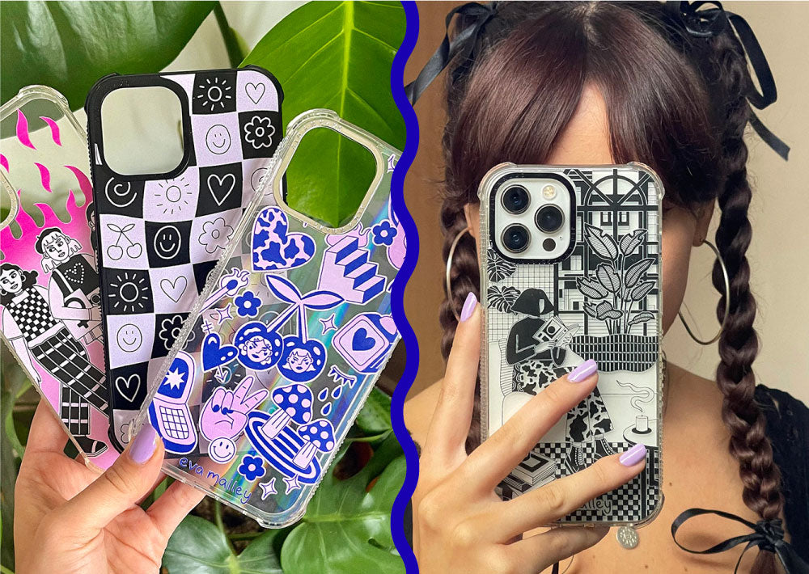

FIGURE 4. Eva Malley. Eva Malley X Skinny Dip Shock iPhone case collection. 2023
https://www.skinnydiplondon.com/collections/eva-malley-x-skinnydip

Liberty London
Visiting Liberty London back in December 2022 for the Illustration Fair, I became inspired by the distinctive and eclectic homeware collections that were being sold. Liberty London is a luxury department store. Known around the world for its close connection to culture and art, the store is mostly famous for its designer floral and bold printed fabrics. The department store also sells men’s, women’s and children’s fashion, homewares and beauty from a mixture of designer and upcoming brands and labels. Liberty London stood out to me in particular because of its commitment of showcasing unique and quirky products. The store also holds a long history of supporting independent designers and artisans, offering them a platform for their creativity and their own personal style to shine. The eclectic mix of patterns, colour pallets and designs found at Liberty London has whimsical and timeless quality, which has influenced me to create my own homeware collection. In comparison to many other homeware collections that you find in stores such as Habitat, Ikea and John Lewis, Liberty London sold homeware collections that stood out to me greatly for its innovation and uniqueness, I felt like the designs were pushing boundaries which inspired me to do the same for my illustrations.
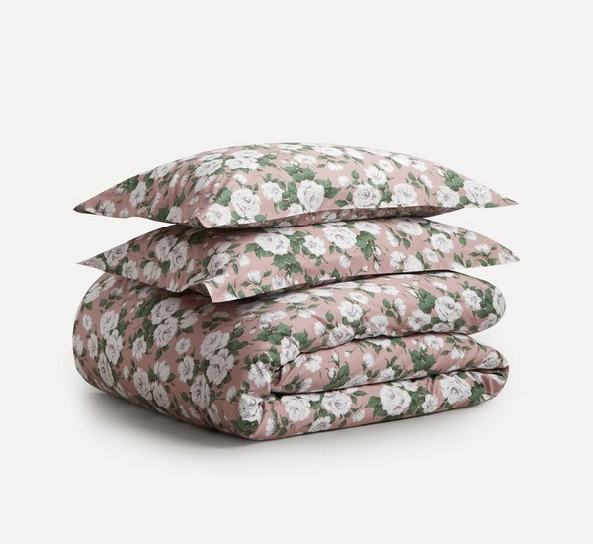

FIGURE 5. Liberty London shop website. Carliene Rose. Sateen Double Duvet cover set. 2024
https://www.libertylondon.com/uk/department/home/home-furnishings/bedding/

Collecting Imagery
As the mundane is one of the core themes of the project, I collected imagery from my day-to-day life which helped gather inspiration for my illustrations. Navigating through my daily routine, whether it’s going on walks on the seafront after work, giving the flat a spring clean or having a relaxing bath in the evening, I took pictures of different aspects of ordinary life. By capturing these moments, I created a visual diary that helped picture the narrative for my next illustration. These pictures infuse the illustrations with character and a part of myself in the image as it’s essentially based on what I do in my day-to-day.
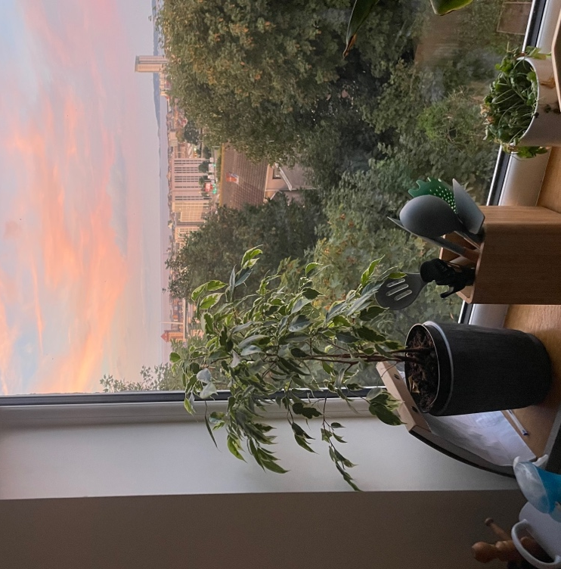
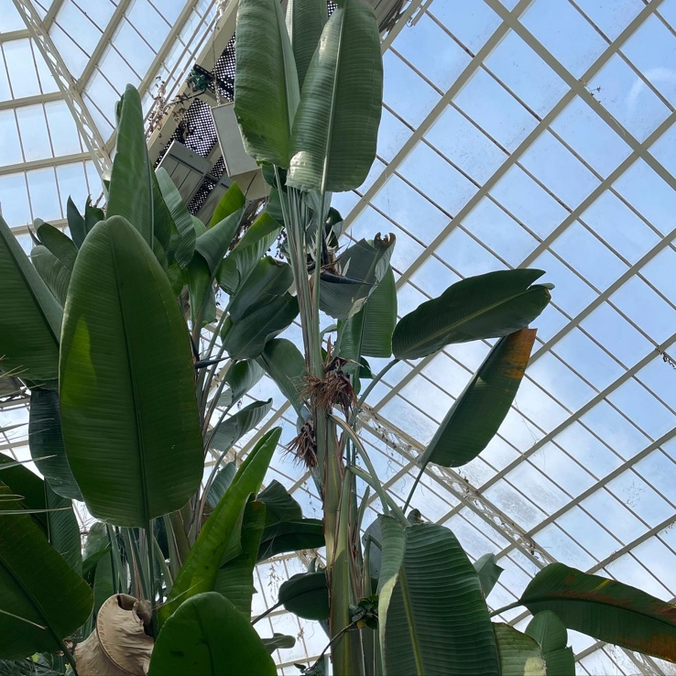

FIGURE (right) 6 The view out of the kitchen. FIGURE (left) 7. The EDEN Project. Becky Davies

Confirmative Praxis illustrations
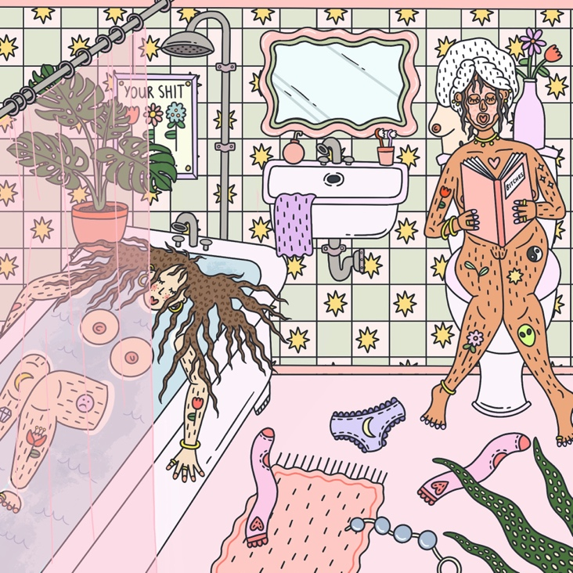
My Bath and Shit illustration is about girls simply relaxing in the bathroom, one girl on the toilet and the other girl in the bath. Although these are tasks that are part of many people’s daily routine, I thought drawing this as an illustration was finding the beauty in the everyday. I also thought that drawing the girl on toilet would show an aspect of crude sense of humour that I wanted to bring into my style. In many of the illustrations, this is a recurring theme in the collection.

FIGURE 8. Becky Davies. Bath and Shit. 2023

Explorative Praxis
The explorative Praxis module was an opportunity to push myself out of my comfort zone and try different mediums and art techniques. I decided to specifically delve into ceramics, drawn by the prospect of creating unique pieces in a different medium to what I’m used to. With the homeware collection in mind, I created mugs, vases and other pieces found in the kitchen. As I immersed myself in ceramics, I discovered that ceramics was difficult to master within the given timeframe. Despite the initial setbacks, this experience served as a valuable lesson in recognising my own preferences and limitations. Acknowledging that ceramics might not be a skill that I will master anytime soon, I decided to redirect my focus towards the application of illustrations to homeware products. Throughout the course, most of modules required experimentation which proved difficult due to already having a developed style. I wanted to further develop my illustration style and create a collection of illustrations that themed around feminism. To achieve this, I experimented with colour, and in particular, pastel tones that accommodated my illustrative style a lot more. In addition, I experimented with the way that I draw the lines, inspired by Eva Malley. I wanted the lines to be bolder prominent to contrast pastel tones and due to the detailed nature of my work, I thought bold lines would accentuate the detail more. Pastel colours and black lines run through the entire illustration collection to keep a strong likeness.
The decision to focus on illustrations rather than new art practices paved the way forward for the Confirmative Praxis module as it helped me recognise that as an illustrator, I did not want to explore different avenues artistically but rather refine my skills and apply them towards product development. The Confirmative Praxis gave me a platform to push boundaries and find creative ways to add versatility to my art. This engagement extends beyond mere aesthetics. Illustration does not have to just be an art form, it is a dynamic and ever-evolving avenue for creative expression, offering limitless possibilities for transforming flat images into products.
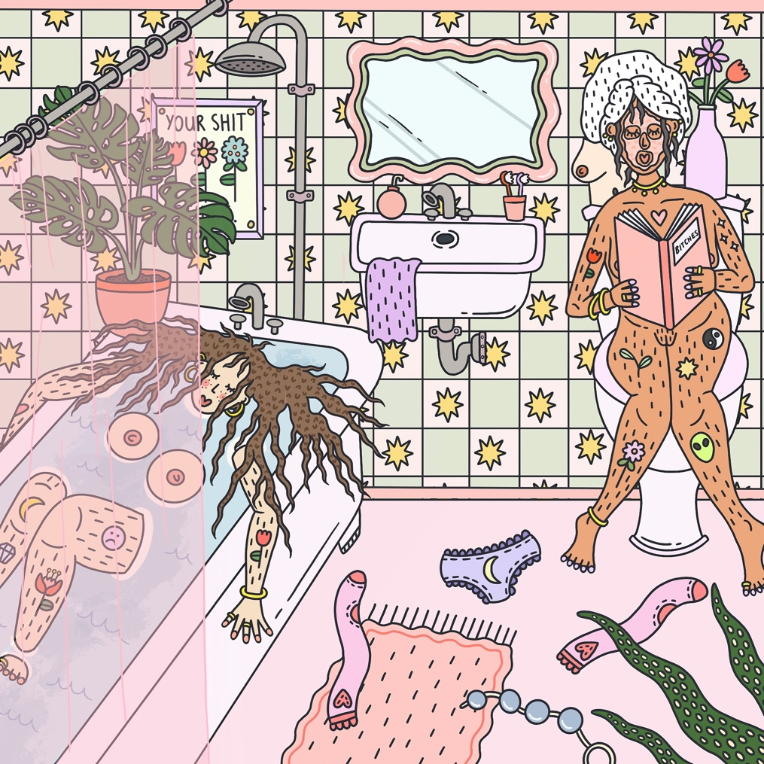
Herein, I will discuss the illustrations exhibited and why the designs were applied on media such as wallpaper, cushion, blanket.
FIGURE 9. Becky Davies. Bath and Shit. 2023
Illustration 1 “Bath and Shit” was drawn digitally in Procreate as part of the Explorative Praxis project. Inspired by the images of day-to-day life and artists mentioned in the Research and Findings section of the project, I created Bath and Shit. I particularly liked the idea of incorporating a bathroom as nothing screams mundane day-today like using the bathroom. The idea of drawing one girl on the toilet and one in bath with her breasts floating above the water was simply humorous to me. The image incorporates as much humorous detail as possible, therefore you’ll see some anal beads, knickers and socks thrown on the floor. I also wanted to incorporate foul language in this piece as a reflection of myself. I use the word “shit” a lot in my day-today life and as this is an illustration based on my mundane life, I thought that this was important. This illustration was one I wanted to later develop in Confirmative Praxis module. I wanted to have this illustration printed on a cushion, purely because I thought that the details and the colours would really make this cushion look unique and stand out.

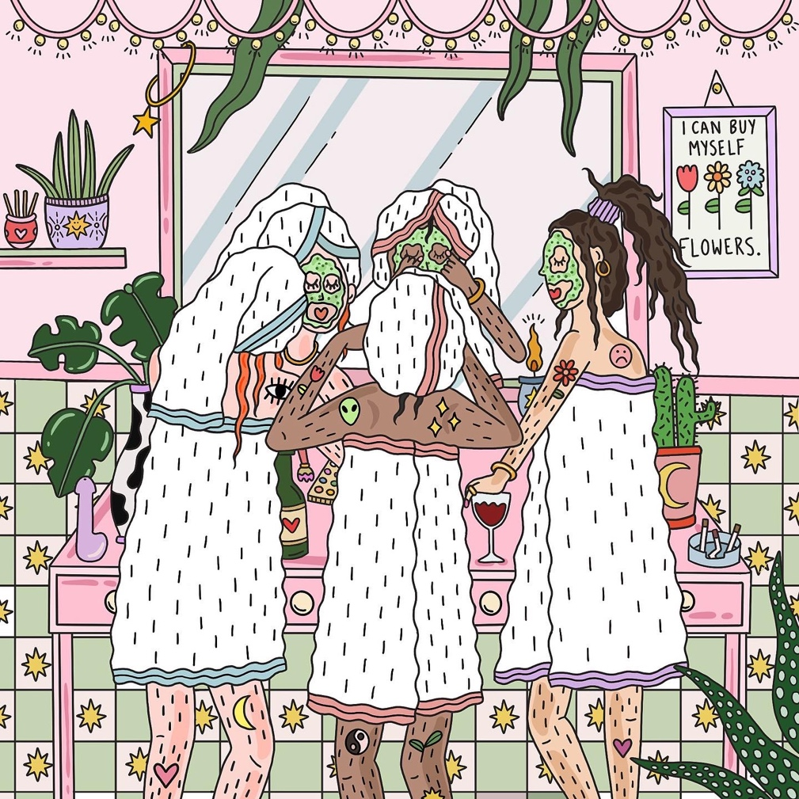

FIGURE 10. Becky Davies. Pamper Evening. 2023
Pamper Evening is another Image created in the Explorative Praxis Module, drawn using Procreate. I wanted to create an image based on my friends and I having a sleepover. Although the pastel colours and plants make the image aesthetically pleasing and feminine, I wanted to incorporate an aspect of myself into this and make the illustration raw. Therefore, I added the cigarettes in the ashtray, the bottle and glass of red wine and the dildo. I thought that these aspects of the illustration gave the overall aesthetic a contrast which added to the light-hearted humour. In the Confirmative Praxis module, I paired the Pamper Evening illustration and the Bath and Shit Illustration together due to the similar theme of being in the bathroom with the towel garments and the humour incorporated. I thought that both illustrations work well together as a pair of cushions.

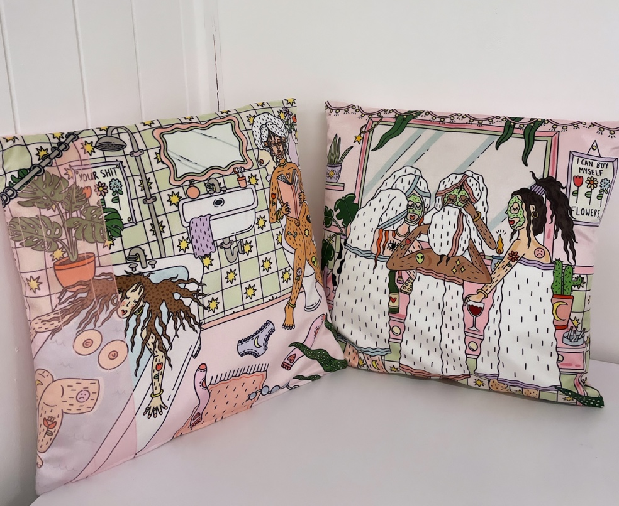

FIGURE 11. Becky Davies
Here is the image of The Bath and Shit cushion and The Pamper Evening together. In the Confirmative Praxis module, I decided to develop this illustration further and get them cushions printed on a velour fabric so that the colours would look stronger and more saturated. The size of the cushions was big enough that viewers were able to see the illustration clearly and distinguish details of the illustration too. The process of printing illustrations on these cushions made me realise that illustrations could be printed onto all kinds of products, from cushions, wallpaper, tote bags with endless possibilities.

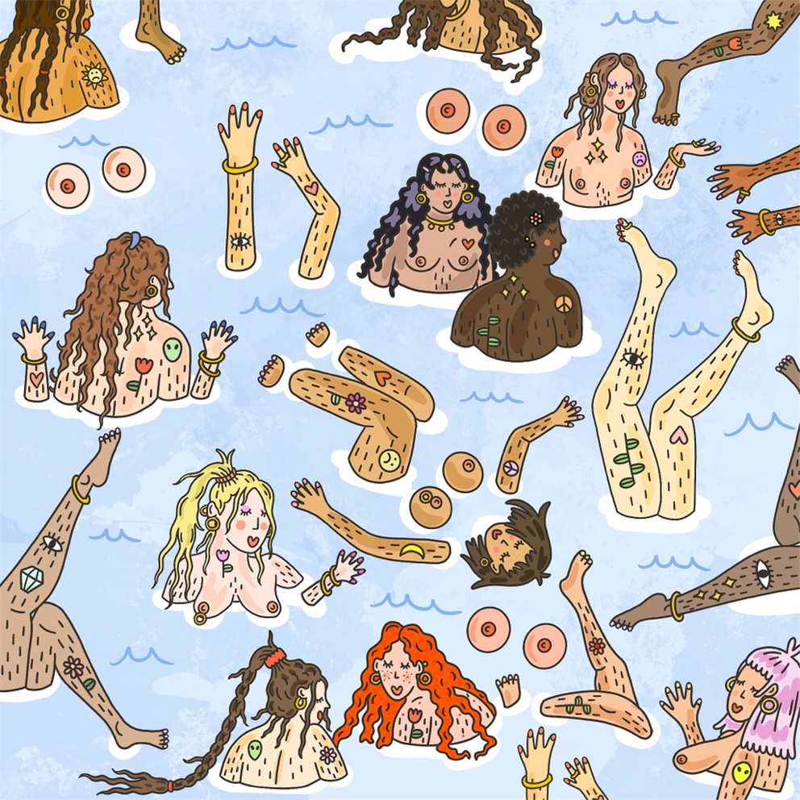

FIGURE 12. Becky Davies. Fancy a Dip? 2023
Fancy a dip is the final illustration from the Explorative Praxis module that I wanted to incorporate into my Confirmative Praxis project. I felt that this illustration would fit with the two cushion illustrations as a collection. As I mainly draw nude women, I thought swimming was a great narrative for this piece to be cohesive. The vision for this image was to capture the women’s faces as well as different aspects of their bodies such as the arms, legs and breasts. I thought that this would be a great way to portray the women in the illustration swimming and diving. The legs and arms peering through the water was also another way for the viewer to pay more attention to the detail of tattoo art on the bodies and the hairs. I also thought that the floating breasts brought an aspect of humour into the collection. I also wanted to add texture, used by the paintbrush tool on Procreate to replicate water. And I created a wave like expression using the “M” shape looking marks.

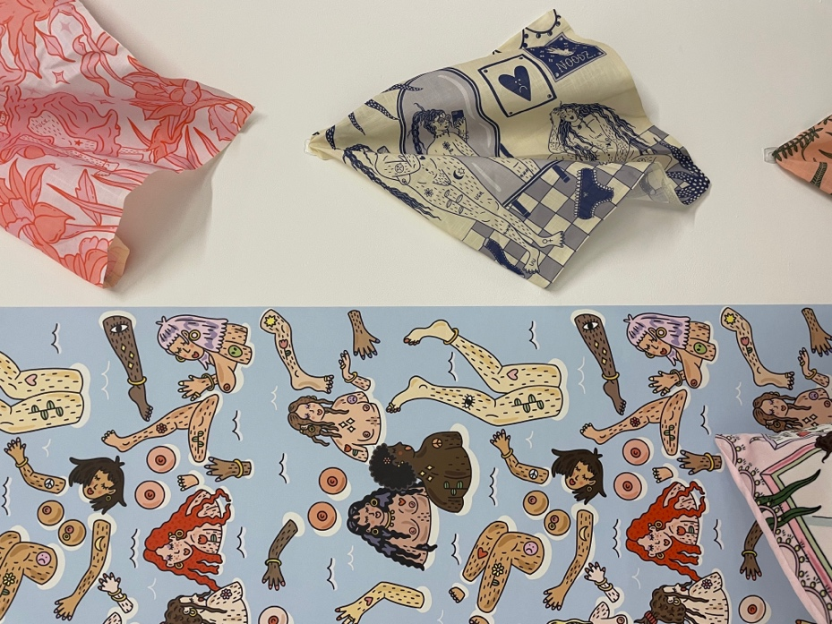
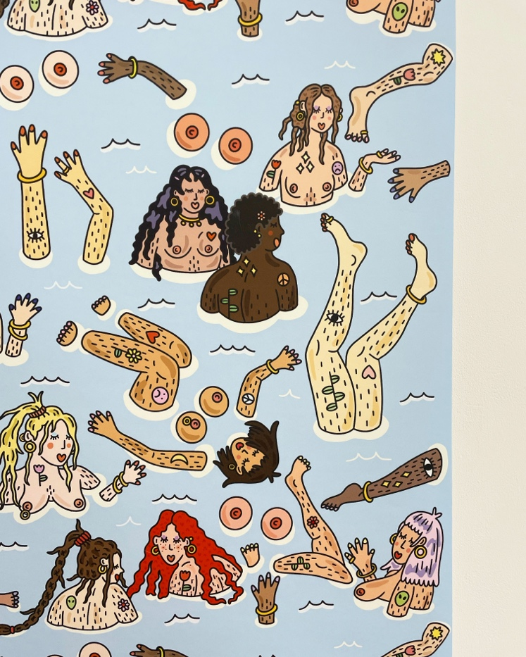

FIGURE (left) 13 and FIGURE (right) 14 Becky Davies
In the Confirmative Praxis project, wondering to myself what I wanted this illustration to be printed on. I began to look at images closely and think that the women in the illustration would make an interesting repeat print. The way that the women in the illustration are spread out made me think that I could easily repeat this and create the image into a wallpaper design. I thought that this wallpaper design would something people had never seen before and could be used in very diverse ways, for bedrooms or bathroom design. I decided to print a sample sized piece for the exhibition, so that the wallpaper piece was long enough to be able to see the repeat in the design and big enough to look like wallpaper and to be able to capture the detail within the illustration. The wallpaper piece was printed by a print company called Contrado. I was happy with the results of the wallpaper because not only was the quality of image crisp and clear but the colours of the of image come out exactly how I drew it on Procreate. Overall, I was very impressed with wallpaper design, and it became a great edition to the collection for the Confirmative Praxis project.

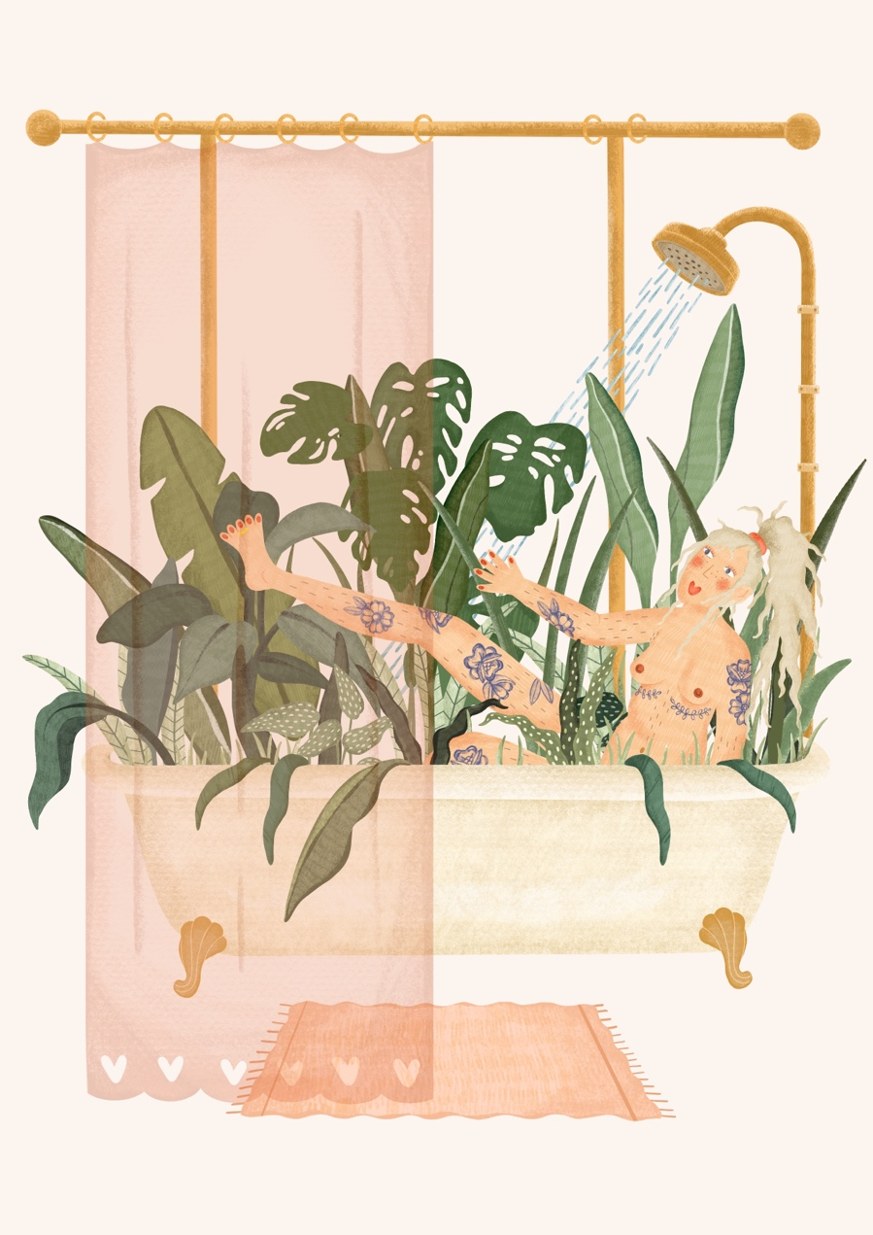

FIGURE 15. Becky Davies. Watering my plants. 2023
Watering my plants is a development of the Bath and Shit illustration. For this piece, I wanted to use a different approach to the style and decided to draw this using more texture and the pencil texture tool on Procreate. Even though the texture of illustration is different, I still wanted to keep in the theme of feminism, the mundane and body positivity. Therefore, I decided to draw a nude woman in a bathtub surrounded by plants. The textured style in contrast to the previous illustrations defined by their black outlines gives the overall image a softer look and makes it more three dimensional. I also decided to draw the tattoos on the woman differently to the previous illustrations. This time, I wanted the tattoos to look more like pencil sketches and instead of using a black coloured outline and fill the image using colour, I decided to keep the tattoos rather simple and use navy as the colour. I also didn’t want to give this illustration a background as I thought that the bathtub, the plants and the woman were detailed enough on their own. Additional detail would detract from the main focus of the image.

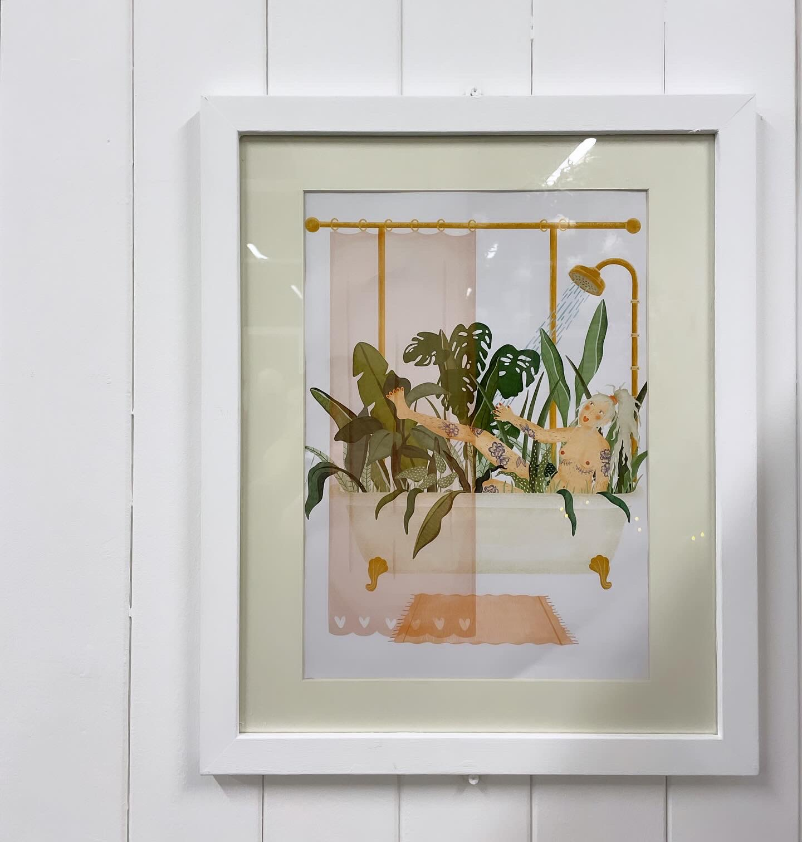

FIGURE 15. Becky Davies
As the Watering Plants illustration is different in terms of style, I thought that framing the illustration worked well as a stand-alone print. Although all the other illustration were printed onto homeware products, I felt that I need a framed print in the exhibition to fill in the negative space as well as demonstrate the versatility of the products. As the exhibition setting is supposed to look like a showroom, I felt that a framed print would tie that overall look together. I also felt that a printed illustration was a way of showing how far I have come in terms of illustration development, going from printed illustrated prints to printing illustrations on homeware products.

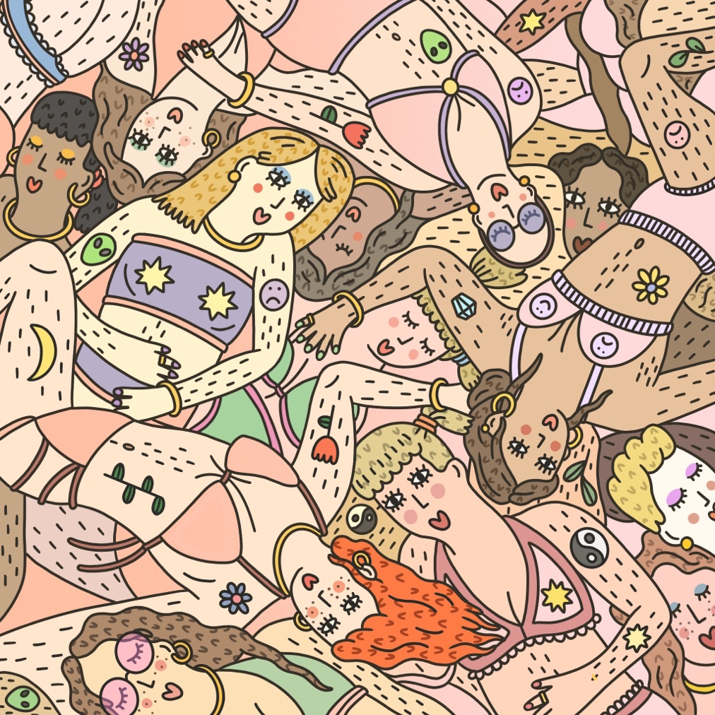

FIGURE 16. Becky Davies. Chill out gal. 2023
Chill out Gal is another illustration I created for the Confirmative Praxis project. I wanted to create an illustration that could be printed on a blanket. I wanted this illustration to be very colourful and have layers of detail. Keeping in with the illustration style of Bath and Shit, Fancy a Dip and Pamper Evening I wanted to work with the bold black outlines and more graphic/stylised look. This sort of style comes most naturally for me I thought this looked the best for this particular project. In this illustration, I wanted to give the women lingerie to emphasise the different colours and personalities while allowing the image to look bold. In addition, by drawing the women in this manner, it gives the illusion that the image is three dimensional and that they are laying on top of each other, hence printing this illustration a throw.

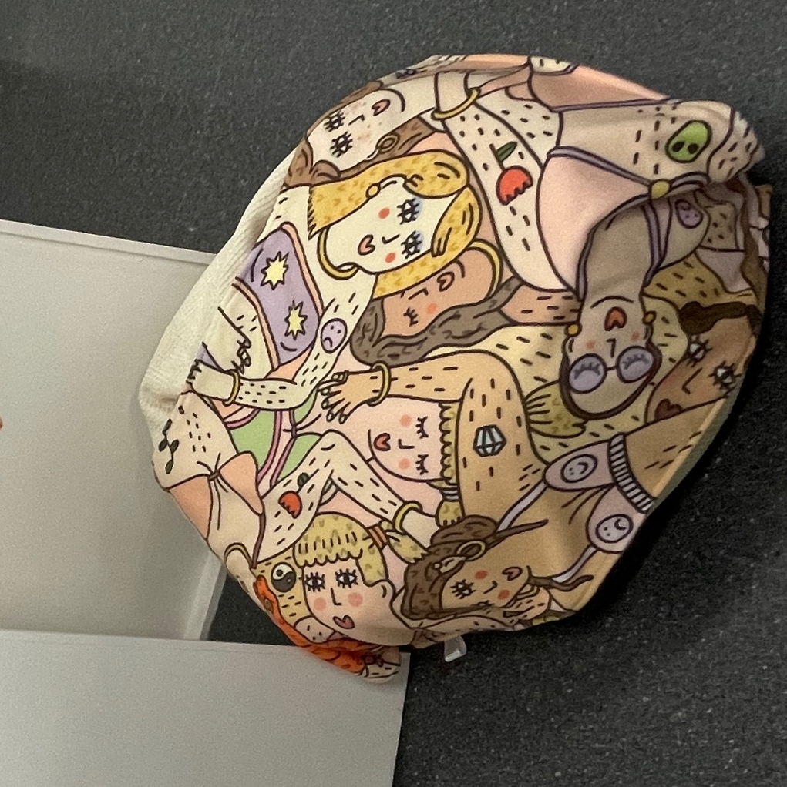
FIGURE 17. Chill out gal throw. Becky Davies
Here is an image of the Chill out gal throw presented at the exhibition, I placed it on top of a bean bag, to give the impression of that showroom look. The throw was printed through Contrado. The throw was of high quality and the image printed well onto the fabric, the colours were as intended, and the texture of the material was soft and cosy. I was also happy with the size of the blanket, I could only afford a sample size but the blanket was still big enough to give the viewer an idea of how a potentially larger throw could look like with the illustration printed on it.

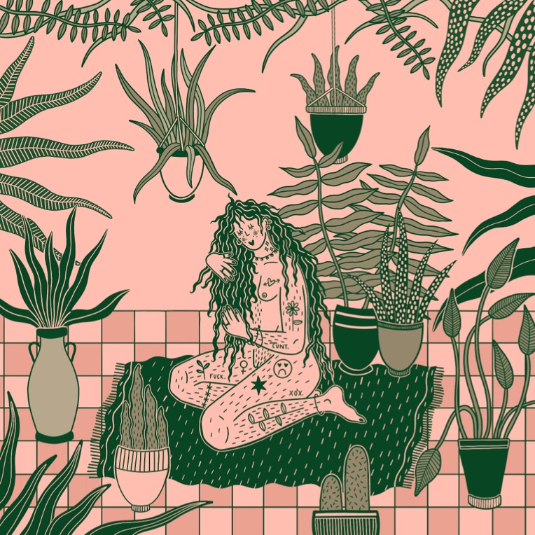

FIGURE 18. Becky Davies. Plant Lady 2023
For Plant Lady, I wanted to draw an illustration where instead of experimenting with the drawing style, I experimented with colour pallets. In this illustration, I only used pink and different tones of green to see the outcome and I thought the outcome was very successful. There was something more contemporary and eye-catching about using only two colours and made me think that although the illustration is still within the overarching themes with others in the collection, it provides a contrast due to the use of different colour pallets. I decided to base this illustration on houseplants as a reflection of my mundane daily routine. Caring for the plants is a form of self-care for myself and that is what I tried to represent here.

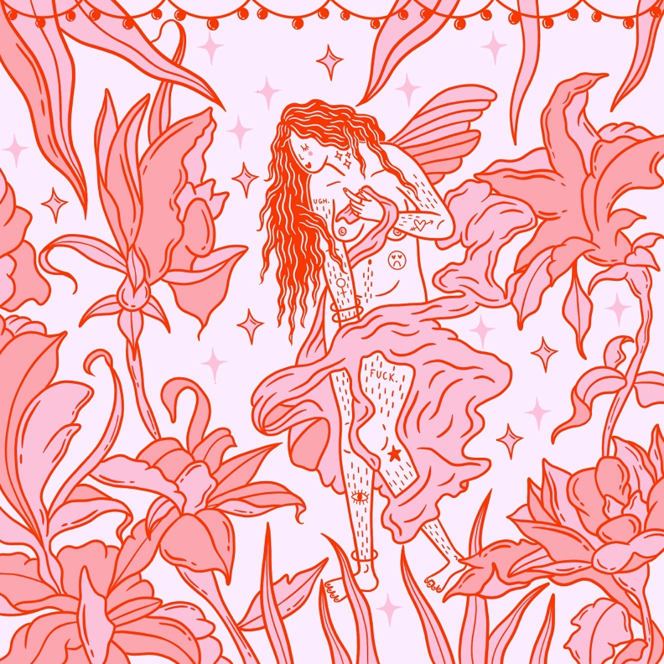
FIGURE 19. Becky Davies. Ethereal Lady. 2023
For Ethereal Lady, I wanted to work with two colours that I have always thought work successfully together, pink and red. I wanted to draw a woman that has inspiration from fantasy this time, so I decided to draw a fairy surrounded by flowers. As I hardly draw flowers or anything in theme of fantasy, I thought that this was mini experiment for myself. I was happy with outcome and the colours as the colours are a lot less muted and a lot more saturated than the other two in the two-colour collection.

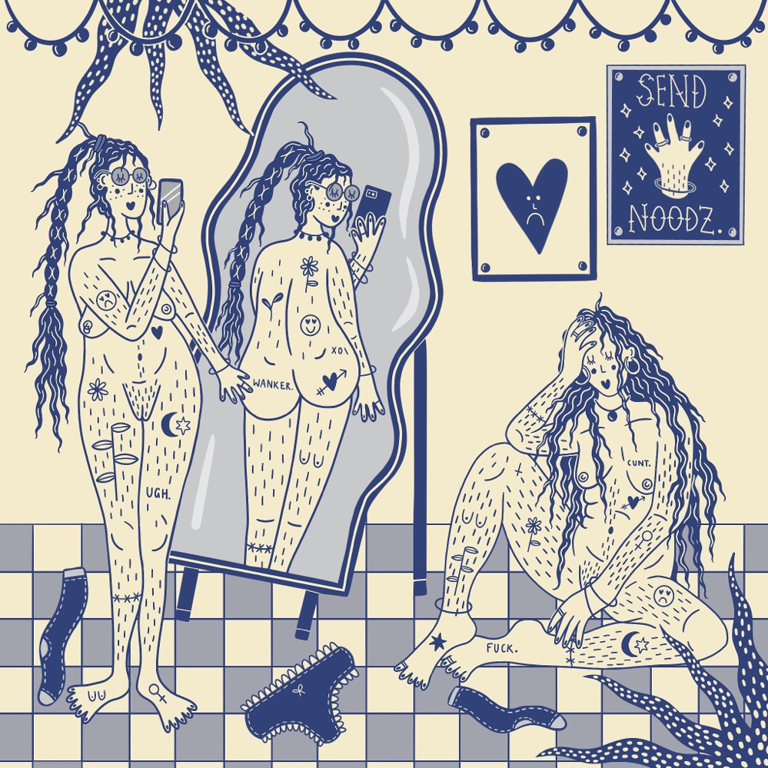
FIGURE 20. Becky Davies. Send Noodz. 2023
Send Noodz is also based on the two colours, cream and navy. I wanted to base this illustration strongly on body positivity. I thought that women taking selfies with their phones is something so common in this generation and there was something very contemporary about this image that works extremely well. Personally, this is one of my favourite illustrations in the collection because the colours used in this illustration are different to the colours I normally, which are usually pastel shades of pink and green. I also think there is something humorous about this image, the way the woman is posing in the mirror.
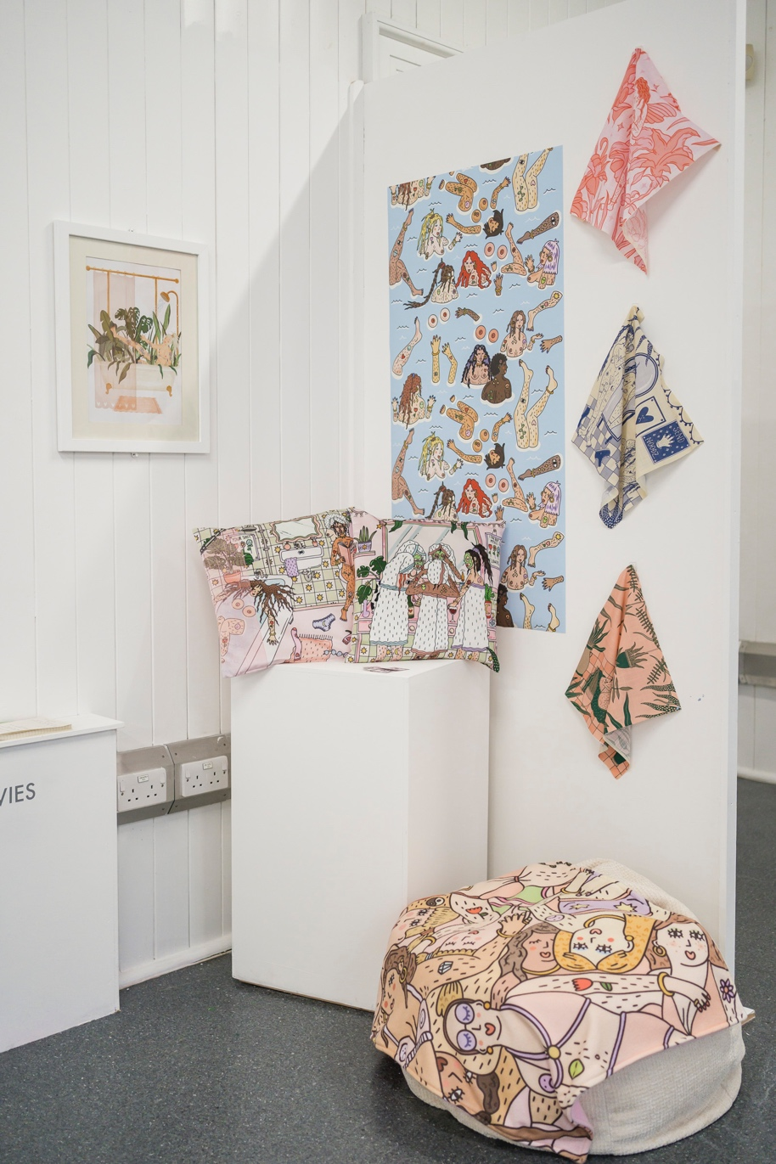
FIGURE 21. Becky Davies
I decided to get the three two-colour illustrations printed on canvas fabric to help viewers conceptualise where the illustrations could also be printed as well as the homeware previously mentioned. I thought that these fabric pieces were a successful addition to the overall exhibition space and filled the negative space as well as showing the versatility of the prints. Canvas fabric is used in a range of products and the fact the colours in the final product were as intended in the illustration, the illustrations can be used to print on tote bags, t shirts, duvet covers and more.

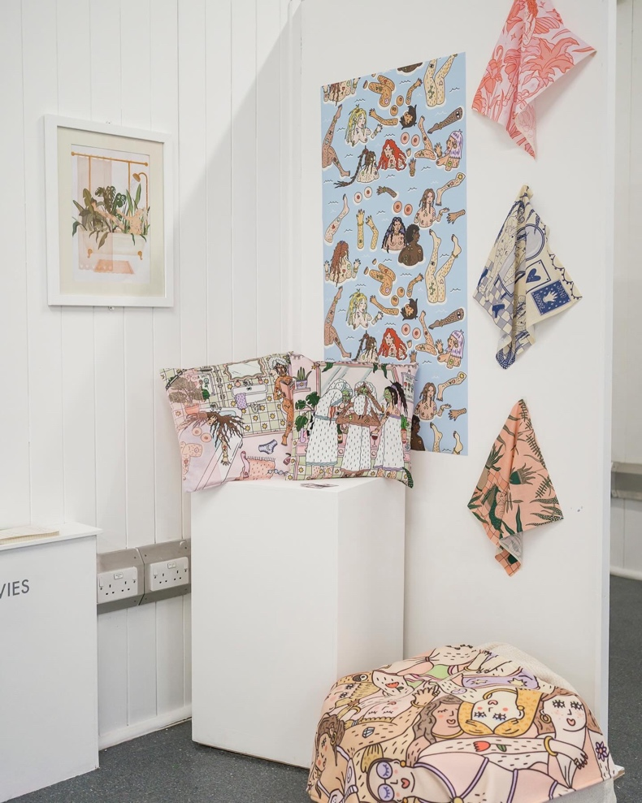
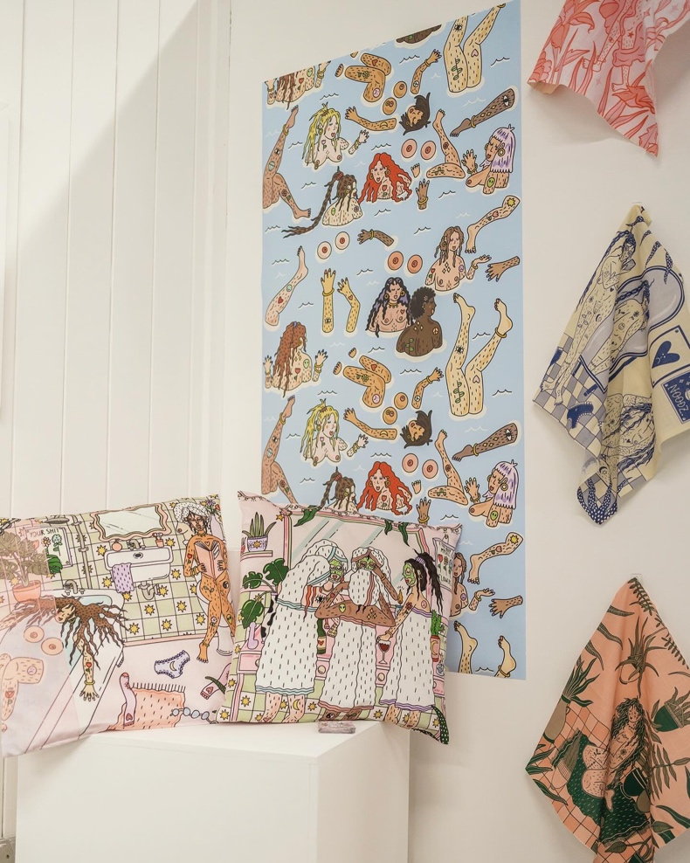

FIGURE 22 (left) and FIGURE 23 (right) Becky Davies
Conclusion
As I conclude the process of my confirmative praxis project, the mixture of researching artists that study similar themes and interest such as Eva Malley, Polly Nor and Laura Callaghan for inspiration for illustrations, capturing pictures and documenting the minutiae of my everyday life to bring aspects of myself into my illustrations and experimenting with other art practices to help me realise that experimenting solely on illustration itself and looking into ways of progressing my style has manifested my final project. Witnessing my illustrations seamlessly transition onto products for homeware has brought gained myself a sense of accomplishment. Being able to push and develop my illustrations into a sellable product has opened my eyes to future career possibilities for my artwork in the surface pattern industry. Seeing my project exhibited at the exhibition and seeing all the products that I had printed all together as a collection made me feel like I had succeeded my final project. The products exude a professional aesthetic that aligns with my artistic aspirations, capturing the essence of my unique style. This project has not only been a celebration of my artistic expression but also a turning point in my illustration process of creation exploration and where my illustrations belong in the world of career and industry. Seeing my final project exhibited, I am overjoyed with the outcome, an outcome of passion and dedication derived my artistic vision to life.

References
[1] Cohen, R., Newton-John, T. and Slater, A., 2021. The case for body positivity on social media: Perspectives on current advances and future directions. Journal of health psychology, 26(13), pp.2365-2373.
[2] ZAVATTARO, S. M. (2021) Taking the Social Justice Fight to the Cloud: Social Media and Body Positivity. Public Integrity, 23 (3), 281-295.
[3] Beasley, C., 1999. What is feminism?: An introduction to feminist theory. What is Feminism?, pp.1-192.
[4] Royce, A.P. and Artaud, A., 1984. ART, THE MUNDANE, AND THE ART OF THE MUNDANE. Kroeber Anthropological Society Papers, (63-64), p.135.
[5] NOR, P. (no date) Learned how to hide my crazy - by Polly nor, POLLY NOR. Available at: https://www.pollynor.com/Learned-how-to-hide-my-crazy-By-Polly-Nor (Accessed: 10 January 2024).
[6] NOR, P. (no date b) Thinking Bout You - by Polly nor, POLLY NOR. Available at: https://www.pollynor.com/Thinking-Bout-You-By-Polly-Nor (Accessed: 10 January 2024).
[7] CALLAGHAN, L. (no date) Laura Callaghan illustration, Laura Callaghan Illustration. Available at: https://www.lauracallaghanillustration.com/ (Accessed: 10 January 2024).
[8] Malley, E. (no date) Eva Malley X skinnydip: Illustrated phone cases, Skinnydip London. Available at: https://www.skinnydiplondon.com/collections/eva-malley-x-skinnydip (Accessed: 10 January 2024).
[9] Bedding (no date) Liberty. Available at: https://www.libertylondon.com/uk/department/home/home-furnishings/bedding/ (Accessed: 10 January 2024).

