

Task 1 – Reading Task Template
Upload your photo of your A3 in-class notes here:
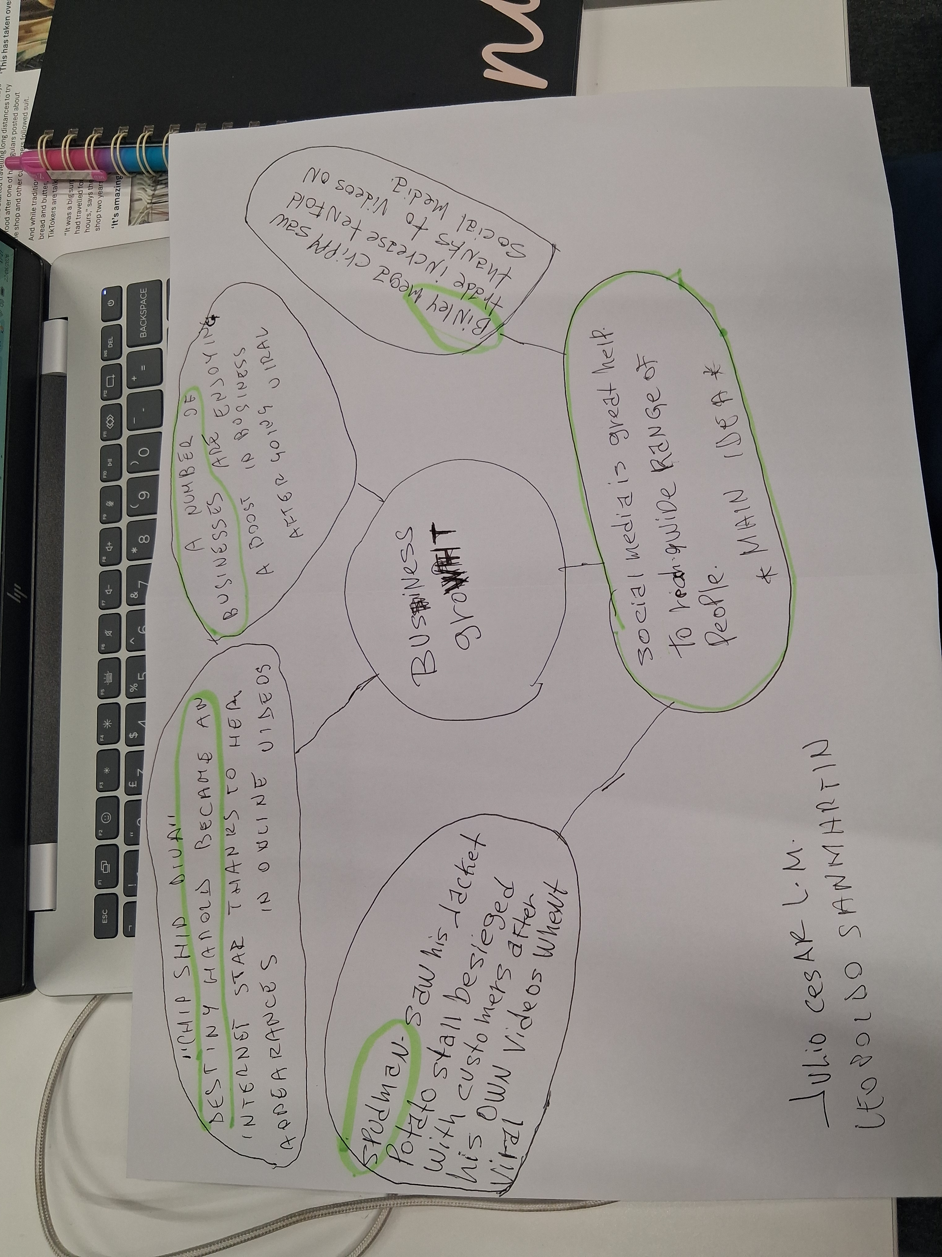

1. Answer these questions using the sentence starters below
a. What is the main idea of the text?
The main idea is that social media are very important for getting known and reaching a large number of potential users not just around the business, and they can serve as a draw to attract customers.
b. What are two key points?
One key point is that a lot of businesses are seeing huge growth after going viral on social media.
Another key point is that the new means of communication also allow even the smallest businesses to gain more strength in the market and be more recognizable.
c. What part of the text did you find most important? Why?
The most important part it's the one related to the data that helps me get the best overall picture.
d. Was anything unclear or difficult to understand?
I was not sure about the full and actual understanding of the text.
e. How did your group help you understand the text better?
My group helped me by finding the key points in the reading of the text.
3. One sentence reflection
Question: What did you find challenging about this task?
The hardest part was find the key points and be able to sum them up effectively by structuring them in a logical and orderly way.

