

University of Wales Trinity Saint David’s
School of Engineering
Impacts of Lockdown on Sustainable Logistics
Sustainable Logistics Operations (M5X01284)
Chris Ashmead
1902167
BSc (Hons) Logistics and Supply Chain Management

Abstract:

As a way of nullifying the spread and infection rate of the coronavirus, global lockdowns were imposed. Consequently, the global logistics industry and international businesses alike have succumbed to overwhelming and relentless pressure to perform by coming up with new initiatives and strategies, to reduce the levels of disruptions that have resonated throughout the entirety of their supply chains. To ensure that the urgent medical, personal protective equipment and food supplies are dispatched, transported and reach their final destinations as quickly and as proficiently as possible.

Table of Contents
1.0. Introduction 3
1.1. The main points that will be addressed from conducting this research 4
1.1.2. The initial reactions of the COVID 19 lockdown on the Logistics sector 4
2.0. What counteractive measures has the logistic industry introduced to cope with the pandemic? 5
2.1. Incorporating new safety procedures 5
5
2.1.1 Seeking alternate modes of transportation 5
2.1.2 The inclusion of Industry 4.0 technology in supply chains 6
3.0. How the logistics industry has maintained a level of social responsibility throughout the pandemic? 6
4.0. Has the COVID 19 outbreak foiled the chances of the logistic industry remaining on track to environmental sustainability? 6
5.0. Post Lockdown/COVID 19 era 7
6.0. How can the logistics industry make improvements to the sustainability of their supply chains in the aftermath of the coronavirus outbreak? 7
7
6.1.1. Supply Chain Agility 7
6.1.2. Supply chain Collaboration 8
6.1.3. Procurement 8
7.0. Conclusion 8

1.0. Introduction

The brief is to critically evaluate and analyse the impact that the global lockdown has had on sustainable logistics concerning the triple bottom line (TBL). As it currently stands, the world, businesses, and the human race face an unprecedented wave of uncertainty due to the global COVID 19 pandemic, which has brought about significant disruption to our way of life, a decline in economic growth, and ecological instability.

Sustainable Logistics – “is considered as an extensive approach, that is mindful of the economic, social and ecological repercussions of certain logistics-based activities, so they strive to make changes to improve these social, environmental and economical undertakings concurrently” (McKinnon,2010).

Triple Bottom Line – “is as an accounting framework which focuses on the three fundamental pillars of sustainability covering people, planet and profit”(Gutowski, 2020).

1.1. The main points that will be addressed from conducting this research

- The initial reaction to the lockdown from a logistics perspective
- What strategies have been adapted by logistic companies as a means of reducing any implications associated to their triple bottom line protocols?
- How can the logistics industry incorporate new measures to their future business approaches and supply chains to better prepare them for the post lockdown era?

1.1.2. The initial reactions of the COVID 19 lockdown on the Logistics sector

The damage sustained to the global logistic sector was of epic proportions, Fig 1 (Guan et al., 2020) represents the economic impact that COVID 19 has had on Logistics and supply chains (in terms of value added loss) during different global lockdowns over a 6-month period under varying degrees on strictness.
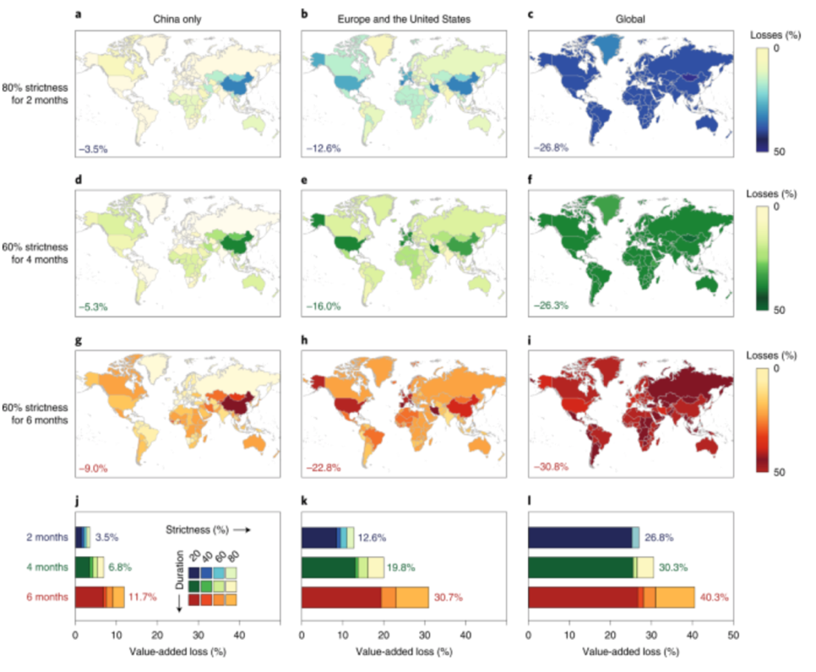
Figure 1 - Economic impacts of COVID 19 during different lockdown Scenarios

Such economic decline was particularly relevant to the Chinese economy. China has a critical role in the manufacturing marketplace. The initial impact saw a significant 15 per cent reduction to their long-haul divisions between the 24th January 2020 to 26th February 2020, which is significantly lower than the 80 per cent capacity on the previous year(Channel, 2020).

Furthermore, in a recent impact survey conducted by the UK Freight Transport Association (FTA) on the 20th of March 2020,it provides a true account of the initial impacts that the lockdown had on the sustainability of enterprises and states how they feel about the future of their business outlook for their company in the next 6 months (FTA, 2020).

2.0. What counteractive measures has the logistic industry introduced to cope with the pandemic?

To help ameliorate the current crisis, logistics companies such as Fed Ex have implemented several strategic alternatives to deal with the uncertainty (FedEx, 2020).These measures both support supply chain efficiency, safety of workers in the sector, but also act to improve public confidence and trust in the safety of the logistics sector and the goods it transports. The most prevalent measures include:

2.1. Incorporating new safety procedures

A greater emphasis and focus for many logistics companies has seen the introduction of new safety measures to prevent the spread of the virus, as depicted in Table 1 (Barnes and Sax, 2020).Companies such as Amazon have revised their safety policies and have invested a staggering $4 billion dollars on COVID related schemes as a way of ensuring that their employees are kept as safe as possible (Debter, 2020).

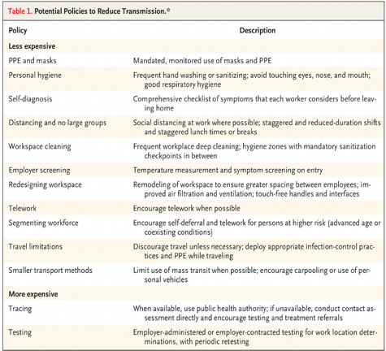
Table 1 - Implementation of new safety procedures

2.1.1 Seeking alternate modes of transportation

Due to global movement restrictions, logistics organisations have had to seek alternative transportation methods than they usually are using. The CEO of DHL Global Forwarding in Germany Tobias Schimdt, has stipulated that the use of charter flights has ensured that their customers can safeguard their supply chains regardless of the reduction in availability of urgent medical supplies among their commercial carriers (DHL, 2020).Notable modal shifts have also taken place in China, with a reported 574,000 shipping containers being transported by rail. As global air and sea freight enterprises were hit by grounding restrictions enforced at airports, sea ports and national boarders as a means to repress the Pandemic. The sudden shift in transportation has allowed a colossal 4.97 million tonnes of medical supplies to be distributed globally (Yingqun, 2020).

2.1.2 The inclusion of Industry 4.0 technology in supply chains

As a means to contend with the ongoing disruptions from the pandemic on logistic enterprises and its associated supply chain capabilities, companies have introduced plans for business continuity by concentrating their efforts through Industry 4.0 technology (Kumar et al., 2020).In particular, supply chain mapping, the effective incorporation of digital technology has allowed vital real-time information to be passed between a logistics company and their associates much more quickly.Moreover, It has also helped them to attain a greater level of visibility of each component of their supply chain, allowing them more time to react to any potential problems that may arise, such as bottlenecks (Javaid et al., 2020).

3.0. How the logistics industry has maintained a level of social responsibility throughout the pandemic?

The social implications that are considered most universal throughout the globe during the lockdown period are the significant loss of jobs—recently addressed by the International Labour Organisation (ILO). They have estimated that 195 million jobs will be lost (ILO, 2020) while it is revealed that in the U.K., the government is paying a substantial figure of 22 billion under a furlough scheme to help businesses to retain employees. However, the logistics industry has played a role in elevating global unemployment rates. Amazon revealed that in March, at the height of the Pandemic, they hired 175,000 new employees (Amazon, 2020) to assist in the heightened demand for essential products due to the coronavirus. Also, the U.K.'s largest supermarket chains reported their need to recruit 45,000 new members of staff (Dawkins, 2020). From another social aspect, the initial lockdown period saw the supermarket retailer Tesco allocate a whopping 30 million pounds to create a community support package, covering 15 million pounds on food donations that were distributed to help the most vulnerable communities (Jahshan, 2020).

4.0. Has the COVID 19 outbreak foiled the chances of the logistic industry remaining on track to environmental sustainability?

At its peak of the pandemic, the logistics sector's environmental considerations were neglected, as the industry had to immediately focus and prioritise all its efforts on the issue, distribution and replenishment of urgent and crucial items that are needed in hospitals and food retailers worldwide. However, whilst global enterprises remained up and running during lockdown, many global businesses and the aviation sector were brought to a standstill which resulted in millions of employees having to work from home. Therefore, as the demand on the logistics sector has only continued to increase, so has the numbers of harmful CO2 emissions that they produce. However studies have outlined, as illustrated in Fig 2 (Le Quéré et al., 2020) that through the sudden reduction or lack of commuting and frequent air travel has paved a way of offsetting against the emissions that the logistics sector was producing. Many global countries have recorded seismic drops in C02 emission levels, America has seen up to a 50% decrease in the state of New York (Sarfraz, Shehzad, and Farid, 2020)whilst the percentage of emissions in the UK fell by 31% and in Australia by as much as 31% (Harvey, 2020).

Figure 2 - Change in global daily fossil CO2 emissions by sector
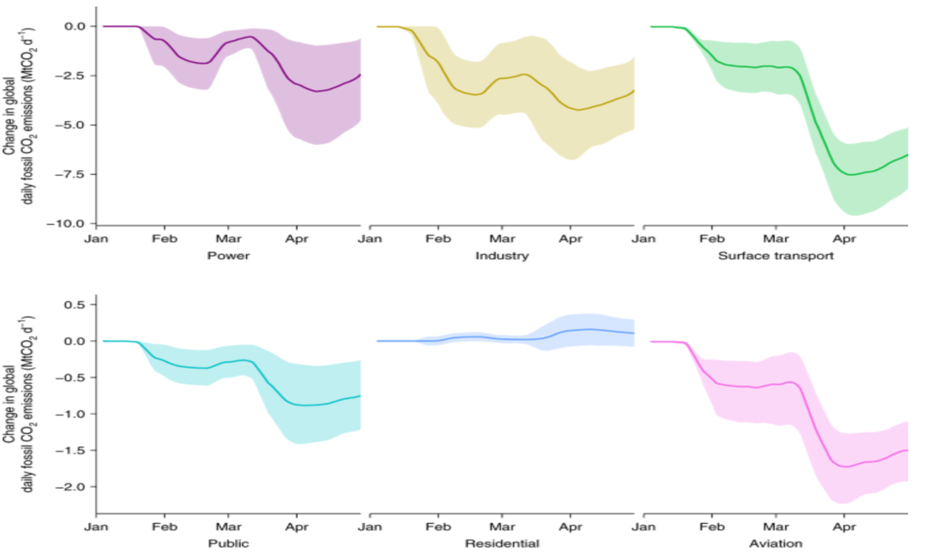

5.0. Post Lockdown/COVID 19 era

What has been apparent and addressed recently in a G20 meeting by a United States representative Robert Lighthizer. Is that for the logistics industry to maintain a level of sustainability, it needs to address and improve its overall resilience level to react more hastily and be better prepared for future pandemics. A country's consistent overreliance can exemplify this on other nations as a source for the much-needed supply of medical products. An alternative response from that Richard Wilding believes that we are moving away from a period where logistics enterprises are procuring for cost to an era that will be more focused on procuring for resilience (Dohrmann, 2020).

6.0. How can the logistics industry make improvements to the sustainability of their supply chains in the aftermath of the coronavirus outbreak?

What the pandemic has highlighted for many companies is a heightened level of weakness within its supply chains. A multitude of logistic companies such as DHL have begun to look into a recovery process as a means of re-evaluating the overall configuration of their supply chains to mitigate against any potential risks so that they are better prepared for any future crisis that may arise.

The recovery process will focus on the company’s geographical location, the volumes of products being produced, the management of materials and information that is being passed along to other active members of supply chain in order to identify positives and negatives before moving onto a complete reconfiguration of the supply chains structure . The main focus of consideration in this recovery process will focus on how logistics companies need to make necessary improvements concerning sustainability drivers, a consolidated list is depicted in table 2.
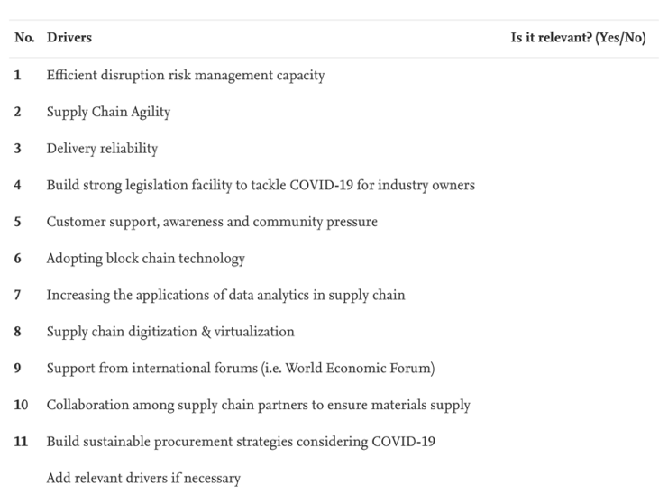
Table 2 - Main sustainability drivers post COVID

6.1.1. Supply Chain Agility

Ensuring that companies obtain a greater level of transparency throughout the entirety of their supply chain will guarantee that orders, procurement, production processes and delivery of products will be met. In addition, enterprises should also concentrate their efforts towards reducing the overall end to end time for the production and final delivery of their products. Such timeframes can be significantly reduced through the implementation of a value stream mapping tool, this will allow a logistics company to react to and ascertain any issues that are impacting upon the flow of material within their supply chains (Karmaker et al., 2020).

6.1.2. Supply chain Collaboration

To have a more substantial and greater understanding of the supply chain's strategy by working more effectively amongst their supply chain partners. Moreover, this will allow companies to improve their performance levels in terms of meeting lead times, to build stronger working relationships, lower a company costing and to improve the businesses' cash flow (Majumdar, Shaw and Sinha, 2020)

6.1.3. Procurement

To effectively protect a firm’s financial viability and its disjoined supply chains, company procurement managers will have to apply a new way of going about their day to day business. More concentrated efforts will need to be applied to remodel their organisations for a post COVID world (Accenture, 2020) for this to be achieved, they need to ensure that they:

- Stay on course - by effectively planning for any potential future lockdown and the risk that the infection may reoccur in weeks or months.
- Learn and evolve - take time to fully understand and expose the fragility in the supply chain that previously went unnoticed. Make changes to already established practices to ensure the safeguarding of other employees, the supply chain and the wider society.
- Be a force for good – lead with a greater purpose and confidence to renovate the organisation to be more resilient to help the company and society come through stronger

7.0. Conclusion

To summarise, this report has extensively evaluated and analysed the implications that the period of lockdown has had on Sustainable Logistics. It has in detail, provided ways that companies have initially responded to the crisis by enforcing stricter measures. Furthermore, it highlights how that key sustainability drivers within a company’s supply chain will need to be reconfigured and are vital as a way to ensure that organisations are better prepared for any future pandemics.

