

Report
ASP.NET Web Development

Shannon Cranfield
P149078
Module: Web Development
M5X01058
Dr Kemi Ademoye

TABLE OF CONTENTS

Abstract 3
Implementation 3
Screenshots 4
Evalution 6
References 6

Abstract
The report delivers details about the ASP.NET MVC Web application that was developed that integrates with SQL Server Express. A description of the application starts the report, its purpose, the target audience and relevance follows. The report additionally identifies features of the app against the MOSCOW method. An evaluation will then close the report looking at how the application works as well as how the web application app can be enhanced in the future.
The model view controller is an architectural pattern that divides an application into three main parts one being the model, the second being the view and the third the controller [1]. The three main parts individually have their own responsibility. The model stores the data of the application, this is usually a database. The view is responsible for allowing users to see the application, so the design of the user interface and the controller is used for the management of the user interaction which communicates with the model and the view [2].

Implementation

A Concert Web Application, ‘TicketOnline’ was developed. The purpose of the web application was to allow users to view artists that have concerts on and then book a ticket / purchase a ticket to go see them. The main objective was to make the application easy to use for the users to get a ticket. The target audience for this application is aimed at users aged 18 and upwards who happen to be a fan of music and the artists to make them. The application enables users to browse for artists they would like to see or are to search for new musical interests. It is more convenient for users to browse one specific web application than search many sites to find a ticket.
The TicketOnline application allows users to view artists, they can also use the search bar provided to search for a specific artist or genre. Once they have found an artist they can view further information about them, for example, if they have special guests appearing at the concert.
The MOSCOW method was used to identify the requirements for the Web application. The table below shows the requirements set out at the beginning of the development and the second column shows the features that was not able to be achieved.
 |  | AT the beginning | AT the end
MO | Must Haves | Artist to view  Booking information  Confirmation of booking | Yes, Artist can be seen  Visually users can’t see this, model entities were set up and data importing but difficulty presenting (discussed in evaluation )  No confirmation booking was implemented.
S | Should- Haves | A search feature – to search for artist  Payment | A search feature was implemented.  No payment method
CO | Could Haves | Comparing ticket prices to other websites  FAQ Sections  Live online help chat | These could haves were not implemented
W | Wont and Would-Haves | Won’t have a direct link to artist | -

Screenshots

Artist Page
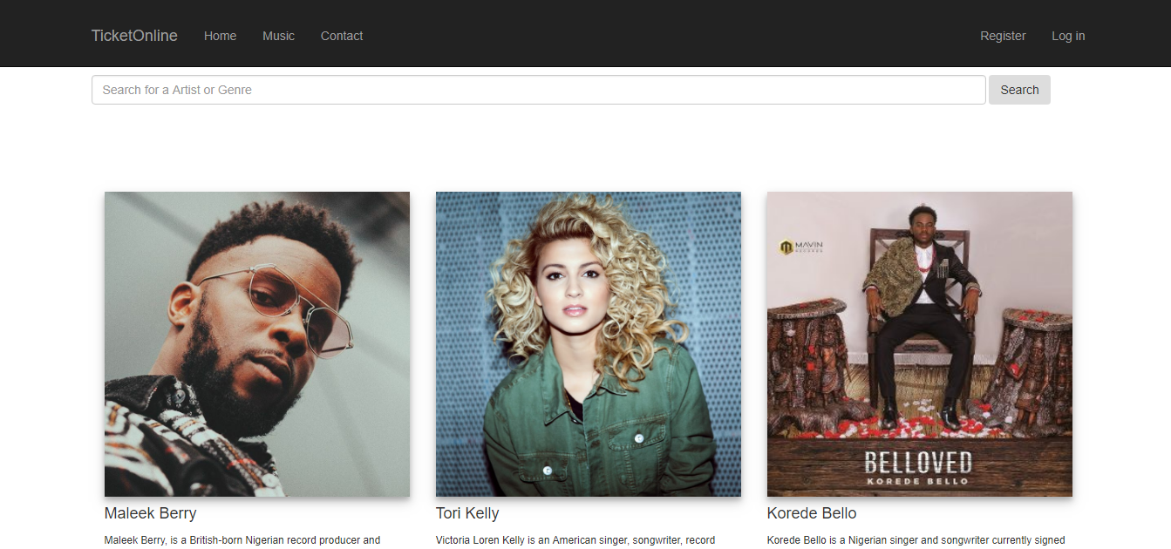
View Artists that have concerts available for fans to go watch

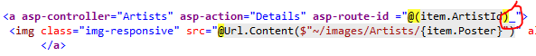

Search for an Artist or Genre
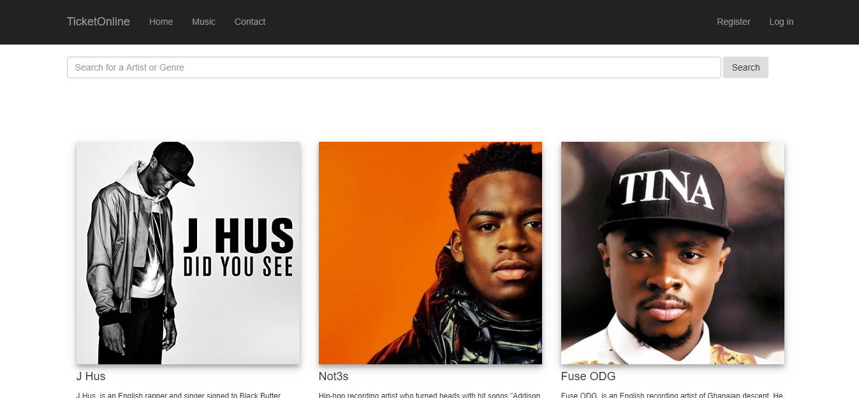

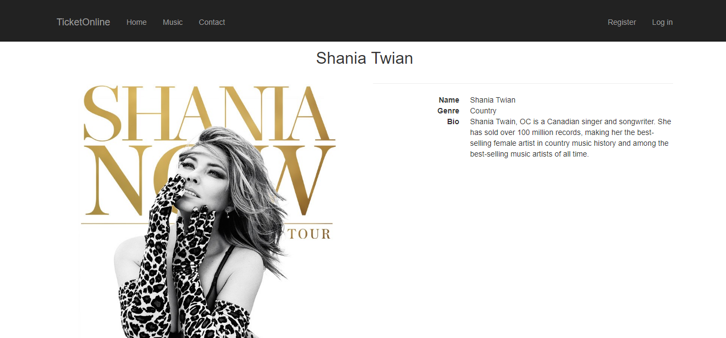
View Artist

Evalution

The below discussion explores the different errors and challenges that were faced during the development of the Concert web application, it goes further by evaluating the design, usability and content of the application and draws close the recommendations for future developments.

Design
Throughout the Concert web application, the colours white and black are consistent. A simple layout was designed to display the artists and a few information about them, this was created in a simplistic way as much clutter on a page can deter a user away from the site.

Usability
There were some strengths and challenges throughout the process of implementing the web application. The web application operates correctly, once the menu items are clicked, the correct pages are loaded and therefore it functions as it should. One of the key features Is the search function, this is useful for when the user wants to refine their search.

Content
One of the main pages is to get more information about the artist, this includes a bit of information about them, special guest exclusive videos and genre. There are three main views of this web application. Both images and informatic text is used to attract the users.

Challenges and errors
During the process of developing the Concert application errors arose. One major error that was encounted was displaying the different event times and venue so that a user can book a ticket.
This played a significant part as it was as it was the main function of the web application.

Recommendations
For the future, the application would undergo many changes so that the user can have the full experience booking with TicketOnline changes to the website that could be enforced are, getting the dates of the concert displaying so the users can book and buy a ticket which is the main objective of the website. Another would be to allow users to register so they can receive information/updates for example when that artist will be returning or similar acts to them who they may enjoy. Another improvement for the future world be to make information on the details page bigger and make the image slightly smaller. Also, to get the videos to play so that the user can have more interaction with the website. Social Networking applications could be linked to the application. To conclude a payment system could be directly linked to the booking system for example PayPal or apple pay.

References
[1] “ASP.NET MVC Overview.” [Online]. Available: https://msdn.microsoft.com/en-us/library/dd381412(v=vs.108).aspx. [Accessed: 07-May-2018].
[2] “ASP.NET MVC: What is it and should I use it? – WebTopics.” [Online]. Available: https://blogs.msdn.microsoft.com/webtopics/2009/09/01/asp-net-mvc-what-is-it-and-should-i-use-it/. [Accessed: 07-May-2018].

marking criteria and Student FEEDBACK

This section details the assessment criteria. The extent to which these are demonstrated by you determines your mark. The marks available for each criterion are shown. Lecturers will use the space provided to comment on the achievement of the task(s), including those areas in which you have performed well and areas that would benefit from development/improvement.

Common Assessment Criteria Applied (Assignment 1) | Marks available | Marks  awarded
1. Research-informed Literature
Extent of research and/or own reading, selection of credible sources, application of appropriate referencing conventions.
References are satisfactory. (Grade mark: 40.00%) | 5 | 2
2. Knowledge and Understanding of Subject
Extent of knowledge and understanding of concepts and underlying principles associated with the discipline.
Demonstrates satisfactory understanding of server-side coding with ASP.NET, but there is room for improvement. Your database though well-designed, is more or less an edited version of the database given in the class tutorial exercise. There is no real evidence of CRUD editing operations. (Grade mark: 43.33%) | 15 | 6.5
3. Analysis
Analysis, evaluation and synthesis; logic, argument and judgement; analytical reflection; organisation of ideas and evidence
A good set of requirements have been identified with good use of the MoSCoW prioritisation technique. A fair discussion of some of the challenges encountered and limitations of the implementation has been provided, but more detail and a more critical review is required. (Grade mark: 48.00%) | 25 | 12
4. Practical Application and Deployment
Deployment of methods, materials, tools and techniques; application of concepts; formulation of innovative and creative solutions to solve problems.
A basic attempt featuring a simple application. The application is limited in functionality as it consists of 2 views that displays information only and a search tool. (Grade mark: 42.00%) | 50 | 21
5. Skills for Professional Practice
Attributes in professional practice: individual and collaborative working; deployment of appropriate media; presentation and organisation.
The report is well-written and presented. (Grade mark: 70.00%) | 5 | 3.5

Assignment Mark (Assessment marks are subject to ratification at the Exam Board. These comments and marks are to give feedback on module work and are for guidance only until they are confirmed. ) | Late Submission Penalties (tick if appropriate) |  | 45%
 | Up to one week late |  | 45%
 | 1st/2nd/3rd attempt? |  | 45%

