

Battleships Web Application

Software Engineering Design & Testing Report
  - By: Ethan Furbert ID: 2308071 Lecturer: Mark Huntly UWTSD

Collaborative Team Project
April 2026

Abstract—This report presents the software engineering design and testing evaluation for a web-based Battleships application developed collaboratively. The document examines the design objectives produced during the development lifecycle—including user stories, Class-Responsibility-Collaboration (CRC) cards, class diagrams, and sequence diagrams—and evaluates software testing methodologies applied to the system. Both black-box and white-box testing approaches are discussed, and the importance of testable code design is assessed.

Keywords—software engineering, battleships, agile design, user stories, CRC cards, UML, black-box testing, white-box testing, unit testing, testable code

Table of Contents
I. INTRODUCTION 2
II. EVALUATION OF DESIGN 2
III. USER STORIES AND USER STORY MAP 2
A. Development Approach 2
B. Evaluation of User Stories 2
C. Link to Testing 3
IV. CRC CARDS EVALUATION 3
V. CLASS DIAGRAM EVALUATION 3
VI. SEQUENCE DIAGRAMS 3
A. Game Start Sequence 3
B. Ship Placement Sequence 3
C. Attack Sequence 4
D. Special Ability Sequences 4
E. End Game Sequence 4
VII. SOFTWARE TESTING EVALUATION 4
A. Black-Box Testing 4
B. White-Box Testing 4
C. Comparison 4
VIII. APPLICATION TEST CASES 4
A. Attack Functionality (TC-001) 4
B. Drop Bomb Special Ability (TC-002) 5
C. Ship Placement Validation (TC-003) 5
IX. UNIT TESTING AND TESTABLE CODE 5
A. Unit Testing 5
B. Designing for Testability 5
X. CONCLUSION 5
REFERENCES 7

I. INTRODUCTION
Building a web-based Battleships game might sound straightforward, but it quickly reveals just how much complexity can hide beneath a familiar surface. Ships need placing, turns need managing, special abilities need validating, and all of it needs to hang together in a way that is actually fun to play. This report documents how our team approached that challenge—from the first conversations about what the game should do, right through to testing that it actually does it.

We cover the full design lifecycle: user stories that captured what players genuinely needed, CRC cards that helped us carve out responsibilities, UML class and sequence diagrams that turned those ideas into something concrete, and a testing strategy that tried to catch the gaps. We have also tried to be honest about where things got harder than expected—because those moments taught us just as much as the parts that went smoothly [1].

The two special abilities—Drop Bomb and Manoeuvre—deserve particular mention. They were not just extra features; they forced us to think much more carefully about state, validation, and edge cases than a straightforward attack mechanism would have. In many ways, they shaped the design more than anything else [2].

II. EVALUATION OF DESIGN
Our design process followed an iterative, collaborative approach—starting broadly with user stories and progressively narrowing into increasingly precise artefacts. This is consistent with agile and object-oriented best practice, where you deliberately avoid over-specifying early and instead let the design emerge through feedback and refinement [4].

The most significant mid-course correction was introducing a centralised Game controller. Early on, responsibility for coordinating gameplay was scattered across several classes, which created confusion about who owned what. Pulling that logic into a single controller made the system dramatically easier to reason about—and easier to test [3].

⚠ Roadblock: Responsibility Ambiguity
Early in the design, it was unclear which class should handle transitions between game phases—for example, moving from ship placement to active gameplay. Board, Player, and a loose GameManager concept all had partial ownership. This only became visible when we tried to write sequence diagrams and realised the flows did not connect cleanly. The fix was to explicitly introduce a Game controller and re-assign responsibilities—but it required revisiting CRC cards and the class diagram together.

III. USER STORIES AND USER STORY MAP

A. Development Approach
User stories were organised using MoSCoW prioritisation (Must Have, Should Have, Could Have, Would Have), ensuring that core gameplay functionality was established before optional enhancements were considered [5].

User story development moved through three stages:

Initial Brainstorm  Raw gameplay needs to be captured | → | MoSCoW Prioritisation  Must / Should / Could / Would | → | Acceptance Criteria  Testable outcomes defined per story

MoSCoW prioritisation helped the team stay focused. It is easy, especially early on, to get excited about features like an AI opponent before the core game even works. By forcing a conversation about what was truly essential, we avoided that trap [5].

The stories covered the complete gameplay lifecycle:
- Game initialisation and configuration
- Ship placement and positional validation
- Turn-based attack mechanics
- Special ability execution (Drop Bomb, Manoeuvre)
- End-game conditions and leaderboard updates

B. Evaluation of User Stories
The decision to attach acceptance criteria (AC) to each story was probably the single most valuable thing we did for testing. Having measurable outcomes written down before implementation meant test cases could be derived directly from the stories, rather than reverse-engineered from the code [6].

Example story: "As a player, I want to place my ships on the grid so that I can strategise my ship layout."

That story came with clear AC about valid placement, overlap rejection, and orientation options—which mapped almost directly onto TC-003 in our test suite.

Strengths | Areas for Improvement
Clear AC on most stories | Some AC were vague ('system should respond appropriately')
MoSCoW kept the scope realistic | Functional and non-functional requirements are sometimes merged
Stories trace well to test cases | 'Would Have' stories (AI opponent) created scope creep risk

⚠ Roadblock: Non-Testable Acceptance Criteria
Several stories had AC like 'the game should feel responsive'. That sounds reasonable until you try to write a test for it. We hit this wall during the testing phase when we realised we had no objective way to verify those criteria. The lesson: every AC should answer the question 'how would we know this passes?'. Vague language needs to be replaced with specific, observable outcomes before a story is considered ready.

C. Link to Testing
Acceptance criteria directly supported acceptance test-driven development principles—defining expected behaviour before writing code, which in turn made the resulting tests meaningfully connected to user requirements rather than just code structure [7].

IV. CRC CARDS EVALUATION
CRC (Class–Responsibility–Collaboration) cards gave us a lightweight way to start naming the moving parts of the system before committing to anything formal. They are deliberately rough—the point is to think out loud together, not produce a polished artefact [8].

The CRC process worked in three passes:

Identify Classes  Name key entities | → | Assign Responsibilities  What each class does | → | Map Collaborators  Who talks to whom

Strengths | Weaknesses
Clear separation: Game, Board, Player | Some responsibilities too vague ('control game actions')
Collaborator mapping revealed key dependencies early | Board class showed signs of violating Single Responsibility Principle [9]
Good traceability back to user stories | DropBomb card was incomplete—noted 'WILL FIX', never revisited

⚠ Roadblock: Incomplete CRC Cards Progressing to the Next Stage
The DropBomb class CRC card had a placeholder note rather than defined responsibilities. When we reached the class diagram stage, there was no clear basis for what methods DropBomb should expose. It caused an early-stage design conversation that seems to be ongoing about future developments. A brief review gate before moving to class diagrams would have caught this.

V. CLASS DIAGRAM EVALUATION
The UML class diagram is where the design stops being conceptual and starts looking like something you could actually implement. It captures classes, their attributes and methods, and how they relate to each other—the structural skeleton of the system [10].

Define Classes  Attributes & methods | → | Model Inheritance  Ship hierarchy | → | Specify Relationships  Associations, multiplicities | → | Validate vs CRC  Cross-check responsibilities

Strengths | Areas for Improvement
Inheritance hierarchy (Ship → subclasses) is well-structured | Relationship annotations largely missing—associations and multiplicities absent
Good encapsulation within class boundaries | Some classes had limited method definitions, reducing utility
Domain model reflected the game logic clearly | Inconsistencies with CRC cards—some responsibilities did not carry through

⚠ Roadblock: Missing Relationship Multiplicities
When developers started implementation, several had questions the diagram could not answer—particularly around how many Ships a Board could hold. The diagram had the classes and general connections, but multiplicities were blank. This led to slightly inconsistent assumptions in the code. Adding multiplicities is quick and should never be deferred.

VI. SEQUENCE DIAGRAMS
Sequence diagrams are where you stop arguing about structure and start thinking about behaviour. They force you to trace through actual scenarios step by step, which reliably surfaces assumptions you did not know you were making [10].

The team produced six diagrams. The development flow for each followed the same pattern:

Identify Scenario  Pick a meaningful use case | → | List Actors  Classes involved | → | Trace Messages  Method calls in order | → | Add Conditionals  Valid/invalid branches

A. Game Start Sequence
This sequence establishes the foundation: Game initialises components and assigns the first player. Getting this right mattered because every other flow depends on the state set up here.

B. Ship Placement Sequence
Placement validation was one of the more complex flows to model because of the number of ways a placement can fail—out of bounds, overlap with existing ships, invalid orientation. The sequence diagram forced us to make each branch explicit.

⚠ Roadblock: Implicit Validation Assumptions
An early version of the ship placement sequence had a single 'validate placement' step that returned true or false, with no indication of what validation checked. Developers made different assumptions—one implementation rejected placements that merely touched another ship; another did not. The sequence diagram needed to show individual validation checks explicitly, not just a black-box result.

C. Attack Sequence
The core gameplay loop. This diagram captured the hit/miss evaluation and resulting state changes across Board, Grid, and Ship. The key insight was that Ship needs to be notified separately from the Grid cell being marked—they are distinct state changes.

D. Special Ability Sequences
Drop Bomb and Manoeuvre were the most complex sequences to model. Drop Bomb required showing area-effect evaluation across a 2×2 grid; Manoeuvre required validating the target position before moving the ship.

⚠ Roadblock: Manoeuvre Edge Case
During sequence diagram review, someone asked: what happens if a player tries to manoeuvre a ship to a position that its own current placement partially occupies? The original validation logic would reject it as occupied, even though it is the same ship. This edge case was not in any user story and was not handled in the class diagram. Diagramming made it visible; without this step, it would have been a live bug.

E. End Game Sequence
The win condition flow and leaderboard update. This was straightforward to diagram but highlighted a missed dependency: the leaderboard update required player identity information that was not clearly accessible from the Game class at the point the win was declared.

VII. SOFTWARE TESTING EVALUATION
Testing is where you find out whether the design actually holds up. A well-defined testing strategy should address both what the system does (functional correctness) and how it behaves under pressure—and it should be planned alongside development, not bolted on afterwards [1][2].

Requirements Review  Map AC to test cases | → | Black-Box Testing  Test from the user perspective | → | White-Box Testing  Test internal logic & paths | → | Unit Testing  Isolate & verify methods

A. Black-Box Testing
Black-box testing treats the system as an opaque entity—we only care what comes out given what goes in, without looking at how it is implemented. This is the perspective of a player, which makes it well-suited to validating the user stories we started with [2].

Test ID | BB-001
Description | Validate attack hit/miss response
Pre-condition | Game started; ships placed on the grid by both players
Input | Attack position (5, 5)
Expected Output | System returns 'Hit' or 'Miss' with appropriate grid update
Purpose | Validate core attack behaviour against the specification

B. White-Box Testing
White-box testing opens the lid. We examine the code's internal branches, loops, and conditions—ensuring every path through the logic gets exercised at least once. This requires source code access and is typically done at the unit level [2].

Test ID | WB-001
Description | Validate checkHit() method branch coverage
Method Under Test | checkHit(position)
Input | Valid hit; valid miss; out-of-bounds position
Expected Output | Returns true for hit, false for miss, throws an exception for invalid input
Purpose | Ensure all conditional branches within checkHit() are exercised

C. Comparison
Black-Box Testing | White-Box Testing
Tests external behaviour without code access | Examines internal logic and code paths
Validates against requirements and user stories | Requires full source code access
Simulates a real end-user perspective | Ensures branches and edge cases are covered
Best for integration and acceptance testing | Best for unit testing and code coverage

The two approaches are genuinely complementary. Black-box testing tells you whether the right things happen; white-box testing tells you whether they happen for the right reasons [2].

VIII. APPLICATION TEST CASES
The following test cases were derived directly from user story acceptance criteria, ensuring clear traceability between what the system is supposed to do and how we verified it [6].

A. Attack Functionality (TC-001)
Test Case ID | TC-001
Feature | Attack Mechanism
Pre-condition | Game initialised; all ships placed by both players
Input | Player selects a grid position
Expected Output | System correctly returns Hit or Miss; grid state updated accordingly
Type | Black-Box
Purpose | Validate the correctness of core attack functionality

B. Drop Bomb Special Ability (TC-002)
Test Case ID | TC-002
Feature | Drop Bomb Special Ability
Pre-condition | Game in progress; player has available Drop Bomb action
Input | Player activates Drop Bomb targeting a 2×2 grid area
Expected Output | All ships within the targeted area register damage or destruction
Type | Black-Box
Purpose | Validate area-effect damage logic of the Drop Bomb ability

C. Ship Placement Validation (TC-003)
Test Case ID | TC-003
Feature | Ship Placement
Pre-condition | Game initialisation phase active
Input | Attempt to place a ship overlapping an existing ship
Expected Output | System rejects placement and prompts player to choose a valid position
Type | Black-Box / White-Box
Purpose | Validate placement validation logic and error-handling behaviour

⚠ Roadblock: Testing Special Abilities in Isolation
The Drop Bomb ability was difficult to unit test in isolation because its outcome depends on the state of the entire grid. Setting up a full game state for each test was verbose and brittle. If a feature is hard to test, that is usually a signal that it is too tightly coupled to the surrounding state. Refactoring DropBomb to accept an explicit grid snapshot as a parameter—rather than reading global state—would have made unit testing straightforward.

IX. UNIT TESTING AND TESTABLE CODE

A. Unit Testing
Unit testing verifies individual components in isolation from everything else. When a unit test fails, you know exactly where the problem is—there is no ambiguity about whether the bug is in this method or something it depends on [11].

Method Under Test | takeDamage(amount)
Input | Damage value of 1
Expected Output | Ship health decrements by 1; sunk status updated if health reaches zero
Framework | Jest (JavaScript)
Purpose | Validate health management logic at the unit level

B. Designing for Testability
Testable code does not happen by accident. It requires deliberate design decisions—modularity, predictability, and minimal coupling between components. The earlier in the development process these decisions are made, the cheaper they are [12].

Modularity  Small, focused methods | → | Dependency Injection  Pass dependencies in | → | Single Responsibility  Each class does one thing [9] | → | TDD  Tests before code [12]

Our design supported testability where responsibilities were clearly defined. Where they were not—particularly in the Board class, which accumulated several concerns—testing became harder. TDD is designed to prevent exactly this situation: by writing the test first, you are forced to think about the interface before the implementation, which naturally produces more modular code [12].

⚠ Roadblock: Board Class Testing Complexity
The Board class ended up responsible for managing the grid, validating placements, tracking hit/miss state, and coordinating with ships. Writing unit tests for it meant either mocking a large number of collaborators or setting up extensive integration-style fixtures. Splitting Board into smaller, focused classes—Grid for cell state, PlacementValidator for placement rules—would have made each independently testable and the overall test suite far more maintainable.

X. CONCLUSION
Looking back at the full arc of this project, what stands out most is how much the design decisions made early—even the rough ones from CRC cards—shaped everything that followed. The places where we were precise and explicit paid dividends in cleaner code and easier tests. The places where we left things vague or incomplete created friction that we had to resolve later, usually at a higher cost.

The project demonstrated solid fundamentals: user-centred requirements capture, thoughtful application of object-oriented design principles, and a coherent testing strategy using both black-box and white-box approaches. The introduction of a central Game controller was a genuine improvement that emerged naturally from working through the sequence diagrams.

For future iterations, three changes would have the biggest impact:
- Enforce a review gate on CRC cards before progressing to class diagrams—no placeholder notes
- Always complete multiplicities and relationship annotations before implementation begins
- Adopt TDD practices for any class with complex state logic, particularly those handling validation

The foundation built here is solid. With those refinements, the next iteration could be genuinely production-quality.

REFERENCES
[1] I. Sommerville, Software Engineering, 10th ed. Harlow, UK: Pearson Education, 2016.
[2] P. Ammann and J. Offutt, Introduction to Software Testing, 2nd ed. Cambridge, UK: Cambridge University Press, 2017.
[3] R. S. Pressman and B. R. Maxim, Software Engineering: A Practitioner's Approach, 9th ed. New York, NY: McGraw-Hill Education, 2019.
[4] K. Beck and C. Andres, Extreme Programming Explained: Embrace Change, 2nd ed. Boston, MA: Addison-Wesley, 2004.
[5] M. Cohn, User Stories Applied: For Agile Software Development. Boston, MA: Addison-Wesley, 2004.
[6] L. Crispin and J. Gregory, Agile Testing: A Practical Guide for Testers and Agile Teams. Boston, MA: Addison-Wesley, 2009.
[7] P. Marchesi, G. Succi, D. Wells, and L. Williams, Eds., Extreme Programming Perspectives. Boston, MA: Addison-Wesley, 2003.
[8] R. C. Martin, UML for Java Programmers. Upper Saddle River, NJ: Prentice Hall, 2003.
[9] R. C. Martin, Clean Code: A Handbook of Agile Software Craftsmanship. Upper Saddle River, NJ: Prentice Hall, 2009.
[10] G. Booch, J. Rumbaugh, and I. Jacobson, The Unified Modeling Language User Guide, 2nd ed. Boston, MA: Addison-Wesley, 2005.
[11] G. Meszaros, xUnit Test Patterns: Refactoring Test Code. Upper Saddle River, NJ: Addison-Wesley, 2007.
[12] K. Beck, Test Driven Development: By Example. Boston, MA: Addison-Wesley, 2003.
[13] IEEE, "IEEE Editorial Style Manual," IEEE Periodicals, Piscataway, NJ, 2022. [Online]. Available: https://journals.ieeeauthorcenter.ieee.org/

APPENDIX
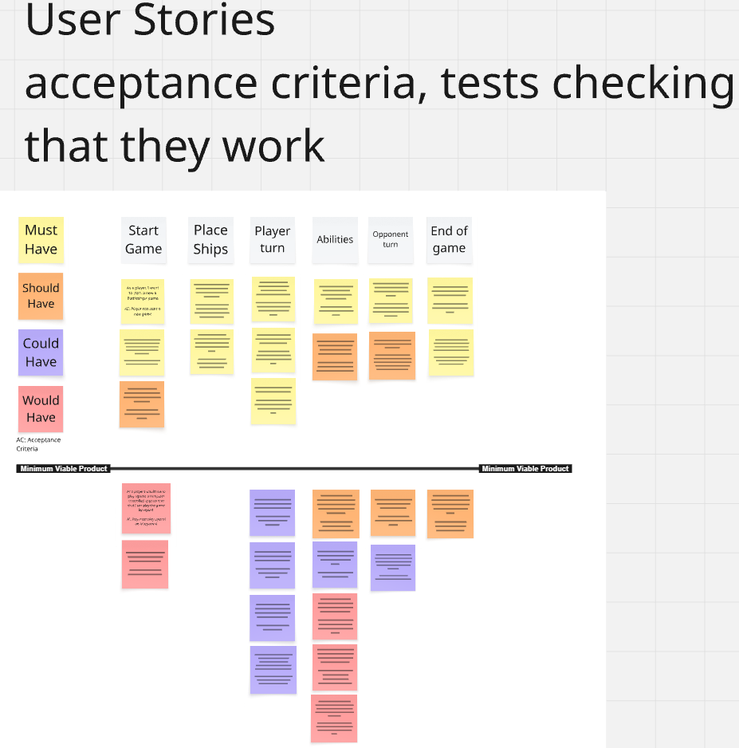
(User Stories)

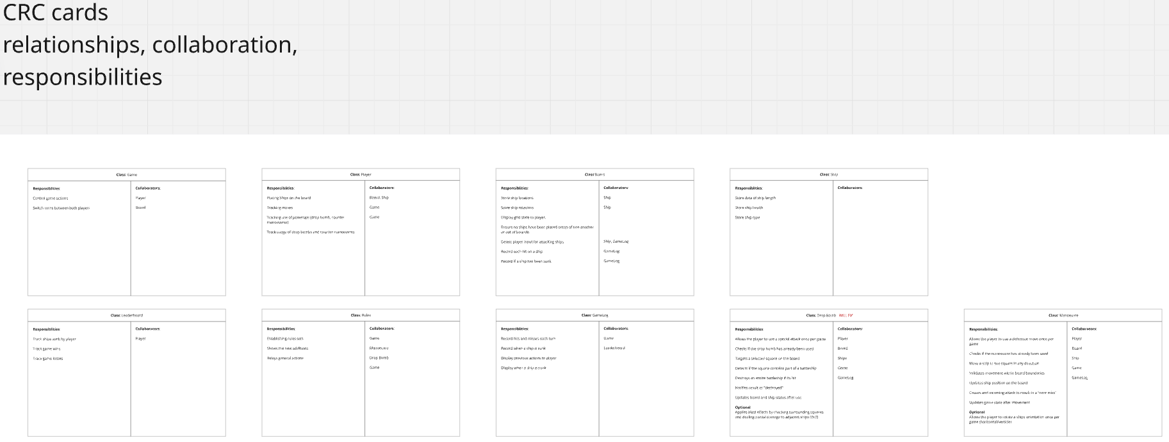
(CRC cards)

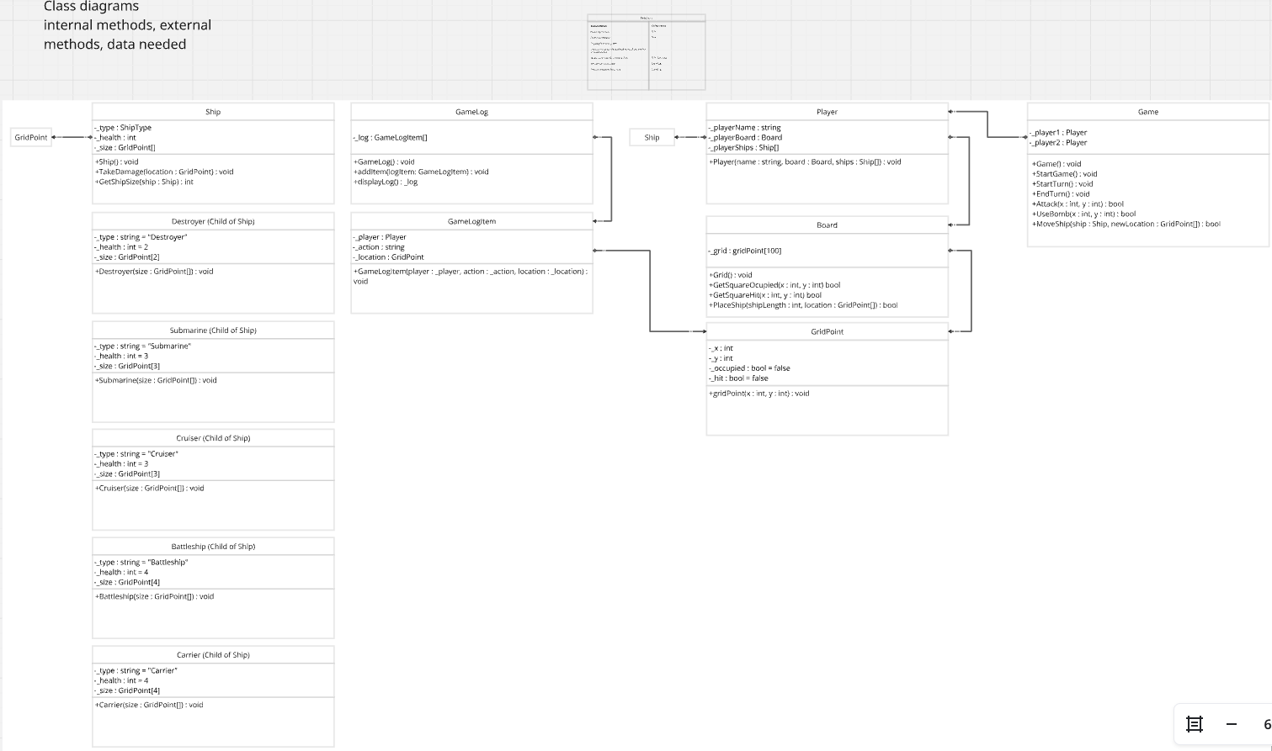
(Class Diagram)

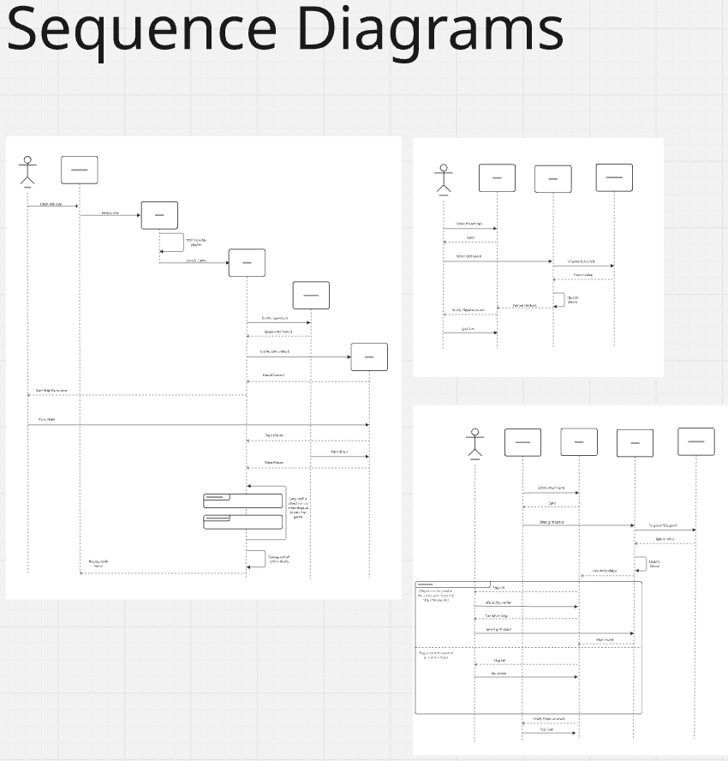
(Sequential Diagrams)

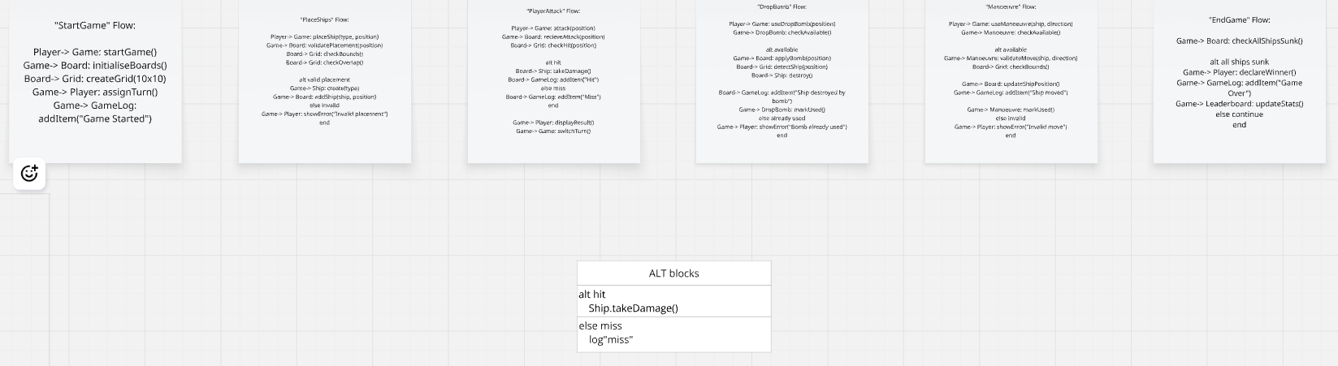
(Sequential Flows)

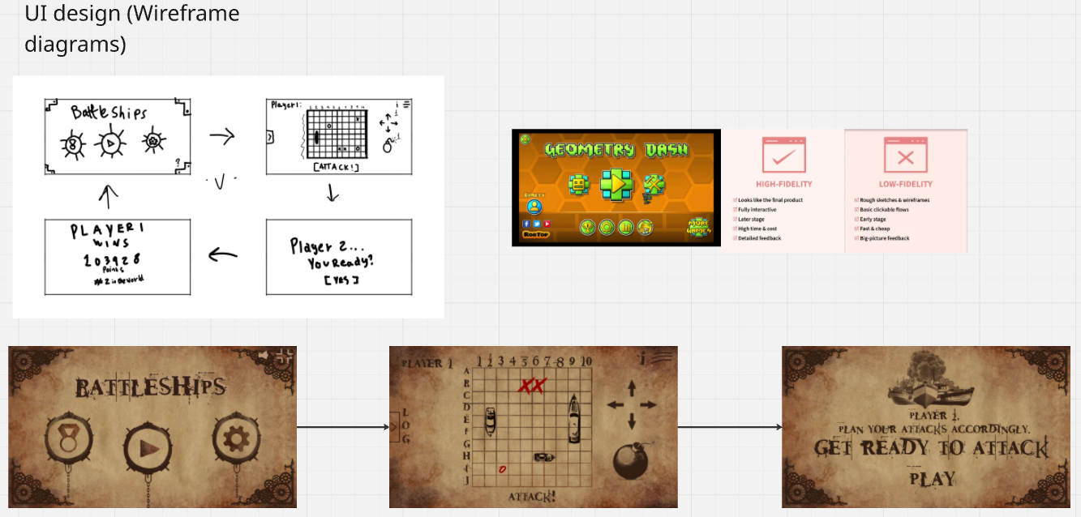
(UI design/Wireframe diagrams Low/High Fidelity)

