
Professional career DEVELOPMENT
BMSW4005

Emil Pietris
1906592
February 21, 2020

Contents:

Introduction…3
Findings.……….4
Conclusion…….7
References…….8
Appendices…….9

Introduction:
Professional development is an essential part of employee engagement. From my point of view developing my career it will help me in the future, it will increase my capabilities and it will help me to manage my time efficiently. To develop my career first is necessary to know where I am, to examine myself and to increase my opportunities.
Conforming with self-awareness , I am a confident person and I have a lot of experience on managing a team from my workplace , where I am working as a nursing assistance, I am creative and a positive person, but I have some weaknesses like patience, reading and trusting people to much sometimes.
‘’ Self-awareness will help you become a happier and more productive employee and leader and can help you align your current life with your passions.’’
Caroline Forsey, May 11, 2018

Since I was 18 years old I decided to start and build my knowledge , I started from choosing my career as a nurse and after by going to Nursing University and begin the practice for the Ambulance Services as a nurse, where I learnt a lot of importance things like: how to be more confident , how to work in a team and the most important one to be kind and helpful with other people. During the practice period I learnt to be positive and jovial which was helping me when I came in United Kingdom and I start my career as a nursing assistant.
Because of my career as a nursing assistant I achieved more experience in a teamwork and I understood how to manage my time better, I also improved my communication skills and I realise that as a leadership in a team you need to be responsible , flexible , creative, positive , but in the same time you need to work with your team for better results.
‘’ Self-development can be defined, in general terms, as gaining information needed in a person's working life, acquiring new information and skills open to the change, learning for the sake of learning and maintaining all this knowledge, throughout one's life. ‘’
FLORIAN KURTZ, 2012

During my work I went to a lot of courses, where I improve my education, but this year I decided to start a new course in Swansea University, I applied for Certificate of Higher Education Skills for the Workplace, which is something new in my life, however it will help me to achieve my knowledge and to hit my goal.
In the next statement I will present my strengths and weaknesses followed by my opportunities and my threats, based on different theories, explained in the course and it will help me to develop my performances in my new career.
Findings:
I wand to become a manager in a health industry and for that I need to improve my knowledge and my experience, like I said earlier I started University to help myself achieving more information and getting more confident, I will measure my progress , by writing more essays and giving them back in the university for them to check my improvement.
For that I will be in the University, three years, I will continue my full job as a nursing assistant in the Nursing home, where I am dealing with dementia in advance stage. I know it won’t be easy for me, will be a stressful and very intensive physically period but I will do my best to achieve my goal. My first objective for this year, is to pass my English Exam which will make me qualified to work as a General Nurse in United Kingdom, so like that I will be able to help every one at a high standard. I will participate to all the trainings and courses which will help to improve myself and as well I will be present to all the lessons in the University , I will make sure that I am very cautious during every lesson to understand exactly what academic field means so in the end , gaining my confidence to deal with any situation in my job and personal life will make me know that I won my goal.
According to Albert S. Humphrey Swot analysis, I realise that I got some precious strengths like: confidence, positive attitude, experience working in a team in my job, good communication skills, creativity, time keeping and the experience working with the people when I was doing my training for my nursing. But like everyone else I also have some weaknesses like: trusting people to much sometimes and for that I will learn how to check two time before making any decisions, one of my important weaknesses is that I don’t have a lot of patience, but I trying to change that by stopping doing things that aren’t important and by being mindful of the thing that make me impatient.
I have the opportunity to improve my weaknesses and my skills in the university and workplace, where I am willing to learn new thing from other people experiences or from my lessons, but I also have to manage my threats like: other people and financial problems.
Developing my abilities it will help me to turn into a better leadership and it will make me pass through bad situations easier, but in conformity with Abraham Maslow’s Theory of Needs (1943), I can classified myself on the fourth level which is Esteem level, because I finished my nursing degree, I was working in the ambulance service during my training for general nurse, where I achieved important goals like: confidence, time management, creativity, team work and I am participating in a lot of professional activities, where I am improving my education / abilities, I started my university where I am learning important things like: personal development, how to be more social and more confident, I will improve my communication and my writing skills also, which will help me to achieved my goal, I want to become a manager in a health professional like I said before, I want to increase my knowledge and to go up on Maslow’s Theory of Needs to self-actualisation, for that I am participating to all the classes from the university, but in the same time I am learning from people experiences or from my own experiences in work or outside work.
"What a man can be, he must be."
"It may be loosely described as the full use and exploitation of talents, capabilities, potentialities, etc. Such people seem to be fulfilling themselves and to be doing the best that they are capable of doing... They are people who have developed or are developing to the full stature of which they capable."
Kendra Cherry, December 03, 2019

In concordance with Kolb’s learning cycle my professional development initiated few years ago when I started the University to become a Nurse, but the best things that I done to improve my knowledge it was to enrol for my practice stage with the ambulance service, because it was a good experience for my life , I learnt how to talk to people, how to help people in different situations, it was very helpful with my time managing and also it build my confidence, it put me in front of good and bad situations, but luckily I manage in everything and I continue to learn from all the incidents.
I continue my learning development when I decide to come in UK and start my career in a nursing home as a nursing assistant, where I learnt how to work in a team , how to be more confident and more communicative with my colleagues. I attend lots of trainings during my nursing assistant career and I am constantly improving my skills from my experiences, from other people and now because I started my skills for the workplace course in the university in Swansea, I have another very good opportunity to develop my career and my knowledge and it will be easier for me when I will finish the university to achieved my goal.
I have just completed the VARK questionnaire in university, with the result of a Kinesthetic learning style. I responded that I was not sure that this is me. But I have suddenly realised that it is, because I was looking on different sources to see exactly what Kinesthetic learning style means and I found out that I have always had a strength in oral communication, I have realise that I have a life history of ‘’trying new things’’ and having ‘’experiences’’, this has been with my job, I also played football, boxing, I was doing voluntary work for ambulance, I was involved in a lot of projects with students from different countries. I only realise now that it is because I need to experience or ‘do’ in order to learn and I take what I have learnt from each experience and apply it to other scenarios, whether this is in the workplace or in my leisure and social life.
Also, by completing Peter Honey and Alan Mumford questionnaires I realise that the second learning style that suit myself is pragmatist style which is true , because I like to save time , to make a good first impression and to deal with awkward people, I like to practice and try new things or to apply better strategies. I tend to go straight to the point instead of talking around the problem, I am realistic, and I am not taking in consideration impracticable solutions.
One of the beneficial questionnaires that I done in the class it was to understand my personality type. That was The Kersey Questionnaire where I found out that I am a ‘’life’s administrators’’, because I am sociable, order and structure, opinionated, results driven producer. In the same questionnaire I notice that I am realistic, practical, not interested in subjects that I see no use for, but can apply when necessary, I like to organise and to run activities. Those skills are complaining with my character/ personality.

Personal Development Plan:

Development objective:
To elevate my communication skills.
Specific actions:
As a pragmatist, place on Peter Honey and Alan Mumford learning style, I will develop this skill by attending group discussions and trainings based on subject.
Blockers and how they will be removed:
One of the blockers can be the time, but I will try to make sure that I will allow enough time to attend to the class and group discussions.
Support required:
I will require some support from my classroom and some feedback from people.
How I will know when I have achieved the objective:
I will know that I develop my skill when I will be confident in presentation.
Development objective:
To improve my time management skill
Specific actions:
I will start to organise my day or my week in advance, I will learn how to prioritise my things.
Blockers and how they will be removed:
Inevitable things can be one of the blockers, where I must learn how to reorganise my day or my week because of that.
Support required:
I may need some support from other people to remove my blockers and to reorganise my time.
How I will know when I have achieved the objective:
I will know that I achieved the skill when I will have everything done on time.
Development objective:
To develop my reading skills.
Specific actions:
I will improve my reading skills by reading more on subjects that I like.
Blockers and How they will be removed:
Time can be one of the main blockers, but with all that I will need to make sure that I will aloud at least 30 mins a day for my reading skills.
Support required:
Finding the right materials to read.
How I will know when I achieved the objective:
I will know that I achieved my objective when I will be able to read without getting distract by other things.

Conclusion:

Overall, I can say that every person need to evaluate their self-awareness and self-assessment, so after they will know exactly where to start their personal development, what are their strengths , weaknesses, opportunities and threats, to see how they can change weaknesses into strengths and how to catch every opportunity or how to learn from all their life /work experiences.
I will work hard and will take any opportunity to achieve my goal, to become a manager in a health profession. I will never give up my dream, I will make sure that all my weaknesses will change into strengths and I will do my best not to have any threats.
I been working as a nurse for the ambulance services , until I decided to come in United Kingdom and start a new career as a nursing assistant in a nursing home , I learnt a lot of important things form my workplace and from my day to day activities, I started to study Skills for the workplace in the university in Swansea, which will help me to develop my skills and to achieve my goal.

Forsey, C. (2018,May 11) The True Meaning of Self-Awareness (&How to Tell If You`re Actually Self-Aware) at: https://blog.hubspot.com/marketing/self-awareness (Accessed: 16th February 2020)
Kurtz, F. (2012) Self-development-Definitions, Process, Methods at: https://www.grin.com/document/190316 (Accessed : 15th February 2020)
Cherry, K. (2019, Dec 03) The 5 Levels of Maslow`s Hierarchy of Needs at: https://www.verywellmind.com/what-is-maslows-hierarchy-of-needs-4136760 (Accessed: 18th February 2020)
A Kinaesthetic Preference ( 2014, Aug 19) at: https://vark-learn.com/testimonial/a-kinesthetic-preference/ (Accessed: 18th February 2020)
McLeod, S. (2018) Maslow`s Hierarchy of Needs at: https://www.simplypsychology.org/maslow.html (Accessed: 18th February 2020)
Madsen, D.O. (2016) SWOT Analysis: A Management Fashion Perspective , International Journal of Business Research, 16(1),39-56 at: https://papers.ssrn.com/sol3/papers.cfm?abstract_id=2615722 (Accessed: 17th February 2020)
Spacey, J. (2018,Sep 25) Examples of a personal career development plan at: https://simplicable.com/new/personal-development-plan (Accessed: 14th February 2020)
Dik, B.J et al.,(2014,Oct 3) Purpose and Meaning in Career Development Applications at : https://journals.sagepub.com/doi/abs/10.1177/0011000014546872?journalCode=tcpa (Accessed : 17th February 2020)
Maund, A. (2017) Certificate in Higher Education: Skills for the Workplace Student Yearbook. SAGE Publications Ltd.
Morgan, P. (2017) The Business Student`s Guide to Study and Employability. SAGE Publication Ltd.

Appendices:
1.

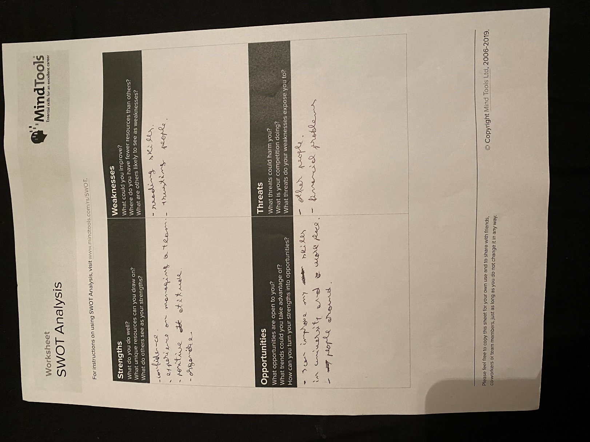
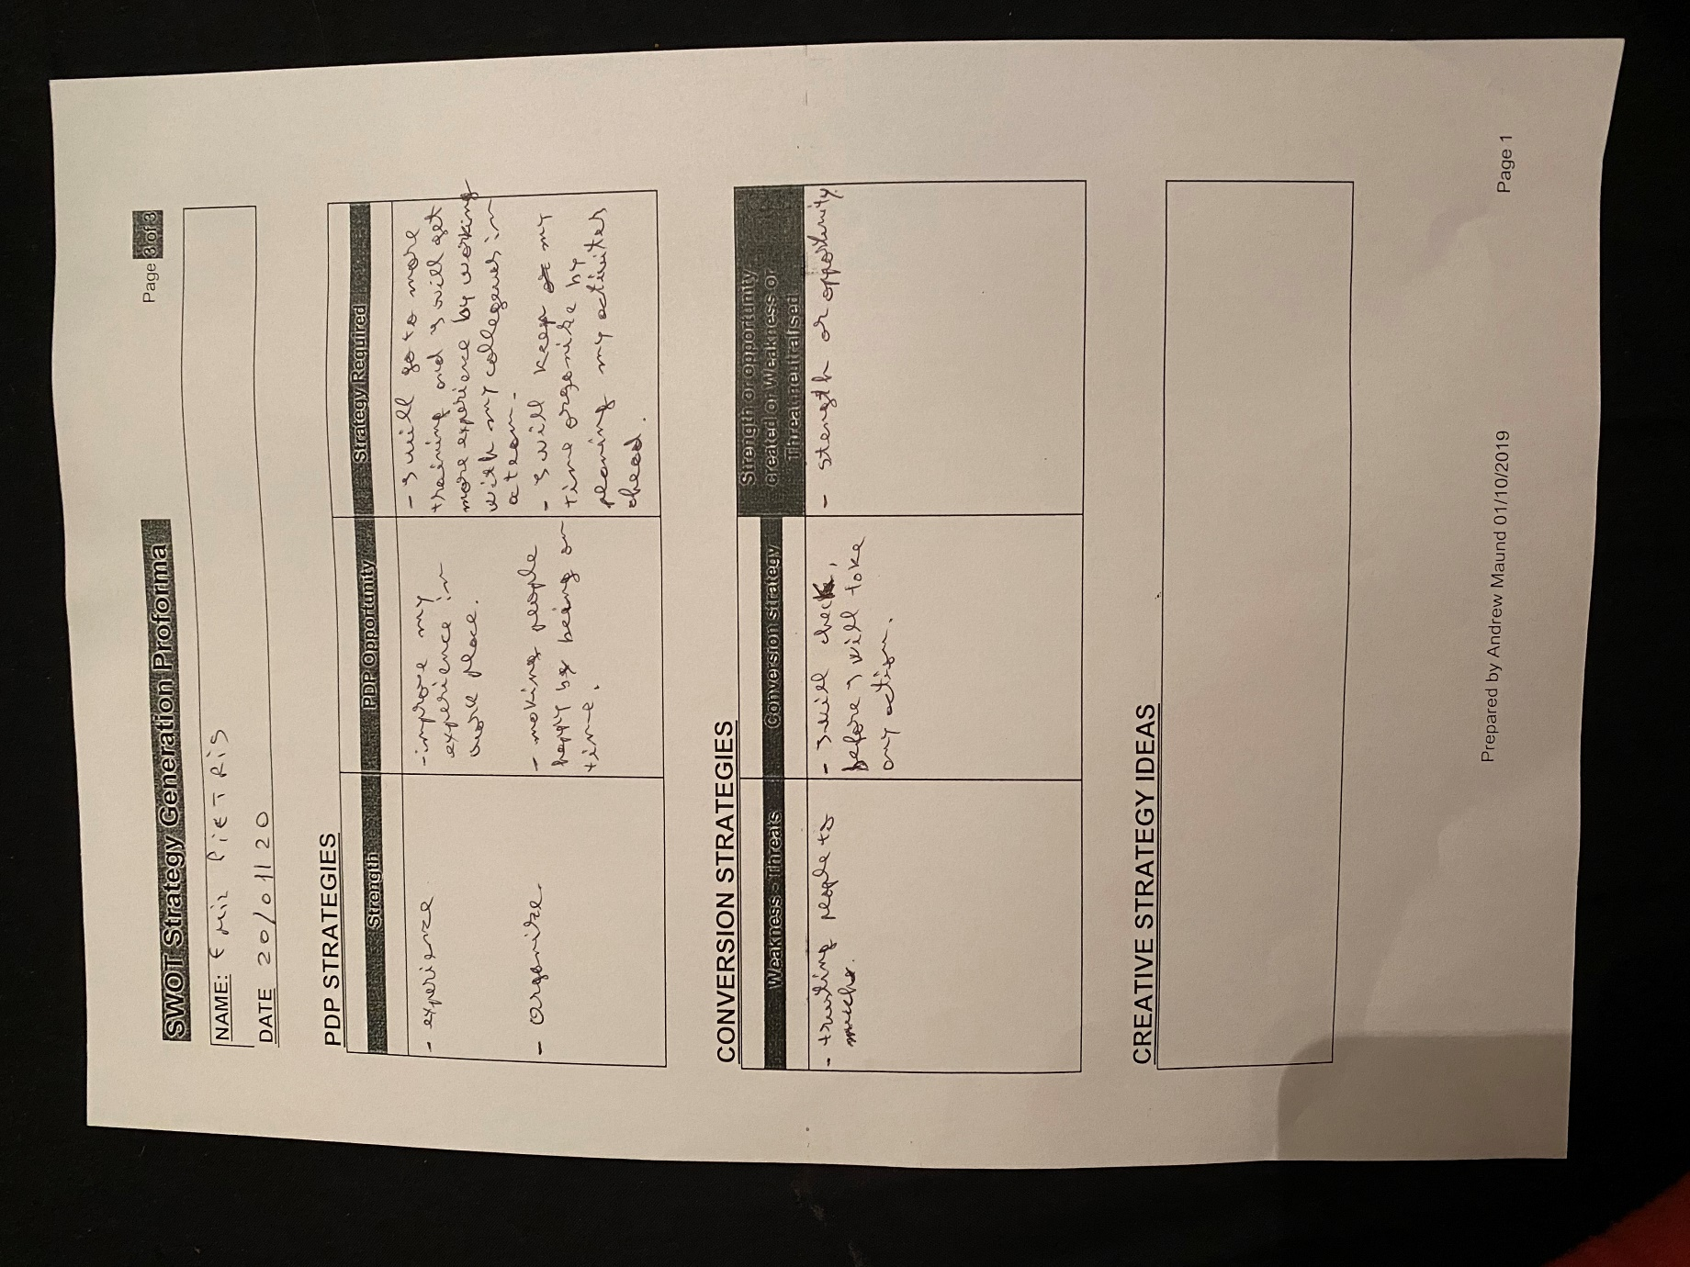

2.
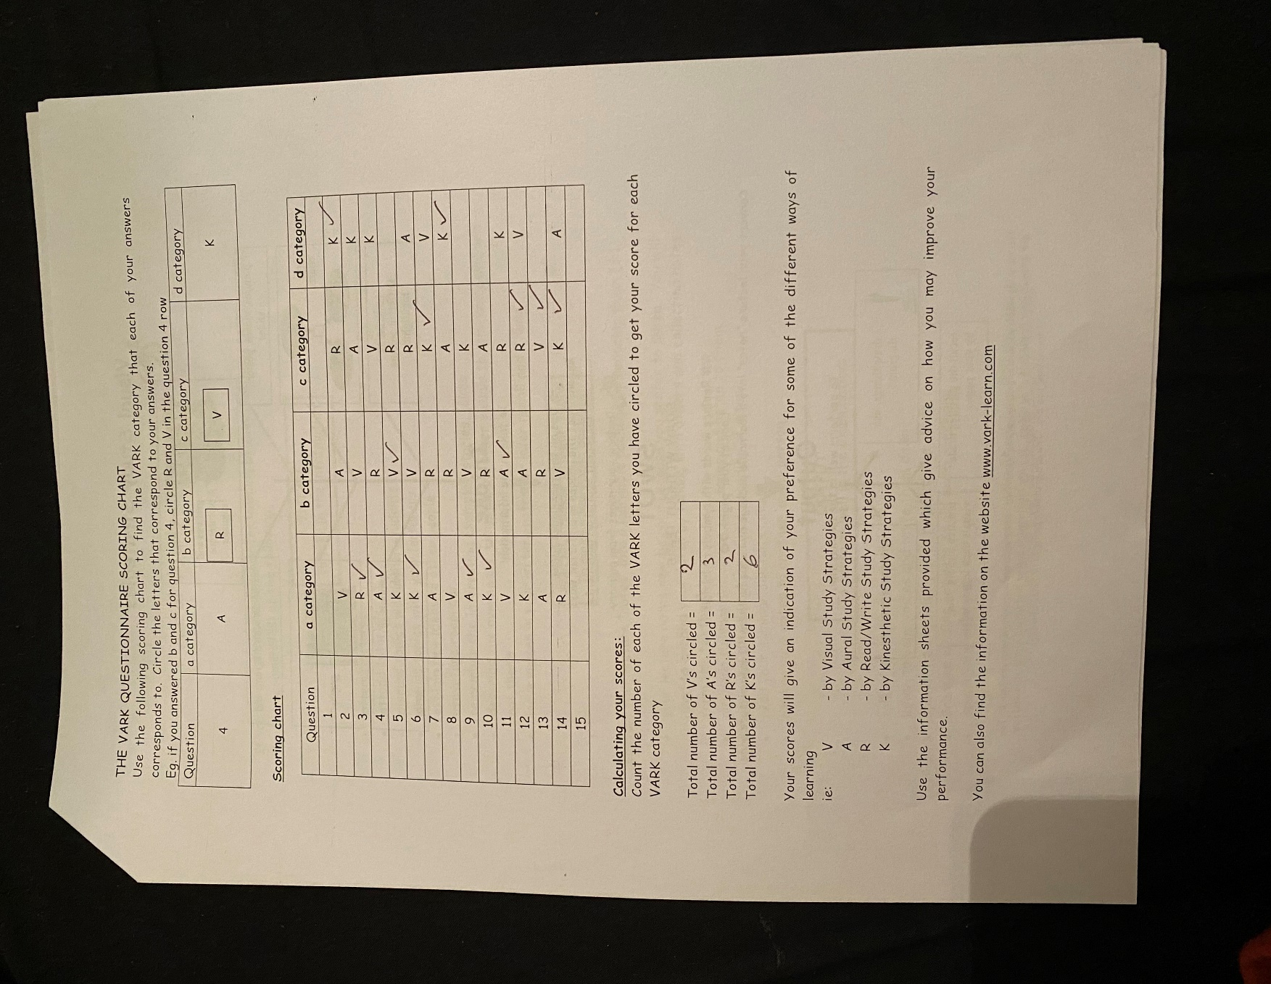

3.
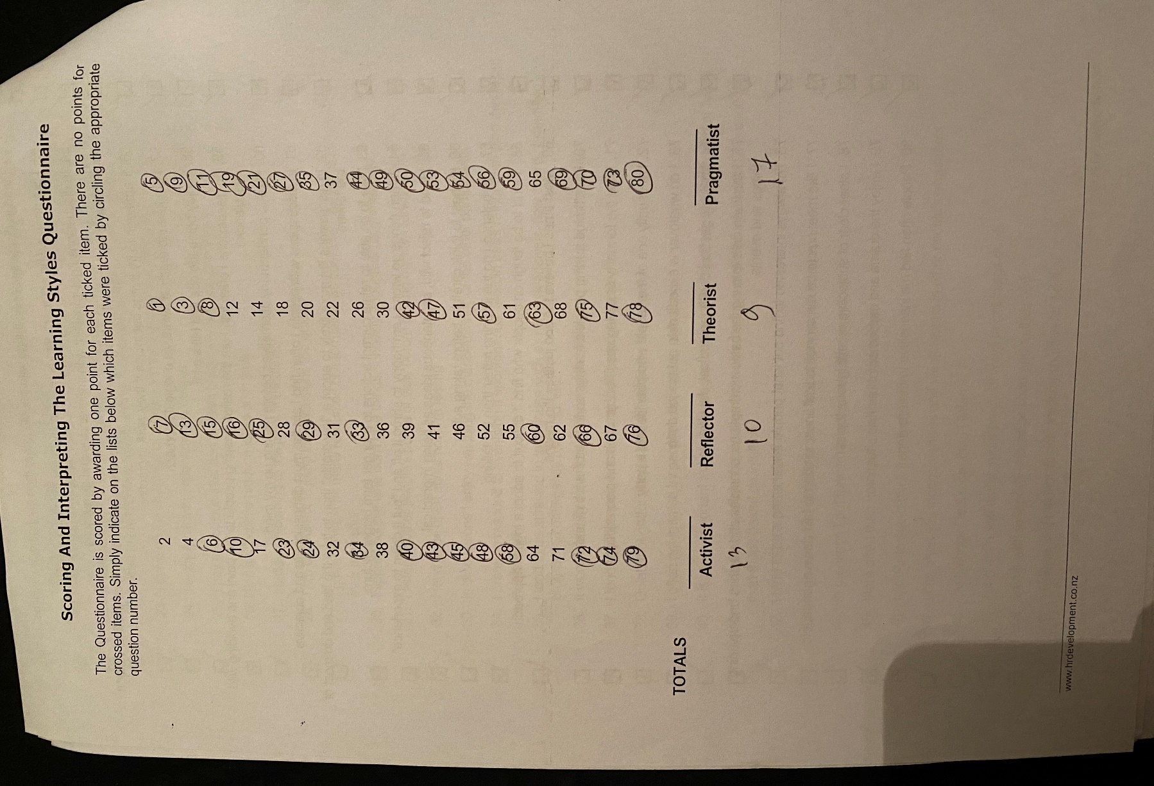

4.
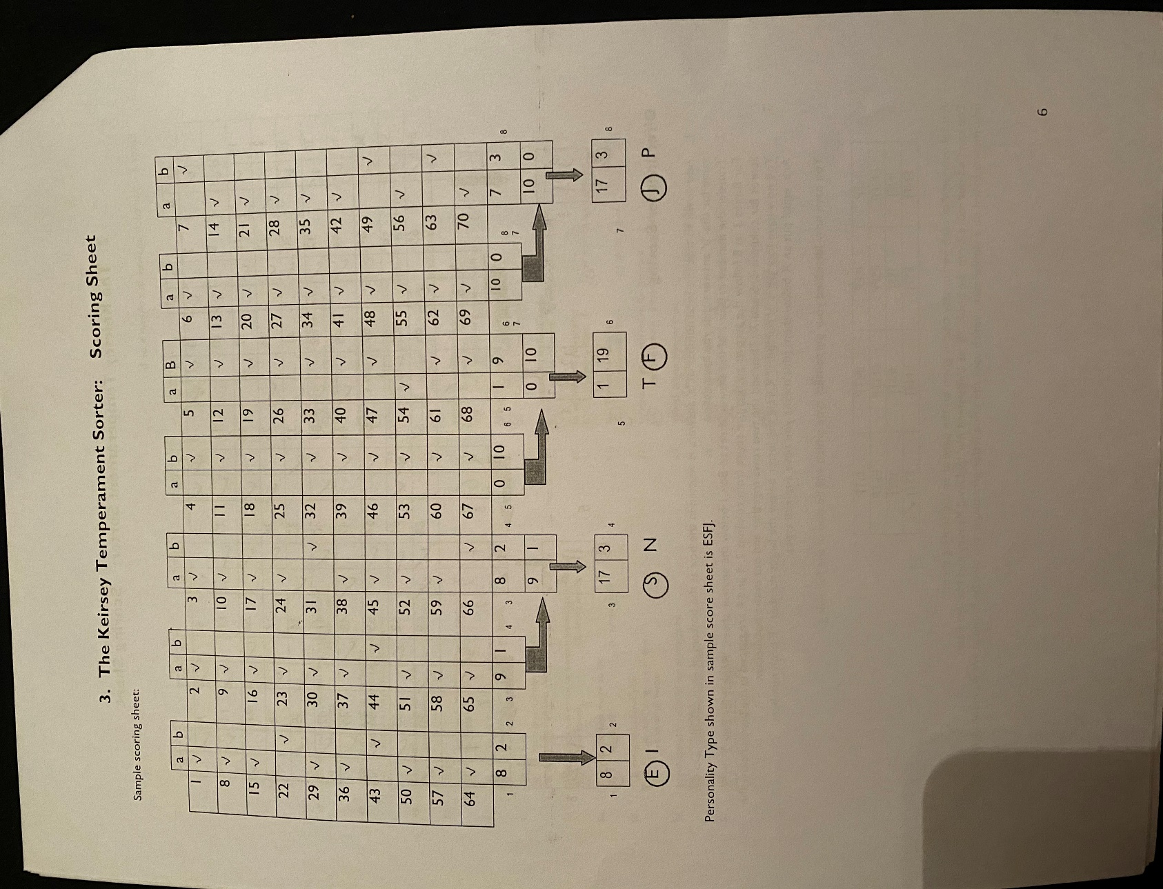
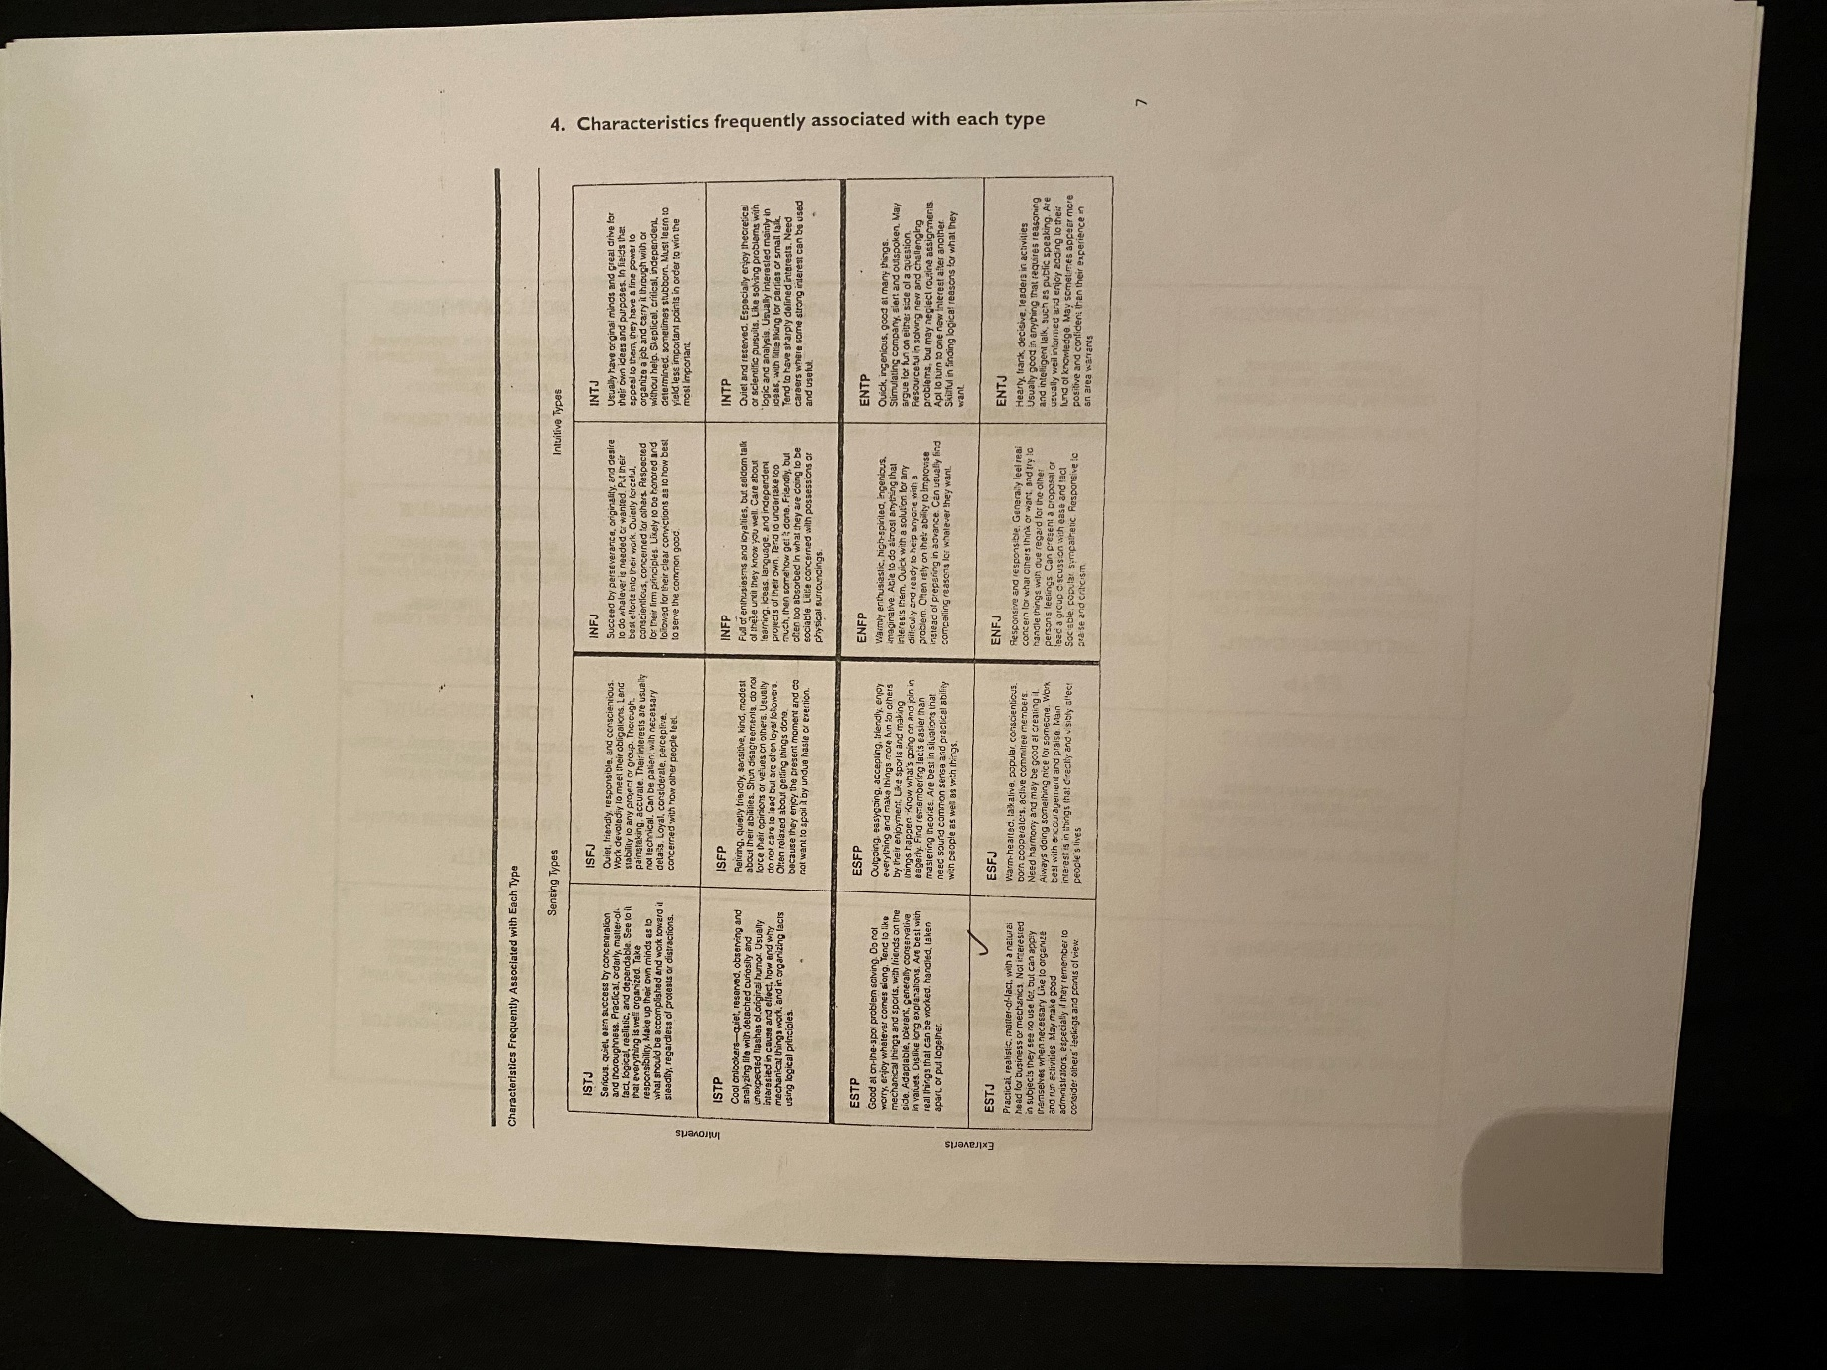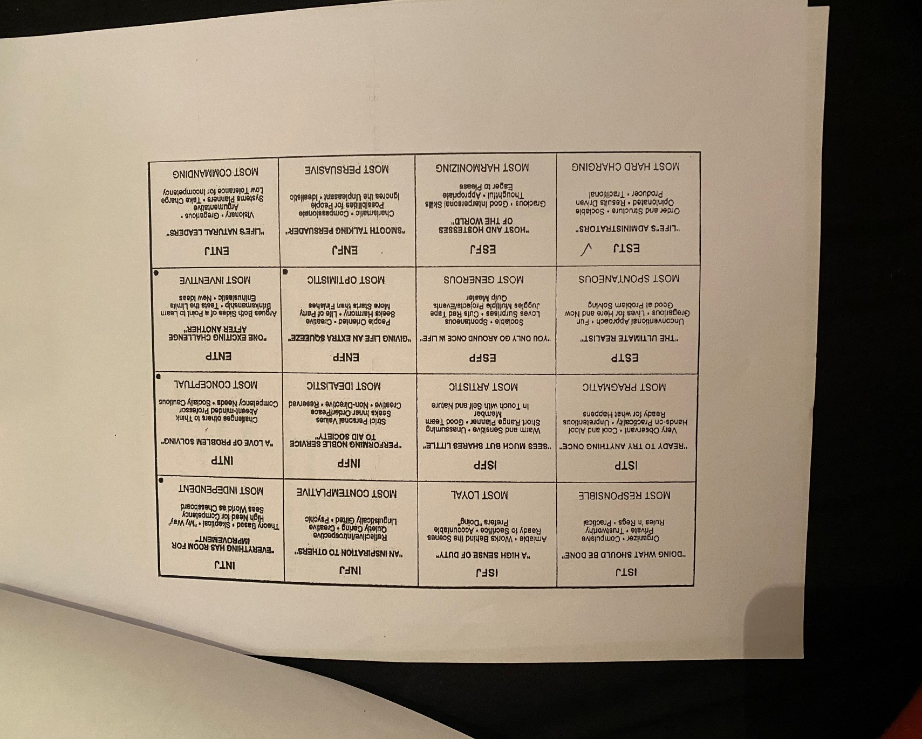

5.

