PROJECT PLANNING AND MANAGEMENT IN WORKPLACE
MOMEANA CHOWDHURY 1711893
MODULE BMSW 5104
LECTURER: PAUL RANSON

Executive Summary
The report emphasised upon the different steps related to the stress associated with skill development in developing the projects successfully within the open market. A plan for self-development was designed. It made it clear and transparent that the project manager could work efficiently by adhering to beneficial laws and norms. In the report, it was demonstrated that the Spark Hill Management Pvt. Ltd. designed the essential project and Vintners Antiques helped them as the manager of the project by sponsoring for the project. Tools and technical aspects related to designing the techniques were utilised to demonstrate the significant features in a systematic way.

Table of Contents
Task 3: Report 4
1.Introduction 4
2. Overview of the organisation 4
3. Critical evaluation related to risks linked to project 5
4. Description of tools and techniques of project management 6
5. Communicating project plans with stakeholders 10
6. Personal reflection on own abilities to manage project 10
6.1 Recommendations 11
6.2 Self-development plan 11
7. Conclusion 12
References 13

Task 3: Report

1. Introduction
The aim of our planning was to ensure that we implemented various activities alongside using Gant charts and waterfall to help us frame our business. We used Mering et al (2017) to help us brainstorm the important steps we needed to take and develop for a proper plan to be designed methodically. Our quality based project would be complete by us, the Sparkhill Project Management Ltd. We would ensure that our vintners Antiques would be used to set up the project activities (White and Shotles, 2016). Doreen has been the sponsor for the project handled by Sparkhill Project Management Ltd. The organisational performance forms the basis of the report aligned with the workplace of Sparkhill Management Company. This marks the beginning of a successful project between all parties, which have been looking to be efficient and transparent from the start. The project manager, Doreen will aid us with help in enhancing productivity of the company and demonstrate features of managing this new concept.

2. Overview of the organisation
Within our company, we try to help all our vintners by establishing different aspects; from setting up initially to the infrastructural framework. This therefore allows the team to develop with the vintners with efficiency and to provide a positive end result. By using sufficient features that have been woven into the foundation of our company along with a healthy workplace environment it allows ideas and projects to deepen and develop. Our team ensures that aspects of all parts of the project are covered from Omar who is the company’s specialist to Doreen who is in charge of the commercial side of our business. This therefore attracts huge numbers of consumers which expect and receive a varied range of assistance and material items (Bhosale et al., 2017).
Not all projects are the same and so the Sparkhill Management Company Ltd. Use different planning methods and steps of managing the project that are adopted to help the company achieve well-defined goals. These attributes exist in the organisational circle by devising the appropriate methods and the hiring of target orientated members of the team. Sparkhill Company comprises of four specific managers to handle and manage the projects efficiently (Ruuskanen et al., 2018). Although we strive for the best we understand that problems may occur along the way, but the proficiency of the team will ensure that a solution is made for any issues encountered.
Our vintners are a small scale goods shop specialising in antiques that are relocating. As a company we feel that by helping this company move to Shirley, West Midlands will provide a gap in the market to be filled. With our help, we are hoping that the vintner’s antique retail outlet is able to form with even more success across the local environment and widen their sphere of influence. Techniques related to product project concept and the Delphi technique, integrated within Waterfall have been used to help in devising the correct steps that would help the company to enhance their productivity and achieve the vintner’s important targets.
The Sparkhill management company aim to adopt specific strategies and policies that help us to acquire sponsorships or funds that are necessary to the success of this project. Organisations can potentially be commercialised and the users of the store will aid economic success. The individuals have different categories of operations to which are recognised by the end target and adopted by the management. Our sponsor Doreen, a third generation migrant works alongside our provider of commercialisation activities and services named Denis who has supported many projects by enabling transformations that our vintners ask for whilst pushing the company to develop and experience our designs and goals for future vintners. Our user specialist whose name is Suha provides support to Doreen by providing funds. Take the position within the project board and help in executing the activities along with our team of project managers. My team and I are specialised individuals with various backgrounds, which allow us to work with a range of diverse vintners and their companies.

3. Critical evaluation related to risks linked to project
Sparkhill Management Company is run by an able management which has helped us to adopt and implement a specific project cycle that is vast in its execution of operational abilities in the market. Our company follows the basic steps of discovery that leads to starting, identifying, delivering and critically analysing what has been implementing to ensure steps of closure. We also pride ourselves in product realisation, related to commodities that are bought and sold in the open market (Succi and Canovi, 2019). The Delphi technique was designed by combining the Microsoft Planner and the Product Project Technique followed by the designing of Gantt chart and lastly leading to conducting a reflection which is what we aimed to follow in our project with the vintner’s.
Microsoft Planner helped us devise the steps that supported the initiative of the organisational entity to make use of the useful sponsors, frame the plans, make the project timeline function smoothly, develop functions for the accountant and for the overall functioning of the stores. Our project is managed by adopting essential steps relating to PRINCE 2 in the social circle. Delphi Technique is linked with the project of antiques as it is applicable and we are efficiently able, as a team, to provide the necessary support in demonstration of the relevant in order to establish the significant features required by the vintner. The Waterfall technique has also been used to help in the efficient management of the project that is designed by the respective authorities in a systematic manner.
The much-needed aspects as well, as the vision related to the organisational aims would be adopted essentially within the market. Our organisation produces the Iron Triangle that plays the role of determining the time range and scope covered for carrying out the operations efficiently. A contingency plan is always put in to place as we understand that our theoretical designs are just that, theory, but once put into a physical format may not slot into each other as perfectly as we would like. However, a contingency plan can be done in an effective manner to help within risk management, time scales and end outcomes of issues that may arise. Managing time can be a significant factor that helps in assessment of prioritising the specific tasks and developing an effective plan. We ensure that a cushioned timescale allows a realistic date of a project reaching its goal.

4. Description of tools and techniques of project management
Gantt chart
During this project I was held accountable for the implementation of a Gantt chart within our company’s proposal and implementation. The Gantt chart can be considered as one of the best tools and methods that can be utilised to good effect in developing the project tasks, in a sequential way in the open market. A description of the pictorial aspects of Gantt chart needs to manage the various tasks and sub categories which therefore align with the project. Working time schedules are provided alongside the Gantt charts (Tonchia, 2018) in order for mini targets and goals to be reached, it will allow both a detailed timeline of this project.
The status of the different steps and the specific tasks related to the antiques business and seen as an essential step in delivering the vintners demands. The duration of work and allotment of tasks to the workers were framed successfully by being guided by the Gantt chart frame work (Zwikael and Smyrk, 2019).

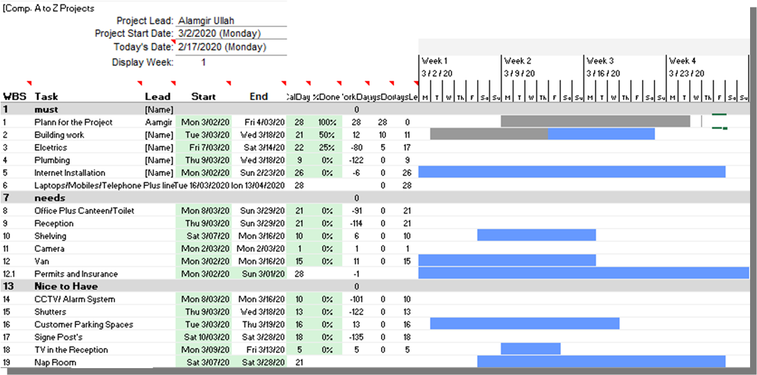
Figure 1: Gantt chart
(Source: Wittwer, 2020)
Waterfall (PRINCE 2) method of Project Management
This tool allows us to manage our projects and has proved to be very effective by arranging the steps in a systematic way by devising the appropriate strategies and simplifying the methods for users (project managers). Waterfall method of managing the project adopts the necessary and simplistic steps that help the project to be executed smoothly and efficiently within the social circle. It is also known as the PRINCE 2 method of project management by adhering to relevant norms and procedures. A special programme has been designed and utilised by our team who are present in the market and now allow us to successfully operate within our organisation as we adhere to relevant goals and training (Evdokimov et al., 2018). PRINCE 2 continues to support our Antiques vintners to frame the various regulating stages that will have a positive impact upon developing the project with efficiency. It includes directing any project by developing branches.
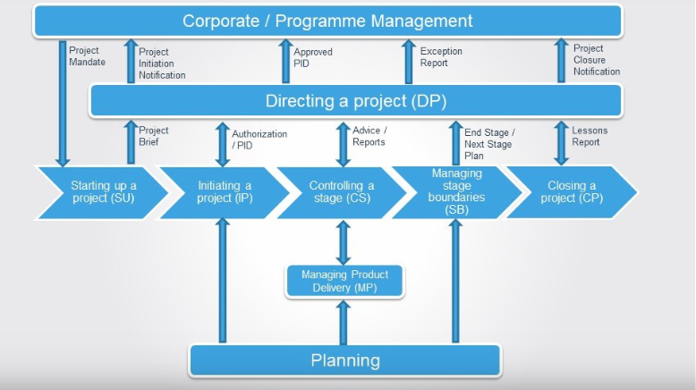
Figure 2: PRINCE 2 Project Management
(Source: Vliet, 2012)
Delphi technique linked with managing the project
The Delphi technique helped in establishing a platform that worked in a comprehensive way and developed a space for us members of the project to express ourselves in a free manner by sticking to the beneficial methods and practices. It is also part of the PRINCE 2 method of project management. Practical work helps us establish productive work in a well-designed manner by adhering to strategies and policies well known to us all (Gunduz Elsherbeny, 2020). The antiques project has to be managed by following the different steps and measures that are scientifically derived and established from this technique
Other specialised teams, some similar to the Sparkhill management company ltd., and experts, related to other projects, gave their experienced ideas and opinions in helping the project to be designed effectively within the society by linking the well framed strategies. No steps or decisions were left out of our decisions and they were carefully considered in order to be suitable to perform the project in a successful way. Different viewpoints and counter viewpoints were demonstrated amongst our planning which eventually allowed us to establish the operational services with efficacy that helped in executing the operations in a beneficial method to achieve the goals of the vintner and our company. (Fink-Hafner et al., 2019).

5. Communicating project plans with stakeholders
Affinity map
We created an affinity map which was utilised to very good effect, combined with the session of brainstorming whilst planning and conducting the operations of the project with success. Expectations were kept high even amongst when facing challenges amongst the start-up of the project. The engagement has been equal by all team players from the aspect of managing the various members of the team to adhering to different types of communication methods (formal and informal language) when not agreeing. This further helped to design the operations.
In addition, this important aspect linked with achievement of communication, allowed us to design in a meaningful way to explain the aspect that the target customers are not aligned with the goals that are framed in a common strategic manner. Communication related to establishing the requirements of execution of project in a specialised way indicating by project managers whilst adhering to important laws (Rodighiero and Romele, 2020). Our brainstorming session proves to be the most useful for operating in the market. Our companies’ project would be implemented with ease by associating with the goals that are important to be adopted well within the boundaries of the project deliverables. Skills of communication have to be suitable to accomplish the project with excellence.
Concept associated with affinity map provides suggestions that our data and facts need to be adopted so that the recording of a session of brainstorming can be produced within the market. The audience can then later help provide market feedback which our company and the vintner would take into consideration to maximise the projects social and economic reach. This process would aid all us stakeholders to communicate well within the limits and enhance the productivity in a smooth and relevant way.

6. Personal reflection on own abilities to manage project
My knowledge is currently stable but growing as I try to maintain an appreciation for training and developing myself further as an individual. This would then help me adopt different approaches to help me in developing my abilities in a structured way by adhering to the relevant norms. Practices of leadership and management have to be designed in an effective method to manage the techniques and tools being used perfectly within the open market. I helped to use the tools of project in an efficient way by aligning with the objectives and goals. I would like to improve upon the deficiencies with the help of adoption of techniques of sound communication could help in future endeavours.

6.1 Recommendations
I need to ensure efficiency within myself as well as increasing my use of academic terminology as that would help me to get the outcomes that I want. Related to this aspect, I need to specialise the areas that help me to perform the project with expertise.
- Acquiring knowledge and valuable information for planning and designing the operations. The proper understanding and arrangement of the tasks would help.
- Designing and framing skills that prove to be effective by illustrating the situations help in execution of the activities with success in the market. Assessment of the project direction is done suitably.
- Developing evaluation skills that prove to be beneficial accounted for the successful completion of the well-defined operations and strategies. Various theories and practices can be developed and their features utilised.

6.2 Self-development plan
Key Goals | Strategic requirements | Time duration | Comments
To acquire a PRINCE 2 certificate | - Developing teams by collaboration and providing roles  - Devising goals to arrange the varied range of relevant steps to establish the project with success | 12 March 2020 to 1 April 2020 | This would ensure perfect team work by combination of the common goals and by following the perfect steps of conducting the project
To enhance transferable skills | - It is needed to emphasise upon interpreting theories into proper activities. | 1 April 2020 to 15 April 2020 | Teams related to skills of theory can be enhanced to see the effective nature of practical work.
Table 1: Personal Development Plan
(Source: Developed by the Researcher)

7. Conclusion
The report covered the beneficial aspects and features of being part of a managing project related to the Sparkhill Management Company Ltd. that helped in assessing the steps that formed and essential part of conducting the important tasks in a specific way. Doreen is the sponsor for carrying out the project with eases and comfort in a methodical way. The vintner’s antique shop could be accomplished in an efficient way by aligning with the essential goals framed by the project managers at Sparkhill Management Company Ltd. Suitable methods of communication were established perfectly to meet the needs of the people in an efficient way by adhering to beneficial methods and practices adopted by the authorities. The use of Delphi technique and PRINCE 2 project management helped in simplifying the steeps of project.

References
Bhosale, A.S., Ravi, K. and Patil, S.B., 2017. A Conceptual Model of Risk Management Maturity For Road Construction Project. International Journal of Research and Scientific Innovation–IJRSI, 4, pp.38-43.
Evdokimov, I.V., Tsarev, R.Y., Yamskikh, T.N. and Pupkov, A.N., 2018, September. Using PERT and Gantt charts for planning software projects on the basis of distributed digital ecosystems. In Journal of Physics: Conference Series (Vol. 1074, No. 1, p. 012127). IOP Publishing.
Fink-Hafner, D., Dagen, T., Doušak, M., Novak, M. and Hafner-Fink, M., 2019. Delphi Method: Strengths and Weaknesses. Advances in Methodology & Statistics/Metodoloski zvezki, 16(2).
Gunduz, M. and Elsherbeny, H.A., 2020. Operational framework for managing construction-contract administration practitioners’ perspective through modified Delphi method. Journal of Construction Engineering and Management, 146(3), p.04019110.
Mering, M.M., Aminudin, E., Chai, C.S., Zakaria, R., Tan, C.S., Lee, Y.Y. and Redzuan, A.A., 2017. Adoption of Building Information Modelling in project planning risk management.
Rodighiero, D. and Romele, A., 2020. The Hermeneutic Circle of Data Visualization: the Case Study of the Affinity Map. Techné: Research in Philosophy and Technology, 24(ARTICLE).
Ruuskanen, T., Vehkamäki, H., Riuttanen, L. and Lauri, A., 2018. An exploratory study of the learning of transferable skills in a research-oriented intensive course in atmospheric sciences. Sustainability, 10(5), p.1385.
Succi, C. and Canovi, M., 2019. Soft skills to enhance graduate employability: comparing students and employers’ perceptions. Studies in Higher Education, pp.1-14.
Tonchia, S., 2018. Project time management. In Industrial project management (pp. 117-129). Springer, Berlin, Heidelberg.
White, J.C. and Sholtes, R.M., 2016. The Dynamic Progress Method: Using Advanced Simulation to Improve Project Planning and Management. Boca Raton: CRC Press.
Zwikael, O. and Smyrk, J.R., 2019. Planning a Project. In Project Management (pp. 231-258). Springer, Cham.

Vliet, V. (2012). What is Prince2? A project management methodology | ToolsHero. [online] toolshero. Available at: https://www.toolshero.com/project-management/prince2/ [Accessed 20 Mar. 2020].

World, W. (2018). Why Agile is So Popular in Project Management World | Hygger Blog. [online] Hygger. Available at: https://hygger.io/blog/why-agile-is-so-popular-in-project-management/ [Accessed 20 Mar. 2020].

Scrum.org. (2020). Scrum and projects. [online] Available at: https://www.scrum.org/resources/blog/scrum-and-projects [Accessed 20 Mar. 2020].

Wittwer, J. (2020). Gantt Chart Template for Excel. [online] Vertex42.com. Available at: https://www.vertex42.com/ExcelTemplates/excel-gantt-chart.html [Accessed 20 Mar. 2020]

