
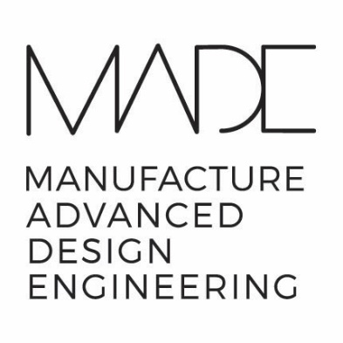

Assessment B:
The Product Design Brief

Student: Iwan Scott Mason - 2223847
Lecturer: Alan Mumby

Version 1.0
Word Count: 4498

Table of Contents

Synopsis………………………………………………………………………………….…….…..…….4
Aesthetics and Ergonomics………………………………………………………….….……..……4,5
Branding………………………………………………………………………………………..……..……5
Company Constraints……………………………………………………………………..……..……6
Competition…………………………………………………….…………………………….….…..….6,7
Customer…………………………………………………….……………………………………..…….7
Circular Economy……………………………………….………………………………………….….8
Documentation…………………………………………………………………………….….…..…..8
Environment…………………………………………………………………………………..…….….9
Legal and Intellectual Property…………………………………………………………….……..9,10
Funding…………………………………………………………………………………………….……. 10
Life in Service & Performance………………………………………………………………..……11
Materials……………………………………………………………………………………….………..11,12
Manufacturing Facilities…………………………………………………………………….….…..12
Market Constraints……………………………………………………………………………….…..13
Packaging……………………………………………………………………………………………..…13,14
Politics……………………………………………………………………………………………….……14
Prototyping………………………………………………………………..……………………………14,15
Product Cost…………………………………………………………………………………….…..…15,16
Processes……………………………………………………………………………………………….16,17
Quality and Reliability……………………………………………………………………………….18
Quantity………………………………………………………………………………………………..…18
Safety………………………………………………………………………………………………….….18,19
Shipping…………………………………………………………………………………………….……19
Social and Cultural……………………………………………………………………………………19,20
Standards………………………………………………………………………………………,,………20
Technical Specifications……………………………………………………………………….……20,21
Testing………………………………………………………………………………………………….….21
Time Scale………………………………….…………………….………………………………….…..21,22
Tooling………………………………….……………………….…………………………………………22
User Interface……………………………………………….…………………………………………..22,23,24
Advertising………………………………………………………………………………….….…………24
Care, Maintenance and Repairs……………………………………………………..………….…24
Calibration…………………………………………………………………………………….………….25
Final Considerations……………………………………………………………………………….….25
References………………………………………………………………………………………………..26,27

Synopsis

In light of the Coronavirus pandemic in 2020, a small Welshpool based company has requested that a product design brief be drawn up, to assess the feasibility for the development of a new portable breathalyser product that can be used to detect the Coronavirus. The company is a market leader in the design and manufacturing of alcohol breathalyser systems and has ongoing contracts with law enforcement agencies as well as private security companies. Furthermore, the company has identified an opportunity to use its existing expertise in breathalyser technology to redesign their current product and allow it to detect ‘organic materials’. It is important to note that a complete redesign of their product is necessary due to the different chemical nature of alcohol (ethanol) and the Coronavirus.
The company intends to manufacture a product that can be used in clinical settings, as well as for personal use. It is essential that the product is accurate enough for use within the medical world, and user friendly enough so that people with no technical expertise can also use it. As well as this, the company has expressed their eagerness to bring this product to market as soon as possible which will be taken into consideration during the design brief.

The Design Brief
The purpose of the product design brief is to keep all members of the production team on the same page and prevent unexpected outcomes as a new product is developed and brought to market, (ProductPlan, 2022). In the design brief, various aspects such as branding, documentation and finance will be considered, and feedback will be given to ensure that the product meets all intended demands and is as successful as possible after its launch into the market.

- Aesthetics
Aesthetics is a core design principle that defines a design’s pleasing qualities. Furthermore, these include qualities such as pattern, shape and visual weight, (Interaction Design Foundation, 2020).

Points of consideration:
- The product should be visually attractive, (modern, technical, sleek).
- The materials used for the product should be of a good quality as the user will be constantly holding it.
- The colour used should represent its clinical capabilities, (neon pink for example may lead the user to see the product as a toy).
- The product should not look overly complicated. For example, too many buttons or displays as it could make it less user friendly.
- Product size, shape and weight should be appropriate for handheld use

- During the development of the product, it may be useful to get public feedback on the design of the product, especially with respect to the user friendliness aspect of it.

- Branding
Branding is a way of distinguishing our product from a competitor and clarifying why our product is the better choice. It also gives our product an identity which allows the customer to develop brand loyalty to our products, (Dandu, 2015).

Points of consideration:
- Our products should be consistent with our brand identity.
- Our products should have unique characteristics which allow them to be distinguishable from competitors products.
- The use of unique fonts, slogans, symbols and colour can be used as a universal identification for our product, (such as the apple on an Iphone).

Key aspects – The company’s unique identifier (such as a logo) should be visible across all parts of the product, such as the device and packaging.

- Company Constraints

With regards to this company’s scenario, constraints are any number of factors that hinder the development of the breathalyser product. Some examples of constrains would be a lack of manpower, lack of funding, lacking the correct materials, or even not having sufficient time for the product’s development, (Brougham-Chandler, n.d.).

Points of consideration:
- Allowing enough time for the product’s development.
- Ensuring the company has the financial capability to develop the product.
- Ensuring that the intended materials are both manufacturable and fit within the cost per unit for each device.
- Do the company’s employees have the correct skill and expertise to develop the product?
- Would the company be able to use its existing manufacturing process to manufacture the device?

Key aspects – A full audit of the company’s workforce, manufacturing capability and financial capability could be done to ensure the company has the means to develop this product.

- Competition

In the case of our product, we can think of competition as contest or rivalry between two or more competitors. Furthermore, having a competitive edge in terms of product value, uniqueness or usefulness is essential to gain the edge on competitors and increase our market share, (Carnrite, 2016).

Points of consideration:
- The company should consider the needs and expectations of our intended market.
- We could conduct research on competitor’s products before we determine where our products will fall with regards to pricing, usability and design
- It may be worth conducting surveys with customers who use similar products to our own, to gather their feedback on the product’s they already use
-This information can then be considered when designing our own product.

- Customer

Target market research is a process that allows a company to understand their customer’s needs, frustrations and preferences. Furthermore, this information can be used to improve on current ideas, generate better advertisements and improve the overall product.

- The use of market research surveys can be used to help identify customer needs.

This is an example of a market research template that can be used.
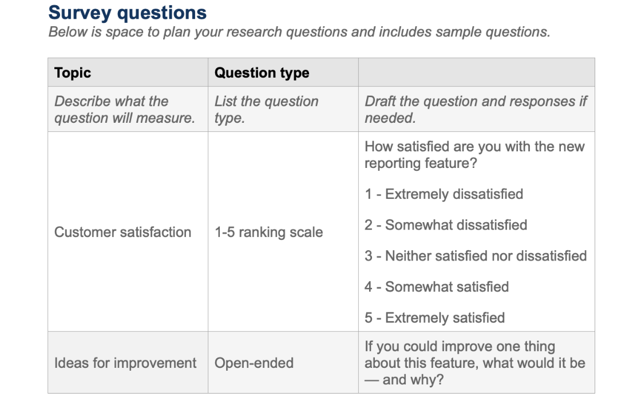

Source: (Aha, 2024)

- Circular Economy

According to the European Union Climate Department, “The circular economy is a model of production and consumption, which involves sharing, leasing, reusing, repairing, refurbishing and recycling existing materials and products as long as possible. In this way, the life cycle of products is extended”. (European Parliament, 2023). Essentially, the importance of using less and keeping waste to a bare minimum is an increasingly important element of business today, and it is important that we take this into consideration during the development of our product.

Points of consideration:
- We should attempt to design our product with as little non-recyclable material as possible
- The company should consider adopting the philosophies of the circular economy: Eliminate waste, keep materials in use and the regeneration of natural systems
- In our product, the mouthpiece will likely be designed for single use only, therefore it should be made from 100% recyclable materials
- Every effort should be made to build the device robustly so that it does not need to be disposed of
- We should attempt to design the device so it can be reconditioned rather than be thrown away

- Documentation
It is important to consider the necessary documentation during the development of the device.
These can include:
- Legal documentation
- Product strategy and vision documents
- OKR’s, KPI’s and success metrics
- Roadmap documents
- Patenting documentation
- Financial documentation for grants and third-party investments
(Appinventiv, 2019)

- Environmental

There are many aspects to consider with regards to environment, location of the device’s storage and construction.

Points of consideration:
- Storage – Ideal environment for the storage of the device (Temperature, humidity, the climate of the region – is the area prone to natural disasters?)
- Construction – Does the site of manufacture have temperature and humidity control? Are there nearby areas prone to explosions such as oil refineries?

- Legal and Intellectual Property
According to the UK government, having the right type of intellectual property protection helps prevent the stealing or copying of:
- The names of your products or brands
- Your inventions
- The design or look of your products
- Things you write, make or produce
(UK Government, 2022)

Furthermore, consideration should be given to aspects such as:
- Non-disclosure agreements. Any information shared or discussed with a third party should be made to sign a non-disclosure agreement prior to any meeting taking place.
- Our own intellectual property assets.
-Patents, trademarks, copyright, and trade secrets are some of the most valuable assets a company has. It is essential that every effort is made to safeguard these assets by making use of intellectual property law (IP Law).

- Branding, innovations, improvements and institutional knowledge also fall under intellectual property (IP).

-This link takes you to the UK government website outlining all things regarding IP Laws and rights - https://www.gov.uk/intellectual-property-an-overview

Points of recommendation:
- Consulting lawyers and experts in IP law
- Consulting product liability lawyers and insurance companies could negate legal issues should the device cause harm or injury to a customer.
- Patent lawyers should also be consulted to ensure that the company does not unintentionally copy or steal, copywritten or patented work.
- The company should consider registering intellectual property.
-This link offers information on how to register intellectual property: https://www.gov.uk/government/collections/intellectual-property-trade-marks

- Funding

As well as reviewing the company’s own financial capability and setting budgets with regards to the device’s development, there may be other resources that the company can utilize such as government grants and investments from a third party.

- Companies such as Innovate UK offer product development loans. It may be worth considering contacting loan companies if the development costs become higher than expected.
-Here is a link to Innovate UK’s website: https://iuk.ktn-uk.org/programme/innovation-loans-future-economy/

- Government grant schemes are very attainable for companies, both through the Welsh and UK governments.
-Here is a link to information regarding government grants: https://www.find-government-grants.service.gov.uk/

- Lastly, the company could reach out to other businesses within a similar field as the financial input of two or more companies should be greater than that of just one.

- Life in Service and Performance

A product’s performance can be boiled down to how well the product does its job and satisfies customers, (Brand24 Blog, 2024). It is important that the company develops a product that works as intended.

- The company could send prototypes to customers and record key details such as:
-The product’s churn rate - The churn rate shows how many customers stop using your product over a specific period.
-The customer retention rate of the product - The customer retention rate indicates the percentage of customers who make repeat purchases.
-The social media and non-social reach – How the internet search rate and feedback vary after customers use the product.

- It is equally important to ensure the product is as resilient as it can be, however it may be limited by environmental factors such as:

-Extreme heat/cold
-Humid environments
-Low service areas (if the product was to have Bluetooth of WI-FI capabilities)
-If the product is dropped, stood on or dropped into water

(Brand24 Blog, 2024)

- Materials

A high degree of consideration should be given to the materials the company intends to use to build the device. We can break down the construction into three elements: the body of the device, the mouthpiece and the internal electronics.

- The mouthpiece

-The mouthpiece should be constructed from non-hazardous materials as it is intended for oral use. The company should consult a material scientist to ensure this is the case.

-Materials used within the mouthpiece should be biodegradable or recyclable. ALCOLOCK UK make non-hazardous, biodegradable mouthpieces for alcohol breathalysers. The company should consider consulting such a company. This is a link to their website: https://alcolock.co.uk/mouthpieces

-The company should also review its current manufacturing capabilities before deciding on what materials to consider.

- The Body of the Device

-As is the case with the mouthpiece, consideration should be given to using non-hazardous and biodegradable/recyclable materials in the body of the device.
-The body should also be robust enough to withstand the pressure of being stood on or dropped on a hard floor.

- Internal Electronics

-The internal electronics must be completely safe.
-Use of the correct wires, components and grounding systems is essential.
-An electronics expert should be consulted to ensure product safety.

(Alcolock.co.uk, 2024)

- Manufacturing Facilities
Having the correct manufacturing facilities is essential to the successful development of the device. Furthermore, some discussion is needed within the company to determine the adequacy of the company’s current facilities.

Points of consideration:
- Is the current equipment capable of producing the device?
- Will the facilities need to be expanded or downsized?
- Do the facilities have enough storage space?
- If the volume of staff was to change, can the facilities accommodate (number of toilets, break room size, car parking, central heating)
- A legal expert should be consulted if to assess the safety of facilities should they need to be modified.

- Market Constraints

Market constraints can be defined as, limiting factors stemming from the market such as competitors, external customers, turbulence, and regulations, (Igi-global.com, 2024).

Points of consideration:
- Competitors – An in-depth analysis should be carried out into the capabilities of our competitors as well as their willingness to develop a similar product. It may be the case that our product is already under development with another company, which could jeopardize our company’s own project.

- Regulations – A legal adviser should be consulted to ensure the device does not breach any laws, such as patent/copyright laws and safety regulations.

- Customers – As previously mentioned, we must take into consideration the willingness of customers to buy/use our product. Furthermore, customers may choose not to use the device out of moral, religious, ethical or cultural reasons. An analysis into the political climate post Covid-19 could be undertaken to estimate potential backlash upon the launch of our product.

- Packaging

The company should consider how the product will be packaged and shipped before any developmental process begins.

Points of consideration:
- The size of the device and packaging
- The material used for packaging – Is it recyclable? Are the materials hazardous? Is it able to withstand shipping (potentially by air and sea freight)
- What branding does the company want on the packaging? (logos, trademarks, warning labels)
- A professional packaging company could be consulted to gather information on the most up-to-date packaging procedures

- Politics
During the Coronavirus pandemic, the political views of the public greatly effected both vaccination and virus testing rates, (Albrecht, 2022). Furthermore, public trust in the safety of the Covid-19 vaccine was continuously affected by politically charged misinformation on social media. It is crucial that the company consider the public reaction to methods used during the pandemic, such as the NHS covid pass and the at-home self-testing kits.
Points of consideration:
- Consideration should be made to our device being used as a political tool to suit certain agendas
- The reputation of the company could be affected if the device is seen as a method of controlling the population
- It is important to gauge the general feeling of the public towards this style of device if it were to be used for pre-entry venue testing
- Surveys of the public should be conducted to ascertain people’s feelings on both voluntary and involuntary virus testing
- It is also worth noting that this device may have a very positive impact on the healthcare of the public which may garner the company positive political attention.
(Albrecht, 2022)

- Prototyping
According to the UK companies house, prototyping is a critical part of the user-centred design process that allows designers and other key stakeholders to deliver better user experiences. As well as this, there are different types of prototypes which are categorised based of their fidelity. It is crucial that the company consider its plan on developing a prototype.

Low-fidelity prototype
- These are simple representations of the product
- They can be done by simply thinking up quick ideas and noting them on whiteboards or post-it notes
- They are great for thinking up quick ideas without spending too much time and money

Mid-fidelity prototype
- These products often begin to look like the true product
- Tools such as ‘wireframing tools’ are normally uses at this stage
- Branding and visual styles are often incorporated at this stage
- At this stage, prototypes should be tested by the targeted user andd their feedback should be considered

High-fidelity prototype
- More information about the target user and technical aspects are known at this stage, allowing us to further refine the product
- At this stage, the product should be very near to its expected performance
- Prototypes should be retested by the targeted users and their feedback should be considered

Prototyping is crucial to the development of a new product and every effort should be made to create a streamlined prototyping process.
(companieshouse.blog.gov.uk, 2023).

- Product Cost
Upon estimating product cost, considerations should be given to as many aspects of the manufacturing process as possible.

Third-party Costs
- Legal fees
- Consultancy fees
- Potential new council or government taxes

The Product
- Raw materials
- Labour costs
- Machine operation costs
- Machine servicing and repair costs
- Sub-components, (batteries, electronics, labels)

Packaging Costs
- The outer packaging
- The inner packaging
- User guide
- Any unique packaging needed for the device will have a higher cost

Shipping
- The mode of transportation, (air freight, sea freight, HGV’s)
- International import fees
- Adequate transportation units, (pallets, shipping containers, crates, wooden/cardboard boxes)

- Processes

The process of developing a new product can be broken down into smaller stages, which allows a company to systematically assess if the development is heading in the right direction.

Generating ideas
- In this stage, all ideas are gathered from both inside and outside the company
- Tools such as ‘Jira product discovery’ can be used to help structure ideas
- Methods such as ‘SWOT’ and ‘Competitive analysis’ should be used to prioritize ideas

Screening ideas
- Ideas can now be individually rated
- Unsuitable ideas should now be discarded, and suitable ideas can be moved to the next stage
- The screening process should primarily consider product priorities when screening ideas

Creating a product strategy
- A definition of the needs that the new product must meet can now be synthesised
- A good product strategy should include: the vision, target market or user, position in the industry, features/benefits, and the value the new product brings to the business.
- A ‘Strategic plan template’ can be used to streamline this stage
Building a product roadmap
- The creation of a product roadmap allows us to manage the new product development through timelines and schedules
- A good product roadmap keeps an entire team working together and moving in the same direction

Prototyping
- The time taken for a product to enter the market is crucial
- Prototyping allows us to make the least number of errors as possible which inevitably saves time and money

Testing
- Defects and changes are an inevitability of new product development
- Testing allows us to screen for defects
- Issue management is crucial. At this stage, issues discussed by quality assurance teams and targeted customers should be addressed

Product Launch
- Every step in this process has led to the product launch. The first impression of the product is crucial
- At this stage, marketing, sales and legal teams can use the product road map to align messaging, identify opportunities, and ensure regulatory compliance.
(Atlassian, 2024)

- Quality and Reliability

It is important that the device meets the correct quality expectations as most quality issues come from poor product design. Furthermore, a recognition of the inevitability of product wear and tear is also important.

Points of consideration:
- The product should perform exactly as intended
- The company should enquire about similar products to ascertain their average lifespan
- The company should think about serviceability. The device could be designed in a way which allows for retrofitting
- User opinions with regards to the devices quality could be sought out in an effort to manage quality issues
(QualityInspection.org, 2022)

- Quantity

- As per the company’s own statement, manufacturing volumes within the first year of production are likely to be no more than 750,000 units and up to 3 million units for consecutive years
- Some consideration should be given to the demand for this type of product
-Can the company realistically sell up to 3 million units per year?

- Safety

User safety should be paramount and all regulations surrounding the device should be adhered to.

Points of consideration:
- Currently, all alcohol breathalyser systems must be approved by the UK secretary of state.
- The company should enquire if similar approval is needed for the company’s new breathalyser
- If the company intends to sell to the medical sector, the device must be approved by the UK Medicines and Healthcare products Regulatory Agency (MHRA)
-This link shows an overview of medical device regulation: https://www.gov.uk/guidance/regulating-medical-devices-in-the-uk

- ISO 13485 – The international standard that establishes quality management system (QMS) requirements for medical devices
-Some research into these requirements should be made before product development

(Medicines and Healthcare products Regulatory Agency, 2020) (ISO, 2016)

- Shipping

The company must decide what modes of shipping it intends to use. These can include air freight, in-house HGV transport and sea freight.

Points of consideration:

- Shipping costs
- Import/export taxes
- Supply chain disruptions
- Packaging costs
- Shipment tracking
- Insurance
- The selection of an appropriate courier

- Social and Cultural

It is important to recognise the social and cultural aspects surrounding the Coronavirus pandemic. The company can use this information to better understand the public’s post-pandemic opinions on aspects such as the NHS and vaccination.

Post Covid-19 statistics:
- As of March 2023, 18% of adults in the UK reported the Coronavirus pandamic as still being an important issue
- As of March 2023, 18% of adults also reported having used a face covering within the last 7 days
- Cases of depression increased by 8.5% during the pandemic, as opposed to the usual expected increase of 0.3%
- Cases of emotional/behavioural issues increased 12.7% during the pandemic as opposed to the pre-pandemic rate of 3.5%

(University of Oxford, 2023) (Office for National Statistics, 2022)
Points of consideration:
- It could be beneficial to ascertain the public’s fears and anxieties surrounding the Covid-19 pandemic
- Some public surveys could be conducted to gather the public’s thoughts on the potential improvement in mental health from using the device

- Standards

As previously mentioned, any device intended for medical use must first be approved by the MHRA. All approved devises must carry markings such as:
-CE, CE UKNI, UKCA

- According to the UK government, “If you claim to hold a valid CE, CE UKNI or UKCA mark for a medical device but are breaching the regulations, typically, you will be contacted by the MHRA compliance unit outlining our concerns and requesting further information.”

-A medical standards expert should be consulted to ensure the product meets all the necessary regulations.

(GOV.UK, n.d.)

- Technical Specifications

The company must ensure the device’s technical specifications are realistic and meet all expected performance metrics.

Points of consideration:
- How will the device be powered? (batteries, mains supply, detachable power packs)
- How can the user operate the device? (touch screen, buttons, voice control, automatic detection, third party – such as a mobile app)
- The accuracy of the device’s detection
- The durability of the device
- How will results be delivered to the user?
- Will the device operate through WI-FI or internet?

- Testing

The device must meet all regulatory requirements as previously mentioned. Furthermore, the device must be registered and approved by the MHRA prior to being put on the market.
All information is up to date, as of October 2024

- There is a registration fee of £100.00 to register a device with the MHRA
- The registration must contain detailed information about the manufacturer
-A legal entity name and address
-Company type (limited, sole trader)
-Administrative contacts - up to 15
- A letter of designation for UK Responsible Persons

- As well as this, applications must contain extensive information regarding the device
-Which regulations apply to the device
-The class of the device being registered
-The GMDM code used to describe the device
-Attributions that apply such as: MRI compatible

(NHS, 2024)

- Timescale

The company should keep to strict timescales in order to avoid extra costs during the device’s development.

- A Gantt chart is designed to help teams plan, track and manage time efficiently
- Some key features of the Gannt chart are:
-Timeline visualisation
-Dependencies between tasks
-Responsibility assignment
-Progress tracking
-Resource allocation

- Here is a link to a free to use, Gantt chart template: https://miro.com/templates/product-development-gantt-chart/

(https://miro.com/, 2024)

- Tooling

The company should consider if its current manufacturing capability is appropriate for the new breathalyser device. Furthermore, tooling can be broadly regarded as the process of acquiring, obtaining, or even manufacturing the manufacturing components, machines, and equipment needed for production, (www.reidsupply.com, n.d.)

Points of consideration:

- Are any tools being sourced from abroad?
- The tool quality
- Tool safety. Do the tools meet regulatory requirements?
- Tool specifications
- What tool maintenance is required?
- Does the tool require regular cleaning or cooling?
- Will the tool be multipurpose or single purpose?

- User Interface

The user interface is the point of human-computer interaction on the device. Furthermore, there are multiple areas within the device that can be classified under ‘user interface’. Some examples include:
- The display screen
- The buttons
- Any sounds or on-screen animations
- The mouthpiece
- The batteries

-In the case of the breathalyser device, we are mainly concerned with ‘Menu-driven UI’ and ‘Touch UI’
- Menu-driven UI – The visual element within a menu screen that allows users to make selections
- Touch UI – Allows for ‘touch screen’ capabilities
-The company should discuss whether it intends for the device to have a touch screen

(Churchville, 2021)

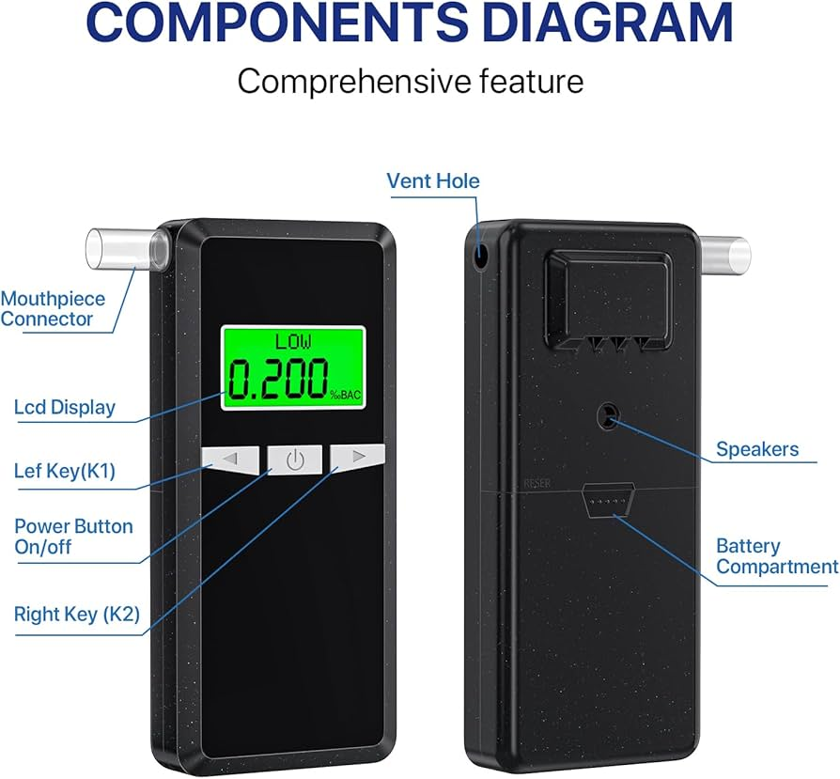
-Here is an example diagram of a breathalyser device with some user interface components labelled.

Image source: (Amazon.co.uk, 2024)

Points of consideration:
- What degree of user interface should the device have?
- As the mouthpiece will be interchangeable, some discussion into the method of swapping the mouthpiece should be had
- If batteries are needed, some thought into their ease of removal and installation should be had

- Advertising

The company should consider how it will manage advertising costs, as well as what platforms it intends to advertise with.

Points of consideration:
- Social media advertising
- Tv and radio advertising
- Conventions
- Newspapers and editorials
- Online via the company’s website
- An advertising agency could be consulted to aid in this process

- Care, Maintenance and Repairs

The company should consider a range of issues regarding the care and maintenance of the device.

Points of consideration:
- What servicing is needed to maintain the device?
- Must the device be kept in specific conditions?
- When the device requires maintenance, will the company be able to provide it?
- Is there a need for a new service engineering team?
- How much technical knowledge does the person making repairs need?
- Can a person doing repairs access the components with relative ease?

- Calibration

Calibration can be thought of as the act of comparing a device under test (DUT) of an unknown value with a reference standard of a known value. Some consideration into how the device will be calibrated should be done by the company’s engineering team.

Points of consideration:
- How often is calibration needed?
- Can calibration be conducted by the user?
- How can we guarantee the accuracy of calibration?
- A scientific research company could be consulted to help with the calibration process
(Fluke Calibration, 2020)

Final Considerations

- The company should discuss all topics mentioned in the design brief
- Some research into the most recent scientific technology regarding Covid-19 virus detection should be done, which could initially help the company ascertain the viability of the device’s production
- Upon doing my own research, I have found many examples of experimental Covid-19 breathalysers. Each example used different technologies for their products
-One example used a laser to detect the virus. Here is a link to more information on this method: https://www.colorado.edu/today/2023/04/10/new-laser-based-breathalyzer-sniffs-out-covid-other-diseases-real-time

References
- ProductPlan. (2022). Product Brief. [online] Available at: https://www.productplan.com/glossary/product-brief/#:~:text=The%20product%20brief%20plays%20a [Accessed 29 Sep. 2024].
- Interaction Design Foundation (2020). What is Aesthetics? [online] The Interaction Design Foundation. Available at: https://www.interaction-design.org/literature/topics/aesthetics#:~:text=Aesthetics%20is%20a%20core%20design.
- Dandu, R. (2015). What Is Branding and Why Is It Important for Your Business? [online] Brandingmag. Available at: https://www.brandingmag.com/2015/10/14/what-is-branding-and-why-is-it-important-for-your-business/.
- Brougham-Chandler, A. (n.d.). Applying the theory of constraints for business success. [online] www.breathehr.com. Available at: https://www.breathehr.com/en-gb/blog/topic/employee-performance/applying-the-theory-of-constraints-for-business-success#:~:text=What%20is%20a%20business%20constraint.
- Carnrite, J. (2016). What is Competition in Marketing? - Definition & Types - Video & Lesson Transcript | Study.com. [online] Study.com. Available at: https://study.com/academy/lesson/what-is-competition-in-marketing-definition-types-quiz.html.
- Aha (2024). A Complete Guide to Customer Research — With Templates. [online] Www.aha.io. Available at: https://www.aha.io/roadmapping/guide/templates/customer-research [Accessed 13 Oct. 2024].
- European Parliament (2023). Circular economy: definition, importance and benefits | Topics | European Parliament. [online] www.europarl.europa.eu. Available at: https://www.europarl.europa.eu/topics/en/article/20151201STO05603/circular-economy-definition-importance-and-benefits.
- Appinventiv. (2019). 10 Most Important Documents Product Managers Must Prepare. [online] Available at: https://appinventiv.com/blog/important-documents-product-managers-must-prepare/.
- UK Government (2022). Intellectual property and your work. [online] GOV.UK. Available at: https://www.gov.uk/intellectual-property-an-overview.
- Brand24 Blog. (2024). How to Measure Product Performance? [2024] | Brand24. [online] Available at: https://brand24.com/blog/product-performance/ [Accessed 14 Oct. 2024].
- Alcolock.co.uk. (2024). Mouthpieces | ALCOLOCKTM - Ignition Interlocks, Breathalysers, Alcohol Breath Testers, Compliance Interlocks. [online] Available at: https://alcolock.co.uk/mouthpieces [Accessed 14 Oct. 2024].
- Igi-global.com. (2024). What is Market Constraints | IGI Global. [online] Available at: https://www.igi-global.com/dictionary/thinking-inside-the-box/56774 [Accessed 14 Oct. 2024].
- Albrecht, D. (2022). Vaccination, Politics and COVID-19 Impacts. BMC Public Health, [online] 22(1). doi:https://doi.org/10.1186/s12889-021-12432-x.
- companieshouse.blog.gov.uk. (2023). How prototyping helps us deliver better user experiences - Companies House. [online] Available at: https://companieshouse.blog.gov.uk/2023/09/13/how-prototyping-helps-us-deliver-better-user-experiences/.
- Atlassian (n.d.). New Product Development Process [7 Stages]. [online] Atlassian. Available at: https://www.atlassian.com/agile/product-management/new-product-development-process.
- QualityInspection.org. (2022). Product Quality and Reliability Issues: Typical Classification. [online] Available at: https://qualityinspection.org/product-quality-and-reliability-issues-classification/.
- Medicines and Healthcare products Regulatory Agency (2020). Regulating Medical Devices in the UK. [online] GOV.UK. Available at: https://www.gov.uk/guidance/regulating-medical-devices-in-the-uk.
- ISO (2016). ISO 13485 Medical devices. [online] ISO. Available at: https://www.iso.org/iso-13485-medical-devices.html.
- niversity of Oxford (2023). Young people’s mental health deteriorated at greater rate during the pandemic | University of Oxford. [online] www.ox.ac.uk. Available at: https://www.ox.ac.uk/news/2023-09-21-young-people-s-mental-health-deteriorated-greater-rate-during-pandemic.
- Office for National Statistics (2022). Coronavirus (COVID-19) latest insights - Office for National Statistics. [online] www.ons.gov.uk. Available at: https://www.ons.gov.uk/peoplepopulationandcommunity/healt
- Innovation Service. (n.d.). Registering your medical device with MHRA. [online] Available at: https://innovation.nhs.uk/innovation-guides/regulation/registering-your-medical-device-with-mhra/.
- https://miro.com/. (2024). Product Development Gantt Chart Template | Miro. [online] Available at: https://miro.com/templates/product-development-gantt-chart/ [Accessed 23 Oct. 2024].
- www.reidsupply.com. (n.d.). What Is Tooling (Everything You Need to Know) | Reid Supply. [online] Available at: https://www.reidsupply.com/en-us/industry-news/what-is-tooling.
- Churchville, F. (2021). What is user interface (UI)? Definition from SearchAppArchitecture. [online] SearchAppArchitecture. Available at: https://www.techtarget.com/searchapparchitecture/definition/user-interface-UI.
- Amazon.co.uk. (2024). Alcohol Breathalyzer High Accuracy Breathalyser - Alcohol Tester Breathalyzer UK with 10Pcs Mouthpieces - Digital LCD Display Breathalysers for Home or Party Use : Amazon.co.uk: Automotive. [online] Available at: https://www.amazon.co.uk/Alcohol-Breathalyzer-High-Accuracy-Breathalyser/dp/B0CYX22BYV [Accessed 24 Oct. 2024].

