
APPENDIX GA36c

LEVEL 6 ASSESSMENT SPECIFICATION

Student name: | Elizabeth Darby | Student ID number: | 2008234
Programme: | Outdoor Adventure Education BA
Module: | Landscape & Sustainable Recreation
Module code: | BMOE6003 | Contribution to Overall Module Assessment (%): | 50%
Lecturer: | Anthony Burns | Internal Verifier: | Roisin Mullins
Assignment Title: | Reflective fieldwork management plan for chosen recreational area. | Word count (or equivalent): | 2,500 words
Submission deadline: | 12th May 2023 – before 3.00pm | Return date of provisional marks & written feedback: | 9th June 2023
Submission method: | All written assessments, where practical and possible, must be submitted via Turnitin unless otherwise instructed by the Lecturer. (Please DO NOT put this assessment specification into Turnitin or it will match many similarities with other students’ submissions.)  Alternative submission method (if applicable):  Late submission of the assessment will result in a late penalty mark. Penalties for late submission: Up to one week late, maximum mark of 40%. Over one week late, 0%. Only the Extenuating Circumstances Panel may approve a change to submission dates.
Academic honesty / referencing: | Academic honesty is required. In the main body of your submission you must give credit to authors on whose research and ideas your work is based. Append to your submission a reference list that indicates the books, articles, etc. that you have used, cited or quoted in order to complete this assessment.

Executive Summary
Dinefwr Park is an 800-acre old country estate located in Llandeilo, west Wales and is home to a manor house, a castle, a deer park, and a herd of white park cattle (National Trust, 2023b). This report addresses the management of the estate and its assets. The plan aims to support and sustain the cultural and natural landscape while providing somewhere for people to come and enjoy. Paths regularly trodden by cyclists and walkers will be reinforced with signs and maps encouraging people to use those paths. The carrying capacity of the park will be regularly assessed to establish and need for a reduction in carrying capacity. Deer populations will be controlled through culling to protect deer and other wildlife. TB will be managed through cattle vaccinations and limiting badger-cattle cross contamination.

Introduction
Parks look to conserve the natural and cultural landscape while also creating a recreational space for people to enjoy (Manning and Anderson and Pettengill, 2017). Recreational use can damage the natural and cultural environment so recreational spaces need to be careful managed to establish an appropriate balance, where they can both be enjoyed and protected (Manning and Anderson and Pettengill, 2017). A management plan requires an understanding of the desired uses for a landscape, as well as the ecological needs (Manning and Anderson and Pettengill, 2017). This is a landscape management plan for Dinefwr Park.
Landscape management plan
Dinefwr Park is located in Llandeilo in west Wales and covers 800 acres of parkland, including historical buildings (National Trust, 2023b). The park and its facilities can be seen in figure 1 bellow.
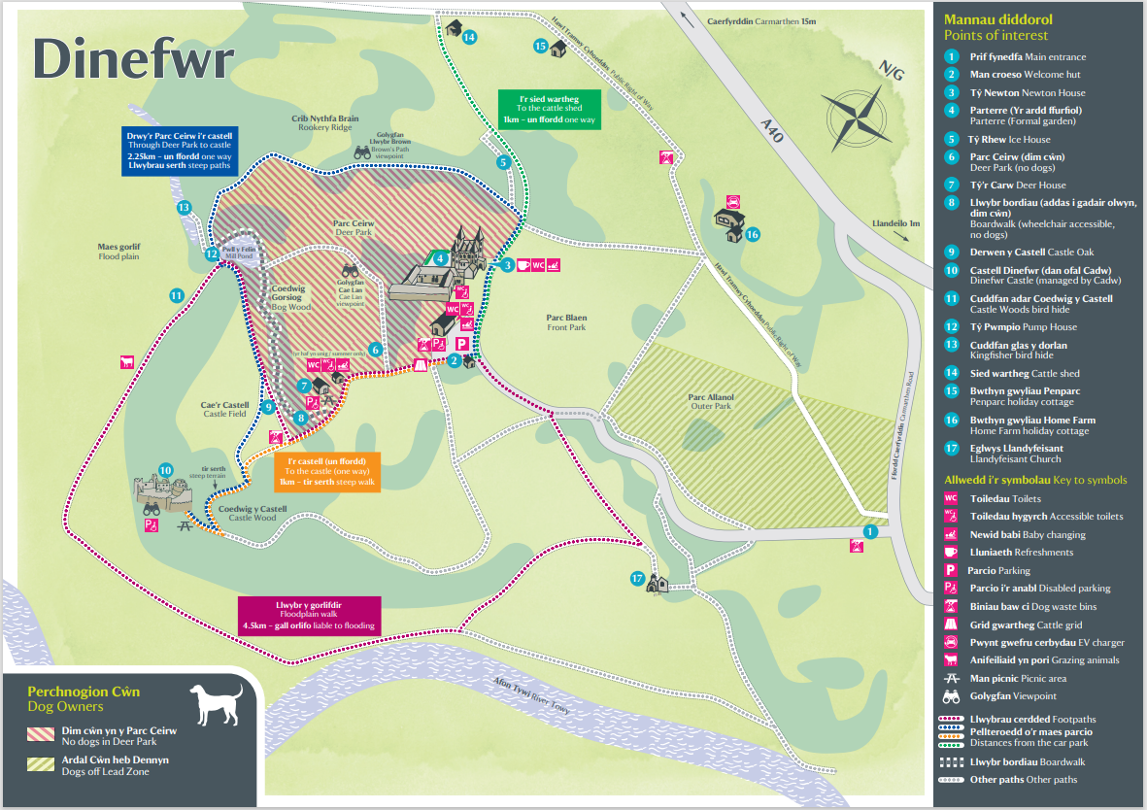
Figure 1. Dinefwr map (National Trust, 2023b)
The park includes several acres of deer park and ancient woodland and is managed by three different organisations (Dwyer, 2023). The castle is managed by Cadw (Cadw, 2023b), who protect historic places in Wales (Cadw, 2023a). The castle woods are overseen by the Wildlife Trust of south and west Wales (Wildlife Trust of south and west Wales, 2023b), who aim to rebuild biodiversity and get people involved in their local environment (Wildlife Trust of south and west Wales, 2023a). The rest of the site is managed by the National Trust (National Trust, 2023b) who aim to conserve and protect nature and history (National Trust, 2023a). The missions of all three of these organisations must be considered in the management plan for Dinefwr Park, making the management plan more complex and requiring good levels of communication between these organisations.
The missions of the three organisations help to form the management objectives upon which to base the expected conditions and resources for the landscape (Manning and Anderson and Pettengill, 2017). For this site, the management objectives are to mange the landscape so that it preserves biodiversity of the natural landscape and preserves the historic sites for future generations, while being a space that people can come to enjoy and connect with. From theses aims, it is possible to establish indicators of unacceptable and undesirable degeneration of the landscape (Manning and Anderson and Pettengill, 2017). For this site, unacceptable and undesirable degeneration will include damage to the biodiversity and nature of the landscape – specifically Castle Wood, and damage to the castle and manor house. If the desired standards aren’t being met, the management plan will be reassessed for further action (Manning and Anderson and Pettengill, 2017). Recreational spaces are made up of environmental, social, and managerial components that can be managed by the recreation opportunity spectrum, which looks to help diversity and meet expectations within each of these areas (Manning and Anderson and Pettengill, 2017). These will be outlined below.
The site is typically used by walkers, bikers, families, and retired individuals (National Trust, 2023b; Dwyer, 2023) and needs to be managed to meet the needs of all the groups. There are many points of historic interest around the site, including Dinefwr Caste and Newton House, the 19th century manor house (Coflein, 2021), all of which need to be preserved as well as being points of attraction (Manning and Anderson and Pettengill, 2017). Additionally, there are many features of the site that require specific management, such as the area of ancient woodland in the Castle Woods (Natural resources Wales, 2020). The whole site is designated as a site of special scientific interest, a national park and national nature reserve (Natural resources Wales, 2023). Furthermore, the Tywi River that runs past the site is registered as an area of conservation (Natural resources Wales, 2023), meaning that water quality must be considered in the management plan (Manning and Anderson and Pettengill, 2017).
There are few conflicting users of Dinefwr Park, and they have different designated paths, so little management is needed in the area of conflict management according to the visitor experience manager (Dwyer, 2023). However, it is still important to understand areas of higher interest which will attract the most visitors (Manning and Anderson and Pettengill, 2017), such as the castle and manor house (Dwyer, 2023). These areas should and will be reinforced to accommodate larger numbers and protect the landscape (Manning and Anderson and Pettengill, 2017). It is also important to understand and correctly place the national designated footpaths that run through the site (OS maps, 2023; Dwyer, 2023) as seen marked in orange in figure 2 below.
Figure 2. Land ranger map (OS Maps, 2023)
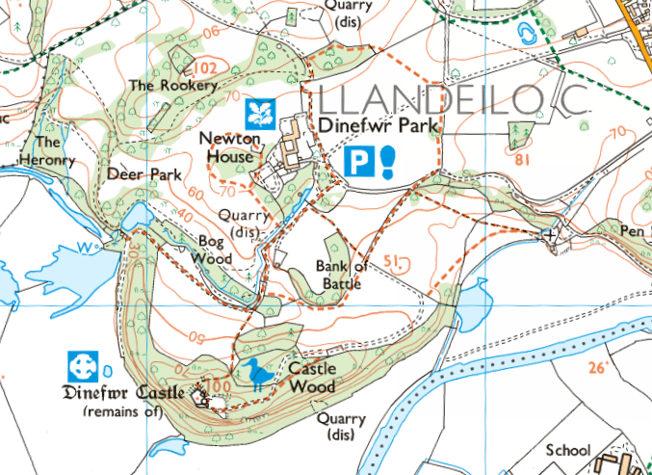
Regardless of the geology of the area and the impact to the landscape of these footpaths, they must be kept in the same place and remain publicly accessible (Dwyer, 2023). To ensure that these footpaths are kept in the same place and maintained properly they will be properly marked every 100m and at junctions (Manning and Anderson and Pettengill, 2017).
Use of footpaths can degrade the landscape and soil quality, impacting ecosystems (Vujko et al, 2017). Visitors may trample vegetation and compact soil (Vujko et al, 2017), which can impact the soil quality and decrease soil absorption. This can increase surface water run-off and decrease water available in the soil for vegetation, degenerating that too (Manning and Anderson and Pettengill, 2017). Hardening footpaths can protect the natural landscape by reinforcing paths with heavy footfall (Manning and Anderson and Pettengill, 2017; Cahill and Marion and Lawson, 2010). Many of the footpaths in Dinefwr Park run over rolling grassland fields, meaning that hardening some of the paths may impact the visual and visitor experience of the landscape which could reduce the number of visitors (Cahill and Marion and Lawson, 2010). Additionally, path hardening can be extremely expensive and may be required annually (Cahill and Marion and Lawson, 2010), as is the case at Dinefwr (Dwyer, 2023). Given this information, the management plan will only harden some of the footpaths in the most popular areas of the site. These footpaths will include the main footpaths to the castle and manor house as indicated in blue and orange in figure 1. These footpaths will be more heavily signposted and of greater focus on available maps.
To help reduce the impact of visitors to a landscape, a carrying capacity can be established, which refers to the of humans or animals an environment is estimated to be able to sustain (Manning and Anderson and Pettengill, 2017). Due to the need for Dinefwr Parks footpaths to remain publicly accessible it is not possible to restrict access to reduce the impact of visitors on foot to the landscape, just like many other national parks and landscapes around Europe (Burns and Arnberger and Ruschkowski, 2010). However, access by car can be limited by car park size and car park fees as will be done here (Manning and Anderson and Pettengill, 2017). The established carrying capacity for a landscape can and should be flexible based on the desired management objectives (Vujko et al, 2017). Carrying capacity can be measured against different criteria; this includes social, ecological, and economic carrying capacity (Vujko et al, 2023). Social carrying capacity refers the visitor capacity of a landscape before visitor experience is significantly impacted negatively (Vujko et al, 2017; Manning and Anderson and Pettengill, 2017). Ecological carrying capacity aims to establish the environmental impact a landscape can sustain without substantial damage (Manning and Anderson and Pettengill, 2017). Economic carrying capacity refers to how many visitors are required to make the landscape economically sustainable (Vujko et al, 2017).
Too many visitors can begin to degrade the visitor experience by increasing the number of other people an individual may encounter while trying to enjoy a landscape (Vujko et al, 2017). The social carrying capacity can be determined by the expectation for visitors to desire solitude or not; this could be variable across different dates (Manning and Anderson and Pettengill, 2017). For example, for bank holidays and special events such as Easter, individuals’ expectation for the landscape may incorporate larger numbers of other visitors encountered. To accommodate for this, on special event days such as Easter and school summer holidays the car park will be expanded to allow for more visitors (Manning and Anderson and Pettengill, 2017). However, specific event activities will be spread out away from areas of significant interest such as the castle and manor house to reduce overcrowding (Manning and Anderson and Pettengill, 2017; Dwyer, 2023). Doing this will reduce damage to the social and ecological carrying capacities while preserving the economic carrying capacity (Manning and Anderson and Pettengill, 2017). Due to the relatively large site of 800 acres and the relatively remote location, carrying capacity is currently of little managerial concern (Dwyer, 2023), although the quality of the site will be carefully monitored should this become a problem in the future, as it should be managed where applicable (Chen et al, 2014).
There is a deer park on the site (National Trust, 2023b) which was built by Edward Rhys in the 17th century (National Trust, 2023c) and like many others was built to be enjoyed by the aristocracy (Fletcher, 2011; National Trust, 2023c). The establishment of many deer parks throughout Europe led to over population of deer, having a detrimental impact on forest health due to over grazing (Maublanc et al, 2016). A common management technique for this problem has been hunting or culling the deer, however, this is not always received favourably by the public (Maublanc et al, 2016). At Dinefwr, one of the main attractions for some is the deer park and the opportunity it affords for sightings of deer, meaning that lower herd numbers can be detrimental to the visitor experience (Dwyer, 2023; National Trust, 2023b). However, managing deer overpopulation is important for the health of both deer and other wildlife, as their grazing can damage plant biodiversity and take away other animals’ food (Levy, 2006). The deer eat the new growth of plants stopping them from growing back (Levy, 2006). Having large numbers of deer can also lead to food shortages for other deer, leading to deer dying from starvation, which is also likely to be detrimental to the visitor experience (Maublanc et al, 2016). At Dinefwr Park there have been further problems such as deer dying from heat exhaustion trying to get away from people during the summer and an outbreak of bovine tuberculosis (TB) (Dwyer, 2023). This has led the management plan that will cull the deer to prevent them suffering.
TB has also had an impact on the white herd cattle on the estate (Dwyer, 2023). The white herd cattle are rare and are attached to local legends surrounding Dinefwr Park, making them important to the history and culture of the site (National Trust). TB has been posing a serious threat to British livestock across the country, and affects mammals such as deer, cattle, humans, and wild carnivores such as badgers (Wilson and Carter and Delahay, 2011). The problem in the UK has been exacerbated by badgers transmitting TB to cattle (Wilson and Carter and Delahay, 2011). Interaction between badgers and livestock increases the risk of the disease spreading (Wilson and Carter and Delahay, 2011). This can occur through direct or indirect contact via respiratory transmission or excretory products form shared grass land (Wilson and Carter and Delahay, 2011; Brooks et al, 2013). Feeding livestock through winter poses additional risks of transmission, as many animals are attracted to the feed area. If livestock are fed through areas such as this, it is important to protect the areas from badgers (Brooks et al, 2013). This adds support to the idea of reducing the number of deer, as it is difficult to keep deer feeding areas secure from badgers (Brooks et al, 2013). For the cattle, management is easier as farm buildings can be made badger proof in addition to feed stores. This is a better option for winter feeding as pastureland can be difficult to protect from cross-contamination (Wilson and Carter and Delahay, 2011).
Current suggested measures for TB aim to manage it rather than prevent it (Brooks et al, 2013). The culling of badgers has been attempted in areas of west Wales where Dinefwr is located but the success of this has been widely debated, particularly longitudinally, in addition to being expensive (Wilson and Carter and Delahay, 2011; Brooks et al, 2013). Vaccinations can also be used to help stop the spread of TB through either the cattle or badgers, although this too come with a cost (Wilson and Carter and Delahay, 2011). This is one of the methods proposed in this management plan that will manage TB outbreaks amongst the cattle. Additionally, abiding by UK law, infected cattle will be removed from the herd and the cases of TB reported (Gov.uk, 2021). To do this most effectively, testing for TB must be improved and implemented (Wilson and Carter and Delahay, 2011). Managing TB in this way will be expensive but necessary given the cultural significance of the white heard cattle to Dinefwr and the number of visitors they attract as a result (National Trust). Bovine TB can be passed on to humans although this is extremely unlikely (Wilson and Carter and Delahay, 2011). Because of the risk of visitors catching TB, in addition to the risk from the size of the cattle which weigh at least 1 tonn Dwyer, 2023), the cattle will be kept behind electric fences with no public access.
Conclusion
This management plan has addressed some areas of management for Dinefwr Park, although there are more areas that could be covered. The missions and the objectives of the organisations that oversee different areas were considered in making a plan for the desired attributes of the landscape and helped to develop carrying capacities for the site. Consideration has also been given to the management of the wildlife and livestock at the park to keep both them and visitors safe. Finally, the TB outbreak was addressed to ensure the longevity of the rare white herd cattle.
Word count: 2458

References
British geological Survey (2023) Geology viewer. Available at: https://geologyviewer.bgs.ac.uk/?_ga=2.12775799.1773344795.1682322250-1144013584.1682322250 (Accessed: 5 May 2023)
Brooks, R. K. (2013) ‘Evaluating use of cattle winter feeding areas by elk and white-tailed deer: Implications for managing bovine tuberculosis transmission risk from the ground up’, Preventative Veterinary Medicine, 108, pp. 137-147
Burns, R. C. and Arnberger, A. and Ruschkowski, E. (2010) ‘Social Carrying Capacity Challenges in Parks, Forests, and Protected Areas’, International Journal of Sociology, 40(3), pp.30-50
Cadw (2023) About us. Available at: https://cadw.gov.wales/about-us (Accessed: 11 May 2023).
Cadw (2023) Dinefwr Castle. Available at: https://cadw.gov.wales/visit/places-to-visit/dinefwr-castle (Accessed: 6 May 2023)
Cahill, K. L. and Marion, J. L. and Lawson, S. R. (2010) ‘Exploring Visitor Acceptability for Hardening Trails to Sustain Visitation and Minimise Impacts’, Journal of Sustainable Tourism, 16(2), pp, 232-245
Chen, H-S. et al. (2014) ‘The construction and application of a carrying capacity evaluation model in a national park’, Stochastic environmental research and risk assessment, 28(6), pp. 1333–1341.
Coflein (2021) Dinefwr Park. Available at: https://coflein.gov.uk/en/search/?term=dinefwr+park (Accessed: 6 May 2023)
Dwyer, H. (2023) Conversation. Elizabeth Darby, 13 March
Fletcher, J. (2011) Gardens of Earthly delight. Oxford: Windgather press.
Gov.Uk (2021) Bovine TB: how to spot and report the disease. Available at: https://www.gov.uk/guidance/bovine-tb (Accessed: 8 May 2023)
Levy, S. (2006) ‘A plague of deer’, Bio science, 56(9), pp.718-721
Manning, R. E. and Anderson, L. E. and Pettengill, P. R. (2017) Managing Outdoor Recreation: Case studies in the national parks. 2nd Ed. Wallingford: CABI
Maublanc, M. et al. (2016) ‘Indicators of ecological change (IEC) as efficient tools for managing roe deer populations: a case study’, European Journal of wildlife Research, 62(2), pp. 189-197
Messmer, T. A. (2020) ‘How close is too close to wildlife’, Human-Wildlife Interactions, 14(2), pp.147
National Trust (2023a) About the National Trust today. Available at: https://www.nationaltrust.org.uk/who-we-are/about-us/about-the-national-trust-today (Accessed: 11 May 2023)
National Trust (2023b) Dinefwr. Available at: https://www.nationaltrust.org.uk/visit/wales/dinefwr (Accessed: 5 May 2023)
National Trust (2023c) History of Dinefwr castle. Available at: https://www.nationaltrust.org.uk/visit/wales/dinefwr/history-of-dinefwr (Accessed: 10 May 2023)
National Trust. White Park Cattle of Dinefwr are deeply embedded in Welsh folk law [Information sign] Newton House, Llandeilo. 23 April 2023
Natural Resources Wales (2020) Interactive map viewer. Available at: https://maps.cyfoethnaturiolcymru.gov.uk/Html5Viewer210/Index.html?configBase=https://maps.cyfoethnaturiolcymru.gov.uk/Geocortex/Essentials/REST/sites/External_Map_Browser/viewers/EMB_Address/virtualdirectory/Resources/Config/Default&locale=en-gb (Accessed: 5 May 2023)
OS maps (2023) Land ranger maps. Available at: https://explore.osmaps.com/?_ga=2.148865271.1500393673.1683761681-1527053317.1677247517&lat=51.879141&lon=-4.019793&zoom=14.5901&style=Leisure&type=2d (Accessed: 11 May 2023)
Vujko, A. et al. (2017) ‘Modelling of carrying capacity in National Park- Fruška Gora (Serbia) case study’, Geographical institute, 9, pp.61-72
Wildlife Trust of south and west Wales (2023a) About us. Available at: https://www.welshwildlife.org/about-us (Accessed: 11 May 2023)
Wildlife Trust of south and west Wales (2023b) Dinefwr/Dynefor Castle Woods, Llandeilo. Available at: https://www.welshwildlife.org/nature-reserves/dinefwrdynefor-castle-woods-llandeilo (Accessed 6 May 2023)
Wilson, G. J. and Carter, S. P. Delahay, R. J. (2011) ‘Advances and prospects for management of TB transmission between badgers and cattle’ Veterinary Microbiology, 151, pp. 43-50

