

Research on Auto Product Configuration Planning Based on Online Review Text Mining
and Demand Analysis

By：Hai Jiang
Supervisor: Dr. Stephen Mosey
Second Marker:

Wales Institute of Science and Art/Athrofa Gwyddoniaeth a Chelf Cymru
School of Applied Computing/Ysgol Cyfrifiadura Gymhwysol

Submitted in Partial Fulfillment of the Requirements for the
master’s degree in M.Sc. Data Science and Analytics

University of Wales Trinity Saint David

November 12th, 2021
DECLARATION

I, Hai Jiang declare that I am the sole author of this Project; that all references cited have been consulted; that I have conducted all work of which this is a record, and that the finished work lies within the prescribed word limits.

This work has not previously been accepted as part of any other degree submission.


Signed:

Date: November 12th, 2021

FORM OF CONSENT

I Hai Jiang hereby consent that my Project, submitted in candidature for the M.Sc. Data Science and Analytics, if successful, may be made available for inter-library loan or photocopying (subject to the law of copyright), and that the title and abstract may be made available to outside organisations.

Signed:

Date: November 12th, 2021

Abstract
A large number of online reviews accumulated on automobile-related Internet platforms can reflect users' expectations and satisfaction attitudes to the product to a large extent. In order to apply the important information from online reviews to the automotive product configuration planning process, to make up for traditional questionnaire surveys or expert interviews. The long cycle, high cost, limited sample coverage, and susceptibility to the judgement of the interviewees are insufficient to achieve a more objective and effective product configuration planning oriented to user needs. This article constructs an automotive product configuration based on online reviews. Planning method. Through the excavation of the car online review text, the product features and satisfaction attitudes that users pay attention to are obtained, and on this basis, user needs analysis and transformation are carried out, and finally the concept of automobile product configuration defined by the target value is obtained. The main research contents and results are as follows:
(1) Mining of online reviews of automotive products oriented to user needs. The review information mining is carried out from two aspects of the product features that the user pays attention to and the user's emotional attitude towards the product features: Combine the TF-IDF algorithm and dependency syntax analysis technology to extract the product feature words mentioned by the user in the review text, and use Word2vec to calculate the similarity of the feature words It classifies similar feature words into the same product feature dimension, and then condenses user needs; then uses the method of fine-tuning the BERT pre-training model to train the sentiment analysis model of the review text.
(2) Analysis of the importance of user needs based on online reviews and the transformation of user needs. According to the sentiment analysis model on the sentiment tendency judgment result of the online reviews of the market segments, determine the user demand attention and user demand satisfaction in the market segments, and combine the IPA analysis and market competition analysis to determine the ultimate user demand importance; use QFD transforms user requirements into engineering technical characteristics, and constructs a fuzzy correlation matrix of demand-engineering technical characteristics.
(3) The definition method of automobile product configuration concept. For the engineering technical characteristics transformed by QFD, the target value of the engineering technical characteristics is determined based on its importance, technical competitiveness evaluation, product life cycle theory, automobile configuration statistical analysis and value engineering, and finally a car defined by the target value is generated Product configuration concept.
The method of automotive product configuration planning discussed in this article based on online reviews has actively explored the promotion of product development in the automotive industry to be more adapted to the information age, and has a higher practice for automotive manufacturers to develop products that are more in line with user needs and improve competitiveness. value.
Keywords: Online reviews, Sentiment analysis, Text mining, Demand analysis, Cluster analysis, Product configuration planning

Contents
Abstract III
Chapter 1 Introduction 7
1.1 Research Background 7
1.2 Research Purpose and Significance 8
Chapter 2 Literature Review 11
2.1 Status Quo of Research on Opinion Mining of Comment text 11
2.2 Status Quo of Research on the Importance of User Needs 15
2.3 Review of Research Status Quo 16
Chapter 3 Research and/or Development Methodology 17
3.1 Online Reviews Analysis 17
3.2 Process Model of Automobile Product Planning Based on Online Comments 19
3.2.1 Sentiment Analysis of Comment Text Stage 20
3.2.2 User Needs Analysis Stage 21
3.2.3 Car Product Configuration Implementation Stage 21
Chapter 4 Information Mining of Automotive Online Reviews Oriented to User Needs 23
4.1 Problem Description and Basic Framework 23
4.2 Comment Text Preprocessing 25
4.2.1 Chinese Word Segmentation 25
4.2.2 Deletion of Stop Words and Symbols 26
4.3 Product Feature Extraction 26
4.3.1 Overview of Related Theories 26
4.3.2 Product Feature Extraction 31
4.4 Sentiment Analysis Based on BERT 34
4.4.1 BERT Pre-training Model 34
4.4.2 Parameter Fine-tuning 36
4.5 Car Commentary Text Mining Experiment 38
4.5.1 Product Feature Extraction 38
4.5.2 Sentiment Analysis 43
Chapter 5 User Needs Analysis Method Based on Online Comments 46
5.1 Related Theoretical Methods and Improvements 46
5.1.1 IPA Analysis Method and Its Improvementation 46
5.1.2 Quality Function Deployment Theory（QFD） 48
5.1.3 Improvement of Quality House Based on Fuzzy Set Theory 51
5.2 User Needs Acquisition 55
5.3 Analysis of User Needs Importance 57
5.3.1 Basic Importance Calculation of User Needs 57
5.3.3 Adjustment of User Needs Importance 58
5.4 User Demand Conversion 58
5.5 Application of User Needs Analysis Method 61
5.5.1 Vehicle Positioning 61
5.5.2 User Demand Acquisition and Importance Calculation 61
5.5.3 User Demand Conversion 66
Chapter 6 Concept Definition Method of Automobile Product Configuration 70
6.1 Overview of Relevant Theories 70
6.1.1 Product Life Cycle Theory 70
6.1.2 Value Engineering Theory 71
6.1.3 Cluster Analysis 71
6.4 Functional Characteristics Target Value Setting 72
6.4.1 Life Cycle Analysis of Automobile Configuration Products 73
6.4.2 Automobile Configuration Product Life Cycle Judgment Based on Cluster Analysis 74
6.4.3 Setting Strategy of Function Characteristic Target Value 80
6.5 Setting Application of Function Characteristic Target Value 82
CHAPTER 7: CONCLUSIONS 86
CHAPTER 8: Reflection and Recommendations 88
8.1 Reflection 88
8.2 Recommendations 89
References 90
Appendix A: Statistics Table of Equipped Product Ratio of Passenger Cars 95
Appendix B: Key code 103

Chapter 1 Introduction

Research Background
With the advent of the data age, technologies such as the Internet, big data, and artificial intelligence have made phased progress and have a foundation for application, becoming a new driving force for industrial development. Its main technologies include Natural Language Processing (NLP)，deep learning and data mining [1]. For the automotive industry, the new technologies, new thinking and new models brought about by the Internet and big data have a profound impact and transformation on the industry as a whole, especially the product development link [2].
Product planning is an important stage in the upstream of the automotive product development process. Focusing on the product planning stage is an important way to improve the comprehensive competitiveness of an enterprise. In the practice of the development of a large number of automotive products, the concept that product planning should be oriented to user needs has been widely recognized, that is, what is really important in automotive product planning is whether the developed products can meet the needs or expectations of users. The car characteristics related to user needs should guide the car product planning process. With the development of society and economy, the continuous change of user consumption concepts and the shortening of product update cycles, users’ focus on products is in the process of dynamic changes, coupled with the long development cycle of automotive products, how to quickly and accurately capture user needs, has become the top priority of automotive product planning.
Due to the interactivity and anonymity of the Internet platform, more and more car users are accustomed to posting their feelings about various aspects of the product on automotive websites or forums. This mutual sharing has produced a large number of online reviews of automotive products. Online reviews contain important information such as the quality characteristics of the corresponding products, users' emotional attitudes, and user purchase purposes, which have a certain impact on the purchase decision of car users. In addition, since comments come from users, it is also an important way for companies to obtain user needs. Therefore, companies can grasp the improvement direction and development trend of products through online reviews, and develop products that meet the needs of users. However, there are a huge number of online reviews, a large amount of irrelevant information and no structural features. In this context, how to use big data or artificial intelligence technologies such as natural language processing, text mining, and deep learning to dig out useful information from massive online review texts, and conduct user demand analysis and product planning for automotive products need to be further explored.

Research Purpose and Significance
The traditional product planning process usually uses structured questionnaires and expert interviews for demand analysis. Factors such as questionnaire design, data acquisition, and respondents’ willingness to participate make the demand analysis process limited in sample coverage, long cycles, high costs, and low efficiency. And the high degree of manual intervention, while online comments are derived from users’ real, objective and directly obtainable data. Therefore, this research considers how to use artificial intelligence technology to grasp consumer opinions, market segment conditions and relevant competitive product performance from online product reviews, and apply it to automotive product planning, aiming to provide a more efficient and intelligent user Demand-driven automotive product planning methods, develop products that meet user needs and conform to market trends, and strive to seize new development opportunities in the era of data and artificial intelligence to improve the product planning process.
This research has certain theoretical significance. First of all, this research uses text keyword extraction technology and text sentiment analysis technology to mine online product reviews, and conducts demand analysis based on the mining results, which enriches the research on user demand analysis methods. The combination provides ideas; secondly, the Importance-Performance Analyze (IPA) analysis method and the fuzzy set theory are introduced into Quality Function Deployment (QFD) to improve the market competitiveness analysis of user demand and the correlation analysis of demand-technical characteristics. It also enriches the research of QFD theory; in addition, this article combines online comment mining, quality function deployment and product life cycle theories to construct a complete product planning model framework based on online reviews, which enriches the research in the field of automotive product planning and promotes. The automobile industry is more adaptable to the era of data and artificial intelligence and has made active explorations.
This research also has certain practical and practical significance. Because online reviews are expressions of consumers’ emotional attitudes such as satisfaction or disappointment with product features, the product planning method based on online reviews proposed in this article can help companies accurately grasp product design and improvement directions, maximize customer satisfaction, and enhance corporate competition It also makes the product planning process well-documented and reduces blind judgments based on subjective experience. Secondly, this research gives full play to the advantages of computers and artificial intelligence. Compared with traditional methods, it reduces the cost of demand analysis, and the time required for the preliminary research stage is shortened, thereby reducing the entire vehicle development cycle; in addition, because the current online comment mining technology is mostly used in mobile phones, tourism and catering industries, there are few studies in the automotive industry, so this article enriches the online Comment on the application of analysis in the automotive industry.

Chapter 2 Literature Review
This research is a product planning based on online reviews. It is necessary to dig out user needs from online reviews and evaluate the importance of the needs on this basis to clarify the focus and direction of product development. The following will mine the commentary text and the importance of needs. Analyze the status quo of related research in two aspects. Therefore, the literature review of this article mainly introduces the research process of domestic and foreign scholars in these two aspects, what methods they use in the research process, what are the advantages and disadvantages of using these methods, and so on.

2.1 Status Quo of Research on Opinion Mining of Comment text
User needs are a necessary element for product planning. To obtain information about user needs from the complex and unstructured review data, opinion mining is an effective technical means. Foreign research on opinion mining is more mature than domestic research. There are already organizations that provide data sets in restaurants, electronic products and other fields for researchers to complete the fine-grained sentiment analysis tasks set by them at the aspect level, such as the SemEval sentiment analysis task [3]. These constantly updated open-source data sets provide a good foundation for textual opinion mining. In recent years, with the continuous deepening of research in the fields of machine learning, deep learning, and natural language processing, some opinion mining competitions have appeared in China [4], and some Chinese text data sets are provided for scholars to study. In terms of model performance good results have been achieved. The current research on comment opinion mining is mostly divided into the research of product feature extraction methods and the research of text sentiment analysis. Next, the research status will be explained from these two aspects.
(1) Product Feature Extraction
Product feature extraction includes supervised learning and unsupervised learning methods.
The supervised learning method is to learn from the labeled sample set, and this method has been applied in many fields. Among the product feature extraction methods based on supervised learning, the most used is the Conditional Random Field (CRF) model. Yu Qiwei et al. used conditional random fields to extract key product feature words [5]. Shu et al. proposed a lifelong learning method that enables CRF to use the knowledge obtained from the extraction results of the previous field to extract feature words in the new field [6]. Liu Li et al. combined multiple features such as words, dependency syntax, part-of-speech and domain ontology, used CRF to extract feature words and opinion words, and used grammar tree pruning to remove irrelevant words [7]. In addition, with the development of deep neural network technology, in recent years, deep learning technology that does not require manual construction of complex text features has been widely used in feature word extraction tasks, such as Recurrent Neural Network (RNN), Convolutional Neural Network (CNN) ) And Long Short Term Memory (LSTM) and other deep learning models have achieved good results [8-12]. The above supervised methods have achieved good results in feature extraction with high accuracy, but they need to manually label the corpus, which is time-consuming and labor-intensive.
The unsupervised learning method does not require manual annotation, the principle is simple, and there are many related studies and applications. Jin et al. used positive and negative review texts to extract product features, screened out the nouns or noun phrases repeatedly mentioned, and identified the same product features expressed in synonyms based on WordNet [13]; Ku used Term Frequency -Inverse Document Frequency (TF-IDF) algorithm extracts comment objects from news texts [14]; Zhang Wenxu and others improved the TF-IDF algorithm to extract product features to build a product performance dictionary [15]. The above method of frequent item extraction based on statistics is simple in principle, easy to implement and low in cost, but it will generate noise words and lose infrequent feature words. Qiu et al. proposed a dual-propagation algorithm based on dependent syntactic structure, which simultaneously solves the extraction of feature words and the expansion of sentiment dictionary [16]; Zhan Wenpeng uses rule matching methods to extract features based on word segmentation, part-of-speech analysis and syntactic analysis. Words and opinion words [17]. The above method of setting extraction rules based on dependency syntax analysis has a better effect on the extraction of feature words covered by the rules, but for comments with random text expression and serious colloquialization, the product features that are not covered by the rules will be lost. Tu Haili et al. used Latent Dirichlet Allocation (LDA) clustering method to mine the topic attributes and emotions that users pay attention to [18], but the topic obtained by the LDA topic extraction method is too broad and cannot correspond to more refined user needs.
(2) Text Sentiment Analysis
Text sentiment analysis, also called sentiment judgment, is a research task in the field of natural language processing. The current research on sentiment analysis has three granularities, which are carried out on the entire document, a single sentence, and the sentiment polarity of a particular aspect of the evaluated object. judge. There are generally two types of discriminating methods, using emotional dictionaries and machine learning respectively.
The method based on the sentiment dictionary is to match the text according to the sentiment dictionary with the help of related rules, and quantify the matched sentiment words to obtain the sentiment analysis value of the text. Commonly used emotional dictionaries include HowNet emotional dictionary, Dalian University of Technology Chinese emotional vocabulary ontology, and National Taiwan University evaluation word dictionary [19]. Ji Xue extracted product attribute words, emotional words and degree adverbs based on dependency syntax analysis and dictionary, and used HowNet dictionary to quantify the emotional tendency of product attributes [20]. However, since the method based on the sentiment dictionary largely depends on the quality of the sentiment dictionary, many scholars have conducted research on the construction and maintenance of the sentiment dictionary. Wu et al. proposed a method for constructing an extensible emotional dictionary based on online resources [21]. Based on a large number of scored review texts, He et al. used regression models to find emotional words and their weights to build emotional dictionaries [22]. Commonly used emotional dictionaries are general emotional dictionaries, which do not have universal applicability and cannot guarantee the recognition effect of special fields.
The core of the machine learning method is to construct a classifier by training a sample set containing emotional labels, so that the classifier can predict the emotional tendency of new data. Chen Changhao used the improved Hidden Markov Model (HMM) for feature construction, and achieved good results in the emotional classification of film review data [23]. Ye et al. applied three different supervised machine learning algorithms to conduct sentiment classification experiments on the comments of 7 popular tourist destinations, and proved that the dynamic language model and Support Vector Machine (SVM) are more accurate than the naive Bayes method. Rate [24]. Based on SVM, Li Tingting et al. used various text features and feature combinations such as sentiment words to classify Weibo texts sentimentally [25]. The above research belongs to traditional machine learning methods. Although the classification effect is good, complex feature engineering is required, and the quality of the constructed features has a great influence on the effect. The deep learning process can greatly reduce the factors of human intervention and learn potential features and information. In recent years, it has been well developed in the field of natural language processing. Methods such as attention mechanism [26], RNN [27], LSTM [28-29], CNN [30] and BERT (Bidirectional Encoder Representation from Transformers) [31] have achieved good results in text sentiment analysis research.

2.2 Status Quo of Research on the Importance of User Needs
Generally, the importance of demand can be obtained by allowing customers to directly assign values ​​to the importance of each demand, pairwise comparison, or preference ranking, etc., to obtain the original data, and then perform statistical analysis on these data to obtain the demand importance analysis results. There are a large number of comparisons. Mature research.
Ramakrishnan requires users to directly assign the importance of requirements on a scale of 1-5 [32]. This method is easy to implement and easy for the respondent to operate. Li et al. used the analytic hierarchy process to analyze the interview data to determine the basic importance of the demand, and then adjusted the basic importance of the demand based on the user's satisfaction with competing products and the company's products [33]. Su Ting allows users to use interval assignments to quantify the importance of needs, and combines the Kano questionnaire and competitive analysis to determine the ultimate importance of user needs [34]. The study introduces rough intervals to better reflect the evaluation. Uncertainty of data. Bai Tao uses the fuzzy Kano model to classify requirements, and adjusts the initial importance of requirements on this basis [35]. This research makes the Kano model more adaptable to the actual situation of users’ ambiguity in demand satisfaction, and makes demand Classification is more accurate. In order to determine the relative importance of user needs, Nahm et al. proposed a new user needs ranking method, which can capture the uncertainty of the relative importance of users to needs [36].
In addition, in order to formulate appropriate product improvement strategies, Qi et al. proposed a method that uses a joint analysis model and a Kano model to evaluate the weight of product features in online reviews [37], but this method is only applicable to online products with overall product rating data. Comment. Wang Hui realized the Kano classification of user needs on the basis of text sentiment analysis, and divided the sentiment value of each product feature into 3 intervals, corresponding to charm, expectation and basic needs [38]. This research realized online comment sentiment. Correspondence between the value and the demand Carnot category. Wu Dongsheng et al. regarded product features with high frequency and low sentiment value in reviews as product features with high importance. These features are features that user pay attention to but are not satisfied and need to be improved [39]. This method is for users Prioritization of requirements provides new ideas.

2.3 Review of Research Status Quo
Through the summary and combing of the research status, it is found that although people are aware of the rich information contained in online reviews, a large number of researches on review text mining have been triggered, but most of the research focuses on how to process and mine review text, and how to base on text mining. As a result, there are few studies on demand analysis. In addition, the data required by traditional demand importance analysis methods cannot be obtained through online reviews, such as the importance comparison information between two attributes and the importance scoring data of a certain attribute. Therefore, the traditional demand analysis methods based on questionnaires or expert interviews are obviously no longer directly applicable to demand analysis based on online reviews, which leads to the mismatch between the user demand information mined from online reviews and the traditional product planning process.

Chapter 3 Research and/or Development Methodology
In this chapter, it mainly describes the research framework and research process of this thesis, and introduces the general research content of each part and the research methods involved. Because this article is mainly based on online reviews, it first introduces what online review analysis is and what kind of online reviews to obtain; then on the basis of obtaining online reviews, it introduces the automotive product planning process model based on online reviews, and explains the planning process the content of each part and the method used.

3.1 Online Reviews Analysis
Online reviews are consumers’ feelings and emotional attitudes about the product that are publicly released on the network platform in the form of text, pictures, ratings, etc. after they have completed the product purchase and experience. It is the quality of the product conducted by consumer groups through the Internet. The exchange of information such as specific characteristics is an important way to spread the reputation of products or services. Online reviews contain users’ comprehensive feedback on products. For companies, they can help companies to improve product quality and determine the direction of product development. For potential consumers, it is also an important way for them to fully understand the product. It is an important basis for deciding whether to purchase, so online reviews have a wealth of potential value worth exploring [40-41].
The text content of online reviews usually refers to the user’s satisfaction with the product entity or a certain feature of the product (such as a certain component, function, performance and quality of the product). The satisfaction attitude refers to the user’s attitude towards the product entity or a certain feature. Emotional inclination, emotional inclination is divided into positive, neutral, and negative, expressing satisfaction, general, and dissatisfaction respectively [42]. The evaluation of product features in online reviews shows the comparison between the actual experience of consumers and their inner expectations, and user needs refer to the product features that users expect from the product. Therefore, online comments imply the expression of user needs and reflect the degree of realization of user needs. For example, for an automobile product comment "The trunk of this car is very large and there is no problem with luggage", the evaluation object of this sentence is the product feature of automobile product "Trunk space", and the emotional tendency of this product feature is Positive, expressing that user are satisfied with the realization of this requirement, as shown in Figure 3-1.
Figure 3-1 The reflection of user needs in comments
User demand-oriented product development should aim at maximizing user satisfaction, and its main influencing factor is the degree of realization of user needs. Compared with traditional methods of acquiring and analyzing user needs, online reviews have a large amount of data, low data acquisition costs, and are not subject to human resources and location restrictions. They are also voluntarily posted reviews by users without interference, and their objectivity is also More secure. In addition, compared to the broad product feature descriptions such as automobile power, handling, and comfort, online product reviews include more fine-grained product characteristics satisfaction evaluations, and more specific and comprehensive presentation of user needs. Therefore, the fine-grained product characteristics and emotional tendencies mentioned in the reviews are of higher value for user demand analysis of automotive products, and can help companies plan product development directions more accurately and meticulously.

3.2 Process Model of Automobile Product Planning Based on Online Comments
In order to analyze user needs based on online reviews of automotive products, and truly and effectively transmit user needs from the market to developers, and put forward specific product development opinions, this article focuses on the technical definition of vehicle models, and builds for the design and development of a single vehicle model. Process model of automobile product planning based on online reviews. That is, it is assumed that the company has completed the model series planning and established the product line in accordance with the strategic requirements, and now it is necessary to make a specific plan for a single product. The whole framework includes three stages: sentiment analysis of comment text, user demand analysis and product configuration concept definition.
In order to make the expression clearer, the meaning of some words in the following is defined as follows:
"User needs" refers to what product features users expect from the product.
"User demand satisfaction" refers to the quantitative value of the user's satisfaction with a certain user demand (satisfied, general, dissatisfied) expressed in the comments.
"User demand target satisfaction" refers to the satisfaction that the company expects a certain user demand to meet for the developed product.
"User demand importance" refers to the importance of a user demand in product development.
"User demand attention" refers to the degree of user attention to a certain user demand in a large number of comments, that is, the number of times a certain user demand is mentioned in all comments. Need attention is the basic importance of user needs.

3.2.1 Sentiment Analysis of Comment Text Stage
Traditional user demand analysis usually conducts questionnaire surveys and expert interviews for specific consumer groups in the target market segment. In order to replace traditional methods and ensure that the user demand analysis is pertinent, it uses web crawler technology to obtain existing models in the target market segment. Word-of-mouth comments are used for sentiment analysis.
Then preprocess the online reviews of models in the target market segment. Since the data crawled by the web may have abnormal problems such as duplication and incompleteness, which may affect the results of data analysis, and the original text cannot be directly used for sentiment analysis, it is necessary to perform data cleaning, traditional Chinese character conversion, and removal of the obtained comment text Pre-processing work such as stop words and word segmentation prepares for the subsequent text sentiment analysis.
The text sentiment analysis model based on BERT fine-tuning (which will be explained in Chapter 4) is applied to the pre-processed review text to determine the sentiment tendency, and it can be recognized that the user's attitude towards various user needs in the review is positive and neutral. negative or not mentioned. Then statistical sentiment analysis results are used as input for the next stage of user demand analysis.

3.2.2 User Needs Analysis Stage
Calculate the basic importance of user needs and the user demand satisfaction of each brand product in the market segment according to the statistics of the text sentiment tendency judgment results in the previous stage; then carry out market competition analysis on this basis, and set various user demand target satisfaction , And adjust the basic importance of user needs according to the satisfaction of various user needs to determine the final importance of user needs; then the expert team will give the technical characteristics related to user needs, and evaluate the correlation between user needs and technical characteristics It also introduces triangular fuzzy numbers for quantification; finally calculates the importance of technical characteristics, determines the priority of technical characteristics, and realizes the conversion of user needs to technical characteristics. The realization principle and basis of this stage will be elaborated in Chapter 5.

3.2.3 Car Product Configuration Implementation Stage
After QFD transformation, the technical characteristics that reflect user needs and their importance are obtained. However, in order to provide more specific and effective suggestions for vehicle development and input quantitative and executable indicators for subsequent product development, it is necessary to further determine the target value of technical characteristics. The engineering technical characteristics are divided into functional characteristics and performance characteristics to determine the target values respectively. The main functional and technical characteristics of this article are used to determine the configuration of automobile products. Functional technical characteristics are technical characteristics that can be reflected in automobile configuration. Combining automobile configuration rate statistics and life cycle theory to analyze functional technical characteristics to determine its target value; performance characteristics often refer to performance Reflected by parameters, structure, etc., due to strong professionalism, its target value depends on expert experience to analyze and determine the technical level of competitive products and the company’s products. Finally, we can get the automotive product concept defined by the target value of the technical characteristics by summarizing. The realization principle and basis of this stage will be elaborated in Chapter 6.

Chapter 4 Information Mining of Automotive Online Reviews Oriented to User Needs

4.1 Problem Description and Basic Framework
In the automobile product planning model framework based on online reviews constructed in the previous chapter, the emotional analysis model of the review text needs to be used in the emotional analysis stage to identify the user's satisfaction with the mentioned user needs in the review. First of all, product features must be determined. Product features can reflect user needs, and the result of the emotional tendency judgment of product features can reflect the user's satisfactory attitude towards a certain demand.
For the determination of product characteristics, firstly, it is necessary to dig out the characteristic words of the reviews. In addition, due to the wide range of Chinese language expressions and the complexity of automotive products, different expressions may be used to express the same product characteristics, such as "the seat is very comfortable", "the sitting posture is very comfortable", "the seat cushion is a bit thin", and the driver's seat is very soft. The evaluation objects of "are all "seat comfort", so it is necessary to cluster and filter feature words to clarify product features. Through the mining of a large number of review texts, comprehensive automotive product characteristics can be obtained, and then a comprehensive list of user needs items can be obtained.
Product feature-oriented sentiment judgment can be extracted by extracting opinion words such as “comfortable”, “soft” and “big”, combined with a sentiment dictionary to determine the sentiment polarity corresponding to the opinion word, but this method requires a high degree of completeness of the sentiment dictionary. Moreover, some opinion words have completely different emotional polarities for different product features. For example, the opinion word "big" has completely different polarities in the comments "large trunk space" and "large noise". The deep learning algorithm can not only obtain the semantic information of the text, but also automatically learn the text features. It does not need to carry out complex feature engineering and performs well in the task of determining sentiment tendency. Therefore, this research uses the deep learning method based on BERT for sentiment analysis.
In order to obtain a sentiment analysis model that can identify the user's emotional tendency for the mentioned product feature, firstly, the product feature items are mined from the online reviews of various car models, and then the user's emotional polarity for each product feature item is marked on the car review text , Form the sentiment analysis training set, and then use the BERT model to fine-tune the sentiment analysis training set, and finally train the sentiment analysis model of the car review text. The research framework at this stage is shown in Figure 4-1, which mainly includes text preprocessing, product feature extraction and sentiment analysis.
Figure 4-1 Research framework for car online review mining

4.2 Comment Text Preprocessing
Text preprocessing is the basic link of natural language processing tasks. Since the original comment text crawled by the web is unstructured data, it cannot be directly used for text mining, and the expression of online comments is very random, which will reduce the effect of comment mining. Therefore, before starting the formal text mining task, you need to Perform text preprocessing. Depending on the actual text processing task, different preprocessing is required, but it usually includes the conversion of traditional characters into simplified characters, Chinese word segmentation, and elimination of stop words, special characters, expressions, and punctuation.

4.2.1 Chinese Word Segmentation
Word segmentation is the process of dividing continuous word sequences into word sequences. After the text is segmented, the subsequent topic analysis, sentiment analysis and concept extraction and other NLP tasks can be carried out. The Chinese text is composed of words as a unit, and several consecutive words are combined into one word. Unlike English, there is no space between Chinese words as an obvious distinction. Therefore, Chinese word segmentation is the primary task of Chinese NLP. Commonly used Chinese word segmentation methods include statistical word segmentation, rule word segmentation or a combination of the two.
The rule-based word segmentation method refers to: use the word segmentation dictionary to match the segmented text one by one. If the component in the text exists in the dictionary, the component is a word.
The word segmentation method based on statistics refers to the use of learning algorithms such as HMM, CRF and neural network to evaluate the reliability of words and word combinations as a word based on their frequency. If the combination frequency is higher than a certain threshold, the combination will be It may be a word.
Since both rule segmentation and statistical segmentation have advantages and disadvantages, a combination of the two methods is usually used for segmentation.

4.2.2 Deletion of Stop Words and Symbols
The segmented review text contains a large number of vocabulary, but some of them do not have a clear meaning by themselves, such as modal auxiliary words, pronouns and conjunctions, such as "了", "我", "呀", "还是", etc. These words are usually frequent Appears but has little practical significance, and it will interfere with the truly effective information to a certain extent. When processing text, you can filter out such words as stop words. For example, when extracting text keywords, stop words are usually removed from the word segmentation results to increase the keyword density.
There are many Chinese stop word lists compiled, such as the stop word list of Harbin Institute of Technology and Baidu stop word list. In addition to words, there are many non-text characters such as punctuation, emoji and emoticons, which are usually included in the stop vocabulary list for removal.

4.3 Product Feature Extraction

4.3.1 Overview of Related Theories
(1) TF-IDF Algorithm
TF-IDF algorithm is a calculation method based on statistics, which is often used for text keyword extraction. It can also be used as a weighting method for text mining to calculate the weight of words in a corpus. The TF-IDF algorithm consists of two parts: TF and IDF. The idea of TF is that the more times a word appears in a document, the more it can represent the document.
(2) Dependent Syntactic Analysis
Dependency syntax analysis technology can judge the grammatical structure of a sentence, identify the dependency relationship between words, and express the word sequence as a clear syntactic structure [43]. First of all, there is one and only one word in a sentence that is independent, it does not belong to any other words, and is the core component of the sentence; the other words must depend on another word in a certain relationship, and no word can depend on two words. One and more than two components [44-45]. There are some open-source syntactic analysis tools, such as LTP and Stanford Parser developed by Stanford University. Among them, LTP dependency syntax analysis has 14 types of dependency syntax relations, some examples are shown in Table 4-1.
Table 4-1 Examples of dependency syntax relations
Relationship Type | Label
Subject-verb relationship | SBV
Verb-object relationship | VOB
Attributive-head structure | ATT
Adverbial-head structure | ADV
Verb-complement structure | CMP
Part of speech is the most basic grammatical attribute of a word. Therefore, before the dependency syntactic analysis, word segmentation must be carried out and the part of speech of the word must be marked. For part-of-speech tagging, there is no unified tagging standard for Chinese text. LTP uses the 863tagging set. See Table 4-2 for some examples.
Table 4-2 Examples of LTP part-of-speech tagging
Label |  | Description | Example | Label | Description | Example
a | Adjective |  | “漂亮” | d | adverb | “很”
n | Nouns |  | “座椅” | ns | Place name | “北京”
nl | Nouns Location |  | “市区” | v | verb | “换挡”
lw | Loan word |  | “ABS” | wp | punctuation | “，。！”
Dependent syntax analysis is performed on the Chinese comment text, and the analysis result is visualized as shown in Figure 4-2.
(a) Example 1
(b) Example 2
Figure 4-2 Visual example of dependency syntax analysis
It can be seen from the results of visual analysis that the dependency relationship between the words in the sentence indicates the syntactic structure of the entire sentence. Below the picture is the result of word segmentation and part-of-speech tagging. The arc between each word is the dependent arc, from the dominant word to the subordinate word, and the dependence between the two words is indicated above the arc. LTP will save the text-dependent syntax analysis results, including <words, postags, arc. Head, arc.releation>, "words" is the result of word segmentation, "postages" is the result of part-of-speech tagging, and "arc.head" is the result of dependent arc The index of the dominant word (that is, the sequence number of the word in the sentence), "arc.releation" is the relationship of dependency arcs.
(3) Word2vec and word similarity
Computers based on binary coding cannot directly understand the semantics of the input text like the human brain, so before performing text classification tasks, they must first obtain a suitable text representation. Most current researches regard words as the basic unit of text processing, so the text representation can be obtained in the form of word vectorization. Word vectorization is to realize the conversion of word symbol information into digital information by mapping a word into a vector with a certain dimension in a vector space.
Word2vec, published by Mikolov et al. [46-47], is currently the most widely used word vector tool. It can obtain word representations from a large amount of unmarked text, and map each word to a dense digital vector. Word2vec word vector does not just symbolize words. It uses neural network models to extract useful information from a large number of unlabeled texts, and uses word context information to map words to word vectors, making the vectors have semantic characteristics. Word2vec has two model architectures, CBOW (Continuous Bag of-Words) and Skip-gram, as shown in Figure 4-3(a) and 4-3(b). CBOW predicts the probability of the current word based on the context; Skip-gram is the opposite, which predicts the context of a given word. After the model is trained, the weight matrix of its hidden layer is the word vector matrix we need.
(a) CBOW model (b) Skip-gram model
Figure 4-3 CBOW and Skip-gram model architecture
A great advantage of Word2vec word vector is that it has great advantages in expressing semantic similarity of words. According to the distributed assumption, if the semantic environment of two words is similar, then the meanings of the two words are considered to be similar. Word2vec makes semantically similar words closer in the vector space. Therefore, word similarity can be measured by calculating the distance between Word2vec word vectors. The closer the distance of words in the vector space, the more similar the semantics between words. This paper uses cosine distance to calculate the similarity between feature words. Cosine distance, also called cosine similarity, measures the similarity of two words by calculating the angle between two vectors:
$$Similarity=\cos\left(θ\right)=\frac{A∙B}{\left\|A\right\|\left\|B\right\|} \text{(}\text{4}\text{-}\text{1}\text{)}$$
Where A and B are the word vectors of word a and word b, respectively, and θ is the angle between the two vectors.

4.3.2 Product Feature Extraction
In terms of product feature word extraction, the TF-IDF algorithm can extract frequently-occurring feature words very well, corresponding to the main product features, but it does not have the ability to extract non-frequent feature words. The method of extracting feature-view word pairs based on dependency syntactic analysis setting rules is not affected by the frequency of feature words, and the idea words can be obtained at the same time, which is conducive to summarizing user needs, but online comments may have random language expression and grammatical confusion. In other cases, the feature words that are not in the extraction rules will be lost. Therefore, this study comprehensively uses two feature word extraction methods, and combines Word2vec word vector similarity calculation to summarize the obtained feature words, and strive to obtain a comprehensive product feature item.
(1) Extraction of Frequent Feature Words
Since the characteristics that make up a product are a certain limited set [15], that is, users’ evaluation objects are limited. Therefore, in a large number of online reviews of a product, the user’s attention points have a certain commonality, and product feature words will be frequent. Therefore, the TF-IDF algorithm is introduced to extract frequent feature words.
Due to the short length of online review texts, when using TF-IDF to extract frequent feature words in this study, the obtained review texts were merged into long documents, making the frequency of feature words more prominent in long documents. In addition, because automotive websites usually limit users’ online comments to the eight topics of cost-effectiveness, power, fuel consumption, space, comfort, handling, interiors, and appearance, this research merges the obtained comment texts into different themes. Eight long-form documents are used to extract frequent feature words respectively with TF-IDF.
(2) Feature-opinion Word Pair Extraction
Online reviews are users’ opinions on product features, so feature words and opinion words often appear in pairs and have a certain syntactic relationship. Therefore, the rule matching method based on dependency syntax analysis is used in comment opinion mining. This method can be used at the same time. Extract feature words and corresponding opinion words.
According to the dependency syntax of the review text, corresponding extraction rules are set to extract product feature-view word pairs. The extraction rules are set as follows:
If the part of speech of a word a in the comment sentence is {n, nl, v}, and the word has a dependency relationship with the adjective b ∈ {SBV, CMP, VOB}, then a is considered to be a feature word, b is a viewpoint word, and two It is extracted in the form of word pair [a, b].
After extracting all feature-view word pairs according to the rules, the repeated word pairs are removed, and the word pairs with the same feature word but different viewpoint words are merged, so as to obtain different viewpoint descriptions of the same feature word. The final extraction result constitutes a feature-view word pair set.
(3) Summary of Product Features
Due to the richness of Chinese expression and the complexity of automobile products, users may use different words to express the same product feature in online reviews, so that multiple different product feature words in the feature word extraction result actually express products of the same dimension Characteristic, this phenomenon is widely present in online reviews. For example, the characteristic words "seat", "chair", "chair", "cushion", "backrest", "headrest" and "waist" are all used to evaluate the product characteristics of "seat comfort". Therefore, in order to better mine the feature dimension level, it is necessary to classify and summarize product feature words. The text classification of words is usually realized based on word vectors. This research is based on Word2Vec word vectors to calculate the similarity between feature words to achieve feature summarization. The steps to summarize product features are as follows:
Step 1: Since the frequent feature words extracted by TF-IDF correspond to the main product features, there are different feature words describing the same product feature item in the extraction result of the dependency syntax analysis, so the frequent feature words extracted by TF-IDF are used as the seed words. Calculate the similarity between each seed word and the feature words in the feature-view word pair, consider that the feature words and the seed words that are greater than the similarity threshold belong to the same evaluation dimension, and classify them into the same category, that is, the same product feature.
Step 2: Through step 1, all the seed words and feature-opinion word pairs describing the same frequent feature item have been classified into the same category. Therefore, through the opinion words among them, you can understand the user's general opinion on the frequent feature item, and then determine the The name of the frequent feature item. For example, step 1 divides the seed word "seat" and the feature-view word pair [cushion, (comfortable, hard, long, soft...)] and [seat, (comfort, high, hard, large...)] into the same product Feature items can be determined as "seat comfort" according to viewpoint words such as "comfort" and "hard".
Step 3: From the feature-view word pair set, remove the feature-view word pairs that have been classified as frequent feature items in the first two steps, and manually read the remaining few word pairs to extract infrequent feature items.
Step 4: Combine frequent feature items and non-frequent feature items to obtain a final product feature item list. Different product feature items in the list correspond to different user needs.
After all the product feature items are determined, the user's satisfactory attitude to each product feature in the review text can be marked to form a text sentiment analysis model training set. The label for each product feature item is divided into four categories: positive, neutral, negative and not mentioned. See section 4.5.2 for labeling examples.

4.4 Sentiment Analysis Based on BERT

4.4.1 BERT Pre-training Model
With the continuous development of deep learning technology, Devlin et al. proposed an advanced language representation model: BERT, which has obtained the best results in a variety of tasks in the NLP field [48]. Instead of CNN and RNN, BERT uses a multi-layer two-way Transformer encoder, which can learn the deep two-way representation of text, which can achieve parallel computing and capture global information. Its pre-training model architecture is shown in Figure 4-4. Devlin uses two unsupervised tasks to pre-train BERT: In order to make the expression fully integrate contextual information, the first task is similar to "cloze filling", which is to randomly block a certain amount of input vocabulary, and then predict that these will be blocked This task can realize the deep two-way representation of pre-training. The second task is "Next Sentence Prediction", which is to determine whether the next sentence of sentence A is sentence B. This task enables the model to capture the sentences between sentences. Relationship.
Transformer introduces a multi-headed self-attention mechanism (Multi-headed self-attention) to describe the global dependence of input and output, using the Encoder-Decoder architecture, its detailed structure is shown in Figure 4-5. Encoder contains two sub-layers of multi-head self-attention and forward neural network; In addition to the above two sub-layers, Decoder also adds a third sub-layer, which performs a multi-head attention mechanism on the output of the Encoder. The introduction of the attention mechanism can help the current node to obtain the contextual semantics and the key content that needs attention.

Figure 4-4 BERT pre-training model architectureFigure 4-5 Detailed structure of Transformer

4.4.2 Parameter Fine-tuning
A common method of using pre-trained language models on large data sets in downstream tasks is fine-tuning. For specific NLP tasks, we do not need to build a complex task architecture, and only add an additional output layer to fine-tune the pre-training parameters of BERT to train downstream tasks. The advantage of this fine-tuning method is that there are few parameters that need to be learned from scratch, and better results can be obtained with less training data. Various downstream NLP tasks have their own fine-tuning models. Except for the added output layer, the fine-tuning model has the same structure as the pre-training model. All types of downstream tasks use the same pre-training parameters as initialization, but implement fine-tuning of all parameters on different label data.
Since the judgment of text sentiment tendency can be regarded as a text classification task, based on the BERT pre-training language model, the softmax output layer is established to realize the sentiment analysis of the review text in the form of a text classification task. The fine-tuning model of the BERT sentence classification task is shown in Figure 4-6. In the figure, E is the input vector, which is represented by the word embedding, segment embedding and position embedding of the input sequence; Ti is the vector containing context information corresponding to the input; [ CLS] is a mark added in front of each input for classification.
Figure 4-6 BERT sentence classification task
Take out the output vector C corresponding to [CLS], and add a layer of h×k dimensional network W behind, where h represents the dimension of the vector, and k represents the number of classifications. All pre-training parameters are fine-tuned and adjusted on the training set of a specific task. The network W is trained until it converges. The calculation formula of the label prediction probability P is:
$$P=Softmax\left(C×W^{T}+b\right) \text{(}\text{4}\text{-}\text{2}\text{)}$$
Where C is the output vector corresponding to the sentence symbol [CLS], which has the semantic information of the input sentence, and W and b are the parameters of the newly introduced network. The prediction type of the final input text is argmax(P).

4.5 Car Commentary Text Mining Experiment

4.5.1 Product Feature Extraction
This study crawled the word-of-mouth evaluations of various models including cars, SUVs, MPVs and new energy from the websites of "Car Home" and "Pacific Auto Network", which have a large number of users. Due to the certain differences in the functions and attributes of different grades of models, the online reviews crawled in this study cover various price ranges to obtain a comprehensive product feature item. Finally, a web crawler tool "octopus" was used to crawl a total of 46,192 online reviews of automotive products for product feature extraction. Examples of automotive reviews are shown in Figure 4-7.
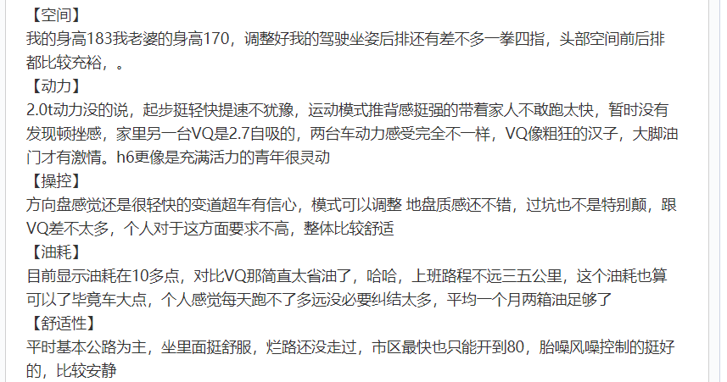
Figure 4-7 Example of online car reviews
After obtaining the online comment data set of various models, the program code for feature word extraction, feature word similarity calculation and text sentiment analysis model training is written based on the Python language to realize comment mining.
(1) TF-IDF Frequent Feature Word Extraction
It can be seen from the comment examples that automobile websites have set the user's comment form, that is, users need to evaluate the vehicle's cost-effectiveness, fuel consumption, space, comfort, handling, power, interior and appearance. Therefore, all the crawled comments are merged into eight long documents according to these eight topics, and the TF-IDF algorithm is used to extract frequent feature words. This method makes the frequency of feature words that truly represent product features and attributes more prominent in a document, and the TF value is larger. In addition, extracting feature words for different topics can more accurately determine the corresponding product feature items. IDF directly uses the IDF value that has been trained in a large-scale document set by the stuttering word segmentation tool. Finally, the 50 words with the largest TF-IDF value are extracted, and some results are shown in Table 4-3.
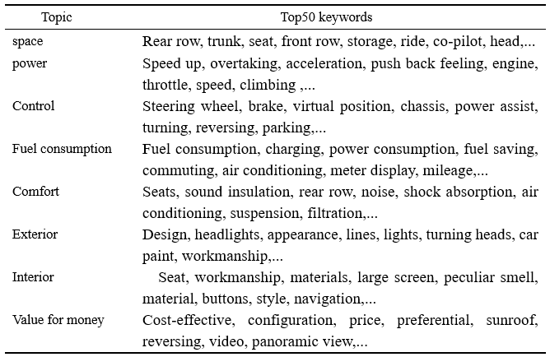
Table 4-3 Extraction results of frequent feature words
(2) Feature-opinion Word Pair Extraction
Follow the extraction rules and operation steps set in section 4.3.2 to extract feature-view word pairs. See Table 4-4 for examples of extraction results.
Table 4-4 Feature-Opinion Word Pair Extraction Results
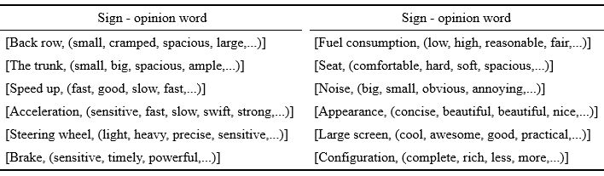
（3）Summary of Product Features
The frequent feature words extracted by TF-IDF are used as seed words, the similarity of each feature word in the seed word and feature-view word pairs is calculated, and the feature words and seed words whose similarity is greater than the threshold are classified into the same category. In addition, the similarities between various sub-words greater than the threshold are also classified into the same category. Through multiple adjustments to the threshold, it is found that when the threshold is 0.6, the classification effect is the best. After classification, the frequent feature items can be preliminarily determined by combining the opinion words corresponding to the feature words. The classification results of some feature words are shown in Table 4-5.
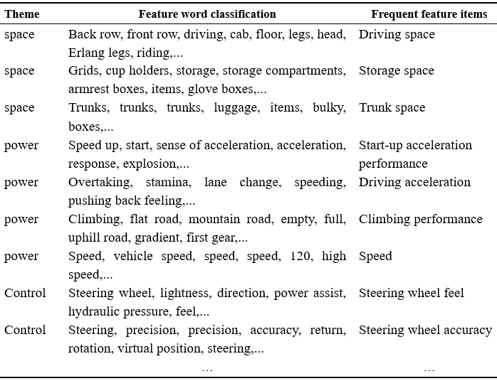
Table 4-5 Classification results of some feature words
Remove the above classified word pairs from all feature-view word pairs, manually filter the remaining few word pairs, and extract infrequent feature items. The final list of all product features is shown in Table 4-6, a total of 41 items.
Table 4-6 List of feature items of automotive products
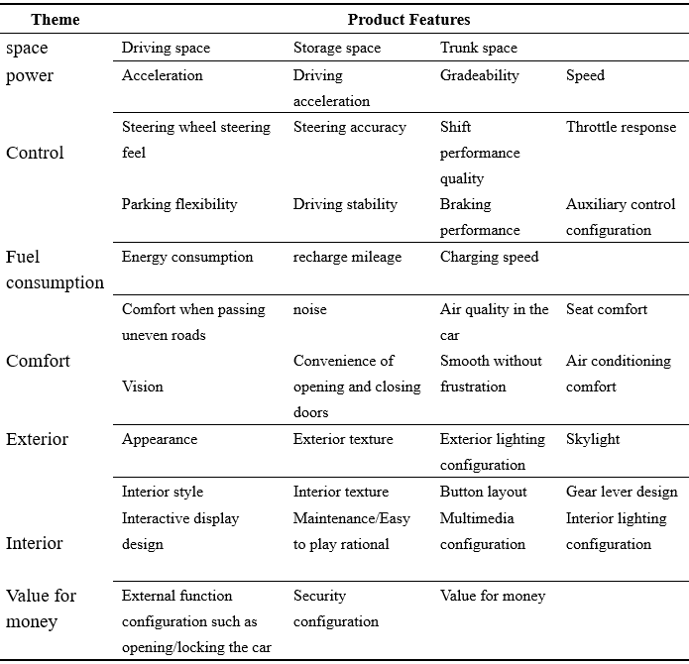

4.5.2 Sentiment Analysis
From all the car reviews crawled, 15462 review texts were randomly selected for emotional polarity labeling. Since a review may mention multiple product features that users pay attention to, the label for each product feature item is divided into four categories: positive, neutral, negative, and no mention, so as to determine whether the review text is mentioned. And a certain product feature item, and whether the emotional tendency toward the proposed product feature item is positive, neutral or negative. Take 13,000 items in the labeled data set as the training set and 2462 items as the test set. An example of comment text annotation data set is shown in Table 4-7.
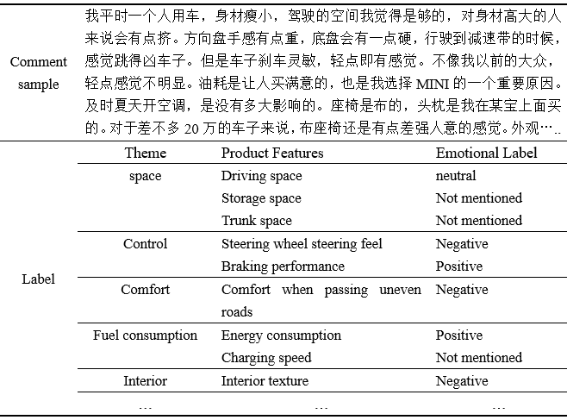
Table 4-7 Annotation sample of comment text data set
Use the BERT pre-training language model to fine-tune the text classification task on the labeled sentiment analysis training set. Since a comment will mention attitudes towards multiple different product features, in order to predict users’ sentimental tendencies towards different product features, a comment needs to be analyzed from 41 levels of sentiment, and 41 categories are constructed during the fine-tuning of the BERT pre-training parameters. In the first layer, emotion classification is performed on 41 product features, and the finally obtained car review text sentiment analysis model can predict whether the user mentions a feature and the emotional tendency of the feature from the perspective of 41 product features for a review.
Since text sentiment analysis is actually a text classification task, the commonly used model classification performance evaluation indicators are precision rate (Precision, Pr), recall rate (Recall, Re) and F1 value. The calculation formula is：
$$\left\{\begin{aligned}Re=\frac{TP}{TP+FN} \\ Pr=\frac{TP}{TP+FP} \\ F1=2×\frac{Re×Pr}{Re+Pr}\end{aligned} \text{(}\text{4}\text{-}\text{3}\text{)}\right.$$
In the formula, TP represents the number of samples that are actually positive and judged as positive; FN represents the number of samples that are actually positive but judged as negative; FP represents the number of samples that are actually negative but judged as positive Number. Because the precision rate and the recall rate are mutually restricted in some cases, and the F1 value is an evaluation index that can comprehensively reflect the precision rate and the recall rate, the F1 value is often used to evaluate the classification performance. The test results of the sentiment analysis model on the four types of sentiment labels for 41 product feature items are shown in Table 4-8.
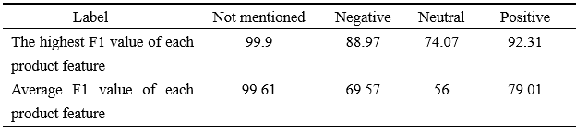
Table 4-8 Test results of sentiment classification model
It can be seen from the test results that the model has a better prediction effect for unmentioned and positive tags, while the neutral prediction effect is poor. Since the prediction effect of sentiment classification is closely related to the number of samples of various labels, within a certain scale, as the number of samples increases, the performance of the model will improve, and less sample data may not be enough to represent the problem. And we found through analysis: in a comment, users will only mention individual product features, a large number of product features are "not mentioned", and the number of "not mentioned" samples is the largest; in the comment data set, users are positive about product features There are also more comments on attitudes, and the user's expression of positive emotions is very clear and clear.
These reasons may cause the positive and unmentioned forecasting effect to be better. Neutral reviews have the smallest sample size, and because neutral emotions are not as strong as negative and positive emotions, users are more ambiguous when commenting, and their emotions themselves are more difficult to understand correctly. In addition, this research is conducting emotional polarity labeling. The user’s thoughts may not be understood correctly at the time, and there may be a mislabeling of neutral emotions. The neutral label, which has a small sample size, may also contain some samples that should be in other label categories, making the neutral label sample more confusing. These factors may cause the result of the poor prediction effect of the neutral evaluation.

Chapter 5 User Needs Analysis Method Based on Online Comments
After mining the online comment information, it is necessary to analyze the information and analyze the needs of users. User demand analysis generally includes user demand acquisition, user demand importance analysis and user demand transformation, so that under limited resource conditions, enterprises can fully consider the needs from the user's perspective, and transform them into reference and implementation in the actual product development process. The design language from the engineer's point of view truly realizes user-oriented product development and ensures that the actual product can meet user needs to the greatest extent.

5.1 Related Theoretical Methods and Improvements

5.1.1 IPA Analysis Method and Its Improvementation
The IPA analysis method was first proposed by Martilla et al. in the early 1980s and applied to the research of locomotive products [49]. The IPA analysis method is simple and practical, which helps to understand user satisfaction and clarify the priority areas for product or service improvement. For a specified product or service, IPA analysis scores the importance of each attribute feature and the performance (satisfaction) that the user actually feels, and uses the importance of each attribute feature as the abscissa, and the performance as the vertical axis. Coordinate drawing IPA analysis two-dimensional coordinate map, draw two intersecting straight lines based on the importance of all attribute features and the average value of performance data, and map each attribute feature to four areas, as shown in Figure 5-1.
Guadrant I
Guadrant II
Guadrant III
Guadrant IV
Performance

Importance
High
low
High
Figure 5-1 IPA analyzes two-dimensional coordinate diagrams
The attribute characteristics of the four regions in the figure have different characteristics. Quadrant I is called the continuation zone, and its internal attributes have higher importance and higher satisfaction in the minds of users. Quadrant II is called the over-performance zone. The attributes in this area are of lower importance, and their priority is lower than that of quadrant I. Quadrant III is called the lower value zone, where the importance and satisfaction of the attribute characteristics are low. If the company's resources are insufficient, you don't need to pay attention. Quadrant IV is called the key improvement area, in which the attribute characteristics are of high importance, but the actual satisfaction performance is low, and resources should be invested in key enhancements and improvements.
Although the classic IPA analysis is useful in evaluating the strengths and weaknesses of an object and clarifying the focus of improvement, it has a shortcoming, that is, it ignores the relative performance of the product or service compared to its competitors. The reality is that consumers will not evaluate a product in a non-competitive environment. On the contrary, the ultimate advantage or disadvantage of a product is determined by its performance relative to its competitors. Therefore, this research has made certain improvements to the classic IPA analysis, incorporating competitive factors into the IPA analysis: the vertical axis no longer uses the performance value of the company’s products, but the performance value of the company’s products compared with the products of several competing companies. The difference of the average performance value is the ordinate to draw the IPA analysis two-dimensional coordinate chart, and the ordinate of the area division datum line is changed to the straight line y=0. The ordinate is：
$$y_{i}=p_{si}-p_{ci} \text{(}\text{5}\text{-1)}$$
Where$y_{i}$is the ordinate corresponding to the i-th attribute feature in the two-dimensional coordinate graph, $p_{si}$ is the performance of the i-th attribute feature of the company’s product, and $p_{ci}$ is the average performance of the i-th attribute feature of all competing products.
It should be noted that the meaning of the four quadrants of the classic IPA analysis still applies to the improved IPA.

5.1.2 Quality Function Deployment Theory（QFD）
Quality function deployment is a product design and development method oriented to user needs. The whole process of product development always aims at demand and the market, so that the developed products can meet user needs to the greatest extent [50].
The QFD deployment model has undergone continuous development and improvement, including Akao model, GOAL/QPC model and ASI (American Supplier Institute) model [51]. Among them, the ASI mode is the most commonly used QFD implementation mode. It can well link product design and production control stages, adapt to the actual vehicle development process, and has been widely used in the automotive industry.
The ASI model divides the product development process into four connected processes: product planning, component development, process development and production planning. Starting from user needs, through four stages of waterfall-like matrix development, the product engineering technology is obtained in turn Characteristics, component characteristics, process characteristics and production requirements. The unfolding process is shown in Figure 5-2.
Figure 5-2 ASI expansion mode of QFD
In the process of quality function deployment, a series of two-dimensional matrices are needed to store information, and these two-dimensional matrices constitute the house of quality. Therefore, the house of quality is the basis for the implementation of QFD, which describes the process of user needs through a series of transformations and finally reflected in product design and production. Product planning The house of quality maps user needs to engineering technical characteristics, and is the most basic house of quality in the QFD system. The structure of the house of quality is not fixed, and can be appropriately improved or deleted according to the actual situation. The structure of a typical product plan of the house of quality is shown in Figure 5-3.
Figure 5-3 Typical structure of the product planning house of quality
①Left wall——WHATS input matrix. As the input of the House of Quality, it is composed of two parts: user needs and their importance, indicating "what" the user needs, and explaining the user's needs.
②Ceiling——HOWS matrix. The HOWS matrix is ​​represented by the characteristics of engineering technology, and its meaning is "how to do" to meet the input user needs. That is, to transform user needs into engineering measures or technical requirements that can be executed and measured.
③Room——Correlation matrix. The relationship matrix is ​​the main body of the House of Quality, which is used to indicate the degree of correlation between various user needs and engineering technical characteristics. The degree of correlation includes strong, normal, and weak, which can be represented by the marks ●, ◎, and ○ respectively. If it is not relevant, it is empty. The scale used when quantifying the correlation is 1-3-5 scale, 1-3-9 scale or other scales.
④ Roof——autocorrelation matrix. A certain engineering technical characteristic may be affected by another characteristic, so the roof is used to evaluate the autocorrelation relationship between the engineering technical characteristics.
⑤Right wall——evaluation of market competitiveness. The right wall is used to evaluate the market competitiveness and judge the competitiveness and feasibility of the product in the market. It analyzes user needs from the perspective of users, evaluates the demand satisfaction of the company's products and other companies' competitive products, analyzes the advantages and disadvantages, and sets the quality target value for demand improvement.
⑥Basement——output term matrix. It is used to express the importance of engineering technical characteristics, technical competitiveness analysis and target value of technical characteristics, etc. So far, the user needs and their importance from the user's perspective have been successfully transformed into the engineering technical characteristics and their importance from the engineer's perspective.

5.1.3 Improvement of Quality House Based on Fuzzy Set Theory
In the QFD analysis process, the determination of the house of quality relationship matrix is ​​artificially evaluated and judged, so there is a certain degree of ambiguity and uncertainty. For example, experts generally use " "Strong correlation", "weak correlation" and other evaluation language to express. In order to quantify the correlation, the traditional house of quality usually sets a precise number to replace these evaluation languages. The nature of language is vague, and precise digital scales cannot handle the vagueness of language well.
Fuzzy set theory emphasizes that people's analysis and understanding are very vague and imprecise. Therefore, things should be described with fuzzy logical concepts. It uses membership functions to express some uncertain or vague problems. Fuzzy set theory can well quantify the variables that are qualitatively represented by language and possess certain subjectivity and ambiguity.
In addition, the relationship matrix in the traditional house of quality is determined with 1-3-5, 1-3-9 and other multiple scales, which may lead to different ranking results of the importance of technical characteristics under different scales after calculation. . Some scholars have proved that using fuzzy numbers to quantify correlations can increase the stability of the importance of engineering technical characteristics [58]. Therefore, the fuzzy set theory can be used to improve the house of quality, and fuzzy numbers rather than precise values ​​can be used to quantify the correlation between user needs and engineering technical characteristics. Some related definitions will be explained below.
Definition 4.1: Any mapping $μ_{\tilde{A}}:X→\left[0,1\right]$ from the domain X to the closed interval of [0,1] determines a fuzzy set $\tilde{A}$ on X, denoted as $\tilde{A}=\left\{x,μ_{\tilde{A}}(x) | x∈X\right\}$, and $μ_{\tilde{A}}(x)$ represents the degree of membership of x to$\tilde{A}$.
Common membership functions include triangular membership functions, Gaussian membership functions and trapezoidal membership functions. Since triangular fuzzy numbers are easy to operate and widely used, this research is based on triangular fuzzy numbers to evaluate the correlation and algebraic operations. The triangle membership function graph is shown in Figure 4-4, and the membership function is shown in Equation 4-2.
Figure 5-4 Triangular membership function

$$μ_{\tilde{M}}\left(x\right)=\left\{\begin{aligned}\frac{x-l}{d-l} l≤x≤d \\ \frac{u-x}{u-d} d≤x≤u \\ 0 other\end{aligned} \text{(}\text{5}\text{-2)}\right.$$
A triangular fuzzy number is represented by $\tilde{M}(l,d,u)$, l and u represent the lower limit and upper limit of $\tilde{M}$. For two triangular fuzzy numbers ${\tilde{M}}_{1}(l_{1},d_{1},u_{1})$ and ${\tilde{M}}_{2}(l_{2},d_{2},u_{2})$, the calculation rule is：
$$\left\{\begin{aligned}\begin{aligned}{\tilde{M}}_{1}±{\tilde{M}}_{2}=\left(l_{1}±l_{2},d_{1}{±d}_{2},u_{1}±u_{2}\right) \\ λ{\tilde{M}}_{1}=(λl_{1},{λd}_{1},λu_{1}) \\ \frac{1}{{\tilde{M}}_{1}}≈(\frac{1}{l_{1}},\frac{1}{d_{1}},\frac{1}{u_{1}})\end{aligned} \\ {\tilde{M}}_{1}×{\tilde{M}}_{2}≈(l_{1}l_{2},d_{1}d_{2},u_{1}u_{2})\end{aligned} \text{(}\text{5}\text{-3)}\right.$$
Definition 5.2: Language variables. A language variable can be defined as a five-tuple: （x,T(x),U,G,$\tilde{M}$）. Where x is the variable name, T(x)is the set of language value names (word set of x), U is the domain of discourse, G is the language rule for generating the language value, and $\tilde{M}$ ̃ is the grammatical rule for determining the meaning of x.
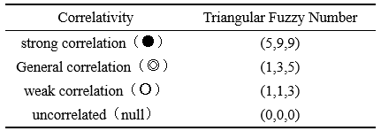
Each linguistic value of a linguistic variable corresponds to a fuzzy number defined in the universe U, and the quantification of qualitative expression can be realized through the vocabulary of the linguistic variable. The correlation relationship in the house of quality analysis is a linguistic variable, so the word set of the linguistic variable can be specified, and it corresponds to the fuzzy number one-to-one. That is, experts still use language terms such as "strong correlation" to evaluate the degree of relevance, but each evaluation result corresponds to a fuzzy number, and the fuzzy number is used to quantify the relationship between user needs and engineering technical characteristics. Correlation (strong correlation, general correlation, weak correlation and irrelevance) corresponding to the triangular fuzzy number [53] is shown in Table 5-1. Finally, the importance of engineering technical characteristics is determined by the operation of triangular fuzzy numbers. The specific calculation method will be discussed in section 5.4。
Table 5-1 Triangular fuzzy numbers related to requirements-engineering technical characteristics

5.2 User Needs Acquisition
User needs can be understood as what users expect from the product, including product functions, performance, and quality. Because users have these expectations for the product, they will pay attention to these specific product features when they enjoy the product. The online reviews posted by users precisely express the disappointment and surprise of the users with regard to the features of the products concerned, and fully reflect the needs of the users. Therefore, in order to solve the shortcomings of traditional demand analysis methods (user interviews, questionnaires, expert consultations, etc.) respondents are vulnerable to interference, small sample size, time-consuming, and geographical restrictions, user needs can be obtained from online comments. Since product features reflect user needs, and Chapter 4 has obtained comprehensive auto product feature items and corresponding opinion words from a large number of car online reviews, this research has condensed user needs items on this basis, and each of them corresponds to A product feature. See Table 5-2 for the requirements of automobile users.
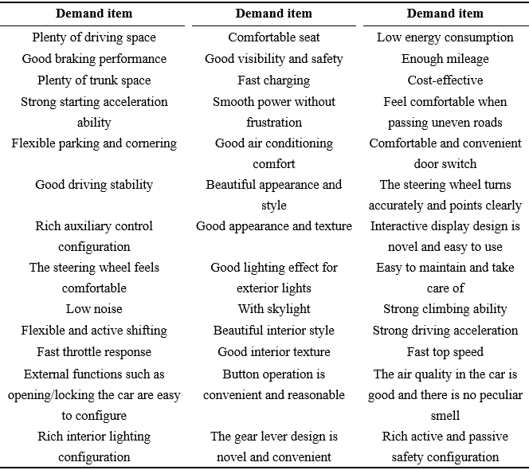
Table 5-2 List of automotive user requirements
In different product price ranges and different market segments, the product features and attention levels of users are not the same. Therefore, the demand acquisition method based on online reviews is: crawl all the online models of existing models in the target market segment Comments, using the sentiment analysis model of automobile product review texts trained in Chapter 4 to perform sentiment analysis on the crawled comments of specific market segments, you can get the user needs mentioned by consumers in that segment Satisfaction attitude of demand.

5.3 Analysis of User Needs Importance
There are differences in the importance of different user needs in the minds of consumers, and the importance of user needs is an important basis for enterprise product development, which helps to maximize the user satisfaction of the developed products. At present, in the analysis of the importance of user needs, the commonly used methods include analytic hierarchy process, Delphi method, Kano model, fuzzy Kano model and joint analysis, etc., but these methods generally rely on expert scores or scoring data obtained from questionnaire surveys and comparisons. Data, etc., are not directly applicable to the analysis of user needs based on online reviews. Therefore, it is necessary to propose a method for analyzing the importance of user needs driven by online reviews. Based on sentiment analysis of review texts, this study uses the results of sentiment tendency discrimination to calculate the basic importance of user needs. Then conduct market competitiveness assessment and IPA analysis to adjust the basic importance. That is, the analysis of the importance of user needs includes three parts: calculation of the basic importance of users, analysis of market competition, and adjustment of the importance of user needs.

5.3.1 Basic Importance Calculation of User Needs
Since the sentiment analysis model can identify whether a certain user need is mentioned in the review and the satisfaction attitude to the mentioned user need, based on the result of the sentiment analysis of the review text, the user needs attention can be calculated：
$$A_{i}=\frac{f_{gi}+f_{mi}+f_{bi}}{G} \text{(}\text{5}\text{-4)}$$
In the formula, A_{i} is the degree of attention of the ith user demand; f_{gi}，f_{mi} and f_{bi} respectively indicate the frequency of satisfaction, general, and dissatisfaction of the user’s satisfaction with the ith user demand in the comments; G is the frequency used for user demand analysis The total number of online comments in the segment.
User demand attention measures the degree of consumer attention to various user needs. The higher the degree of attention to a certain user demand, the more important the user needs, the higher the importance of the user demand. The more attention should be given to the development, so the attention of user needs is regarded as the basic importance of user needs.

5.3.3 Adjustment of User Needs Importance
In order to seize market opportunities, product development must focus on user needs with greater basic importance and a greater level of improvement. Therefore, it is necessary to calculate the level of improvement based on market competition analysis and revise the basic importance of user needs. The formula for calculating the level improvement rate and the importance of user needs is：
$$\left\{\begin{aligned}{IM}_{i}=\frac{S_{ti}}{S_{ci}} \\ {A_{i}}^{*}=A_{i}×{IM}_{i}\end{aligned} \text{(}\text{5}\text{-5)}\right.$$
In the formula, ${IM}_{i}$ is the level improvement rate of the ith user demand, $S_{ti}$ is the target satisfaction of the ith user demand, $S_{ci}$ is the current satisfaction degree of the ith user demand of the enterprise product, and A_{i} is the ith user Demand attention degree, ${A_{i}}^{*}$ is the revised importance degree of user demand for the i-th item. The relative weights of the revised m user requirements are:
$$w_{i}=\frac{{A_{i}}^{*}}{\sum_{i=1}^{m}{{A_{i}}^{*}}} \text{(}\text{5}\text{-6)}$$

5.4 User Demand Conversion
Use fuzzy correlation coefficients to improve the house of quality, and realize the transformation of user needs into engineering technical characteristics by building an improved product planning house of quality. Since this study has considered market competitiveness evaluation when calculating the importance of user needs, the final process of building a house of quality and transforming user needs is as follows:
① Determine user needs and the relative weight of user needs from Sections 5.2 and 5.3, and form an expanded table of user needs.
②Determination of engineering technical characteristics. Convene technical experts, develop a table based on user needs, combine the analysis of automotive industry product technical data, product feature catalogs and automotive theoretical knowledge, and collect executable and quantifiable key engineering technical characteristics related to requirements through brainstorming methods to form a project Expanded table of technical characteristics.
③Correlation matrix evaluation. Convene an expert group to evaluate the correlation between each user requirement CN_{i}(i=1,2,…,m) and engineering technical characteristics EC_{j}(j=1,2,…,n), and use triangular fuzzy to quantify the evaluation results . Regarding the weight of each expert as consistent, the final fuzzy correlation coefficient is:：
$${\tilde{r}}_{ij}=\frac{\sum_{z=1}^{t}{{\tilde{r}}_{zij}}}{t} \text{(}\text{5}\text{-7)}$$
Where ${\tilde{r}}_{zij}$ is the fuzzy number corresponding to the evaluation result of the z-th expert on the correlation between the i-th user demand and the j-th engineering technical characteristic, and ${\tilde{r}}_{zij}$is the average value of the fuzzy number of the evaluation results of t experts.
④Evaluation of the importance of engineering technical characteristics. The importance of engineering technical characteristics can be calculated using the independent collocation method combined with the correlation matrix. The independent collocation method matrix is shown in Table 5-3.
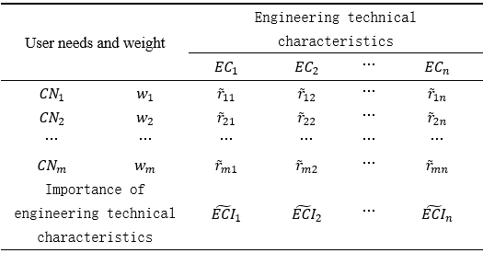
Table 5-3 Independent collocation method matrix
Calculation formula of independent collocation method:
$$\tilde{{ECI}_{j}}=\sum_{i=1}^{m}{w_{i}×{\tilde{r}}_{ij}} \text{(}\text{5}\text{-8)}$$
In the formula: $\tilde{{ECI}_{j}}$ is the importance of the j-th engineering technical feature, $w_{i}$ is the weight of the i-th user demand, and ${\tilde{r}}_{ij}$ is the fuzzy number corresponding to the relationship between the user demand and the engineering technical characteristic.
$\tilde{{ECI}_{j}}$is a fuzzy number. If you want to get a specific importance value, you need to use the weighted average method for defuzzification [53]:
$${ECI}_{j}=\frac{(l_{{\tilde{ECI}}_{j}}+2d_{{\tilde{ECI}}_{j}}+u_{{\tilde{ECI}}_{j}})}{4} \text{(}\text{5}\text{-9)}$$
In the formula: ${ECI}_{j}$ is the defuzzification result of the engineering technical characteristics, $l_{{\tilde{ECI}}_{j}}$, $d_{{\tilde{ECI}}_{j}}$and$u_{{\tilde{ECI}}_{j}}$are the low, median and high values of the triangular fuzzy number E, respectively.
At this point, the user needs and their importance from online reviews are transformed into engineering technical features and their importance, so that user needs can truly be integrated into the design and development of the product.

5.5 Application of User Needs Analysis Method
This section will take the user demand analysis of micro electric vehicle product planning as an example to verify the feasibility of the user demand analysis method based on online reviews proposed in this chapter.

5.5.1 Vehicle Positioning
Micro-electric vehicles have the advantages of low pollution, convenient travel and low cost, making them very convenient for daily commuting. In today's travel environment with traffic jams and difficult parking, the huge market demand for this practical and convenient transportation tool has been verified. Therefore, the development and promotion of micro-electric vehicles are in line with my country's national conditions and market trends. The model positioning is as follows: positioning in the micro pure electric vehicle segment with a price of 50,000 to 80,000 yuan; the target customer group is the young user group pursuing individuality, technology and intelligence in the first and second tier cities; striving to use intelligence, The features of science fiction and safety define the new mode of urban travel.

5.5.2 User Demand Acquisition and Importance Calculation
"Auto home" is an auto website with complete information, rapid update, large number of users and complete classification in China. Therefore, the "octopus collector" is used to climb the online comments of micro pure electric vehicles with 50000 ~ 80000 yuan in the current market from the word-of-mouth page of "auto home", and finally climb Baojun E100, Baojun E200, Euler R1, Benben EV A total of 1566 online comments on micro pure electric vehicles such as BYD E1 and Chery EQ1 constitute a text collection for user demand analysis in target market segments.
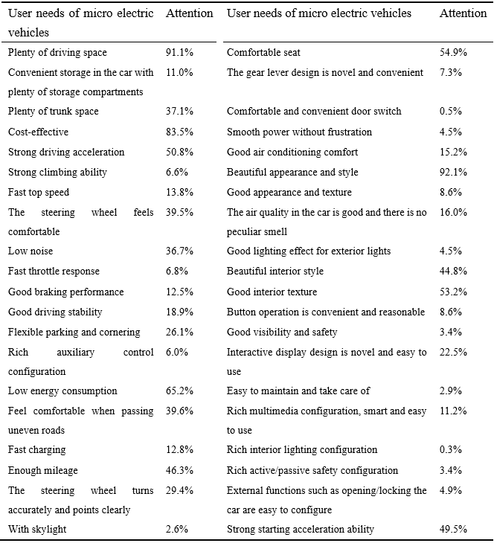
Firstly, preprocess the above comment text set, remove the empty lines in the comment text set, and only retain Chinese, English and numbers. Then, use the emotion analysis model of automobile comment text trained in Chapter 3 to judge the emotional tendency in the preprocessed text set, and obtain the user needs mentioned in the comment text set and the user's satisfaction with the needs. According to the statistics of emotion analysis results, there are 40 user needs mentioned in this market segment. The attention of each user demand calculated by equation 5-4 is shown in table 5-4.
Table 5-4 Attention to user demand of micro electric vehicles
Select two models with better performance in the market as competitive products for market competition analysis, calculate the user demand satisfaction of the company's products (a) and competitive products (B and C) respectively, and draw the two-dimensional coordinate diagram of improved IPA analysis. The results are shown in Figure 5-5.
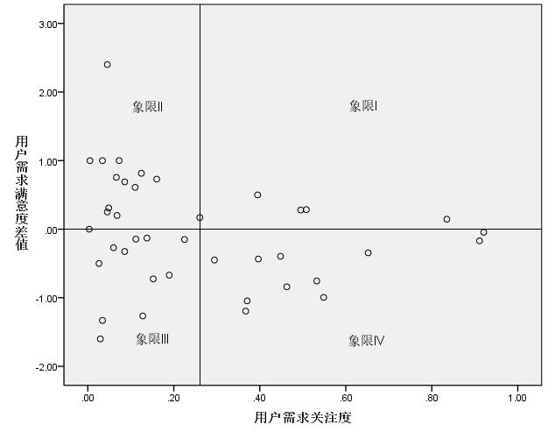
Fig. 5-5 Two dimensional coordinate diagram of IPA analysis of micro electric vehicle
The user needs in quadrant I include comfortable steering feel, strong starting acceleration ability, strong driving acceleration ability and high cost performance. These demands are highly concerned by users, and our products perform better than other products, which is the advantage. The user requirements in quadrant II include comfortable and convenient door opening and closing, good field of vision, smooth power without frustration, good lighting effect of exterior lamps, easy configuration of external functions such as opening / locking the car, strong climbing ability, rapid throttle response, novel and convenient gear lever design, convenient and reasonable key operation, sufficient storage space, good braking performance, good air quality in the car, no odor and flexible parking and turning. The attention to these needs is not high, and the enterprise's products have better met these needs. If the resources are not sufficient, there is no need to improve them. The user requirements in quadrant III include skylight configuration, easy maintenance and care, rich active and passive safety configuration, rich auxiliary control configuration, good appearance texture, rich multimedia configuration, fast charging speed, high maximum speed, good air conditioning comfort, good driving stability and novel and easy to use interactive display design. These demands have low attention, and the performance of our products is not as good as that of competitive products. If we can make corresponding improvement, there may be some opportunities, but if the resources are insufficient, we don't need to pay attention. The user needs in quadrant IV include accurate steering, low noise, sufficient boot space, comfort when passing through uneven roads, beautiful interior design style, sufficient mileage, good interior texture, comfortable seats, low energy consumption, sufficient driving space and beautiful appearance. This kind of demand has a high degree of attention, but the product performance of the enterprise is not as good as that of competitive products. Therefore, we should focus on improvement and vigorously invest resources for improvement. According to the characteristics of each user demand quadrant, set the user demand target satisfaction, calculate the improvement rate of user demand level and correct the importance of user demand according to equation 5-5. See table 5-5 for an example of the process.

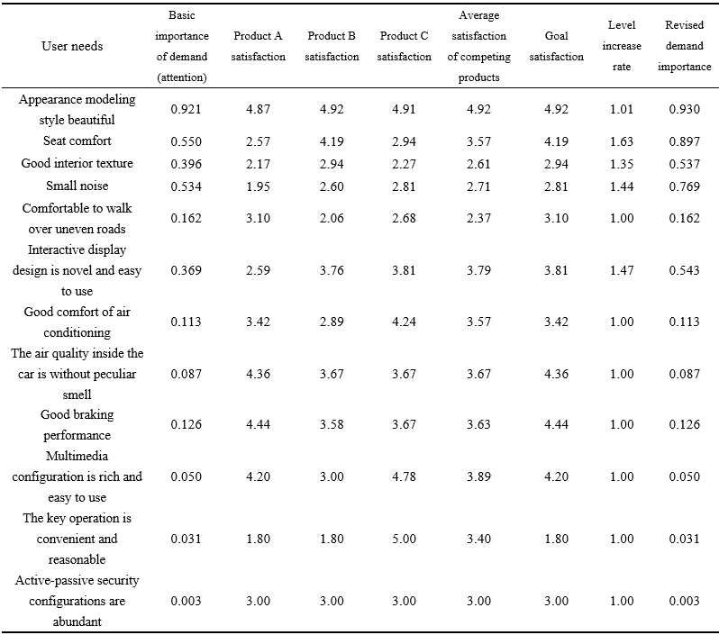
Table 5-5 Example of market competition analysis and user demand importance correction
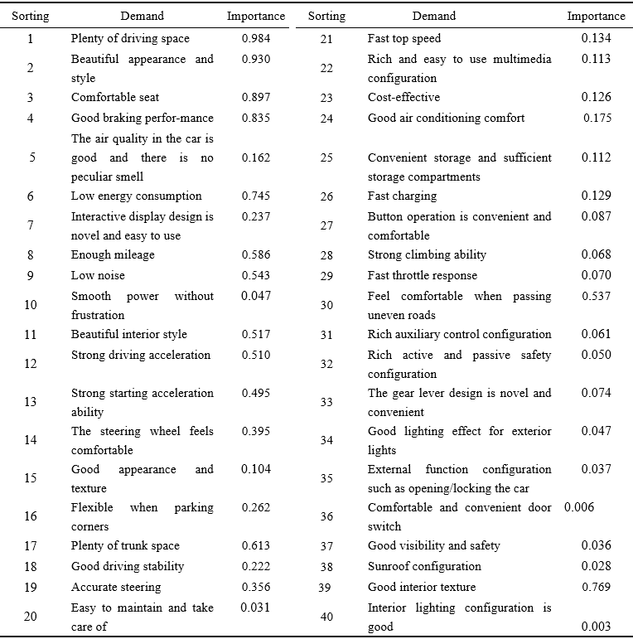
See table 5-6 for the order of user demand importance from high to low after correction.

5.5.3 User Demand Conversion
Through the study and research of existing technical data and product data, the brainstorming method is used to determine the expansion table of engineering and technical characteristics related to various user needs, and build the house of quality of product planning. Due to space constraints, only some user requirements and corresponding engineering and technical characteristics are selected here to build the house of quality: normalize the importance of the selected user requirements and calculate the relative weight W of the requirements_ I left wall as house of quality; Select engineering and technical characteristics related to user requirements; The two personnel respectively evaluate the correlation between user requirements and engineering technical characteristics, quantify it with the fuzzy triangle number in Table 5-1, calculate the average value of the two people, and construct the fuzzy correlation matrix; Use formula 5-8 to calculate the importance of engineering technical characteristics, and use formula 5-9 to clarify in order to obtain a clear expression of the importance of engineering technical characteristics. See table 5-7 for the transformation process of user requirements.
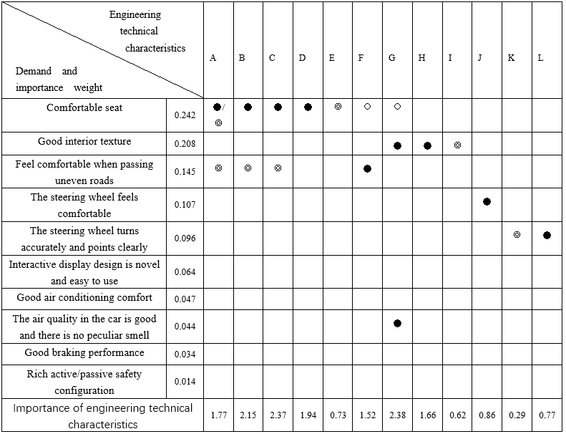
Table 5-7 example of user demand transformation
A: Person-seat system parameters
B: Seat wrapping
C: Seat padding
D: Adjustable seat
E: Seat function configuration
F: Vibration isolation characteristics on uneven roads
G: Interior material
H: Interior surface treatment process
I: Interior structural quality
J: Steering wheel force characteristics
K: Turn back to normal performance
L: Steering response sensitivity
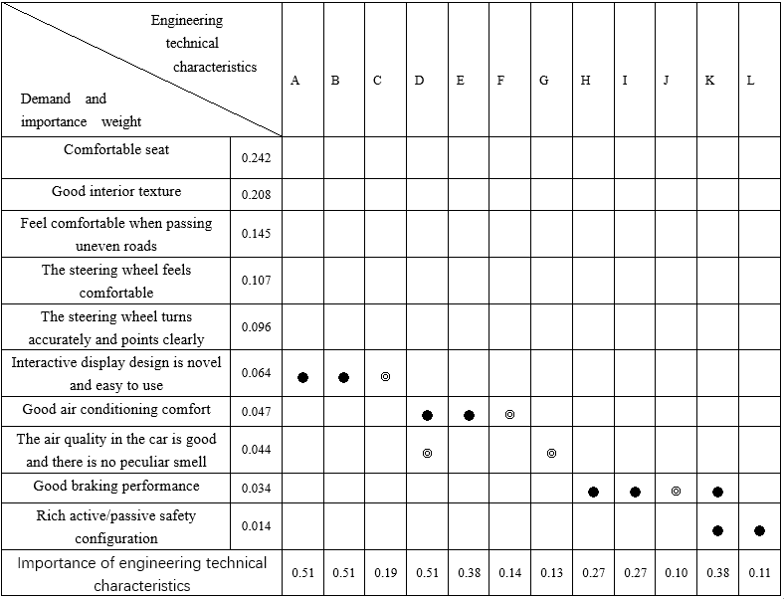
Continued table 5-7
The product planning house of quality in table 5-7 transforms the user demand and the importance of user demand into its related engineering and technical characteristics and importance. The engineering and technical characteristics are ranked from high to low in order of importance: interior material, seat filling, seat wrapping, seat adjustable direction, human seat system parameters, interior surface treatment process, vibration isolation characteristics on uneven roads Steering wheel force characteristics, steering response sensitivity, seat function, interior structure quality, central control color LCD screen, instrument information display mode configuration, air volume of air conditioning system, ABS / ESP and other brake related safety configuration, air conditioning refrigeration and heating efficiency, steering return performance, braking distance, braking stability, diversity and readability of instrument information, air conditioning temperature regulation configuration Air purification device, other safety configuration and braking feeling.

Chapter 6 Concept Definition Method of Automobile Product Configuration
In the previous chapter, the user requirements from online comments have been mapped into engineering technical characteristics and their importance through the house of quality. Based on the house of quality mapping in the previous chapter, this chapter will study the decision-making part of the house of quality of product planning, and finally generate the automobile product concept defined by the target value of engineering technical characteristics.

6.1 Overview of Relevant Theories

6.1.1 Product Life Cycle Theory
According to the product life cycle (PLC) theory, a product will go through four different but predictable stages in its life course: introduction, growth, maturity and decline. When the product enters the market, the cycle begins until the product exits the market, and the cycle ends. Each stage has different characteristics.
Introduction period: the introduction period begins with the completion of product design and development and entry into the market.
Growth period: through the product marketing and advertising investment during the introduction period, customers have improved their understanding of the product and gradually accepted the product. Therefore, after a certain sales success during the introduction period, they enter the growth period.
Mature period: the product sales volume is increasing, the enterprise has mass production capacity, and the production cost is further reduced.
Recession: refers to the stage when products enter the market and are eliminated.
Each stage of product life cycle has different characteristics. Based on this, enterprises can accurately analyze the development characteristics and stage of products, predict their development trend, and then formulate reasonable development and marketing strategies, so as to improve the competitiveness of products.

6.1.2 Value Engineering Theory
Value Engineering (VE) theory originated from L.D. miles, an American General Electric Engineer. It is a method that comprehensively considers function and cost and can systematically analyze technology and economy at the same time. VE theory includes three elements: function, cost and value.
"Function" can be understood as the performance and purpose of the research object. Miles believes that function is a feature to meet the needs of users.
"Cost" refers to the life cycle expenses that must be paid to meet a function, including the expenses incurred in the whole process of product research, formation and withdrawal.
"Value" is the ratio of the function of the product to the total cost of realizing the function, that is, value = function / cost.

6.1.3 Cluster Analysis
Cluster analysis is a widely used data mining technology, which can realize data classification according to the similarity of samples, intuitively reflect the relationship between samples and categories, and mine the key information contained in data. At present, there are various clustering analysis technologies based on partition, model and entropy, as well as spectral clustering and uncertain clustering [54]. K-means algorithm based on partition is an unsupervised, practical, simple and efficient method, which is widely used in commercial and industrial fields. Therefore, k-means method is used for clustering in this paper.
The core of K-means algorithm is to take the distance as the similarity evaluation basis for a given sample set, and divide it into a specified number of clusters through iteration, so that the samples in the same cluster have high similarity (close distance), the samples in different clusters have low similarity (far distance), and there are great differences between clusters [55]. K-means algorithm first needs to determine the number k of clusters and specify K initial cluster centroids; Then, the distance between each data point and each centroid is calculated, and the data point and the nearest centroid are divided into a cluster; Then calculate the sample mean in each cluster, get a new cluster centroid and re divide it; After several iterations, the cluster centroid is continuously updated until the centroid before and after the iteration is consistent, the clustering is completed, and the sample data is divided into k categories. The distance between each data is Euclidean distance, and the Euclidean distance between sample point $x=(x_{1},x_{2},…,x_{q})$ and sample point $y=\left(y_{1},y_{2},…,y_{q}\right)$ is：
$$d\left(x,y\right)=\sqrt{\sum_{i=1}^{q}{{\left(x_{i}-y_{i}\right)}^{2}}} \text{(}\text{6}\text{-}\text{1}\text{)}$$
After clustering, the final clustering centroid of each category can reflect the attributes of each category. By comparing and analyzing the clustering centroid of each category, we can judge the information and significance contained therein [56].

6.4 Functional Characteristics Target Value Setting
The target value of functional characteristics is set as "equipped" or "not equipped" for a certain vehicle configuration. Here, we introduce the life cycle theory to judge the life cycle stage of each vehicle configuration, and give different configuration strategies according to the different stages of vehicle configuration products.

6.4.1 Life Cycle Analysis of Automobile Configuration Products
If the vehicle configuration is taken as the research object, the vehicle configuration products in different product life cycle stages have different characteristics. Therefore, according to the allocation rate of automobile configuration products in different price ranges, analyze their life cycle stage and predict the development trend of automobile configuration products.
The introduction period is the stage when automobile configuration products have just entered the market. The product has high technical content, imperfect production conditions, high price and few competitors of similar products in the market. In view of the cost and technical constraints, the vehicle configuration in the introduction period should appear on the high-end models with higher prices, but rarely or not on the medium and low-end models.
The car configuration products in the growth period will spread from the high-end models in the introduction period to the medium and low-end models, and their configuration will be distributed in most price ranges. However, since the car configuration in this stage gradually spreads from the high-end to the medium and low-end, the configuration rate of the car configuration products in each price range in the growth period should decrease with the decrease of the model price.
In the mature period, the product performance has been improved, the standard quality level has been formed, the market demand tends to be saturated, the output is large, the cost is low, and the cost and technical restrictions basically disappear. Therefore, the models in each price range will be equipped. Therefore, the mature vehicle configuration should be the configuration that has been popularized among the models in all price ranges.
Due to the continuous progress of scientific and technological level and the upgrading of user demand level, automobile configuration products in the recession will no longer adapt to the current consumer market. Automobile enterprises will adopt other configuration products that can better meet user needs. Therefore, automobile configuration in the recession will eventually be eliminated by the market.
In addition, combined with the characteristics of each life cycle stage and Herzberg's two factor theory, it can be concluded that the configured products in mature stage belong to health factors and the configured products in growth stage belong to incentive factors [57]. If the health care factors are satisfied, they will not make users satisfied, but if they are not satisfied, they will cause strong dissatisfaction; Incentive factors are factors that can bring satisfaction to users. Therefore, if the vehicle model is equipped with mature configuration that has been popularized in the automobile market, it will not necessarily make users satisfied, but if it is not equipped, it will cause users' dissatisfaction; If equipped with long-term configuration, it can bring satisfaction to users, which is the main means to improve product competitiveness.

6.4.2 Automobile Configuration Product Life Cycle Judgment Based on Cluster Analysis
In order to determine the life cycle stage of each vehicle configuration, this study crawls the configuration data of passenger vehicle models on sale in the market in December 2020, divides the models into different price ranges according to the price, and counts the allocation rate of each vehicle configuration in each range. According to the analysis in the previous section, the distribution of vehicle configuration in each price range should show a certain law. The configuration in the same stage has similar characteristics, and there are some differences in the configuration in different stages. Therefore, in order to verify the above analysis and classify the vehicle configuration according to the life cycle stage, this study takes the allocation rate data of vehicle configuration products in the price range of each vehicle model as the sample, and uses the K-means clustering method to realize the clustering of vehicle configuration with similar distribution law.
Since the end result of automobile configuration products in the recession period is to be eliminated by the market, and the configuration disappears on the vehicle model, set the clustering number k = 3, cluster the sample set of allocation rate of various automobile configurations in each price range by using SPSS software, and finally divide all automobile configurations into three categories. In order to observe the distribution characteristics of each type of configuration, verify the distribution law of automobile configuration products at each stage analyzed in the previous section, and draw the distribution diagram of three types of configuration, as shown in Figure 6-2.
It can be seen from figure 6-2 that the first type of configuration obtained through cluster analysis has a certain allocation rate on models in each price range, and the allocation rate increases with the increase of model price. The second type of configuration has been popularized in the models, and the models in each section are equipped on a large scale, and the allocation rate is close to 100%. The third type of configuration is rarely equipped in medium and low-end models, generally less than 20%. Although it is equipped in high-end models, the allocation rate is not high, which is in line with the distribution characteristics of configuration in the introduction period.

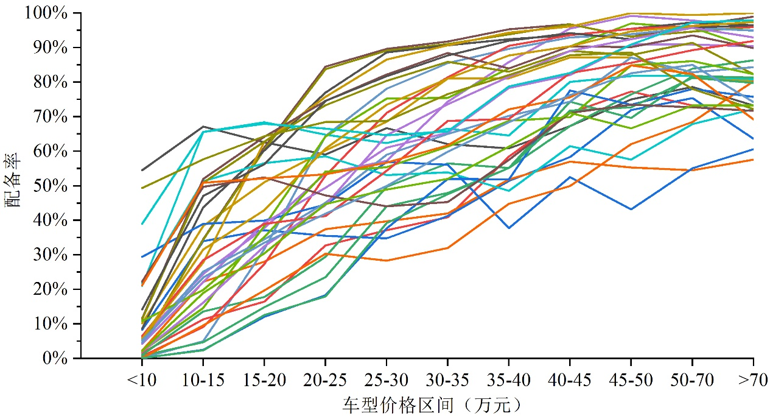
Figure 6-2 (a) Type I configuration distribution
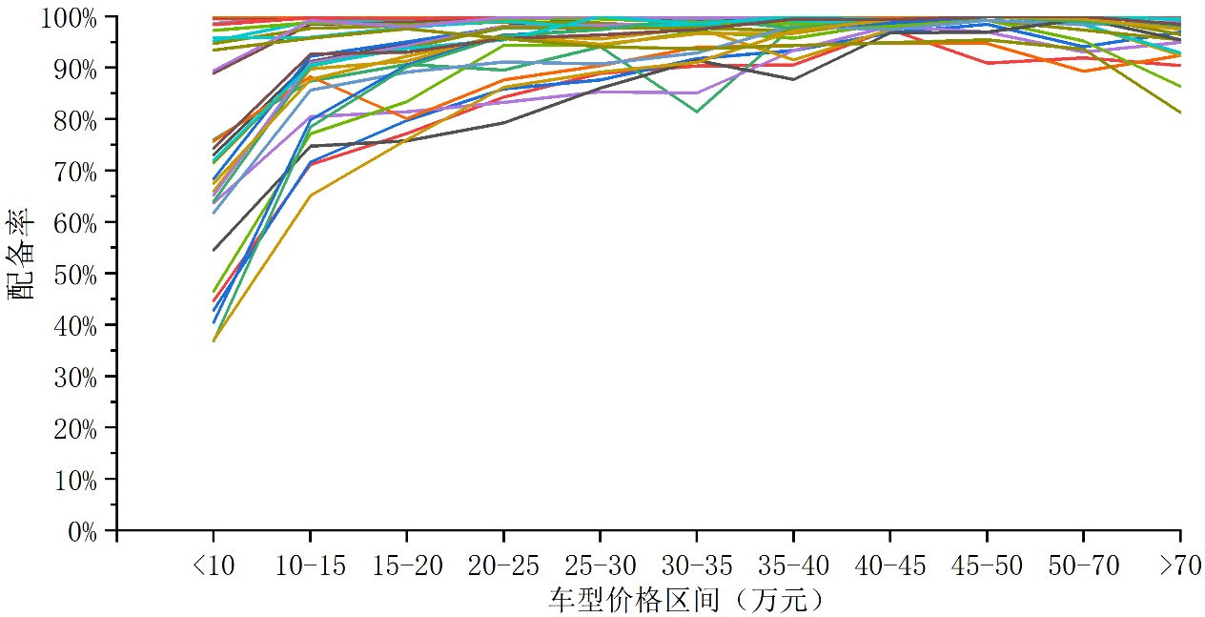
Figure 6-2 (b) Type II configuration distribution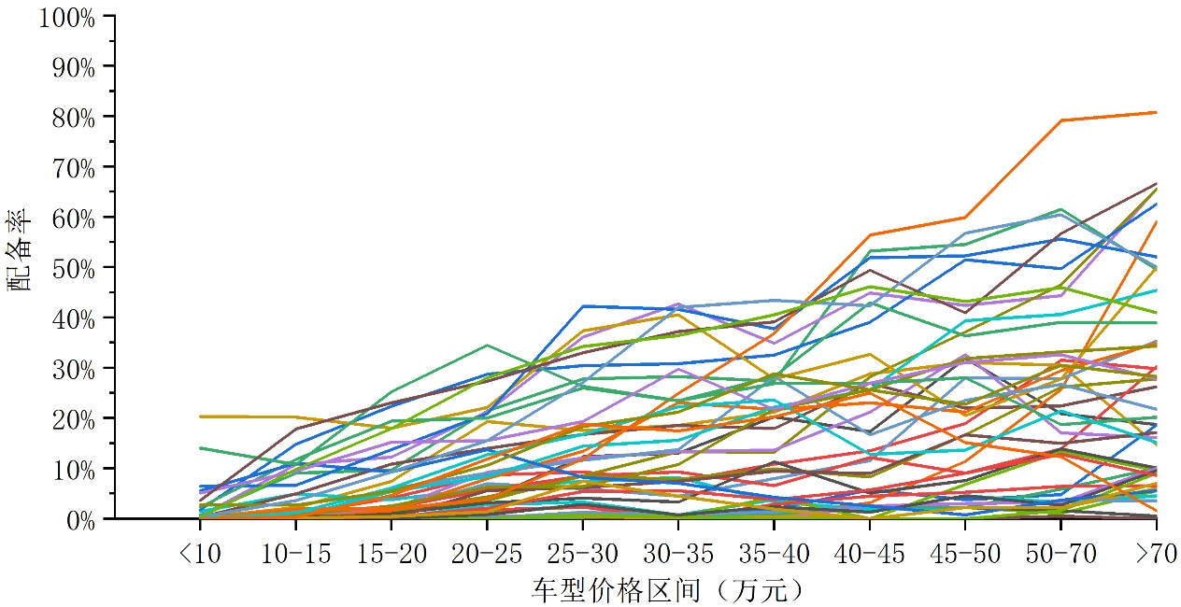
Figure 6-2 (c) Type III configuration distribution
Because the clustering centroid is the mean value of each category of sample data, it can characterize the characteristics of this category to a certain extent. Therefore, the characteristics of vehicle configurations in these three categories can be analyzed by clustering centroid. The final clustering centroid is shown in table 6-1.
Table 5-1 Final cluster center
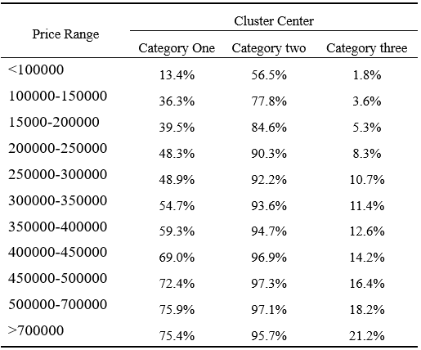
It can be seen from table 6-1 that the data of the cluster center is consistent with the above analysis, which further verifies the distribution law of the life cycle of automobile configuration products. Therefore, the automobile configuration products are divided into three categories by cluster analysis: growth period, maturity period and introduction period. See table 6-2 for vehicle configuration names at each life cycle stage.

Table 6-2 division of life cycle stages of vehicle configuration
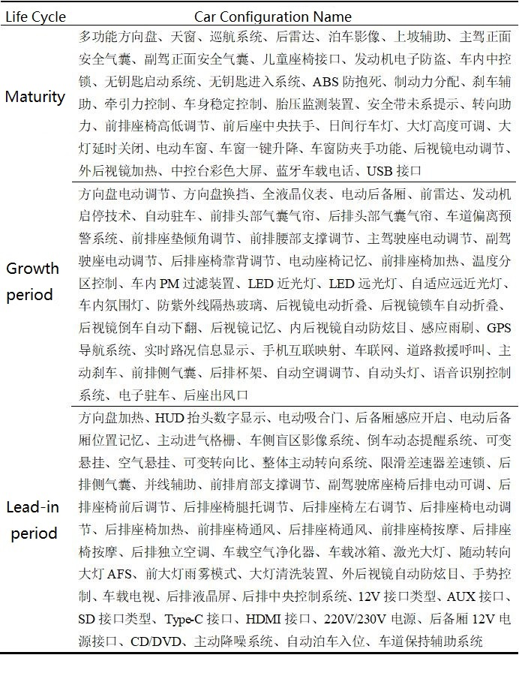

6.4.3 Setting Strategy of Function Characteristic Target Value
The target value of the functional characteristics is whether the corresponding vehicle configuration is equipped. The target value setting of functional characteristics has different allocation strategies according to the different life cycle stages of corresponding vehicle configurations：
①Mature period: take the car configuration in the mature period as the basic configuration, that is, the car configuration that must be equipped. If it is not equipped, it will cause customer dissatisfaction.
② Growth period: take the car configuration in the growth period as an optional configuration, which needs to be comprehensively evaluated by value engineering in combination with the importance and cost of the configuration. The calculation formula is as follows:：
$${ECI}_{j}^{*}={ECI}_{j}×{COM}_{j} \text{(}\text{6}\text{-}\text{2}\text{)}$$
Where ECI_{j}* is the adjusted importance of the j-th car configuration, ECI_{j} is the importance of the j-th car configuration output by the House of Quality, and COM_{j} is the competition coefficient of the j-th car configuration.
After adjusting the importance of car configuration, for car configuration with high importance and value coefficient V> 1, the equipment can be determined; in other cases, the configuration can be ranked according to the value coefficient, and the overall cost of the model can be evaluated according to the model. Differentiate selection of high, medium and low configurations. The value coefficient calculation formula is as follows.
$$\left\{\begin{aligned}{FI}_{j}={{ECI}_{j}^{*}}/{\sum_{j=1}^{p}{{ECI}_{j}^{*}}} \\ {CI}_{j}={C_{j}}/{\sum_{j=1}^{p}{C_{j}}} \\ V_{j}={{FI}_{j}}/{{CI}_{j}}\end{aligned} \text{(}\text{6}\text{-}\text{3}\text{)}\right.$$
Where FI_{j} is the functional coefficient of the jth configuration, CI_{j} is the cost coefficient of the jth configuration, and C_{j} is the cost of the j-th configuration. V_{j} is the value coefficient of the j-th configuration.
③Import period: the vehicle configuration can be selected as the highlight configuration during the import period. The enterprise decides whether to equip it according to the cost, product positioning, selling points, importance of functional characteristics and its own actual technical level.

6.5 Setting Application of Function Characteristic Target Value
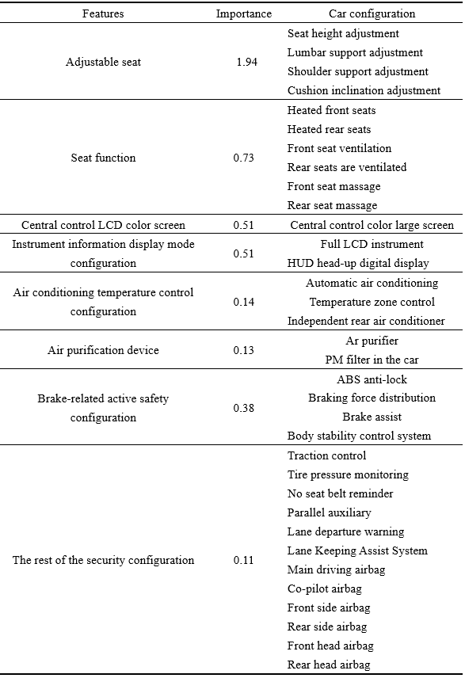
The setting of functional characteristic target value is to confirm whether corresponding vehicle configuration products are equipped. See table 6-4 for the functional characteristics of the output of the house of quality and its corresponding vehicle configuration and importance。
Table 6-4 Function characteristics and importance of corresponding car configuration
Then, according to the deployment strategy of the mature period, the growth period and the introduction period, determine whether the developed micro-electric vehicle should be equipped with the above configuration.：
- Maturity. Match the various configurations in Table 6-4 with the life cycle stages of Table 6-2, and select the mature stage configurations and equip them in this mini-car development.
- Growth period. The growth period configuration in Table 6-4 is selected, and the growth period configuration is calculated for the deployment rate of micro-electric vehicle models that perform well in the market, and this is used as a competition coefficient to adjust the importance of car configuration, and according to formula 6 4 Calculate the function coefficient, cost coefficient and value coefficient of each configuration respectively. Since I cannot get the exact cost of various configurations, I use the optional cost of the configuration to calculate the cost coefficient. The selected growth period configuration value engineering analysis is shown in Table 6-5.
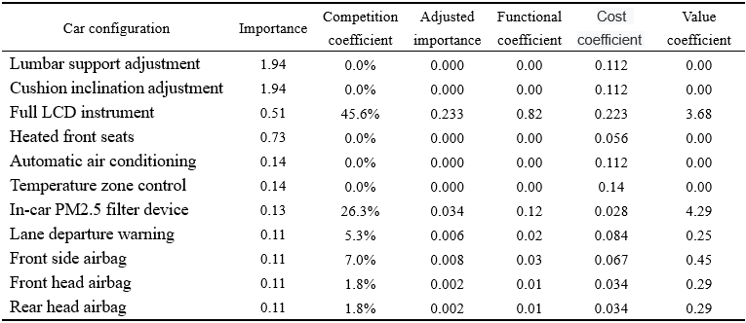
Table 6-5 Analysis of configuration value engineering during growth period
It can be seen from table 6-5 that the value coefficient of all liquid crystal instrument and PM2.5 filter device in the vehicle is greater than 1, indicating that more important functions can be realized at a lower cost. Therefore, these two configurations should be equipped in the developed micro electric vehicle. Lane departure warning is an intelligent auxiliary system for driving safety, which can improve safety and intelligence. Therefore, lane departure warning is selected to be equipped in high configuration models, so as to attract customers with higher requirements for active safety.
- Import period. Select the configuration of import period from table 6-4, and select the highlight configuration in combination with product positioning. As the development cost of this micro electric vehicle is greatly limited, only high configuration vehicles are equipped with lane keeping assist system as a highlight configuration.
After the above analysis, the final allocation decision of vehicle configuration in table 6-4 is shown in table 6-6.
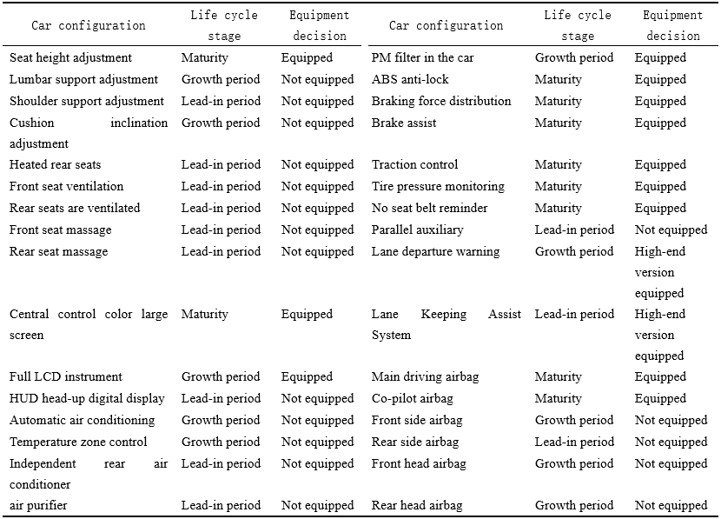
Table 6-6 allocation decision
The vehicle product concept defined by the characteristic target value and the vehicle configuration list can be obtained, and the configuration planning of a single vehicle model is completed.

CHAPTER 7: CONCLUSIONS
In order to adapt to the information age and the highly competitive market environment, this study constructs a product planning method that can quickly and objectively analyze user needs through text mining technology and put forward specific suggestions for vehicle development, so that user needs can really act on the subsequent vehicle design and development. The main research results are as follows：
（1）By combing the characteristics of online review of automotive products, mainly focusing on the technical definition of single model products, an automotive product planning model based on online review is constructed. The model mainly includes three stages: Emotional Analysis of review text, demand analysis and definition of product configuration concept.
(2) The feature word extraction rules based on dependency syntax analysis are set up, and combined with TF-IDF algorithm to extract product feature words from automobile online comments. Word2vec is used to calculate the similarity of feature words, classify similar feature words into the same product feature items, and finally summarize a more comprehensive list of user demand items; Using the Bert pre training model to fine tune the emotional tendency annotation set of automobile comment text, a comment text emotion analysis model for automobile users' needs is obtained.
(3) A user demand analysis method based on automobile online comments is proposed. In this method, the text emotion analysis model is used to process the online comments of target market segments, and obtain the user demand item and the emotional tendency to the demand item; Calculate the user demand attention and user demand satisfaction according to the emotion analysis results, evaluate the market competitiveness in combination with the improved IPA analysis, and complete the calculation of the importance of user demand; The fuzzy correlation coefficient is used to replace the accurate digital scale to quantify the correlation between user needs and engineering technical characteristics, build a house of quality for product planning, and transform user needs and the importance of user needs into engineering technical characteristics and the importance of engineering technical characteristics.
(4) The concept definition model of automobile product configuration is constructed. The concept of automobile product configuration is defined by the target value of engineering technical characteristics. According to the functional characteristics, this study counts the allocation rate of vehicle configuration products on passenger cars in each price range, judges the life cycle stage of each configuration through cluster analysis, and sets different allocation strategies for the vehicle configuration corresponding to the functional characteristics according to the different stages.

CHAPTER 8: Reflection and Recommendations

8.1 Reflection
The purpose of writing this paper is to apply the knowledge and methods learned in this year to the field of vehicle engineering after learning the courses of data science and analysis, because I studied vehicle engineering for my master's degree in China.
We all know that the traditional automobile product planning process usually uses structured questionnaires and expert interviews for demand analysis. Factors such as questionnaire design, data acquisition and respondents' willingness to participate make the demand analysis process have problems such as limited sample coverage, long cycle, high cost, low efficiency and high degree of manual intervention, Online comments come from users' real, objective and directly accessible data.
Therefore, this study considers how to use big data or artificial intelligence technologies such as natural language processing, text mining and in-depth learning to mine useful information from a large number of online comment texts for user demand analysis and product planning of automotive products, which needs further exploration.
In the process of writing this article, I learned a lot of knowledge and methods, such as text mining, emotion analysis, IPA, QFD, etc. of course, I also encountered many difficulties and troubles. By overcoming difficulties, I successfully applied the methods and technologies learned in this year to the field of vehicle engineering. I have only studied data science and analysis for one year. The methods and technologies used in this paper are relatively simple and rough in many aspects, but I believe that with my continued efforts, I will do better.

8.2 Recommendations
Due to the limitation of my academic level and research resources, there are still some parts that can be improved and extended. In the future, we can further study the following aspects：
（1）The size of the training set has a great impact on the discrimination effect of the emotion analysis model, but subject to time and energy, the emotion analysis data set marked in this study is limited. In the future, we can also increase the training samples and try to add other text features to improve the performance of text emotion classification.
(2) This study only starts from the content of the comment text, and does not consider the comment publisher's account level, user comment time and user's star rating data on space, interior decoration and other topics. Later, it can continue to mine, so as to analyze user needs more comprehensively and accurately.
(3) Due to the limited data resources and time, this study mainly focuses on the setting of functional characteristic target value, does not include the setting of performance characteristic target value, and does not consider the technical cost factor. In the future, if conditions permit, enterprises can be sought to cooperate to obtain the actual data of each performance characteristic level and the cost of each technical level. The cost factor is also taken into account when setting the target value of performance characteristics. If enterprise data can be obtained, we can also consider whether artificial intelligence technology can be used to realize the automatic transformation from the importance of user requirements to the importance of engineering and technical characteristics based on the data resources accumulated by the enterprise.

References
- Chen Yubo, Ma Yefeng, Hu Yulong, et al. Artificial intelligence-driven digital transformation of China's economy---China's artificial intelligence social cognitive development and demand research report [EB/OL]. [2021-02]. http://cidg.sem.tsinghua.edu.cn/ details/achdetails.html?id=170.
- Kang Dan, Zhao Fuquan, Liu Zongwei. Comparative analysis and improvement strategy research of automobile and smart phone product development process[J]. Science and Technology Management Research, 2018, 38(02): 112-118.
- Chen Ping, Feng Lin. Overview of aspect extraction in sentiment analysis[J]. Journal of Computer Applications, 2018, 38(S2): 84-88.
- Yuan Ding, Zhang Jianlin, Wu Guangjian. Fine-grained sentiment analysis of restaurant user reviews based on aspect level[J]. Software, 2019, 40(08): 181-189.
- Yu Qiwei, Xiao Ying, Lin Jing, et al. Feature word extraction in product review text and its association model construction and application[J]. China Mechanical Engineering, 2017, 28(22): 2714-2721.
- Shu L, Xu H, Liu B. Lifelong Learning CRF for Supervised Aspect Extraction[C]// Proceedings of the 55th Annual Meeting of the Association for Computational Linguistics. Vancouver: Association for Computational Linguistics, 2017: 148-154.
- Liu Li, Wang Yongheng, Wei Hang. Fine-grained sentiment analysis for product reviews[J]. Journal of Computer Applications, 2015, 35(12): 3481-3486+3505.
- Liu P, Joty S, Meng H. Fine-grained Opinion Mining with Recurrent Neural Networks and Word Embeddings[C]//Proceedings of the 2015 Conference on Empirical Methods in Natural Language Processing. Lisbon: Association for Computational Linguistics, 2015: 1433-1443.
- Kalchbrenner N, Grefenstette E, Blunsom P. A Convolutional Neural Network for Modelling Sentences[J]. Computer Science, 2014, 2(188): 655-665.
- Poria S, Cambria E, Gelbukh A. Aspect Extraction for Opinion Mining with a Deep Convolutional Neural Network[J]. Knowledge-Based Systems, 2016, 108: 42-49.
- Du J C, Gui L, Xu R F. Extracting Opinion Expression with Neural Attention [J]. Social Media Processing, 2016, 669: 151-161.
- Li Shengqiu, Zhao Yanyan. Evaluation object and evaluation word extraction based on LSTM network [J]. Intelligent Computers and Applications, 2017, 1(05): 95-97.
- Jin J, Ji P, Kwong C K. What Makes Consumers Unsatisfied with Your Products: Review Analysis at a Fine-grained Level[J]. Engineering Applications of Artificial Intelligence, 2016, 47: 38-48.
- Ku L W, Liang Y T, Chen H H. Opinion Extraction, Summarization and Tracking in News and Blog Corpora[C]//Proceedings of AAAI. Stanford: American Association for Artificial Intelligence, 2006: 100-107.
- Zhang Wenxu, Xiao Renbin, Lin Wenguang. Research on Customer Demand Model Driven by Comment Data Based on Product Performance Dictionary[J]. China Mechanical Engineering, 2020, 31(15): 1866-1876.
- Qiu G, Liu B, Bu J, et al. Opinion Word Expansion and Target Extraction Through Double Propagation[J]. Computational Linguistics, 2011, 37(1):9-27.
- Zhan Wenpeng. Research on product demand mining based on Chinese online reviews[D]. Xiamen: Xiamen University, 2018.
- Tu Haili, Tang Xiaobo, Xie Li. Research on User Demand Mining Model Based on Online Comments[J]. Journal of Information, 2015, 34(10): 1088-1097.
- Wang Ke, Xia Rui. A review of automatic construction methods of sentiment dictionary[J]. Acta Automatica Sinica, 2016, 42(04): 495-511.
- Ji Xue, Gao Qi, Li Xianfei, et al. Review mining and demand acquisition method considering the hierarchy of product attributes[J]. Computer Integrated Manufacturing System, 2020, 26(03): 747-759.
- Wu L, Morstatter F, Liu H. SlangSD: Building, Expanding and Using a Sentiment Dictionary of Slang Words for Short-Text Sentiment Classification[J]. Language Resources and Evaluation, 2018, 52(3): 839-852.
- He T, Hao R; Qi H, et al. Mining Feature-Opinion from Reviews Based on Dependency Parsing[J]. International Journal of Software Engineering and Knowledge Engineering, 2016, 26(11): 1581-1591.
- Chen Changhao, Fan Taihua. Application of improved HMM model in feature extraction[J]. Computer Measurement and Control, 2018, 26(04): 217-220+224.
- Ye Q, Zhang Z, Law R. Sentiment Classification of Online Reviews to Travel Destinations by Supervised Machine Learning Approaches[J]. Expert Systems with Applications, 2009, 36(3): 6527-6535.
- Li Tingting, Ji Donghong. Microblog sentiment analysis based on SVM and CRF multi-feature combination[J]. Application Research of Computers, 2015, 32(04): 978-981.
- Wu Jialin. Fine-grained comment sentiment analysis based on Aspect hierarchy[D]. Guangzhou: South China University of Technology, 2019.
- Nguyen T H, Shirai K. Phrase RNN: Phrase Recursive Neural Network for Aspect-Based Sentiment Analysis[C]//Proceedings of the 2015 Conference on Empirical Methods in Natural Language Processing. Lisbon: Association for Computational Linguistics, 2015: 2509-2514.
- Jiang Kun. Design and implementation of sentiment analysis service based on LSTM and attention mechanism[D]. Nanjing: Nanjing University, 2018.
- Wang Y Q, Huang M L, Zhao L. Attention-Based LSTM for Aspect-Level Sentiment Classification[C]//Proceedings of the 2016 Conference on Empirical Methods in Natural Language Processing. Austin: Association for Computational Linguistics, 2016: 606-615.
- Cai Qingping, Ma Haiqun. Fine-grained sentiment analysis model for product reviews based on Word2Vec and CNN[J]. Library and Information Service, 2020, 64(06): 49-58.
- Cunha Sergio G, Lee M. Stacked DeBERT: All attention in incomplete data for text classification[J]. Neural Networks, 2021, 136: 87-96.
- Ramanathan R, Jiang Y F. Incorporating Cost and Environmental Factors in Quality Function Deployment Using Data Envelopment Analysis[J]. Omega, 2009, 37(3): 711-723.
- Li Y, Tang J, Chin K, et al. Rough Set-Based Approach for Modeling Relationship Measures in Product Planning[J]. Information Sciences, 2012, 193: 199-217.
- Su Ting. Research on Conceptual Design of Car Comfort Based on User Perceived Value[D]. Changsha: Hunan University, 2016.
- Bai Tao, Li Zhongkai. Calculation method of customer demand importance based on fuzzy Kano model[J]. China Mechanical Engineering, 2012, 23(08): 975-980.
- Nahm Y E, Ishikawa H, Inoue M. New Rating Methods to Prioritize Customer Requirements in QFD with Incomplete Customer Preferences[J]. The International Journal of Advanced Manufacturing Technology, 2013, 65(9-12): 1587-1604.
- Qi J, Zhang Z, Jeon S, et al. Mining Customer Requirements from Online Reviews: A Product Improvement Perspective[J]. Information & Management, 2016, 53(8): 951-963.
- Wang Hui. Research on user demand mining based on feature extraction and sentiment analysis[D]. Hangzhou: Zhejiang Sci-Tech University, 2019.
- Wu Dongsheng. Research on New Product Demand Discovery Method Based on Chinese Internet Reviews[D]. Wuhu: Anhui University of Technology, 2018.
- Jin J，Ji P， Gu Ｒ． Identifying comparative customer requirements from product online review s for competitor analysis [J]. Engineering Applications of Artificial Intelligence ，2016，49: 61 － 73．
- Gao S，Tang O，Wang H W，et al． Identifying competitors through comparative relation mining of online review s in the restaurant industry [J]. International Journal of Hospitality Management，2018，71: 19 － 32
- Liu Y，Jiang C Q，Zhao H M ． Assessing product competitive advantages from the perspective of customers by mining user-generated content on social media［J］． Decision Support Systems，2019，123: 113079
- YAMADA H, MATSUMOTO Y. Statistical dependency analysis with support vector machines[C]. Vancouver: Proceeding of the 8th International Workshop on Parsing Technologies, 2003: 195-206.
- EISNER J. Bilexical grammars and a cubic-time probabilistic parser[J]. Proceedings of the International Workshop on Parsing Technologies, 1997 (20):54-65.
- JUN H, TAKUYA M, YUSUKE M, et a1.Incremental joint approach to word segmentation, pos tagging, and dependency parsing in Chinese[C].Beijing: Proceedings of the 5th International Joint Conference on Natural Language Processing, 2011: 1225一1234.
- Mikolov T, Sutskever I, Chen K, et al. Distributed Representations of Words and Phrases and Their Compositionality[J]. Advances in Neural Information Processing Systems, 2013, 26: 3111-3119.
- Mikolov T, Chen K, Corrado G, et al. Efficient Estimation of Word Representations in Vector Space[EB/OL]. [2021-02-20]. arxiv.org/abs/1301.3781.
- Devlin J, Chang M, Lee K, et al. BERT: Pre-training of Deep Bidirectional Transformers for Language Understanding[C]//Proceedings of 2019 Conference of the North American Chapter of the Association for Computational Linguistics: Human Language Technologies. [S.1]: Association for Computational Linguistics, 2019: 4171-4186.
- Guan Liyuan. Research on AWB’s Wall-hung Boiler Product Optimization Oriented by Customer Satisfaction[D]. Beijing: China University of Political Science and Law, 2020.
- WAND Mciqing,丁ANU Xiaoqing. Research on Mapping Method between User Requirements and Product Quality Characteristics in Product Design[J]. Journal of Mechanical Engineering, 2004,40(50):136-140.
- WU Xinli，Ll Renwang, ZHANg Sirong, et al. Application of Mixed Method of QFD and Orthogonal Test in Mass Customization[J].China Mechanical Engineering, 2011,22(5)：576-579.
- Cui Yong. Research on Fuzzy Quality Function Allocation Technology in Product Design[D]. Harbin: Harbin Engineering University, 2006.
- You Jianxin, Wang Cenlan, Tala Mirzaei, et al. Multinational supplier selection based on fuzzy quality function expansion[J]. Journal of Tongji University (Natural Science Edition), 2019, 47(06): 878-887.
- TIRNAUCA C，BALCAZAR J L, GOMEZ-PEREZ D，et al. Global optimality in K-means clustering[J]. Information Sciences: An InternationalJourna1,2018,439/440:79-94.
- AHMAR A S，NAPITUPULU D. Using K-means clustering to cluster provinces in Indonesia[J]. Journal of Physics: Conference Series,2018.1028(1):012006.
- CHIESA M B，BODINI I.K-means clustering approach for damage evolution monitoring in RCF tests[J]. Journal of Physics: Conference Series , 2018，1065(10):102018
- Wu Zhengting. Research on the diffusion of automobile safety configuration based on consumer psychology[D]. Changsha: Hunan University, 2016.

Appendix A: Statistics Table of Equipped Product Ratio of Passenger Cars
Table A1 Statistics on the allocation rate of passenger car vehicle configuration products
Configuration name | Price range (ten thousand RMB)
Configuration name | <10 | 10-15 | 15-20 | 20-25 | 25-30 | 30-35 | 35-40 | 40-45 | 45-50 | 50-70 | >70
Electric steering wheel adjustment | 54.5% | 67.2% | 62.6% | 59.1% | 66.8% | 62.1% | 60.8% | 67.3% | 75.0% | 78.6% | 73.2%
Multifunction steering wheel | 73.1% | 91.3% | 94.7% | 98.1% | 99.7% | 99.3% | 99.1% | 99.4% | 100 % | 100% | 100%
Steering wheel shift | 1.6% | 11.4% | 16.5% | 32.8% | 37.1% | 40.9% | 58.5% | 71.2% | 77.3% | 73.3% | 73.2%
Steering wheel heating | 0.0% | 0.5% | 1.5% | 3.8% | 12.4% | 13.0% | 20.3% | 17.3% | 31.8% | 20.9% | 18.7%
Full LCD instrument | 8.3% | 33.9% | 37.1% | 35.5% | 34.8% | 41.3% | 51.4% | 58.3% | 72.0% | 75.4% | 63.6%
HUD head-up digital display | 0.4% | 0.9% | 4.1% | 8.7% | 9.3% | 7.4% | 10.8% | 13.5% | 18.9% | 31.6% | 29.8%
Equipped with sunroof | 44.7% | 71.2% | 77.2% | 84.3% | 88.9% | 90.3% | 90.6% | 97.4% | 90.9% | 92.0% | 90.4%
Electric closing door | 0.0% | 0.0% | 0.1% | 0.5% | 0.0% | 0.0% | 1.9% | 5.8% | 3.8% | 4.8% | 18.7%
Electric trunk | 1.1% | 13.6% | 17.8% | 29.4% | 49.7% | 56.5% | 55.2% | 67.3% | 76.5% | 84.0% | 86.4%
Trunk induction opens | 0.8% | 9.1% | 9.7% | 21.4% | 27.8% | 28.3% | 27.4% | 53.2% | 54.5% | 61.5% | 49.5%
Electric trunk position memory | 0.5% | 10.8% | 12.3% | 21.3% | 36.1% | 42.8% | 34.9% | 44.9% | 42.4% | 44.4% | 65.7%
Active grille | 0.2% | 2.2% | 7.4% | 19.3% | 17.5% | 18.6% | 21.2% | 28.8% | 31.1% | 30.5% | 14.6%
Cruise system | 42.8% | 71.7% | 79.8% | 85.9% | 87.6% | 91.8% | 93.4% | 96.8% | 98.5% | 94.1% | 97.0%
Front radar | 6.0% | 24.5% | 37.8% | 53.7% | 57.2% | 74.3% | 85.8% | 95.5% | 99.2% | 97.9% | 96.0%
Rear radar | 76.0% | 87.4% | 90.7% | 89.5% | 94.1% | 81.4% | 98.1% | 99.4% | 99.2% | 98.4% | 99.0%
Parking image | 63.7% | 80.5% | 81.4% | 83.3% | 85.3% | 85.1% | 93.4% | 98.1% | 97.0% | 93.0% | 94.9%
Vehicle side blind zone imaging system | 1.4% | 5.0% | 3.8% | 6.1% | 7.5% | 8.2% | 3.3% | 1.9% | 2.3% | 1.6% | 0.5%
Reversing dynamic reminder system | 0.3% | 5.0% | 10.9% | 13.9% | 16.8% | 18.6% | 17.9% | 26.9% | 22.0% | 22.5% | 26.3%
Engine start-stop technology | 10.2% | 38.4% | 51.0% | 60.3% | 68.6% | 81.0% | 81.1% | 87.2% | 87.1% | 81.8% | 80.3%
Uphill assist | 66.0% | 89.8% | 91.3% | 96.5% | 95.6% | 97.8% | 91.5% | 97.4% | 100% | 100% | 100%
Automatic parking | 21.0% | 65.6% | 68.4% | 64.8% | 62.4% | 66.5% | 64.6% | 80.1% | 81.8% | 81.8% | 80.8%
Variable suspension | 0.0% | 0.0% | 1.6% | 4.4% | 8.5% | 13.4% | 13.2% | 28.2% | 37.1% | 46.5% | 65.7%
Continued Table A1
Variable steering ratio |  | 0.0% | 1.4% | 1.6% | 7.0% | 5.9% | 4.5% | 8.0% | 11.5% |  | 28.0% | 27.8% | 35.4%
Air suspension |  | 0.0% | 0.0% | 0.0% | 0.0% | 0.0% | 0.0% | 0.5% |  | 3.2% | 11.4% | 25.7% | 59.1%
 | Overall active steering | 0.2% | 0.2% | 0.3% | 0.3% | 0.3% | 0.4% | 0.9% |  | 0.0% | 2.3% | 1.1% | 5.6%
Limited slip differential differential lock |  | 0.0% | 0.9% | 2.1% | 5.7% | 8.2% | 7.4% | 10.8% |  | 3.8% | 6.8% | 10.2% | 19.2%
Main driving front airbag |  | 95.2% | 99.1% | 99.3% | 100% | 100% | 99.6% | 100% |  | 98.7% | 100% | 100% | 100%
Front passenger airbag |  | 88.9% | 98.4% | 98.8% | 99.8% | 100% | 99.6% | 100% |  | 98.7% | 100% | 100% | 100%
Front side airbag |  | 19.9% | 65.9% | 81.0% | 94.4% | 95.9% | 97.8% | 98.1% |  | 98.1% | 100% | 98.9% | 98.5%
Rear side airbag |  | 0.0% | 0.3% | 2.2% | 5.7% | 8.5% | 9.3% | 6.6% |  | 12.2% | 9.1% | 13.9% | 30.3%
Front head airbag air curtain |  | 4.2% | 34.6% | 61.1% | 84.5% | 89.7% | 91.8% | 95.3% |  | 96.8% | 93.2% | 96.3% | 99.0%
Rear head airbag air curtain |  | 4.2% | 34.4% | 60.5% | 83.8% | 89.2% | 91.1% | 93.9% |  | 96.8% | 93.2% | 94.7% | 96.0%
ISOFIX child seat interface |  | 94.7% | 97.7% | 98.2% | 99.0% | 98.7% | 97.8% | 99.5% |  | 98.7% | 100% | 100% | 96.5%
Engine electronic anti-theft |  | 75.7% | 88.3% | 80.1% | 87.6% | 90.5% | 94.1% | 94.3% |  | 94.9% | 94.7% | 89.3% | 92.4%
In-car central lock |  | 98.7% | 100% | 100% | 100% | 100% | 99.6% | 100% |  | 99.4% | 100% | 100% | 100%
Keyless start system |  | 46.6% | 77.2% | 83.4% | 94.4% | 94.3% | 97.0% | 95.8% |  | 98.7% | 99.2% | 95.2% | 86.4%
Keyless entry system |  | 41.4% | 72.4% | 76.9% | 82.6% | 80.9% | 78.1% | 73.6% |  | 82.7% | 74.2% | 84.5% | 75.8%
ABS anti-lock |  | 99.6% | 99.7% | 99.9% | 100% | 100% | 99.6% | 100% |  | 99.4% | 100% | 100% | 100%
Braking force distribution EBD/CBC, etc. |  | 99.5% | 99.6% | 99.7% | 100% | 100% | 99.6% | 100% |  | 99.4% | 100% | 100% | 100%
Brake assist EBA/BAS/BA, etc. |  | 68.4% | 92.2% | 95.0% | 97.9% | 98.2% | 98.9% | 99.5% |  | 98.7% | 100% | 100% | 100%
Traction control ASR/TCS/TRC, etc. |  | 64.0% | 90.4% | 94.0% | 97.7% | 97.7% | 98.1% | 99.5% |  | 98.7% | 100% | 100% | 100%

Continued Table A1
Body stability control ESP/DSC/ESC, etc. | 65.2% | 91.0% | 94.3% | 98.1% | 98.2% | 98.9% | 98.6% | 98.7% | 100% | 100% | 100%
Tire pressure monitoring device | 67.5% | 87.8% | 92.3% | 96.3% | 94.6% | 96.7% | 96.7% | 99.4% | 99.2% | 98.4% | 92.4%
No seat belt reminder | 95.9% | 95.9% | 97.9% | 99.1% | 97.7% | 98.5% | 99.1% | 99.4% | 99.2% | 98.4% | 92.9%
Parallel auxiliary | 1.7% | 14.8% | 22.4% | 28.7% | 30.4% | 30.9% | 32.5% | 39.1% | 51.5% | 49.7% | 62.6%
Lane departure warning | 2.3% | 22.2% | 28.0% | 37.5% | 39.7% | 42.0% | 51.9% | 57.1% | 55.3% | 54.5% | 57.6%
Power steering | 99.8% | 100% | 100% | 100% | 100% | 100% | 100% | 100% | 100% | 100% | 100%
Front seat height adjustment | 71.5% | 90.6% | 93.8% | 97.9% | 97.7% | 97.8% | 97.2% | 98.7% | 99.2% | 97.3% | 95.5%
Front seat cushion inclination adjustment | 0.2% | 5.0% | 31.7% | 64.5% | 78.1% | 85.5% | 89.6% | 92.9% | 93.9% | 95.7% | 94.9%
Front lumbar support adjustment | 2.2% | 14.7% | 38.4% | 64.3% | 75.3% | 75.5% | 84.0% | 90.4% | 97.0% | 95.7% | 89.9%
Front shoulder support adjustment | 0.9% | 0.6% | 0.2% | 0.0% | 0.3% | 0.7% | 0.9% | 2.6% | 2.3% | 5.9% | 10.1%
Electric adjustment of the main driver's seat | 8.7% | 43.8% | 60.3% | 77.0% | 88.7% | 90.7% | 92.5% | 93.6% | 95.5% | 97.3% | 96.5%
Electric adjustment of front passenger seat | 0.7% | 9.1% | 27.3% | 53.0% | 71.1% | 81.4% | 90.6% | 93.6% | 95.5% | 96.3% | 96.0%
The rear passenger seat is electrically adjustable | 0.0% | 0.4% | 1.9% | 9.2% | 12.1% | 13.4% | 13.7% | 21.2% | 32.6% | 17.1% | 16.2%
Rear seat backrest adjustment | 29.4% | 39.0% | 39.9% | 44.6% | 57.0% | 56.1% | 37.7% | 52.6% | 43.2% | 55.1% | 60.6%
Rear seat front and rear adjustment | 20.3% | 20.2% | 18.0% | 22.1% | 37.4% | 40.5% | 27.8% | 32.7% | 20.5% | 27.8% | 50.0%
Rear seat leg drag adjustment | 0.0% | 0.2% | 0.1% | 2.8% | 3.4% | 0.7% | 3.8% | 1.3% | 4.5% | 3.2% | 4.5%
Rear seat left and right adjustment | 0.0% | 0.2% | 0.0% | 0.2% | 0.8% | 0.4% | 0.0% | 0.0% | 0.0% | 0.5% | 0.0%
Electric adjustment of rear seats | 0.0% | 0.0% | 1.1% | 3.7% | 8.5% | 7.8% | 9.9% | 8.3% | 16.7% | 26.2% | 27.8%

Continued Table A1
Power seat memory | 0.8% | 4.7% | 14.9% | 23.5% | 44.1% | 48.0% | 55.2% | 74.4% | 69.7% | 81.8% | 81.3%
Heated front seats | 4.2% | 22.1% | 39.2% | 49.5% | 61.1% | 65.4% | 78.3% | 82.1% | 90.9% | 90.9% | 90.4%
Heated rear seats | 0.0% | 0.0% | 1.6% | 8.0% | 13.4% | 23.0% | 21.7% | 23.1% | 21.2% | 29.4% | 34.8%
Front seat ventilation | 0.0% | 0.0% | 6.0% | 9.1% | 11.6% | 13.8% | 28.3% | 16.7% | 23.5% | 26.7% | 21.7%
Rear seats are ventilated | 0.0% | 0.0% | 0.2% | 1.6% | 2.3% | 0.4% | 4.2% | 0.0% | 6.8% | 13.4% | 9.6%
Front seat massage | 0.0% | 0.0% | 1.0% | 3.1% | 4.1% | 3.3% | 11.3% | 5.1% | 7.6% | 13.9% | 10.1%
Rear seat massage | 0.0% | 0.0% | 0.2% | 1.7% | 2.3% | 0.0% | 2.8% | 4.5% | 5.3% | 6.4% | 6.6%
Central armrest for front and rear seats | 100% | 100% | 100% | 100% | 100% | 100% | 100% | 100% | 100 % | 100% | 100%
Temperature zone control | 5.9% | 27.8% | 62.8% | 75.8% | 86.6% | 90.7% | 94.3% | 96.2% | 100% | 99.5% | 100%
Independent rear air conditioner | 6.5% | 6.6% | 13.7% | 20.9% | 42.3% | 41.6% | 37.7% | 51.9% | 52.3% | 55.6% | 52.0%
PM filter in the car | 21.9% | 51.3% | 56.6% | 58.5% | 53.1% | 53.9% | 48.6% | 61.5% | 57.6% | 67.9% | 72.2%
Car air purifier | 2.3% | 11.8% | 19.4% | 20.0% | 26.0% | 23.4% | 28.3% | 42.9% | 36.4% | 39.0% | 38.9%
Car refrigerator | 0.0% | 0.0% | 0.0% | 0.5% | 0.5% | 0.0% | 0.0% | 2.6% | 3.0% | 3.2% | 10.1%
LED low beam | 11.6% | 52.0% | 64.2% | 74.6% | 82.2% | 88.5% | 84.0% | 90.4% | 90.2% | 93.6% | 89.9%
LED high beam | 11.3% | 50.9% | 62.9% | 73.3% | 80.4% | 85.9% | 83.0% | 89.1% | 87.9% | 91.4% | 82.3%
Laser high beam | 0.0% | 0.0% | 0.1% | 0.2% | 0.5% | 0.0% | 0.5% | 0.0% | 2.3% | 2.1% | 6.1%
Adaptive far and near beam | 0.1% | 9.6% | 19.7% | 30.3% | 28.4% | 32.0% | 44.8% | 50.0% | 62.1% | 68.4% | 80.3%
Daytime running lights | 61.8% | 85.7% | 89.1% | 91.1% | 90.7% | 92.9% | 98.1% | 97.4% | 99.2% | 98.4% | 99.0%
Follow-up turn headlight AFS | 0.0% | 0.4% | 5.4% | 8.4% | 14.4% | 15.6% | 22.2% | 25.6% | 39.4% | 40.6% | 45.5%
Headlight rain and fog mode | 0.0% | 0.8% | 0.1% | 5.6% | 6.2% | 7.4% | 9.4% | 9.0% | 16.7% | 15.0% | 17.2%

Continued Table A1
Adjustable headlight height | 97.3% | 98.8% | 98.3% | 99.5% | 99.5% | 98.9% | 98.6% | 98.1% | 100% | 100% | 100%
Headlight cleaning device | 0.0% | 0.7% | 2.6% | 6.3% | 6.4% | 10.8% | 21.7% | 25.6% | 31.8% | 33.2% | 34.3%
Delayed headlight off | 54.6% | 74.8% | 75.8% | 79.3% | 86.1% | 91.4% | 87.7% | 96.8% | 97.0% | 99.5% | 95.5%
Ambient lights in the car | 4.7% | 25.1% | 34.5% | 45.1% | 59.0% | 65.1% | 70.3% | 74.4% | 87.1% | 82.9% | 84.3%
Power windows | 98.4% | 99.8% | 99.5% | 100% | 100% | 99.6% | 100% | 99.4% | 100% | 99.5% | 100%
One-key lift of car windows | 40.4% | 79.8% | 90.6% | 96.3% | 97.4% | 99.6% | 97.6% | 98.7% | 100% | 98.9% | 98.0%
Anti-pinch function on windows | 36.8% | 78.5% | 90.2% | 96.2% | 97.4% | 99.6% | 97.6% | 99.4% | 100% | 98.9% | 98.0%
Anti-ultraviolet heat insulation glass | 10.8% | 19.9% | 35.1% | 54.2% | 55.4% | 61.3% | 68.9% | 69.9% | 84.8% | 86.1% | 82.3%
Rearview mirror electric adjustment | 89.5% | 99.2% | 98.0% | 99.8% | 100% | 99.6% | 100% | 99.4% | 100% | 100% | 99.5%
Heated exterior mirrors | 37.0% | 65.2% | 76.0% | 86.2% | 89.2% | 91.1% | 97.2% | 99.4% | 100% | 99.5% | 97.5%
Rearview mirror electric folding | 14.2% | 47.1% | 56.3% | 74.6% | 81.7% | 87.7% | 92.0% | 94.2% | 92.4% | 95.7% | 96.5%
Rearview mirror lock car automatically folds | 6.5% | 28.5% | 39.0% | 41.3% | 54.4% | 68.8% | 69.3% | 82.7% | 85.6% | 89.3% | 91.9%
Rearview mirror automatically flips down when reversing | 0.1% | 2.5% | 12.1% | 18.3% | 37.6% | 52.0% | 51.9% | 77.6% | 73.5% | 78.1% | 75.8%
Rearview mirror memory | 0.2% | 2.4% | 12.6% | 17.9% | 39.2% | 47.6% | 55.2% | 71.8% | 72.7% | 81.3% | 79.8%
Automatic anti-glare inside rearview mirror | 2.0% | 16.2% | 32.5% | 44.4% | 64.7% | 73.6% | 81.6% | 89.1% | 92.4% | 95.7% | 92.9%
Automatic anti-glare of exterior rearview mirror | 0.0% | 1.9% | 1.9% | 3.8% | 11.9% | 24.9% | 36.8% | 56.4% | 59.8% | 79.1% | 80.8%
Induction wiper | 5.7% | 31.6% | 43.0% | 60.8% | 73.5% | 81.0% | 87.7% | 90.4% | 94.7% | 96.3% | 97.5%
Large color screen in the center console | 72.0% | 90.5% | 93.8% | 95.5% | 100% | 98.5% | 100% | 99.4% | 100% | 100% | 99.5%
GPS navigation system | 39.0% | 65.6% | 68.0% | 66.6% | 64.7% | 65.8% | 78.8% | 82.7% | 90.9% | 97.3% | 98.0%
Real-time traffic information display | 22.3% | 49.7% | 52.5% | 47.2% | 44.1% | 45.4% | 57.5% | 71.2% | 73.5% | 72.7% | 71.7%

Continued Table A1
Mobile phone interconnection mapping | 49.4% | 57.7% | 64.4% | 68.5% | 68.8% | 76.6% | 82.1% | 87.8% | 88.6% | 78.1% | 72.2%
Internet of Vehicles | 21.2% | 50.9% | 52.2% | 53.3% | 56.7% | 61.7% | 72.2% | 75.6% | 84.8% | 82.4% | 69.2%
Roadside assistance call | 5.2% | 23.5% | 33.5% | 42.0% | 50.0% | 59.9% | 68.4% | 76.3% | 82.6% | 85.0% | 74.2%
Gesture control | 0.0% | 0.2% | 0.0% | 0.2% | 1.3% | 0.7% | 1.4% | 2.6% | 0.8% | 3.7% | 3.5%
Bluetooth car phone | 74.4% | 92.6% | 93.0% | 95.6% | 96.4% | 97.4% | 99.5% | 99.4% | 100% | 100% | 98.5%
Car TV | 0.1% | 0.0% | 0.1% | 0.0% | 0.8% | 0.4% | 0.0% | 0.0% | 0.0% | 1.6% | 9.1%
Rear LCD screen | 0.0% | 0.1% | 0.1% | 0.9% | 2.8% | 0.7% | 2.4% | 1.3% | 4.5% | 2.7% | 9.6%
Rear central control system | 0.0% | 0.2% | 0.4% | 2.1% | 5.4% | 5.6% | 3.8% | 5.8% | 9.1% | 12.8% | 8.6%
usb interface | 93.5% | 95.8% | 97.6% | 95.6% | 94.1% | 93.7% | 94.3% | 94.9% | 95.5% | 93.6% | 81.3%
12V interface | 5.5% | 11.0% | 9.3% | 13.8% | 8.2% | 7.1% | 4.2% | 2.6% | 0.8% | 3.7% | 5.6%
auux interface | 14.1% | 10.8% | 25.2% | 34.5% | 26.3% | 23.4% | 26.9% | 26.9% | 28.0% | 18.7% | 20.2%
SD interface | 5.1% | 9.5% | 15.2% | 15.5% | 19.3% | 29.7% | 21.7% | 26.9% | 31.1% | 32.6% | 27.8%
type-c interface | 0.1% | 1.1% | 5.9% | 15.0% | 31.4% | 37.9% | 33.5% | 41.7% | 47.7% | 33.2% | 27.3%
HDMI interface | 0.3% | 0.1% | 0.5% | 1.4% | 7.5% | 4.5% | 1.9% | 0.0% | 2.3% | 2.1% | 7.1%
220V_230V power supply | 0.0% | 1.2% | 6.1% | 12.7% | 16.8% | 22.3% | 23.6% | 12.8% | 13.6% | 21.4% | 15.2%
12V power interface in the trunk | 3.7% | 17.8% | 23.0% | 27.4% | 33.0% | 37.2% | 39.2% | 49.4% | 40.9% | 56.7% | 66.7%
CD_DVD | 2.7% | 2.7% | 5.5% | 10.6% | 18.3% | 21.2% | 28.8% | 25.6% | 22.7% | 30.5% | 28.3%
Active noise reduction system | 0.0% | 0.4% | 4.7% | 11.8% | 18.8% | 17.5% | 20.3% | 25.0% | 15.2% | 12.3% | 1.5%
Automatic parking | 0.4% | 3.7% | 9.3% | 15.5% | 27.1% | 42.0% | 43.4% | 42.3% | 56.8% | 60.4% | 50.0%
Lane Keeping Assist System | 0.3% | 9.9% | 17.9% | 28.0% | 34.3% | 36.4% | 40.6% | 46.2% | 43.2% | 46.0% | 40.9%
Active braking | 2.2% | 19.0% | 30.5% | 44.8% | 49.0% | 52.0% | 61.3% | 71.2% | 66.7% | 73.3% | 73.2%

Appendix B: Key code
1 Data preprocessing
1)data_prepare
if __name__ == '__main__':
for i in range(2, table.nrows):
line = []
for j in range(table.ncols):
if j == 0 or j == 1: # id and license plate throw away
continue
value = table.cell(i, j).value # (i, j) value
if isinstance(value, float):
if value > 0.5: # 1 -> 3, Positive emotion
value = str(3)
elif -0.5 < value < 0.5: # 0 -> 2， Neutral emotion
value = str(2)
elif value < -0.5: # -1 -> 1 ，Negative emotions
value = str(1)
elif isinstance(value, str):
if len(value) <= 0:
assert j > 1 # Prevent empty strings from appearing in the comment column
value = str(0) # Empty -> 0, not mentioned
else:
value = text_norm(value)
line.append(value)
line = "\t".join(line)
out_file.write(line + '\n')
out_file.close()

2)spilt:
res = [{'未提及':0, '负面':0, '中性':0, '正面':0} for _ in range(41)]
for line in file:
line = line.strip().split('\t')
assert len(line) == 42
data = line[0]
label = line[1:]
#label = " ".join(label)
#in_file.write(data + '\n')
#out_file.write(label + '\n')
for i in range(len(label)):
la = int(label[i])
if la == 0:
res[i]['未提及'] += 1
elif la == 1:
res[i]['负面'] += 1
elif la == 2:
res[i]['中性'] += 1
elif la == 3:
res[i]['正面'] += 1
index = 0
for cc in res:
print(index, cc)
index += 1

2 Training model
- train_graph
class BertModel(object):
def __init__(self, **FLAGS):
self.num_warmup_steps = 5 * int(FLAGS['filelen'] // FLAGS['batch_size'])
self.num_train_steps = self.num_warmup_steps * FLAGS['epoch'] / 5
self.bert_config = BertConfig.from_json_file(FLAGS['bert_config_file'])
self.lr = FLAGS['lr']
self.use_tpu = False
self.init_checkpoint = FLAGS['init_checkpoint'] # chinese_L-12_H-768_A-12/bert_model.ckpt
self.build_graph()
def build_graph(self):
with tf.variable_scope("inputs"):
self.input_ids = tf.placeholder(dtype=tf.int32, shape=[None, None], name='input_ids')
self.input_mask = tf.placeholder(dtype=tf.int32, shape=[None, None], name='input_mask')
self.input_shape = modeling.get_shape_list(self.input_ids)
self.input_labels = {}
for i in task_name:
self.input_labels[i] = tf.placeholder(dtype=tf.int32, shape=[None], name='%s_label' % i)
model = modeling.BertModel(
config=self.bert_config,
is_training=True,
input_ids=self.input_ids,
input_mask=self.input_mask,
use_one_hot_embeddings=False
)
bert_output = model.get_pooled_output()
bert_output = tf.nn.dropout(bert_output, keep_prob=0.95)
self.tasks_loss = []
self.tasks_output = []
with tf.variable_scope('output'):
for name in task_name:
with tf.variable_scope(name + '_output'):
fc_output = tf.layers.dense(bert_output, units=4, activation=None, trainable=True)
fc_output = tf.nn.dropout(fc_output, keep_prob=0.9)
fc_output = tf.reshape(fc_output, [-1, 4], name='output')
# print(fc_output)
# print(tf.one_hot(indices=self.input_labels[name], depth=4))
fc_loss = tf.nn.softmax_cross_entropy_with_logits_v2(
logits=fc_output,
labels=tf.one_hot(indices=self.input_labels[name], depth=4)
)
self.tasks_loss.append(fc_loss)
self.tasks_output.append(fc_output)
with tf.variable_scope("loss"):
self.loss = tf.reduce_sum(self.tasks_loss)
tvars = tf.trainable_variables()
if self.init_checkpoint:
(assignment_map, initialized_variable_names) = modeling.get_assignment_map_from_checkpoint(tvars, self.init_checkpoint)
tf.train.init_from_checkpoint(self.init_checkpoint, assignment_map)
for var in tvars:
init_string = ""
if var.name in initialized_variable_names:
init_string = ", *INIT_FROM_CKPT*"
print(" name = %s, shape = %s%s" % (var.name, var.shape,
init_string))
self.train_op = optimization.create_optimizer(self.loss, self.lr, self.num_train_steps, self.num_warmup_steps, use_tpu=False)

- training
# Model structure
model = BertModel(**FLAGS)
#Start training
config = tf.ConfigProto()
config.gpu_options.allow_growth = True
init = tf.global_variables_initializer()
saver = tf.train.Saver(max_to_keep=30)
log_file = open(FLAGS['output_dir'] + 'train_log.txt', 'w')
with tf.Session(config=config) as sess:
sess.run(init)
for step in range(FLAGS['epoch']):
data = Load_batch(**FLAGS)
for batch_step in trange(batch_num):
input_ids, input_mask, input_label = data.next()
train_data = {
model.input_ids: input_ids,
model.input_mask: input_mask
}
for i in range(len(task_name)):
train_data[model.input_labels[task_name[i]]] = input_label[i]
loss, _ = sess.run([model.loss, model.train_op], feed_dict=train_data)
log_file.write(str(step * batch_num + batch_step) + '\t' + str(loss) + '\n')
log_file.flush()
# After one round of training shuf
os.system('shuf %s -o %s && mv %s %s' % (FLAGS['data_file'], 'asdsadsadsa', 'asdsadsadsa', FLAGS['data_file']))
saver.save(sess, FLAGS['output_dir'], global_step=step, write_meta_graph=True) # Save the results of each round
log_file.close()
print("The model is saved in " + FLAGS['output_dir'])

- Testing model
class Test:
def __init__(self, ischar=True):
self.vocab = self.__load_vocab(VOCAB_PATH)
self.w = []
logging.info('Start loading the model...')
tmp = time()
self.sess, self.input_ids, self.input_mask, self.outputs = load_pb(PB_PATH)
logging.info('The model is loaded, time-consuming:' + str(time() - tmp))
def __load_vocab(self, vocab):
"""Loads a vocabulary file into a dictionary."""
index = 0
vocabs = {}
with open(vocab, "r") as fi:
for line in fi:
line = line.strip()
vocabs[line] = index
index += 1
return vocabs
def __parser(self, sentence):
input_ids = None
input_mask = None
ids = []
for ch in sentence:
try:
ids.append(self.vocab[ch])
except:
ids.append(self.vocab['[UNK]'])
ids = ids[:512]
input_ids = np.asarray(ids).reshape((1, -1))
mask = [1 for _ in range(len(ids))]
input_mask = np.asarray(mask).reshape((1, -1))
time_1 = time()
feed_dict = {
self.input_ids: np.asarray(input_ids),
self.input_mask: np.asarray(input_mask)
}
outputs = self.sess.run(self.outputs, feed_dict=feed_dict)
outputs = [x.tolist() for x in outputs]
time_2 = time()
return outputs, (time_2 - time_1) * 1000
def query(self, sentence):
sentence = [x for x in sentence.strip().split(" ") if x]
logits = []
time_cost = float(0)
outputs, _ = self.__parser(sentence)
time_cost += _
logits.append(outputs)
# Weight adjustment of head and tail
logits = logits[0]
logits = [x[0] for x in logits] # logits.shape = (41, 4)
logits = softmax(logits)
logits = argmax(logits)
return logits # list, type(logits[0]) == np.ndarray, len(logits) = 41
def query_file(self, in_file, out_file):
file_len = int(os.popen('wc -l ' + os.path.join(in_file)).read().split()[0])
in_file = open(in_file, 'r', encoding='utf-8')
out_file = open(out_file, 'w', encoding='utf-8')
index = 0
for _ in trange(file_len):
line = in_file.readline()
line = line.strip()
if len(line) < len('\n'):
continue
if line.startswith('#'):
continue
index += 1
outputs = self.query(line)
out_file.write(" ".join(list(map(str, outputs))) + '\n')
in_file.close()
out_file.close()
print('The path where the result is saved is :', out_file)
return index

