

Name: Lucy Pugh
Student Number: 2247367
Module Code: BMPF7330D
Module Title: Work-Based Research
Word Count: 2535

Assessment Component 2:

Quantitative Data Analysis

Table of Contents

Table of Figures 2
1 Introduction 3
2 Analysis 5
2.1 Gender Analysis 5
2.2 Distance Analysis 5
2.3 Spend Analysis 6
2.4 Newspaper Analysis 7
2.5 Opinion Analysis 7
2.6 Gender vs. Distance 7
2.7 Gender vs. Spend 8
2.8 Gender vs. Newspaper 8
2.9 Gender vs. Opinion 9
2.10 Distance vs. Spend 9
2.11 Distance vs. Newspaper 10
2.12 Distance vs. Opinion 10
2.13 Spend vs. Newspaper 11
2.14 Spend vs. Opinion 11
2.15 Newspaper vs. Opinion 12
2.16 Association Matrix 13
2.17 Analysis of Three Variables 13
3 Conclusion 15
Appendix 1: Supplied Data 17

Table of Figures

Figure 1 - Gender split 5
Figure 2 - Customer distance from store 6
Figure 3 - Customer spend 6
Figure 4 - Newspaper split 7
Figure 5 - Opinion of local council 7
Figure 6 - Gender vs distance 8
Figure 7 - Gender vs spend 8
Figure 8 - Gender vs newspaper 8
Figure 9 - Distance vs spend scatter chart 9
Figure 10 - Distance vs spend correlation 9
Figure 11 – Distance vs spend table 10
Figure 12 - Distance vs opinion 10
Figure 13 - Spend vs newspaper 11
Figure 14 - Spend vs opinion 12
Figure 15 - Newspaper vs opinion 12
Figure 16 - Association matrix 13
Figure 17 - Gender vs opinion vs newspaper 13
Figure 18 - Spend vs newspaper vs opinion 14

1 Introduction
This report presents the analysis conducted on a set of business-related quantitative data (Appendix 1) and includes recommendations on how the findings could be used to benefit the business.

The data relates to customers of Gwalia Stores, a grocery and newsagents in a Welsh village, and contains the following:
- Customer reference: anonymised subject ID.
- Distance (m): distance between customer’s home and the shop. This is scale data, representing a measurable quantity with equal intervals between values and a start point of zero.
- Spend (£): average weekly customer spend amount. This is also scale data.
- Gender: male or female. This is nominal data, categorising individuals without order or ranking.
- Newspaper: the newspaper regularly purchased by the customer. This also is nominal data as there is no inherent order or ranking.
- Opinion: the opinion held by the customer of the local borough council. This is ordinal data as although it represents a ranked order from very discontented through to very contented, the intervals between values may not be equal.

The data was collected via a quantitative research method and has the typical format of data that has been obtained via a survey; possibly a questionnaire, using closed questions, or maybe via structured interview. There are only a small number of respondents, with just twenty participants. Interestingly, all of the participants were regular purchasers of a newspaper, which is somewhat uncommon these days, so it may have been that a questionnaire sheet was located near the newspaper shelves.

One of the variables is ‘opinion of local council’ and is indicated using Likert Scale, but in this case there is no ‘neutral’ position, with respondents being required to select an option on either the discontented or the contented side.

It is unlikely that the data was collected through observation, as it would not be possible to observe an opinion of local borough council. Secondary data analysis of existing records or databases maintained by the store could be a possibility, but again would be unlikely to hold details of opinions.

Yet if the data were indeed gathered using a survey, it would be unusual for people to know their average weekly spend to such a specific degree (e.g. £23), or to know the distance from their home to the shop to such a specific measurement (e.g. 340m). It is therefore possible that the data is an amalgamation of database records held by the shop and survey data.

It should be ascertained how the data was collected, in case a sampling or non-response bias has inadvertently been created.

The next section of this report provides a detailed analysis of the data, covering factors like gender, distance, and customer behaviour, with key findings summarised at the end of each subsection.

The final section summarises the findings and provides actionable recommendations based on the analysis.

2 Analysis
The data was analysed in various different ways. Each of the categories (i.e. gender, distance, spend, newspaper) was first analysed on its own, before being compared to each of the other categories in turn to ascertain if there is any association between them. Finally, if a relationship were found, this was further analysed to see if additional insights could be determined. This is explained in more detail below.

2.1 Gender Analysis
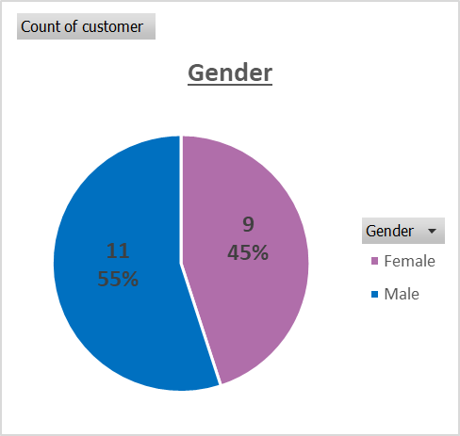
The gender breakdown of the respondents is shown in Fig. 1 and is nearly equal, with 9 (45%) of the 20 respondents identifying as female and the rest male.

This statistic on its own is probably not that interesting to management as is shows a nearly even split between the genders, which is likely to be expected.

Figure 1 - Gender split

When proceeding to plot gender against the other variables (distance, spend, newspaper and opinion), it was important to factor in that there were more males than females in the survey, so for example it would be expected that males would have a greater overall spend. Therefore, proportional figures were used in comparisons where necessary.

2.2 Distance Analysis
The distance travelled by the respondents from their home to Gwalia stores varied from just 5m to 1100m, a range of 1095m. The average (mean) distance is 259.5m, with the median being 160m (lying between the 10th value of 140m and the 11th value of 180m) and the mode (most common distance) being 50m with 3 respondents living at that distance.
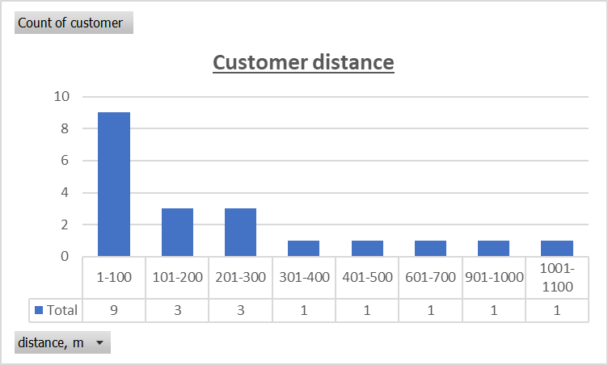
Figure 2 - Customer distance from store
Fig. 2 shows the distance travelled, with the distance being grouped into intervals of 100m. It can be seen that 15 of the respondents (or 75%) live within 300m of the stores.

This information may be interesting to management as it shows that the large majority of their customers live very close to the store.

2.3 Spend Analysis
The average weekly spend of the respondents varied from just £6 to £24, a range of £18. The average (mean) spend is £15.25, with the median being £15. The total weekly spend across the respondents is £305. The dataset is multimodal, with modes (most common spend amounts) being £6, £11, £15, £19 and £23. Having multiple modes, with just two customers at each modal point makes mode a poor measure in this example.
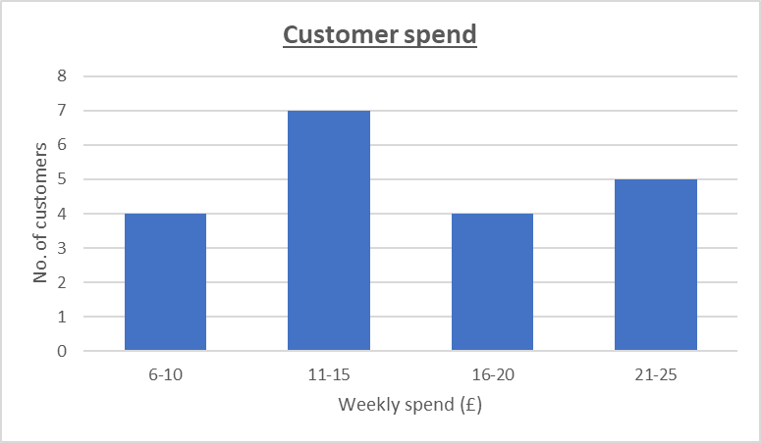
Figure 3 - Customer spend
Fig. 3 shows the spend for all customers, with the spend being grouped into intervals of £5 for ease of viewing.

This information could be of interest to management, but it does not appear to contain any unexpected findings.

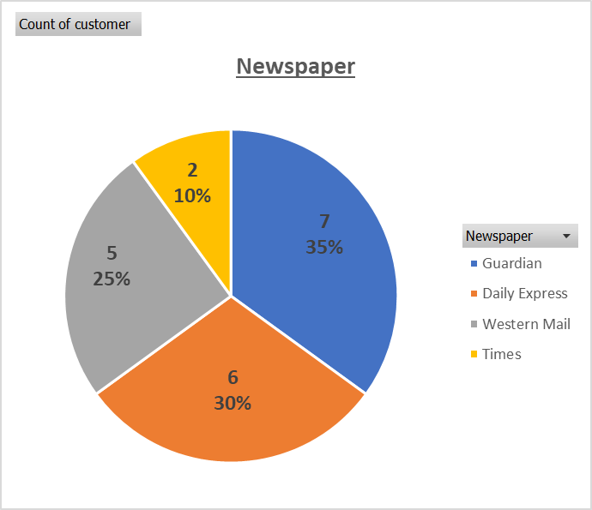
2.4 Newspaper Analysis
Figure 4 - Newspaper split
The newspaper breakdown of the respondents is shown in Fig. 4 and shows that the Guardian is the most popular paper, with the Times the least popular.

This information may be of interest to management as it could influence which papers need to be kept in stock, or there could potentially be another causative factor in play behind the popularity of the papers.

2.5 Opinion Analysis
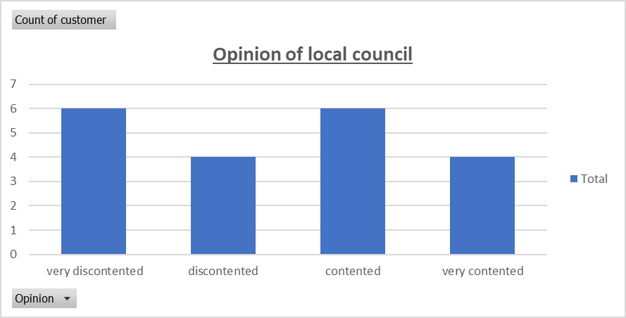
The range of opinions of the local borough council is fairly evenly spread across total respondents, with half of respondents holding a generally discontented view, and the other half holding a generally contented view, as can be seen in Fig. 5.
Figure 5 - Opinion of local council

This information is not likely to be of interest to management as in this format, there is little of note.

2.6 Gender vs. Distance
It was shown that there was little association between gender and distance, either with the distances grouped (as shown in Fig. 6) or ungrouped. The average distance was slightly higher for females at 292m than for males at 233m.

It is unlikely that this information would be of interest to management.
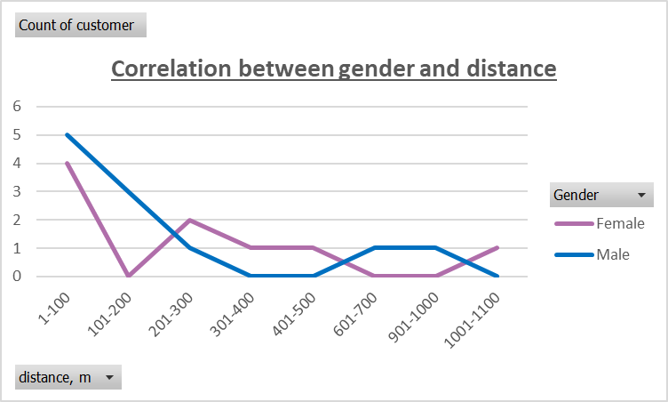
Figure 6 - Gender vs distance

2.7 Gender vs. Spend
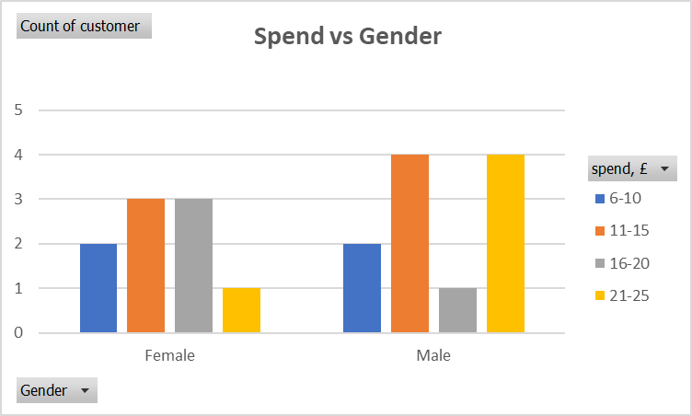
Spend also showed weak association to gender with females spending an average of £14 per week and males spending slightly more at £16.27 per week. Males were also more likely (4:1) than females to spend between in the highest bracket of £21-25.
Figure 7 - Gender vs spend

However, the difference is not statistically significant, so this measure may not be that useful to management.

2.8 Gender vs. Newspaper
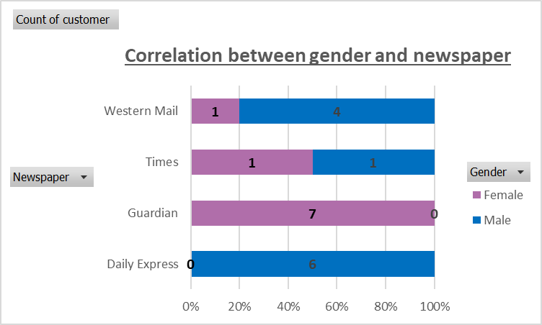
However, the preferred newspapers showed a strong association to gender, with the Guardian having a female-only audience and the Daily Express having a male-only audience, as shown in Fig. 8.
Figure 8 - Gender vs newspaper

This could well be of interest to management as there may be local factors at play which are influencing this purchasing pattern.

2.9 Gender vs. Opinion
The opinion of the local borough council was analysed against gender, and it was found that gender had little bearing on opinion, with the average opinion score being 2.33 for females and 2.45 for males.

2.10 Distance vs. Spend
Spend was shown to be highly associated with distance (shown in Fig. 9), with those living closest to the stores spending significantly more per week than those living further away.

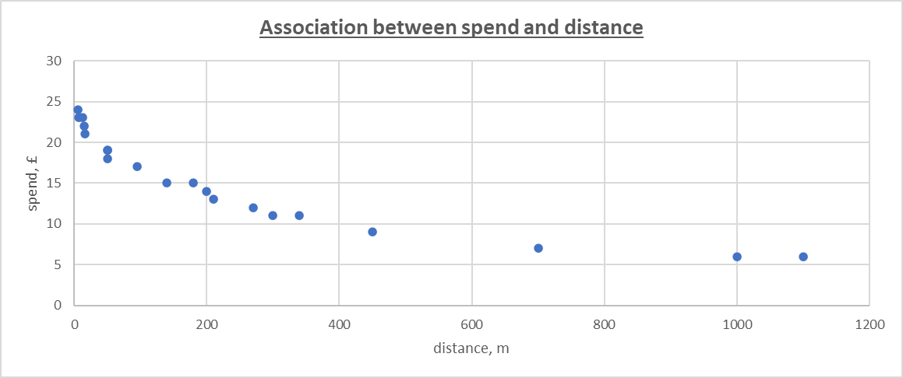
Figure 9 - Distance vs spend scatter chart

As both of these measures contain scale data, it is possible to calculate the correlation coefficient between them (the measure of association between the variables).

Using Excel to calculate the correlation (Fig. 10) gave a strong negative coefficient of -0.875, meaning that as distance from the shop increases, average weekly spend decreases.
Figure 10 - Distance vs spend correlation

As most customers live close to the shop AND those that live close by tend to spend more than those further away, this has a compound effect on spend vs distance. In fact, it can be shown that £266 (87%) of the surveyed £305 total weekly spend comes from those customers that live within 300m of the shop (Fig. 11).

Distance (m) | Sum of spend (£) | Cumulative Spend (£) | Cumulative % of Total Spend
1-100 | 186 | 186 | 61%
101-200 | 44 | 230 | 75%
201-300 | 36 | 266 | 87%
301-400 | 11 | 277 | 91%
401-500 | 9 | 286 | 94%
601-700 | 7 | 293 | 96%
901-1000 | 6 | 299 | 98%
1001-1100 | 6 | 305 | 100%
Figure 11 – Distance vs spend table

This would very likely be of interest to management as it would be advantageous to understand why proximity is affecting spend levels.

2.11 Distance vs. Newspaper
There did not appear to be any significant association between distance and newspaper.

2.12 Distance vs. Opinion
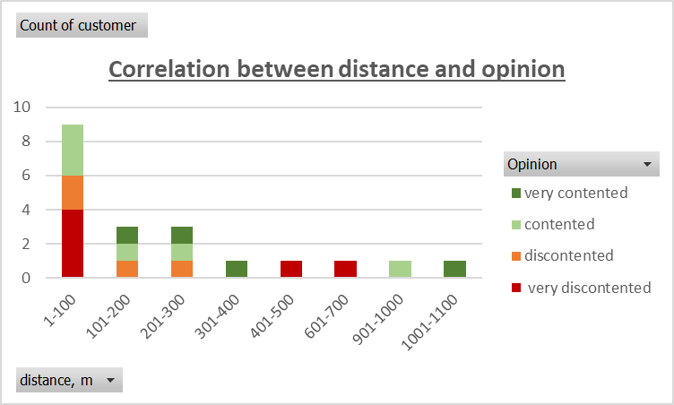
Analysing distance against opinion showed that the people living within 100m, and between 400m and 700m from the shop were the most likely to be very discontented, as can be seen in Figure 12.

This could be of interest to management as they may understand the reasons behind this.
Figure 12 - Distance vs opinion

2.13 Spend vs. Newspaper

Spend and newspaper at first glance seems to have an interesting association, with readers of the Guardian and Daily Express spending considerably more in total than the other two papers; indeed five times the amount being spent by the Times readers. This is shown by the blue bars in Fig. 13 below.
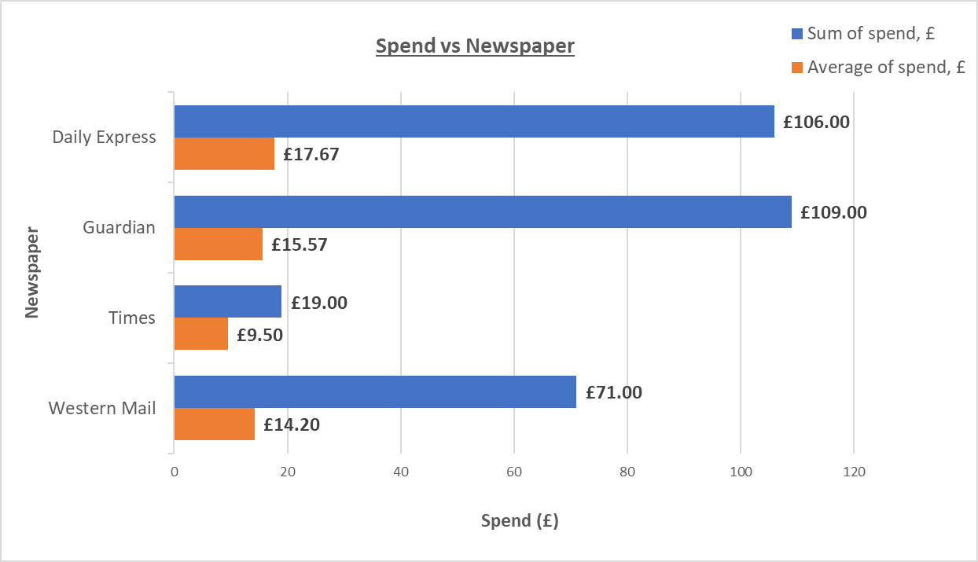
Figure 13 - Spend vs newspaper

However, this can largely be attributed to the larger number of people reading the Guardian and Daily Express than the Times. When calculated as an average, the difference is less pronounced, as shown by the orange bars.

Having said that, there is still a notable difference in the average spend by the readers of the different newspapers, with Daily Express readers spending the most, and Times readers spending the least. This may well be of interest to management as they may wish to try to understand this relationship.

2.14 Spend vs. Opinion
Spend and opinion appears to be associated, with those spending less than £15 per week having a higher incidence of “4 - very contented” responses, as shown in Fig. 14 below:

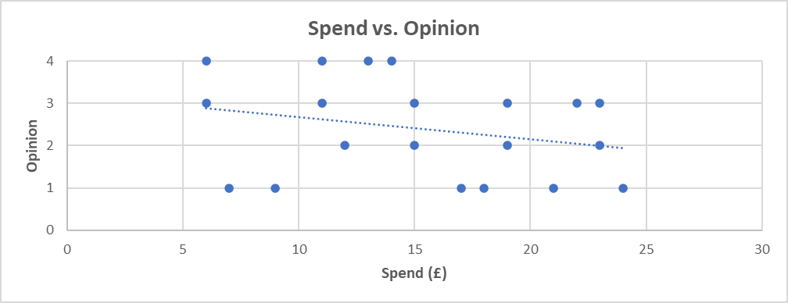
Figure 14 - Spend vs opinion

There is also a general negative trend between spend and opinion, indicating that those that spend more also have a lower opinion of the local council.

This data may be of interest to management as it appears that dissatisfied customers are spending more in the store than satisfied customers.

2.15 Newspaper vs. Opinion
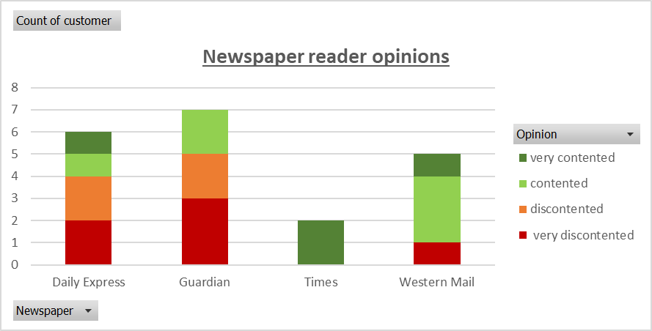
When plotted against opinion, it can be seen that readers of the Times and Western Mail generally tend to be more contented than readers of the Guardian and Daily Express – see Fig. 15.

Figure 15 - Newspaper vs opinion

2.16 Association Matrix
The associations found above (along with the section heading) were recorded in the matrix shown in Fig 16 below. This allowed visualisation of the relationships.

Figure 16 - Association matrix

The 3 areas of high association and 3 of medium association would be expected to be of particular interest to management.

2.17 Analysis of Three Variables
After comparing all combinations of variables, it was considered whether comparing three variables could yield any meaningful data.

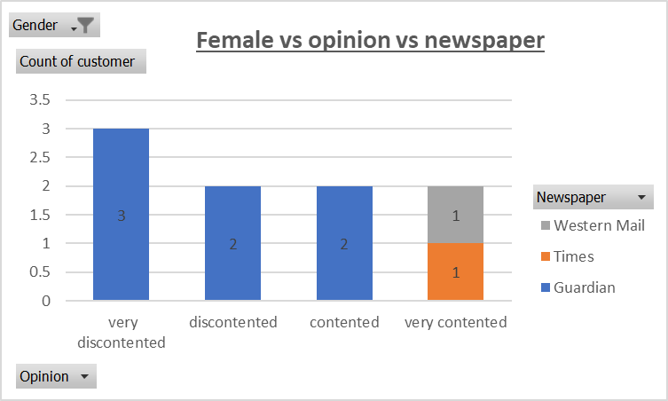
It has already been shown that there is an association between gender and newspaper, and newspaper and opinion. By comparing these three variables with each other, we can see that the most contented females appear to be those that do not read the Guardian (Fig. 17).
Figure 17 - Gender vs opinion vs newspaper

We have further seen that there is a relationship between spend and newspaper, newspaper and opinion, and opinion and spend. Comparison of these three variables is shown in the pivot table (Fig. 18) below.

Average of spend, £ | Contentment
Newspaper | very discontented | discontented | contented | very contented | Overall Average
Daily Express | £15.50 | £19.00 | £23.00 | £14.00 | £17.67
Guardian | £16.00 | £15.50 | £15.00 |  | £15.57
Times |  |  |  | £9.50 | £9.50
Western Mail | £17.00 |  | £14.33 | £11.00 | £14.20
Overall Average | £16.00 | £17.25 | £16.00 | £11.00 | £15.25
Figure 18 - Spend vs newspaper vs opinion

There are a few interesting points that can be observed from this relationship, for example Guardian readers show consistent spending regardless of their opinion. However, realistically the sample size is too small when analysed in this way to draw any meaningful conclusion from the data, and further investigations comparing three variables were discontinued.

3 Conclusion

This report has analysed the quantitative data presented, interpreted the findings and presented the analysis. The main findings can be summarised below:
- Customers living closer to the shop generally spend more on average than those who live further away.
- 75% of the shop’s customers live within 300m of the store.
- 86% of the spend comes from those customers living within 300m of the store.
- Females are more likely to purchase the Guardian newspaper, while males are more likely to purchase the Daily Express.
- Purchasers of the Times newspaper have an average spend far lower than purchasers of other newspapers.
- Those customers living between 100m-400m and those living more than 900m from the shop tend to have a higher opinion of the local council than those living within 100m or those living between 400m-700m away.
- Readers of the Times and Western Mail tend to be more contented with the local council than readers of the Guardian and Daily Express.
- Customers that are discontented with the local council tend to spend slightly more than contented customers.
However, it should be noted that the sample size of 20 is rather low, and more accurate results would be obtained from using a larger sample size.

The above findings could help the development of the organisation by giving them visibility of spending patterns, allowing them to capitalise on what is working well, and remediate what is not working well. They could consider the following:
- While retaining nearby customers is important, attracting distant ones could be beneficial. This could potentially be achieved through:
  - Surveys to understand why people are not traveling to the shop.
  - Improved parking or secure bicycle points.
  - Delivery service.
  - Promotions for repeat visits.
- Identifying and rewarding high-spending customers with loyalty programs may help retain them.
- Stock popular newspapers to meet demand.
- Understanding gender preferences could help personalise the shopping experience and manage stock more effectively.
- Exploring lower average spends by Times newspaper purchasers might reveal opportunities for targeted promotions or bundling to increase their expenditure.
- Investigating higher contentment ratings among customers living between 100m-400m and beyond 900m from the shop may provide insights on customer satisfaction factors.
- Tailoring marketing efforts towards readers of the Times and Western Mail could enhance loyalty and engagement.
- Conducting further research with a larger, diverse sample could yield more accurate insights for strategic decisions.

It can be seen from the above insights that regularly surveying customers will give the opportunity to discover trends, relationships and needs of the customers. By using these insights to improve the shopping experience for the customers and cater to their needs, Gwalia Stores will be in a strong position to retain existing customers and possibly also extend their customer base. This will help ensure the long-term success of the business.

Appendix 1: Supplied Data

The following data refer to customers of Gwalia Stores, a grocery and newsagents in a Welsh village:
distance' is the distance in metres (m) from the shop to the customer’s home
spend' is the average weekly customer spend in pounds (£)
newspaper purchased regularly: G: Guardian, T: Times, DE: Daily Express, W: Western Mail
opinion of local borough council: 1= very discontented; 2 = discontented; 3 = contented; 4 = very contented
customer | distance, m | spend, £ | gender | newspaper | opinion
a | 95 | 17 | m | W | 1
b | 5 | 24 | m | DE | 1
c | 7 | 23 | m | DE | 3
d | 200 | 14 | m | DE | 4
e | 270 | 12 | f | G | 2
f | 15 | 22 | m | W | 3
g | 340 | 11 | f | W | 4
h | 450 | 9 | f | G | 1
i | 16 | 21 | f | G | 1
j | 700 | 7 | m | DE | 1
k | 50 | 19 | f | G | 3
l | 1000 | 6 | m | W | 3
m | 50 | 19 | f | G | 2
n | 140 | 15 | m | W | 3
o | 300 | 11 | f | G | 3
p | 210 | 13 | m | T | 4
q | 12 | 23 | m | DE | 2
r | 180 | 15 | m | DE | 2
s | 50 | 18 | f | G | 1
t | 1100 | 6 | f | T | 4

