Jose Antonio

Student ID 2508239

Introduction to Health Social Care

DR Azina Zainol

23/02/26
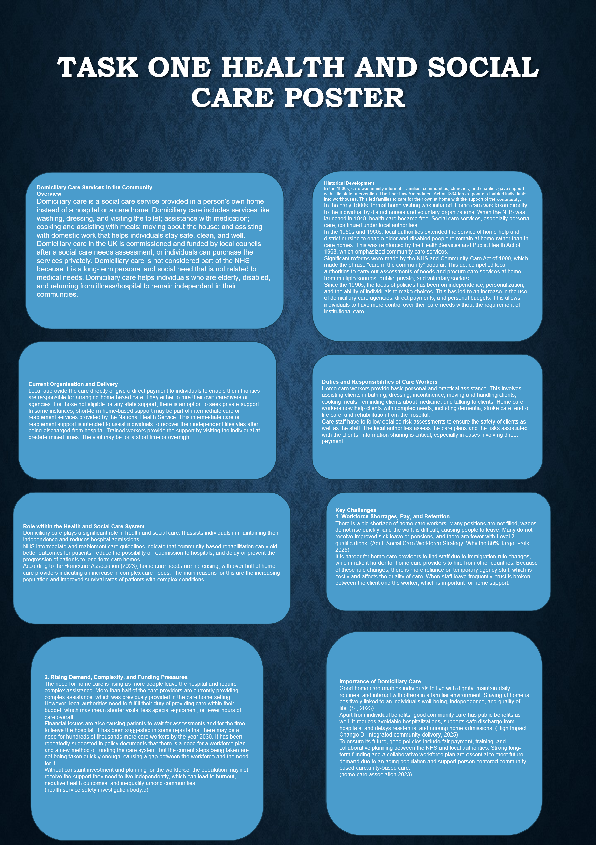

TASK 2

ORIGINS AND HISTORICAL CONTEXT
Ambulance services, as an organised response, are a relatively new phenomenon, which was necessitated by the onset of industrialisation, urbanisation, and the occurrence of frequent accidents, requiring rapid response and care for individuals who were ill or injured (Jr., 1990). Prior to this, individuals who were injured or ill were transported to hospitals by the police, fire department, or passers-by in any available cart, which was not only unsafe but also caused further harm to the patient. However, mid-nineteenth-century reforms brought horse-drawn ambulances, operated by voluntary bodies like St John Ambulance and the British Red Cross, which transported the urban poor and provided first aid to them (A HISTORY OF THE AMBULANCE, 2025; Early Ambulances, n.d.). These ambulances were open and offered no comfort, but they signified the new idea of social responsibility for providing safe transport for people in distress (Pollock, 2013).
Similar histories of the development of ambulance services in the nineteenth century are recorded in general histories of emergency services in Britain.

The First and Second World Wars greatly contributed to the development of prehospital care. Military medicine proved the importance of prioritizing treatment through the system of triage, training stretcher bearers, and rapid evacuation of the wounded from the front line. Such innovations greatly influenced the development of the ambulance vehicle, communication systems, and training of staff. This laid the groundwork for the development of more professionalized emergency care. The National Health Service Act of 1946 enabled county and borough councils to have a legal duty to provide an emergency ambulance service. This integrated the provision of the ambulance service with the new NHS system (National Health Service Act 1946, n.d.). In the late twentieth century, petrol-driven vehicles, radio communication systems, a system of coordinated control rooms, and the development of the role of the paramedic greatly changed the face of the ambulance service from a basic transport system to a mobile extension of accident and emergency departments (Our history – a timeline, 2026).

How ambulance services function today
Current ambulance services are sophisticated and clinically focused, not simply “blue light taxis.” NHS ambulance trusts deal with emergency 999 calls, urgent 111 calls, GP referral for unplanned admissions, high-dependency interhospital transfers, and responding to major incidents. Calls are prioritized depending on urgency to ensure life-threatening calls are responded to quickest by a Category A response. On-scene paramedics and emergency medical technicians provide a broad range of prehospital care interventions, which include airway management, defibrillation, analgesia, and early treatment for cardiac problems, respiratory problems, and neurological problems (Price et al., 2025).

Current practice has moved to emphasize clinical decision-making rather than simply transporting to hospital. NHS England’s service model enables “hear and treat,” “see and treat,” where suitable patients can be treated over the phone or at home when safe to do so, rather than transporting to hospital (NHS Ambulance Services Delivering Urgent and Emergency Care, n.d.). Clinical hubs within control rooms involve advanced paramedics and other clinical professionals who assist in the review of calls, provide support in triage, and assist the front-line teams, which may involve community nurses, mental health teams, and palliative care teams. Research on advanced prehospital critical care has indicated that such teams can improve outcomes, including survival, in cases of severe trauma, as opposed to standard ambulance services (Price et al., 2025).

However, ambulance services face many demands, including increased demand, increased delays in emergency departments, and increased crowding in hospitals, which can mean that ambulance teams spend long hours queuing outside the hospital with patients on trolleys, unable to hand them over to the emergency department. The demands of the job, including the trauma that the teams face, can have a detrimental impact on the quality of life of the paramedics, and thus, in order to provide a high-quality ambulance service, it is not simply the effectiveness of the service that is important, but the humanity shown to the teams as well.

Significance for service users’ quality of life
For service users, the importance of ambulance service provision stretches far beyond the immediate need for transportation to the hospital. Prompt prehospital evaluation and treatment within the "golden hour" after trauma, cardiac arrest, stroke, or respiratory failure can be the determining factor for the preservation of life and the maintenance of future functionality, allowing the majority of service users to resume their work and daily life (Ebinger et al., 2015). Triage and routing of service users to the most appropriate hospital can prevent deterioration and reduce the potential for delays, which can impact neurological or functional outcomes (MS & MD, 2021).
The ambulance service has significant emotional and social importance. To the service users, the ambulance service represents the provision of expert help and reassuring presence in moments of fear, pain, and uncertainty, where the service user may be suffering from trauma in the middle of the street or at home. Timely and understanding help from the ambulance service can protect the dignity and mental trauma of service users long after the acute episode has passed. To the community, the knowledge of the presence of a 24/7 needs-based ambulance service provides security, which allows service users with long-term conditions to live at home rather than in hospital or residential homes. Thus, the ambulance service provides a vital link between crisis and continuity, where service users can pass through acute illness and return to a state of safety, functionality, and hope.

References
Jr., J. S. (1990). The beginnings of urban ambulance service in the United States and England. Journal of Emergency Medicine 8(6), pp. 743-755. https://doi.org/10.1016/0736-4679(90)90289-8

A HISTORY OF THE AMBULANCE. Liverpool Medical Institution. (2025) https://www.lmi.org.uk/history-of-the-ambulance

Early Ambulances. Ripley and District Heritage Trust. https://www.rdht.org.uk/early-ambulances/

Pollock, A. (2013). A backwards look at London and Britain ambulance services—from 1860 to the present—drawn mainly from contemporary journal pages. Emerg Med J, 30(3), 218–222. https://doi.org/10.1136/emermed-2011-200086

Shoaf, D. B. (March 20, 2024). The Rosecrans Ambulance. Hallowed Ground Magazine, Spring 2024. https://www.battlefields.org/learn/articles/the-rosecrans-ambulance

National Health Service Act 1946. https://www.legislation.gov.uk/ukpga/Geo6/9-10/81/contents/enacted

Our history – a timeline. London Ambulance Service NHS Trust (2026) https://www.londonambulance.nhs.uk/about-us/our-history/our-history-a-timeline/

Price, J., Lachowycz, K., Major, R., McLachlan, S., Keeliher, C., Finbow, B., Moncur, L., Sagi, L., Targett, M., Steel, A., Sherren, P. B. & Barnard, E. B. (2025). Prehospital Postintubation Hypotension and Survival in Severe Traumatic Brain Injury. JAMA Network Open 8(11). https://doi.org/10.1001/jamanetworkopen.2025.44057

Ebinger, M., Kunz, A., Wendt, M., Rozanski, M., Winter, B., Waldschmidt, C., Weber, J., Villringer, K., Fiebach, J. B. & Audebert, H. J. (2015). Effects of golden hour thrombolysis: a Prehospital Acute Neurological Treatment and Optimization of Medical Care in Stroke (PHANTOM-S) substudy. JAMA Neurol 72(1), pp. 25-30. https://doi.org/10.1001/jamaneurol.2014.3188

MS, S. P. & MD, T. K. (August 1, 2021). Study finds recent change in EMS transport policy could improve stroke outcomes. UChicago Medicine. https://www.uchicagomedicine.org/forefront/neurosciences-articles/2021/august/change-in-transport-policy-could-improve-stroke-outcomes
- Social Welfare History Project Indoor And Outdoor Relief (1890). Social Welfare History Project. https://socialwelfare.library.vcu.edu/issues/indoor-outdoor-relief-1890/
- The Poor Law Amendment Act of 1834. Tooting180. https://tooting180.org/1834-poor-law-amendment-act.php
- History of the Queen’s Institute of Community Nursing. Queen's Institute of Community Nursing. https://qicn.org.uk/explore-qicn/about/history-of-the-qicn/
- Dismantling the National Health Service in England (2023) PMC9449439. https://doi.org/10.1136/bmjgh-2023-010000
- Health Services and Public Health Act 1968. The National Archives. (July 1, 1968). https://www.legislation.gov.uk/ukpga/1968/46/enacted
- The Legal Structure of Mental Health Services. International Journal of Mental Health and Capacity Law 1, pp. 149-153. https://www.northumbriajournals.co.uk/index.php/ijmhcl/issue/download/48/35
- The mechanisms of social care reform. https://academic.oup.com/policy-press-scholarship-online/book/55383/chapter/435953284
- Capacity and workforce survey 2023. Homecare Association. https://www.homecareassociation.org.uk/resource/capacity-and-workforce-survey-2023.html
- Assessment of priority skills to 2030. https://www.gov.uk/government/publications/assessment-of-priority-skills-to-2030/assessment-of-priority-skills-to-2030
- (2025). Adult Social Care Workforce Strategy: Why the 80% Target Fails. Edgeworks. https://www.edgeworks.co.uk/adult-social-care-workforce-strategy-qualification-target-impossible/
- (n.d.). Workforce and patient safety: temporary staff - integration into healthcare providers. https://www.hssib.org.uk/patient-safety-investigations/workforce-and-patient-safety/third-investigation-report/
- S., M. (2023). Care in my own home: Elders' accounts of receiving domiciliary care for the first time. University of East London. https://repository.uel.ac.uk/download/6d7ca16fdd1c6fc8dab7a36cbd7d2ac2a99945dd3387b607a739f32a35b59fbc/2635400/2023_DClinPsych_Manning.pdf
- (2025). High Impact Change D: Integrated community delivery. Local Government Association. https://www.local.gov.uk/our-support/partners-care-and-health/better-care-fund-support-programme-2025-26/high-impact-change/change-d

