Vikki Thomas
‘The Sleep Whisperer’
Personalised Sleep Routines Devised For Children 0-6 years
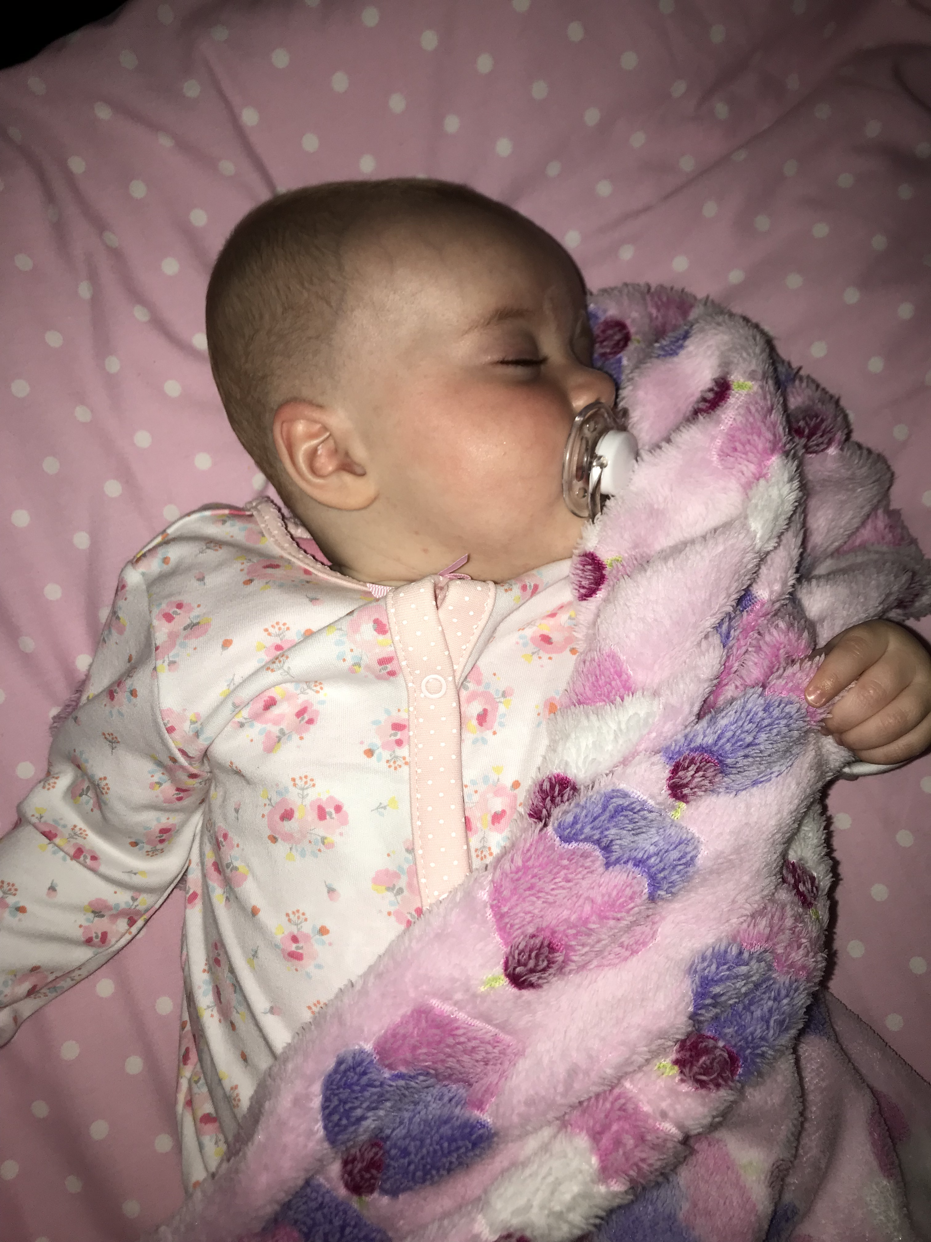
(Source: Thomas, 2018)

- Are you struggling with daily life because of sleep deprivation?
- Is your family lacking the enjoyment it deserves?
- Could you benefit from one-to-one support and advice?

Then ‘The Sleep Whisperer’ can help!

Call today for a tailored sleep routine devised around your family life and parenting style.

What is my business concept?
It’s a simple fact that we all need sleep. I have devised an innovative business plan focusing on issues surrounding children’s sleep and the struggles both children and parents experience to get a good nights rest. The phrase ‘The Sleep Whisperer’ came from a friend of mine who had jokingly referred to me as it when I helped her settle her little one.
According to Price (2015) issues surrounding sleep is one of the main reasons that parents seek health advice in the early years. ‘The Sleep Whisperer’ will devise an individual sleep routine programme for children. All programme techniques are devised using research-based methods. Home visits will be offered to provide advice and guidance to families whose children have irregular sleep patterns or have no routine. This includes optional overnight stays to aid with the devised routine so that help is at hand with advice and reassurance when the child wakes through the night.
Professional guidance and support is offered that is peronalised to each family routine and parenting style. The routine will be devised around current family situations, for example, what time parents finish work, are both parents home at the child’s bed time, does the child share a bedroom with others? Asking questions about your family life and what your desired outcomes are but remaining realistic with understanding guidelines on how long children should sleep for at their current ages. I will provide a sympathetic, gentle approach to the routine. These sleep routines are not just for babies but young children too, research shows that children who sleep well can have improved reading and math skills for school aged children (Kurcinka. Cited in Erickson, 2015), and even benefit their memory (Stickgold, 2013). I am open to new ideas and experiences, having the ability to use one experience and change it to tailor another family.

My background
My name is Vikki Thomas and I have been a full time Registered Childminder for 13 years caring for children from birth to 11 years. Over this time I have had the opportunity to help and guide parents with sleep routines for their little ones. I have developed tried and tested methods that I have tailored to suit different routines and the diversity of families. I have also aided with daytime napping, which has great benefits for children, a study regarding sleep patterns and the development of vocabulary size in infants and toddlers provide evidence that daytime napping can enhance children’s vocabulary (Horvath and Plunkett, 2016).
As a mum of two children I understand how sleep deprivation can affect your daily life and the lives of others around you. When my first child was born I had not anticipated how exhausting it was to try and get through the day on such little sleep. He would take almost an hour to settle though me rocking him and then a further two hours of back and forth his room until he would finally fall to sleep, I would then begin the quiet tip-toe escape from his room only to know that within a few hours I would be back to begin the settling all over again. This did not only affect my son and I, but family relationships too.
When I had my second child I had already been childminding for four years and over this time I had developed strategies to aid sleep time routine to benefit my child and also the family as a whole. Through a devised plan that worked around our family life and our routine, everything fell into place. My daughter was able to settle herself and slept all night.

Are there other sleep programmes available?
This is not an original concept and there are currently sleep nanny’s available in the UK, however, I am yet to meet anyone that has heard of this sort of training without researching it, that’s why I feel like there is gap in the market for this. Having researched these programmes available to aid with children’s sleep, and discovering that many sleep trainers offer mainly online advice; my service is personal to my home area so I will personally be there to offer guidance and support. I intend to contact the local authority and other early years settings such as local primary schools, flying start settings and playgroups with the possibility of offering sleep programme workshops at their settings, this is encouraging collaborative working, and gives parents a chance to gather and talk about the issues faced and to understand that they are not alone. We can share tips to promote healthy sleep. It is not about saying ‘you’re doing it wrong’ it is understanding that each family might have different values, routines and structure, its about sharing information, hints and tips with professional advice on why sleep is important. These sessions will be available for approximately 10-15 people at one time to enable each person to have the opportunity to share stories and to gain advice. These sessions will last one hour and follow up meetings will be available with the prospect of acquiring 2-3 families to work one-to-one with.

The National Sleep Foundation (2018) suggests that a sleep specialist is a possible route for parents who require help and guidance regarding children’s sleep.

Some recommended sleep strategies that will be discussed are:
- Put baby down to sleep awake
- If baby usually falls to sleep on a bottle or breast then try feeding earlier to avoid this
- Read a story
- Sing soothing songs
- Rock the child to drowsiness but put down awake
- Dim lights so child is able to differentiate between day and night
- Quiet voices
- Avoid changing nappy during the night unless needed
- Understand its not playtime, remove toys from cot, although if a toy is a comforter then this should be kept with the child. Too much stimulation before bedtime can cause them to be over excited.
- Establish a routine – bath, clean clothes and nappy, brush teeth.

Why is sleep important?
Sleep is vital for a child’s physical growth and for them to reach their full potential (Koulouglioti et al., 2014). Children who are well rested are curious, energetic, happy, playful and eager to learn, they are also better able to deal with challenges and develop secure attachments (Stanton, 2017) Attachment theory was established by the work of John Bowlby and Mary Ainsworth and incorporated both intimacy and independence (Armstrong et al., 2014), something that is needed when providing a sleep routine for children. Sleep is as important for adults and can improve their mental and emotional well-being (Price, 2015).
Research undertaken regarding a nighttime routine in early years has shown that it can play a key part in children’s development and well-being (Mindell and Williamson, 2017).
It is important to remember that all children are individual and will require different amounts of sleep, are they waking happy, content and do they sleep longer when given the opportunity (Owens and Moore, 2017). For example during the weekends will they sleep for later as appose to weekdays when they have to be awakened for parents to go to work and child to attend childcare, these are all factors to consider when devising a sleep routine for children.
Quality sleep is necessary to enhance children’s memory (Frenda et al., 2014), for children to have the maximum ability to retain information and enhance creativity and imagination it is vital that they receive the best possible sleep, a sleep routine can positively enhance this.
According to The National Sleep Foundation (2018a) children over 6 months do not necessarily need feeding through the night; this is when I recommend beginning a sleep routine. The NHS (2017) recommends that children aged between 6-12 months require between 12-15 hours of sleep, this includes on average 11 hours during the night and the other hours made up of daytime naps. This will need to be considered when creating a sleep routine and establishing what is the best time for the child to start settling to sleep.

Who might need a sleep package?
- Children
- Parents/ single parents
- Parents with relationships under strain from sleep issues
- Adoptive families
- Twins
- Siblings sharing the same room
- Children with disabilities.

Children might protest to this change and not all children will be happy about it, this is to be expected and it is important to re-assure parents that their child might initially cry and be upset by this change, babies use crying to attract attention, this is how they communicate with adults to ensure they get what they need (Brock and Rankin, 2008:4). These programmes are not intended to distress children and children will never be left alone to cry or ignored. Children that feel safe and secure with their primary caregiver have the base to develop, learn and grow and emphasizes attachment theory (Wilson, 2016), this leads to emotional regulation, this is when children are able to develop and manage stressful situations through interactions with parents, this enables the child to learn how to self sooth (Armstrong et al., 2014), a skill that is important for children and incorporated into sleep routines.

Cost –
This initial cost of this concept is relatively low. There would be initial start up costs such as advertising, flyers and a website, which could include previous family testimonials. As I will be visiting families’ homes a DBS would be required.
The sleep consultant industry is currently unregulated, nevertheless, there are sleep-training courses available at an average cost of £250.00 and is a full days training (Babyem, 2018). These courses involve knowledge to understand the different approaches to sleep training.
The initial cost to provide group sessions will range from £3.00 - £5.00 per individual. Follow on one-to-one plans will be available from £150 - £600 depending on requirements, which is a competitive price in relation to other sleep professionals.
There is always room for improvement with any business plan and further development might be needed, such as, a possibility of traveling further from my chosen area or taking on other experienced members of staff to aid if the workload becomes too much for one individual.

Why Choose Me –
I have qualities such as enthusiasm, warmth and integrity, according to Adair, (2013) are qualities of good leadership. I am reliable and offer full commitment to families. References are available on request.
Although this is a business opportunity I really want to help people understand that sleep is an issue for so many families. I feel like I can make a difference to families lives in the long term and enhancing their quality of life by providing compassion and understanding and also nurturing care and early stimulation which according to Mindell and Williamson (2017), is crucial for positive outcomes.

According to Eisenmann (2013) Entrepreneurship can be defined in many ways, however, he continues to say that Professor Howard Stevenson defined it as ‘the pursuit of opportunity beyond resources controlled’, establishing an opportunity and embracing it, for example, seeing a gap in the market for an innovative product or concept and putting plans in place to accomplish a successful outcome.

A sleep association is something that helps your child fall to sleep and babies and infants sleep routines may provide positive and negative aspects of this. Aydin (2017) highlights that a negative sleep association usually involves a parent being directly involved with soothing the child to sleep, such as rocking them until they are sleeping, and a positive sleep association would be something that the child will do to comfort themselves, such as humming or singing, devising a sleep routine to incorporate positive sleep associations can be beneficial for the child.

There are many influential factors that determined how babies sleep, for example, genetics, lifestyles and roles and responsibilities (Crawford, 2017). McCarthy (2017) states that sleep habits can be changed, however, not all sleep routine interventions can be achieved, as other underlying issues might be highlighted such as childhood insomnia, which is a difficulty that children have in falling to sleep, this is usually diagnosed if accruing 3 times a week for at least 3 months (Owens and Moore, 2017). If left untreated, these sleep issues may lead to damaged brain development and a permanent loss of development abilities (Jan et al., 2010). This highlights the importance of early intervention, which according to the Early Intervention Foundation (NO DATE) is taking action as soon as it is possible to prevent problems becoming too difficult to reverse. This can be said for children’s sleep patterns, developing a routine when a child is young can be of great benefit for both the child and the families’ well-being. Families First is designed to improve outcomes for children, young people and families. Incorporated in this document is the importance of early intervention as well as providing support for families (Welsh Government, 2018).

There are many sleep nannies available in the UK who offer tailored packages to families in need of help and guidance. These sleep nannies usually emphasis the high recommendations and successful outcomes they receive, however, Ockwell-Smith (2015), challenges the need to sleep train babies, highlighting that no-one ‘sleeps through the night’ and it is healthy for children to wake 10-12 times per night, stating that these regular wakes have the potential to keep them safe and can protect them from cot death. Furthermore a study reveled that sleep techniques provided no positive or negative long lasting effects (Price et al., 2012).

Children need sleep, which is something we do know. Sleep is necessary for a child’s good health, development and behavior (McCarthy, 2017). Research has shown that young children that take a while to fall to sleep in the evening and then wake regularly through the night were more likely to have behavioral problems (Hall, 2017). However, researchers from The Murdoch Children’s Research Institute (2015) highlight that research shows the amount of sleep children receive is not the most important thing for health and well-being and challenges current sleep guidelines, they emphasize that other factors of sleep are as equally important such as routine and how long children usually take to fall to sleep.
Parents can promote health sleep by introducing techniques (Hall, 2017). Being consistent and providing the same bedtime routine if the child wakes during the night, for example if the routine devised requires children to be put in their own bed to sleep then that’s what should happen if the child wakes during the night (Owens and Moore, 2017).

Restful sleep for babies strengthens the connections of the babies brain, which means that their capability to learn and be creative are increased (Cooper, 2015), the NHS (2016) reports that according to a recent study, sleep deprivation can damage children’s brain, causing a negative affect on their ability to reach their full potential, however, this study was on a small scale over a short period and the uncertainty of the long term effects are highlighted. On the other hand, research regarding insomnia and creativity highlighted that at times less sleep predicted more creative behaviours (Beaty et al., 2013). Early childhood experiences have an effect on children’s brain development, not only that but how a child will learn in the future (World Bank, 2016).

A Sleep Routine Programme can be a cost effective method to promote early childhood development (Mindell and Williamson, 2017). Understandably the initial cost of such help can seem extreme for some families, as sleep guidance can cost anywhere between £150-£800, nevertheless, investing in the health and well-being of children is vital to for promoting positive outcomes (Mindell and Williamson, 2017).

Lack of sleep for parents can lead to depression and lack of control over children’s behavior (Owens and Moore, 2017). Even a one-hour decrease in sleep can considerably effect parent’s participation with regards to work, which can then affect household income (Costa-Font and Fleche, 2017). Wallis and Gupta (2016) documented that a survey showed that out of 7,500 parents, 35% said that were ‘sleep deprived and exhausted’. Sleep deprivation effects cognitive function that can affect many aspects of daily life (Frenda et al., 2014), Piaget is know for his theory of cognitive development and how children progress these skills through experiences (Armstrong et al., 2014). Children learn when they are focused and engrossed in play, this can be challenging if they have not had enough sleep.

Children who do not sleep well during the night might take longer naps during the day, The Daily Mail (2015) reported that daytime naps should stop when children turn two as it provides poor sleep quality during the night, however, this has been critiqued by the NHS (2015) who suggests that out of the 26 studies this is based on, only one was with regards to napping in children under the age of three and calls for more research on this subject. Furthermore, Ford (2015), highlights that daytime napping can be highly beneficial for children’s learning development and memory recall, studies undertaken on infants aged 6-12 months documented that new skills were learnt and retained in children that took regular naps compared to those that did not. Children who receive a high sleep quality have a high ability to control their behavior, which can promote better outcomes for children, this can enable them to behave better at school and focus their attention on learning (Hall, 2017). According to Stanton (2017) children aged between 4-36 months old need between 12-16 hours of sleep per day, however, McCarthy (2017) emphasis that guidelines are not based on solid evidence, and the required amount of sleep will differ between each child.

It should not be a given that it is the children that have the sleep issue, there might be underlying issues such as the environment that the child is in (McCarthy, 2017). It has been documented that certain things can cause children to have disturbed sleep, such as televisions in their rooms and access to screen time devices including ipads, the use of these devices so close to bedtime can have dramatic effects on children’s sleep patterns (Koulouglioti et al., 2014). It has also been reported that parents have even resorted to using medication to help with children’s sleeping patterns, such as melatonin (Kleeman, 2017). Clearly there is an issue regarding sleep for many families and according to NHS data, hospital attendances for children under 14 years old who have sleep disorders have tripled in the last ten years (Kleeman, 2017).

It is understandable that parents might find a new routine daunting, however, understanding the importance of working together is of great importance. Its relevant to highlight Bronfenbrenner’s Ecological Theory when establishing a new sleep routine with parents (Blunder et al., 2016) and how the responsibility does not fall on one individual but as the family as a whole. For example if the mother sticks to the routine one evening and the father does not the next evening then that will result in a breakdown of routine and could have significant consequences not only for the routine but more importantly the child. Routines are best followed as consistent as possible, even if the child attends childcare or regularly spends time with family outside the home, it is essential that these individuals are aware of the child’s routine and makes every effort to adhere to it. Parental conflict can also affect the mother-child and father-child relationship, according to the Early Intervention Foundation (2016) evidence suggested that this could be more detrimental for the father-child relationship. Each parent needs to have clear thoughts and realistic expectations, however, some parents might have conflicting issues, for example, the mother might feel complied to put the child to bed where as the father might also want to be a part of this routine, its about working together.

Of the sleep coaches that are available within the UK, there seems to be a gap in the market for sleep programme workshops. Many parents are unaware of the importance of sleep in early childhood and the effect that it can have on many aspects of learning and development. According to Blunder et al., (2016) studies show that parents lack of knowledge of sleep routines and recommended sleep amounts resulted in their children not gaining enough sleep and that parents who set rules regarding bedtimes and the recommendations surrounding the use of media before bedtime provided healthier sleep behaviors in adolescents. Being a new parent can be isolating and can highlight other problems such as loneliness and this can possibly affect their mental health (Young Woman’s Trust, 2017). Incorporating sleep workshops can have the ability to bring people together and share experiences.

To conclude, entrepreneurship doesn’t come without risks including initial costs and uncertainty, however, according to Resnick (2014), passion, perseverance, resourcefulness, open-mindedness and having the ability to absorb information are key characteristics for any promising entrepreneur.

