Changemakers

Building Your Personal Brand for Sustainable Employment

Alexander Jenkins (2103347)

Logo/s

First Concepts
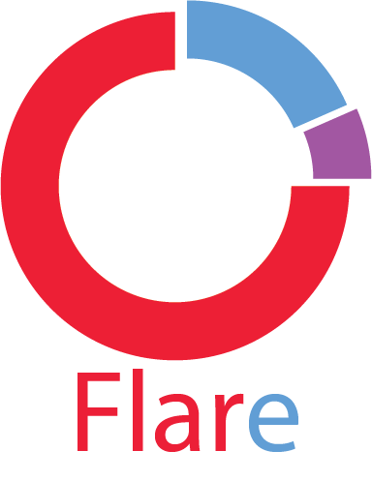
This was the first logo that I made, although after it was done, I deemed it to not fit the style of an esports organisation logo at all in comparison to (most) other esports organisations logos, this logo looks to me one that would be used for a piece of software and is too modernised for the purpose.

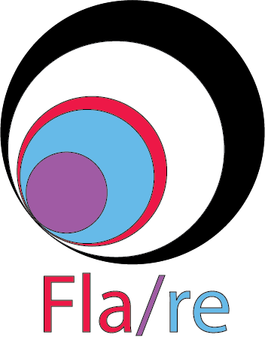
This is the second incarnation of my logo, this has the same issues as the first one, that being too simple and modernistic to fit the aesthetic of a logo for an esports organisation. I kept elements from the first logo such as the same colour scheme being the red, blue and purple, but also added black and white.


This was my third and most major logo design, as this became the staple for my current logo design, the logo represents a flare stick going off, hence, to match the name. The first two logos made were necessary as they were part of the process to getting to this stage, I also used colour schemes from the second logo, as I kept the red, black and white but left out the blue and purple for the final logo design.


Final Logo

This is my final logo design, which is an altered version of the third one. The size of the flare and flare sparks have been increased to make it look like it’s breaking out of the circle, as well as appearing significantly less bold. Other than that, the logo hasn’t changed too much.

Mind Map
To compete in Esports competitions in a variety of games to win tournaments and aim to be the best.

Being a part of team Flare can provide useful skills such as communication and teamwork, as these are vital for playing together as a team.

Skills
Goal

Anyone can have the opportunity to join Flare if they have the required skill level.

Purpose of team Flare
Inclusive
Variety
Industry
Any competitive game can be in the roster for team Flare, as long as there are enough players within Flare that specialise in that game.

The Esports industry is an evergrowing industry worth a billion dollars, showing there are careers to be made in Esports.

Banner Ads

Medium Rectangle
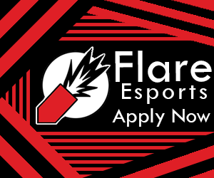

Large Rectangle
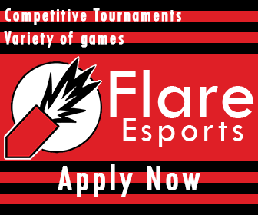

Leaderboard


Mobile Leaderboard


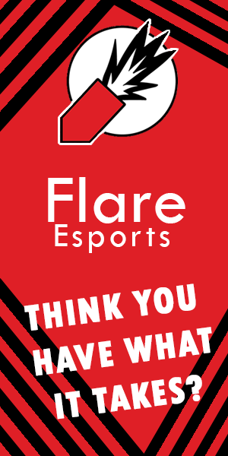
Half Page or Large Skyscraper

Motion Graphic Sequence
https://www.youtube.com/watch?v=hHJOxKKJ0QY

