LDE Assignment 1
Leonardo Iwasaki (2531571)
London campus
3/3/2026

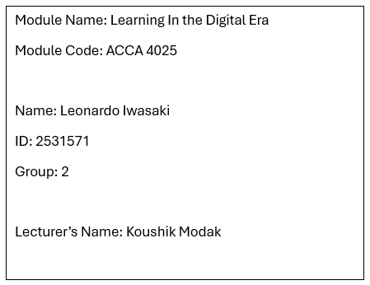

e-portfolio
e-portfolio link
leonardo-Eportfolio
Table of Contents
Introduction 2
Main Body 3
Task 1: Essential Academic and Employment Skills for the future career Path 3
Task 1 (a): Report on Essential Academic and Employment Skills 3
Task 1 (b): Evaluation of Task 1 (a) based on Similarity report 5
Task 2: Collaborative Mind Map and Individual Poster 6
Task 2 (a): Mind Map 6
Task 2 (b): Poster 7
Task 3: Virtual Collaboration and RefWorks 8
Task 3 (a): Report on Virtual Collaboration 8
Task 3(b): Step-by-step process of using RefWorks with visuals 9
Task 4: E-Portfolio Creation and Evaluation 14
Task 4 (a): E-Portfolio Creation 14
Task 4 (b): Illustrative Review of E-Portfolio tool Selection 17
Conclusion 18
References 19
Task 1 References: 19
Task 3 References: 19

Introduction
Digital Technology is constantly transforming and evolving. Currently, this evolution is occurring exponentially, and as a result, numerous studies have sought to understand and explain the positive and negative factors in the educational landscape. Learning in digital era utilizes tools, methodologies, and support to understand and improve academic training in the new digital age. Essential skills and behaviours, as feelings and emotions, are topics that contributes to the academic graduation to achieve a qualified profession. This assessment aims to examine some of these aspects and provide some explanations about how the digital world affects our academic and professional lives, with support of mind maps, poster, images and an E-portfolio.

Main Body

Task 1: Essential Academic and Employment Skills for the future career Path

Task 1 (a): Report on Essential Academic and Employment Skills
Essential Academic and Employment Skills are the base form how people start the journey of a professional life and could determinate the path of area`s specialty that a person will follow. This report is about what are some important skills and how it might help the life`s cycle development.
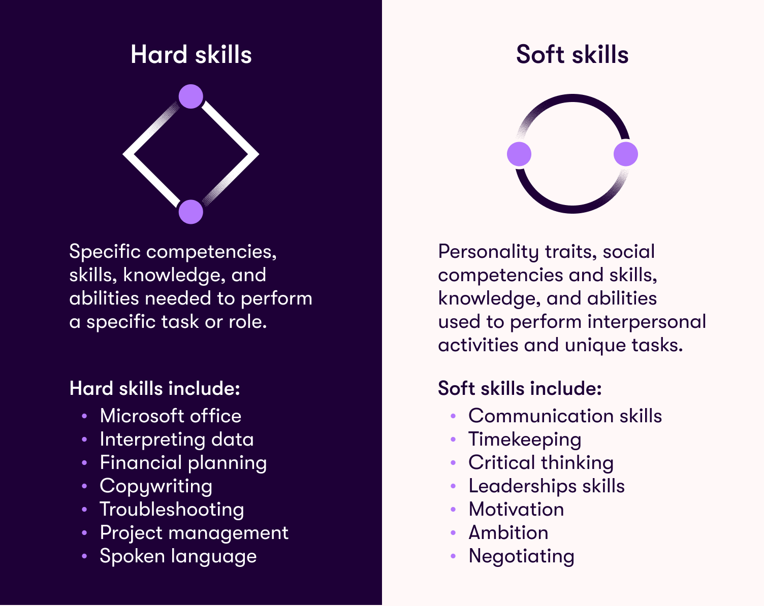
First, we need to understand what a skill mean, “an ability to do an activity or job well, especially because you have practised it” [1], meaning that these skills are going to be practiced to accomplish your basic employment basis. According to Kevin Gallagher “Sometimes skills can be divided into two categories, ‘hard’ and ‘soft’” [2]. A hard skill involved a logical, mathematics and procedural approaches. For example, like using some software’s routines in word/excel, serving a car engine or resolve a mathematics problem. And a soft skill means emotional and people orientated. For example, Persuasion people, talking in public or dealing with stress.
Figure 1: Examples of Hard vs Soft Skills [5]
The development or a combination of these two categories (Hard skill vs soft skill) is essential for employment necessities. The Oxford College [3] suggest that there should be balance between the two categories and the weakest have need for development. In the article they reinforce the difficult of how to force us to train something that we are not good in taking steps “you’ll need to have the bravery to step outside your comfort zone, and to learn something new” [3].
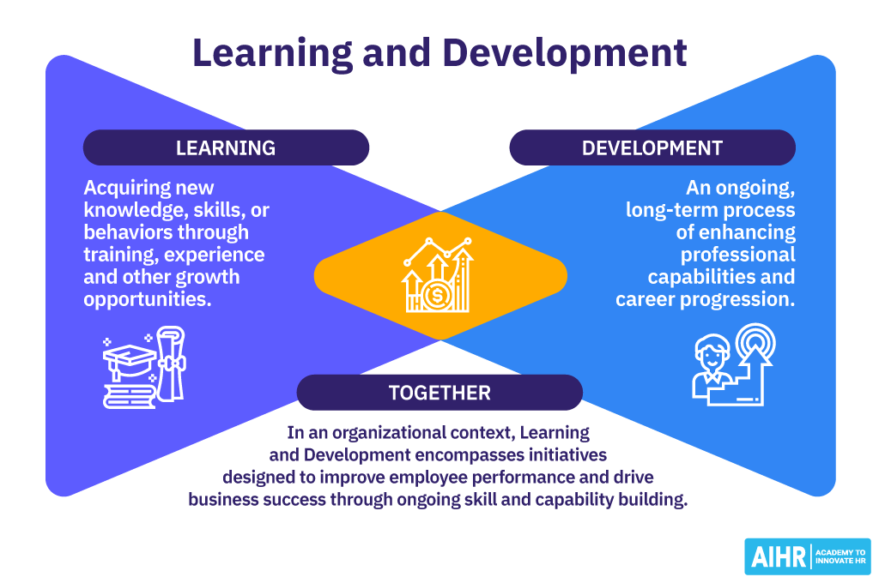
Figure 2: Learning and Development [4]
Defining these categories is fundamental to better understanding how they affect your performance and professional skills, or lack thereof. This will be valid both for the academic field and, consequently, for professional life. Learning and Development are the keys you acquire in academia to achieve a solid, successful, and rewarding professional career.

Task 1 (b): Evaluation of Task 1 (a) based on Similarity report

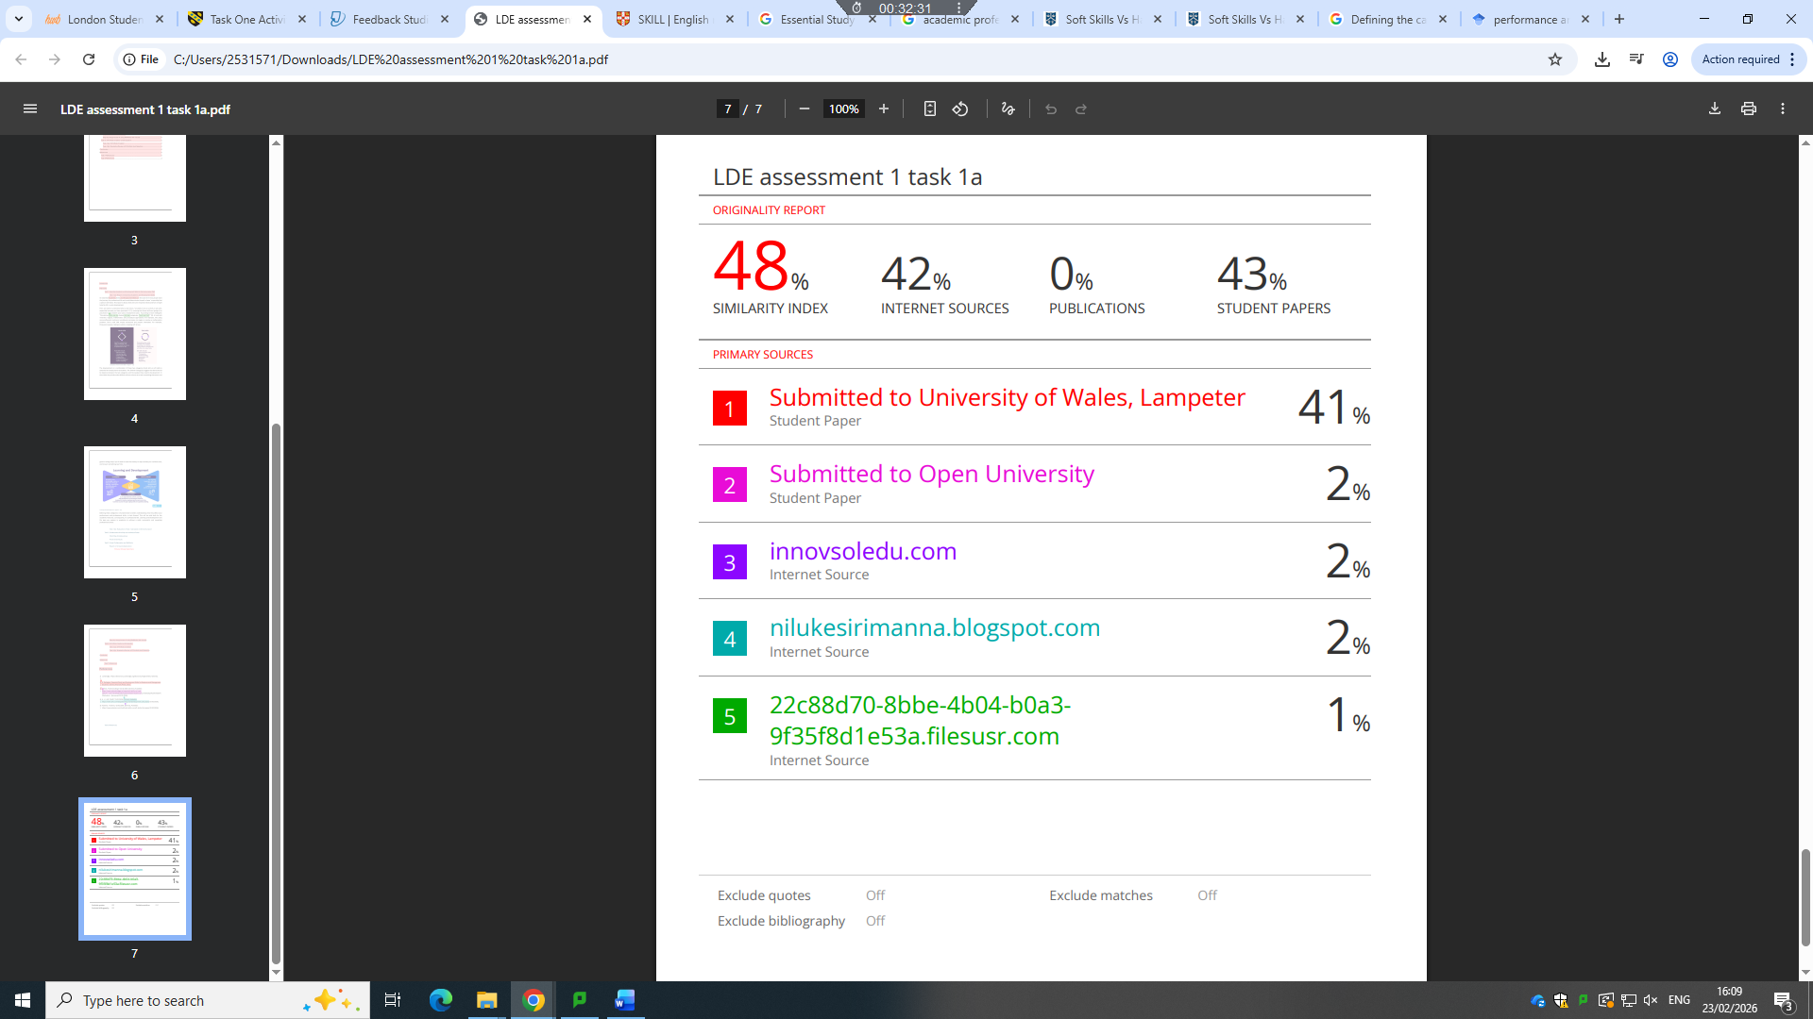

According to the similarity report, I believe my report is correct and meets the requirements of task A. It found some observations regarding the references and images, and how they have already been cited in other sources. The most relevant issue concerns the model used to maintain the same template file format. Items 1 to 4 are regarding References and template standard. Item 5 is regarding a quotation already identified as reference [2]. Even though the similarity index is quite high (48%), most of it has been generated by the template and bibliography. So, the similarity report helps me to understand my paraphrasing and referencing are done correctly.

This report tries to give an idea of how important skills are. And how important is to deal with lacks skills. For this report I think 80 of 100 will be more accurate.

Task 2: Collaborative Mind Map and Individual Poster

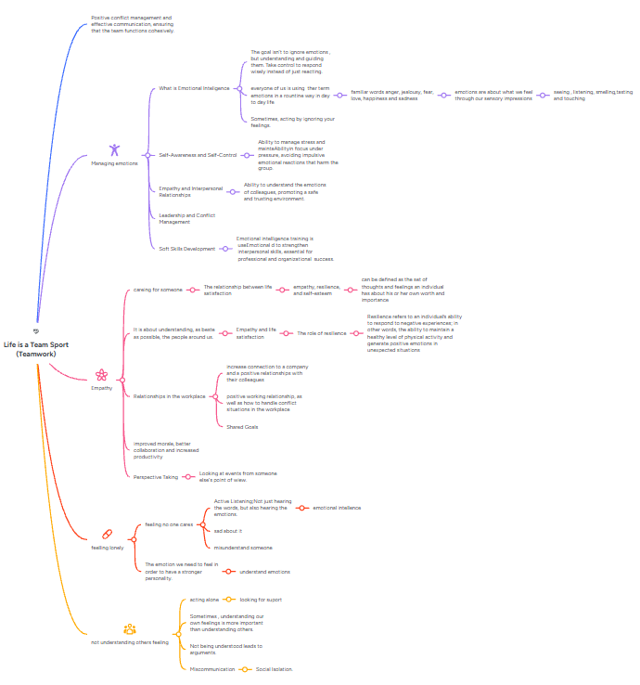
Task 2 (a): Mind Map

Link to Mindmap Mindmeister

Task 2 (b): Poster
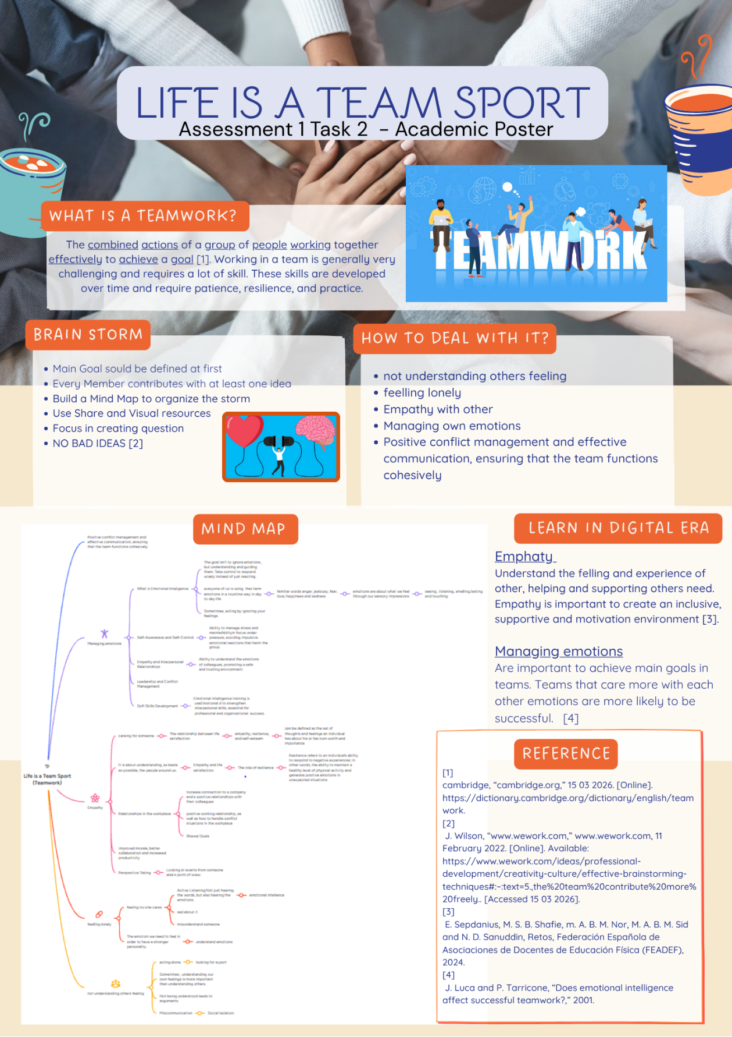
Link to Canva - Poster

Task 3: Virtual Collaboration and RefWorks

Task 3 (a): Report on Virtual Collaboration

Unit 3 Topic Summary4: Lights, camera, action!

When a team works in complete harmony, some judgments, decisions, and movements tend to follow the same pattern of thinking. “Groups bring out the worst as well as the best” [1]. One of the challenges in teamworking are the overcome and avoid some key concepts – Inattention to results and Groupthink. In this task we are going to explore how these challenges can be sorted out or prevented. The groupthink theory was first studied by psychologist Irving Janis, in 1972, his research was conducted on group decision-making under certain conditions. Individuals tend to accept what the group consensus establishes, even if it is not their own choice [7][6].

A Groupthink is a team management issue many times associated with lack of best judgment [7]. Typically, a groupthink event occurs after a problem or failure [2]. In a group sometimes the cohesion and conformity are so intrinsic that issues and problems are left a side or not seeing by the group consensus. “This is how we’ve always done it.” [5].
The groupthink can be related to stress conditions and necessity of fast decision. A clear symptom to understand is when a group feel threatened emotion or physical, the group may get the ideal of “Us versus them” mentality [4]. This picture can direct the decision of the group, even if there are people that do not agree with it, flow only to what they see as the only solution to a perspective or problem.
There are some approaches to avoid or at least identify the behaviour pattern. Some of them can be: Each member of the group should be motivated to criticise the group course of action, Leaders should be impartial and look things from “outside” of groups, more than one group with leaders in order to work together, splits teams in less individuals to effectively proposal, bring experts to discuss issues, reconsider decisions in second chance meetings, should be at least one devil’s advocate during the meetings [6][1].
There is no consensus about the best form in term of identifying and avoiding this phenomenon, but the relationship between people is the most challenging problem this this behaviour [6]. How people deal with pressure, how people are leaded to achieve goals, how healthy is the environment and how some people in the group impose their thoughts more than others. These “How” are a good way to start thinking about this subject.

Task 3(b): Step-by-step process of using RefWorks with visuals

This task will reference steps of screenshots and comments of use of RefWorks automatic referencing management tool.
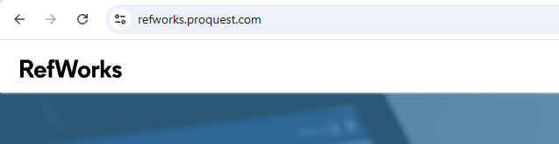 | Web site address  https://refworks.proquest.com/
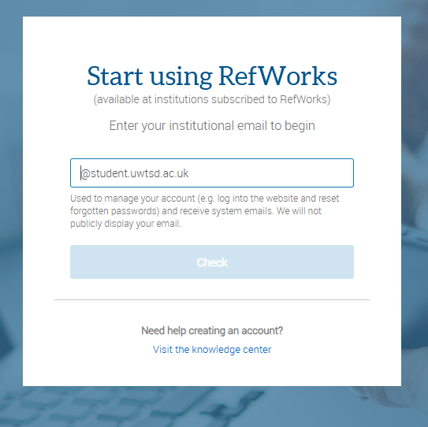  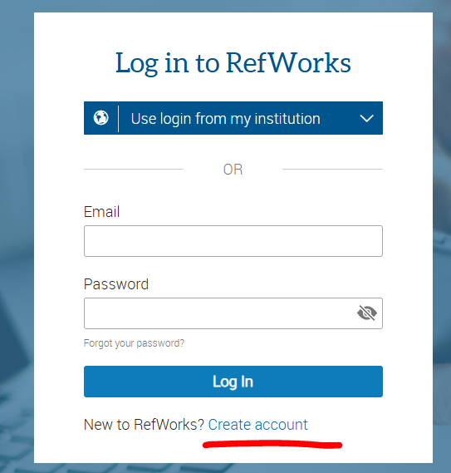 | Create an account with student email
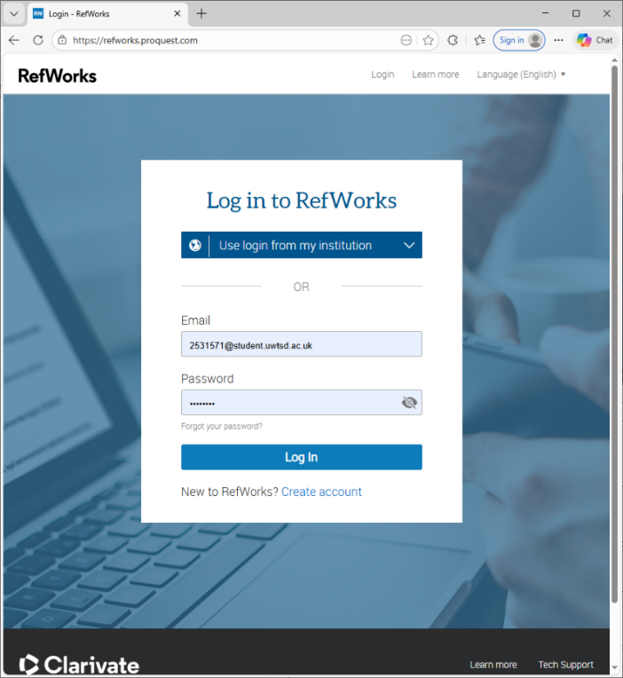 | Login in account
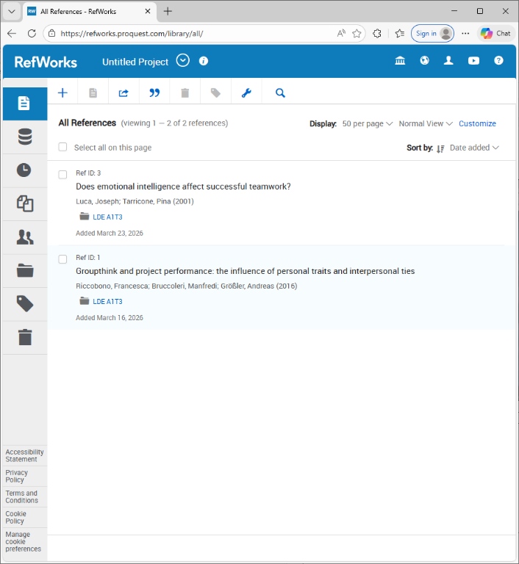 | View of Dashboard with created citations
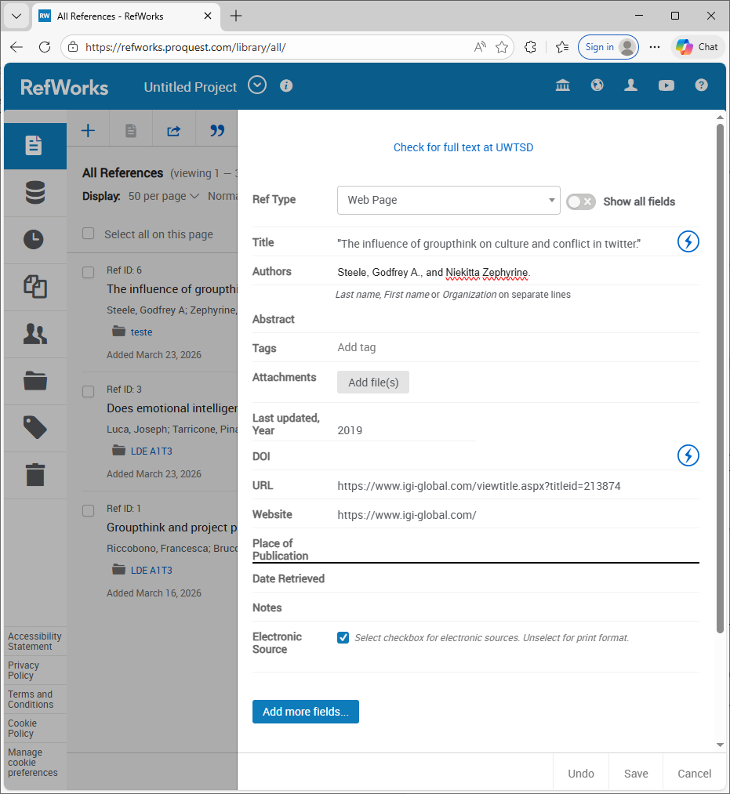 | Adding a manual citation  - Click on “+” icon.  - Fill the form with the reference.  - Click Save.
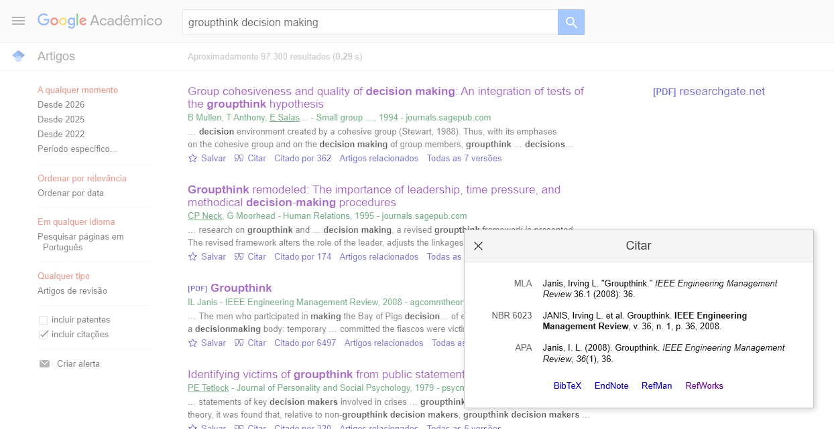 | Adding a automatic citation  - Search and find the document or article.  - Click on link “Cite.  - Choose the tool (RefWorks)
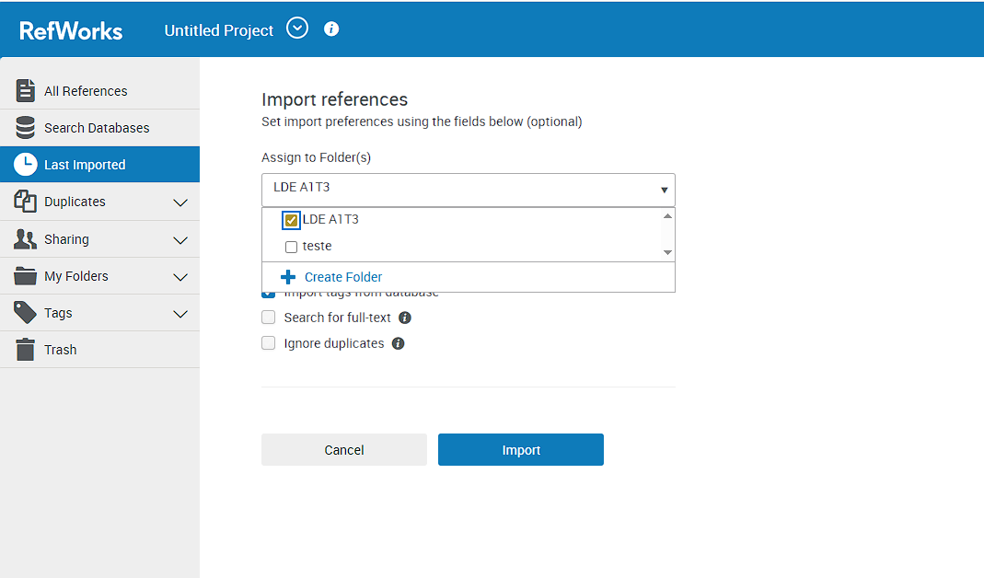 | It will open Refworks  - Choose in wich Folder is going to import  - <LDE A1T3>
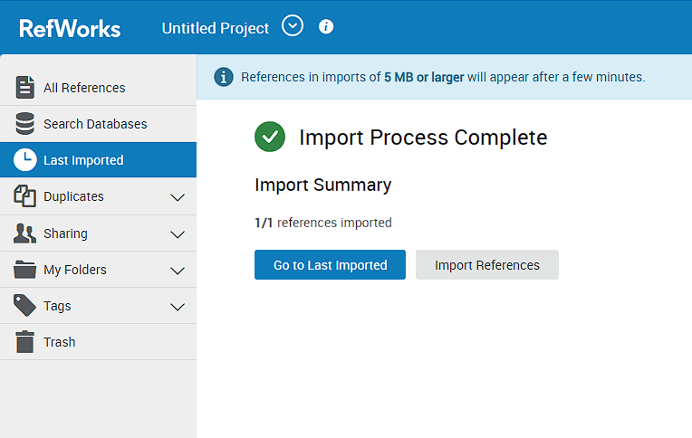 | Import Process Complete  Check for Summary  - Go to Last Imported
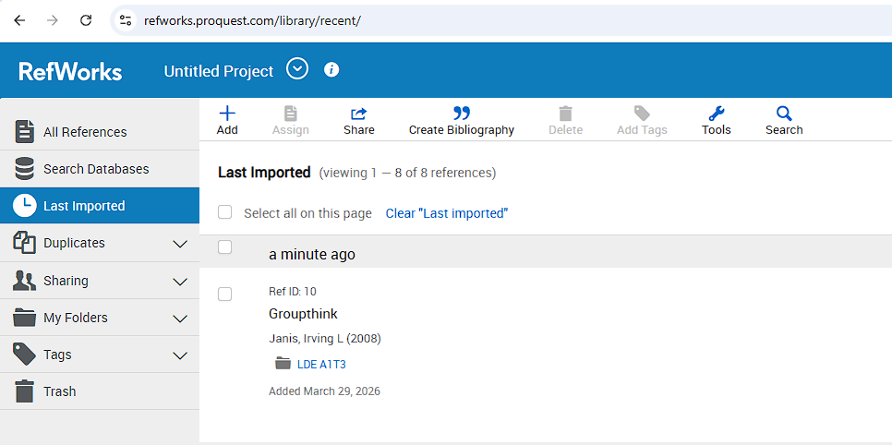 | Recent imported View
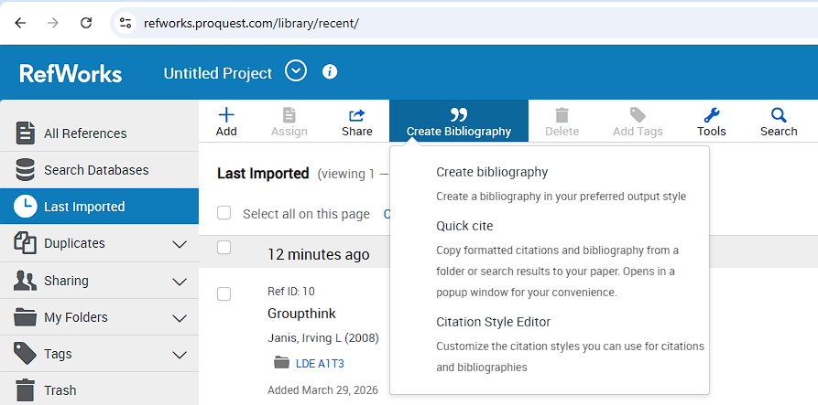 | Create Bibliography
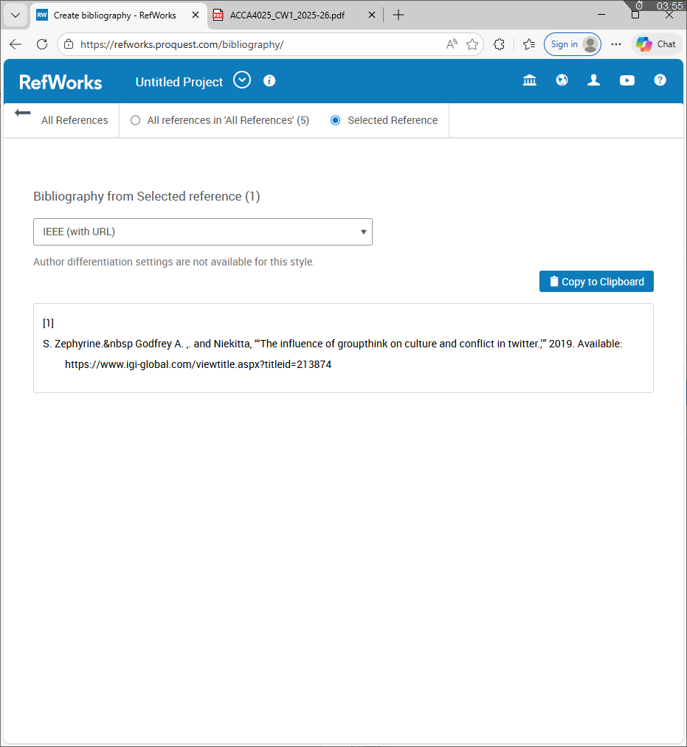 | Choose the style to IEEE  Check the reference created
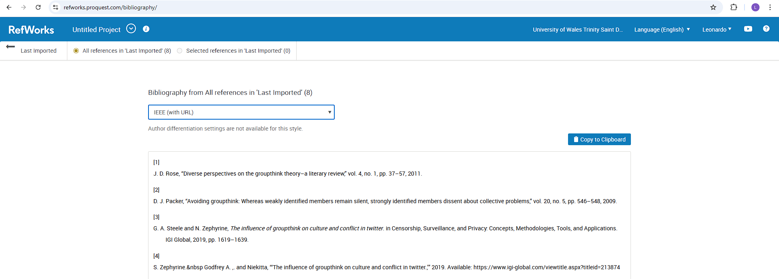 | - Copy the list  - Past in Assessment
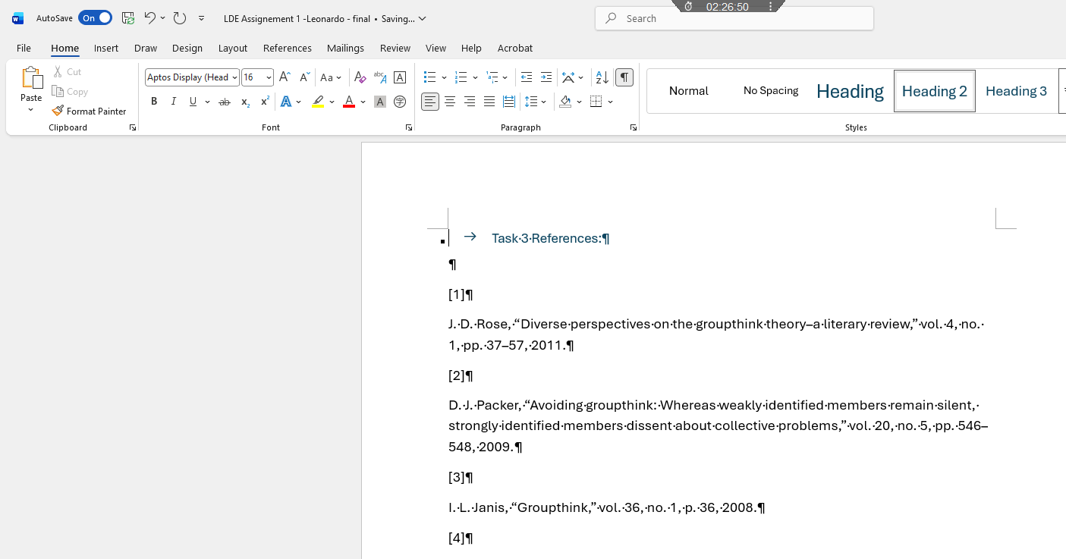 | Task 3 References

Task 4: E-Portfolio Creation and Evaluation

Task 4 (a): E-Portfolio Creation
Link to Home | Leonardo Portfolio
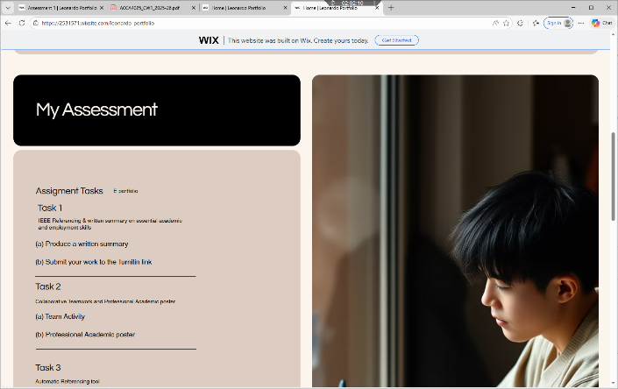
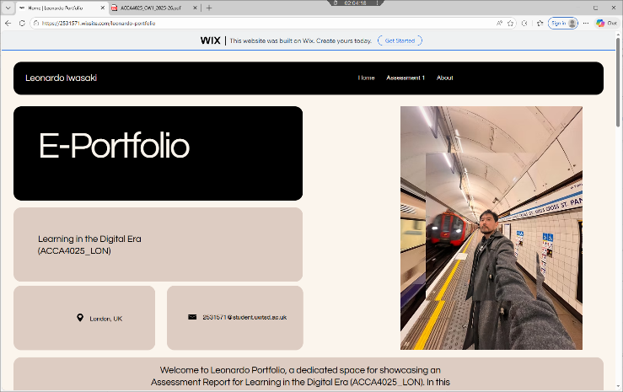
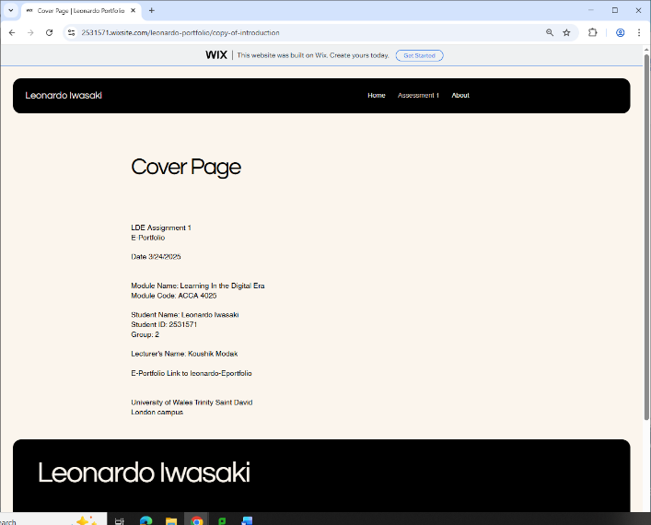
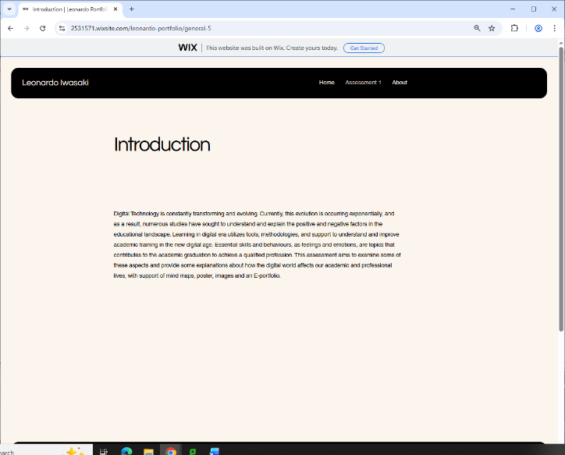

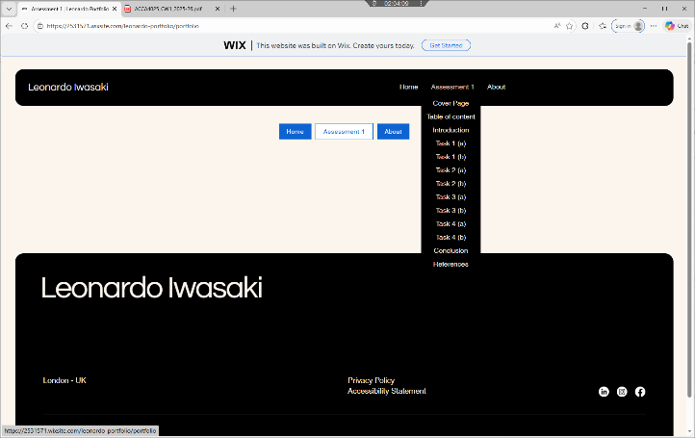

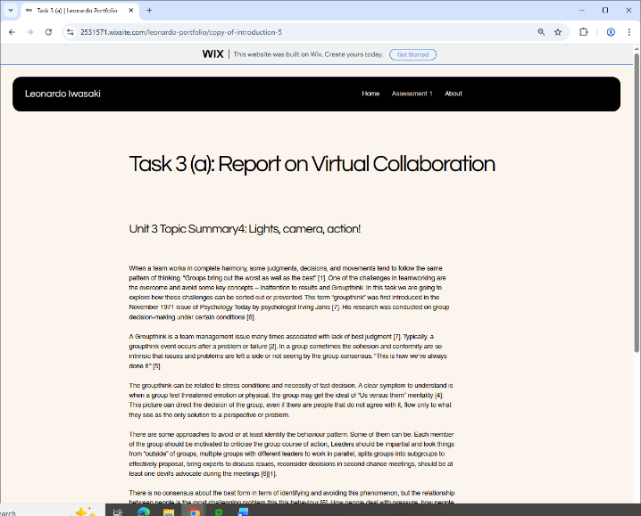
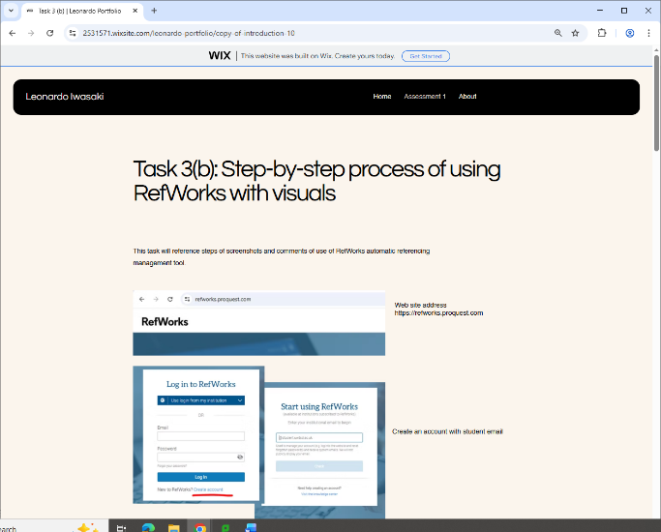
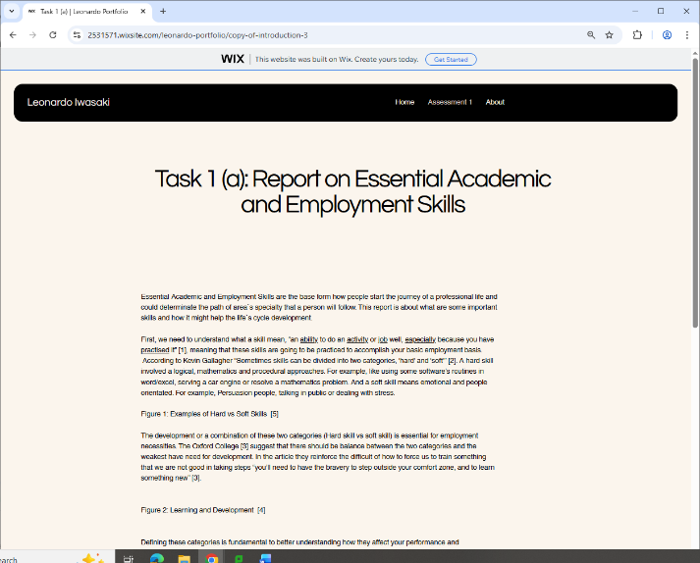
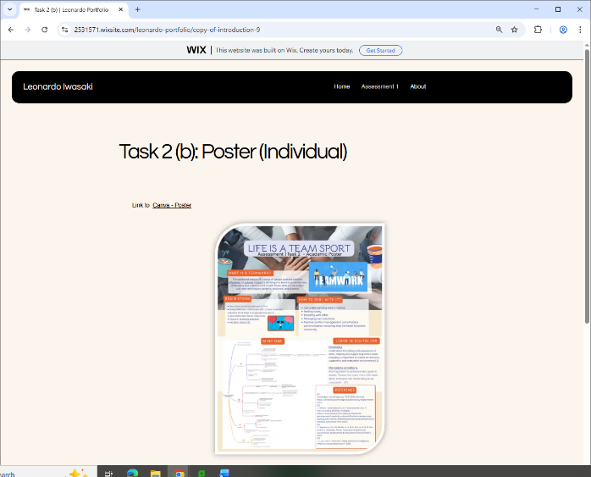
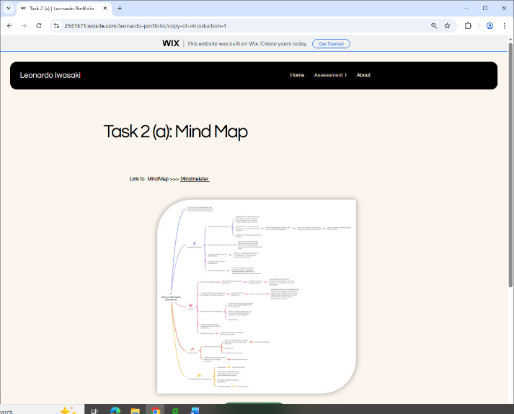
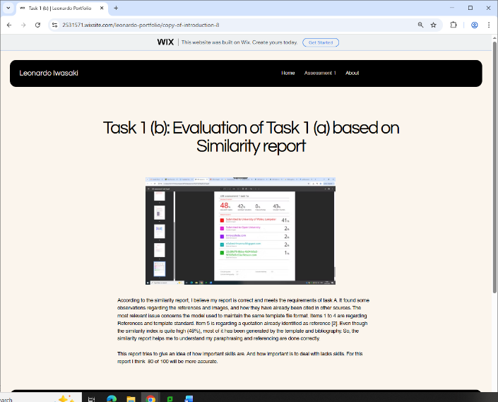

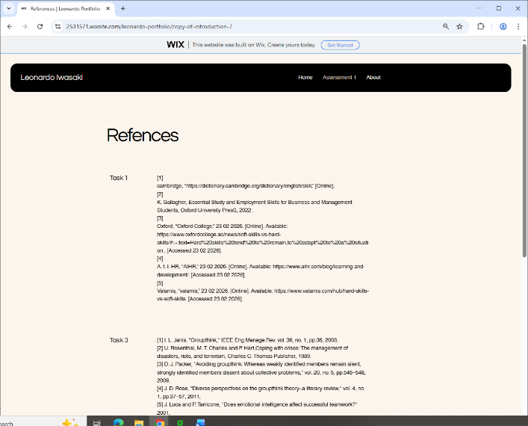
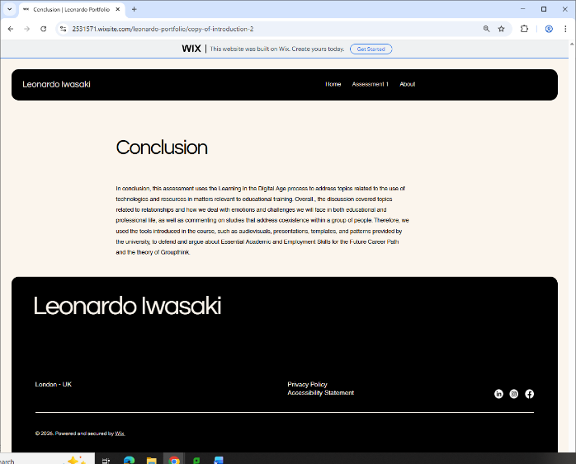
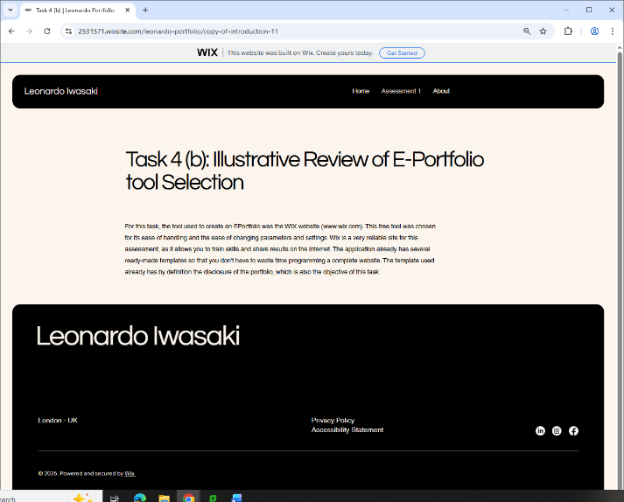
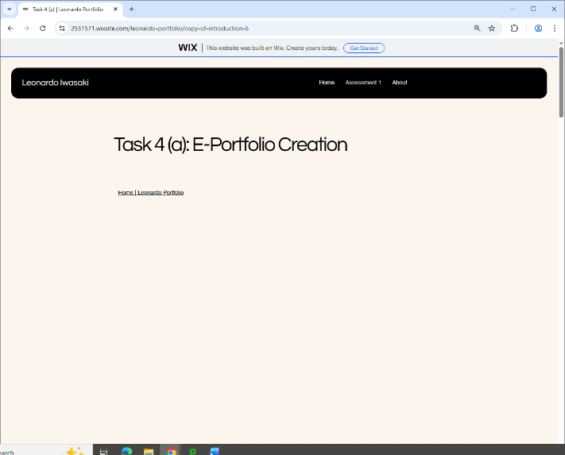

Task 4 (b): Illustrative Review of E-Portfolio tool Selection
For this task, the tool used to create an EPortfolio was the WIX website (www.wix.com). This free tool was chosen for its ease of handling and the ease of changing parameters and settings. Wix is a very reliable site for this assessment, as it allows you to train skills and share results on the internet. The application already has several ready-made templates so that you don't have to waste time programming a complete website. The template used already has by definition the disclosure of the portfolio, which is also the objective of this task.

Conclusion

In conclusion, this assessment uses the Learning in the Digital Age process to address topics related to the use of technologies and resources in matters relevant to educational training. Overall., the discussion covered topics related to relationships and how we deal with emotions and challenges we will face in both educational and professional life, as well as commenting on studies that address coexistence within a group of people. Therefore, we used the tools introduced in the course, such as audiovisuals, presentations, templates, and patterns provided by the university, to defend and argue about Essential Academic and Employment Skills for the Future Career Path and the theory of Groupthink.

References

Task 1 References:

[1] | cambridge, “https://dictionary.cambridge.org/dictionary/english/skill,” [Online].
[2] | K. Gallagher, Essential Study and Employment Skills for Business and Management Students, Oxford University PresS, 2022 .
[3] | Oxford, “Oxford College,” 23 02 2026. [Online]. Available: https://www.oxfordcollege.ac/news/soft-skills-vs-hard-skills/#:~:text=Hard%20skills%20tend%20to%20remain,to%20adapt%20to%20a%20situation.. [Accessed 23 02 2026].
[4] | A. t. I. HR, “AIHR,” 23 02 2026. [Online]. Available: https://www.aihr.com/blog/learning-and-development/. [Accessed 23 02 2026].
[5] | Valamis, “valamis,” 23 02 2026. [Online]. Available: https://www.valamis.com/hub/hard-skills-vs-soft-skills. [Accessed 23 02 2026].

Task 3 References:
[1] I. L. Janis, "Groupthink," IEEE Eng.Manage.Rev. vol. 36, no. 1, pp.36, 2008,
[2] U. Rosenthal, M. T. Charles and P. Hart,Coping with crises: The management of disasters, riots, and terrorism, Charles C. Thomas Publisher, 1989.
[3] D. J. Packer, "Avoiding groupthink: Whereas weakly identified members remain silent, strongly identified members dissent about collective problems," vol. 20, no. 5, pp.546–548, 2009,
[4] J. D. Rose, "Diverse perspectives on the groupthink theory–a literary review," vol. 4, no. 1, pp.37–57, 2011,
[5] J. Luca and P. Tarricone, "Does emotional intelligence affect successful teamwork?" 2001,
[6] F. Riccobono, M. Bruccoleri and A. Größler, "Groupthink and project performance: the influence of personal traits and interpersonal ties," vol. 25, no. 4, pp.609–629, 2016,
[7] Schmidt, Anna. "groupthink". Encyclopedia Britannica, 1 Apr. 2025, https://www.britannica.com/science/groupthink. Accessed 16 March 2026.

