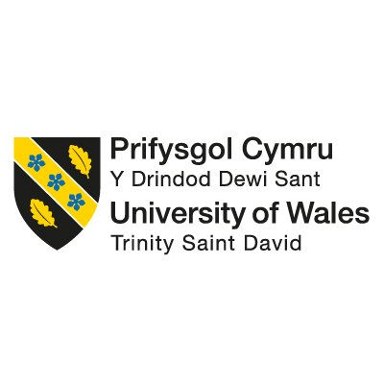

Student Name: Krisztian Horvath
Student Code: 1913410
Module Name: Organizational Consultancy

Housekeeping staffing issues in the Holiday Inn Express


K.H. Management & Consultancy
(Redefining Your Business Strategy)

15.11.2021.

Table of Contents
Executive Summary 3
Introduction to the report 5
Main Body: Scope and Analysis 7
SWOT analysis 9
PESTLE analysis 11
Findings and recommendations 15
Action Plan 18
Reference List 20

Executive Summary

The main purpose of this paper is to investigate the issues of the client while looking at the issues of the housekeeping department in relation to the overall performance of the hotel.

As seen in the tile, the client of this report is Holiday Inn Express Nuneaton, a hotel part of the InterContinental Hotels Group, which is one of the largest hotel chains in the industry.

In order to ensure that all the details of the client are well-processed using the right information, internal and external environmental analysis are going to be applied, by this, direct reference to the PESTLE analysis and SWOT analysis is being made. Both analyses are strategic tools used by businesses to investigate their internal environment and external environment. After applying these two strategic tools, clear consideration of the reasons why the issues have appeared could have been made as there was enough information accumulated to be able to draw conclusions and provide some recommendations.

After applying the SWOT analysis, the report outlined that the hotel has both strengths and weaknesses, one of the strengths being that it has accessible prices, while the weaknesses included the fact that it has absolutely affected employee engagement and motivation at the workplace, as well as bad coordination between department, these both aspects affecting the overall function of the hotel.

However, when it comes to the external environment analysis, the report has demonstrated that the political factors and the economic factors, as well as the social factors can easily act negatively upon the development of the hotel and automatically if the external factors are not covered by great engagement and coordination between the employees of the hotel and departments, all together are going to definitely drag the company even downer than it is already.

Having in mind what has been discussed already, it is important to mention that the report is taking the audience through a problem that is experienced by many hotels not just the chosen one, to be more specific, the issues in the housekeeping department and their engagement along with the other departments. As seen in the report, the housekeeping employees have a bunch of duties and responsibilities, while getting the same salary to a member of staff working in a department that requires it to have less responsibilities, and in the majority of cases this thought can affect the motivation and desire to work of the housekeeping employees.

Throughout the report recommendations have been made to make sure that the hotel is considering introducing new strategies and new motivational techniques towards the employees from the housekeeping department. One of the recommendations that have been made include setting targets for the members of staff from the housekeeping department, and based on the targets, the employees that are working above the targets could be entitled to receiving a particular reward, this being under the responsibility of the Human Resources Department to think about the rewarding system which to enhance greater implication of the employees towards the work they are doing. Apart from the set of target and rewards, the managerial teams must also get involved more in the work that is done by the housekeeping employees because, they tend to be considered as being the most important employees by the guests especially because they are the ones ensuring that the room, they are going to live in for a particular period of time promotes great health and safety, cleanness, the right equipment for bedding and washing. Therefore, coming back to the managerial teams, they could ease of the issues by valuing the housekeeping employees more, as in the majority of cases the employees from the housekeeping department tend to be treated with inferiority by the other departments including the front office department, the Management department and so on.

Considering that there are more types of problems, the audience must understand the problem of the current client, which is analysed in this report, is not a minor problem which is happening on a daily basis, it is a problem that could affect the hotel performance of a long-term period of time, and then it could become even worse for the hotel to get out of this issue.

Introduction to the report

This report as the title indicates is written with the main purpose of serving the current client, with a report which to investigate their current problem in relation to the housekeeping department, which lately started to affect the overall performance of the hotel, and the managerial teams started not to be as happy seeing that the hotel they manage is going down rather than going up.

Furthermore, the report is going be well-structure following a flow between information to make sure that the audience firsts understand who the client is, what is the background of the client, what services it is offering, what departments it has, and a lot of other essential information that the audience must know before reading into the issues, analyses, and the recommendations. As the cover page indicates, the client of this consultancy report is Holiday Inn Express, a hotel which is part of the InterContinental Hotels Group, one of the largest hospitality chains. Regardless the fact that there are numerous Holiday Inn Express hotels in the United Kingdom this report is only focusing on the Holiday Inn Express from Nuneaton, an area which is not as populated, however, considering the lower prices on rooms, people tend to choose this hotel.
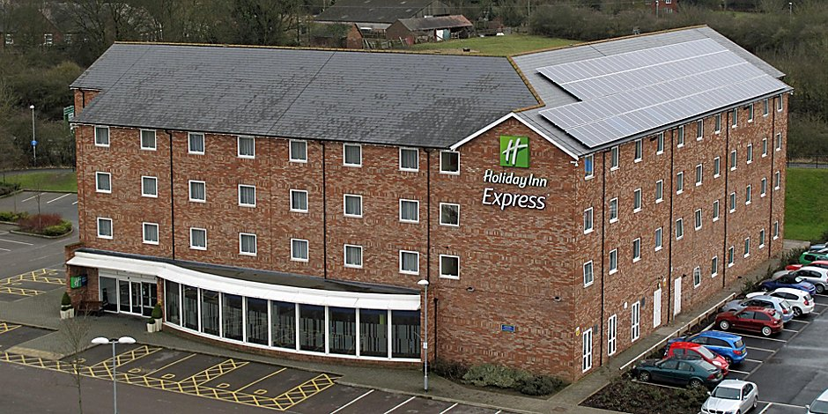

In a request made by this client, it was mentioning that the issues that have been developed within the housekeeping department started to affect the other elements of the hotel as well and therefore, they felt forced by the situation to request some help from the professionals to requests in-depth analysis of the business and recommendations based on the results to see what can be done to solve the problems they are currently facing.

In order to be able to help this hotel out, there particular procedures that must be firstly applied to investigate the background of the hotel, the factors that are affecting internally and externally, the competitors, the roles of the department and their engagement, and a lot of other things that will help reaching out some clear conclusions and recommendations for the future. When speaking about procedures to undertake, the principal analyses to be applied, as mentioned before are the SWOT analysis and the PESTLE analysis. The SWOT analysis is going to support with the investigation of the internal environment this including the Strengths of the hotel, the Weaknesses, the Opportunities, and the Threats. Once these are investigated, it is going to be easy to note where the issues are in the company, and what opportunities could be accessed to try and solve the problems in the company. Going further to the PESTLE analysis, this is a business strategic tool, used by companies to investigate the external environment by looking into the Political factors, the Economic Factors, The Social Factors, Technological Factors, Legal Factors, and lastly the Environmental Factors that could affect the hotels negatively from the outside (Fitzen, 2009). The PESTLE analysis would support the hotel to reach out reasons why the external factors could play upon the engagement and motivations of the housekeeping members of staff and also upon managerial staffing towards the housekeeping department.

Main Body: Scope and Analysis

As mentioned in the introduction the main purpose of this report is to help the client solve its operational issues within the staffing upon the housekeeping department and the influence of the staffing methods upon the engagement of housekeeping employees in the organization (Kelleher, 2013). Considering what has been discussed until this point, it is clear that the Holiday Inn Express Nuneaton is dealing with poor communication between the employee and employer, this being applicable within the housekeeping department. Having in mind that the hotel has requested support from professionals, it is clear that the problem is nowhere near to being recent, and it automatically means that the problem has already affected to some points the progression of the hotel.

This section of the report is designated with the main purpose and scope of conducting the SWOT analysis, which as mentioned before is looking into the strengths, weaknesses, opportunities, and threats of the hotel (Sarsby, 2016). This analysis will bring some advantages to the hotel, one of these including the advantage of getting better support in the future decision-making processes that are going to be undertaken by the members of staff of the hotel. Just to remind that the SWOT analysis will be included to look into the internal environment of the company while looking into the current operation of the departments, the strategies that are used, the communication channels that are applied, the engagement events that they organize to bring the employees all together, and a lot of other things to make sure that the best results are generated in the discussion.

Another reason for writing this section has to do with the analysis of the external environment, which is going to be undertaken as mentioned in the introduction by applying the PESTLE analysis, which as mentioned is looking into the external factors which include Political factors, Economic Factors, Social Factors, Technological Factors, Social Factors, and Environmental Factors (Campbell, 2015). Each particular group of factors is equally important when investigating the situation of the hotel as there could be small bits from each group of factors working together to affect a section of the hotel, which on a long-term basis could expand. The information for this PESTLE analysis is going to be accumulated from interviews held by this hotel, the status of the competitors, the reviews that are provided and a lot of other things. Especially the reviews they play a very important role as they are the ones that are guiding the hotel to success by outlining their opinions about the services that are currently offered and also products (Uysal & Williams, 2003).

Before going through the analysis, it is important to provide a company background to get the audience introduced to information about the client. Therefore, the first thing to mention is that the hotel is located near great touristic points and also, it is leading the guests to big towns such as Coventry, places where they can take advantage of historical places, night life, shopping, and a lot of other things (Booking.com, 2021). On their website they do mention that they are an eco-friendly hotel and that has a lot of service to offer of which room service, free parking, free breakfast, free internet, pet allowance (Holiday Inn Express, 2021). Because it is an “Express” Holiday Inn not a normal Holiday Inn hotel, it is important to mention that the Holiday Inn Express from Nuneaton has less services to offer comparing to the other Holiday Inn hotels. In terms of number of guests, it is important to mention that the hotel has been highly affected by the situation with the Pandemic COVID-19 (IHG Hotels & Resorts, 2020) because the government guidelines made the hotels close and looking at the statistics, there has been a significant decrease in revenue for Holiday Inn company as a whole (Statista, 2021).

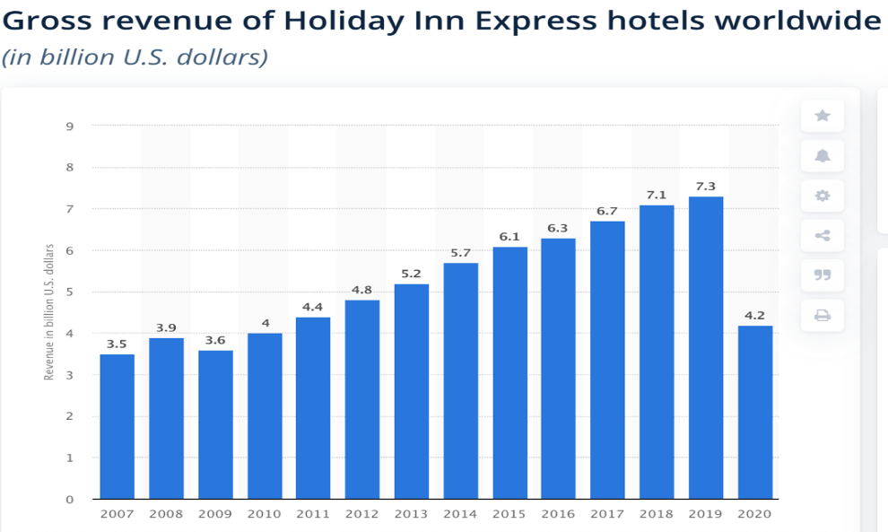
More to add, considering that the client is part of the InterContinental Hotels Groups, careful attention should be provided as it is a large hotelier chain, and the reputation of it as well the appreciation of people facing it as hotel chain must be well-maintained.

SWOT analysis

As mentioned before, this business tool which is going to be applied on Holiday Inn Hotels is looking after four main things within the company and these are the Strengths, Weaknesses, Opportunities, and Threats.
Starting with the Strengths- Holiday Inn ensures to provide for its guests what they are desired for. Holiday Inn portfolio includes 1,186 hotels with 215,714 rooms globally as of March 2019 (Statista, 2021). Approximately 100 million people stay in Holiday Inn hotels every year. There is an amazing fact that 9 out of 10 travellers have been accommodated in a Holiday Inn hotel globally (IHG, 2019). Holiday Inn owned by the one of the biggest hotel chains in the world, IHG group. IHG is a global organisation that owns numerous hotel brands through franchises, leases, manages, owns many hotels all around the globe (Hotels, I.H.G., 2021). Holiday Inn provides a budget hotel service but efficiently managed and benefited as well as the other brands of the IHG group. Holiday Inn brands work really well to uplift the image of the brand.
Brexit affected beneficially Holiday Inn alongside with other brands of IHG Group due to the decreasing value of the British Pound. Investors can turn towards investments which bring dollar earnings. This can happen because half of the company’s earnings gained from the US. Share price rose from £27.23 in June 2016 to £40.93 in October 2017 (Dunkley, 2019).
Going further to the Weaknesses- In April 2017 Holiday Inn UK was targeted by hackers. This attack affected 1,200 of the brand’s franchisees. The attack was made at the time of the payment at the front office desk, where the hackers could steal information from guests, such as card number, verification code etc. This clearly demonstrates Holiday Inn’s vulnerability against cyber-attacks (BBC, 2017).
The Holiday Inns Birmingham once had to be temporary closed due to a lack of hygiene standards discovered by health and safety inspectors. These poor hygiene standards caused a food poisoning outbreak. The hotel could reopen after the improvement of cleanliness and food safety management (BirminghamLive, n.d.). This event could affect the image of the brand.
The next aspect to look into has to do with the Opportunities- Holiday Inn has a great opportunity to grow by extending its market using the profit gained from their UK hotels financing the expansion towards the German market. There is a plan for a partnership with Manchester Airport City to open a large Holiday Inn hotel in 2019, which is also a good opportunity. Furthermore, they have a similar plan at the Luton Airport (IHG- Hotels & Resorts, 2021).
Atlas Hotels, and Somerston Capital fund are implementing huge investments into Holiday Inn franchises. Atlas already owns and runs numerous Holiday Inn Express in UK. Atlas also plans the extension with 1,000 bedrooms soon. Their future plans include increasing their collection to over 60 hotels with some 7,500 rooms within the next few years. This has been agreed with IHG for the further 15 years starting 2018 (Gowrea, n.d.)
Lastly to discuss, there are the Threats, which are extremely to be known- The biggest threats of Holiday Inn are the competitors from the same market. These are the other well-known brands as Premier Inn, Travelodge, Ibis, Comfort Inn, Fairfield Inn. Holiday Inn has to face a price competition with the above-mentioned brands. For example, Travelodge and Ibis practice can provide lower rate for their guests thanks their low-cost strategy. In comparison Premier Inn owns more building and rooms than Holiday Inn. It is also important to mention that the competitor budget hotel’s expansion rate is better than Holiday Inn has (Gowrea, n.d.)
Overall, it is important for the client to look after more opportunities that could engage the employees more in the work that needs to be completed at the workplaces as this will make them have more advantages and greater performance of the hotel. More to add, another thing recommended for Hilton Inn express after looking into the general SWOT analysis, it is important to mention that they must think about strategies that will help them turn the threats in their advantage and refuse just living up to them, as this would definitely not bring the hotel back on track.

PESTLE analysis

There are many factors in macro-environment that could affect the of organizations. These changes could bring certain positives as well as negatives for every business. PESTEL (Political, Economic, Social, Technological, Environmental and Legal) Analysis is a tool which is widely used by business managers for analysis of these critical factors. It is very helpful for development of strategic decision making (Del Marmol, Feys and Probert, 2015). These changes could be sudden Changes in Tax, Imposition of Laws, Increasing or Reducing Trade Barriers, Cultural & Demographic Changes and Changes in Political Environment & Government Policy are some of the key examples of macro environment. The Holiday Inn’s PESTLE Analysis is going to be written below, aiming to critically evaluates and identifies different strategic in a competitive and dynamic environment.
Starting with the political factors, it is important to start by saying that they are both positive and pragmatic in collaboration with the UK Government as this has influenced the hospitality industry to become a key to the success area to the economic development of the United Kingdom. Therefore, some political factors that could affect in the future include:
The first ones to discuss are the travel bans this is said because in more circumstances this could make the hotel fail. The government and its decisions can impact the hotel industry with ease and therefore, the political decisions can affect negatively. According to Fox (2019) a study demonstrates that with the implementation of Brexit international guests, especially Europeans, find it more difficult to travel and less likely want to go into abroad holidays in the United Kingdom.
Furthermore, another political factor has to do with the tax reforms, which refer to the fees that the hotel must pay throughout a year. This could have to do with the taxes that the hotel pays for transport of raw material, tax that is paid towards employees (Schafer, 2019). Having this in mind, hotels must always have a plan B to ensure that they do have saved money which to be used to cover extra charges input by the government.
The last factor to discuss in the political factors section has to do with the presidential elections and this because a lot of owners of hotel tend to be on edge in the period when the elections start and this because the new president could think about introducing new restrictions on the sale of some products such as cooked food, alcohol, etc. Therefore, the hotel should always be prepared to adapt to different changes that could come into place.

Going further to the economic factors, same as for political there are quite few that could easily affect the hotel negatively and these include:
Firstly, there is a big investment expected to grow, hotel owners never know what the best idea to invest into is and this because guests have different preferences and therefore, they could react differently to changes made in the hotel. Therefore, the hotel must not put all of its finances into one idea that is not assured to be successful for a longer period.
Secondly, there is the strength of currency can affect the hotel industry, there are positives and negatives when it comes to currency and this because in some cases this could affect the attractiveness of a spot in a holiday. One example to give can be outlined by the fact that if currencies are better than the Britain pound, then international people may want to visit it.
Going further, the importance of economic cycling is another factor to discuss since a lot of companies tend to be affected by changes that are made in the economy, however, the hospitality industry is considered as being one of the most susceptible to the influence. The hotel industry tens to go through cycles of economy first, but it is also the most expected to successfully get out of the economy crisis, especially Holiday Inn which has managed to gain a great brand awareness in the industry and satisfy thousands of guests yearly.
Tailoring to patrons in varying locations is another factor since there are more and more hotel chains that have started to improve their profitability some to include are Marriott International, Hilton hotel and therefore Holiday Inn should think about innovative strategies which to make their brand unique in front of their customers, there should be something that the other brands do not have (Frue, 2019).

Thirdly, the social factors are very important because these have to do with the preferences of people and their behaviour towards the hotel. Therefore, for Holiday Inn, some of the social factors that affect the hotel include”
- Big trouble with Airbnb: Airbnb is the major competitor for the hotel industry. Travelers can find numerous of rooms that Airbnb offers. There is a fast and convenient way to book a room by using their app to find a less expensive room than the hotels provide in the nearby area. The advantages of Airbnb that it can overcome on hotels during peak seasons. Because when peak season hits hotels can be fully booked, or they increase their prices in order to gain higher profit. In this scenario travellers easily and more likely can find a room with Airbnb, which is cheaper and suitable for them, instead of trying to find another hotel to fulfil their needs. In other hand hotels with useful facilities such as pool, gym, restaurant, and other extras offer much more than a simple room booked via Airbnb (Frue, 2019). Therefore, Holiday inn could think about such strategies to improve their guest’s time and accessibility while being in the hotel.

The technological factors have always been important in the last decade and this because the technology has been improving periodically and automatically the hotel must be aware of everything that is new to be able to keep the step. These technological factors include:
Firstly, there is the new tech that hotels must worry about, for example, before hotels used to use traditional methods of marketing and their management used to be paper based. However, in the current world most of the hotels have started to focus on online check-in to make the process easier for both the guests and the employees, this involving technology and making customer’s data safer being kept in the archive of the hotel. However, hotels must now focus on social media platforms such as Facebook or Instagram, where the majority of internet user spend most of their time on (Frue, 2019).
Secondly, there is fast sharing of information due to the rapidity of internet, for example, when there is feedback of the hotel or when some better deals from other hotels are written, such things will be quickly published on the internet for the people that are interested in the hotel as based on what has been published about the hotel, will make them make a firm decision if they want to go to that hotel or not. (Wainstein, 2019).

Reviews and feedbacks can influence a hotel’s reputation: hotel guests can write a review, give feedback, and share their experience about their stay on different technological platforms. This information used to collect by the hotels. These data collection can be automated in many hotels. But hotels have to protect their guest’s data what many of them already failed (Rahman, n.d.). Furthermore, according to Frue (2019) the reviews and feedbacks can build or destroy the hotel reputation. Because in recent years there are many ways to share any feedback what easily accessible to anybody.

Legal factors: Problems with following regulations

- Crime rates can ruin hotel profit and reputation: Every guest desire for a safe stay. If a hotel stays in an area with high crime rates can ruin its reputation. According to Huang, Kwag and Srteib (1998) crime can be a big concern of many hotels. Therefore, hotels have to ensure that their guests stay and feel safe. However, hotels are equipped with security systems they may still have high crime rates because of untrained staff members and/or their location. A safe location with low crime rate is essential in the hotel industry to attract travellers.
- Inn Keeper laws: Hotel owners have to follow innkeeper laws, which are standing for protecting guests. These laws can be varied from different locations, most require hotels ensure the safety of guests and their properties. The innkeeper law ensures guests how much compensation guests entitled for any stolen or damaged belongings (Bradley-Hole, 2007).
- GDPR: Europe has implemented the European Union’s General Data Protection Regulation (GDPR) this year. This includes a strict data and privacy policy of users. Violating the regulation could lead to several penalties. And Facebook has had a few issues alongside with Google with following the GDPR guidelines already (Dhont & Theodorakis, 2021).
- Truth-in-menu laws: Hotels with food or beverage establishments within such as restaurants, room service, function rooms must follow truth-in-menu laws. According to NSU (n.d.) the false presentation of food and beverage products is a violation against the law. Therefore, the food establishment must be truthful about the food and beverages served to guests.

The last factors are Environmental factors, and these are hand in hand with the sustainability that is promoted by the company. Some of these include:
- A small carbon footprint: Most of Facebook’s emissions are from the company’s American data centres. However, it has been decreased over the last few years, compared to other companies (Sustainable hospitality alliance, 2020). Facebook still uses coal power to generate power in the data centres, but they also use gas and nuclear as well. They should put more effort into using renewable energy systems to cut their carbon footprint further. It will put less strain on the environment as well.
In order to prevent the environmental factors, the hotel is clearly outlining that they are trying their best to be an eco-friendly hotel and make sure that sustainable procedures are being applied (IHG Hotels and Resorts, 2021).

Findings and recommendations

As mentioned throughout the report, the client came with the problem in relation to the staffing issues and engagement problems in relation to the housekeeping department and therefore, after looking into the SWOT analysis and PESTLE analysis there have been some clear things that came on top of the situation.
The first thing to mention is regarding the fact that the managers are focusing on some other different things but not on how the employees are feeling at the workplace or how they are thinking when they look at the tasks that they have to complete, and this because the managers are focusing on investing in marketing, dealing with travel bans, rate of tax and a lot of other things, which are important for the hotel as well.
However, the managers should pay attention to how their employees feel, how they find their work and so on. Therefore, as a professional, the main recommended thing to the Holiday Inn Express hotel is to focus more on the communication with the employees, and here it is meant with all the employees, because it was clear that the managers had great communication with the front office department, finance department HR department (Hayes & Ninemeier, 2009), but it was nothing in relation to the housekeeping department, which as mentioned tends to be neglected to a major level, thing influencing them to neglect the work that they have to do and by this, the guests that are coming will se that the work that has been undertaken has not be done properly, and this will affect the general reviews of the hotel.
Currently, the client particularly from Nuneaton has 4.1 stars out of 5 stars and this is based on 466 reviews on TripAdvisor.
One example of negative review left for Holiday Inn Express in regard to the housekeeping has been left by Lauren F. and she says:

“Upon arrival I was pleasantly surprised, the reception area of the hotel was bright and clean, and I was feeling positive about the trip. Helen at reception checked us in, she was lovely and one of the best bits about the hotel. It was distracting that the young lad that was checking the couple in next to me had 2 large stains on his shirt, not the best advert when you work front of house. We went up to our room at slightly after 3, the time we were advised we could check in, when we arrived at our hotel room the cleaners were still in. I appreciate that it is a large hotel and many rooms to clean however if they are struggling for time then maybe they need to employ more cleaners or push back the check-in time. We had to come back downstairs for 10 minutes and sit in the bar and wait.

When we got back up to the room (215) we were horrified. The room smelt overpoweringly like BO, so we had to open the window as wide as possible to air it out. There were significant dirty marks all over the wallpaper, more so over the headboard of the bed. There were dirty stains all over the carpet. There were stains on the bed sheets, along with hairs...nice! The lamp next to the bed was hanging off the wall. The soap dispenser in the bathroom was disgusting, you would need to wash your hands after washing your hands! There were hairs in the shower also.

I did not feel comfortable staying in this room and so went downstairs to complain. When I got downstairs there was a huge que in reception waiting to check in, looks as though they were from a coach trip. An older lady had also slipped in reception on some spilt water where there hadn't been any wet floor signs, I do not know the outcome however at breakfast the following morning she was in a wheelchair. When we eventually got seen I complained to the manager, he did not seem surprised when I listed my complaints and offered to get me moved straight away. Saying that the room I had been allocated was due a refurbishment...not kidding!

The room we got changed to (219) was marginally better. There were still stains on the carpet however they were near the tea + coffee making facilities and therefore felt much more at ease about this as at least we knew what the stains were! There were still marks all over the walls also however the bed was much cleaner. Had I been able to get my money back, I would have taken it and gone down the road and booked the Premier Inn without a doubt as we've stayed there before and it's lovely.

Breakfast the following morning was nice, no complaints there. Plenty of choice and everything looked great.

Would I stay here again? Not a chance! Would I recommend? No”

Therefore, looking at the review, it is clear that they are dealing with numerous issues, one of them also being the cooperation between departments, which in most of the cases, such as the case of the customer is very affective towards the impression that is developed by the guests, and then they start to compare the services you offer to the ones of another hotel, in the case of the review, the guest has mentioned about Premier Inn which until present did not manage to disappoint her with the services.
One recommendation to improve the communication has to do with the introduction of some walkie-talkies and share information about the status of rooms instantly so the front office departments knows if it is the right time to check the guest in or not (Senasi, 2020).

Action Plan

- Introduce walkie talkies: As mentioned before, these are going to help the departments to communicate one with another and ensure that there is not miscommunication, or there is no action taken in the wrong time. For example, if there is a guest coming for a room that is still in the process of cleaning, the front office can request information about the status of the room and based on what the housekeeping member of staff is responding to take a decision in terms of when to do the check-in.
- Managers engage more in the relationship between them and the employees as when the employees are feeling neglected, the performance of their work is automatically expected to decrease and when this is happening, the overall performance and reputation of the hotel is going to go down as well. Even the reviews of the hotel are demonstrating that the guests are firstly looking at the cleanliness of the hotel before doing anything else.
- The other departments must appreciate the work done by the housekeeping team rather than excluding them just because they do a different sort of job, because if you think about it, a lot of research has demonstrated that they are (Digital Workplace, 2021)the most important especially because they are the ones ensuring health and safety in the hotel, throughout the corridors, in the toilets, in the kitchen and so on…

Conclusion

To conclude the consultancy report, numerous issues have been identified in the client hotel. These identified issues affecting the smooth housekeeping operations of the hotel. The issues identified by the consultancy team are staffing issues and engagement problems in the department under investigation. As a result of the evaluated issues, it can be stated that the problems affecting the customer satisfaction and even the reputation of the hotel. Therefore, the recommendations and the action plan should be implemented to mitigate the identified issues included in the report. With the successful implementation will lead to a better housekeeping department and more satisfied customers.

Reference List

BBC (2017) Holiday Inn hotels hit by card payment system hack. [online] available at: https://www.bbc.co.uk/news/technology-39642172 last accessed on: 9th June 2021

BirminghamLive, (n.d.), Six people sick of food poisoning outbreak at Holiday Inn in Birmingham city centre. [online] available at: https://www.birminghammail.co.uk/whats-on/food-drink-news/six-people-sick-food-poisoning-12725656 last accessed on: 10th October 2021

Booking.com, (2021), Holiday Inn Express Nuneaton- an IHG hotel: about & reviews. [online] available at: https://www.booking.com/hotel/gb/daysinnnuneaton.en-gb.html last accessed on: 8th June 2021

Bradley-Hole, A., (2007), Innkeeper laws: What are they? [online] available at: https://www.nbcnews.com/id/wbna17260798 last accessed on: 12th October 2021

Campbell, P., (2015) PESTLE analysis in a day, published by: CreateSpace independent publishing platform.

Del Marmol T., Feys B., Probert C., (2015), PESTLE Analysis: Understand and plan for your business, published by: 50Minutes.com. [online] available at: https://www.google.co.uk/books/edition/PESTLE_Analysis/h_uQCgAAQBAJ?hl=en&gbpv=1&dq=environmental+and+pest+analysis&printsec=frontcover last accessed on 11th October 2021

Digital Workplace, (2021), The importance of collaboration and appreciate in the workplace. [online] available at: https://kissflow.com/digital-workplace/collaboration/importance-of-collaboration-in-the-workplace/ last accessed on: 12th October 2021

Dhont, J., & Theodorakis, N., (2021), General Data Protection Regulation, published by: Intersentia Limited.

Dunkley, D. (2019) Brexit bounce for Holiday Inn group, available at: https://www.thetimes.co.uk/article/brexit-bounce-for-holiday-inn-group-mnkcdjxhz last accessed on: 8th June 2021

Fitzen, L., (2009), Marketing Environment, published by: GRIN Verlag.

Fox, J. T., (2019), Study shows Brexit has hurt traveler’s perception of UK. [online] available at: https://www.hotelmanagement.net/legal/no-deal-brexit-could-hurt-uk-perception-among-travelers last accessed on: 10th October 2021

Frue, K., (2019), PESTLE Analysis for Hotel Industry. [online] available at: https://pestleanalysis.com/pestle-analysis-for-hotel-industry/ last accessed on 12th October 2021

Gowrea, V., (n.d.), SWOT analysis of Holiday Inn (Holiday Inn SWOT). [online] available at: https://howandwhat.net/swot-analysis-holiday-inn/ last accessed on 10th October 2021

Huang, W.S., Kwag, M. and Streib, G., 1998. Exploring the relationship between hotel characteristics and crime. Hospitality review, 16(1), p.9.

Kelleher, B., (2013), Employee engagement for dummies, published by: John Wiley & Sons

Hayes, D. K., & Ninemeier, J. D., (2009), Human Resources Management in the Hospitality Industry. John Wiley & Sons.

Holiday Inn Express, (2021), Holiday Inn Express Nuneaton: An IHG Hotel. [online] available at: https://www.ihg.com/holidayinnexpress/hotels/us/en/nuneaton/xnvuk/hoteldetail last accessed on: 8th June 2021

Hotels, I.H.G., 2021. IHG Celebrates Seventh Straight Year as a Best Place to Work for LGBTQ Equality.

IHG Hotels & Resorts, (2020), IHG Way of cleaning: promise. [online] available at: https://www.ihg.com/content/us/en/customer-care/clean-promise last accessed on: 8th June 2021

IHG (2019) Holiday Inn, available at: https://development.ihg.com/s/amea-holiday-inn last accessed on: 9th June 2021

IHG Hotels & Resorts (2021), The growth of Holiday Inn Express shows brand momentum in Europa.

IHG Hotels & Resorts (2021), IHG Green Engage system, [online] available at: https://www.ihg.com/content/gb/en/about/green-engage last accessed on: 8th June 2021

NSU, (n.d.), THRUTH IN MENUS Managing Hospitality Risks, [online] available at: https://www.ultrariskadvisors.com/wp-content/uploads/2012/07/MHR_Menus.pdf last accessed on: 12th October 2021

Rahman, M., (n.d.), PESTEL analysis of the hotel industry. [online] available at: https://howandwhat.net/pestel-analysis-hotel-industry/ last accessed on 12th October 2021

Senasi, S., (2020), Tonality in communication for the hospitality industry. Published by: Partidge Publishing Singapore.

Sarsby, A., (2016), SWOT analysis, published by: Lulu.com

Schafer, S., (2019), How is the tax reform affecting the hospitality industry, [online] available at: : https://blog.smithschafer.com/tax-reform-impact-hospitality-companies last accessed on: 9th June 2021

Statista, (2021), Gross revenue of holiday inn express hotels worldwide. [online] available at: https://www.statista.com/statistics/223347/holiday-inn-express-hotels-revenue/ last accessed on: 8th June 2021

Sustainable Hospitality Alliance, (2020), Area of action: Climate action. [online] available at: https://sustainablehospitalityalliance.org/our-work/climate-action/ last accessed on: 8th June 2021

TripAdvisor, (2020), Holiday Inn Express Nuneaton. [online] available at: https://www.tripadvisor.co.uk/Hotel_Review-g504201-d589361-Reviews-or5-Holiday_Inn_Express_Nuneaton-Nuneaton_Warwickshire_England.html#REVIEWS last accessed on: 10th June 2021

Uysal, M., & Williams, J. A., (2003), Current issues and development in hospitality and tourism satisfaction.

Wainstein, L., (2019), Data security in Hospitality: risks and best practices, published by: EHL.

