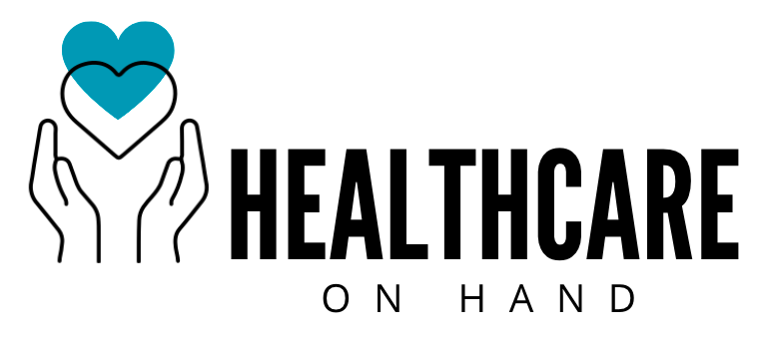

Wellbeing at Work

GUIDANCE DOCUMENT
Updated 21st June 2023

How can we ‘achieve’ a work-life balance? (AC 3.1)
Overview
This guidance advises owners and managers at Healthcare on Hand of relevant legislation and compliance, support the wellbeing of our people - by working towards a work-life balance - and to recognise the importance of diversity and inclusion. It aims to summarise fundamental organisational practices and employment law, in an easily digestible manner and provide clarity for those looking to further their understanding of welfare at work. Helpful links for further reading, relevant to each section, will be found as footnotes.
The employment relationship shaped by us all at Healthcare at Hand, is influenced by the requirement of legal compliance as well as more particular factors within [and external] to the organisation, including individual needs. These mutually agreed ‘terms’ should holistically outline what we believe to be work-life balance, as well as the roles both the company and employee play in working towards it; it is vital that we show employees we recognise and value the significance both their personal and professional lives (Waite et al., 2021). For instance, flexible working arrangements lead to more satisfied staff and lessen the conflict between the two, therefore a commitment to exploring the different forms of flexible working is important. Research suggests that over 10 million workers in the UK have taken burn-out induced sick days, which could be extremely costly for businesses (Visavadia, 2022). Employees are more likely to be able to ‘switch off’ from work if they are given the trust and autonomy to control their own work environment (Youngs, 2023).

Needless to say, policies at Healthcare on Hand should comply with legal requirements, such as Working Time Regulations 1998 and the Health and Safety at Work etc Act 1974, and respect employee entitlements (Suff, 2022c). However, it is also important that employers are making their people aware of these. Research by employment law solicitors has found that 41% of parents are not aware that they are legally allowed to take unpaid parental leave and three-quarters have never exercised this right (Working Families, 2019).

What is workplace wellbeing? (AC 3.2)

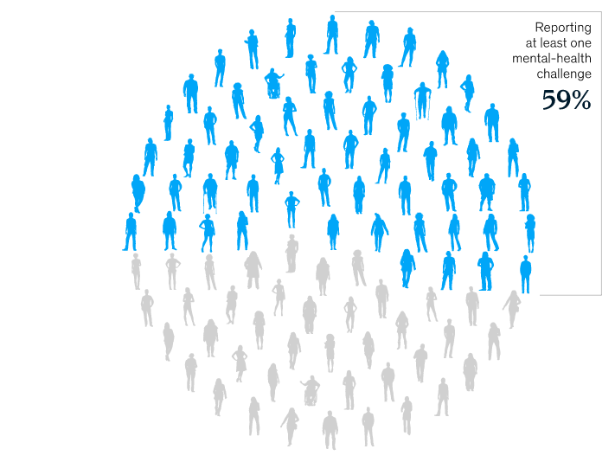
By focusing on wellbeing, we will be supporting our own and employees’ ability to sustainably thrive with there being a strong, positive correlation between employee wellbeing, productivity and firm performance (Krekel, Ward & De Neve, 2019). The term represents a person’s quality of life, accompanied by a sense of meaning and purpose as a result of their contribution to the world (WHO, 2023).
McKinsey & Company (2022)

We can confidently suppose that the majority of our employees will have been affected by at least one mental-health challenge in their life so far. This representation of respondents’ experiences in a survey across 15 countries, is helpful in visualising a common, individual factor effecting the quality of life of those we work with.

Overall employee wellbeing is profoundly important in the current economic climate, but especially financial wellbeing. Recent data from the Office of National Statistics suggests that adults struggling with bills were more likely to report low well-being in other forms, with 17% of people having financial difficulties also reporting low life satisfaction and 20% reporting low happiness. The likelihood of this hardship was predicted by the CIPD (Cotton, 2017), who highlighted how pressures are likely to intensify in upcoming years. They suggested that levels of high-stress and anxiety can directly affect levels of absenteeism, productivity, decision-making, concentration and job performance in employees. Despite posing a critical issue for organisations, this area of wellbeing remains to be the least common included in HR strategies – so if we are to meet the needs of our employees, action to promote and support financial wellbeing should be at the forefront of our agenda.

A summary of discrimination legislation (AC 3.3)

Discrimination law outlined in the Equality Act (2010) safeguards people against discrimination in the workplace and although everyone should be accountable for their actions, the principal responsibility for discrimination and its prevention lies with employers, who have a duty of care and must take steps to ensure employees are protected from being treated ‘less favourably’ because of a protected characteristic (ACAS, 2023). Through ‘vicarious liability’, an employer can be held to account for the actions of their employees and even if the ‘less favourable’ treatment was not intended it can still be deemed as discriminatory, thus it is essential that appropriate measures to avoid any kind of inappropriate conduct, are taken.
Legislation protects our people from discrimination at every stage of the employee lifecycle, from job applicants, to existing employees (including contractors), to former employees – and although there is no official legal term to define putting someone at disadvantage, ACAS (2023) gives examples of what this may look like in practice.
What is Diversity & Inclusion? (3.4)

It is useful to understand the interconnection between the what and the how when it comes to creating a diverse and inclusive workplace culture:
Workplace Diversity
This is the what – we rely on our people to bring unique and varied perspectives and/or experiences to our company. This means diversity should be at the forefront of hiring and selection processes, to ensure a representative workforce and a wide range of characteristics amongst employees.

Workplace Inclusion
This is the how – for us to be inclusive as an organisation and as individuals, we must continue to be informed by our people and place value in diversity of thought/action, to ensure each person feels valued and respected. This relies on our commitment to continuous learning, as well as our combined ability to effectively enact policies and practices, with attention to employee voice and individual needs. Workplace inclusion is shaped by workplace diversity (Scott, 2023; Verlinden, 2023).

Over ¾ of job seekers mention that an organisation’s workforce diversity is a non-negotiable for them when considering opportunities (Scott, 2023). If we are to truly reflect our diverse clientele at Healthcare on Hand, diversity and inclusion need to be at the forefront of our strategic intent, starting with our selection process (Khuntia, 2022). We need to “go beyond a moral obligation of minimum compliance within the law” (Waite et al., p.154), recognise the myriad of benefits that promoting a diverse and inclusive environment bring and focus on effective implementation. Through careful, consistent management, commitment and communication, there is potential to add value by creating a workplace that is conducive to employee engagement, driven by diversity and inclusion initiatives – inclusivity makes every individual feel respected and welcome and “on a fundamental level, wellness is inclusiveness” (Mirchandani, 2021).

What is the difference between fair & unfair dismissal? (3.5)

Ending an employee’s contract should be handled fairly and lawfully: a dismissal is fair or unfair depending on the reason given for it and/or how those involved act throughout the process (GOV.UK, 2023). After the employer has shown that the dismissal was for a fair reason, they must ensure that they follow their own disciplinary procedures in line with the ACAS Code of Practice (Employment Rights Act, 1996; Brione, 2022; UK Parliament, 2022). This came into force in 2009, when existing legislation was rewritten and the Employment Act 2008 came into effect – this removed the legal obligation to deal with workplace disciplinaries a rigid way (Mitchell, 2009).
Fair dismissal
Section 98 of the Employment Rights Act (1996) specifically outlines fair reasons for dismissal; you must have a valid cause for dismissing an employee (Waite et al., 2021; GOV.UK, 2023). If the reason cannot be categorised by those listed, it may still be judged as a fair dismissal, as tribunals will assess each case and take distinct nuances into account. The legal phrase they must abide to is that there must be a: "substantial reason of a kind such as to justify the dismissal of an employee holding the position which that employee held" – a phrase that could be subjectively interpreted (TUC, 2022).

Unfair dismissal
Part 10 of the Employment Rights Act (1996), provides employees with the right not to be unfairly dismissed. If an employee deems their dismissal unfair, they may look to sue for unfair dismissal. It is therefore important that we are aware of the surrounding legality - for instance, if they have been employed with us for at least 2 years and there was no fair reason given, the reason was not justifiable for dismissal or a fair procedure was not followed, then the employment tribunal may decide the employee was unfairly dismissed (ACAS, 2022; Waite et al., 2021).

Word Count: 1,376
Conclusion
We are facing a complex climate post-pandemic, with people facing financial uncertainty in a cost-of-living crisis, a collective recognition for the importance of work-life balance. With some employees’ ‘quiet-quitting’¹⁰ and expecting better from employers when it comes to understanding the ‘occupational phenomenon’ that is burn-out (Ahmed, 2022; Christian, 2021; WHO, 2019). Looking after our wellbeing is a cyclic process and is something that needs to be consciously and frequently thought about, individually and as an organisation. According to research by the Harvard Business Review, (Lupu & Ruiz, 2021), some people only recognise the impact of ‘overworking’ on their personal lives and/or mental and physical health, when they “hit rock bottom”, instead of pausing to reflect and evaluate their state of wellbeing regularly. In this context, a focus on ensuring people at work are ‘financially well’ and promoting this reflection and evaluation process, will improve productivity and allow employees to contribute to a more positive workplace environment (Mirchandani, 2021).

With legislation that will support employees in ensuring their holistic needs are met, such as the Employment Relations (Flexible Working) Bill (UK Parliament, 2023) currently in progress in parliament, organisations need to be looking at ways to improve and adapt policies and practices to encourage work-life balance, and leaders should be able to implement and communicate these effectively with our people. Any improvements that are made however, must be evidence-based and genuine - company spending decisions should be made with a critical lens; ‘fool’s gold’ quick-fixes to wellbeing offered by commercial providers can be unrealistic and superficial (Bevan, 2021).

Similarly, despite it being a health-system-wide challenge to develop strategies to successfully increase workforce diversity, Healthcare on Hand need to ensure that there is no bias, conscious or unconscious, within the employee journey¹¹ (Grandis, 2023). Attention to inclusive language is particularly important in the copy content and on our website. As mentioned earlier, a commitment to diversity is top on the list for what candidates look for in an employer (Khuntia, 2022). Efforts to protect employees from any kind of discrimination and ensuring fair treatment at all times should never cease, not only in the interest of our people, but also to protect our brand. Employment tribunals have vast discretion on what they consider to be ‘fair’, thus it is vital that correct processes are followed and leaders are professional in their conduct (Suff, 2022a).

¹⁰ What is quiet-quitting?
https://theconversation.com/quiet-quitting-why-doing-less-at-work-could-be-good-for-you-and-your-employer-188617
¹¹ Unconscious biases continue to hold back women in medicine, but research shows how to fight them: https://theconversation.com/unconscious-biases-continue-to-hold-back-women-in-medicine-but-research-shows-how-to-fight-them-and-get-closer-to-true-equity-and-inclusion-200496

References

ACAS (2023) Discrimination and the Equality Act 2010. Available at:
https://www.acas.org.uk/discrimination-and-the-law (Accessed: 15 June 2023).

ACAS (2022) Dismissals. Available at:
https://www.acas.org.uk/dismissals/unfair-dismissal (Accessed: 12 June 2023).

Ahmed, N. (2022) Quiet quitting: why doing less at work could be good for you – and your employer. Available at: https://theconversation.com/quiet-quitting-why-doing-less-at-work-could-be-good-for-you-and-your-employer-188617 (Accessed: 8 June 2023).

Bevan, S. (2021) Pilates, fruit and Amazon’s zen booths: why workplace wellbeing efforts can fall short. Available at: https://theconversation.com/pilates-fruit-and-amazons-zen-booths-why-workplace-wellbeing-efforts-can-fall-short-162143 (Accessed: 6 June 2023).

Brione, P. (2022) Key employment rights. Available at: https://researchbriefings.files.parliament.uk/documents/CBP-7245/CBP-7245.pdf (Accessed: 12 June 2023).

Christian, A. (2021) The Great Resignation is here and no one is prepared. Available at: https://www.wired.co.uk/article/great-resignation-quit-job (Accessed: 9 June 2023).

CIPD (2023) Employee financial wellbeing. Available at:
https://www.cipd.org/en/knowledge/guides/employee-financial-well-being/ (Accessed: 15 June 2023).

Employment Rights Act 1996, c.18. Available at:
https://www.legislation.gov.uk/ukpga/1996/18/part/X (Accessed: 12 June 2022).

Equality Act 2010, c.15. Available at: https://www.legislation.gov.uk/ukpga/2010/15/contents (Accessed: 13 June 2023).

GOV.UK (2023) Dismissing staff. Available at:
https://www.gov.uk/dismiss-staff (Accessed: 12 June 2023).

Grandis, J. R. (2023) Unconscious biases continue to hold back women in medicine, but research shows how to fight them and get closer to true equity and inclusion. Available at: https://theconversation.com/unconscious-biases-continue-to-hold-back-women-in-medicine-but-research-shows-how-to-fight-them-and-get-closer-to-true-equity-and-inclusion-200496 (Accessed: 11 June 2023).

Khuntia, J. et al. (2022). Valuing diversity and inclusion in health care to equip the workforce: survey study and pathway analysis. JMIR Formative Research, 6(5). Available at: DOI:10.2196/34808

Ku, L. (2021) Work-life balance: what really makes us happy might surprise you. Available at:
https://theconversation.com/work-life-balance-what-really-makes-us-happy-might-surprise-you-168446 (Accessed: 8 June 2023).

Krekel, C., Ward, G. and De Neve, J.E. (2019) Happy employees and their impact on firm performance. Available at: https://blogs.lse.ac.uk/businessreview/2019/07/15/happy-employees-and-their-impact-on-firm-performance/ (Accessed: 8 June 2023).

Lupu, I. and Ruiz-Castro, M. (2021) Work-life balance is a cycle, not an achievement. Available at:
https://hbr.org/2021/01/work-life-balance-is-a-cycle-not-an-achievement (Accessed: 13 June 2023).

McKinsey and Company (2022) Present company included: Prioritizing mental health and well-being for all. Available at: https://www.mckinsey.com/mhi/our-insights/present-company-included-prioritizing-mental-health-and-well-being-for-all (Accessed: 12 June 2023).

Mirchandani, N. (2021) The key to employee wellbeing: start with inclusion. Available at:
https://www.forbes.com/sites/forbeshumanresourcescouncil/2021/06/02/the-key-to-employee-well-being-start-with-inclusion/ (Accessed: 15 June 2023).

Mitchell, R. (2009) Employment Act 2008. Available at:
https://bdaily.co.uk/articles/2009/06/03/employment-act-2008 (Accessed: 13 June 2023).

Scott, C. (2023). Beyond race and gender: the 10 types of diversity in the workplace. Available at:
https://www.aihr.com/blog/types-of-diversity/ (Accessed: 12 June 2023).

Suff, R. (2022a) Dismissal procedures. Available at:
https://www.cipd.org/uk/knowledge/factsheets/dismissal-factsheet/ (Accessed: 12 June 2023).

Suff, R. (2022b) Wellbeing at work. Available at: https://www.cipd.org/en/knowledge/factsheets/well-being-factsheet/ (Accessed: 15 June 2023).

Suff, R. (2022c) Working hours and time off work. Available at:
https://www.cipd.org/uk/knowledge/factsheets/working-time-factsheet/ (Accessed: 14 June 2023).

UK Parliament (2022). Unfair dismissal. Available at:
https://commonslibrary.parliament.uk/research-briefings/cbp-7245/#:~:text=and%20working%20time.-,Unfair%20dismissal,qualify%20to%20bring%20a%20claim. (Accessed: 12 June 2023).

UK Parliament (2023). Employment Relations (Flexible Working) Bill. Available at: https://bills.parliament.uk/bills/3198 Accessed: 16 June 2023).

Verlinden, N. (2023) Diversity vs inclusion: What’s the difference? Available at: https://www.aihr.com/blog/diversity-vs-inclusion/ (Accessed: 12 June 2023).

Visavadia, H. (2022) Burn out could cost employers £700m annually. Available at:
https://www.covermagazine.co.uk/news/4045795/burn-cost-businesses-700-annually-metlife (Accessed: 8 June 2023).

Waite, K. et al (2021) People practice: a complete guide. London: Kogan Page.

Working Families (2019) Knowing your rights for work-life balance. Available at: https://workingfamilies.org.uk/news-events/blogs/knowing-your-rights-for-work-life-balance/
(Accessed: 14 June 2023).

World Health Organization (2019) Burn-out an “occupational phenomenon”. Available at:
https://www.who.int/news/item/28-05-2019-burn-out-an-occupational-phenomenon-international-classification-of-diseases (Accessed: 8 June 2023).

World Health Organization (2023) Promoting well-being. Available at:
https://www.who.int/activities/promoting-well-being (Accessed: 12 June 2023).

Young, J. (2023) CIPD Good Work Index 2023: Summary report. London: Chartered Institute of Personnel and Development.

Work-life balance: https://theconversation.com/work-life-balance-what-really-makes-us-happy-might-surprise-you-168446
The cost of burn-out for businesses: https://www.covermagazine.co.uk/news/4045795/burn-cost-businesses-700-annually-metlife
Leaders are in a position to improve employee mental health and wellbeing: https://www.mckinsey.com/mhi/our-insights/present-company-included-prioritizing-mental-health-and-well-being-for-all https://www.mckinsey.com/featured-insights/well-being-in-the-workplace
ONS Financial Wellbeing: https://www.ons.gov.uk/peoplepopulationandcommunity/wellbeing/articles/howarefinancialpressuresaffectingpeopleingreatbritain/2023-02-22
CIPD guidance on developing an employee financial wellbeing policy: https://www.cipd.org/en/knowledge/guides/employee-financial-well-being/
List of protected characteristics: https://www.equalityhumanrights.com/en/equality-act/protected-characteristics
Discrimination & the law: https://www.acas.org.uk/discrimination-and-the-law
Employment Rights Act 1996, Part 10: https://www.legislation.gov.uk/ukpga/1996/18/part/X
It is also important to note that a dismissal is considered to be automatically unfair if the reason given for ending the employment contract is connected with any of those listed here by the Trades Union Congress: https://www.tuc.org.uk/guidance/what-automatically-unfair-dismissal

