Krystal Gardner
2027750
Effective Teamwork and Communication
BMSW4002
Joy Botu

Table of content
- Title Page
- Introduction
- Three models of Communication
- Workplace Examples
- Communication Skills
- Conclusion
- Reference

Introduction
The purpose of this report is to demonstrate my understanding of the three models of communication as well as communication skills and why they are important in life and in the world of work. I will be analysing which models of communication best fit certain barriers that could affect the message and the consequences that may arise from poor communication. In my report, I go over these three models of communication in greater detail and explain them by using scenarios from case studies we went through in class to show what they mean. I will be referring to several case studies. Maria, Pedro, Shannon, and Weaver (1948–49), Barry's case study and Professor and the Village People.

Three Models of Communication
This is my understanding of the three models of communication. The linear communication model is where feedback is not presented, the interactive communication model is a two-way communication, and the transactional communication model can be face-to-face or over the phone. Each model offers a slightly different perspective on communication.

Model Communication
Shannon and Weaver
The Shannon and Weaver model is a linear communication model in which feedback is not provided, so the sender, encoder, and decoder take this message and convert it into signals. In other words, this is the language we use to communicate our ideas. It could be written or spoken, or it could be communicated through sign language or body language. Using gifs and emojis is also a form of encoding! The channel refers to how the message is delivered, which could be via email, text, or spoken communication. Once delivered, the message must be decoded.
This stage describes how the receiver interprets and translates the message. Again, this could be a machine that does this electronically using binary data, or it could be our brains picking up on all the language and communication data that comprise a communication transaction, such as words, visuals, intonation, and so on. Finally, the message has been received and interpreted into something meaningful by the receiver's brain. It is not always an easy process. Shannon and Weaver also coined the term "noise," which refers to anything that interferes with the channel, from background noise to interruptions. (Chris Drew, Ph.D., 2019).
Barry case study
Another case study we spoke about in class was Barry
This case study is about interactive communication, which is two-way communication. At work, Barry faces barriers such as language communication because many of the employees come from diverse cultural and ethnic backgrounds. Many people do not speak English as their first language. As a result, staff do not understand what Barry says or requires of them, and they do not follow the kitchen rules for food hygiene, even though Barry posts reminders everywhere. Another barrier is staff inability to read the signs.
Solutions, I think, include regular training, perhaps once a week, to keep employees reminded of what has been expected of them at work, as well as requesting employers to take an English course so the language barrier becomes clearer, and English can be read to signs are able to be read.
Employees will be motivated by effective communication, so try a different approach and give appraisals when employees follow food hygiene practises. Hold a weekly staff meeting and pay attention to your staff. These are suggestions for enhancement.
Maria and Pedro
The phone conversation between Maria and Pedro was a transactional communication. This model best explains this model because the "noise" on the construction site distorted their conversation and Pedro misheard Maria say "kitchen" instead of "chicken." This is where Pedro misunderstood Maria. This could have been prevented if Pedro went to a quieter place to speak to Maria. Shannon and the weaver’s module could have prevented this, as if Maria sent a text, Pedro would have read it clearly and responded appropriately.
Examples of transactional models include face-to-face meetings, phone calls, Skype calls, chat sessions, interactive training, or meetings in which all attendees participate by sharing ideas and comments.
Sender, Maria,
Noise
Receiver, Pedro

The professor and the village people
A well-known Welsh university's English professor lived in a large house near a small village. He never went to the village and instead shopped in the town near the university because he had nothing in common with the village people, who were illiterate and worked in manual labour.
One night, while smoking his pip, the professor fell asleep, and the pip fell on the carpet, starting a fire. When the professor awoke, he rushed into the village, screaming, "The edifice is being consumed by a great conflagration!"
People in town ignored him because they didn't understand what he was saying, so he said, "Don't you realise the edifice is being consumed by a great conflagration?" When he returned to town the next day to ask why they had ignored him and why the house had been set on fire, the people in town asked why he hadn't said that the night before.
He should have stated that his house was on fire and that he needed assistance so that the uneducated people could understand him and assist him.
Because there was a communication barrier and they couldn't understand or hear what he was saying, transactional communication is the best module to explain this situation
Workplace Examples
This experience was linear communication model, referring to my previous job where I feel communication could have been handled better, as a manager of a hair and beauty salon, I came across barriers during the pandemic. My staff didn’t call me to explain how they were feeling, they emailed me with their problems and concerns they were facing, and in the email, it came across as if they didn’t want to work at the salon anymore. The choice of words they were using showed this, it then turned in a transactional communication model, so I called a face-to-face meeting. While in the meeting, I noticed the employers' body language such as crossing her arms and legs, her facial expressions were not interested. She kept checking her phone, so I felt there was no point continuing the meeting and she didn’t want to return to work once we opened.
There are numerous ways to communicate to correctly convey a message. I believe I handled this situation well because it was tuned into a transactional communication model, which provided me with an open understanding of body language.
Workplace Examples
As we meet face-to-face, we will use this transactional communication model. A staff member attended a meeting with me, and she wasn't happy with the situation in the emails she was sending me at the time, but when she came in, I listened to her concerns she was expressing in her emails, I told her I understood her concerns, and she seemed happier as the face-to-face meeting progressed. It was a completely different conversation than the emails, and what wasn't how she felt about the staff, so emails and text messages can come across in a variety of ways. It all depends on how the person interprets the messages.
These types of misunderstandings are totally avoidable if both the manager and the worker had a good understanding of effective communication skills.
Communication skills
Communication affects not only you as a person, but also those with whom you interact. Those with communication difficulties are either ignored or have no connection with them. Everyone values and appreciates effective communication abilities. Good communicators are always popular among their peers. What is the definition of effective communication? If you want to improve your communication skills, the following are the most important steps to take. Body language, facial expressions, gestures, and verbal and pitch word choice are all examples of nonverbal communication. Participate in the discussion, show interest, and pay close attention to the speaker.
Communication skills allow you to understand and be understood by others. These can include but are not limited to communicating ideas to others clearly, a friendly and confident demeanour, respecting other points of view and speaking in a public setting. Developing your communication skills can do much to help you advance in the workplace. In this article, we explain what communication skills are and how you can improve your own. You use communication skills when giving and receiving different kinds of information. This can be written, spoken, typed or even body language. You might need to communicate ideas, feelings or what's going on around you. Communication skills involve listening, speaking, observing, and empathising. The skills are important whether you are speaking face-to-face, on a video call or through letters and emails. (Indeed,2020)
Communication is not as simple as it appears, and speaking is only one component of it. It appears that only 7-11 percent of it is accounted for by words. There is also body language that many people are unaware of or are unsure how to use. And if someone's speech and body language do not match, they can be easily misinterpreted. Intentions will be unclear. (UK Essay 2021)
A good communicator always maintains an eye contact with the audience. It’s due to eye contact that you can get people involved in you. Thought eye contact, you can always watch the boy posture of your audience. Their body posture can give you much information as to what they are thinking of you or whether they are interested in you or not. Gestures are also of vital importance in communication skills. Use gestures and expressions as often as possible but they should be a natural part of your communication. These gestures should not be intrusive in your communication. The last tip for good communication is practice, practice and practice a lot. You can take a book and start reading aloud imagining an audience before you. You can also watch a TV program and mimic their presentations. (Neo English, A.2010).
Conclusion
In conclusion, the model of communication has been fully explained and understood in depth and summarised many times in various forms and ways in my case studies and my own workplace examples. It is significant to mention that things can be relayed in multiple ways, and communication skills are essential. The various types of communication are outlined above to demonstrate my complete understanding of the models of communication and how beneficial it has been to me. I will use the model of communication in my work life as well as my personal life.
The Shannon Weaver model of communication is the ‘mother of all models’ of human communication. It is also known as the ‘information theory’. It is a mathematical theory considered to be a ‘linear’ communication model. Created be Claude Shannon and Warren Weaver, it is a highly effective communication model that explained the whole communication process from information source to information receiver. (Drew, C.2019).
References
Drew, C. (2019). 7 Key Concepts | The Shannon-Weaver Model of Communication. (Online)The Helpful Professor. Available at: https://helpfulprofessor.com/shannon-weaver-model/. (Assessed 04.01.2022)
Drew, C. (2019). 7 Key Concepts | The Shannon-Weaver Model of Communication. (Online)The Helpful Professor. Available at: https://helpfulprofessor.com/shannon-weaver-model/. (Assessed 05.01.2022)
Indeed, Career Guide. (2020). What Are Communication Skills? (Online)Available at: https://uk.indeed.com/career-advice/career-development/communication-skills. (04.01.2022)
Neo English, A. (2010). A Basic Introduction to English Communication Skills. (Online) Neo English: www.profnaeem.com. Available at: https://neoenglish.wordpress.com/2010/12/26/a-basic-introduction-to-english-communication-skills/ (Accessed 04.01.2022)
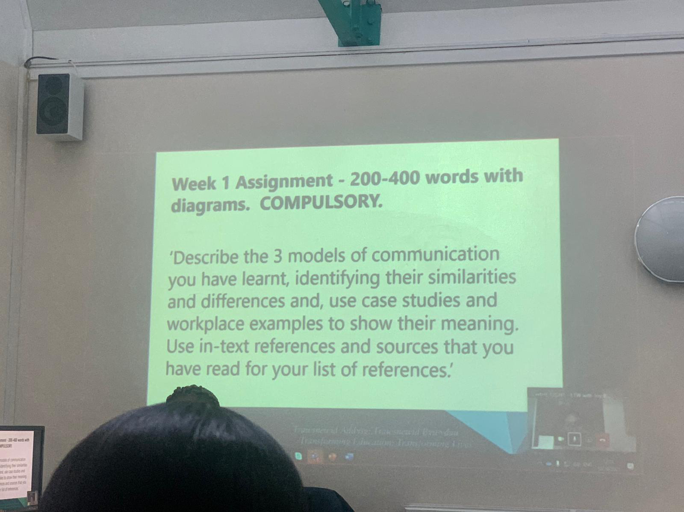
www.ukessays.com. (2021). A Summary of The Communication Process English Language Essay. (Online) Available at: https://www.ukessays.com/essays/english-language/a-summary-of-the-communication-process-english-language-essay.php. (Assessed 04.01.2022)

