Dylan Payne
Renishaw Quality Technician

Andrew thorn
Lecturer



SCRAP REDUCTION OF QUILLS DURING PRE-SUB-CON MACHINING INSPECTION
Six sigma green belt (acma5005 - 2024)

Contents
1. Introduction 2
1.1 Background 2
1.2 Purpose / Benefits 3
2. Define 4
2.1 Problem Statement 4
2.2 Process Mapping 4
2.3 Customer Requirements 4
2.4 Project Scope 4
2.5 Project Charter 4
3. Measure 5
3.1 Scrap Rate Analysis 5
3.1.1 Pareto Analysis 5
3.2 Cost of Poor Quality (COPQ) 6
3.3 Identify Measurement Variation 7
3.4 Perform Measurement System Analysis 7
3.5 Implemented Data Collection and Assessed Process Capability 7
4. Analyse 8
4.1 Fishbone Analysis: Diagram 8
4.1.1 Fishbone Analysis: Root Causes of Quill Scrap 9
4.2 Failure Mode and Effect Analysis (FMEA) 10
4.2.1 FMEA Summary 11
5. Improve 12
5.1 Revised Inspection Criteria 12
5.2 Training Programs 12
5.3 Purchasing Improved Material 12
5.4 Reducing Transit Between Sites 12
5.4.1 Future State Process Map 13
6. Control 14
6.1 Real-Time Monitoring 14
6.2 Regular Audits 14
6.3 Control Plans 14
6.4 Transit Reduction Control 14
7. Conclusion 15
8. Tables & Figures 15
9. Bibliography 15

Introduction

1.1 Background
Renishaw is a top global supplier of manufacturing and measurement systems. Its solutions offer a high degree of accuracy and precision, collecting data to give customers and end users confidence in their work and traceability. This is a multinational company with more than 5,000 workers spread over 36 nations (Renishaw plc, 2023).
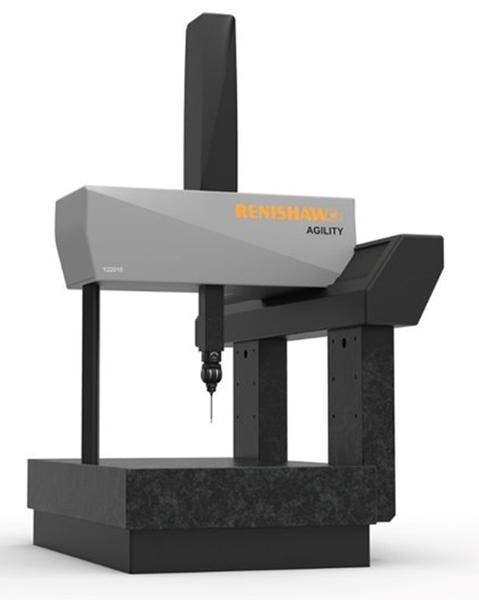
Agility is Renishaw’s flagship CMM Product range. It is a high-precision machine built around the UCC 5-Axis control system.
The quill is a customer visible component that holds a high precision measuring device on its tip. Every face is functional and requires a strict flatness tolerance, as air bearings fly over the surface at a height of 10µm, approximately 1/5 of the thickness of a human hair.
Figure 1 - Renishaw Agility CMM
The quill needs to be scratch resistant, as a burr from a scratch can interfere with the air bearing flight, affecting machine accuracy, and potentially writing off the bearing and quill. Etching is required to remove any light scratches picked up during manufacture. Sealing using the anodising method is required as unsealed surfaces are badly marked by the machine brake, as this applies pressure to the air bearing surfaces (plc, 2022).
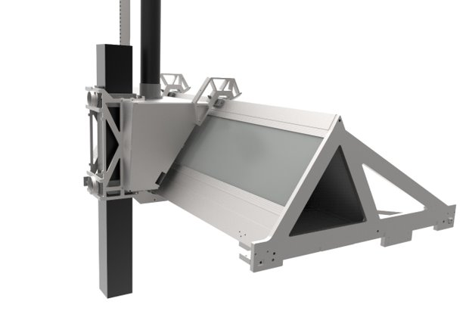
Figure 2 - Quill location in CMM
Quill

1.2 Purpose / Benefits
Making sure components are of the highest quality is crucial in the ever-changing production world. Nonetheless, there are frequently multiple inspection phases involved in the process from raw materials to final products, all of which are essential for upholding quality standards. The presence of scrap during the examination of quills, a crucial aspect in the production of CMM machines, is one particular area of concern.
Since quills are a crucial component of the CMM assemblies, strict quality control procedures are required. Prior to major value addition, the inspection procedure acts as the last line of defence against flaws before sub-con anodising takes place, as this process will essentially “lock-in” any visible defects.
There are still cases of scrap in quills despite our strict inspection procedures, which causes delays in manufacturing, higher expenses, and sometimes even disgruntled customers. Therefore, there is an urgent requirement to launch a targeted endeavour to cut down on scrap during the quill pre-sub-con anodising inspection.
In order to minimise scrap occurrences, this Green Belt project uses the DMAIC technique to methodically analyse, identify the underlying reasons, and implement workable remedies. We seek to increase the efficacy and efficiency of our inspection procedure by working together, using data-driven analysis, and making focused adjustments. This will eventually raise the calibre of our quills and guarantee customer satisfaction.

Define

2.1 Problem Statement
There are various defects in the quill inspection process that lead to rejects when quills are utilised in the assembly of CMMs. These consist of comet markings, material splits, staining and problems with the perpendicularity at the ends of the extrusions. When they can't be reworked, all inspected quills that fail need to be scrapped.

2.2 Process Mapping
The quill production process involves multiple steps and various transporting operations of the quills.
The process flow is as follows:
- Material ordered/delivered.
- Sawed to length.
- Sent to Old Town for oven cure.
- Transported back to Miskin.
- Machined to drawing specifications.
- Brushed finish.
- Return to Old Town for inspection and cleaning.
- Sent for anodising at subcontracted company.
- Returned to Old Town once anodizing is complete.
- Inspected and cleaned again.
- Sent to Miskin for storage and assembly.

2.3 Customer Requirements
Quills are always visible to customers and are required to be free of material or machine flaws. Since customers do not receive damaged quills on their purchased CMM machines, there have been no complaints.

2.4 Project Scope
In order to minimise flaws and lower the quantity of quills that are scrapped, the project seeks to optimise the quill inspection procedure utilised in the assembly of Agility CMMs. This include assessing the efficacy of the current inspection processes, pinpointing opportunities for development, and putting plans into action to raise the calibre and dependability of the quills that are evaluated. The scope also includes looking into ways to streamline processes, possibly changing the source of materials, and putting best practices into action to guarantee that every quill satisfies strict functional and aesthetic standards. In the end, the project aims to maximise resource utilisation and minimise waste in the production process while providing high-quality quills to improve customer satisfaction.

2.5 Project Charter
The purchasing, quality, and machine shop manufacturing departments are important stakeholders. The quality department leads the project team, which is in charge of putting changes into action and accomplishing project objectives. Data collection is still underway, but for this study the data used is from September 2021 to February 2024.

Measure

3.1 Scrap Rate Analysis
Year | Perpendicularity | Material Splits | Comets | Staining | Cost
2021 | 3 | 0 | 0 | 0 | £6,000.00
2022 | 1 | 5 | 3 | 1 | £20,000.00
2023 | 0 | 9 | 5 | 3 | £34,000.00
2024 | 0 | 1 | 0 | 1 | £4,000.00
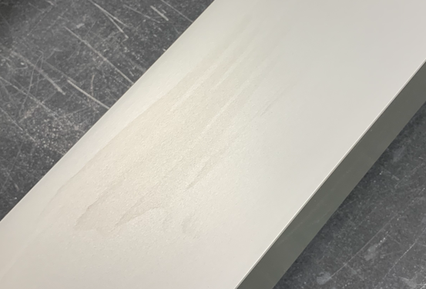
Figure 3 - Quill Scrap Data
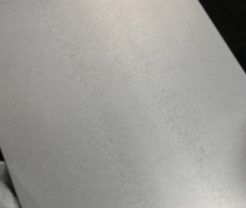
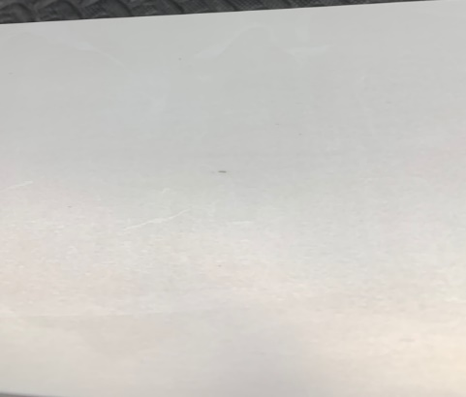
Figure 4 - Material Split Example
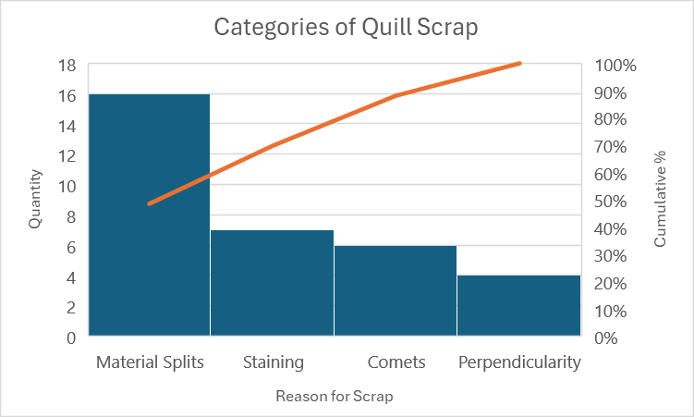
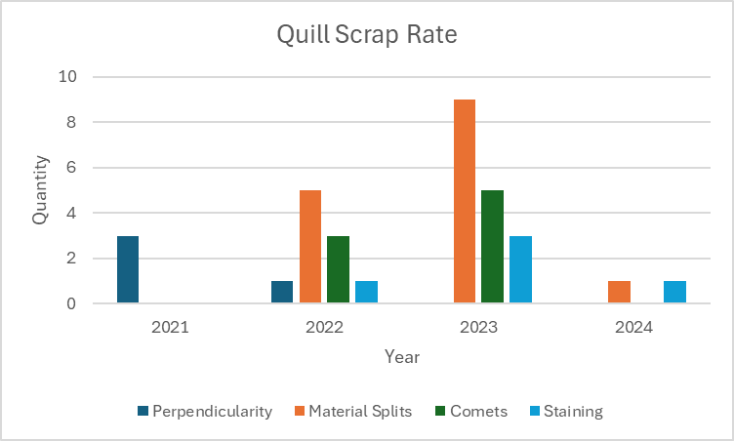

Figure 5 - Comet Example

3.1.1 Pareto Analysis
Figure 6 - Staining Example
As the data collected can be expressed categorical, the Pareto chart shown in Figure 8 enables us to determine the main causes of quill scrap and arrange improvement efforts in that order (Renishaw Plc, 2024).
Figure 7 - Quill Scrap Rate
Material Splits (48.5% of Total Scrap): Nearly half of all quills that are scrapped are due to material splits, which are the most common cause of quill scrap. This suggests that there might be problems with the processing or quality of the raw material used to make quills. Reducing scrap rates and raising overall product quality could be accomplished by addressing the incoming material quality and the handling practices.
Figure 8 - Categories of Quill Scrap

Staining (21.2% of Total debris): Approximately one-fifth of all quills that are scrapped are due to staining, making it the second most frequent cause of quill scrap. Improper handling, storing, or processing of quills can cause staining and cause flaws in terms of appearance. Staining problems may be lessened by enforcing stronger handling and storage procedures as well as by enhancing cleaning and finishing techniques.
Comets (18.2% of Total Scrap): Comets, which show problems with surface flaws or irregularities, make up a sizable amount of quill scrap. These flaws could be the consequence of handling or storage procedures, as well as machining or finishing procedures. Comet frequency can be decreased by strengthening inspection protocols, sharpening machining techniques, and enforcing more stringent quality standards.
Perpendicularity (12.1% of Total Scrap): A smaller but significant amount of quill scrap is related to problems with perpendicularity. This implies that dimensional precision may be difficult to maintain during the machining or assembly procedures. Perpendicularity problems can be resolved by improving measurement methods, fine-tuning machining procedures, and giving operators more training.

Overall, quill scrap rates are influenced by material quality, handling, and processing; material splits are the most common problem. Enhancing finishing procedures and quality control measures is crucial since aesthetic flaws like comets and stains also dramatically increase the scrap rates. By addressing these important problems found in the Pareto analysis, scrap rates can be significantly reduced, which will reduce cost and improve product quality.

3.2 Cost of Poor Quality (COPQ)
Multiplying the quantity of scrapped quills by the quill cost (£2000) yields the Cost of Poor Quality related to scrapped quills. This will shed light on how scrap affects the organization's finances.

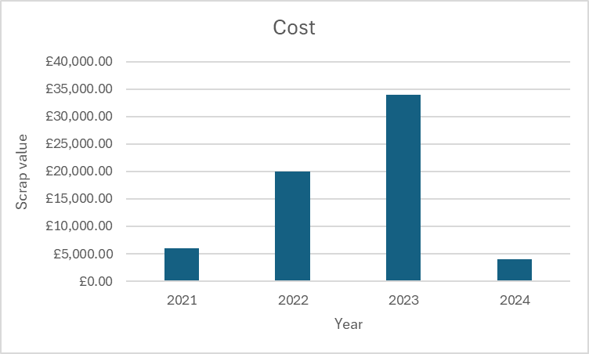

Figure 9 - COPQ

3.3 Identify Measurement Variation
To address the issues around perpendicularity, a CMM machine was used to gather measurement data in order to evaluate surface quality, dimensional accuracy, and surface flatness—all of which are factors related to quill inspection. Measurement variation was defined as differences in these measurements that went beyond predetermined limitations.

3.4 Perform Measurement System Analysis
To assess the stability, accuracy, and precision of the CMM utilised for quill inspection, a gauge R&R study has been conducted. The research consists of:
- Repeatability is the evaluation of measurement variation made by the same operator measuring the same quill more than once.
- Assessing measurement deviation amongst operators who measured the same quill in order to determine reproducibility.
- Equipment Variation: Analysing how measurement variation is affected by the CMM machine and other measurement tools.
- Providing sufficient training to operators so they could operate the measurement instruments and reliably interpret the measurement data.
Recommendations were made based on the study in order to decrease measurement variation, increase the accuracy of inspection results, and improve measuring system performance.

3.5 Implemented Data Collection and Assessed Process Capability
A data collection plan was implemented to collect relevant data on quill inspection results.
The plan specified:
- The sampling strategy - Determined the sample size and inspection frequency for the manufactured quills.
- Data capturing Procedures - Standardising the processes for capturing inspection data to guarantee accuracy and consistency.
- Measurement Methods - Assuring that the right methods were applied to measure surface quality, dimensional accuracy, and flatness.
- Process Capability Analysis - After gathering enough information, this analysis was carried out to determine whether the inspection procedure could satisfy the required standards for quality.

Analyse
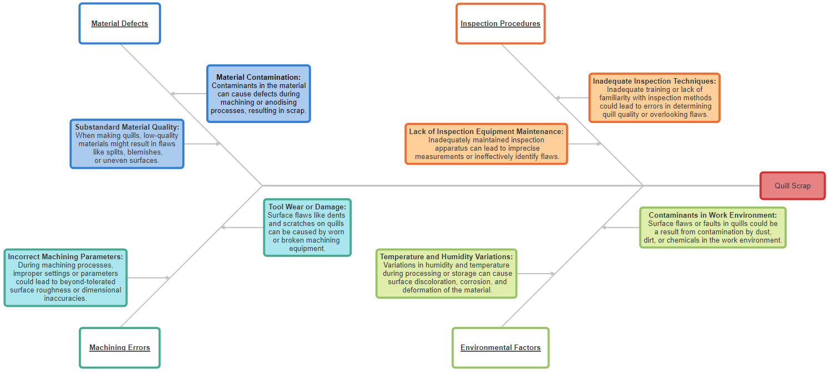

4.1 Fishbone Analysis: Diagram
Figure 10 - Fishbone Diagram (SmartDraw, 2024)

4.1.1 Fishbone Analysis: Root Causes of Quill Scrap
The Fishbone Analysis identifies several important variables, including material defects, machining errors, improper inspection techniques, and environmental issues, that affect quill scrap rates. Surface imperfections have been found to be significantly influenced by material defects, such as contamination and low material quality, which poses a high severe risk to quill quality. High-severity machining errors can also result in dimensional errors due to tool wear or damage. Scrap rates are further increased by inadequate inspection procedures, which include insufficient training and skills and raise the possibility of overlooked faults. Variations in temperature and humidity pose moderate-to-high risks of surface contamination, which can have an impact on the quality of quills. Mitigating scrap rates and raising overall product quality requires addressing these core causes with focused corrective actions, such as strengthening supplier quality control, putting predictive maintenance for machining tools into place, offering advanced inspection training, and enforcing stronger environmental controls.

4.2 Failure Mode and Effect Analysis (FMEA)

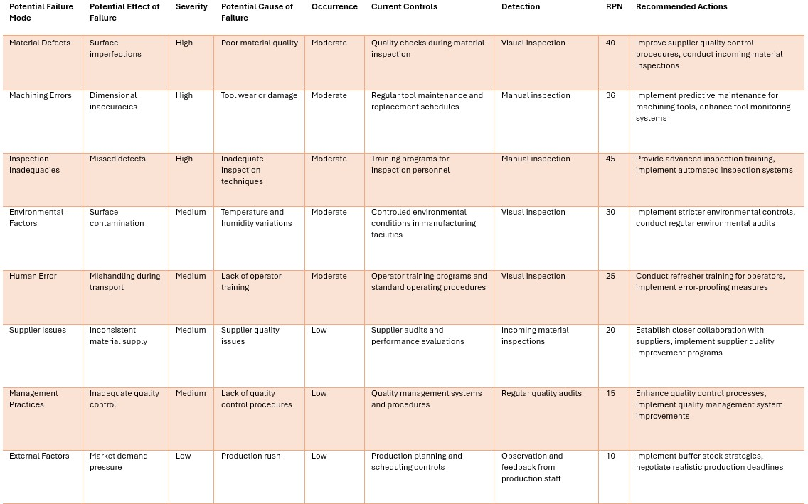
Figure 11 - FMEA

4.2.1 FMEA Summary
Critical failure modes and their possible impacts on service quality are highlighted by the Failure Mode and Effect Analysis (FMEA), with an emphasis on Severity, Occurrence, and Detection. Material flaws, machining errors, and inadequate inspection procedures are examples of high-severity failure mechanisms that significantly jeopardise the quality of quills. Though not as much, moderate-severity failure types including human error and environmental factors still affect scrap rates. Though they carry less risk, low-severity failure modes including supplier issues and management practices still need to be addressed. As a tool for prioritisation, the Risk Priority Number (RPN) indicates which regions require remedial action the most. Stricter environmental controls, better inspection training, predictive maintenance for machining tools, and improved supplier quality control are among the suggested courses of action. Addressing these root causes through targeted interventions is essential to reducing scrap rates and improving overall product quality.

Improve

5.1 Revised Inspection Criteria
Collaboration has been conducted with other members of the quality team to improve and update the quill inspection criteria, with an emphasis on preventing common scrap causes found in the Fishbone Analysis and FMEA. Stricter tolerance limits, more surface quality inspections, and enhanced defect detection techniques are some of the updated criteria.
Cleaning methods have also now been improved with the use of lint-free cloths and IPA dispensers to control the magnitude of chemicals used. A clear instruction has now been put in place to wipe the full length of the quill in one movement, ensuring not to re-wipe using the same side of the cloth to prevent dragging any swarf along the surface.

5.2 Training Programs
Training has now been implemented thorough a step-locked standard discipline procedure (SDP) to improve inspectors' capacity to recognise and stop flaws during quill inspection. SDP’s are maintained using the Renishaw system where a training level is assigned to each trained operator respective of their inspection experience. Assessment of material quality, comprehension of the machining process, and efficient defect detection methods are some of the subjects covered in training. Training is conducted by an experienced member of the quality team, and quills are verified post-inspection whilst the operators are still under training.

5.3 Purchasing Improved Material
In January 2024, we have started a trial effort to assess the advantages of pure aluminium over the existing stock material previously purchased. This material does come at more of a premium cost, but analysis is currently underway to weigh up whether this improvement would be a cost-effective method to improve quill scrap. The purchasing department has been working together with suppliers to evaluate the new material's compatibility and quality for the production of quills. As the trials commence, a comparison will be conducted to compare the two materials' scrap rates, surface quality, and dimensional accuracy using statistical analysis.

5.4 Reducing Transit Between Sites
We have recently expanded our Renishaw manufacturing plant to accommodate the increase in production of CMM machines. A plan has been put into place to internalise the operations of quill manufacture, inspection, and assembly in order to cut down on travel time and possible damage during site transfer. Our goal is to reduce handling, optimise production workflow, and guarantee constant quality control across the whole manufacturing process by centralising all processes. Better departmental collaboration will be made possible by this project, allowing for quicker resolution of quality-related concerns and shorter lead times overall. Not only this, but the environmental impact would also be improved due to the reduction of internal van runs required.

5.4.1 Future State Process Map
- Material ordered/delivered.
- Sawed to length and oven cured.
- Machined to drawing specifications with a brushed finish.
- Inspection and cleaning.
- Sent for anodising at sub-contracted company.
- Returned once anodising is complete.
- Inspected and cleaned again.
- Sent to the assembly cell for storage/use.

Comparing this process map to the original for the manufacturing process of the quills, the transit has been reduced significantly by 4 journeys, of which are approximately 52 miles in length.

Control

6.1 Real-Time Monitoring
Real-time monitoring tools were put in place to identify and manage possible sources of scrap during the quill manufacturing process. Scrap rates will continue to be monitored and the trends tracked over time using sample plans. Sample plans are implemented directly into the job manufacturing process and are tracked using the Renishaw system. This means that the quills cannot be processed beyond the inspection process without the sample plan data being completed. Within the SDP, an instruction now states that the operator must take photos of each defect found during inspection and store them in a localised folder, which is then tracked using the quill's unique serial number. This makes it possible to identify reoccurring problems quickly and to support focused corrective action.

6.2 Regular Audits
Routine audits are now conducted once every quarter to make sure the updated inspection standards are being followed and to find any new problems in the quill manufacturing process. During these audits, the SDP and individual operator training levels are tracked and checked to make sure they were current and in line with the updated standards. Evaluations of inspection methods, equipment calibration, and compliance with quality control protocols are also all part of the audit. Any deviations from the new standard will quickly be addressed by the use of a CCAR (Correction and Corrective Action Report) with the appropriate corrective measures and further training implemented immediately.

6.3 Control Plans
Control plans have now been created and put into action to maintain the decrease in scrap rates attained by the improvement projects. Control plans provided step-by-step instructions on how to keep an eye on important process variables, carry out routine inspections, and handle deviations from quality requirements. To guarantee constant quality and reduce scrap rates, review meetings will be conducted on a regular basis, alongside the machine shop COPQ meeting, to evaluate the success of the control methods and make any required modifications.

6.4 Transit Reduction Control
With the expansion of the Miskin Renishaw site, and the companies latest initiative to become more sustainable, the manufacturing of the CMM machines will now be carried out primarily at one site, rather than split across two. The transit reduction programme aims to internalise the processes of quill assembly, inspection, and manufacture. The inspection of quills will now consider what failure modes are more absent with the lack of transit that the quills will be subjected to. The despatch team will continue to monitor the emissions of their internal transit van, which should now require less trips to transport urgent quills to a different site for production.

Conclusion

Renishaw has made great strides in lowering quill scrap rates and improving product quality through the execution of several improvement initiatives. We have successfully identified the underlying causes of scrap, improved inspection criteria, offered thorough training programmes, and put mistake-proofing measures in place through cooperative efforts and calculated actions. Furthermore, internalising the inspection, assembly, and quill production processes has reduced transit-related costs and further optimised operations. With strong control mechanisms in place, such as sample plans, frequent audits, and real-time monitoring, we are prepared to maintain the progress made and keep enhancing our operations to meet customer expectations. This project demonstrates our dedication to excellence in quality and ongoing development, ensuring the supply of high-quality products to our customers while maximising operating effectiveness and cutting expenses.

Tables & Figures
Figure 1 - Renishaw Agility CMM 2
Figure 2 - Quill location in CMM 2
Figure 3 - Quill Scrap Data 5
Figure 4 - Material Split Example 5
Figure 5 - Comet Example 5
Figure 6 - Staining Example 5
Figure 7 - Quill Scrap Rate 5
Figure 8 - Categories of Quill Scrap 5
Figure 9 - COPQ 6
Figure 10 - Fishbone Diagram (SmartDraw, 2024) 8
Figure 11 - FMEA 10

Bibliography
plc, R., 2022. PD-6218-4791-02. s.l.:s.n.
Renishaw plc, 2023. Company biographies. [Online]
Available at: https://www.renishaw.com/en/company-biographies--32462
[Accessed 18 February 2023].
Renishaw Plc, 2024. Quill Situation Report. s.l.:Renishaw Plc.
SmartDraw, 2024. Tree Diagrams. [Online]
Available at: https://app.smartdraw.com/?nsu=1
[Accessed 09 03 2024].

