Course nume:Academic Skills(LCLM4001)
Student numere:2612225

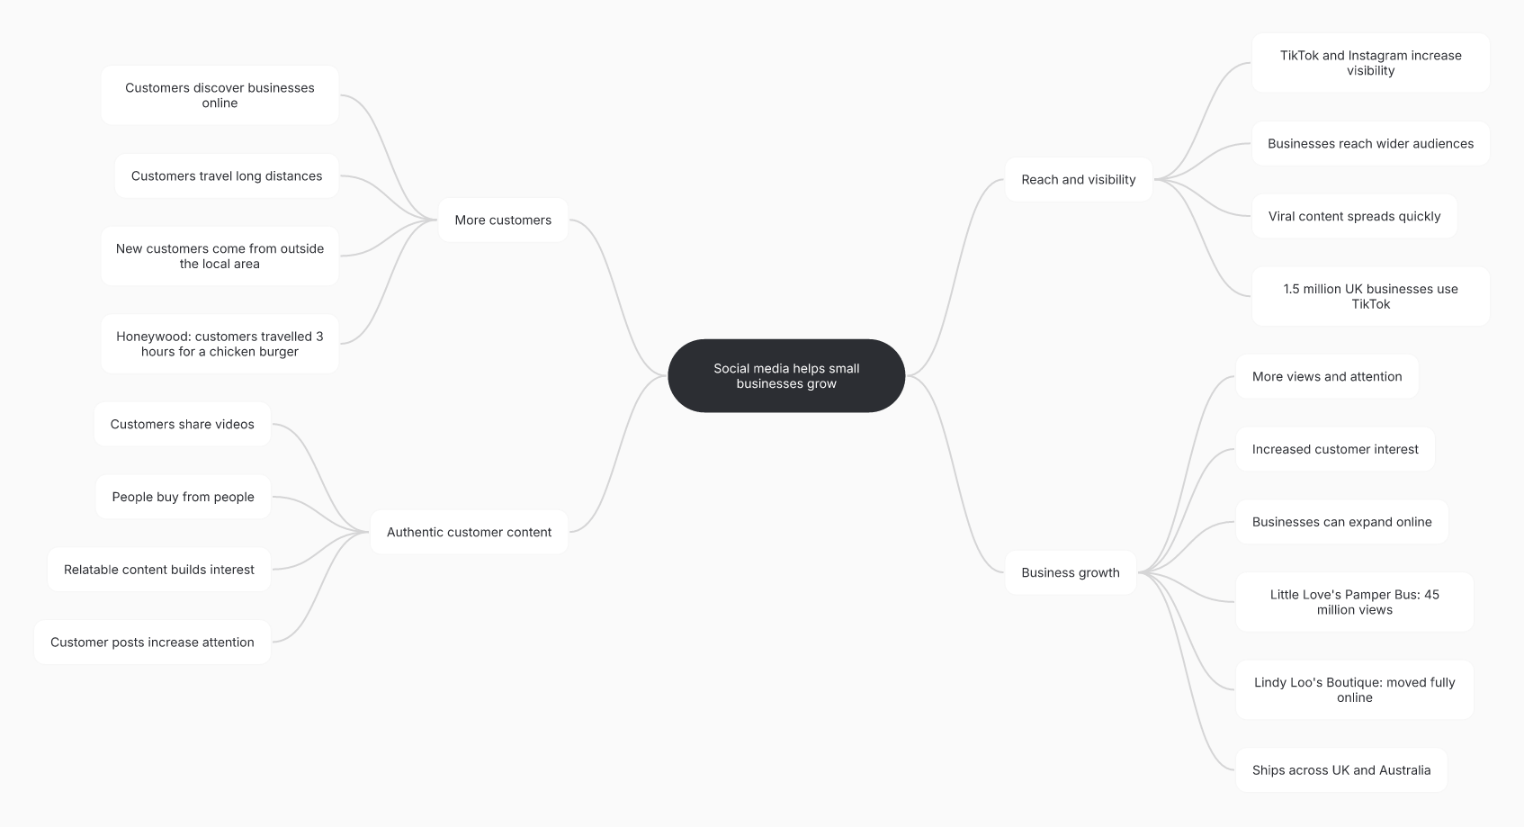

- What is the main idea of the whole text?
The general idea of the text is that social media may be employed to help small businesses become larger and more popular to be able to find more clients. Instagram and Tik Tok are social media platforms, which allow companies to advertise even when not at their location.

- What is one key point that supports the main idea, and which specific example from the text shows this?
Among them is the fact that social media has the potential to attract out-of-town customers. Online attention can bring in a customer as depicted who was situated miles away when customers took three hours to the Honeywood Sandwich Shop to sample its chicken burger.
- What is a different key point that supports the main idea, and which specific example from the text shows this?
The other important aspect is that social media can assist small firms to increase their markets. Lindy Loo developed into an entirely online-based shop that delivers clothes to the UK and even Australia, demonstrating how a company can attract the clients in other locations.
- Which part of the text do you think is most important, and why?
I believe that the most significant aspect is the notion that individuals shop with individuals. The customers will be able to make the content more authentic and close to them as they post videos and experience about a business, which will drive other people into becoming interested in the business.

Reflection:
- What did you find difficult in this task (including in-class components), and why was it difficult?
I had problems with differentiating the key points and supporting examples of the main idea. The development of the A3 mind map was also not that easy since I needed to determine what information is the most significant.

- What helped you with this difficulty, and how did it help you?
The mind map helped me to organize the information into separate categories such as the visibility, customers, business growth and customer content. The comparison of my ideas with another pair also helped me to determine what information I did not pay attention to.

