

Student Name. | Cristian Rotari
Student ID. | 1909888
Module Name. | Digital skills and Research Methods.
Module Code. | (BMSW4003_LON).
Lecture Name. | Koushik Modak

Table of Contents

Introduction 3
Rational 3
Objectives 3
Literature Review 3
Research Methodology 4
Ethics in Data Collection 5
Findings and Analysis. 5
Summary of the findings 14
Conclusion 15
References 16
Appendix1……………………………………………………………………………………………………………………………………17
Appendix2……………………………………………………………………………………………………………………………………18

Introduction
The purpose of this research report is to analyze and describe a survey which was based on virtual learning environment. The analyzing will be built on quantitative research in a sample of 20 students. The first closed ended question is made to help my survey understanding the impact of Virtual Learning.
The analyze is to understand how often students are accessing (VLE), in our case at University of Wales which is Moodle. The better way to describe students’ opinions is through the Bar- Graphs and Pie-Charts.

Rational
The purpose of this survey is to realize a comparison between numbers of students who using (VLE), and those who are not familiar with this kind of study. Additionally, I will have a look at my survey and describe each sector that I have made, and how it is impacted on student. The rational of this questionnaire is expected because our world are in continuous changing in technology, and (VLE) is going to be introduced in each university.

Objectives
Nowadays traditional study is in permanent trouble, because of constant danger from VLE, but anyway traditional style, remain to be main player in this competition. My objectives are to examine how Virtual learning environment is going to be introduced on study, additionally, what outcomes does offer this way of study, presented in my survey. My achievements are based on two open ended question, to examine if the students are using VLE, and if they like the design plan of the platform which is the Moodle.

Literature Review
According to Vedamo.com (2013-2020), virtual learning is a learning familiarity that is improved through exploiting computers and/or the internet together beyond and within the capabilities of the didactic association. Education generally gets a place in a virtual environment.
According to Virtual college (2020), The Virtual learning environment is huge benefit, students are engaged to improve their abilities through this method, to take a feedback without leaving their homes. Furthermore, for teachers are the same advantage, they can upload lessons through the portal and enjoying the student’s activities also teachers can share their work instantly.
Virtual learning, looks that are in process of increasing in trust from students, a number of people were in process to complete a survey about satisfying of VLE, all students completed that survey with not too much troubles, seems that learners are in a way to achieve easily this mode of learning (ncbi.nih.gov, 2019). Additionally, according to dexway (2020), there is five reason why virtual learning is better than traditional way, they found that the students learn with five times more when they have control, even in the classroom the speed of learning is flexible, that means that the achievement in (VLE) will be much more than face to face learning. Another reason why Virtual way of learning is a beneficial is about environment, the study was deducted per student and locks like students economises 90 % of energy and 85 % of CO2 emission.
According to enhancementthemes (2006), 76 percent of respondents engaged in study of higher education, using virtual learning environment, and absolutely all university said that they are in process to improve (VLE). Most people which were involved in survey are satisfied with this system of learning.
If I will relate my work with their research, we will see an extremely approach, because of same topic which I analyse in this report, we seen that the most of respondence using already at that time virtual learning, but now the percentage of users are increasing absolutely, and we could see this in my survey which is Q1. Additionally, most of students and teachers are already familiar with Virtual Learning.
The percentage of people who are satisfied with virtual learning environment also is high, and will increase constantly in the next years, students are satisfies with delivery of information and quickest way accessing to (VLE). My survey including two close ended question which is relate with survey of others people, this kind of questions help us a lot to understand the proper impact of virtual learning and of course how it is using frequently, also in my case I have a question, if the students like the organising plan of the Moodle, which is a platform of learning University of Wales Trinity Saint David.

Research Methodology
Qualitative Research Method, qualitative research is a form of research in the social sciences which gathers, works with, and understands the significance of non-numerical information, which allows us to understand social life through monitoring objective populations or places, thoughtco.com (2020).
Quantitative Research Method, Quantitative research is characterised by the collection of real data and performance of numerical and analytical methods, questionpro.com (2020).
As I am involved to conduct a survey, the best way is to use both research. My audience will be students in University of Wales Trinity Saint David, which I had collect data through the Virtual Learning Environment this information will be kept into qualitative research method, is a good way because I work with my audience hand by hand, and it make me to take a superior understanding.
Additionally, I will use graphs, and pie charts to make sense of what people said, through the statistical and numerical method this is about quantitative research, after using this kind of research I will take a better understanding about hole survey.

Population, As I am student in UWTSD, my population are learners who are involved in education environment, because of too many students in London campus, I made a sample of population. According to explorable.com (2020), study community is often described as a well-defined group of individuals or objects that have similar features. In a certain community, all individuals or objects typically have a growing, combining characteristic or attribute.
Sample and Sample size, according to methods.sagepub.com (2008), the sample size of a survey normally applies to the total of groups through which results have been obtained. The sample size can, however, be described in various forms. The sample size is the number of elements chosen for interaction or processing of data.
The sample size are students from my class, which is 20 people, my survey will conduct each person to obtain better result, which will cover my topic ‘Impact of Virtual Learning environment’.
Data Collection Process
For Better understanding my respondents, I made some question to made them in easiest mode to answer, my third question about rating will make me take a conclusion which will cover students feedback on (VLE), in this case I will realize what is the impact of virtual learning, through the answers available like (very good, good, ok, bad and very bad) .
Another thing that I trying to cover is that how long it takes to access Moodle, this is one of the important factors that students are struggle with. As we are in bad times, I made a question which will contain the difficult to access (Moodle or Microsoft Team), this is the inevitable process during this bad time.
The process of collecting data also will be in assemble of Virtual learning, through mails with a total of respondents 20 students.

Ethics in Data Collection
As I am conducting a research, I have to follow ethics in my data collection, the survey is part of academic education in my university. Student service and our lecturer gave me permission to conduct this survey, but, with some restrictions in accordance with confident of respondents. Of course, during my data collection, I followed these terms and conditions. Names of respondents will be anonymous to maintain higher and clear process.

Findings and Analysis.

Results Table.
Q.1 | yes | no |  |  |  |  | SUM
Do you use VLE? | 18 | 2 |  |  |  |  | 20

Q1). We can see that 90% of respondents are answered with ‘yes’, that means that most of students using Virtual learning environment, 10% of my respondents answered with ‘no’ they do not use VLE, but they are familiar with that.
90% of students is huge number, according with this question, I can conclude that education life is in permanent change, and traditional study in a short time will be just history.

Results Table
Q.2 | everyday | more than once a week | once a week | once a month | never
How often you use VLE? | 4 | 9 | 3 | 2 | 2 |  | 20

Q2) 45% of students are using Virtual learning environment more than once o week, also we have 20% of respondents who using VLE every day, that means that more than half of students using VLE constantly for their work at university, also we have 10% of respondents who do not using VLE, but they are combine two different learning style for better results.
We can see that most of students are in progress with learning style, and our university are based on this type of learning and they are sure that students are in better way for their academic life.

Results Table.
Q.3 | very good | good | ok | bad | very bad
How do you rate VLE? | 3 | 14 | 3 | 0 | 0 |  | 20

Q3) My respondents are passed VLE, we can see that 100% (VLE) took a good feedback from students, 70% of people answered with good, this means that students are in good relationship with this kind of study.
Additionally, we have 15% of respondents who choose ‘very good’ they like the organisation of the Moodle and how tutors sharing their work with students. Any way we have a good feedback here, and I think that is based on justly.

Q.4 | yes | no
Do you like organisational plan of the Moodle? | 17 | 3 |  |  |  |  | 20
Results Table.

Q4) Most of students they like our university platform and the organising plan, we can see that in pie-chart 85% of respondents, also we have 15% of student who do not like organising in Moodle, this means that students are finding stressful to access some information’s.
85% of students is a huge number and we see that most people are comfortable with this, but another 15% people do not like the organisation in Moodle, that means we need to improve this kind of platform to be accessible for everyone.

Results Table.
Q.5 | 10 min | Less than 10 min
How long it takes to find information in moodle? | 5 | 15 |  |  |  |  | 20

Q5) 75% of people are finding information less than 10 min, others 25% navigating 10 min to find some material. Collecting data, information, news in our platform, it takes some time, and we can see this in my question. For people who are facing for first time with VLE, it is quite difficult to navigate on platform, because of nonfamiliar with this.
But in experience, I found difficult to search timetable, and it takes for me 10 min, that’s way this question have a legal right to live here.

Q.6 | very good | good | fair | poor | very poor
What do you think about the IT services (Moodle)  during the Online classes. | 7 | 7 | 6 | 0 | 0 |  | 20

Q6) During the online classes we tackled with unpredictable things, we had connection problems, but only at the start of lesson. Unquestionably this is an experience for most of us including lectors, we can see that most of students are likely with online classes, and for them everything went well. We do not have ‘poor’ and ‘very poor’, that means we are in a right way with this platform.

Q.7 | less than 20 | 20 to 30 | 30 to 40 | 40 to 50
What is your group age? | 3 | 12 | 4 | 1 |  |  | 20

Q7) Group age is very important in this research report, because we can find exactly the point of view of any individuals, we have age segment, virtual learning is used mainly of young people. That means is a technology or is a platform of new generation.

Open-ended questions.
Q.8
Please supply what difficulties you have accessing the VLE (Moodle) | 20 % not difficulties |  | 80 % system difficulties |  |  |  | 20

In this question I have tried to ask my respondence regarding their difficulties accessing the Moodle. Most of them have or had some systems problems, it could be page cookies or too much waiting time for uploading the page.

Q.9
What you like to see in additional services provided via Moodle | 50%are enough information |  | 50 % should be more detailed information |  |  |  | 20

Same as Q8, I have a done a summary of the results, 50% of students are getting enough information from the Moodle, also we have 50 % of respondents who wants to take more information from Moodle and to be more detailed.

Summary of the findings
After all the information and analysis which were described here, we can see that most of students are using VLE and they are already familiar, also most of them are satisfied with.
VLE have a huge impact on the students, after all analysing of findings, we can see that VLE is using frequently. This questionnaire is very useful for obtaining information in the same area or place as you. Virtual Learning Environment is coming to change the student’s life and after my questionnaire I understand that ‘the revolution is not bad’.

Conclusion
Virtual learning environment – platform of the future. It is not a secret that this platform will change our life in the future and traditional learning will remain history for us. But if we take in consideration my questionnaire, we can see 10-20 % of people who are possessing problems in using VLE.
I recommend having 2-3 lessons for accommodation and acclimatisation, especially for people who are not familiar with VLE. To find those students who are not familiar with VLE I recommend introducing a simple digital skills test.
In general, my report went well because of the same area’s persons, who answers to my questionnaire. Once again VLE is going to be introduced in the world, and we will follow its growing.

References
Vedamo.com (2020) [Online] ‘What is virtual learning’, Available at Vedamo.com (Accessed: 01 May 2020).
Ncbi.gov (2019) [Online] Available at Ncbi.Gov (Accessed: 01 May 2020).
Dex way (2020) [Online] Available at dexway.com (Accessed: 02 May 2020).
David J walker (2006) ‘Evaluation of Virtual Learning environment in higher education’ in all enhancement themes, pp, 4-8. Ch, 2.
thoughtco.com (2020) [Online] Available at thoughtco.com (Accessed: 29 April 2020).
Questionpro (2020) [Online] ‘Quantitative-research’, Available at questionpro.com (Accessed: 1 May 2020).
explorable (2020) [Online] Available at explorable.com (Accessed: 02 May 2020).

Appendix 1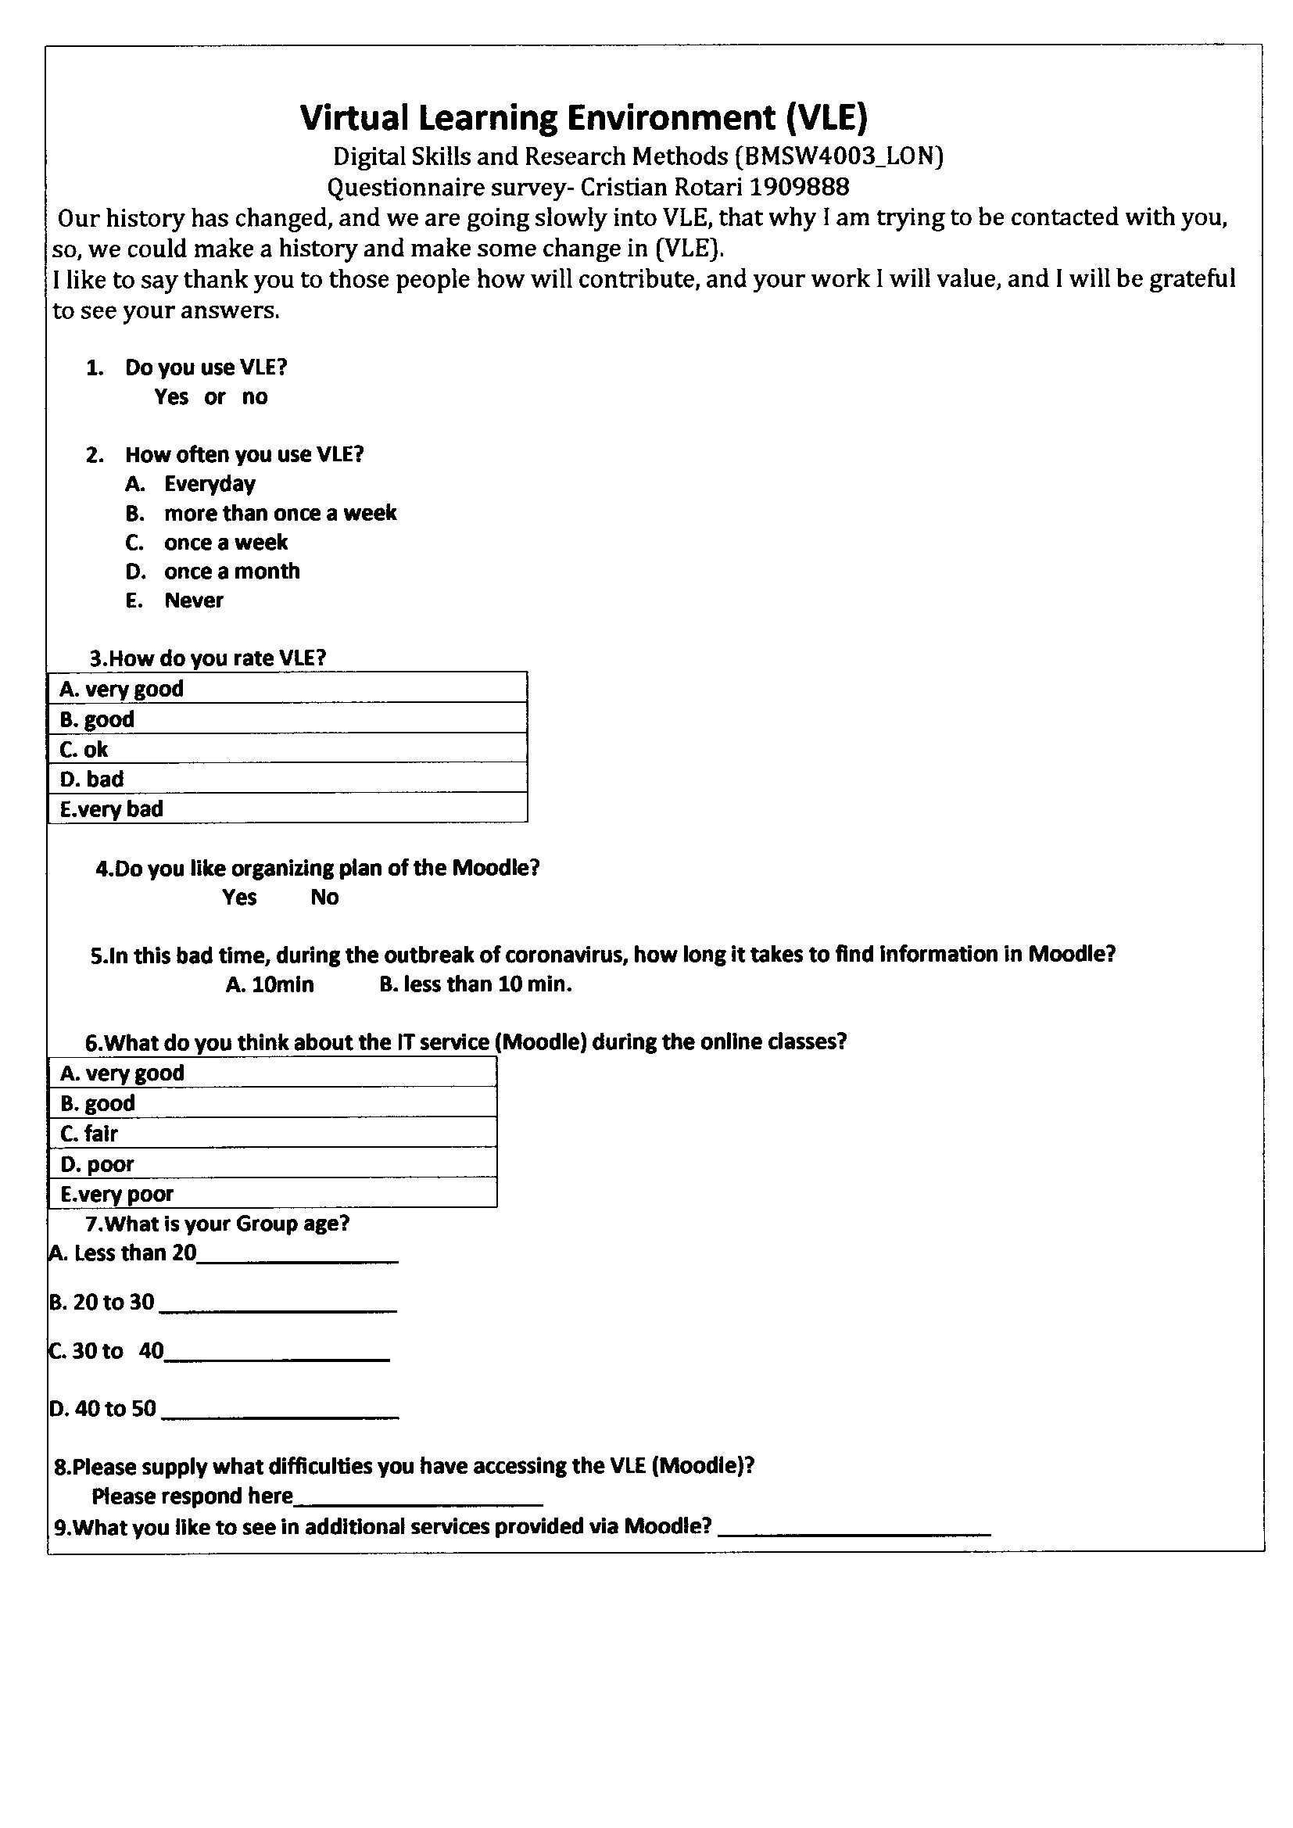

Appendix 2

