Eleonora Filip

1807163

Lecturer: Yajesh Kumar

BMSW5104_LON

Managing Projects in the Organisation

Sydney Metro

Executive summary
This report has included the plan for Sydney metro. Here, importance of project management and its benefits has been explained. Moreover, Gantt chart, PERT and CPM has been developed for the mentioned project. Project scope and communication plan are included to show the project requirements and deliverables. Stakeholder’s matrix and project plan has been used to show distribution of work and time for project. The report has also outlined the important qualities that a successful project manager needs to possess. This is followed by highlighting the management scope of the chosen Sydney Metro project. Further, change management model has been used for understanding the transformation process involved in the project.
Table of Contents
Introduction 5
Discussion 6
1. Provide a critical assessment of the usefulness of project management tools and techniques. 6
What is project management? 6
Benefits of project management 6
Project manager quality 7
Project scope management 8
Project management- tools and techniques 8
2. Prepare a plan for the implementation of the project and specify the relevant steps that must be followed and how the plan is going to be implemented. Communicate the project plans with appropriate colleagues and stakeholders. 12
Project scope Statement 13
Project Plan 13
Stakeholder communication 14
Stakeholder mapping 15
Risk management Plan 15
Time project management 16
Project communication method 17
3. Critically evaluate your ability to manage a project. Use feedback from others to evaluate your own ability to plan and implement a project by identifying strengths and weaknesses. Create a self-development plan to improve your own performance in managing projects. 18
Kotter’s change management model 18
ADKAR successful change management model 19
Implementing project change management 20
Management of transformation process 20
Relevant models for reflecting project manager skills 21
Belbin’s team model 22
Personal Development Plan 23
Conclusion 25
Education for Sustainable Development (ESD) 26
References 27

Introduction
Project management is the concept that is used for analysing the methods, skills, processes, and knowledge along with experience for achieving major objectives of the project. In this project, project management plan will be developed for an ongoing project named Sydney Metro. The project of metro is going to be built on three stages such as City and Southwest, Northwest and West part of Australia. Sydney Metro is one of the largest public transport projects that would have 31 metro stations running on 66 Kilometres of new metro rail (Harris, 2020). In this report, project management plan will be developed for the project where stakeholder mapping, risk management, stakeholder communication, project quality and others will be discussed. Additionally, the study will focus on developing Gantt chart, CMP, and network diagram for managing the project effectively.

Discussion

1. Provide a critical assessment of the usefulness of project management tools and techniques.

What is project management?
Project management is the way of organising and managing resources, which is, requires for completing project efficiently. In every project, project manager is the key individual who is having responsibility of analysing the key activities and implements those in the project properly. In this project of Sydney metro, project management plays a major role, as it would help in ensuring effective expectations that are set around which can be delivered within the set time. As Sydney Metro Project is estimated to be opened by 2024, project manager is responsible for managing the activities such as initiation, proper planning, implementation, controlling along with project closure. As mentioned by Kerzner (2017), project manager of team involved in the project is responsible for managing different activities such as managing expectations of the stakeholders, analysing requirements and identifying scope and risks.

Benefits of project management
The major benefits of the project management are mentioned below:
- It helps in improving the scope of opportunities of achieving the desired result.
- It enables in gaining fresh perspectives on the project and help in fitting with the business strategy.
- It enables in prioritising the resources of business and ensures efficient usage of them.
- It also helps in setting schedule, scope, and budget from the starting of the project.
- Project management improves the quality and productivity of the work (Zwikael, Chih & Meredith, 2018).
- It increases customer satisfaction and helps in mitigating risks of project failure.
In the project of Sydney Metro, it has been found that with the use of proper project management, the manager can be able to construct the rails by planning costs and resources effectively. For example, with the use of project management, the manager can be able to analyse the number of homes that are required to be redevelopment because of construction of railway tracks of Sydney Metro. It would help in evaluating the costs and risks related with the same, which is important for constructing the metro properly.

Project manager quality
Project managers play the leading role in planning, implementing, monitoring and supervising, controlling and closing projects. In other words, they are responsible for the entire scope of the project, the team working under them, critical resources required for the project and the eventual failure of success of the project (Alvarenga et al., 2020). The project manager responsible for ensuring the success of the Sydney Metro project is required to possess certain qualities, some of which are listed as follows:
Effective communicator – This is the most important quality that the project manager of Sydney Metro possesses in order to communicate the goal, roles and responsibilities, expectations, performance and feedbacks to the project team members at all levels. Moreover, since the project manager is the team’s link to the larger company undertaking the project, they must be able to negotiate and also use the power of persuasion whenever necessary to ensure the team and the project’s success.
Working under pressure – This is the second most important quality of a project manager that enables them to deal with problems arising before or during the course of a project with the utmost calm and composure (England & Bucero, 2019). The project manager responsible for the Sydney Metro project shall have the ability to take problems and challenges arising during a project in stride. They should instead regard the problem as an opportunity and be able to influence the outcome.
Strong leader – This quality is crucial for a project manager as it helps them to provide the substance for holding the team together and work towards common goals. The project manager of the Sydney Metro project is required to use the most suitable leadership style to lead the team through each stage of the project and also have a strong understanding of the dynamics and processes required to transform a group of strangers into one cohesive unit (Goździewska-Nowicka & Rajs, 2018).
Delegation – This quality of a project manager helps them to delegate tasks involved in a project with ease. The person recognises the expertise and skills of each of their team member and assigns them tasks according to those. Trust plays a key role in the relationship of a project leader and their team members. The project manager managing Sydney Metro shall demonstrate their trust in their team members through their actions such as how much they allow them to participate, how much they assess and control their work and so on.

Project scope management
The phrase, ‘Project Scope Management’ can be defined as the processes that ensure that the scope of a project is established and mapped accurately. Techniques of scope management enable supervisors and project managers to delegate the right amount of involved in a project by focusing primarily on controlling and regulating what is and what is not one of the components of the project’s scope.
The Sydney Metro project is, at present, the largest public transport project which is built across three stages: City and Southwest, Northwest and West (navartis.co.uk, 2020). The scope of the project is vast and is aimed at making the daily metro transport for people travelling to offices and colleges more convenient and safe. The working class people and their transport needs would be taken into consideration while defining the scope of the project. The project’s scope extends beyond expanding the metro services of Sydney to redeveloping new office buildings and housing in the locations where the metro services are to be expanded. Moreover, the scope also involves plans to transform homes into high-rise towers. Overall, the completion of the project shall result in the doubling up of the number of daily metro commuters.

Project management- tools and techniques
Sl No. | Activities | Start Date | Duration (days) | End date
1 | Initiation | 01.08.2020 | 120 | 29.11.20
1.1 | Discussion on initial actions and funding process of the project | 1.8.20 | 60 | 30.9.20
1.2 | Reviewing of the standards associated with the Project charter development | 30.9.20 | 93 | 1.1.21
2 | Planning | 1.1.21 | 365 | 1.1.22
2.1 | Planning on new approach based on the redevelopment of the homes coming in railway track | 1.1.21 | 60 | 2.3.21
2.2 | Restructuring of railway design, cross-checking of railway lines, perway, signalling technologies | 2.3.21 | 90 | 31.5.21
2.3 | Planning on the telecommunication system such as PA system, surveillance and CTCs | 31.5.21 | 61 | 31.7.21
2.4 | Pointing out the risk associated areas and planning of the electrical system such as cables, gantries and power lines | 31.7.21 | 64 | 3.10.21
2.5 | Developing new designs of Signalling permits | 3.10.21 | 90 | 1.1.22
3 | Execution | 1.1.22 | 365 | 1.1.23
3.1 | Construction of railway tracks | 1.1.22 | 120 | 1.5.22
3.2 | Presenting new guidelines associated with the speed limit and rules for the metros of Sydney | 1.5.22 | 75 | 15.7.22
3.3 | Developing guidelines related to maximum permissible limits and headway | 15.7.22 | 90 | 13.10.22
3.4 | Construction of railway stations, managing signalling between stations and other requires construction works | 13.10.22 | 80 | 1.1.23
4 | Performance | 1.1.23 | 183 | 3.7.23
4.1 | Testing of the efficiency of track and bearing capacity of the rail | 1.1.23 | 92 | 3.4.23
4.2 | Investigation of the speed limit and managing of unauthorised networks for preventing risk | 3.4.23 | 91 | 3.7.23
5 | Monitoring | 3.7.23 | 182 | 1.1.24
5.1 | Monitoring and inspecting the developed railway signals and infrastructure | 3.7.23 | 90 | 1.10.23
5.2 | Reviewing the railway tracks by inspecting every minute area | 1.10.23 | 92 | 1.1.24
6 | Project closure | 1.1.24 | 60 | 1.3.24
6.1 | Final inspection of the tracks, electric connection, mechanical parts and others | 1.3.24 | 30 | 31.3.24
6.2 | Completion of the project and handover to project sponsor | 31.3.24 | 30 | 30.4.24
Table 1: WBS

Figure 1: Gantt chart
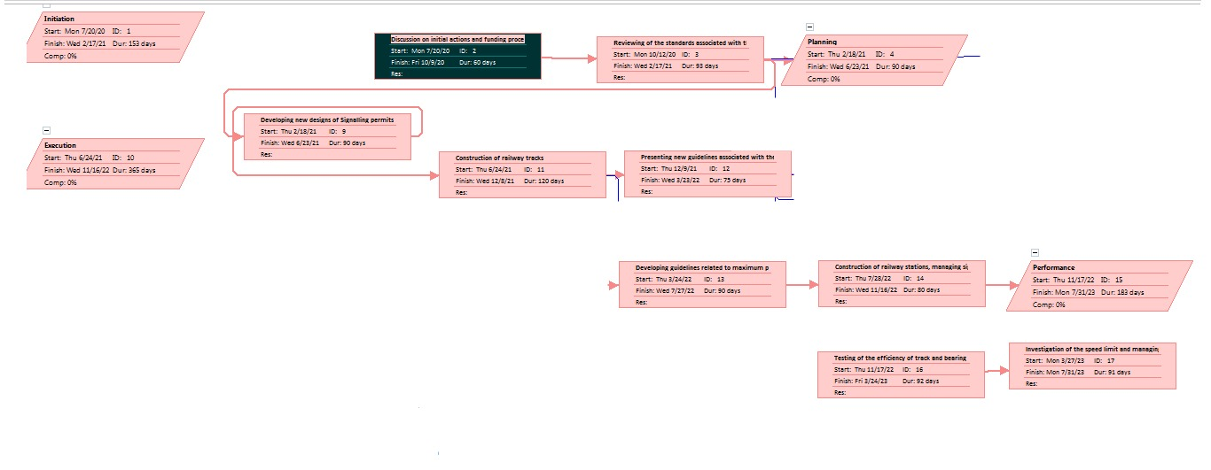
Figure: Critical Path
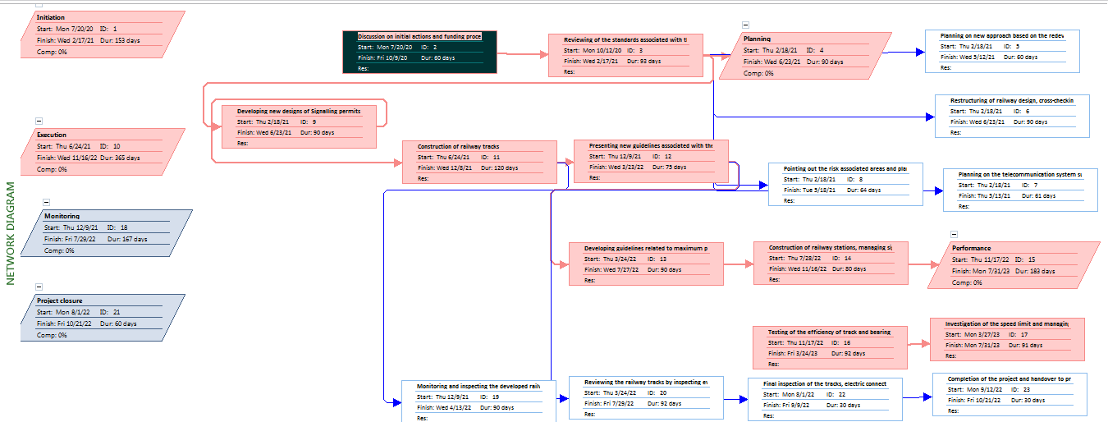
Figure: Network diagram
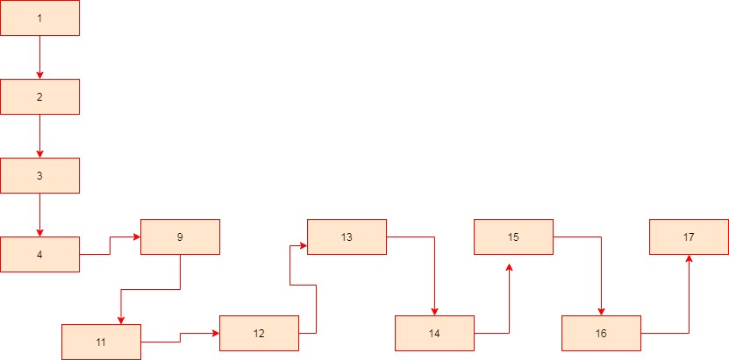
Figure: PERT chart
As opined by Ram Subramanian and Albrecht (2018), in communication management planning there are different modes of communication that include face to face communication and others modes of communication in adhering and maintain the communication in a project. This is shown with the help of Pert Chart and Network diagram. Monitoring and closure is the main activity.

2. Prepare a plan for the implementation of the project and specify the relevant steps that must be followed and how the plan is going to be implemented. Communicate the project plans with appropriate colleagues and stakeholders.
Aims
Aim of this plan is to improve the safety and convenience of people travelling through Sydney metro. Extension in metro would also connect the city with suburbs.
Objectives
- To improve safety at metro stations and trains for public
- To reduce the risk of technical failures during the operations
- To add new services for convenience of people who use metro on regular basis
- To extend metro to suburbs for greater reach

Project scope Statement
Project Name: Sydney Metro
Product Description: This project is going to be the extension of Sydney metro in Western suburbs. There is also going to be better connectivity and developments in these areas due to metro reach. Hence, new housing and office buildings would be re-developed in these locations for development. Safety and technical efficiency would be focused to improve performance at metro stations and trains.
Target Audience: This project is going to target the need of public who use metro on daily basis for travelling to office and college. Requirements of working class people would be considered such as timely transportation and better safety. Metro staff is also going to be the target audience, as their performance would be enhanced with the new project.
Project requirements: There would be need for tangible and intangible resources to execute the project. For instance, tools, equipment’s and materials would be required to build infrastructure. Human and financial resources would be required to meet obligations of project and execution of project.
Project Assumptions: It is assumed that the public needs and political conditions would be stable during the project performance. Prices of materials and equipment’s would also be as per the budget.
Project Deliverable: Final deliverable would be the 31 metro stations and more than 66 kilometres of new metro railway all across the Sydney. It would double the number of daily metro users.
Table 2: Project scope Statement

Project Plan
Project Phase | Task | Time required | Responsible team | Deliverable
All Project phases | Project management | 4 years | Project Management | 31 metro stations and 66 KM metro railway track.
Design | Create detailed designs and documents for project execution | 3 month | All project teams | Project scope, plan, communication and stakeholder plans, list of deliverables
Analyse | Analyse the plans and scope created in current working scenarios. Test design to identify failure risks. | 3 months | Project manager, IT team and design team. | Test results, issues in designs and plans, proposed changes
Build | Execution of plan and start building tracks and metro stations as per schedules and available resources | 24 months | Operation team, IT team, design team, finance team, HR team and marketing team | Railway stations and tracks with planned amenities and design
Testing | Testing for safety and amenities to avoid any risk of failure | 6 months | Quality team, IT team and review team
Table 3: Project Plan

Stakeholder communication
Stakeholder Name | Engagement Action | Owner | Channel | Frequency
Owner | Managed closely | Project Manager | Meetings, emails, phone calls | Daily
Sponsor | Keep informed | Project Manager | Meetings, news letter, phone calls | Weekly
Investor | Keep informed | Project Manager | News Letter, emails, meetings | Monthly
Manager | Monitor | Project Manager | Memos, agenda summary | Monthly
Table 4: Stakeholder communication

Stakeholder mapping
Stakeholder Name | Designation | Power | Interest | Engagement Strategy
Stakeholder 1 | Owner | High | Low | Meetings and emails
Stakeholder 2 | Sponsor | High | High | Meetings and emails, calls
Stakeholder 3 | Investor | Low | High | Meetings and emails
Stakeholder 4 | Manager | Low | Low | Calls, meetings and emails
Table 5: Stakeholder mapping

Risk management Plan
Type of risk | Level of impact | Frequency | Responsible person | Ways to mitigate risk
Operational risk | Moderate | Low | Project manager | Motivate teams to perform well with quality. Utilise resources properly to avoid wastage and poor quality.
Technical risk | High | Moderate | IT team | Regular inspection of machines and equipments can help in identifying technical risks.
Financial risk | Low | High | Finance team | Comparison of budgeted and actual cost can help in identifying financial risks and preventive measures can be taken.
Table 6: Risk management Plan

Time project management
Time project management is the process of managing time as per the schedule and budget allocated to a project. Project of Sydney metro is going to be completed on 30.4.2024 and total cost of project is expected to be 22 billion dollars (navartis.co.uk, 2020). Hence, time, cost and scope would be considered to ensure timely competition of project. These elements are also related to quality and risk and resources.
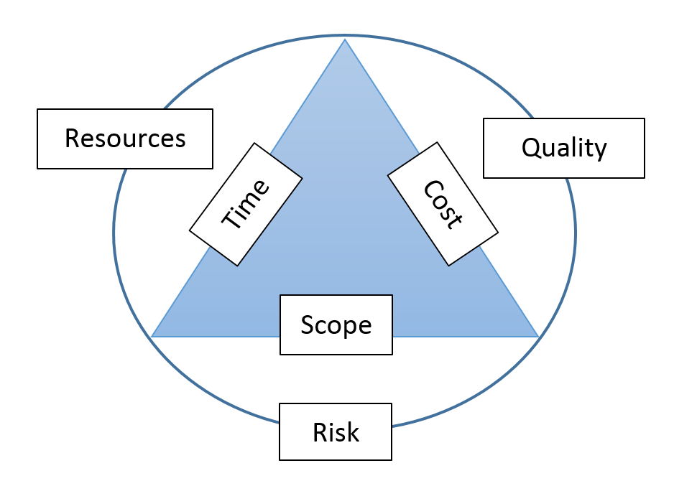
Figure 2: Time Project Management
For instance, timely availability of resources would ensure consistency in operations and time execution of stages planned for project. Cost would be helpful in determining the quality of resources used. Higher cost means high quality materials and equipment’s and low cost can indicate poor quality. Similarly, scope of project would determine the risk associated with project. For instance, timely completion, budget constraints and quality is determined through scope. Sydney metro project would also consider these factors to manage risks and time with quality. Time would be crucial factor, as it is a public project hence timely completion is necessary.

Project communication method
In the project of Sydney metro, different types of communication method will be used for informing and discussing the key components of the project. These are mentioned below:
Verbal: Verbal communication method such as meetings will be conducted with the investors and contractor involved with Sydney Metro in order to discuss on the requirements of the project. Additionally, different rounds of meetings shall be done with the stakeholders in each of the phase of project to discuss on the fundamental aspects such as design of tracks, redevelopment of homes, managing contract process and others (Samáková et al., 2017).
Non-verbal: In this regards, body language is important for understanding the perspectives of investor and workers those are involved in the project. Additionally, eye contact is important in the project that would help in understanding the requirements and demands of the labours of metro project.
Writing: Emails are the suitable form of written communications that plays a major role in the project. In this project, using emails, the key individual such as project manager can sent the vital information related to each stage of the project to associated parties effectively.
Listening and visual: Both these methods of project communication are required for implementing the project successfully (Sanghera, 2019). For example, labours of Sydney Metro need to adapt these methods of communication for understanding the instructions that would be given by their project manager for meeting all the requirements of project. Visual method would enable in analysing the measurements and designs of the metro project properly.

3. Critically evaluate your ability to manage a project. Use feedback from others to evaluate your own ability to plan and implement a project by identifying strengths and weaknesses. Create a self-development plan to improve your own performance in managing projects.
The process of change management is usually a long and complex process. The case of Sydney Metro development, for instance, requires the need of change management models for successful implementation. Some of the important change management models have been discussed below.

Kotter’s change management model
John Kotter believes that about eight steps are required for successful change management. He believed that great change in a single step might bring about adverse effects. The first of the eight steps refers to increasing urgency. For this, individuals need to identify their threats and opportunities in an environment and further request the involvement of important people such as the stakeholders (Haas et al., 2020). The second step is for building a guiding team. Leaders need to form a team and guide the members to improve their weak points. In the third step, they need to develop a vision and strategies in accordance to the same.
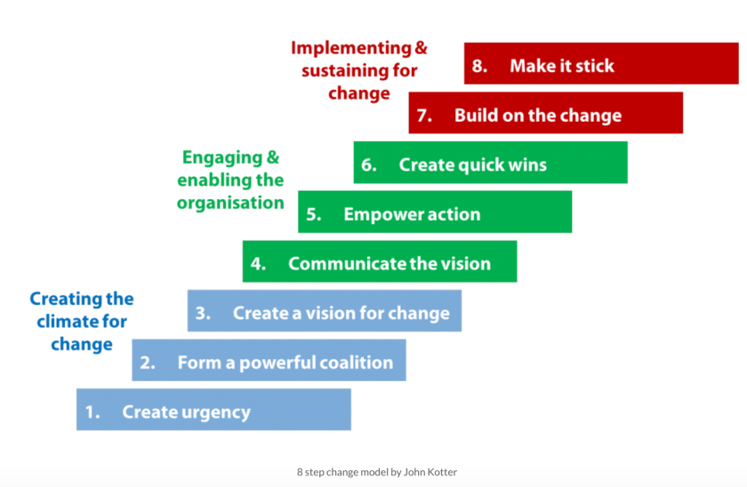
Figure 3: Kotter’s change management model
(Source: Haas et al., 2020)
The fifth stage is that of empowering action, which is done by removing the barriers and obstacles in the way. The sixth stage believes in creating short term wins. This is the gradual process of preparing for the long term goal and thereby boosting the morale of the individuals with these achievements (Galli, 2018). The seventh stage refers to “Don’t let up”, that is, consolidated gains. In this, the success stories of the individuals and accomplishments are analysed. The final stage aims at making the change stick. Following this theory, change management becomes simpler by small steps at a time.

ADKAR successful change management model
Another well known change management model is Prosci ADKAR (Awareness, desire, Knowledge, Ability and Reinforcement). It helps the leaders, managers and employees to facilitate change by guiding them into the process. The first phase is that of awareness, and it believes in stepping outside the comfort zone in order to generate knowledge regarding the surroundings (Tang, 2019). They generate passive reactions or actively resist the changes taking place. Desire, on the other hand, refers to understanding the need for change. They try to facilitate the change once they realise that the change might bear positive effects for them.
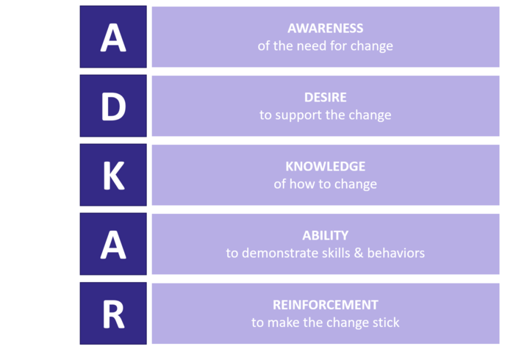
Figure 4: ADKAR successful change management model
(Source: Tang, 2019)
In the phase of knowledge, people generate quality information regarding the entire change management process and plan on implementing the same effectively. The process can never become successful if proper planning is not made, and if the employees do not organise towards achieving the goal. The next phase is that of ability, which refers to the process of implement the knowledge to understand the capacity of working towards the same (Karambelkar & Bhattacharya, 2017). Finally, the reinforcement phase believes that a process might be repeated if the level of satisfaction is not reached the first time. Using this model, change process might be easier with the understanding of the process and its proper implementation.

Implementing project change management
Sydney metro is expected to be released in 2024 and might cost up to about $12 billion. The project aims at delivering about 31 metro rails in the public transport arena. Several changes might take place as the authorities acquire a 15,600 square metre area in Australia and work on the project (navartis.co.uk, 2020). In this process, they might implement the change management model by Kotter. In this, they need to build a proper team for working towards the change and work in accordance to their identified vision. They need to remove the barriers, such as legal complications and objections from the localities. Apart from this, taking short term steps in the process might be necessary, as it is a long and sensitive process involving advanced technology. The leaders need to take time and appreciate the hard work of the team members in order to keep their morale boosted. They need to make sure that the project is flawless so that it sustains long term.
Following the ADKAR model also might make it easier for the authorities to complete the project and make effective changes. In the first place, the team needs to indulge in research and development before they undertake any strategy. Following this, they need to understand the requirement for the new project of metro rail. This helps them connect to the work structure further. In the work structure, the individuals need to possess knowledge of their assigned job roles and the associated factors such as the raw materials, supply chain and manufacture of the rails and tracks. They need to practice their work structure in order to maintain a flawless workflow.

Management of transformation process
One of the main attributes of a project involves transformation. This is mainly because the process infers for change and transformation in some aspects. The main purpose of transformation is to make significant shifts and alterations within the business. It does so in accordance to the global trends and changes in the business market. Usually, the top management of the company is responsible for setting up the transformation team for the project. The transformational project managers have the role of examining the risks and the presence of possible technology for the project (Buschmeyer, Schuh & Wentzel, 2016). For the project of Sydney metro, a digital transformation might be suitable. Following this, they might use computer and internet to make their work structure more efficient and accurate. Analytical technology might help the project managers further elevate the quality of performance and result in better returns on investments.

Relevant models for reflecting project manager skills
The framework of Gibbs reflective model might be helpful for analysing the overall skills and self assessment. In my case and my experiences of working in the project of Sydney metro, this helped me analyse my skills and weaknesses. This framework consists of six stages. The first stage is that of description, whereby the entire experience is noted. The following stage is of feelings. In this, I can express my overall feelings and understanding while working for the project. In the stage of evaluation, I can jot down my experiences and accomplishments of working as a project manager (Tanaka, Okamoto & Koide, 2018). This stage helps me understand the issues and drawbacks in my skills. The following stage of analysis evaluates the reasons for these drawbacks. In the stage of conclusion, I might note down the facts and skills I learned after completing this role. Finally, I need to analyse my short term and long term goals in the action plan phase.

Figure 5: Gibbs reflective model
(Source: Tanaka, Okamoto & Koide, 2018)
Another relevant model might be that of Kolb’s experimental cycle. It has four key stages for reflecting upon an experience or event. The first stage is that of concrete experience, whereby a new experience is encountered. The following stage is that of reflective observation of the experience. In this, I might ponder upon my experiences of working as a project manager and understand my skills and competences in the process. The third stage is that of abstract conceptualisation, which might arise new ideas and insights in my though process of being a project manager (Moorhouse & Jung, 2017). The final stage is that of active experimentation, whereby I might apply the new skills and knowledge I gained from this experience. In the diverging style of learning, people are sensitive and look into things from a distinct perspective. The assimilating style, however, adds a logical approach and the converging style uses the learning and experience to solve current problems. The accommodating uses intuition over logic.
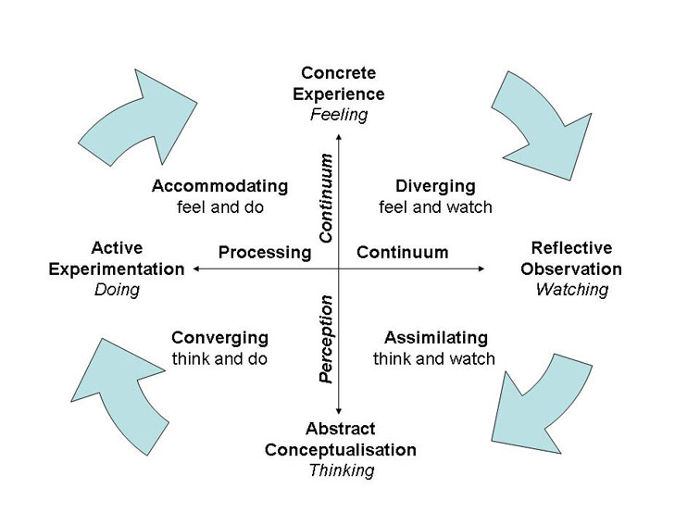
Figure 6: Kolb’s experimental cycle
(Source: Moorhouse & Jung, 2017)

Belbin’s team model
Belbin gave away his views on the various types of team roles and activities in terms of about nine roles. Under the action oriented roles, there is the shaper responsible for removing obstacles to the workflow and the implementer for turning ideas into reality. The completer-finisher, on the other hand, verifies the work by removing errors. The co-coordinator plays a part in the people oriented roles by clarifying the goals and targets for all (Paulamäki, 2018). The team-worker is responsible for being cooperative and organising the work, whereas resource-investigator communicates with the team to identify the opportunities. The thought oriented role involves the plant, coming up with creative and innovative ideas. The monitor-evaluator scans all the ideas and the Specialist provides additional knowledge in the same.

Personal Development Plan
After assessing my skills and weaknesses as a project manager, the following table has prepared a personal development plan for my future growth and development.
Skills | Resources | Measuring success | Timeline
My communication and negotiation skills need improvement | I need to communicate with my team and the employers to gain knowledge of effective communication. I might explore books and journals on active listening and seek opinions of employers. | Once I am able to improve this skill, I might be able to strike attractive deals for my project and take resort to impressing investors for the same. I might come to the notice of my employers. | 3 weeks (Short term goal)
My critical thinking skill is not satisfactory | I need to access the internet to read scholarly journals and frameworks on critical thinking. I might read case studies on the same. | This skill might be measured when I am able to make innovative decisions for the project and foresee the strategies with my critical thinking skills. | 6 months (Midterm goal)
My team working skills require much improvement. | I need to communicate with my teammates and understand their perspectives. I might access theories such as Belbin’s team role and so on to understand the concept of effective team working. | The effectiveness of this skill shall be reflected in the success of my projects. I might be able to satisfy my team members and convince them to follow my vision. | 1 year (Long term goal)
Table 7: Personal Development Plan

Conclusion
Thus, it can be concluded that managing a project requires various activities such as planning, execution, completion and review of project. There are also tools and techniques that are used to manage plan such as network diagram, CPM and program evaluation. Quality and scope are crucial elements that determine the smooth execution of project. It is seen that project plan of Sydney metro included project scope plan, stakeholder mapping, communication plan and risk plan to manage the project. It is also found that teamwork and managerial skills are useful for enhancing project quality. Change management is also a significant part of project management, as a project go through changes during planning and execution process.

Education for Sustainable Development (ESD)
Sustainable development is required for long-term availability of natural resources and reducing environmental risk. Hence, education for sustainable development is helpful in creating awareness about sustainable practice. It helps students in learning about social and environmental issues. Project management process also includes sustainable practices to ensure less impact on nature. It can be stated that this module contributed much to ESD. It looked into the concept of project management, which is a prime requirement in the recent times. It also explored the various theories, models and frameworks of change management and reflective studies, which might be helpful in developing the minds of students for their future endeavours.

References
Alvarenga, J. C., Branco, R. R., Guedes, A. L. A., Soares, C. A. P., & e Silva, W. D. S. (2019). The project manager core competencies to project success. International Journal of Managing Projects in Business.
Buschmeyer, A., Schuh, G., & Wentzel, D. (2016). Organizational transformation towards Product-Service Systems---empirical evidence in managing the behavioural transformation process. Procedia CIRP, 47(1), 264-269.
Englund, R., & Bucero, A. (2019). The complete project manager: Integrating people, organizational, and technical skills. Berrett-Koehler Publishers.
Galli, B. J. (2018). Change management models: A comparative analysis and concerns. IEEE Engineering Management Review, 46(3), 124-132.
Goździewska-Nowicka, A., & Rajs, A. (2018). Leadership Qualities in Project Management. Journal of Corporate Responsibility and Leadership, 5(1), 7-22.
Haas, M. R., Munzer, B. W., Santen, S. A., Hopson, L. R., Haas, N. L., Overbeek, D., ... & Huang, R. D. (2020). # Didactics Revolution: Applying Kotter’s 8-Step Change Management Model to Residency Didactics. Western Journal of Emergency Medicine, 21(1), 65.
Harris, P., (2020). 5 Australian infrastructure projects to watch in 2020 | Navartis. Retrieved 20 July 2020, from https://www.navartis.co.uk/industrynews/5-australian-infrastructure-projects-to-watch-in-2020-04918115046
Karambelkar, M., & Bhattacharya, S. (2017). On boarding is a change. Human resource management international digest.
Kerzner, H., (2017). Project management: a systems approach to planning, scheduling, and controlling. John Wiley & Sons.
Moorhouse, N., & Jung, T. (2017). Augmented reality to enhance the learning experience in cultural heritage tourism: An experiential learning cycle perspective. Review of Tourism Research, 8.
navartis.co.uk 2020. 5 Australian infrastructure projects to watch in 2020 | Navartis Retrieved 20 July 2020, from https://www.navartis.co.uk/industrynews/5-australian-infrastructure-projects-to-watch-in-2020-04918115046
navartis.co.uk. (2020) 5 Australian infrastructure projects to watch in 2020 | Navartis. Retrieved 20 July 2020, from https://www.navartis.co.uk/industrynews/5-australian-infrastructure-projects-to-watch-in-2020-04918115046
Paulamäki, E. (2018). Valued Manager Through Belbin Team Roles.
Samáková, J., Babčanová, D., Hrablikchovanová, H., Mesárošová, J., & Šujanová, J. (2017). Using the Communication Methods, Tools and Support During Management of Project Communication in Industrial Manufacturing Enterprises. Research Papers Faculty of Materials Science and Technology Slovak University of Technology, 25(41), 51-62.
Sanghera, P. (2019). Project Communication Management. In CAPM® in Depth (pp. 343-377). Apress, Berkeley, CA.
Tanaka, M., Okamoto, R., & Koide, K. (2018). Relationship between Reflective Practice Skills and Volume of Writing in a Reflective Journal. Health, 10(3), 283-288.
Tang, K. N. (2019). Change management. In Leadership and Change Management (pp. 47-55). Springer, Singapore.
Zwikael, O., Chih, Y. Y., & Meredith, J. R. (2018). Project benefit management: Setting effective target benefits. International Journal of Project Management, 36(4), 650-658.

