Academic and Employability Skills
Mominur Rahman
Student ID:1705768

Lecturer: Sylvia Hoffmann
Module Code: BMSK4001

Table of Contents
Introduction 3
UK Job Market Trend and Overview 4
Job market movement in the context of Brand Executive Position 6
Key roles and responsibilities of a Brand Executive 8
Skills Demanded in the Context of Brand Executive 9
Employer Perspective: Burger King is looking for Branding Executives 10
Personal SWOT Analysis and Personal Development Plan 11
Conclusion 14
References 15

Introduction
In UK job market, different types of organizations have been emerging at every day and it is providing several job roles. This allows people to get involved with professionals more and more. They are taught how to develop their personal skills for being eligible to compete for a job role. Brand executive is such a role by which organization can build up their product or service image to the customers, parties, investors, and competitors (Huber, 2018). Every organization maintains their distinct logos, mottos, and slogans to express their uniqueness to the world through brand management. This role imposes some challenging criteria and it motives any employers by its nature. Through this motivation, students nowadays are involving with this type of professional. Because it is a place where one can come up with his distinct creativeness. Employers may not bore in doing the same role again and again rather than they can build their own plan. Moreover, organizations are trying to compete with existing markets by emerging different promotional strategies and this is another reason for increasing the practice of this role (Burke and Williams, 2012). I, personally, have found this role quite interesting as it matches with my inherited skills and I can flourish in this type of job.

UK Job Market Trend and Overview
Due to immense commercialization, people tend to involve with several professionals in their early stage of education. More specifically, graduates are trying to involve with professionals in a frequent number. And business organizations are also cooperating with their response because of their fresh knowledge. A non-graduates is comparatively less demanded than graduates because he has lots of requirements meant to be acknowledged. Analyzing the following comparison among graduates, non-graduates, and postgraduates in finding a job in UK market, graduates are considered in a better position.
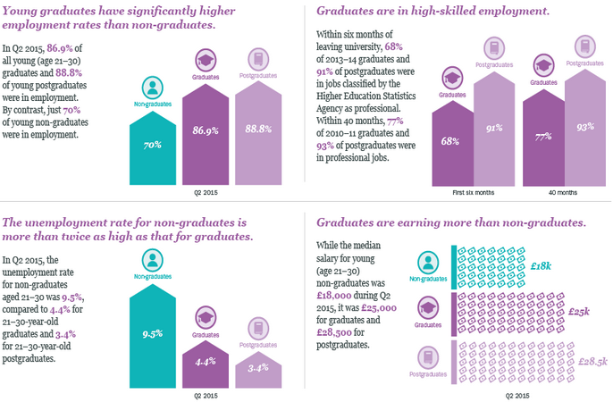
Figure 01: Graduate Employability in the UK
Source: (Universities UK.ac.uk, 2018)
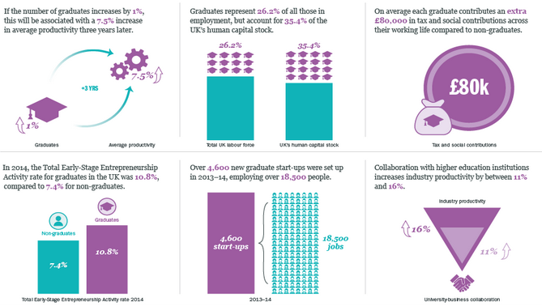
Graduates are considered as the most productive resource for an organization as they are inherited with high-skills. They tend to reflect their capability through their performance. The demand for post-graduates is a bit higher than graduates. But for judging the overall condition of the economy of a country, people should start a job just after their graduates because it allocates a great amount of economic benefit. The earning of a graduate or post-graduate is higher than the earning of non-graduate. On the other hand, the employability skills of a graduate can be more polished and qualified rather than a non-graduate. Because he can get a space where he can practice his skills or learn skills. So, it is estimated that the number of unemployment among non-graduates is high.
Figure 02: Graduates and Economic Growth in the UK
Source: (Universities UK.ac.uk, 2018)
While managing both study and work respectively, it increases the productivity level of a graduate from 1%to 7.5% after three years later. It also helps to choose the right pathway of career. For example, the tendency of being an entrepreneur has risen from 7.4% to 10.8% in the UK.
These graduates and post-graduates have their significant adoption in a different section of a business. Graduates tend to work an executive different elementary position such as relationship manager, branding executives, junior accountants whereas post-graduates tend to work in a senior position such as senior executives and senior positions in management, marketing or branding (Singh, 2012). People of this level have the recent ideas of marketing or business environment and can estimate accurate planning also. They know how to manage any risk, time or critical situation which inspires an organization to hire the fresher.

Job market movement in the context of Brand Executive Position
Among the functional areas in an organization, marketing is one of the fundamental factors for any business. It links with the activities that create an image to both outsiders and insiders, builds a relationship and focuses on the demand of the market. Branding is a portion of it as it holds an image within customers, employers and other groups (Contemporary thoughts on corporate branding and corporate identity management, 2014). It is, in fact, a medium of getting involved with people. By implementing unique ideas regarding marketing, organizations try to hold the competition. Brand management is the term that reflects both advertisements and promotions. Moreover, it covers the criteria of marketing and it becomes an area where organizations broadcast their effectiveness, uniqueness, and creativeness (Burke and Williams, 2012). According to US Bureau of Labor Statics, an estimation of upcoming areas is built up through merging the present increasing demand for this job role.
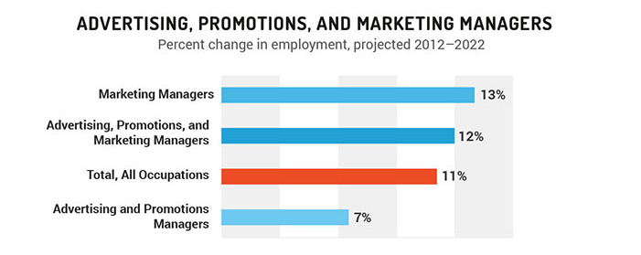
Figure 03: Estimated job role in branding site
Source: (Moz, 2018)
Analyzing the chart, there is a huge demand for jobs in different sections and all the sections are somehow related to the nature of branding. About 75,315 jobs are enlisted as various positions of the marketing function in 2015. So, it is assumed that jobs related to promotional strategies are the main focus of the new graduates. The roles of branding executive are to generate ideas, establish planning for remarkable image and provide continuous approaches to different conditions of the market. Moreover, branding executive has a responsibility for continuous development and maintenance approaches by which employees may find courage and enthusiasm.
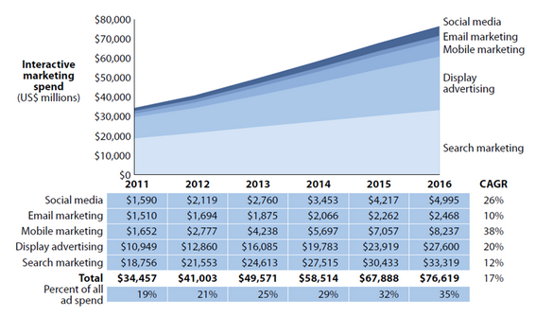
Figure 04: Research on Marketing Spend from 2011 to 2016
Source: (Huber, 2018)
Here, organizations in the UK spend a big amount of money on promotional activities year by year. As promotional factors resemble the concept of brand management so that the demand for employment in brand management in current UK market is in a rising condition (Messum et al., 2017). As students tend to move for new trend always, branding executive has become an interesting role for them.

Key roles and responsibilities of a Brand Executive
Branding refers to verify the identities of products manufactured by different organizations. It helps to identify the effective suppliers, inputs, and processes that should be maintained. It combines with both tangible and intangible facts by which people get a perception of any specific product or organization (Contemporary thoughts on corporate branding and corporate identity management, 2014). As the business organizations are trying to become more commoditized, branding becomes the way of verifying as well as differentiating the identities of same products. The market is always fluctuating according to the buying behavior of employers. Buyers usually do not have any acknowledgment about the quality of a product at first. For this, he might be influenced by the existing competitions of the market, pricing range and the inspirations that organization promotes. So, it assumes the necessity of maintaining a sound brand for survival.
Branding indicates some important factors such as the core manufacturer, current and further responsibilities, risk managing processes, cost management, quality assurance and keeps the slogans or objectives. It also helps an organization through promoting legal features and helps to mark down the ways of managing any obstacles (The Richards Group, 2018). Branding can be made on goods, services, organizations, people, locations, retail companies, sports and idea generation. It concerns about fulfilling the promises to the customers by providing their true needs (Dev, 2012). It also helps people to memorize about a product or commodities easily. The job role in brand management refers a fascinating and marvelous profession for the graduates.

Skills Demanded in the Context of Brand Executive
The educational institutions of nowadays inspire most of the students and provide space so that they can generate their ideas and opinions (Moorthi, 2002). The academic practices become more comprehensive. Through academic practices, students can learn the legal and right way of managing a business or a portion of a business. Brand management is such an area where the practice of exploring new ideas is at high-frequency level. People can find different type motivation from this role, as it is concerned with multi-factors (Jasper, 2013). For this, employers can rarely get bored. From my perception, branding is a small illustration of a wide meaning of organizational goal. It is a plot where a student has the freedom of establishing a plan of promotional strategy. The brand manager also encourages his brand executives to come up with fine ideas so that the respective organization can keep pace with its market position.
For me, the brand executive is an engrossing profession, as I have developed several qualifications for this role. Some qualifications are inherited naturally also. My academic skills also convenient to the decision of being a branding executive. I have learned how to observe certain situation quickly and organize different ideas instantly. I have participated in several competitions related to branding. Moreover, participating in different groups and clubs with different roles has developed my quality. To work under brand management, proper knowledge about market and marketing strategies, principles are required. As I am doing HND program in marketing, I have already attained a lot of terms.

Employer Perspective: Burger King is looking for Branding Executives
Burger King is a global chain fast-food restaurants established in 1954. It has earned a huge fame during its maturity level and for this, it has become a global brand. The brand value of Burger King has reached on 4,569 million US$ and the rating is AAA- in 2016. Somehow it has a decreased position in UK market. To regain the publicity, this organization is looking for graduates who can sum up with distinct ideas and opinions. They demand an institutional degree in marketing, good academic grades, and extra-curricular activities. Achievements in competitions, previous working experience, mental and physical capacity and accomplishment in some other professional degrees are also appreciated.

Figure 05: Requirements for being a Branding Executive
Source: (self-designed)

Personal SWOT Analysis and Personal Development Plan
Besides my previous achievements, accomplishments and current academic practices, I have prepared a personal improvement plan. A personal SWOT analysis is required to develop for identifying the further development planning at first.
Internal | External
Strength  - Academic degree in marketing  - Experiencing obstacles in branding competitions  - Professional degrees in supply chain management  - Good interpersonal skill  - Observation ability and creativity | Opportunities  - Reduce my weakness  - Building capacity in presenting anything  - Practice short project handling in voluntary works  - Try to lead in class, group or club
Weakness  - Less patience  - Less punctual and inconsistency  - Nervousness  - Pronunciation problem | Threats  - Competitors’ advancement  - Increasing competitors  - Technological barriers
Table 01: SWOT Analysis
Source: (Self-designed)
Activities are arranged according to their duration of completion such as long, medium and short-term. In the chart, urgent tasks are assumed as short-term and not urgent is assumed as medium-term task
 | URGENT | NOT URGENT
I  M  P  O  R  T  A  N  T | - Goal set: Get hired by Burger King as branding executives  - Completing all the courses under the respected programs  - Develop communication skills  - Increase cooperation with others  - Participate in random challenging work to reduce nervousness  - Time maintenance for academic, professional and extra curriculums | - Practice speaking for fluency  - Participate in different curriculums  - Build favorable relationship with surroundings  - Practice in free writing  - Work as voluntary or probationary  - Psychological development  - Learn to operate technological devices
N  O  T  I  M  P  O  R  T  A  N  T | - Learn multi-language  - Do physical exercise  - Sleep sufficiently  - Do proper meditation for mental peace  - Practice some brain-storming activities  - Learn about safety and security in organizational context  - Regular participation in lectures | - Unnecessary browsing  - Avoid excess use of social media  - Minimize sporting which reduces the time of learning
Table 02: Personal Development Plan
Source: (Self-designed)
As I have selected the necessary and urgent works, I will try to cover those in short time. But some of them are a long-term task which requires regular maintenance. Later on, I will concern about the not urgent but important tasks part of which most of the works are of medium duration. After that, I will focus on not important tasks. I will do those tasks when I will get extra time and I will also try to reduce some habits which usually waste times. Each and every role is regulated according to the following cycle:
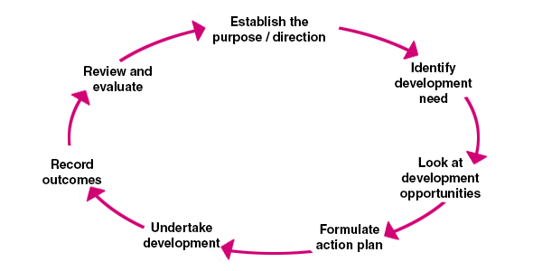
Figure 06: Cycle of maintaining my personal development plan
Source: (Google.com, 2018)

Conclusion
This description refers an individual profession named branding executives which becomes a wide fascinating job role for today’s generation. It provides an organization some advantages such as people can distinguish the uniqueness of different products, helps to know customers’ demand, implement effective pricing strategy etc. Here, the role of brand management and the current job market strategy has also discussed. Evaluation of my current capabilities is also attached. An example of recruitment in Burger King is also given. The SWOT analysis of my current position is made in order to make a further personal development plan. I have also shown a cycle which elaborates how my tasks will be run in the continuous process.

References
Burke, L. and Williams, J. (2012). Two thinking skills assessment approaches: “Assessment of Pupils’ Thinking Skills” and “Individual Thinking Skills Assessments”. Thinking Skills and Creativity, 7(1), pp.62-68.
Contemporary thoughts on corporate branding and corporate identity management. (2014). [Place of publication not identified]: Palgrave Macmillan.
Dev, C. (2012). Hospitality Branding. Ithaca: Cornell University Press.
Huber, M. (2018). How Much Should I Spend on Content Marketing in 2017? [Online] Vertical Measures. Available at: http://www.verticalmeasures.com/content-marketing-2/how-much-should-i-spend-on-my-content-marketing-in-2017
Jasper, M. (2013). Professional Development. Wiley.
Keller, K. (2013). Strategic brand management. Harlow: Pearson.
Messum, D., Wilkes, L., Peters, K. and Jackson, D. (2017). Content analysis of vacancy advertisements for employability skills: Challenges and opportunities for informing curriculum development. Journal of Teaching and Learning for Graduate Employability, 7(1), p.72.
Moz. (2018). The Inbound Marketing Economy. [Online] Available at https://moz.com/blog/the-inbound-marketing-economy
Moorthi, Y. (2002). Branding Principles - Application to Business-to-Business Branding. SSRN Electronic Journal.
Singh, R. (2012). Brand management. New Delhi: Random Publications.
The Richards Group. (2018). Employment. [Online] Available at https://richards.com/careers/employment/#/job/AF84989276?rpid=33085&postid=pQnjx3Fo23E
Universities UK.ac.uk. (2018). Supply and demand for higher-level skills. [Online] Available at http://www.universitiesuk.ac.uk/policy-and-analysis/reports/Pages/supply-and-demand-for-higher-level-skills.aspx

