

Intercultural Communication and Culture
International Business Communication (BMBM6021)
Wenxuan Dang (2300603)

Executive Summary

This report describes international business communication and its skill requirements, Hall's high and low context approach to communication, effective communication, Trompenaar's 7 dimensions to culture, the importance of building business relationships, building trust in business relationships and the impact of failed business relationships. And by using ASOS as a case study of these dimensions. During the course of the study, it was found that the two main characteristics of Asian communication styles are respect and honor, and that hierarchy and authority are also very important in Asian culture. In Hall's high and low contexts, high context cultures prefer indirect communication styles and low context cultures prefer direct communication styles. People in high-context cultures will tell each other what they think by being very subtle, but speakers in low-context cultures will say what they think directly. In Trompenaar's 7 dimensions to culture, there are differences between people from different cultures because each culture has its own way of thinking, values and beliefs, and different preferences for various different factors. In Asia, trust has to be established before doing business, and business can only be done when the other party proves to be trustworthy. If ASOS makes mistakes in communication because of cultural differences, this could lead to problems or failure in business. In response to these issues, the researchers recommended that ASOS train its staff on Asian business practices to help the business expand in the Asian market.

Contents
Executive Summary 1
Contents 2
1.0 Introduction 3
2.0 Main Findings 4
2.1 International Business Communication 4
2.2 Skills Requirements 5
2.2.1 Strong Communication 5
2.2.2 Cultural Awareness 5
2.2.3 A Wealth of Knowledge 6
2.3 Methods of Communication 6
2.3.1 Hall’s High Low Context 6
2.4 Effective Communication 8
2.5 International Culture 10
2.5.1 Trompenaar’s 7 dimensions to culture 10
2.6 Importance of Building Business Relationships 12
2.7 How to Build Trust in Business Relationships 13
2.8 The Impact of Failed Business Relationships 14
2.8.1. Communication 14
2.8.2. Business Activity 14
2.8.3 Work Culture 15
3.0 Conclusion 16
4.0 Recommendations 17
4.1 Communication Skills Training for Asian Countries 17
References 18
Appendices 23

1.0 Introduction
The purpose of this report is to use ASOS as a case study of the cross-cultural communication theories that need to be understood when expanding a business from the UK to the Asian market, so that organizations can understand different international cultures when expanding their business, and to provide guidance and advice. ASOS is a British online fashion and cosmetics retailer. The company was founded in London in 2000 and caters for young people. It sells more than 850 brands as well as its own clothing and accessories ranges and ships to all 196 countries from its operating centers in the UK, USA and Europe. Through researching the Asian market, it was found that Asian communication styles mainly include respect and honor, with hierarchy and authority also important. In Hall's High-Low Context, the Asian market belongs to a high-context culture that prefers an indirect way of communicating and will let the other person understand what they are thinking by being very subtle. In Trompenaar's 7 dimensions to culture, Asian countries all have different ways of thinking, values, beliefs and preferences and will also have different preferences for different situations.

2.0 Main Findings

2.1 International Business Communication
International business communication is the development and sharing of information through verbal and non-verbal messages in an international environment and context. It is important for maintaining good business relations across cultures, as cultural norms and expectations can vary greatly from one country to another (Mcrill, 2019). Cultural differences refer to the variety of beliefs, behaviors, languages, customs and expressions characteristic of members of a particular race, ethnic group or nation. Cultural differences reflect the diversity of human societies and cultures around the world. Cultural diversity is the quality of different cultures respecting each other's differences (Adler, 2001). ASOS needs to be aware of cultural differences and respect them while expanding the company's business into the Asian market. The Asian way of communicating has two main characteristics: respect and honor. However, as Asians rarely use body language and facial expressions to express themselves, this can make many Westerners feel uncomfortable in conversation (Hofstede, 2013). Hierarchy and authority are also very important in Asian cultures, so meetings that bring people of different hierarchies together are inappropriate (Findcourses, 2016). ASOS can also engage in appropriate cultural interactions when building business relationships with Asian companies.

2.2 Skills Requirements

2.2.1 Strong Communication
There are several steps to improve communication skills in international business. Firstly, consider which languages are spoken by potential employers, partners, suppliers and customers. Proficiency in these languages can open doors that might otherwise be closed. Next, consider non-verbal communication through body language, posture and eye contact. This can vary greatly from culture to culture, so it's important to understand how non-verbal communication affects the message that is trying to be conveyed. The researchers recommend ASOS to hire a translator who is familiar with the communication skills of Asian countries as it expands into the Asian market, so that it can avoid some inexcusable mistakes in the communication process for the other country.

2.2.2 Cultural Awareness
Every culture has unique nuances and quirks. However, these cultural differences can occasionally lead to misunderstandings, failed deals or embarrassment (CultureVulture, n.d). If one is very interested in entering the field of international business, one needs to have an in-depth knowledge of the various cultures that one will be exposed to. Not only should one learn their language, but one should also become familiar with their beliefs, traditions and social norms. A strong cultural awareness ensures that the messages conveyed and actions taken are always moving towards the goal. For example, a company may want to craft a marketing campaign that resonates with the local community. If cultural awareness is not strong, the message will be ineffective or the business deal will fall apart due to minor details.

2.2.3 A Wealth of Knowledge
Companies need a solid understanding of basic economic principles, financial accounting and entrepreneurial frameworks. In addition, knowledge specific to the international context is required. For example, while macroeconomic theory affects all businesses, it has a greater impact on those that operate on a global scale. The profits of multinational corporations can be affected by a variety of political and social factors, but these are not encountered by firms operating in their home countries. Taxes, tariffs and trade deficits can easily become threats, but occasionally they can also become opportunities, and they must all be dealt with properly (Stobierski, 2021).

2.3 Methods of Communication

2.3.1 Hall’s High Low Context
High-context cultures prefer indirect methods of communication. Thus, in high-context communication or information, the message either exists in the actual context or is internalized within the person, while the explicit and transmitted part of the message is minimal. On the other hand, low-context cultures prefer direct methods of communication (Hall, 1976). According to Hall's classification, high-context cultures include Japan, China, Russia, and Arab countries. High-context cultures tend to be collectivist cultures in which maintaining group harmony is important. People who communicate in such cultures are more concerned with not losing respect or 'face' and with peaceful coexistence. According to Bargiela-Chiappini et al. (2013, p.232), 'the need for the speaker to be respected and liked and the need for the listener's positive self-image to be socially recognized when considering 'face' is salient in any type of communication, especially in environments where the participants may encounter potential conflict'. High-context communication tends to 'rely heavily on elaborate symbol systems, body language, tone of voice, and hidden, culturally based meanings' (Hurn & Tomalin, 2013 p.21). Thus, when communicating, the receiver needs to "read between the lines' in order to fully understand the message being conveyed.

Speakers in low-context cultures say what they think without adapting the message to the other person. According to Hurn and Tomalin (2013, p.7), the result of their communication may be transparent and clear, but people who are used to communicating in high-context cultures may perceive them as rude. In low-context communication everything is expressed in words, which means that the meaning is more in the words than in the layout or structure of the document or website. This may explain why people prefer written communication in this context. Low-context communicators also 'don't think everyone has most of the information they need, so communication needs to be more explicit' (Hurn & Tomalin, 2013, p.22). Consequently, communication in this context is usually clearer and more detailed than in high-context cultures. Hall's research generally identifies Western/Northern European cultures as low-context cultures, a category that includes Scandinavian countries, the United States, and European countries.

The UK, where ASOS is based, is a low-context culture, so care should be taken when communicating with Asian countries that are part of a high-context culture to use high-context culture communication. When communicating, ASOS need to use indirect communication and think deeply about the responses to get the key messages. In written communication, ASOS needs to focus on hiding the true meaning of the message in the text, so that Asian countries can feel the sincerity of ASOS, which will make the business development more smoothly.

2.4 Effective Communication
Effective communication is a process of exchanging ideas, thoughts, opinions, knowledge and data so that messages are received and understood clearly and purposefully. For communication to be effective, it must be clear, correct, complete, concise and empathetic (Coursera, 2023).

ASOS maintains accounts on all major social networks and engages existing and potential customers through regular posts and interactive comments. They also ran an inclusive campaign in 2014 with the hashtag #asseenonme, which users could add under their own posts about ASOS products. This provided customers with real, non-sponsored photos and opinions of ASOS products. ASOS have also focused on making their profiles versatile to ensure that their products match every occasion, as well as adding the option to shop directly from Instagram to make shopping easier and more convenient for customers. ASOS have a separate account called @ASOS_HeretoHelp which is dedicated to dealing with customer queries. This ensures that their main account always presents a positive brand image and allows them to give customers the attention they deserve. Additionally, they offer a number of quick reply options to make the whole experience customer friendly and ensure efficiency (Fadhil, 2020).

The ASOS stylists are all different genders, ages, ethnicities and body types, and they all have their own personal pages on the ASOS website with their current favorite pieces, as well as links to their social media profiles. ASOS also happened to use real people in this way to communicate to consumers how easily it harmonizes with different lifestyles. This makes customers more likely to buy items designed by people they have seen connect with them, rather than items displayed on impersonal models. the ASOS stylists exist to encourage consumers to develop a personal connection with the stylist, and therefore with the brand (Phillips, 2017).

2.5 International Culture

2.5.1 Trompenaar’s 7 dimensions to culture
The seven dimensions of culture were identified by Fons Trompenaars and Charles Hampden-Turner in their 1997 book 'Riding the Waves of Culture'. They found that each culture has its own way of thinking, values and beliefs, as well as different preferences for different factors (Trompenaars & Turner, 1997).

ASOS, when using Trompenaars and Hampden-Turner's Seven Dimensions of Culture for the Asian market, pays major attention to the particularism, communitarianism, diffuse, ascription, synchronous time, and outer direction. These dimensions of culture are found in Asian countries, which is useful for ASOS's business development. People in Asian countries believe that every situation and every relationship determine the rules by which they live. Their reactions to situations may change depending on what is happening at the time and who is involved. They believe that the group is more important than the individual, that the group provides help and security in exchange for loyalty, and that the group always comes before the individual. They see good relationships as essential to achieving business goals, both at work and in social situations with others. They spend time with colleagues and clients outside of working hours. They believe a person should be valued for who they are. Power, title and status are very important in these cultures and these roles determine people's behavior. People believe that the past, present and future are intertwined. They often work on multiple projects at the same time and believe that plans and commitments are flexible. They believe that nature or the environment controls them and that they must co-operate with the environment to achieve their goals. At work or in interpersonal situations, they focus their actions on others and avoid conflict whenever possible.

When communicating with Asian countries, ASOS has to adapt and integrate their cultural dimensions. For example, in business co-operation priority is given to working in groups and helping each other in groups to achieve tasks. People in Asian countries place a high value on relationships, and good relationships can lead to a higher chance of achieving business goals. ASOS needs to pay attention to people's status when interacting with Asian companies, because the higher the status, the more power and respect they receive. ASOS must always be aware of this focus if they want to access better resources and information. Asian companies pay a lot of attention to the general environment of the whole country, so ASOS needs to pay attention to the situation of the local business environment while expanding its business, and the good or bad business environment will have a great impact on the business. In the process of working with Asian companies, ASOS needs to give encouragement to Asian staff when they are doing a good job and recognize that they are doing a good job. This creates a better working relationship and brings employees closer together (EmpiricsAsia, 2015).

2.6 Importance of Building Business Relationships
Trustworthy business relationships will lead to employee satisfaction, co-operation, motivation and innovation. In addition, business relationships built on loyalty help companies build strong and lasting relationships with employees, customers and suppliers (Medina, 2019).

Great business relationships help ASOS build strong relationships with people who will help them in the future. They also give ASOS the opportunity to learn new things about themselves and others. In addition, they allow ASOS to connect with people from different cultures, backgrounds and experiences (Kronos, 2022). Healthy relationships between ASOS and its employees, as well as between employees and staff, are also vital to the success of the organization. By treating them with respect and applauding their successes, no matter how big or small, they increase their productivity, commitment to their work and contribution to the development of the organization (Ajaero, 2023). Regularly connecting with customers and actively listening to their feedback is equally important as it increases brand loyalty. Building relationships with customers through positive, authentic experiences will ultimately contribute to the overall business growth of ASOS (Jabli, 2022).

2.7 How to Build Trust in Business Relationships
Generally, the default trust in the West is 'trust'. People will give the other person the benefit of the doubt that they are basically trustworthy until they do something that breaks the trust between them. In Asia, on the other hand, the default is more towards 'distrust', where other people will only give people the benefit of the doubt if they prove themselves trustworthy. In Asia, trust has to be established first, and once that is established, business can only be done. Whereas in the West, people are used to doing business almost immediately when working in the same industry. Given the opportunity, Westerners prefer to build trust while doing business. In Asia, the primary function of trust is to protect and establish an initial sense of security. In the West, on the other hand, trust is more about exploring and building as much fertile ground as possible for future opportunities. From the perspective of building international business, it's clear that from an Asian perspective they need to earn trust before things can move forward. Asian business people will invest a lot of time in getting to know each other. From a Western perspective, it may be thought that they are already discussing business deals, but their Asian counterparts may not have considered a possible deal and they may still be evaluating (Cremer, 2015).

Because a personal relationship does not yet exist at the initial stage, ASOS should be aware that building trust primarily through social means (e.g. organising parties or giving gifts) may be counterproductive. In the early stages, it is more important to demonstrate the value of ASOS to their business. At this stage, it is also necessary to remember that the most important thing is to demonstrate their competence and expertise and not just simply talk about it (Gross, 2014). Once the business relationship has got off the ground and ASOS have started working with Asian managers and staff, it is important to build on this. It is important that your Asian counterparts feel your sincerity throughout the business process so that good business relationships can be built over the long term. Whilst building trust in Asia is an involved and time-consuming activity, the level of trust that can be achieved is everlasting (AsialinkBusiness, n.d).

2.8 The Impact of Failed Business Relationships

2.8.1. Communication
If ASOS emphasizes the mistakes and missteps of Asian colleagues, this can cause them to lose face, as can arguing or shouting in public. Losing face can be extremely uncomfortable for Asians and they may feel that they are not being given enough respect and privacy. This is likely to lead to awkward relationships between ASOS and their Asian colleagues, which can further lead to problems in business (Bernardo, 2017).

2.8.2. Business Activity
If ASOS doesn't spend a lot of time building 'relationships' in the Asian market, then no one may step up to help when they need it. When working with Asian companies, ASOS can be seen as not being group orientated if they don't consult senior Asian staff before agreeing to an action or deal (Mauser, 2019).

2.8.3 Work Culture
If ASOS do not understand the hierarchy of the organisation they are dealing with and how they work and whether business partners have specific titles, Asian colleagues are likely to feel that they are not respected and that ASOS do not value formality at work (Cook, 2022).

3.0 Conclusion
By examining the skills required to facilitate successful international business communication, Hall's high and low context approach to communication, effective communication, Trompenaar's 7 dimensions to culture, the importance of the various skills required to build in professional relationships, building trust in business relationships and the impact of potential failures in business communication on the relationship building process. The main findings were that failure to use appropriate communication styles, failure to build helpful relationships, and failure to understand the relevant corporate culture can lead to failure in business relationship building. In response to these issues, the researchers suggest that ASOS could train its employees on Asian business practices before establishing business partnerships.

4.0 Recommendations

4.1 Communication Skills Training for Asian Countries
ASOS can train employees in Asian business practices. For example, use both hands to give and receive business cards when exchanging business cards with Asians. Always read your business cards carefully before placing them in a card case or on your desk. When communicating with Asians, pay more attention to non-verbal cues and express deeper messages through facial expressions and body language (Gabriel, 2016).

References
- Mcrill, D. (2019) The importance of communication in International Business, Bizfluent. Available at: https://bizfluent.com/info-7761139-importance-communication-international-business.html (Accessed: 22 November 2023).
- Adler, N.J. (2001) International dimensions of organizational behavior. 3rd edn. Cincinnati: South-Western College Publishing (Accessed: 22 November 2023).
- Hofstede, G. (2013) Culture’s consequences: Comparing values, behaviors, institutions, and organizations across nations. paperback. Thousand Oaks, CA: Sage. (Accessed: 1 December 2023).
- Findcourses (2016) Cross-cultural communication: What to expect, findcourses.co.uk. Available at: https://www.findcourses.co.uk/inspiration/articles/cross-cultural-communication-styles-8888 (Accessed: 22 November 2023).
- CultureVulture (no date) ‘How Lack of Cultural Awareness Can Cost A Business Big’, Commisceo Global. Available at: https://www.commisceo-global.com/blog/cultural-sensitivity-in-business-1 (Accessed: 01 December 2023).
- Stobierski, T. (2021) 4 skills you need to get involved in international business, Business Insights Blog. Available at: https://online.hbs.edu/blog/post/international-business-skills (Accessed: 22 November 2023).
- Hall, E. (1976) Southeast Asian history and historiography: Essays presented to D. G. E. Hall. Hardcover edition. Ithaca: Cornell University Press, p.91. (Accessed: 22 November 2023).
- Chiappini, F.B., Nickerson, C. and Planken, B. (2013) Business discourse. Electronic version Basingstoke, Hampshire: Palgrave Macmillan, p.232. (Accessed: 22 November 2023).
- Hurn, B.J. and Tomalin, B. (2013) Cross-cultural communication: Theory and practice. electronic version. Houndmills: Palgrave Macmillan. (Accessed: 22 November 2023).
- Coursera (2023) What is effective communication? skills for work, school, and life, Coursera. Available at: https://www.coursera.org/articles/communication-effectiveness (Accessed: 23 November 2023).
- Fadhil, Z. (2020) ASOS: Where customers’ content is our marketing tool, Medium. Available at: https://medium.com/digital-society/asos-where-customers-content-is-our-marketing-tool-3e8e060d4ea7 (Accessed: 23 November 2023).
- Phillips, A. (2017) How asos communicates online, Medium. Available at: https://medium.com/digital-society/how-asos-communicates-online-fa66450f6987 (Accessed: 23 November 2023).
- Trompenaars, F. and Turner, C.H. (1997) Riding the waves of culture: Understanding diversity in global business. London: Nicholas Brealey. (Accessed: 23 November 2023).
- EmpiricsAsia (2015) Business Culture Of Asia, Empirics Asia. Available at: https://empirics.asia/business-culture-of-asia/ (Accessed: 01 December 2023).
- Medina, K. (2019) Why are relationships important for business?, Tricycle Europe. Available at: https://www.tricycle-europe.com/why-are-relationships-important-for-business/ (Accessed: 24 November 2023).
- Kronos (2022) Why is relationship building important in business?, Kronos Experience. Available at: https://kronosexperience.com/why-is-relationship-building-important-in-business (Accessed: 24 November 2023).
- Ajaero, T.M. (2023) Top 10 reasons business relationships are important, ProfitableVenture. Available at: https://www.profitableventure.com/why-relationships-important/ (Accessed: 24 November 2023).
- Jabli, M. (2022) Council post: Why cultivating relationships is key to building your business, Forbes. Available at: https://www.forbes.com/sites/forbesbusinesscouncil/2022/03/03/why-cultivating-relationships-is-key-to-building-your-business/ (Accessed: 24 November 2023).
- Cremer, D.D. (2015) Understanding Trust, in China and the West, Harvard Business Review. Available at: https://hbr.org/2015/02/understanding-trust-in-china-and-the-west (Accessed: 01 December 2023).
- Gross, A. (2014) 3 tips for building strong business relationships in Asia, Pacific Bridge Medical. Available at: https://www.pacificbridgemedical.com/ameing-for-asia/3-tips-for-building-strong-business-relationships-in-asia/ (Accessed: 01 December 2023).
- AsialinkBusiness (no date) Understanding the concept of ‘guanxi’, Asialink Business. Available at: https://asialinkbusiness.com.au/china/conducting-business-in-china/understanding-the-concept-of-guanxi (Accessed: 01 December 2023).
- Bernardo, J. (2017) Why businesses fail when expanding to asia - VA partners, VA Partners - Sales and Marketing for Startups. Available at: https://vapartners.ca/businesses-fail-expanding-asia/ (Accessed: 01 December 2023).
- Mauser, P. (2019) When Western Brands Fail in Asia, it’s because....., LinkedIn. Available at: https://www.linkedin.com/pulse/when-western-brands-fail-asia-its-because-patrick-mauser (Accessed: 01 December 2023).
- Cook, S. (2022) Business cultures from around the world, Startups.co.uk. Available at: https://startups.co.uk/analysis/business-cultures-from-around-the-world/#asia (Accessed: 01 December 2023).
- Gabriel, J. (2016) A guide to business culture in Asia, Gengo. Available at: https://gengo.com/language-and-culture/guide-business-culture-asia/#:~:text=A%20guide%20to%20business%20culture%20in%20Asia%201,Networking%20...%204%20Communication%20...%205%20Decision-making%20 (Accessed: 01 December 2023).

Appendices
- The ASOS #AsSeenOnMe campaign
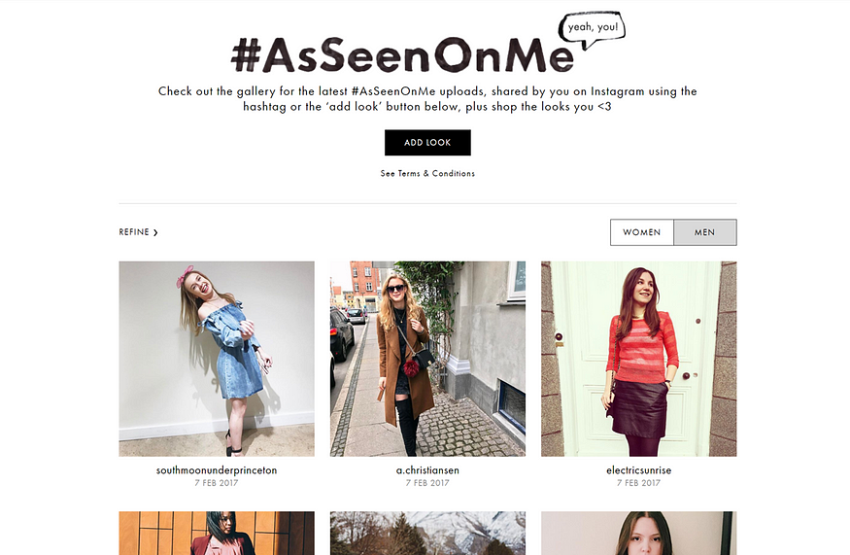

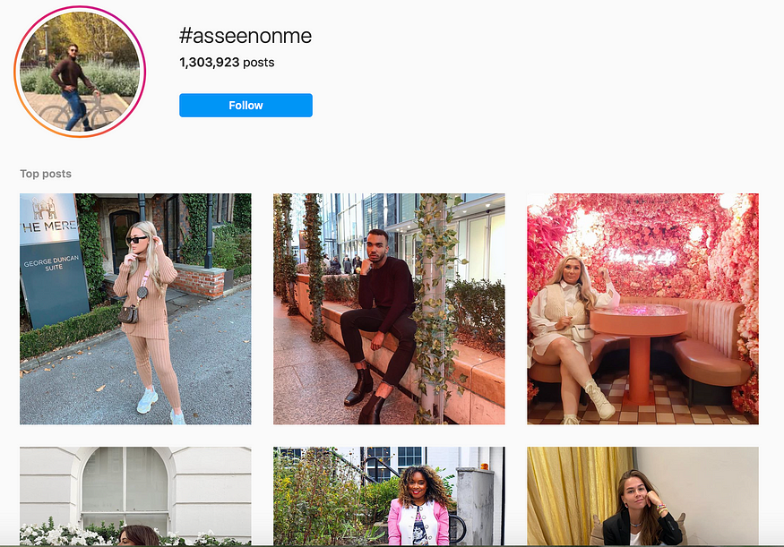

- Quick responses of ASOS help account

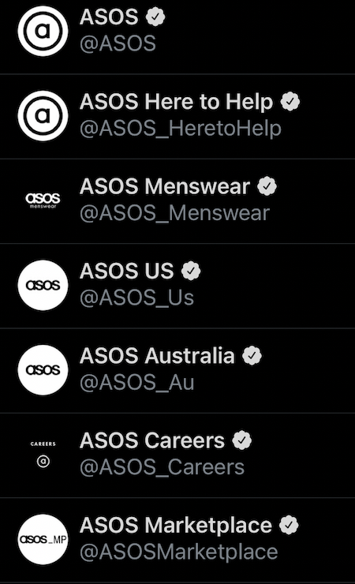

- The ASOS Stylist with the current highest number of followers
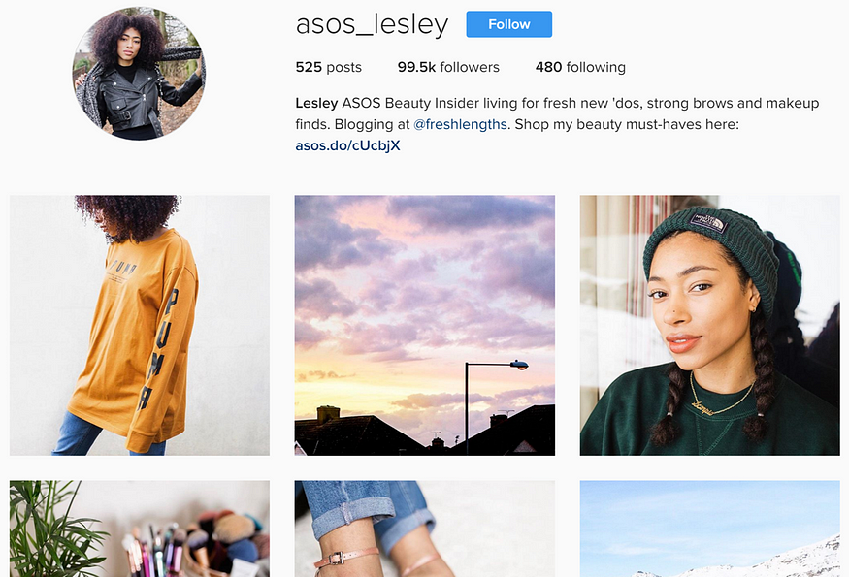

- Trompenaar’s 7 dimensions to culture


