UWTSD
WISA
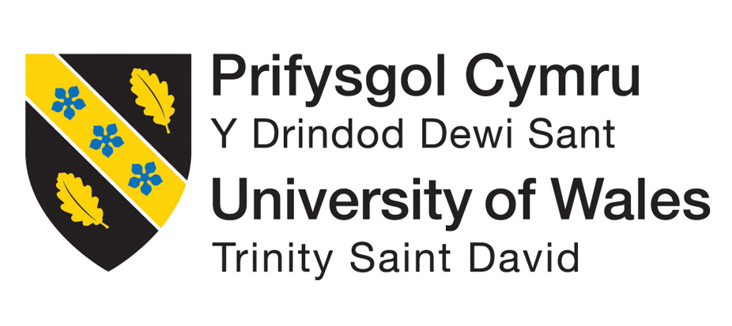

Thermodynamics and Combustion
ACHA5011

Callum Francis-Beck
2312005
07/12/25

Table of Contents
1 Introduction 2
2 Roles and Responsibilities 2
3 Tasks and Timings 2
4 Personal Tasks 3
5 Milestones 3
6 Concerns 4
7 Full Plan 4

Introduction
This Assignments purpose is to investigate the results of a practical session carried out in the workshop where the characteristics of an engine were closely looked at. The focus is on the valve train of a 2.0 litre Ford Duratec engine, many aspects will be looked at against crank and camshaft angles such as piston position, intake and exhaust valve lift, piston velocity and acceleration and a plethora of other factors. The use of a flow bench will be required to complete some of the tasks at hand, using the university’s own flow bench both intake and exhaust of the bare block will be tested to discover the volumetric flow rate over a range of valve lifts. The collected data will be presented in graphs and calculations on a separate excel spreadsheet.

Component Characteristics
When taking measurements for the components, many issues can arise with the measurement equipment. Weighing scales not being zeroed will have a major effect on accuracy as it could be a few grams or even kilograms out depending on the scale of what is being measured. Another piece of equipment that could give incorrect measurements is a calliper, if these also are not zeroed, they will give false readings, knowing how to use the equipment is important too as holding or moving the equipment a certain way could knock figures out slightly. On top of these issues another one could be due to the person using the equipment reading the results wrong, so it is very important to know what you are looking for.

3 Lightweight Component research

Flowbench
To get these results, the university’s flow bench was used as well as a university supplied Ford Duratec engine to carry out the measurements on,

Discussion

Results
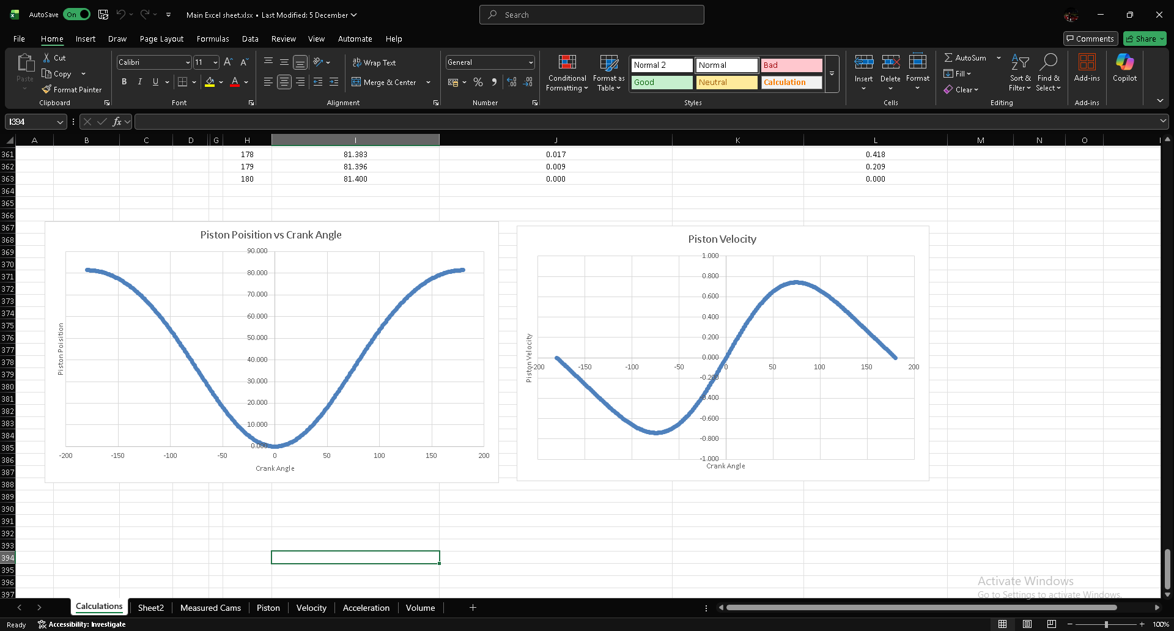

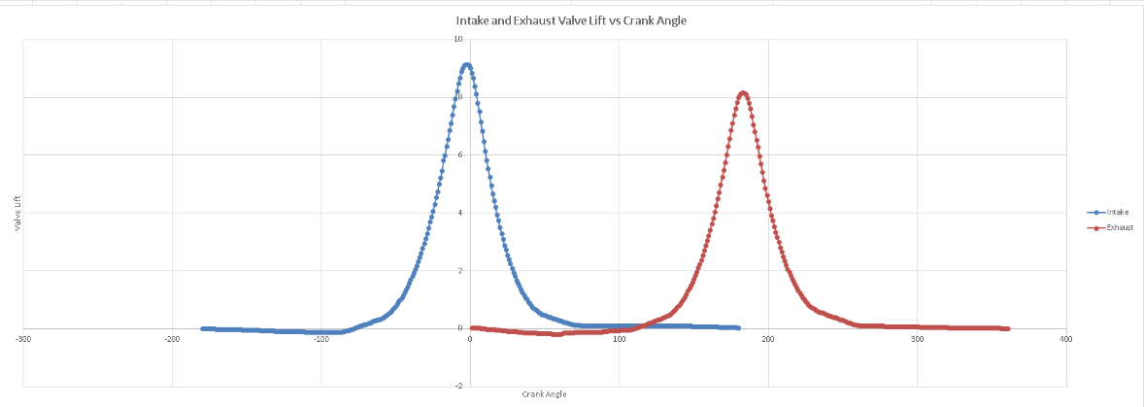

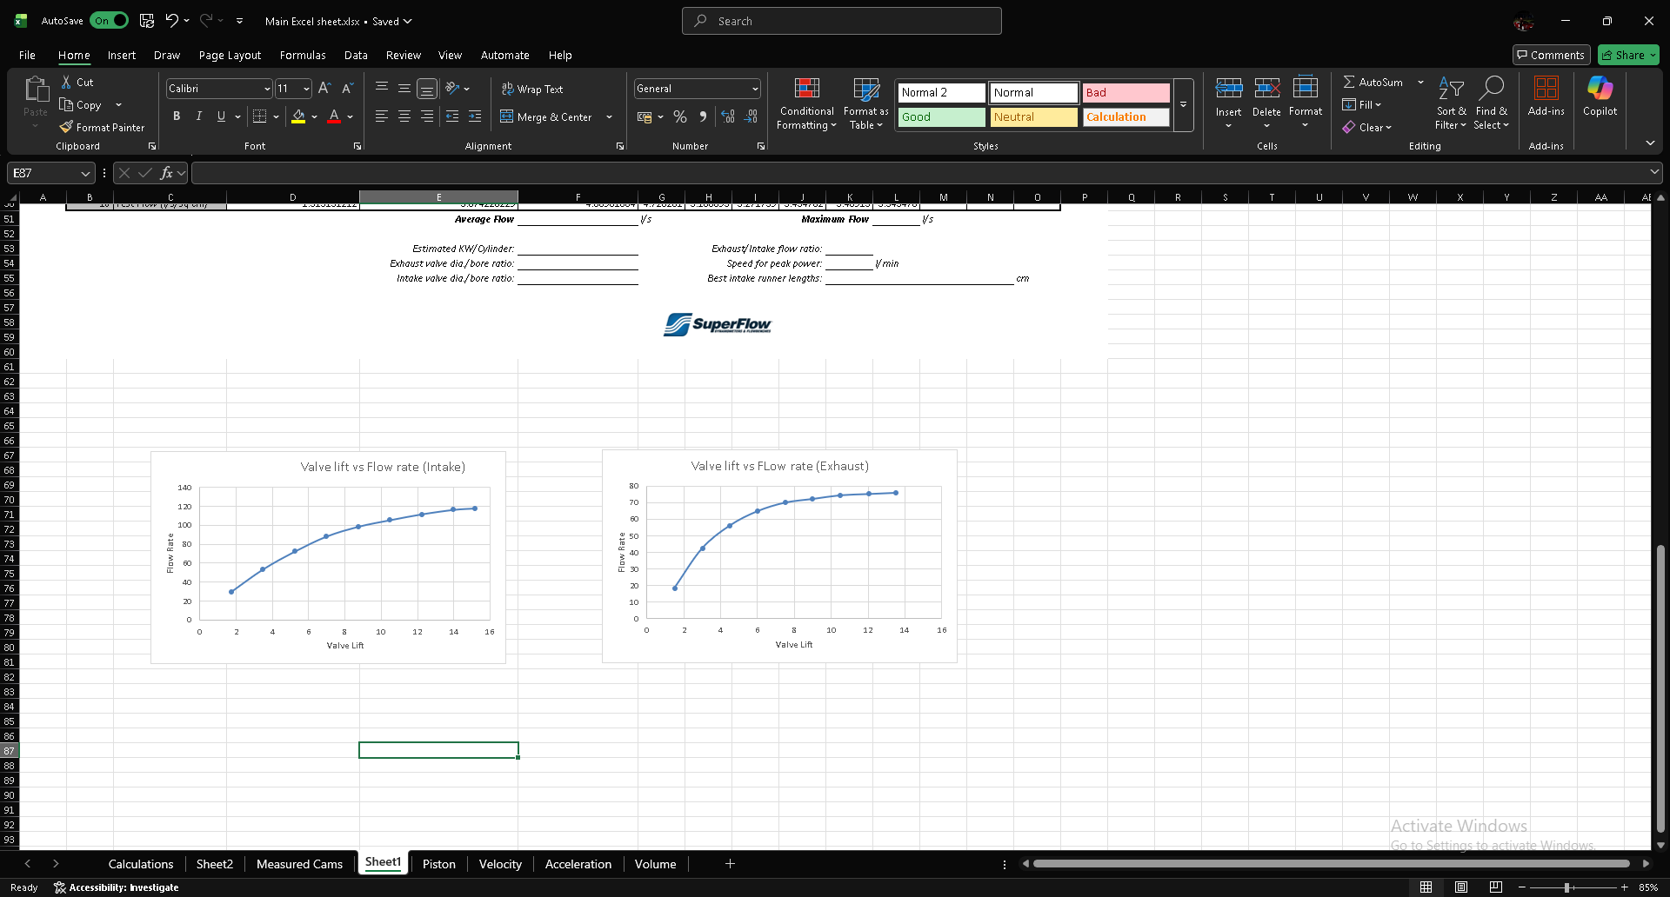

References

