Adam Willstead (2309258)
ACMA6012
Computational Methods: 2D Transient Heat Equation Solved with the Explicit Finite Difference Method

Table of Contents:

Table of Contents: 1
List of figures: 2
Chapter 1: Introduction 3
Context and Background: 3
Aims and Objectives: 3
Methodology/Approach: 3
Summary of Structure: 3
Chapter 2: Governing Equation. 4
Background to Heat Conduction: 4
The Heat Equation: 4
Mathematical Formulation of the 2D Heat Equation: 4
Definition of Terms and Physical Meaning: 5
Applicability to the Present Study: 5
Chapter 3: Finite Difference Method. 5
Taylor series: expansions about a point. 5
Forward expansion: 5
Backward expansion: 6
First derivative approximations: Forward difference for $f'(x)$ 6
Backward difference for $f'(x)$ 6
From the backward expansion: 6
Central difference for $f'(x)$ 7
Second derivative approximations: Central difference for $f''(x)$ 7
Finite Difference Approximations and Truncation Error: 8
Discretisation of the Spatial and Temporal Domains: 8
Explicit Finite Difference Formulation: 9
Fourier Number and Stability Criterion: 9
Chapter 4: Initial Condition, Boundary Conditions and Analytical Solution. 10
Initial Condition: 10
Boundary Conditions: 10
Dirichlet Boundary Conditions: 10
Mathematical form: 10
Other boundaries: East, West, and South: 10
Justification of Boundary Conditions: 11
Analytical Steady-State Solution: 11
Chapter 5: Codes’ Details and Explanations. 12
Step 1: 12
Step 2: 12
Step 3: 13
Step 4: 13
Step 5: 13
Step 6: 14
Step 7: 14
Step 8: 14
Step 9: 15
Step 10: 15
Step 11: 16
Step 12: 17
Chapter 6: Validation of the Model: 18
Chapter 7: Sensitivity Analysis of Key Numerical Parameters. 21
Grid spacing: 21
Time step: 22
Thermal equilibrium tolerance: 23
Chapter 8: Limitations of the Numerical Model: 25
Truncation Error: 25
Round-Off Error: 25
Stability Constraints: 25
Geometric and Boundary Condition Constraints: 25
Limitations of the Coding Implementation: 25
Thermal Equilibrium Criterion: 25
Dependence on User-Defined Parameters: 26
Summary of Model Limitations: 26
Chapter 9: Suggested Improvements and Future Developments: 26
Future improvements: 26
Chapter 10: Conclusion 27
References: 28
Appendix: Matlab Code 30

List of figures:

Figure 1 - Heat conduction/transfer of thermal energy within solids 5
Figure 2 - North Boundary screenshot 11
Figure 3 - Initialize temperature matrix screenshot 11
Figure 4 - Time step loop screenshot 12
Figure 5 - Analytical solution screenshot 12
Figure 6 - Step 1 screenshot (Clean up commands) 13
Figure 7 - Step 2 screenshot (Defining properties of aluminium) 13
Figure 8 - Step 3 screenshot (User inputs) 14
Figure 9 - Step 4 screenshot (Calculation of Number of rows/columns) 14
Figure 10 - Step 5 screenshot (Temperature matrix) 14
Figure 11 - Step 6 screenshot (dtMax calculation / time step input) 15
Figure 12 - Step 7 screenshot (Temperature matix T2) 15
Figure 13 - Step 8 screenshot (Convergence criterion CC) 15
Figure 14 - Step 9 screenshot (Calculation for T2) 16
Figure 15 - Step 10 screenshot (Analytical solution at steady state) 16
Figure 16 - Step 10 screenshot (Plotting solution) 17
Figure 17 - Step 11 screenshot (Code validation) 17
Figure 18 - Step 11 screenshot (Numerical vs Analytical comparison - heatmaps) 17
Figure 19 - Step 11 screenshot (error heatmap) 18
Figure 20 - Step 12 screenshot (Time to Thermal Equilibrium) 18
Figure 21 - User inputs screenshot 19
Figure 22 - All 2D heatmaps including error heatmap 19
Figure 23 - Heatmap 1 T2 19
Figure 24 - Command window values for T2 20
Figure 25 - Heatmap 2 TA 20
Figure 26 - Commando window values for TA 20
Figure 27 - Error heatmap 21
Figure 28 - Command window error values between T2 and TA 21
Figure 29 - Code validation results 21
Figure 30 - Grid spacing table 22
Figure 31 - Grid spacing against thermal equilibrium time graph 23
Figure 32 - Time step table 23
Figure 33 - Time step against thermal equilibrium time graph 24
Figure 34 - Thermal equilibrium tolerance table 24
Figure 35 - Tolerence against thermal equilibrium time graph 25

Chapter 1: Introduction

Context and Background:
The prediction of temperature progression in solid materials is a problem within heat transfer and has applications in engineering and materials science. Understanding transient heat conduction in metallic plates is essential for the design and analysis of thermal systems such as heat exchangers, electronic components, and structural elements subjected to thermal loading (Incropera & DeWitt, 2007; Özişik, 2013). Assumptions of uniform material properties, no internal heat generation, and perfect insulation are commonly made (Croft & Lilley, 1977). The temperature field within a solid can be described by the two-dimensional transient heat equation (Özişik et al., 2017).

Aims and Objectives:
In this report, the transient temperature distribution within an aluminium plate is investigated. The governing heat conduction equation is solved numerically using the Explicit Finite Difference Method (EFDM) (Smith, 1986; Langtangen & Linge, 2017). The aluminium plate is discretised using grid spacing, and the evolution of temperature is computed using a time step (Mazumder, 2015).

Methodology/Approach:
The model incorporates material properties for aluminium and applies a combination of boundary conditions to represent the thermal constraints on the aluminium plate (Özişik, 2013; Bejan, 2013). Starting from a uniform temperature, the solution is stepped in time until thermal equilibrium is reached. To assess the accuracy and validity of the numerical model, the steady-state numerical results are compared against an analytical solution (Press et al., 2007).

Summary of Structure:
The primary objective of this report is to develop a MATLAB code implementing the EFDM for two-dimensional transient heat conduction, examine the influence of spatial and temporal discretisation parameters, and demonstrate convergence towards the analytical steady-state temperature distribution (Özişik et al., 2017).

Chapter 2: Governing Equation.

Background to Heat Conduction:
Heat conduction is the transfer of thermal energy within solids (Carslaw & Jaeger, 1959). Prediction of conduction is essential for designing components with thermal loads (Incropera & DeWitt, 2007). Transient heat conduction issuews, when temperature varies with space/time commonly arise in manufacturing processes, electronic devices, and energy systems (Özişik, 2013; Bejan, 2013).
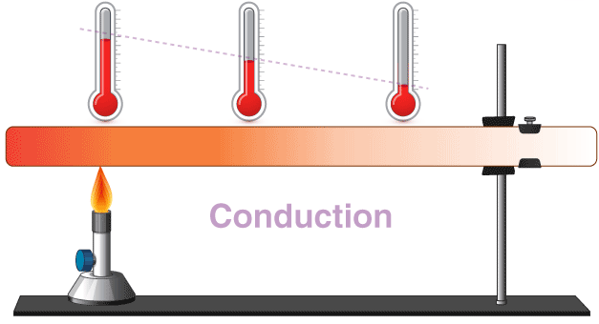
Figure 1 - Heat conduction/transfer of thermal energy within solids
The Heat Equation:
The heat equation shows temperature changes in materials from conduction. It is derived from the conservation of energy and Fourier’s law of heat conduction (Özişik, 2013; Croft & Lilley, 1977). Analytical solutions are available for simple geometries, but numerical methods such as finite difference methods are often required for difficult problems (Smith, 1986; Langtangen & Linge, 2017).

Mathematical Formulation of the 2D Heat Equation:

Two-dimensional domain with no internal heat generation and constant material properties, the transient heat conduction equation is:
$$\frac{∂T}{∂t}=\frac{k}{ρc_{p}}\left(\frac{∂^{2}T}{∂x^{2}} + \frac{∂^{2}T}{∂y^{2}}\right)$$
This above equation assumes isotropic heat conduction, uniform density, uniform specific heat capacity and uniform thermal conductivity (Croft & Lilley, 1977; Özişik, 2013).

Definition of Terms and Physical Meaning:
In the governing equation: $T\left(x,y,t\right)$ represents the temperature at spatial coordinates $\left(x , y\right)$ and time $t$.
The term $∂T/∂t$is the rate of change of temperature with respect to time. (Capturing the transient nature of the heat transfer process).
$k$, $ρ$, and $c_{p}$ the thermal conductivity (W/m·°C), density (kg/m³) and specific heat capacity (J/kg·°C) of aluminium.
Second order spatial derivatives $∂^{2}T/∂x^{2}$and $∂^{2}T/∂y^{2}$ describe heat diffusion in the horizontal and vertical directions.
$k/(ρc_{p})$ is known as the thermal diffusivity and expresses the rate at which temperature gradients dissipate within materials (Özışık, 2013).

Applicability to the Present Study:
The 2D heat equation provides the governing equation for the numerical model, discretised in space and time using the finite difference method (Smith, 1986; Langtangen & Linge, 2017).

Chapter 3: Finite Difference Method.
The finite difference method (FDM) approximates derivatives using Taylor series expansions about discrete grid points (Croft & Lilley, 1977; Press et al., 2007; Smith, 1986). Central difference approximations are commonly used for second-order spatial derivatives due to higher accuracy (Özişik, 2013).

Taylor series: expansions about a point.
$f(x)$ sufficiently smooth function
$h>0$ step size.
Expand $f$ about point $x$:

Forward expansion:
$$f(x+h)=f(x)+hf^{'}(x)+\frac{h^{2}}{2}f^{''}(x)+\frac{h^{3}}{6}f^{\left(3\right)}(x)+\frac{h^{4}}{24}f^{\left(4\right)}(x)+O(h^{5})$$

Backward expansion:
$$f(x-h)=f(x)-hf^{'}(x)+\frac{h^{2}}{2}f^{''}(x)-\frac{h^{3}}{6}f^{\left(3\right)}(x)+\frac{h^{4}}{24}f^{\left(4\right)}(x)+O(h^{5})$$
These two expansions are the raw material for finite difference formulas.

First derivative approximations: Forward difference for $f^{'}(x)$
Forward Taylor expansion:
$$f(x+h)=f(x)+hf^{'}(x)+\frac{h^{2}}{2}f^{''}(x)+O(h^{3})$$
Subtract $f(x)$ and divide by $h$:
$$\frac{f(x+h)-f(x)}{h}=f^{'}(x)+\frac{h}{2}f^{''}(x)+O(h^{2})$$
Rearrange:
$$f^{'}(x)=\frac{f(x+h)-f(x)}{h}-\frac{h}{2}f^{''}(x)+O(h^{2})$$
Forward difference approximation:
$$\boxed{f^{'}(x)≈\frac{f(x+h)-f(x)}{h}}$$
Truncation error $O(h)$.

Backward difference for $f^{'}(x)$

Backward expansion:
$$f(x-h)=f(x)-hf^{'}(x)+\frac{h^{2}}{2}f^{''}(x)+O(h^{3})$$

Rearrange:
$$\frac{f(x)-f(x-h)}{h}=f^{'}(x)-\frac{h}{2}f^{''}(x)+O(h^{2})$$
$$\boxed{f^{'}(x)≈\frac{f(x)-f(x-h)}{h}}$$
Error $O(h)$.

Central difference $f^{'}(x)$
Subtract backward expansion from forward expansion:
$$f(x+h)-f(x-h)=2hf^{'}(x)+\frac{h^{3}}{3}f^{\left(3\right)}(x)+O(h^{5})$$
Divide by $2h$:
$$\frac{f(x+h)-f(x-h)}{2h}=f^{'}(x)+\frac{h^{2}}{6}f^{\left(3\right)}(x)+O(h^{4})$$
Central difference approximation:
$$\boxed{f^{'}(x)≈\frac{f(x+h)-f(x-h)}{2h}}$$
Error $O(h^{2})$

Second derivative approximations: Central difference for $f^{''}(x)$
Forward and backward expansions:
$$f(x+h)+f(x-h)=2f(x)+h^{2}f^{''}(x)+\frac{h^{4}}{12}f^{\left(4\right)}(x)+O(h^{6})$$
Rearrange / isolate $f^{''}(x)$:
$$f(x+h)-2f(x)+f(x-h)=h^{2}f^{''}(x)+\frac{h^{4}}{12}f^{\left(4\right)}(x)+O(h^{6})$$

Divide by $h^{2}$:
$$\frac{f(x+h)-2f(x)+f(x-h)}{h^{2}}=f^{''}(x)+\frac{h^{2}}{12}f^{\left(4\right)}(x)+O(h^{4})$$
Standard second derivative finite difference:
$$\boxed{f^{''}(x)≈\frac{f(x+h)-2f(x)+f(x-h)}{h^{2}}}$$Error $O(h^{2})$.

Finite Difference Approximations and Truncation Error:
Finite difference method (FDM) is a widely used numerical technique for solving partial differential equations in heat transfer problems. Replacing derivatives with algebraic approximations derived from Taylor series expansions about discrete grid points (Croft & Lilley, 1977; Press et al., 2007).
For a sufficiently smooth temperature field $T(x,y,t)$, a Taylor series expansion in time about $t^{n}$yields the forward difference approximation for the first-order temporal derivative:
$$\frac{∂T}{∂t}≈\frac{T_{i,j}^{n+1}-T_{i,j}^{n}}{Δt}+O(Δt)$$
This approximation is first order accurate in time. Truncation error decreases as the time step reduces.
Taylor series expansions lead to the central difference approximations for the second-order spatial derivatives:
$$\frac{∂^{2}T}{∂x^{2}}≈\frac{T_{i+1,j}^{n}-2T_{i,j}^{n}+T_{i-1,j}^{n}}{Δx^{2}}+O(Δx^{2}) \\ \frac{∂^{2}T}{∂y^{2}}≈\frac{T_{i,j+1}^{n}-2T_{i,j}^{n}+T_{i,j-1}^{n}}{Δy^{2}}+O(Δy^{2})$$
Central difference schemes are second order accurate, providing higher accuracy than forward or backward schemes for a given grid spacing.
Truncation error shows the error by replacing derivatives with finite differences. Understanding truncation errors is needed for proving numerical accuracy and analysing how grid spacing and time step influence the solution (Özışık, 2013).

Discretisation of the Spatial and Temporal Domains:
The domain of the aluminium plate is separated in a two-dimensional structured grid with uniform spacing $h=Δx=Δy$. Each node is identified by indices $\left(i , j\right)$.

The spatial coordinates:
$$x_{i}=iΔx,y_{j}=jΔy$$
The temporal domain is separated into uniform time steps $Δt$, and the temperature at time level $t^{n}=nΔt$ is:
$$T(x_{i},y_{j},t^{n})≡T_{i,j}^{n}$$

Explicit Finite Difference Formulation:
The two-dimensional transient heat conduction equation is given by:
$$\frac{∂T}{∂t}=α\left(\frac{∂^{2}T}{∂x^{2}} + \frac{∂^{2}T}{∂y^{2}}\right)$$
where $α=\frac{k}{ρc_{p}}$ is the thermal diffusivity.
Finite difference approximations introduced:
$$\frac{T_{i,j}^{n+1}-T_{i,j}^{n}}{Δt}=α\left(\frac{T_{i+1,j}^{n}-2T_{i,j}^{n}+T_{i-1,j}^{n}}{Δx^{2}} + \frac{T_{i,j+1}^{n}-2T_{i,j}^{n}+T_{i,j-1}^{n}}{Δy^{2}}\right)$$
Rearranging the explicit finite difference equation:
$$T_{i,j}^{n+1}=T_{i,j}^{n}+Fo\left(T_{i+1,j}^{n}+T_{i-1,j}^{n}+T_{i,j+1}^{n}+T_{i,j-1}^{n}-4T_{i,j}^{n}\right)$$
This formulation is explicit because the temperature at the next time step depends only on known values from the current time level.

Fourier Number and Stability Criterion:
The dimensionless Fourier number is defined as:
$$Fo=\frac{αΔt}{h^{2}}$$
Fourier number is the ratio of heat transport during time step to the thermal energy stored in a control volume. It governs the balance of spatial and temporal discretisation.
For the two-dimensional explicit, numerical stability requires:
$$Fo≤\frac{1}{4}$$
This stability condition is derived using von Neumann stability analysis, which examines the growth of numerical errors through Fourier mode decomposition (Croft & Lilley, 1977; Press et al., 2007). Violating this criterion leads to exponential growth of errors, resulting in non-physical oscillations and divergence of the solution.

Chapter 4: Initial Condition, Boundary Conditions and Analytical Solution.

Initial Condition:
The transient heat conduction problem in this report requires specification of initial temperature distribution over the computational domain. The aluminium plate is assumed to be first at uniform temperature of zero degrees Celsius.
Expressed as:
$$T(x,y,0)=0\text{for}0<x<X_{dim}, 0<y<Y_{dim}$$
This initial condition represents a plate that is first at thermal equilibrium with its surroundings before thermal boundary conditions are applied. It provides a simple starting point for transient simulation and ensures that subsequent temperature evolution is due to the boundary conditions.

Boundary Conditions:
To get a good solution to the heat equation, appropriate boundary conditions must be set along the edges of the plate. In this report, a combination of Dirichlet and Neumann boundary conditions are applied.

Dirichlet Boundary Conditions:

North boundary T0 (fixed): This is the only explicit Dirichlet boundary condition in the Matlab code.
Figure 2 - North Boundary screenshot
- The top edge of the plate (North boundary)
- Temperature is held constant at T0 = (50 degrees)
- Applies to all interior nodes along that edge (corners excluded = 0 degrees)

Mathematical form:
$$T(x,y=Y_{\text{dim}},t)=T_{0}$$

Other boundaries: East, West, and South:
Fixed at 0 °C because of how the matrix is initialized.
Figure 3 - Initialize temperature matrix screenshot
T1(:,1) = West
T1(:,NC) = East
T1(NR,:) = South
Time-stepping loop updates interior nodes:
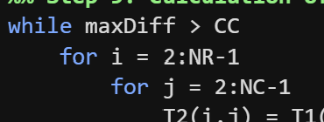
Figure 4 - Time step loop screenshot
Mathematical form:
$$\begin{matrix}T(x=0,y,t) & =0 \\ T(x=X_{\text{dim}},y,t) & =0 \\ T(x,y=0,t) & =0\end{matrix}$$
These conditions represent boundaries at constant temperature. This can be interpreted as the plate in contact with thermal reservoirs that enforce fixed temperatures along the north, east and south.

Justification of Boundary Conditions:
The particular conditions are chosen because they link exactly to a the analytical solution of the two-dimensional steady-state heat equation provided. Analytical solutions for heat conduction problems are only available for a limited set of geometries and boundary conditions (Özışık, 2013).
Having boundary conditions for which an analytical solution exists, it is possible to compare the numerical results using the Explicit Finite Difference Method with an exact solution at thermal equilibrium. The comparison will provide a detailed way of validating the numerical implementation, identifying errors and assessing the accuracy and stability.

Analytical Steady-State Solution:
At equilibrium, the transient equation reduces to Laplace’s equation. The analytical solution provides a benchmark to validate the EFDM results (Press et al., 2007; Özişik, 2013).
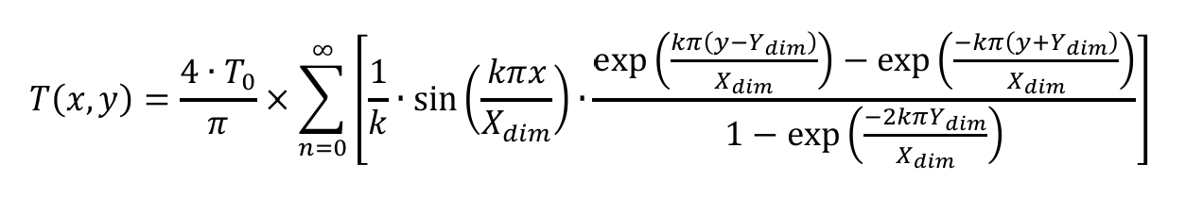
Figure 5 - Analytical solution screenshot
This series solution represents the exact temperature distribution within the plate at steady state. In practice, the infinite series is truncated after a sufficient number of terms to achieve the desired accuracy.

Chapter 5: Codes’ Details and Explanations.
This chapter provides snapshots of each section of the code with explanations.

Step 1:
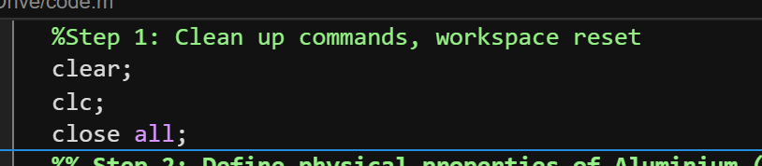
Figure 6 - Step 1 screenshot (Clean up commands)
This step is the first step of the code, clean up commands are used to reset the workspace to provide a starting point.

Step 2:
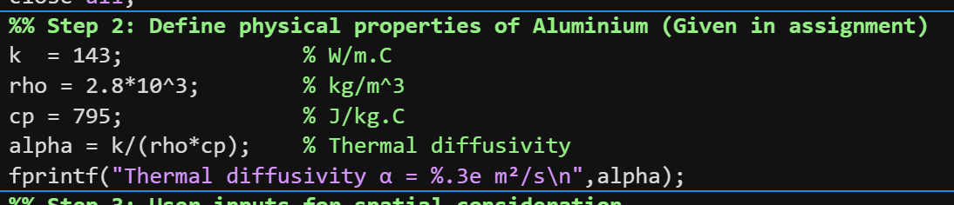
Figure 7 - Step 2 screenshot (Defining properties of aluminium)
This section defines the physical properties that are given in the brief.
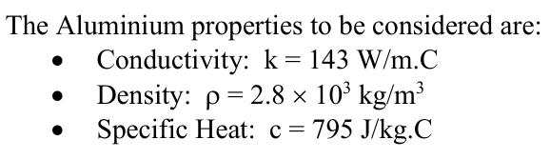

Step 3:
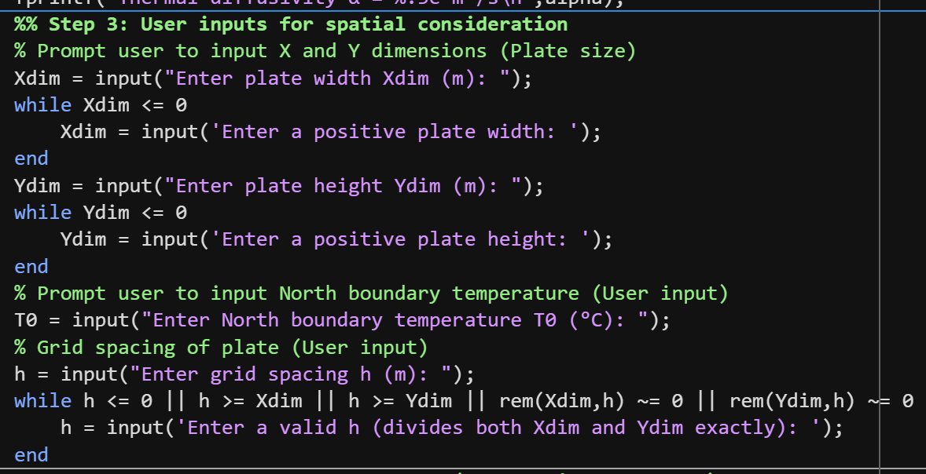
Figure 8 - Step 3 screenshot (User inputs)
Step 3 is the section of the code where users are prompted to input plate dimensions when the code is run within the command window. Plate widths must be positive in value (12mx12m). Users are also prompted to enter the North Dirichlet boundary condition T0 value (50 degrees) and the grid spacing (For example 1m). The grid spacing value inputted must divide within the plate dimensions exactly for the code to run.

Step 4:
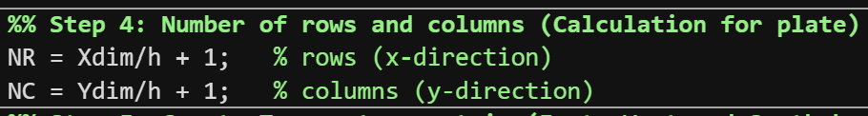
Figure 9 - Step 4 screenshot (Calculation of Number of rows/columns)
This step calculates how many grid points (nodes) needed in each direction of the plate, based on:
- Size of the plate (Xdim, Ydim)
- grid spacing (h)
Discretising a continuous plate into a finite difference mesh.

Step 5:
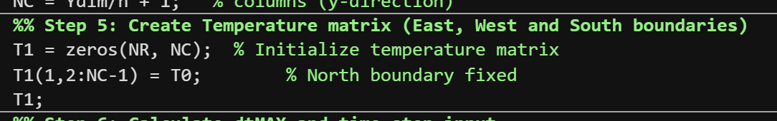
Figure 10 - Step 5 screenshot (Temperature matrix)
Step 5 initializes the temperature field as a zero matrix and applies the fixed north boundary temperature, preparing the grid for the finite difference simulation.
- Sets up the numerical grid.
- Applies initial temperatures to all points.
- Enforces Dirichlet boundary condition (fixed temperature) on the north edge.
- Prepares the grid for the time-stepping iteration.

Step 6:
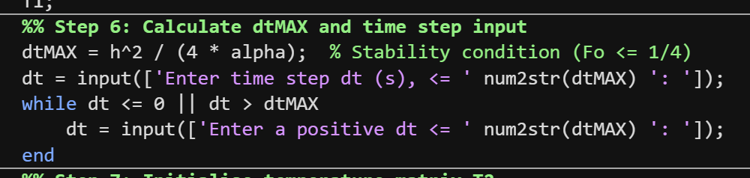
Figure 11 - Step 6 screenshot (dtMax calculation / time step input)
Step 6 calculates the maximum stable time step based on the spatial grid and thermal diffusivity, then prompts the user to choose a valid time step for the explicit finite difference simulation.
- Stability of the explicit finite difference method.
- User chooses a valid time step.
- Sets up the time increment for advancing the temperature field.

Step 7:
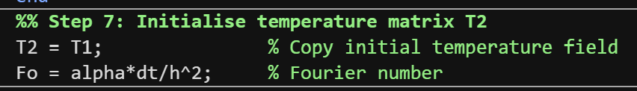
Figure 12 - Step 7 screenshot (Temperature matix T2)
Step 7 initializes a copy of the temperature matrix for updates and calculates the Fourier number, which quantifies the relative effect of heat conduction per time step and is used in the finite difference update formula.
- Prepares T2 as a placeholder for updated temperatures.
- Calculates Fo, which governs: How quickly heat propagates in the simulation and Stability of the explicit scheme (must satisfy Fo <= 1/4 in 2D).
- Sets up the simulation for Step 9, where T2 is iteratively updated until convergence.

Step 8:
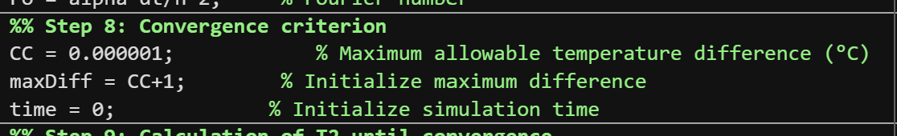
Figure 13 - Step 8 screenshot (Convergence criterion CC)
Step 8 defines the convergence criterion for the simulation by setting a small allowable temperature change between iterations and initializing variables to track the maximum difference and elapsed time.
- Sets a high-precision tolerance (CC) for equilibrium.
- Initializes a variable to track the maximum change in temperature (maxDiff).
- Initializes a simulation timer (time).

Step 9:
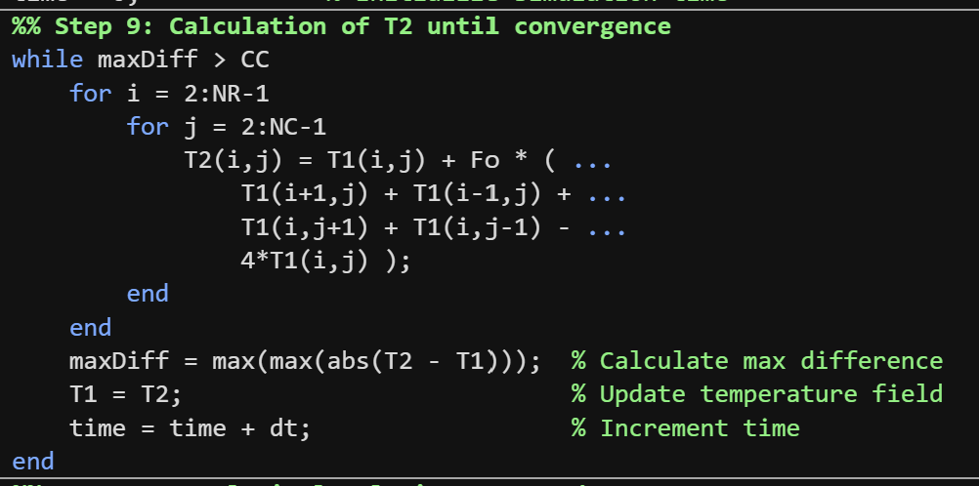
Figure 14 - Step 9 screenshot (Calculation for T2)
Step 9 iteratively updates the temperature of all interior nodes using the 2D explicit finite difference formula, checking the maximum change at each step, until the entire plate reaches thermal equilibrium.
- Iteratively updates interior temperatures using the 2D explicit finite difference method.
- Checks for convergence at each iteration.
- Updates the simulation clock.
- Stops when the system reaches steady state (all nodes change by less than CC.

Step 10:
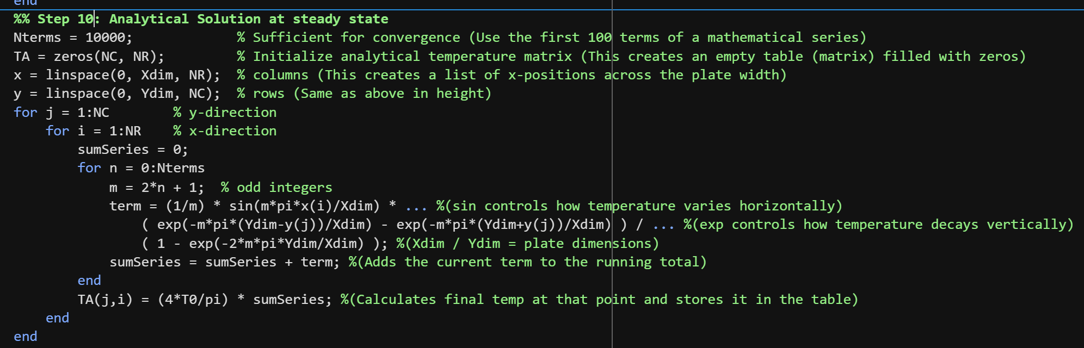
Figure 15 - Step 10 screenshot (Analytical solution at steady state)
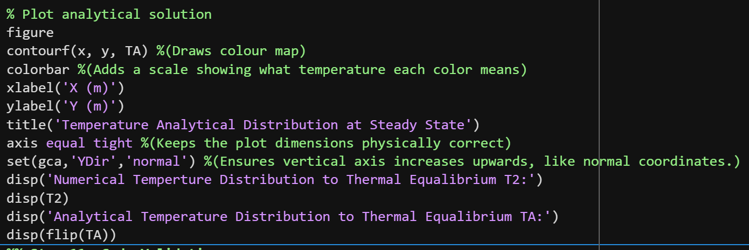
Figure 16 - Step 10 screenshot (Plotting solution)
Step 10 calculates the exact steady-state temperature distribution on the plate using a truncated Fourier series solution of the 2D heat conduction equation and visualizes it for comparison with the numerical solution.
- Computes the exact analytical solution using a Fourier series.
- Uses the same grid as the numerical solution for direct comparison.
- Produces a visualization of steady-state temperature.
- Provides a reference to validate the numerical solution (Step 11)

Step 11:
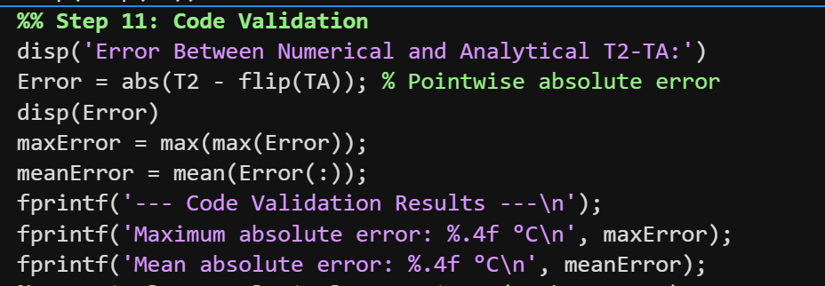
Figure 17 - Step 11 screenshot (Code validation)
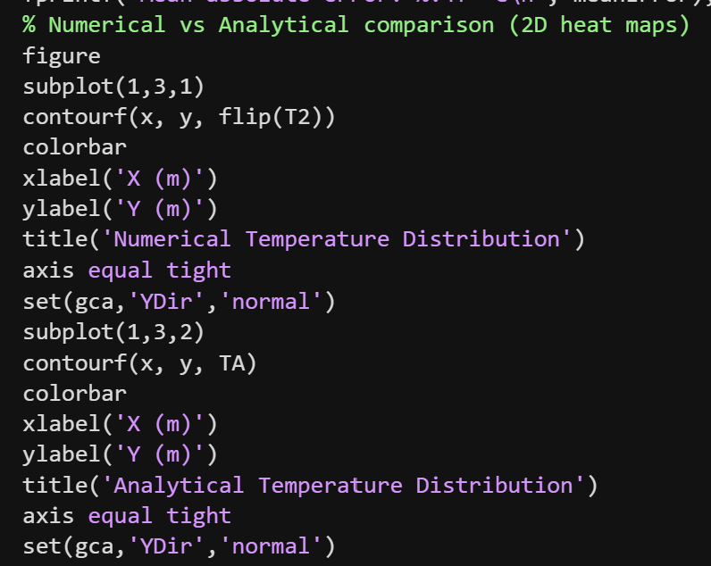
Figure 18 - Step 11 screenshot (Numerical vs Analytical comparison - heatmaps)
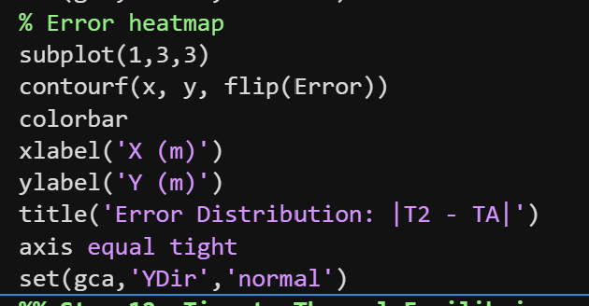
Figure 19 - Step 11 screenshot (error heatmap)
Step 11 validates the numerical solution by computing the absolute pointwise error relative to the analytical solution, reporting the maximum and mean errors, and visualizing both the numerical, analytical, and error distributions for comparison.
- Calculates pointwise error between numerical and analytical solutions.
- Quantifies accuracy with maximum and mean errors.
- Visualizes the results for easy inspection.
- Provides confidence that the numerical simulation is correct.

Step 12:
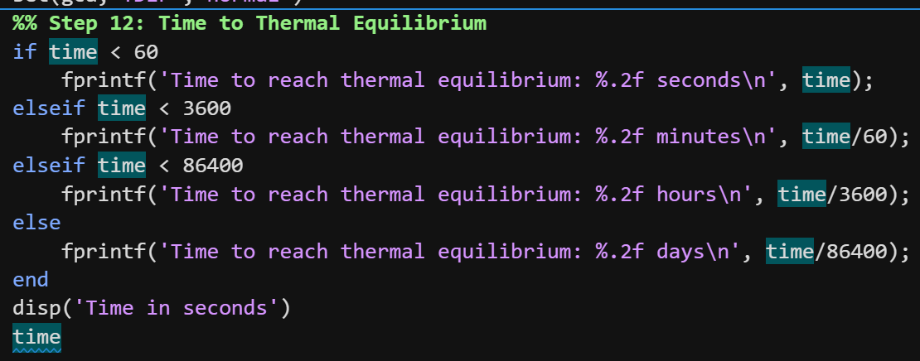
Figure 20 - Step 12 screenshot (Time to Thermal Equilibrium)
Step 12 reports the total simulation time required to reach thermal equilibrium, converting it into seconds, minutes, hours, or days depending on its magnitude for easy interpretation.
- Reports total time to reach thermal equilibrium.
- Converts it into a human-readable format.
- Ensures users can understand how long the simulation physically took.
This step is purely informational; it doesn’t affect the simulation itself.

Chapter 6: Validation of the Model:
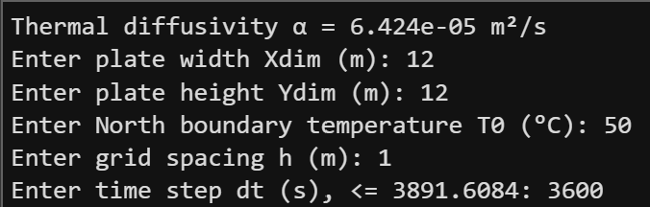
Figure 21 - User inputs screenshot
Above are the values added in Matlabs command window when running the code.
Below are the heatmaps from the code when inputting all values.
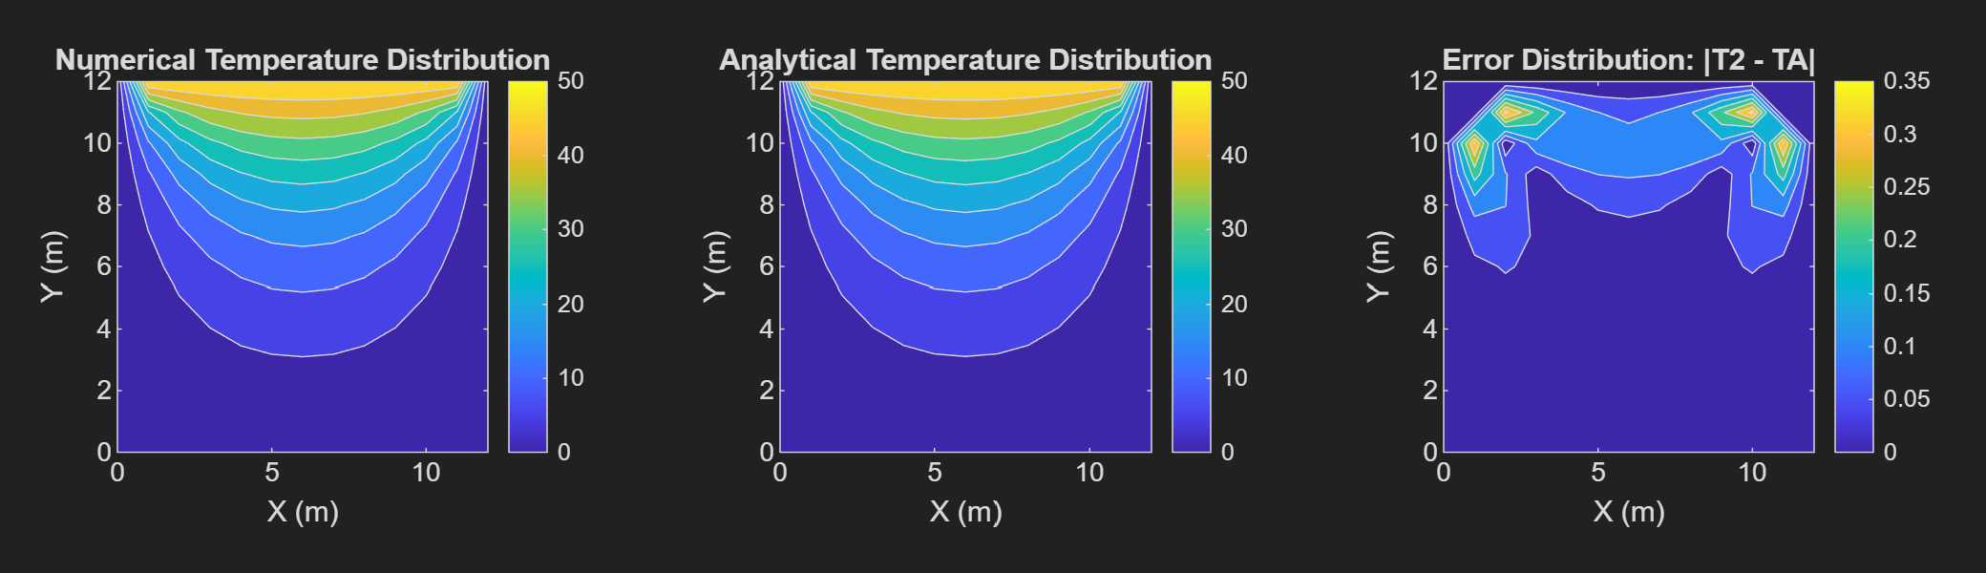
Figure 22 - All 2D heatmaps including error heatmap
Heatmap 1 T2:
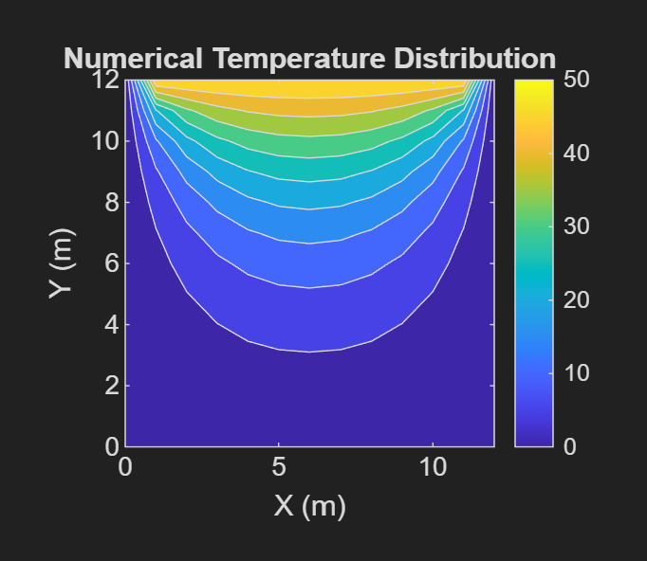
Figure 23 - Heatmap 1 T2

Command window values for T2.
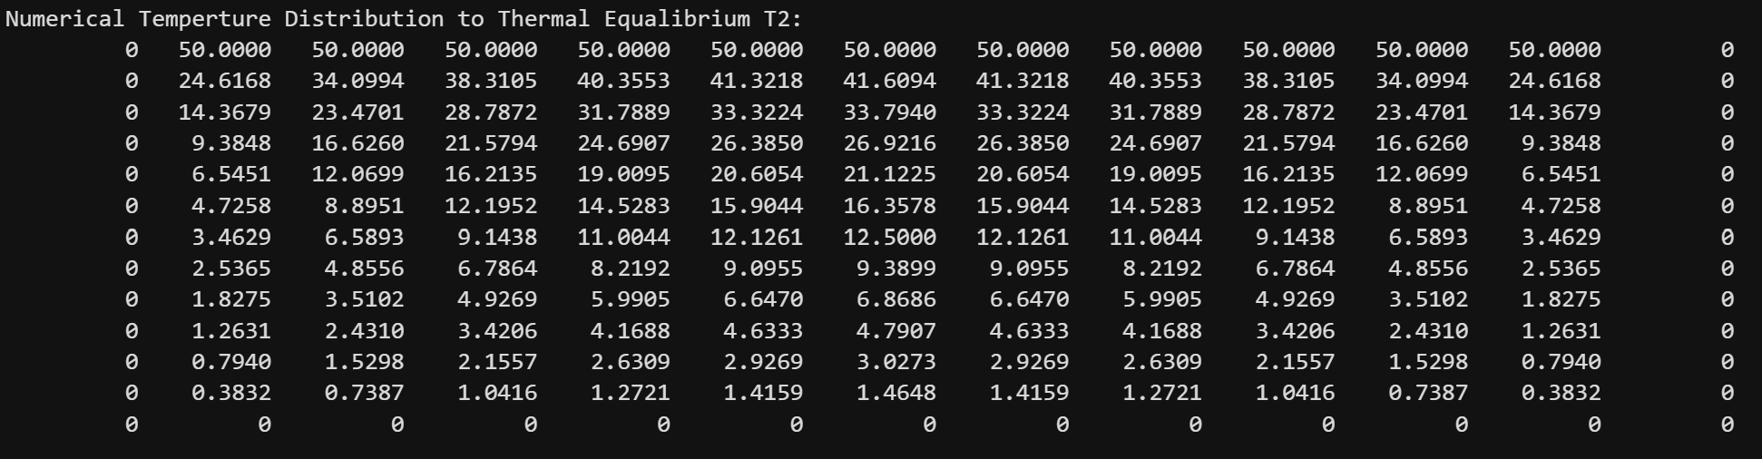
Figure 24 - Command window values for T2
Heatmap 2 TA:
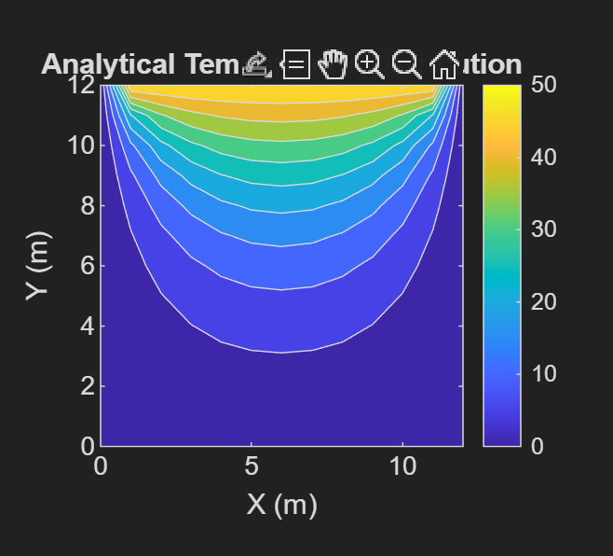
Figure 25 - Heatmap 2 TA
Command window values for TA:
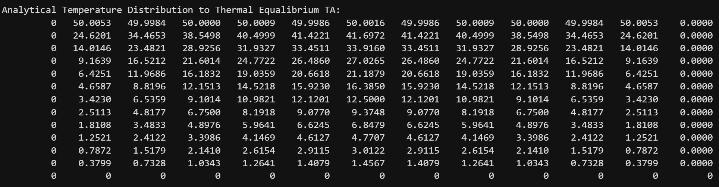
Figure 26 - Commando window values for TA

Heatmap 3 Error distribution / comparison of heatmap 1 and 2 (T2-TA):
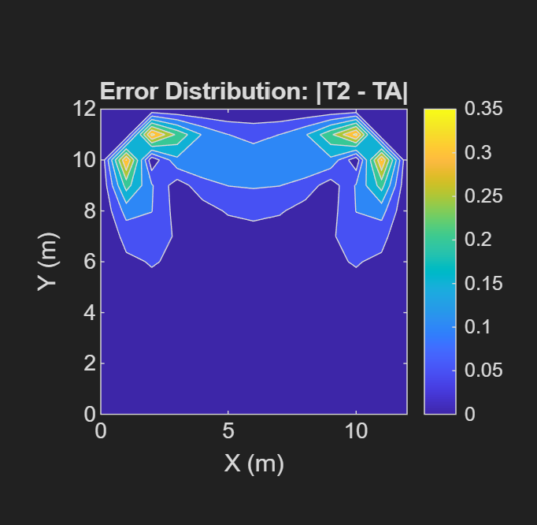
Figure 27 - Error heatmap
Error values between T2 and TA in command window:
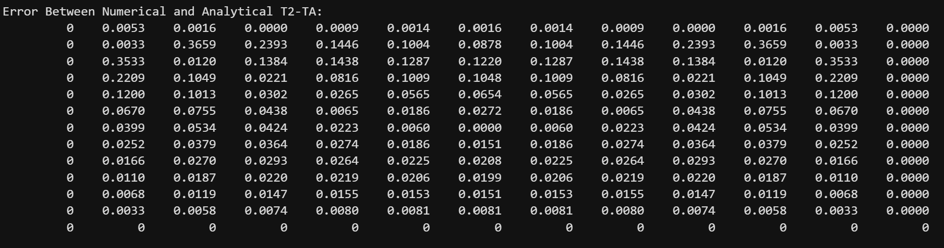
Figure 28 - Command window error values between T2 and TA
Code validation results:
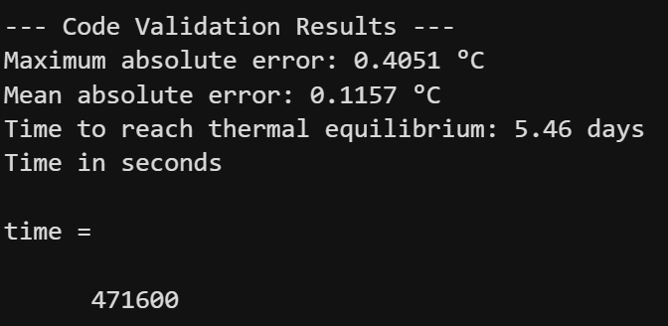
Figure 29 - Code validation results
Figure 29 shows the results of a thermal model validation and that the simulation performs with good accuracy and stability. Maximum error between the model predictions and the reference solution is 0.4051 °C and mean error is only 0.1157 °C, showing that predictions are close to expected values. The code states thermal equilibrium after approximately 5.46 days (471,600 seconds). These results prove that the code reliably gives the thermal behaviour of the system with only minor deviations.

Chapter 7: Sensitivity Analysis of Key Numerical Parameters.
Grid spacing, time step and tolerance influence accuracy and computational cost. Finer grids reduce truncation error but restrict the maximum stable time step. Smaller time steps improve temporal accuracy but increase runtime (Press et al., 2007; Özışık, 2013; Langtangen & Linge, 2017).
A sensitivity analysis is performed to evaluate the robustness of the numerical model.
Grid spacing: Finer grids reduce spatial truncation error but increase computational cost and restrict the maximum stable time step.
Figure 30 - Grid spacing table
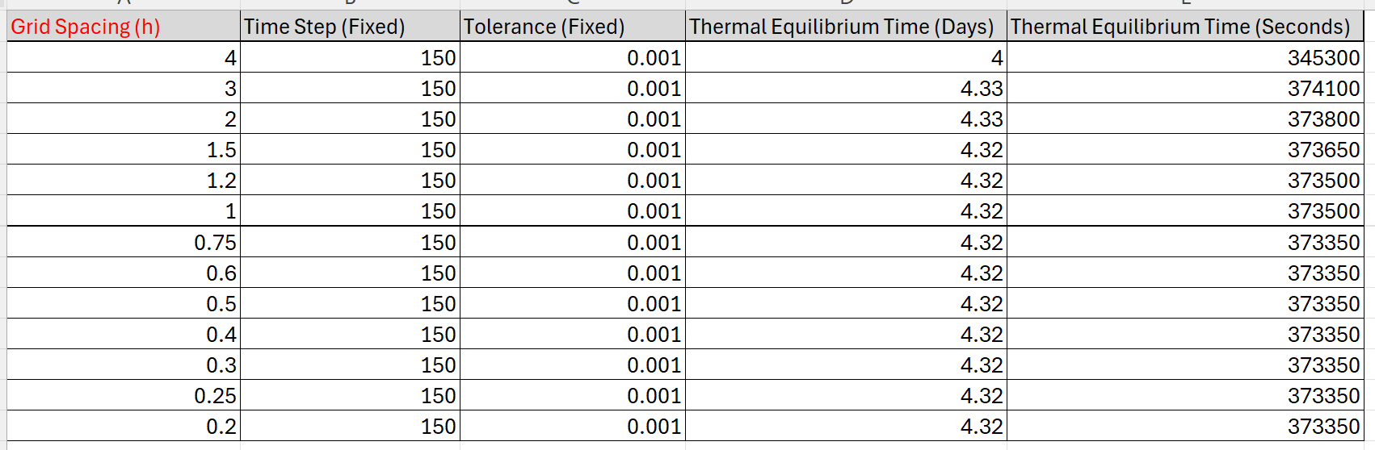
Figure 30 shows the effect of grid spacing on thermal equilibrium time. Convergence is observed for small grid spacings, while coarser grids introduce numerical inaccuracies.
Figure 31 - Grid spacing against thermal equilibrium time graph

Figure 31 shows the change of thermal equilibrium time with grid spacing h. For small grid spacings (h ≤ 0.7), the equilibrium time stays constant at around 3.73 × 10⁵ s, proving grid convergence and numerical stability (Roache, 1998; Ferziger, Perić and Street, 2020). As the grid spacing increases (h ≳ 0.7), an increase in the equilibrium time is observed, reflecting reduced spatial resolution and increasing discretisation error linked to coarser meshes (Versteeg and Malalasekera, 2007). At the largest grid spacing (h = 3.0), a decrease in equilibrium time occurs, which is characteristic of numerical instability or loss of physical fidelity when the grid is too coarse to adequately resolve thermal gradients (Ferziger, Perić and Street, 2020). Consequently, a grid spacing within the converged region was selected to ensure an optimal balance between computational efficiency and solution accuracy, in line with established best practice in numerical verification studies (Roache, 1998).
Real world example:
For example, in CFD studies of mixed convection heat transfer around cooling coils, researchers perform formal grid independence tests to ensure that numerical results are not dependent on the spatial discretisation. In one such study, five different mesh densities ranging from approximately 5,000 to over 120,000 elements were evaluated by monitoring average Nusselt and Sherwood numbers; significant changes were observed between the coarsest meshes, but the values stabilised beyond a certain mesh density, indicating convergence and negligible truncation error for the finer grids (Abed and Abdel-Hafez, 2025). This allowed the investigators to select an optimal mesh that balanced computational cost with numerical accuracy, as further refinement did not materially change the thermal performance metrics. This behaviour aligns with the trend seen in Figure 31, where thermal equilibrium time converges at small grid spacings but diverges with coarser grids that do not resolve gradients adequately.
Time step: Smaller time steps improve temporal accuracy and stability but significantly increase runtime.
Figure 32 - Time step table
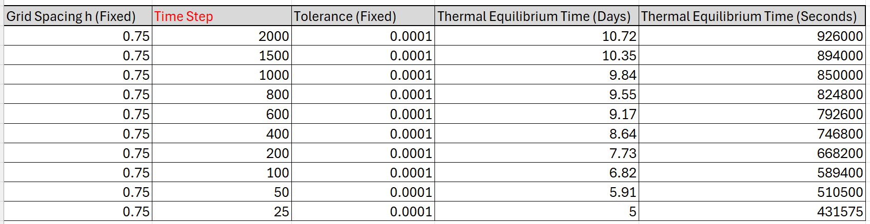
Figure 33 - Time step against thermal equilibrium time graph

Figure 33 shows the relationship between time step and thermal equilibrium time. As time step increases, equilibrium time increases, reflecting the growing influence of temporal discretisation error (Ferziger, Perić and Street, 2020). At small time steps (Δt ≲ 200 s), equilibrium time increases rapidly, indicating strong sensitivity to the chosen time step and a lack of temporal convergence (Versteeg and Malalasekera, 2007). As time step increases beyond approximately 500 to 1000 s, the curve begins to flatten, showing reduced sensitivity to further increases in time step and indicating that the solution has approached temporal convergence (Roache, 1998). On this basis, a time step within the range 500 to 1000 s was selected, providing an appropriate compromise between numerical accuracy and computational efficiency, consistent with established verification practices for time-dependent simulations (Ferziger, Perić and Street, 2020).
Example:
This relationship is a well-documented challenge in Building Energy Simulation for instance, Crawley et al. (2001) demonstrate that while larger time steps reduce the computational burden, they risk misrepresenting the transient thermal behavior of building envelopes, potentially overestimating the time required for internal spaces to reach a balanced thermal state.

Thermal equilibrium tolerance: Stricter tolerances improve accuracy but may lead to excessive computational effort or premature convergence.
Figure 34 - Thermal equilibrium tolerance table
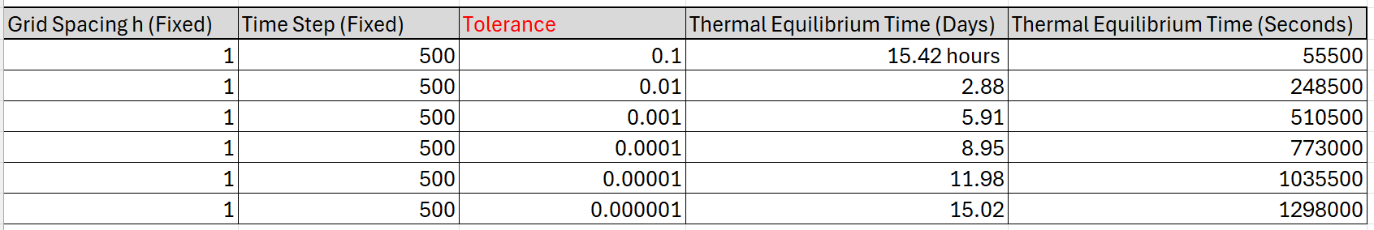
Figure 35 - Tolerence against thermal equilibrium time graph

Figure 35 illustrates the relationship between tolerance and time required for a system to reach thermal equilibrium. As the tolerance becomes smaller (indicating a stricter definition of equilibrium), the time needed increases sharply, reaching very large values for near-zero tolerances. This reflects the fact that thermal systems approach equilibrium asymptotically, with the final stages of equilibration occurring very slowly. Conversely, allowing a larger tolerance significantly reduces the equilibration time, with most of the time savings occurring at small increases in tolerance. Overall, the graph highlights a strong trade off between accuracy and time, showing that modest tolerances can achieve practical equilibrium much faster than extremely strict ones.

Chapter 8: Limitations of the Numerical Model:

Truncation Error:
Finite difference method is used to solve the 2D heat conduction problem. This method approximates spatial and temporal derivatives using finite differences, introducing truncation errors. Central difference schemes in space and a forward difference in time result in truncation errors of order $O(h^{2})$and $O(Δt)$, staed by (Patankar, 1980).
Sensitivity analysis demonstrates that reducing grid spacing $h$leads to improved numerical and analytical solutions by a reduction in maximum and mean errors. Coarser grids show increased deviation, particularly near boundaries where temperature gradients are steep and are consistent with established numerical heat transfer theory (Incropera et al., 2007).

Round-Off Error:
These come from finite precision of floating-point arithmetic. While negligible for coarse grids, their impact becomes more pronounced as grid resolution increases and convergence tolerances are tightened (Ferziger and Perić, 2002).
Sensitivity analysis shows low values of $h$ and convergence tolerance $CC$, reduction in numerical error becomes small. Round-off error begins to dominate. Fluctuations in convergence behaviour near the tolerance threshold provide evidence of limitations.

Stability Constraints:
The explicit FDM employed in this study is conditionally stable and requires the Fourier number to satisfy:
$$Fo=\frac{αΔt}{h^{2}}≤\frac{1}{4}$$
(Versteeg and Malalasekera, 2007).
Sensitivity analysis confirms this limit results in numerical instability. Reducing grid spacing necessitates a small time step, increasing computational time to reach steady state.

Geometric and Boundary Condition Constraints:
The numerical approach is based on a structured grid, which restricts the model to rectangular shapes. Complex/curved geometries/boundaries, or varying material properties can’t be shown accurately without modification. This limitation is linked to finite difference methods and contrasts with more flexible numerical approaches such as the finite element method (Zienkiewicz et al., 2005).

Limitations of the Coding Implementation:

Thermal Equilibrium Criterion:
Thermal equilibrium is the maximum temperature change between iterations falls below a tolerance. This is computationally efficient but doesn’t represent true physical equilibrium (Patankar, 1980). Sensitivity analysis shows that strict tolerances increase the predicted time to equilibrium without an improvement in accuracy, indicating that the criterion reflects numerical convergence rather than steady state.

Dependence on User-Defined Parameters:
Accuracy and stability of the code are influenced by defined parameters (grid spacing, time step size, convergence tolerance, terms used in analytical solution). Sensitivity analysis shows small changes in parameters leads to variations in error magnitude and convergence time, underscoring the numerical code. (Ferziger and Perić, 2002).

Summary of Model Limitations:
The numerical model states several limitations: truncation and round-off errors restrict accuracy; conditional stability imposes strict limits on time step size; computational cost increases with grid refinement; and simplified geometry limits applicability. Sensitivity analysis provides evidence of these theoretical limitations and influence model behaviour.

Chapter 9: Suggested Improvements and Future Developments:

Future improvements:
Finite Difference Method used successfully shows transient heat conduction in a 2D aluminium plate, improvements will improve numerical efficiency and accuracy.
A limitation of the explicit method is its stability, which shows a restricted time-step constraint through the Fourier number criterion. This could be addressed by adding implicit or semi-implicit methods such as Crank Nicolson method, which is stable for diffusion problems and second order accurate in time (Smith, 1986; Özişik, 2013). Implicit methods require solving systems of equations at each time step, they help larger time steps and reduced overall computational time (Versteeg and Malalasekera, 2007).
Also improvements could be adaptive mesh refinement and adaptive time stepping. Refining grid in areas with steep temperature gradients while maintaining coarser grids elsewhere will reduce truncation error without excessive computational cost (Ferziger, Perić and Street, 2020). Adaptive time stepping similarly improves efficiency by altering time step during phases of transient solution (Patankar, 1980).
The finite difference method is limited to structured grids and rectangular geometries. To model complex geometries alternative numerical methods such as the finite volume method or finite element method could be employed. These approaches offer greater geometric flexibility and improved conservation properties, making them more suitable for practical engineering applications (Versteeg and Malalasekera, 2007; Zienkiewicz et al., 2005).
Definition of thermal equilibrium could be improved by adopting energy based convergence criteria. This criteria could provide a physically meaningful indication of steady state than a purely numerical tolerance on temperature change (Incropera et al., 2007; Patankar, 1980).
Stated developments would improve the robustness, accuracy, and applicability of the numerical model, providing a stronger foundation for advanced heat transfer simulations.

Chapter 10: Conclusion
The conclusion should provide a brief overview of the report's findings, and results. A conclusion typically reviews the aims and objectives that are established at the beginning of the report.
This report has given a study of transient heat conduction in a 2D aluminium plate using Explicit Finite Difference Method (EFDM). The aim was to develop a numerical code capable of calculating the temperature distribution over time and to validate it against an analytical steady-state solution.
Through discretisation of the spatial and temporal domains, implementation of boundary conditions and solution of the finite difference equations, the code successfully simulated the steps of temperature until thermal equilibrium was reached.
Validation against the analytical solution showed that numerical results matched the temperature distribution with errors low, confirming the accuracy of the EFDM method. Sensitivity analysis highlighted the influence of grid spacing, time step, and convergence tolerance on solution accuracy and computational efficiency, providing insight into the trade-offs in numerical simulations.
Limitations of the current model, which are stability constraints and sensitivity to discretisation parameters were identified and potential improvements such as implicit schemes, adaptive meshing and advanced equilibrium criteria were suggested for future work.
Overall, the report demonstrates that the Explicit Finite Difference Method is an effective and accessible tool for modelling transient heat conduction in simple geometries. This study cements the importance of selection of numerical parameters and boundary conditions while providing a foundation for more advanced simulations in complex systems.

References:
General References:
- Croft, D.R. and Lilley, D.G. (1977) Heat transfer calculations using the finite difference equations. London: Applied Science Publishers Ltd.
- Özişik, M.N. (2013) Boundary value problem of heat conduction. Dover Publications.
- Press, W.H., Teukolsky, S.A., Vetterling, W.T. and Flannery, B.P. (2007) Numerical recipes: the art of scientific computing. 3rd revised ed. Cambridge: Cambridge University Press.
- Langtangen, H.P. & Linge, S., 2017. Finite Difference Computing with PDEs: A Modern Software Approach. 1st ed. Cham: Springer Nature; Springer International Publishing.
- Mazumder, S., 2015. Numerical Methods for Partial Differential Equations: Finite Difference and Finite Volume Methods. Amsterdam: Academic Press.
- Croft, D.R. & Stone, J.A.R., 1989. Heat Transfer Calculations Using Finite Difference Equations. Rev. ed. PAVIC Publications.
- Smith, G.D., 1986. Numerical Solution of Partial Differential Equations: Finite Difference Methods. 3rd ed. Oxford: Clarendon Press.
- Hunt, B.D., 2006. A Guide to MATLAB: For Beginners and Experienced Users. 2nd ed. Cambridge: Cambridge University Press.
- Evans, G., Blackledge, J.M. & Yardley, P., 2000. Numerical Methods for Partial Differential Equations. Berlin: Springer.
- Schaum, 1971. Outline of Theory and Problems of Calculus of Finite Differences and Difference Equations. New York: McGraw-Hill.
- Ferziger, J.H., Perić, M. and Street, R.L. (2020) Computational methods for fluid dynamics. 4th edn. Cham: Springer.
- Roache, P.J. (1998) Verification and validation in computational science and engineering. Albuquerque: Hermosa Publishers.
- Versteeg, H.K. and Malalasekera, W. (2007) An introduction to computational fluid dynamics: The finite volume method. 2nd edn. Harlow: Pearson Education.
- Abed, A. and Abdel-Hafez, S. (2025) ‘Numerical investigation of mixed convection in a combined cooling system: grid sensitivity analysis’, Journal of Thermal Science and Engineering Applications, 17(4), pp. 345–359.
Core Heat Transfer & Theory:
- Incropera, F.P. and DeWitt, D.P. (2007) Fundamentals of heat and mass transfer. 6th ed. Hoboken: John Wiley & Sons.
- Özişik, M.N., Orlande, H.R.B. and Cotta, R.M. (2017) Finite difference methods in heat transfer. 2nd ed. Boca Raton: CRC Press.
- Carslaw, H.S. and Jaeger, J.C. (1959) Conduction of heat in solids. Oxford: Oxford University Press.
- Özişik, M.N. (2013) Heat conduction. 2nd ed. Hoboken: John Wiley & Sons.
- Bejan, A. (2013) Convection heat transfer. 4th ed. Hoboken: John Wiley & Sons.
Numerical Methods & Finite Difference Schemes:
- Press, W.H., Teukolsky, S.A., Vetterling, W.T. and Flannery, B.P. (2007) Numerical recipes: the art of scientific computing. 3rd ed. Cambridge: Cambridge University Press.
- Smith, G.D. (1985) Numerical solution of partial differential equations: finite difference methods. Oxford: Oxford University Press.
- Thomas, J.W. (1999) Numerical partial differential equations: finite difference methods. New York: Springer.
- Morton, K.W. and Mayers, D.F. (2005) Numerical solution of partial differential equations: an introduction. Cambridge: Cambridge University Press.
- LeVeque, R.J. (2007) Finite difference methods for ordinary and partial differential equations: steady-state and time-dependent problems. Philadelphia: SIAM.
Advanced Numerical & Comparative Methods:
- Zhao, S. (2014) A matched alternating direction implicit (ADI) method for solving the heat equation with interfaces. arXiv preprint. Available at: https://arxiv.org/abs/XXXX (Accessed: 28 January 2026).
- Wang, Y., et al. (2024) ‘A closed-box kernel function for numerical simulation of transient heat conduction’, Scientific Reports.
- Lu, L. and Viskanta, R. (2007) ‘Solving transient conduction–radiation heat transfer by lattice Boltzmann and finite volume methods’, Journal of Computational Physics, 223, pp. XXX–XXX.
- Aprecio, N.V., Garcia, H.R., Roy Jr., F., Igno, J.J. and Lomboy, M.J. (2025) ‘2D flat plate heat conduction with constant thermal conductivity: ADI method’, Journal of Engineering & Technological Advances.
- Özişik, M.N. and Orlande, H.R.B. (2006) Solving direct and inverse heat conduction problems. New York: Springer.

Appendix: Matlab Code
%Step 1: Clean up commands, workspace reset
clear;
clc;
close all;
%% Step 2: Define physical properties of Aluminium (Given in assignment)
k = 143; % W/m.C
rho = 2.8*10^3; % kg/m^3
cp = 795; % J/kg.C
alpha = k/(rho*cp); % Thermal diffusivity
fprintf("Thermal diffusivity α = %.3e m²/s\n",alpha);
%% Step 3: User inputs for spatial consideration
% Prompt user to input X and Y dimensions (Plate size)
Xdim = input("Enter plate width Xdim (m): ");
while Xdim <= 0
Xdim = input('Enter a positive plate width: ');
end
Ydim = input("Enter plate height Ydim (m): ");
while Ydim <= 0
Ydim = input('Enter a positive plate height: ');
end
% Prompt user to input North boundary temperature (User input)
T0 = input("Enter North boundary temperature T0 (°C): ");
% Grid spacing of plate (User input)
h = input("Enter grid spacing h (m): ");
while h <= 0 || h >= Xdim || h >= Ydim || rem(Xdim,h) ~= 0 || rem(Ydim,h) ~= 0
h = input('Enter a valid h (divides both Xdim and Ydim exactly): ');
end
%% Step 4: Number of rows and columns (Calculation for plate)
NR = Xdim/h + 1; % rows (x-direction)
NC = Ydim/h + 1; % columns (y-direction)
%% Step 5: Create Temperature matrix (East, West and South boundaries)
T1 = zeros(NR, NC); % Initialize temperature matrix
T1(1,2:NC-1) = T0; % North boundary fixed
T1;
%% Step 6: Calculate dtMAX and time step input
dtMAX = h^2 / (4 * alpha); % Stability condition (Fo <= 1/4)
dt = input(['Enter time step dt (s), <= ' num2str(dtMAX) ': ']);
while dt <= 0 || dt > dtMAX
dt = input(['Enter a positive dt <= ' num2str(dtMAX) ': ']);
end
%% Step 7: Initialise temperature matrix T2
T2 = T1; % Copy initial temperature field
Fo = alpha*dt/h^2; % Fourier number
%% Step 8: Convergence criterion
CC = 0.01; % Maximum allowable temperature difference (°C)
maxDiff = CC+1; % Initialize maximum difference
time = 0; % Initialize simulation time
%% Step 9: Calculation of T2 until convergence
while maxDiff > CC
for i = 2:NR-1
for j = 2:NC-1
T2(i,j) = T1(i,j) + Fo * ( ...
T1(i+1,j) + T1(i-1,j) + ...
T1(i,j+1) + T1(i,j-1) - ...
4*T1(i,j) );
end
end
maxDiff = max(max(abs(T2 - T1))); % Calculate max difference
T1 = T2; % Update temperature field
time = time + dt; % Increment time
end
%% Step 10: Analytical Solution at steady state
Nterms = 10000; % Sufficient for convergence (Use the first 100 terms of a mathematical series)
TA = zeros(NC, NR); % Initialize analytical temperature matrix (This creates an empty table (matrix) filled with zeros)
x = linspace(0, Xdim, NR); % columns (This creates a list of x-positions across the plate width)
y = linspace(0, Ydim, NC); % rows (Same as above in height)
for j = 1:NC % y-direction
for i = 1:NR % x-direction
sumSeries = 0;
for n = 0:Nterms
m = 2*n + 1; % odd integers
term = (1/m) * sin(m*pi*x(i)/Xdim) * ... %(sin controls how temperature varies horizontally)
( exp(-m*pi*(Ydim-y(j))/Xdim) - exp(-m*pi*(Ydim+y(j))/Xdim) ) / ... %(exp controls how temperature decays vertically)
( 1 - exp(-2*m*pi*Ydim/Xdim) ); %(Xdim / Ydim = plate dimensions)
sumSeries = sumSeries + term; %(Adds the current term to the running total)
end
TA(j,i) = (4*T0/pi) * sumSeries; %(Calculates final temp at that point and stores it in the table)
end
end

% Plot analytical solution
figure
contourf(x, y, TA) %(Draws colour map)
colorbar %(Adds a scale showing what temperature each color means)
xlabel('X (m)')
ylabel('Y (m)')
title('Temperature Analytical Distribution at Steady State')
axis equal tight %(Keeps the plot dimensions physically correct)
set(gca,'YDir','normal') %(Ensures vertical axis increases upwards, like normal coordinates.)
disp('Numerical Temperture Distribution to Thermal Equalibrium T2:')
disp(T2)
disp('Analytical Temperature Distribution to Thermal Equalibrium TA:')
disp(flip(TA))
%% Step 11: Code Validation
disp('Error Between Numerical and Analytical T2-TA:')
Error = abs(T2 - flip(TA)); % Pointwise absolute error
disp(Error)
maxError = max(max(Error));
meanError = mean(Error(:));
fprintf('--- Code Validation Results ---\n');
fprintf('Maximum absolute error: %.4f °C\n', maxError);
fprintf('Mean absolute error: %.4f °C\n', meanError);
% Numerical vs Analytical comparison (2D heat maps)
figure
subplot(1,3,1)
contourf(x, y, flip(T2))
colorbar
xlabel('X (m)')
ylabel('Y (m)')
title('Numerical Temperature Distribution')
axis equal tight
set(gca,'YDir','normal')
subplot(1,3,2)
contourf(x, y, TA)
colorbar
xlabel('X (m)')
ylabel('Y (m)')
title('Analytical Temperature Distribution')
axis equal tight
set(gca,'YDir','normal')
% Error heatmap
subplot(1,3,3)
contourf(x, y, flip(Error))
colorbar
xlabel('X (m)')
ylabel('Y (m)')
title('Error Distribution: |T2 - TA|')
axis equal tight
set(gca,'YDir','normal')
%% Step 12: Time to Thermal Equilibrium
if time < 60
fprintf('Time to reach thermal equilibrium: %.2f seconds\n', time);
elseif time < 3600
fprintf('Time to reach thermal equilibrium: %.2f minutes\n', time/60);
elseif time < 86400
fprintf('Time to reach thermal equilibrium: %.2f hours\n', time/3600);
else
fprintf('Time to reach thermal equilibrium: %.2f days\n', time/86400);
end
disp('Time in seconds')
time

