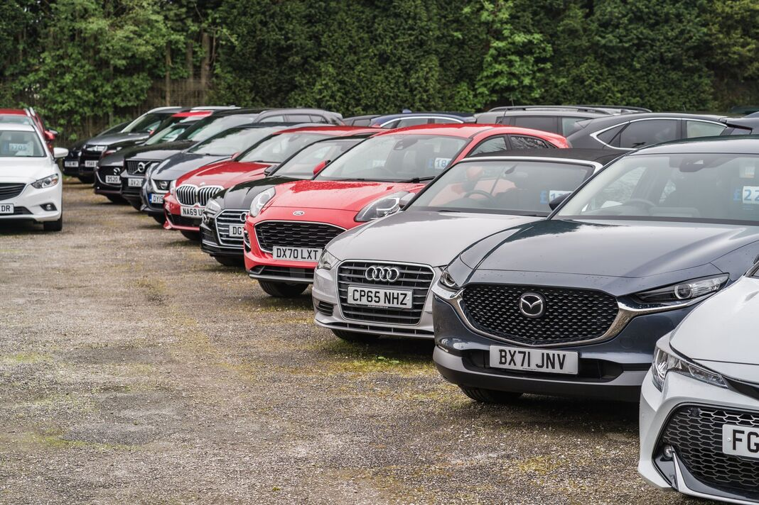
BUSINESS PLAN
Motera Autohaus
An affordable, trustworthy and sustainability-focused used-car dealership
Programme of study: CertHE Level 4 Business skills for the workplace
Module name and code: LCLM4006 -Enterprise & Entrepreneurship
Assignment title: individual Written Business Plan (1500 words)

Lecturer: Bohdan Kovalov
Student name: Ibrahim Kabal
Student ID number: 2528515
University: University of Wales Trinity Saint David
Submission date: 25th October 25, 2026

Executive Summary
Motera Autohaus is an envisioned small-scale independent used-car dealership in Birmingham, specializing in selling reliable second-hand cars in the price range of £2,000 to £8,000. The target group will be new young drivers, students, and families. Initially, there is going to be three to four cars available on a small car showroom along with the online listing of the same. The total number of used-car sales in the UK in 2025 was 7,807,872, which increased by 2.2% from the previous year (2024), according to (SMTT, 2026).
This is to be set up as a private company limited by shares. The owner will be responsible for buying, selling, customer care, and finances, while the specialists in the area will handle the inspections, maintenance, and valeting of the vehicles. Sustainable practices will include the prolongation of the life of the car through repairs, the recycling of parts, and the use of authorized waste disposal companies.
The projected amount of £25,000 needed for setting up the business will come from the savings of the founder. Any profit will be used for the replenishment of the stock and reserve fund. Risks to consider include repair expenses, slow sales of the stock, competition, and limited working capital. The unique selling proposition of Motera includes affordable cars and their clear description and checks along with a pressure-free purchasing process.

Table of Contents
Executive Summary 2
1. Overview of the Business Idea 4
2. Legal Format and Management Structure 5
3. Market Research: PESTEL and Competition 5
4. Marketing Communications 7
5. Funding and First-Month Expenses 7
6. Conclusion 8
Reference List 9

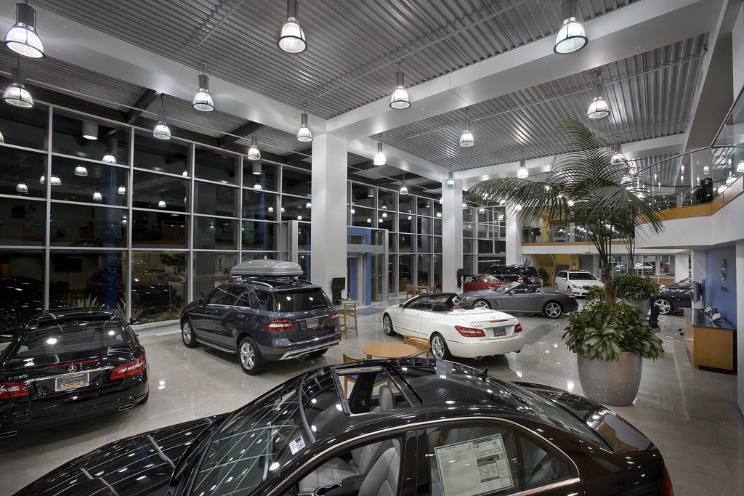

1. Overview of the Business Idea
Motera Auto Haus will be a small used-car dealership based in Birmingham, dealing mostly in second-hand vehicles priced from £2,000 to £8,000. Customers at Motera Auto Haus will be newly passed drivers, students, young professionals and families. Cars for sale initially at Motera Auto Haus will be compact hatchbacks and compact family cars based on their condition, demand and cost of operation. Customers will either be able to view the cars on display or arrange for a appointment. Listings online will include photos of the car, mileage figures, MOT information, service history and problems, if any.
The viability of this opportunity depends on the size of the market. According to SMMT data, the number of the UK used-car sales in 2025 was 7,807,872, representing a 2.2% increase compared to 2024; the number of transactions in the West Midlands was 806,032 (SMMT, 2026). These numbers demonstrate the scale of the market rather than assured demand for Motera.
The USP ( unique selling proposition ) will be affordable cars with good information and no pressure. Motera will compete using selective and transparent buying processes, not by stock levels. Sustainability will be done in practice – needed repairs prior to resale, safe recycling of usable parts, proper waste disposal of batteries, oil, tires and workshop waste to authorized handlers. Mechanics and valet services will be utilized locally where quality and pricing is competitive and price effective. Refurbishment does not make petrol and diesel cars emissions free, claims will therefore be in line with reality, as per the entrepreneur principle of differentiation through risk management (Burns, 2022). Batteries will go to appropriate disposal rather than dealerships (Environment Agency, n.d.).

2. Legal Format and Management Structure
Motera Auto Haus is proposed as a limited company with a share capital. Limited companies are separate legal entities from their shareholders, whose liability for debts of the company is restricted to what is unpaid on their share capital (GOV.UK, 2026). Such a form of business is appropriate for a business dealing with stock of vehicles and making agreements with the customers, landlords, insurance companies and suppliers. It will also allow the possibility for outside investors in the future, once the business grows. Nevertheless, a limited liability will not exempt the directors from any duties they have under the law, nor will it cover all situations, including personal guarantees.
The owner will take care of purchasing, pricing, selling, marketing, and cash flows. In the initial stages, inspection, repair, and cleaning will be outsourced to approved local companies, thereby saving on costs associated with having a garage and permanent employees. An assistant can be employed if the business has enough sales. The director will have to keep company accounts and fulfill tax and filing responsibilities. According to the Consumer Rights Act of 2015, consumer goods must meet certain requirements, which include satisfactory quality and be as described (UK Parliament, 2015).

3. Market Research: PESTEL and Competition

PESTEL analysis
Factor | Implications for Motera Autohaus
Political | Clean air policies and taxes on vehicles can affect consumer choices and used car prices. Motera needs to verify the emissions data of each vehicle along with local driving requirements before purchasing stock.
Economic | Affordability is influenced by household budgets, interest rates, fuel prices, and repair costs. Low-cost vehicles will certainly pull in customers, but low profits mean that savings are crucial.
Social | The buyers could feel uneasy due to the possible existence of defects, particularly new customers. It is important to provide detailed explanations, conduct viewings without pressure, and answer any questions.
Technological | Internet markets, vehicle histories, and social media can help a small dealer access customer affordably. These factors make the market transparent and competitive; hence, there is need to be accurate in advertising.
Environmental | Repairing and reusing can add to the car’s lifespan and minimize unnecessary waste. Nonetheless, old petrol-powered and diesel-powered cars will still produce emissions; therefore, Motera should not exaggerate environmental benefits.
Legal | It must abide by the laws relating to consumers, advertising, data protection, insurance, and related waste laws. The standards under the Consumer Rights Act of 2015 are quality, goods that fit their description (UK Parliament, 2015).

The wider small business environment is important since according to the Department for Business and Trade there were 5.7 million private sector firms operating in the UK at the beginning of 2025, out of which small businesses comprised the majority (DBT, 2025). This gives some background on small businesses but is not any direct indication of profitability in the business. Motera needs to check for local demand in stock, number of days in stock, costs of preparation and gross margin per transaction.

Competition
Competition includes Fort Used Car Centre, a large Birmingham car supermarket that promotes a showroom with more than 200 vehicles, and Smallbone & Son Cars in Selly Oak, an established local dealer offering a wide range of used cars and online browsing (Fort Used Car Centre, n.d.; Smallbone & Son Cars, n.d.). ASU Cars in Small Heath also targets customers looking for competitively priced used vehicles (ASU Cars, n.d.). These businesses have established reputations, wider stock or experience that a new dealer cannot match straight away. Motera’s response will be to maintain a smaller, well-selected stock, provide prompt replies and clear disclosures, and offer a straightforward viewing process. Online marketplaces also make car prices easy to compare. A key risk is that a cheap auction purchase may need expensive repairs, each car should undergo history checks and be inspected, with a maximum buying price set after budgeting for preparation and a achievable profit margin. Motera should compare advertised prices for similar age, mileage and specification rather than automatically undercut competitors. A simple monthly competitor log can record stock, advertised prices, warranties and delivery options. This makes the business’s decisions evidence-based and helps avoid buying cars that are widely available. This is achieved by keeping a straightforward competitor log each month, noting stock levels, advertising prices, warranty information, and shipping alternatives. This makes the company's decision-making process evidence-based, and it will help the company avoid purchasing vehicles that are already being sold at a lower price.

4. Marketing Communications
Motera will use digital marketing supported by its forecourt. This will be through having a mobile responsive website with information on inventory, pictures, pricing, mileage, MOT dates, servicing history, and ways to contact. The marketing strategy will include search targeting phrases like “cheap secondhand cars in Birmingham.” It may also include paid listings on a car marketplace Autotrader etc. when the cost of the listing would be justified by the coverage gained from it.
Brand message would be “Drive with confidence”. Motera would inform customers about any checks performed and tell them about any problems that it knows of without making false promises. The positioning would be reliable and fairly priced cars with all necessary information available. This is because customer value communication is very significant (Kotler, Keller and Chernev, 2022).
The dealership must find a secure and humble location which has enough room for three to four cars. It does not need a high-rent area because most of its customers will arrive via Internet search and pre-arranged viewing appointment. Prior to making any lease agreement, it is recommended that the founder makes comparisons of the rent amount, business tax, security, signage permission, and the existence of any competitors near the location. Performance will be measured by the following parameters: number of inquiries, number of viewings, conversion ratio, advertising expense per sale, car turnover period, and gross profit per car. As the location has a limited forecourt space, the founder must personally visit potential locations and evaluate the factors of visibility, parking facilities, safety in accessing, and accessibility through public transport facilities.

5. Funding and First-Month Expenses
The total amount needed for Motera Autohaus will be around £25,000, which will be financed through the savings of the founder themself. Although this way, there will be no need to pay back any loans or give away any shares of ownership, the personal savings are limited, so the money can’t be invested in slow-moving inventory.
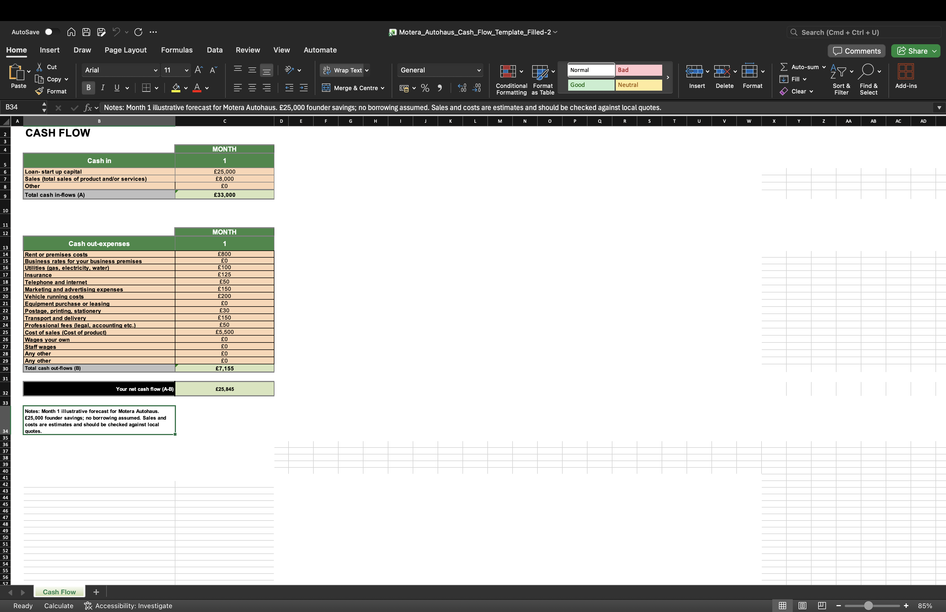
The figures are estimates for planning purposes and not quotations from suppliers. The founder should get quotations for the premises, insurance, transport and repairs if needed. The reserve is essential since the cars could take time to sell or unfortunately require some unforeseen repairs. For example, a gross profit of £800 per car will generate a gross profit of £2,400 from three cars sold without the deduction of the overhead costs, taxes, and other expenses. Motera should make a cost sheet of every car purchased and a cash flow statement for every month.

6. Conclusion
Motera Autohaus may cater to the demands of Birmingham customers looking for well-prepared cars at affordable prices. Market size looks good; however, the possibility of competition, shortcomings and lack of working capital makes success less predictable. Small forecourt, outsourced preparation and electronic marketing will make this business run without becoming complex. Sustainability and community involvement - through extending car life, proper waste disposal and use of locally sourced parts - have to be more than a part of marketing. The figure of £25,000 should be verified against the quotes and savings possible.

Reference List
ASU Cars (n.d.) *Used cars in Birmingham, West Midlands*. Available at: https://www.asucarsltd.co.uk/used/cars/birmingham/ (Accessed: 25 October 2026).
Burns, P. (2022) *Entrepreneurship and Small Business*. 5th edn. London: Red Globe Press.
Department for Business and Trade (DBT) (2025) *Business population estimates for the UK and regions 2025: statistical release*. Available at: https://www.gov.uk/government/statistics/business-population-estimates-2025/business-population-estimates-for-the-uk-and-regions-2025-statistical-release (Accessed: 25 October 2026).
Environment Agency (n.d.) *Waste batteries: treat, recycle and export*. Available at: https://www.gov.uk/guidance/waste-batteries-treat-recycle-and-export (Accessed: 25 October 2026).
Fort Used Car Centre (n.d.) *Used cars in Birmingham and the West Midlands*. Available at: https://www.fortauto.com/ (Accessed: 25 October 2026).
GOV.UK (2026) *Set up a private limited company*. Available at: https://www.gov.uk/limited-company-formation/setting-up (Accessed: 25 October 2026).
Kotler, P., Keller, K.L. and Chernev, A. (2022) *Marketing Management*. 16th edn. Harlow: Pearson.
Smallbone & Son Cars (n.d.) *Used cars for sale in Birmingham and the West Midlands*. Available at: https://www.smallboneandson.co.uk/ (Accessed: 25 October 2026).
Society of Motor Manufacturers and Traders (SMMT) (2026) *EVs power up used car market in three-year growth run*. Available at: https://www.smmt.co.uk/evs-power-up-used-car-market-in-three-year-growth-run/ (Accessed: 25 October 2026).
UK Parliament (2015) *Consumer Rights Act 2015*. Available at: https://www.legislation.gov.uk/ukpga/2015/15/contents (Accessed: 25 October 2026).

