Creativity and Value Creation
Professions

Component 1: Online portfolio of set exercises

Student name: Erika Dorado
Student number: 2430471
Lecturer’s name: Caroline salami

Table of Contents
Introduction
Task 1
Key concepts during practice
Innovation
Creativity in Practice
Value Creation
Value Creation
Interpretation
Task 2
Long Waiting lists in healthcare
Interpretation
Task 3
Selfreflection using Gibbs' reflective cycle
Task 4
Analysis of a UK Innovation
Task 5
Research
Task 6
Digital healthcare service
- In the management of chronic diseases, what the of wearable technology
- Communication and collaboration improve through electronic records
- Health promotion and digital technology at the service of preventive care
Task 7
Leadership within the NHS
Inspiring a shared purpose
Reflective
Task 8
Self-reflection

Creativity and Value Creation in Health and social care
Online Portfolio of set Exercises

Introduction
Value creation in healthcare and social care is achieved through innovation and the implementation of new technologies and systems designed to improve the quality and efficiency of patient care. These innovations have transformed healthcare delivery, created more accessible and flexible forms of care, while also contributed to reduced waiting times and an improved overall patient experience.
Task 1
Key concepts during practice
Innovation,
When we talk about innovation, we're referring to the search for new ideas for successful change. With this, we aim to improve services for users through new technologies, achieving extraordinary results and thus improving and updating services within healthcare centers. (West, 1990)
In the health and social care sector, the implementation and development of new technologies have been successful because they have helped improve patient centered care, enhance the quality of care, and improve service safety, thus responding effectively to the constant changes within the healthcare sector. A clear example is electronic health records, such as the Electronic Health Record (EHR). This system has improved information and communication among healthcare professionals, reduced medication errors, and enhanced continuity of care. (Rogers, 2003)
Creativity in Practice
Creativity is the talent for creating and innovating ideas that solve problems and improve practices in the healthcare field. Creativity in healthcare helps us improve patient centered care, and professionals efficiently create solutions that meet the needs of citizens. In the occupational therapy sector, they can create individualized activities that can be done at home using everyday objects. Amabile's theory of creativity arises from experience and interaction, motivating interest. (Ambile, 1996)
Value Creation
Value creation refers to improving outcomes with appropriately available resources. In healthcare, value means providing high-quality, beneficial care that improves health and contributes to patient well-being. For example, diabetes management programs reduce costs by monitoring patients frequently. Adequate information prevents premature intervention. Porter's value-based healthcare margin argues that healthcare organizations create value when they achieve improved patient outcomes relative to the cost of care. (Porter, 2010)
Value Creation
Change helps us improve existing practices and work methods, optimizing organized performance. Change is necessary to adapt to constant technological advancements. For example, the implementation of infection prevention procedures during the COVID-19 pandemic required adapting to new procedures. Lewin's Change Management Model states that successful change occurs through freezing and unfreezing stages, modifying behaviours. (Burnes, 2017)

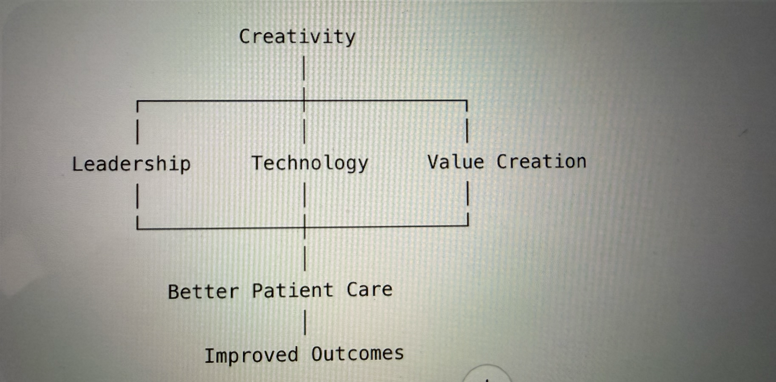
Task 2
Long Waiting lists in healthcare

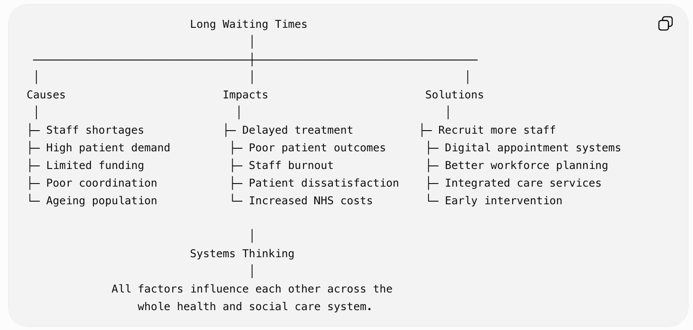
Source: Author's own illustration, adapted from Meadows (2008).
Interpretation
Long waiting lists create a problem in the healthcare and social services sector. This delays treatments, generates patient dissatisfaction, and can lead to poor health outcomes. From other perspectives, the interconnected factors are increasingly seen as the result of associated statistics. These include staffing levels, patient demand, limited patient funding, tight budgets, poor inter-service cooperation, and the disproportionate impact on the elderly population. This situation exhausts healthcare professionals and worsens patients' health. This adds stress to the National Health Service (NHS). Problems of disproportionate care are particularly prevalent among the elderly, and this trend is increasing. For adults with chronic illnesses, the community is the most disadvantaged. One solution is to recruit more staff, innovate in digital appointments, and reduce the demand on the healthcare system. (Meadows, 2008)
Task 3
Selfreflection using Gibbs' reflective cycle
Gibbs's reflective cycle (1988): This reflection forms the framework for evaluating learning in convergent and divergent thinking.
- Convergent thinking: This involves generating multiple ideas.
Divergent thinking: This involves evaluating ideas to identify the most practical solution. (Cropley, 2006)
Our group presented numerous ideas, demonstrating divergent thinking. We managed to reach a consensus on the ideas presented, suggesting a balancing of positive and negative aspects to compare them. This helped us put divergent thinking into practice, and we enjoyed the creative possibilities. We learned that teamwork is effective but requires balancing and evaluating logic. We encouraged each other to organize practical solutions for improvement and decision making.
This experience showed us that listening to and combining different thinking styles helps us improve results. Next time, we will encourage all members to participate to further improve efficiency. Practice helps students progressively improve their knowledge and performance. (Gibbs, 1998)
Task 4
Analysis of a UK Innovation
Innovation means improving patient services, such as virtual appointments, which allow patients to receive hospital-like care at home through technology and monitoring. Due to hospital bed shortages and long waiting lists, the priority is safe care outside the hospital setting. This shift has been positive in terms of monitoring, digital communication, and multidisciplinary teamwork for the design of healthcare service delivery. (NHS, 2022)
Rogers' theory (2003) shows that ideas adopt better sales and offerings that are easy to adapt and that the results improve over time because they lead to better patient outcomes, and efficiency and standards of care increase. This model could be extended to other health services, particularly the management of chronic diseases and community support. (Rogers, 2003)
Task 5
Research
Currently, there is stress and burnout among healthcare workers in the NHS, this impacts patient well-being and the quality of services. A key reference for understanding the problem of burnout is Maslach's Burnout Inventory, which explains that burnout develops through emotional exhaustion, disengagement, and minimization of personal reality. (Maslach, 1981)
They discovered that excessive workloads, long working hours, and limited support are the main causes of stress and burnout among healthcare professionals. This research suggests that improving leadership, staff well-being, and teamwork reduces burnout and improves patient care. This article helped me understand aspects of the work environment, and that more than individual resilience, it plays a significant role in personal stress. (West, 2016)
Panagioti, similarly, identifies high job demands, a lack of resources, and a poor work-life balance as key factors contributing to burnout. His systematic review also revealed that organizational intervention, like individual intervention, can reduce burnout. He demonstrates the need for changes across the entire healthcare system. (Panagioti, 2017)
Both studies show that excessive workload and pressure are the main causes of burnout. Panagoiti (2017) points to administrative interventions, while West (2016) highlights the importance of leader support and teamwork in creating a healthy work environment.

Task 6
Digital healthcare services
- In the management of chronic diseases, what are the benefits of wearable technology
Wearable technology offers significant health benefits. Fitness trackers and smartwatches are particularly helpful in managing chronic conditions by enabling regular monitoring and providing accurate information. This type of technology measures heart rate and blood oxygen levels, allowing for early detection. This type of technology detects cardiovascular problems by identifying irregular heart rhythms. he use of wearable technology can be understood through the Technology Acceptance Model , (Davis, 1989)
This encourages and promotes healthy habits. It helps reduce hospital admissions and improves patient participation in their own care. New technologies are valuable and appreciated because they facilitate prior monitoring and improve information between patient and professional. (Shah, 2018)
- Communication and collaboration improve through electronic records
Electronic registration has been a great help to healthcare professionals and facilitates their access to accurate and up-to-date patient information across different sectors, such as GP, hospital, pharmacy, etc. It enables professionals to share correct information; previously, registration was done on paper, and much information was lost. (EHR) Electronic Health Records technology in the healthcare sector facilitates more organized healthcare, enabling decision-making based on comprehensive patient information. The technology model (Davis, 1989) suggests that healthcare professionals are better equipped to adapt to the system and improve their methods. (Davis, 1989)
New implementations require training for professionals and attention to data security. Electronic health records (EHRs) foster continuous improvement and teamwork by ensuring accurate information and providing safe care.
New implementations require training for professionals and attention to data security. Electronic health records (EHRs) foster continuous improvement and teamwork by ensuring accurate information and providing safe care. (Kruse, 2018)
- Health promotion and digital technology at the service of preventive care
Technology helps and improves preventative care within the healthcare system. It helps patients manage their health and access information. This fosters patient engagement and personalized care, enabling them to receive timely intervention before their health deteriorates. Health apps, online care, and digital health education platforms have enabled patient collaboration in their care (UK Health, Counseling and Appointment Services). This type of monitoring allows for early detection within the healthcare system. (WHO, 2019)
This type of model has considerable acceptance within the technology. (Davis, 1989) The new technology is considered useful, valuable, and easy to use. The new digital system can encourage healthier behaviors thanks to constant reminders that track individual progress and personalized guidance. However, the digital system remains a challenge; some groups lack internet access or digital skills. Overall, the technology improves access to the healthcare system and supports prevention. (WHO, 2019)
Task 7
Leadership within the NHS
In the pursuit of shared leadership, behaviors, skills, and knowledge must be identified. Once these factors are identified, the need for shared leadership among all staff, regardless of their role and responsibility, becomes clear, as everyone is committed. The goal is to achieve progression and improved results. This involves promoting compassionate leaders to guide shared leadership in response to real-world needs, identifying key behaviors, and encouraging the team to embrace change based on capacity building and achieve positive outcomes (NHS, n.d.). This type of leadership and work culture enhances teamwork and fosters continuous training, learning, and development. A leader's effectiveness is demonstrated through its application; this contributes to the profile of high-quality care. Staff well-being enables organizations to respond successfully to change and challenges. Accountability is also fundamental to providing safe services.
Inspiring a shared purpose
A leader must inspire a shared goal. A leader with a clear vision communicates and motivates staff to achieve common objectives focused on improving patient care. By encouraging staff to share ideas, the leader implements new ideas to minimize wait times. This form of creativity increases staff engagement, enhances problem-solving, and helps patients have a positive experience. Support and encouragement help inspire employees (This is transformational leadership theory). (Bass, 1994)
Reflective
In this module, I have developed a greater understanding of the importance of innovation, creativity, and values ​​in healthcare. Creativity is the ability to create and innovate great ideas to improve existing services for the benefit of patients. I learned about leadership, innovation models, and values ​​that have demonstrated creativity, which depends on teamwork. Effective leadership is key. In the future, I will promote team collaboration using evidence-based methods.
Task 8
Self-reflection
Gibbs's reflective cycle (1988) has allowed me to reflect on my understanding of creativity and value creation in healthcare. At the beginning of the module, during group activities on divergent and convergent thinking, I understood that innovation improves services, patient experience, and communication through creative problem-solving.
References
West, M.A. and Farr, J.L. (1990) Innovation and Creativity at Work: Psychological and Organizational Strategies. Chichester: John Wiley & Sons.
Rogers, E.M. (2003) Diffusion of Innovations. 5th ed. New York
Amabile, T.M. (1996) Creativity in Context. Boulder, CO: Westview Press.
Porter, M.E. (2010) ‘What Is Value in Health Care?’, New England Journal of Medicine, 363(26), pp. 2477–2481
Burnes, B. (2017) ‘Kurt Lewin and the Harwood Studies: The Foundations of OD’, The Journal of Applied Behavioral Science, 53(3), pp. 255–281.
Meadows, D.H. (2008) Thinking in Systems: A Primer. White River Junction, VT: Chelsea Green Publishing.
Cropley, A. (2006). In Praise of Convergent Thinking. Creativity Research Journal, 18(3), 391–404.
Gibbs, G. (1988). Learning by Doing: A Guide to Teaching and Learning Methods. Oxford Polytechnic.
https://www.england.nhs.uk/publication/supporting-guidance-virtual-wards-including-hospital-at-home/
Maslach, C. and Jackson, S.E. (1981) The measurement of experienced burnout. Journal of Occupational Behaviour, 2(2), pp. 99–113.

West, C.P., Dyrbye, L.N., Erwin, P.J. and Shanafelt, T.D. (2016) Interventions to prevent and reduce physician burnout: A systematic review and meta-analysis. The Lancet, 388(10057), pp. 2272–2281.
Panagioti, M., Panagopoulou, E., Bower, P., Lewith, G., Kontopantelis, E., Chew-Graham, C., Dawson, S., van Marwijk, H., Geraghty, K. and Esmail, A. (2017) Controlled interventions to reduce burnout in physicians: A systematic review and meta-analysis. JAMA Internal Medicine, 177(2), pp. 195–205.
Kruse, C.S., Stein, A., Thomas, H. and Kaur, H. (2018) ‘The use of electronic health records to support population health: A systematic review of the literature’, Journal of Medical Systems, 42, Article 214.
Davis, F.D. (1989) ‘Perceived usefulness, perceived ease of use, and user acceptance of information technology’, MIS Quarterly, 13(3), pp. 319–340.
https://www.leadershipacademy.nhs.uk/healthcare-leadership-model/
Bass, B.M. and Avolio, B.J. (1994) Improving Organizational Effectiveness through Transformational Leadership. Thousand Oaks, CA: Sage Publication

.

