

Financial Management for the Hotel Industry
Assignment 1: Grand Hotel Budget
Planner

Student name: Dragos Stefan Coanca
Student ID: 2026724
Contents
Introduction 3
Task 1 4
Task 2 9
Analyses of part 1 9
The importance of budgeting 10
Understanding of incremental budgeting, activity-based, value proposition and zero-based budgeting 11
Budgeting control can support sustainability 13
Conclusion 14
References 15

Introduction
This report is divided into two tasks. The first task will show the prepared budget planner for the grand hotel. The second task is to prepare a report for the account’s director. The report will briefly discuss different types of budgetary methods.

Task 1
Here, the task one has been attached.
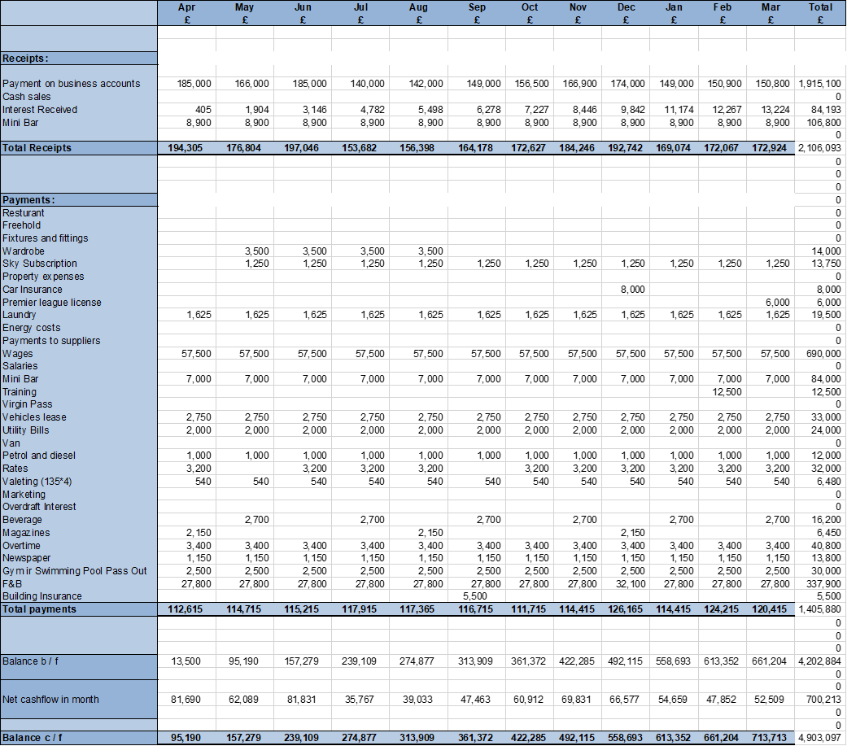

Task 2

Analyses of part 1
Grand hotel received £176804 in May, £ 197,046 in Jun, £ 153,682 in July, £ 156398 in August, and 164,178 in September and so on. So, in comparison to all the months, Grand hotel gained the highest receipt in Jun which is £ 197,046. Then the second highest is in December which is £192,742. And the third highest received in October £184246. The main source of income of the grand hotel is payments on the business account, cash sales, interest received and minibar. The total earned from all the receipts is £2106093. The highest amount has come from the payment on the business account £1915, 100 and then the mini bar which is £106,800. But surprisingly the expenses were lowest in those months when Grand hotel gained the most amount of their revenue for example, in May it spent £114, 715 where it spent 3 thousand extra pounds in July when the revenue was way lower. The highest number of amounts of money spends in the month of December. The major payments items done by Grand hotel are restaurant, Freehold, Fixtures and fittings, Wardrobe, Sky Subscription, Property expenses, Car Insurance, Premier league license, Laundry, Energy costs, Payments to suppliers, Wages, Salaries, Mini Bar, Training, Virgin Pass, Vehicles lease, Utility Bills, Van, Petrol and diesel, Rates, Valeting, Marketing, Overdraft Interest, Beverage, Magazines. Over time the higher expense may be happened because of extra magazine subscriptions, and car insurance payments. Two of the most frequent and high expenses items of the Grand Hotel are wages and F&B where it has spent consecutively £690,000 and £337,900. Grand hotel also has spent a subsequent amount of money on the mini bar, which is £ 84000, though in this specific year Grand hotel has not spent single money on marketing activities. But it has provided training only in February to the employees which have cost the hotel around £12,500. The total amount spends on operations is £1405880. The net cash flow of Grand hotel started from August to march are £39,033, £47,463, £60,912, £69,831, £66,577, £54,659, £47,852, £52,509 and £700,213. So according to the cash flow, the result is different than the highest revenue month previously. Now based on the net cash flow in a month, the grand total has earned the highest in November then December and then October. The lowest number of profitable months was august. But the Grand Hotel has seen positive returns in all the months of the year.

The importance of budgeting
Budgeting is a process of tacking down when and how much an organization would earn or spend money. The overall success and security of a business depend on the creation of the budget. An organization can oversee and get a better understanding of whether the business has enough revenue to pay the expenses or not. An organization can make more informed financial decisions by using a budget (Brownell, 2018). For example, if Grand Hotel knows how much money it will earn and spend every week for the last couple of months then it will know how much it can afford to spend if it wants to hire a new employee. Grand Hotel can map out its goals, save money and keep track of the progress. Organizations can avoid precarious positions by taking proper budgeting processes. Budgeting helps organization keep operating expenses on track and measure performance continuously. Budgeting helps an organization to find out the lacking and inefficiencies in the operation. Budgeting helps an organization control the finances of the business. Budgeting helps an organization to ensure that the business can fund its current commitments and also budgeting ensures that the organizations have enough for future operations. And also, organizations can review and compare the budget with actuals and can provide data that highlights the strengths and weaknesses of the business (Brownell, 2018). For example, a particular department of the Grand Hotel is overlapping the required amount of the budget every month. A well-communicated budget helps an organization to result from a better result in long term. As a hotel Grand hotel needs more accurate budgeting because it needs to carry on a subsequent amount of cash regularly to operate regular activities. Grand hotel needs to prepare the proper budget to achieve its goals. Transformation, effectiveness and efficiency depend on effective budgeting. Budgeting helps an organization crunch the numbers, provide attention to detail and make informed decision fund allocation. Planning financials prior helps to utilize monetary and non-monetary resources effectively and efficiently.

Understanding of incremental budgeting, activity-based, value proposition and zero-based budgeting
Budgeting is the process of overseeing and preparing a financial document that estimates expenditure and revenue for a period. There are different types of budgets that organizations use to prepare their budget. Following are some types of budgeting:
Incremental budgeting: Incremental budgeting is a type of budget where it is based on the idea that a new budget can be developed by changing some marginal amount to the current budget (Raghunandan et al. 2012). In short, the base should be the current budget of the incremental budget and the incremental assumptions are either subtract or added to the base amounts to fix the new budget. Incremental budgeting is the simple and easiest budgeting process. A few assumptions are needed to make the new budget. Another advantage is consistency and operational stability. But incremental budgeting can result in unnecessary spending for a company. It promotes unnecessary spending. Another disadvantage is that it discourages innovation and growth.
Activity-based budgeting: Activity-based budgeting method is where activities are analyzed thoroughly to predict the expenses. As opposed to the more limited cost adjustments made by traditional planning methods due to inflation or shifts in company activity, the more comprehensive analysis of expenses that activity-based budgeting provides is a major benefit. All of a company's expenses will be scrutinized to find places where savings and efficiency might be made (Wetherbe and Montanari, 2021). It may take the shape of doing less overall, or it may include doing away with some or all of the things that aren't essential. When compared to other budgeting approaches, ABB provides greater transparency into the expenditures connected with running a business. The expenses of doing business can be broken down into its component parts in order to better understand the factors that may be stifling a company's profits. Adopting ABB is more expensive and time-consuming than alternative budgeting approaches, which is the main drawback of using it. Anything technical about a company operation has to be documented as it happens, just like everything else.
Value proposition method: Under this method, the businesses use to consider each item on the budget list and analyse whether it generates value or not. The aim of this budget is to ensure that all the money spent will generate positive value for the organization. Considerable nuance is required when employing value-based budgeting due to the variety of elements that must be taken into account (Hall, 2020). To succeed, businesses must first pinpoint "value drivers" and begin directing resources toward initiatives that directly affect those drivers. One of the advantages of this method is that it tracks where the money is being spent specifically. This budget method optimization of spending and business. But this method is difficult to measure value. Another disadvantage is that it requires constant reassessment which is time-consuming and costly.
Zero based budgeting: Zero-based budgeting is a type where managers are forced to think about how every dollar is spent in every budget period. It is different from all traditional methods in that it starts from all zero in every fiscal. The first advantage of using this method is that the managers must justify all operational expenses. Zero based budgeting keeps legacy expenses in check (Seal, 2013). But the inability to plan beyond the next fiscal year or budget period is a key flaw of zero-based budgeting, which is often used to incentivize spending on projects that will bring in money in the near future. Another disadvantage is that zero-based budgeting is very resource intensive as it takes more time and resources to review it closely.

Budgeting control can support sustainability
The prime objective of budgeting is to maintain planning. Budgeting is very important for effective financial planning. There is a great deal of competition between businesses in today's business world. Therefore, every corporate action should be carefully deliberated to ensure steady and lasting growth (Ndiritu, 2017). Every strategy needs a backup plan in case something goes wrong with the primary one. Naturally, it is important to factor in the plan's financial requirements and the plan's financial impact. This requirement is met via budgeting. Planning one's financial resources is another name for budgeting. Creating a budget requires meticulous preparation. This plan includes discussions of revenue, expenditure, cash flow, assets, liabilities, and resources. Good budgeting helps organization achieve financial sustainability. Mainly business organizations fail due to their inconsiderate behaviour towards regular cash flow. Forecasts show how organizations spend their money regularly in terms of income. Proper forecasts predict the expenses and require the amount of money to pay the dues, and invoices and save the organization from any kind of uncomfortable situation. There is a great deal of competition between businesses in today's business world (Schick, 2012). Therefore, every corporate action should be carefully deliberated to ensure steady and lasting growth. Every strategy needs a backup plan in case something goes wrong with the primary one. Naturally, it is important to factor in the plan's financial requirements and the plan's financial impact. This requirement is met via budgeting. Planning one's financial resources is another name for budgeting. Creating a budget requires meticulous preparation. This plan includes discussions of revenue, expenditure, cash flow, assets, liabilities, and resources. All business organizations like Grand Hotel operate to earn profit. Profit is what makes an organization survive in the long run as no organization can sustain constant losses. But a proper budget helps an organization avoid any kind of disruptions which may affect the organization adversely. A budget is a necessary tool for business organizations in all sectors such as hospitality, finances, airlines, logistics, manufacturing and all other sectors. The budget helps an organization in proper decision making which later help an organization to achieve long-term sustainability.

Conclusion
This report has divided into two tasks. The first task is a cash forecast of the total payments and expenses of the Grand hotel. In the next task, the author has shown analyzed the first part and brief discussion on the budgeting process.

References
Brownell, P., 2018. Participation in the budgeting process: When it works and when it doesn't.
Hall, J.H., 2020. Investigating aspects of the capital budgeting process used in the evaluation ofinvestment projects. South African Journal of Economic and Management Sciences, 3(3), pp.353-368.
Ndiritu, G.M., 2017. Effectiveness of cash budgeting in public institutions: a case study of Telkom Kenya Ltd (Doctoral dissertation, University of Nairobi).
Raghunandan, M., Ramgulam, N. and Raghunandan-Mohammed, K., 2012. Examining the behavioural aspects of budgeting with particular emphasis on public sector/service budgets. International Journal of Business and Social Science, 3(14).
Schick, A., 2012. Planning, Programming, Budgeting System: A Symposium. American Society for Public Administration, 23 (2), pp. 2,
Seal, W., 2013. Modernity, modernization and the deinstitutionalization of incremental budgeting in local government. Financial Accountability & Management, 19(2), pp.93-116.
Wetherbe, J.C. and Montanari, J.R., 2021. Zero based budgeting in the planning process. Strategic Management Journal, 2(1), pp.1-14.

