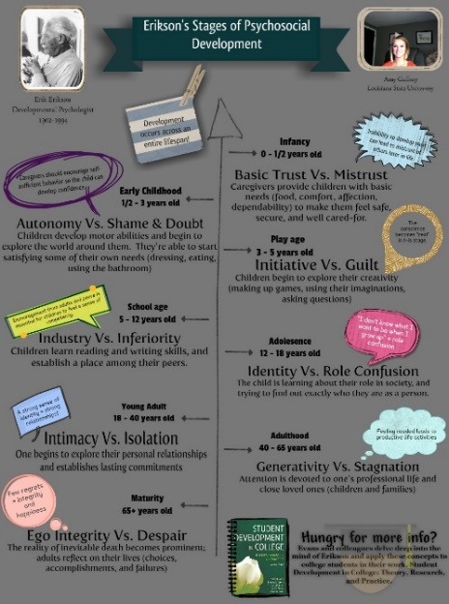
Erik Erikson believed that during the first 4 stages a child’s success is mainly based on their parents and teachers.
Whilst stages 5-8 of Erikson’s psychosocial theory of development is based on the individuals have more control over their environment. Individuals gain responsibility for crisis resolution in each stage.
“Erikson’s (1950/1963) eight stages of psychosocial development is a comprehensive theory of not only the processes of how an individual develops throughout the life cycle but a theory of identity formation and the process of establishing a coherent sense of self”. Knight, Z,G. (2017)
There are many theories and ideas as to what stages are included in a human life span from birth to death. Our focus is on Erik Erickson’s and Sigmund Freud’s psychosocial development theories. Both Erik Erikson and Sigmund Freud have a psychodynamic approach to life span changes. Both theories focus on the importance of early experiences. All psychodynamic theorists believe that the unconscious mind determines your actions, thoughts and your feelings. Erikson’s psychosocial theory of development (1958, 1963) was influenced by Freuds earlier psychosexual theory of development (1885) but they still have very important differences.

Erik Erikson believed that personality develops in 8 stages across a human life span. Each stage is linked to social experiences across the lifespan. A 9th stage was added by Mrs Erikson after his death.
According to Erikson, an individual must successfully resolve eight sequential developmental crises. Each crisis can result in the emergence of a positive or negative trait. Successful resolution occurs when an individual reaches the end of a crisis having developed the positive trait with which it is associated. Boyd, D, & Bee, H (2019).
If an individual unsuccessfully cope with a stage, it’ll making the next stage harder/impossible.

Erik Erikson’s (1902-1994) Psychosocial Theory of Development

Freud supports mental health and believes that what happens to you as a child has a lasting effect on their adult mind. Freud believes the unconscious mind plays a big role in psychoanalysis.
“Sigmund Freud emphasized the importance of the unconscious mind, and a primary assumption of Freudian theory is that the unconscious mind governs behavior to a greater degree than people suspect. Indeed, the goal of psychoanalysis is to make the unconscious conscious”.

Sigmund Freud says children go through 5 development stages in life.
“These phases of sexual growth, with their mental, social, and physical changes, are known as psychosexual stages, and they can have important consequences for the child’s emerging personality, depending on the management of tasks that accompany each stage”. Fernald, D. (2008).
“Understanding psychological development across the lifespan”
Sigmund Freud 1856-1939- The Psychosexual Development Theory
(Glogster EDU, 2015)
Local community hospital staff can help and support older individuals that are in stage 8 of Erikson’s lifespan development, by keeping them vitally involved and present. Regular visits from the local nursery children, adolescents on work experience from local schools and adult volunteers is very important. The visitors can participate in games, movie hour, gardening and assist on day trips with the patients/residents. A patient/residents suggestion box is essential, so patients/residents can provide their ideas and opinions for any changes or improvements they would like to see at the local community hospital. Once weekly a patient/resident and staff tea should be organised, in order to discuss the thoughts and ideas the patients/residents have provided.

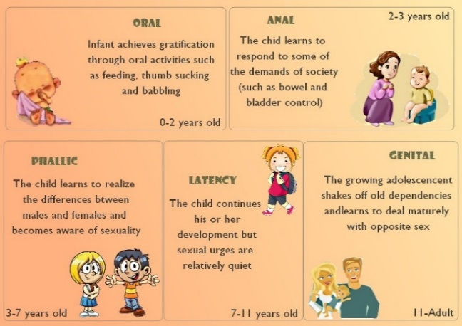
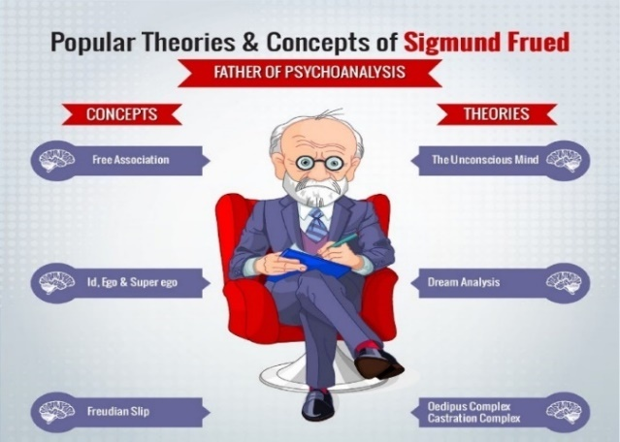

Annotated bibliography
Micheala Lee 2010757
As shown, both theories differ in many ways. In stages age 1 to 3 years old and adolescences both psychodynamics theorists have very similar ideas. In both theories the second stage, age 1-3 both theories focus on children developing a sense of independence. Also, in both Freud and Erikson’s theories, the fifth stage, which is adolescence years, focuses on individuals finding their own identity.

(Qwantify.org, 2020)
Rock Content, 2021)
FREUD VS ERIKSON- Freud believed that the majority of an individual’s personality was formed around age 5 following the phallic stage. Whereas Erikson believed that the nature of the personality develops as it unfolds from birth through to old age.
“Freud suggested that individual differences in personality originate in the nursing and weaning practices of infants’ mothers. Erikson emphasized the roles of both mothers and fathers, as well as other adults in the infant’s environment, in providing for all the infant’s needs, thereby instilling a sense of trust concerning the social world”.
Boyd, D, & Bee, H (2019).

Annotated bibliography
Glogster EDU, 2015. Erikson's stages of psychosocial development. [image] Available at: <https://edu.glogster.com/glog/eriksons-stages-of-psychosocial-development/20qpe2sx7v8> [Accessed 2 June 2021].

- This image gives information on Erikson’s 8 stages of development. I found it very useful as it explains the theory very thoroughly.
- The image shows the name of each psychoscocial stage and the age range of each stage is clearly shown too.
- It gives a brief easy to explain explanation of each stage of development.
- The image outlines how others can help the child going through each stage and it also outlines the potential outcome of each stage.
- The image also shows how our thoughts and feelings may develop in adult years according to Erikson’s theory

Qwantify.org, 2020. Sigmund Freud 5 stages. [image] Available at: 👍 Psychosexual stages. Psychosexual development. 2019-02-19 (webstreaming.com.br) [Accessed 5 June 2021].

- This image clearly displays Sigmund Freud 5 psychosexual stages of child development.
- The image shows the age range and the name of each of Freuds psychosexual stages of development.
- From the image you can see what the child will learn from each stage and the potential outcome of each stage.
- Freud’s first 4 stages are based on childhood years and the last stage age ranges from adolescence years to adulthood. This image is a clear picture of Freud’s beliefs that what happens to you as a child has a lasting effect on their adult mind.

Rock Content, 2021. Popular Theories & Concepts of Sigmund Freud. [image] Available at: <http://Popular Theories & Concepts of Sigmund Freud | Visual.ly> [Accessed 1 June 2021].

- This image shows a clear display of Sigmund Freud’s concepts and theories. The concepts included on the image are:
- Free association
- ID, EGO and SUPEREGO- Erikson believes that personality is split into 3 parts.
- Freudian slip
- The theories included on the image are:
- The unconscious mind, Sigmund Freud believes the mind is like an iceberg, very little is seen by the eye as most of the iceberg is underwater.
- Dream analysis
- Oedipus complex castration complex

Annotated bibliography continued
Boyd, D, & Bee, H 2019, Lifespan Development, Global Edition, Pearson Education, Limited, Harlow, United Kingdom. Available from: ProQuest Ebook Central. [15 June 2021].

- This book has a wide variety of information on both Sigmund Freud and Erik Erikson which I could use to compare the 2 theories.
- Sigmund Freud theory is described as a psychoanalytic theory in this book. Psychoanalytic theorists believe that emotions and internal drives influence behaviour and this is what causes developmental changes to happen. believes the mind is like an iceberg, very little is seen by the eye as most of the iceberg is underwater.
- According to Sigmund Freud’s theory he believes that personality is split into 3 parts, ID, EGO and SUPEREGO, Freud had his own definition of each word, slightly different to the actual meaning of each word. Each of the 3 parts has some contribution to the functioning of the personality in a unique way. ID is the unconscious mind, sexual libido, and basic nature present at birth. Ego is the conscious mind, reason and self-control and superego according to Freud’s theory acts as a moral judge also known as the quest for perfection. According to Freud the superego is developed before early childhood ends at around age 6yrs old.
- Erik Erikson (1902-1994) is the Freudian theorists and he was known to have the greatest influence on the study of development, in 1950, 1959, 1980 and 1982.
- Erikson’s theory of development is based around the interaction of cultural demands and internal drives. It has 8 stages of development and a 9th stages was added after his death by mrs erikson.
- Erikson’s theory is based on psychosocial stages of development.
- According to Erikson’s theory he believed that development persists throughout the 8 stages across the whole lifespan not just childhood.

Boyd, D, & Bee, H 2019, Lifespan Development, Global Edition, Pearson Education, Limited, Harlow, United Kingdom. Available from: ProQuest Ebook Central. [14 June 2021]. Page40 chapter2

- This chapter displays a clear table of Erikson’s 8 stages of development.
- According to Erikson an induvial must complete each stage successfully in order to cope with the next stage, making the next stage easier to cope with.
- A comparison of child and adult social stages of development are outlined in this chapter also.
- This chapter also outlines the main idea of Erikson theory along with the strengths and weaknesses of the theory.

Annotated bibliography continued
Dodge Fernald (2008) Psychology : Six Perspectives. Los Angeles: SAGE Publications, Inc. Available at: https://search-ebscohost-com.ezproxy.uwtsd.ac.uk/login.aspx?direct=true&db=nlebk&AN=474599&site=ehost-live (Accessed: 18 June 2021).page 89/90 chapter 4.

- Sigmund Freud based his theory around the stages of sexual growth we experience whilst growing up along with mental, social, and physical changes we experience, all this together equals to Freud’s theory of 5 psychosexual stages of development.

- Freuds 5 psychosexual stages of development are thoroughly explained by Fernald in this book.
- This chapter states that according to Freud’s theory we begin our sex lives twice once during the phallic stage and the again during the latency stage of development.
- In this chapter Fernald discusses Freud’s theories on the concept of the unconscious, structure of personality, development of personality and psychoanalysis as a therapy

Knight ZG. A proposed model of psychodynamic psychotherapy linked to Erik Erikson’s eight stages of psychosocial development. Clin Psychol Psychother. 2017;24:1047–1058. https://doi.org/10.1002/cpp.2066

In this chapter knight discusses the malignant and the maladaptive tendencies of Erikson’s theory.
- According to knight Erikson’s 8 stages of development is also a theory of identity formation.
- knight also states the Erikson’s theory also includes the process of establishing a coherent sense of self.
- Erikson believed that each developmental stage is initiated or triggered by a crisis or turning point in the life cycle.
- Knight also went on to discuss maldevelopment- ehtehr the individual develops malignant or maldaptive tendencies.
- Lastly knight compared Erikson’s 8 stages of psychosocial development with the 8-stage model of psychodynamic psychotherapy. They are very closely linked.
McLeod, S. A. (2018, April 05). What are the most interesting ideas of Sigmund Freud?. Simply Psychology. https://www.simplypsychology.org/Sigmund-Freud.html

- This article discusses the importance of the unconscious mind according to Freud’s theory. Freud believed that people could be cured by making conscious their unconscious thoughts and motivations, thus gaining insight.

- McLeod stated that the primary assumption of Freudian theory is that the unconscious mind governs behaviour to a greater degree than people suspect.

- McLeod also stated that Freuds goal of psychoanalysis is to make the unconscious conscious. This will make the things we are unaware of become part of the small amount of activity we can remember and acknowledge.

- In this article McLeod displayed the image of the iceberg Freud previously used to show his definition, interpretation of the conscious mind, subconscious mind, the unconscious mind and the ID which according to Freud is also part of the unconscious mind.

