Problem-solving and Decision-making
Name: Ana Caltea
Student ID: 1920393
Professor Name: Akinseye Aluko
Table of Contents
Task 1: Role play on MS Teams 3
Task 2: Individual Report 7
1. Introduction 7
2. Defining a complex workplace problem along with its scope and impact 7
3. An analysis of information on the identified problem for informing the decision-making process 8
4. Proposing alternative solutions to the aforementioned problems 9
5. Using a decision-making technique to evaluate all the identified solutions and selecting the most appropriate one 11
6. Developing a plan for implementing the solution 12
7. Communicating the plan to the stakeholders 14
8. An assessment of suitable review or monitoring techniques 14
9. Conclusion 14
Reference list 16

Task 1: Role play on MS Teams
[Scenario: Here a role-play has been developed between two people; one is a management consultant and the other is an unsatisfied employee, works in a health care setting. Therefore, the management consultant is discussing with the employee the causes of his job dissatisfaction and its impact on his personal as well as the entire organizational performance. However, the main aim of the consultant is to determine the most appropriate solution for the identified problem, its implementation, and evaluation.]
Management consultant: Hello! Welcome to the discussion and please feel free to communicate with me. I am not going to record anything regarding this schedule and you can remain assured of your anonymity. Also, I want to convey that whenever you feel that you want to discontinue please let me know, I’ll stop this session at once.
Employee: Thank you. I have understood you completely and I’m prepared to answer you.
Management consultant: Okay, so, first tell me something about your job role and how are feeling while working in your current organization?
Employee: Presently I’m working as a staff nurse in a reputed health care center in the UK and I don’t want to disclose the name.
[Management consultant nods his head to show positive appreciation and indicates him to continue]
Employee: I am working here for the last two years approximately since I have finished my education and right now actively looking for the opportunity to switch to any other organization. If you have asked me about my feeling regarding this organization, I am not satisfied at all and also, I don’t feel motivated enough to go here and work.
Management consultant: May I know the reason behind such a feeling? Are you feeling any trauma or pressure while working here?
Employee: Yes, indeed. Too much pressure is here and I think it is inhumane. Management must understand that employees are not machines but flesh-and-blood people and they need personal time for their families or some refreshment.
Management consultant: Yes, I agree with you but as far as I know that health care organizations are made for providing emergency aids and thus, pressure is quite common in this kind of workplace. Isn’t it?
Employee: It is true that we, the employees of health care organizations, have been trained with the oath to provide necessary help to the needy. Still, I think the management has to recruit more employees so that the current ones do not require working over-time. Also, they do not maintain any proper schedule and force employees to work under tremendous pressure. I must say that this is why 10 co-workers of mine had already left since the last five months to other companies.
Management consultant: Work stress is undoubtedly a major fact for job dissatisfaction but is such pressure prevailed in your organization even in the pre-pandemic condition? As we all know the government of the UK has enforced the guidelines for the frontline warriors and requested them to work actively.
Employee: It was even before the pandemic and here I also wish to mention that the management of my organization makes irrelevant decisions in allocating job roles to us which are affecting our performance and also of the organization. I think it is an important need for this organization to recruit suitable employees with the proper expertise. When all the other health care organizations are hiring overseas candidates, here only local people are getting recruited.
Management consultant: [By making an appreciating tone] You are right but I think it is because of the Brexit issue which has not only restricted migration but also impacted the national economy greatly. Here you can also notice that the pandemic has slowed down the rate of economic profit greatly, maybe this is the reason for which your company is preferring to recruit local talents.
Employee: Yes, I'm agreeing with you but they also need to bring transparency when they are recruiting or even managing the current employees. The policies in my organization are too much vague and one can clearly identify the gaps there. It does not clearly talk about employee benefits or appraisals and also, I did not notice any such changes in the practices. Even after working very hard, management does not feel the need to appreciate us and we feel that we are being taken for granted.
Management Consultant: That’s obviously not right and yes here, I think your organization must take some active initiatives to understand what its employees want apart from getting them paid. It is a must to appreciate their works from time to time to feel valued and enhance their performance. Here I want to know how is your relationship with your co-workers or what initiatives have your organization taken to maintain a positive relationship among the employees?
Employee: To be very honest, employees prefer working collaboratively as they understood the benefits of teamwork but here, the management used to shuffle team members that usually hamper the bonding. Also, the new manager who has joined recently is unable to understand the workplace culture but very much imposing in nature. This is why I along with other employees are feeling highly dissatisfied.
Management consultant: Therefore, here I must say that your organization needs to support teamwork properly and create an environment where employees can work comfortably with each other and help in achieving success together. Also, management is required to develop policies where employees irrespective of their culture, race, age, gender, or background will be treated fairly and equally and empowered with equal opportunities that bring ultimate satisfaction among all the employees and keep them motivated to work efficiently. Have you ever faced any discriminatory practices by your management?
Employee: Yes, I had and it was regarding work scheduling and taking leave. I was extremely sick but the management did not allow me to take leave and even forced me to work in a tight schedule when it is mentioned in the policy that emergency medical leaves are allowed. Also, I think my organization is not protecting employee rights properly and is prominently violating the employment legislation.
Management consultant: I think then it is a punishable offense but still, to avoid any legal and ethical dilemma, your organization must comply with the guidelines provided by employment legislation and frame workload, wage structure, policies for employee health and well-being based on those through which organizational performance and reputation will also be increased. I think such modification will reduce the level of job dissatisfaction among the employees as well.
Employee: Also, I think they need to become more empathetic with employees' physical and mental state as well as proper respect must be shown towards their culture, opinions, and practices that not only feel them appreciate but also enable in gaining proper confidence for accomplishing the tasks.
Management consultant: That’s true but don’t you think that compliance with proper corporate rules is also necessary to enhance organizational performance as you can see the business environment for health care centers is becoming highly competitive?
Employee: Certainly, but that does not mean they will not think about the satisfaction level of the employees. I think they are molding the corporate rules according to their own accord but not properly.
Management consultant: This is undeniably a serious problem and a proper understanding of employee satisfaction is required to boost up organizational performance and efficiency holistically. Thus, your organization must formulate proper workplace policies by maintaining all the ethics and legal codes, and also, it must think properly about the employees who are one of the most important stakeholders. Hence, I can here state that the organizations must not create huge pressure on the employees that disrupt the smooth working process and at the same time, when they are working hard, it is essential to appreciate their performance to keep them motivated and interested in their jobs. Here, I can also suggest that proper training must be provided to all and after implementing the plans feedback must be taken from the employees first to determine whether they are satisfied or the plan needs to be changed.
Employee: Yes, you are right absolutely.
Management consultant: So, I think we have discussed a lot regarding the issue and hopefully identified its solutions. Thanks for your precious time and active participation.

Task 2: Individual Report

1. Introduction
The recent era is witnessing the evolution of globalization and the advancement of technology in every mechanism of society and thus, business here is no exception. Therefore, in this period the modern business environment is going through a phase of rapid transformation and creating major scope for the enterprises to grab and thrive. Hence, such a lucrative environment has appeared as one of the most appealing grounds for the majority of business organizations worldwide, and thereby, the number of organizations is increasing in the local and global markets continually (Akhmetshin et al. 2017). Therefore, the external market condition is becoming more challenging and it has become important for organizations to acquire, manage and retain employees properly to provide them with ultimate job satisfaction and keep them highly productive and efficient which further helps in enhancing organizational performance. In this context, Raziq and Maulabakhsh (2015) have mentioned that job satisfaction is one of the key drivers for optimizing employee performance and gaining a high sustainable business advantage in the competitive business grounds. Still, organizations are facing great troubles in keeping employees properly satisfied which is evident in the given case study. Thus, here in this report, this particular problem of job dissatisfaction has been discussed along with necessary decision-making techniques that will help in evaluating all the probable solutions and selecting the most appropriate one. Lastly, a plan has been developed for proper implementation of the chosen solution that will further have been communicated with the stakeholders as well as suitable reviewing and monitoring techniques will also be considered to ensure successful implementation.

2. Defining a complex workplace problem along with its scope and impact
With technological advancements and globalization, organizations have understood the significance of including diverse people in the workforce to achieve higher success in the global business arena. Therefore, to manage employees from different nations, backgrounds, generations, etc, and to receive higher organizational productivity, profitability, and performance, it is essential to keep them properly satisfied and realize that they need something more than what they are presently getting from their jobs. Lack of understanding of the management in this aspect creates the issue of job dissatisfaction among the employees i.e., one of the major challenges that every organization is brooding over.
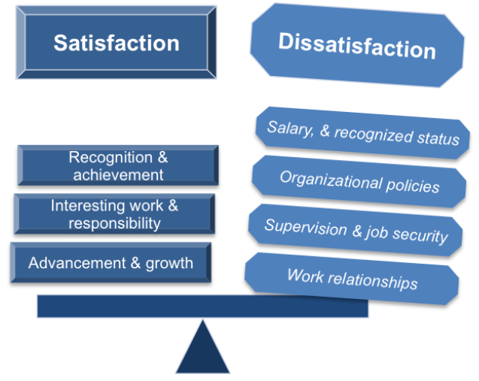
Figure 1: Factors that create job dissatisfaction
(Source: free-management-ebooks, 2021)
Employees, on the other hand, being greatly dissatisfied with their current job are trying to switch to another organization that is increasing the rate of annual employee turnover. While discussing the problem of employee dissatisfaction or job dissatisfaction, authors like Platis et al. (2015) have enunciated that it is a situation for the employees where they need to do the job to earn money but they do not feel motivated or interested enough to work with high efficiency and full of commitment and this can arise due to immense workload, workplace discrimination, less employee recognition, and benefit, unhealthy work patterns, relationships, and environment, etc. Hence, all these factors of job dissatisfaction are not only impacting organizational performance adversely but also creating several problems for the employees regarding their health, safety, relationships, and well-being.

3. An analysis of information on the identified problem for informing the decision-making process
The given case study has portrayed by mentioning the survey of Investors that the number of unhappy employees is rising with every passing year and one of the major reasons is they not receiving proper value or appreciation for what they are doing. Here, Judge et al. (2017) have also articulated that though employees are working hard for earning bread and a proper livelihood, still are not finding ultimate happiness as they are not appreciated properly by the management. Here, communication gaps and improper employee recognition are the other causes for which employees feel undervalued in their workplaces. On the other hand, Bakotić (2016) has mentioned the factor of huge work pressure that is creating stress among the employees and hampering their physical and mental well-being. For such massive pressure employees are becoming unable to balance their work-life properly and feeling like they have to work 24*7.
Judge et al. (2020) have posited that workplace discrimination is one of the most significant factors of job dissatisfaction among employees. Where organizations are talking about implementing equality, inclusion, diversity in the workplace, still are suffering from eliminating discriminatory practices and biased attitudes which are creating resentment and dissatisfaction among the employees especially those who have undergone such situations. Thiagaraj and Thangaswamy (2017) have identified that dissatisfaction can occur if management remains ineffective in creating an efficient and strong employee relation. Therefore, lack of camaraderie can prevent employees from creating a personal bond with each other, and thereby, they can feel less motivated and interested in their job role especially when they are required to perform in teams.

4. Proposing alternative solutions to the aforementioned problems
The problems that have been identified in the previous section hold the trigger for creating job dissatisfaction among the employees greatly. Here, organizations require understanding and implementing proper employee management. In the study of Akkas et al. (2015), authors have defined employee management as a holistic process that ensures proper utilization of human resources and boosts up the efficiency level among the employees so that they remain goal-focused, perform best and achieve necessary targets. While discussing this discourse of employee management, authors have emphasized majorly three areas, i.e., employee acquisition, employee engagement and retention, and performance management. Thus, the HRM of any organization can focus on these areas to identify necessary solutions to the prevailing issues that are making employees unsatisfied regarding their jobs. Here, some strategic solutions have been outlined based on the suggested areas to provide proper satisfaction to the employees.
- The management of every organization needs to understand the ways to maintain effective employee recognition to make them feel valued and appreciated. Here, Akafo and Boateng (2015) have suggested that it is necessary to provide proper scope to the employees where they can freely speak out and express their needs, expectations, and opinions regarding their job role as well as all the aspects that are associated with the workplace. Along with this, it is also required to identify and measure how well employees are performing and provide them proper benefits and appraisals accordingly in terms of keeping them motivated and interested in finishing their responsibilities.
- A strong focus must also be given while scheduling tasks or allocating responsibilities for particular employees in order to maintain a proper work-life balance. Banerjee and Mehta (2016) have asserted that organizations and their management system do hold the tendency of providing multiple tasks on the employees with a very tight schedule which not only affects their physical and mental state but also harms their performance equally. Here, it is necessary to hold proper empathy and sensibility towards the employees before scheduling tasks, and also, proper assessment is required regarding their capabilities, physical and mental abilities as well as other surrounding conditions.
- Workplace culture, on the other hand, plays a key role in creating ultimate job satisfaction among the employees and therefore, it is necessary to create and implement proper workplace policies and rules where all the employees will be treated equally and fairly starting from hiring, managing their performance and retaining them for longer. At the same time, Baptiste (2015) has suggested that more transparency must be brought into every organizational system so that bias and discriminatory practices can be identified at once and necessary measures can be implemented to prevent them.
- Proper maintenance of employee relations is another factor that must be accomplished by the management to provide better satisfaction to the employees.
Inuwa (2016) has articulated that to maintain a diverse workforce first it is necessary to create an ambiance of mutual trust, respect, and empowerment where employees will feel valued and feel comfortable working with each other efficiently. At the same time, employee relation helps in creating a strong bond among the employees by going beyond formal relationships and such scenarios provide higher emotional security and motivation to the employees.
- Adequate training must be provided to the employees to handle stress as mentioned by Pang and Lu (2018) and also, organizations can offer recreational activities or other paid leave facilities to the employees to keep them satisfied and maintain a balanced work-life.

5. Using a decision-making technique to evaluate all the identified solutions and selecting the most appropriate one
Shepherd et al. (2015) have defined decision-making as a strategic organizational process that helps the management in identifying the issues, analyzing them properly, choosing a range of solutions, assessing their benefits and drawbacks, and thereby, selecting the most suitable one that will help in eliminating the problems, running organizational processes smoothly and achieving established objectives by satisfying the interests of all the stakeholders. Here, the authors have mentioned that this decision-making process imbibes the stages like identification of problems, recognition of probable solutions, assessment of all the identified solutions, selection of the best one, implementation, monitoring, and control. Therefore, based on these stages, the best model for taking suitable decisions in the modern workplace context is the Recognition Primed Decision model. It is a combination of two traditional models called the Rational Model and the Intuitive Model. According to Okoli et al. (2016), in the real-world situation managers do not get ample time for making quality decisions and therefore they just need to collect all the information, evaluate them properly and take decisions what they think would be the best one for the current scenarios and here, this RPD model works brilliantly as it goes through just three simple steps of experiencing the situation, analyzing it properly and implementing the decision.
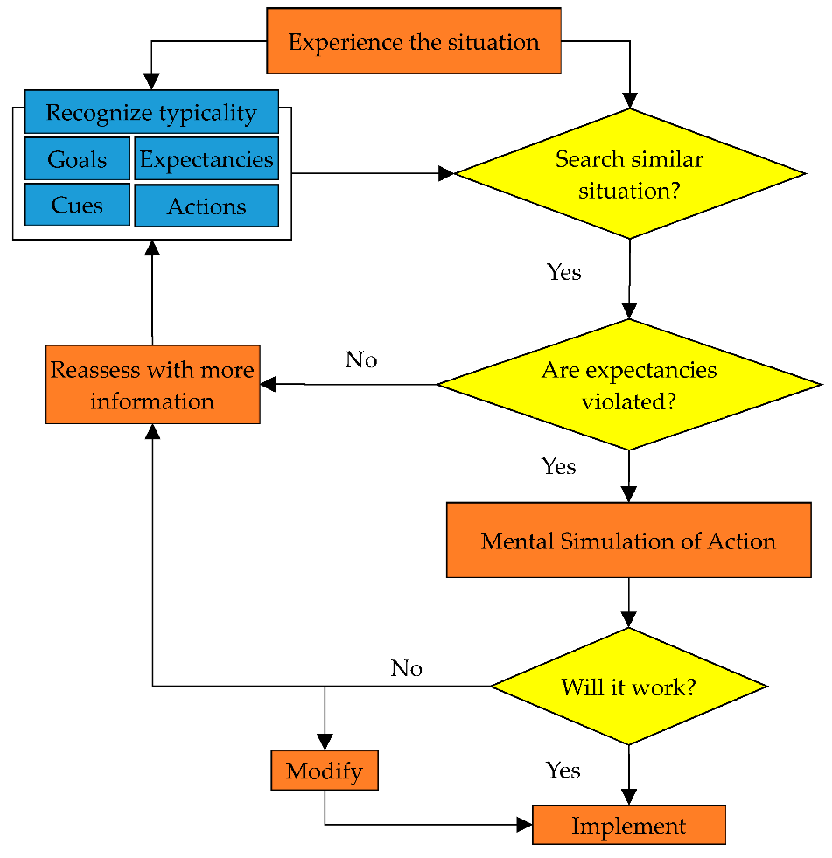
Figure 2: Recognition Primed Decision model
(Source: Yang et al., 2020)
Hence, by utilizing this model, the best-chosen solution is the maintenance of proper work-life balance for the employees by scheduling and allocating tasks sensibly. Therefore, the current situation is portraying that employees are drooping over the issue of higher work stress that are causing physical illness, tension, sleeping problem, relationship issues, etc. due to which they are feeling reluctant and unsatisfied with their jobs. Thus, by maintaining proper task allocation and schedules, organizations can provide value to employees’ requirements as well as their work-life can be balanced and they can receive proper motivation and interest if they need to work under less pressure. At the same time, justified task allocation without any discrimination and bias will enhance positive employee relations that will help in promoting a comfortable and healthy workplace situation.

6. Developing a plan for implementing the solution
Activities | Date of commencement | Date of finish | Duration (In days)
Evaluating employee performance and turnover for the last 5 years | 05/04/2021 | 09/04/2021 | 4
Collecting information from primary and secondary sources | 09/04/2021 | 14/04/2021 | 5
Identification of problems and sources | 14/04/2021 | 16/04/2021 | 2
Making ranges of solutions from different sources | 16/04/2021 | 20/04/2021 | 4
Assessing pros and cons of the solutions | 20/04/2021 | 24/04/2021 | 4
Selecting the best solution | 24/04/2021 | 27/04/2021 | 3
Communicating with the stakeholders | 27/04/2021 | 30/04/2021 | 3
Implementing the decision practically | 30/04/2021 | 20/05/2021 | 20
Collecting employee feedback | 20/05/2021 | 25/05/2021 | 5
Conducting surveys | 25/05/2021 | 28/05/2021 | 3
Interacting with the employees individually | 28/05/2021 | 31/05/2021 | 3
Monitoring the results and further planning | 31/05/2021 | 04/06/2021 | 4
Table 1: The plan for implementing the chosen solution
(Source: Created by self-learner)

7. Communicating the plan to the stakeholders
Stakeholders are undeniably the most significant part of any business process and therefore, Miles (2017) has stated that the decisions taken by any organization directly or indirectly influence its stakeholders. Thus, it is necessary to convey the business plans properly to the stakeholders from time to time. Here, the decision is completely associated with the internal stakeholders i.e., the employees and all the departmental managers. Hence, all of the associated members will be informed about this plan through direct or virtual meetings and necessary suggestions will be taken from them too.

8. An assessment of suitable review or monitoring techniques
As employees are at the center of the identified problem of job dissatisfaction and the decision that has been taken is to provide proper work satisfaction to the employees, therefore, their feedback is necessary to review how well the chosen plan is working. At the same time, the informal or one-to-one conversation can be done to determine whether they are feeling satisfied with their job. Furthermore, organizations can arrange surveys, and therefore, results can be measured by proper analytical techniques or standards which can also be proven as fruitful to assess the level of job satisfaction among the employees as well as their current requirements (Ashton, 2018).

9. Conclusion
Thus, to conclude this report, it can be stated that job dissatisfaction is increasing among the employees rapidly with the changing working scenarios, practices, dynamics, and patterns. Therefore, organizations need to take proper care in facilitating systems and policies through which employees can be provided with proper value, satisfaction, and motivation regarding their jobs and an environment can be fostered where they can work with full efficiency and interest. Hence, the solution that has been discussed in this report can offer desired benefits in creating ultimate satisfaction among the employees by removing all the existing obstacles if managements implement and monitor them properly.

Reference list
Akafo, V. and Boateng, P.A., 2015. Impact of reward and recognition on job satisfaction and motivation. European Journal of Business and Management, 7(24), pp.112-124.
Akhmetshin, E., Danchikov, E., Polyanskaya, T., Plaskova, N., Prodanova, N. and Zhiltsov, S., 2017. Analysis of innovation activity of enterprises in modern business environment. J. Advanced Res. L. & Econ., 8, p.2311.
Akkas, M.A., Chakma, A. and Hossain, M.I., 2015. Employee-management cooperation: The key to employee productivity. Journal of US-China Public Administration, 12(2), pp.81-88.
Ashton, A.S., 2018. How human resources management best practice influence employee satisfaction and job retention in the Thai hotel industry. Journal of Human Resources in Hospitality & Tourism, 17(2), pp.175-199.
Bakotić, D., 2016. Relationship between job satisfaction and organisational performance. Economic research-Ekonomska istraživanja, 29(1), pp.118-130.
Banerjee, S. and Mehta, P., 2016. Determining the antecedents of job stress and their impact on job performance: A study among faculty members. IUP Journal of Organizational Behavior, 15(2), p.7.
Baptiste, M., 2015. Workplace discrimination: An additional stressor for internationally educated nurses. OJIN: The Online Journal of Issues in Nursing, 20(3), p.8.
Free Management Books. 2021. Herzberg’s Motivators and Hygiene Factors. [online] Available at: <http://www.free-management-ebooks.com/news/herzbergs-motivators-and-hygiene-factors/> [Accessed 5 April 2021].
Inuwa, M., 2016. Job satisfaction and employee performance: An empirical approach. The Millennium University Journal, 1(1), pp.90-103.
Judge, T.A., Weiss, H.M., Kammeyer-Mueller, J.D. and Hulin, C.L., 2017. Job attitudes, job satisfaction, and job affect: A century of continuity and of change. Journal of Applied Psychology, 102(3), p.356.
Judge, T.A., Zhang, S.C. and Glerum, D.R., 2020. Job satisfaction. Essentials of Job Attitudes and Other Workplace Psychological Constructs, pp.207-241.
Miles, S., 2017. Stakeholder theory classification: A theoretical and empirical evaluation of definitions. Journal of Business Ethics, 142(3), pp.437-459.
Okoli, J.O., Weller, G. and Watt, J., 2016. Information processing and intuitive decision-making on the fireground: towards a model of expert intuition. Cognition, Technology & Work, 18(1), pp.89-103.
Pang, K. and Lu, C.S., 2018. Organizational motivation, employee job satisfaction and organizational performance. Maritime Business Review.
Platis, C., Reklitis, P. and Zimeras, S., 2015. Relation between job satisfaction and job performance in healthcare services. PROCEDIA-Social and behavioral sciences, 175, pp.480-487.
Raziq, A. and Maulabakhsh, R., 2015. Impact of working environment on job satisfaction. Procedia Economics and Finance, 23, pp.717-725.
Shepherd, D.A., Williams, T.A. and Patzelt, H., 2015. Thinking about entrepreneurial decision making: Review and research agenda. Journal of management, 41(1), pp.11-46.
Thiagaraj, D. and Thangaswamy, A., 2017. Theoretical concept of job satisfaction-a study. International Journal of Research-Granthaalayah, 5(6), pp.464-470.
Yang, Q., Sun, X., Liu, X. and Wang, J., 2020. Multi-agent simulation of individuals’ escape in the urban rainstorm context based on dynamic recognition-primed decision model. Water, 12(4), p.1190.

