Module Title: Community Engagement

Student Name:VERONICA-DANIELA FLORIA
Student Id No:2115140
MODULE CODE:LCBB4002
LECTURER NAME:NADEEM MIRZA
Date :07.05.2023

Table of Contents
Introduction 3
Identification and discussion on the social issues in Croydon council 3
Stakeholders’ consultation, communication and strategic implementation feedback 5
Conclusion and recommendations 8
References 9

Introduction
Community engagement involves collaborative working with and through different groups of people who are affiliated by either their proximity geographically, having similar interests or are faced by similar situations that they are addressing. Community engagement therefore aims at achieving sustainable outcomes, deepening the trust and relationships between the government organisations and communities. Community engagement increases understanding and visibility of issues thus empowering communities to have their voices heard concerning decisions that are affecting their lives, neighbourhoods, towns, and cities. The paper is research identifying and discussing the prevailing social issues in Croydon Council, it will also identify the procedures for stakeholders, consultation, communication and strategic implementation of feedback.
Croydon council is the local authority of the London Borough of Croydon in the Greater London. It provides numerous services to local people, businesses and visitors to borough such as services to adults, children, environmental, sports cultural and housing services. The council comprises of three major political function which are the Executive (leader and cabinet), Committees and Scrutiny. It’s funding originate from three sources, two thirds from the central government including a share of business rates, a portion from incomes such as leisure facility fee and parking fees, and the rest from the locally set council tax (Andrews and Ferry, 2023).

Identification and discussion on the social issues in Croydon council
Social issues are subjects that have impact to many people and they are a reflection of the current events and also a representation of longstanding problems that are difficult to solve (Quin, Carmichael and Hopper, 2022). Example of social issues include unequal opportunities, poverty, malnutrition, unemployment, child abuse and neglect among others. There are a number of issues being faced by Croydon council as discussed below.
Health inequalities
Health inequalities are avoidable, unfair differences in health across the population, and between different groups within the society. These include the health conditions being experienced by people, their likelihood of living long, and the available health care services. In the last few years, the impact of Covid-19 has been felt across the world, Croydon included (Little et al., 2021). There have been lasting impacts on the communities and geographies of Croydon including people being driven into poverty, disruption of children’s education socially impacting the young people especially for the poorer children as well as increasing rate of poor mental health especially for the marginalised and disadvantaged groups (Andrews and Ferry, 2023).
Other factors that have resulted to increased health inequalities that is facing Croydon council include the war in Ukraine and the increased cost of living. Therefore, economic and social circumstances have been the major contributors of health behaviours. In Croydon, it has been reported of 9.9-year difference in male life expectancy across the boroughs of Selsdon, Selhurst and Ballards, 1 in 10, 4-5 years old are obese in Croydon and about 47,987 adults in Croydon are having mental health issues (Little et al., 2021). The council has therefore been working toward building a healthier and happier society by improving the people’s living standards and offering equal lifestyle choices and opportunities. They are improving the economic and social conditions of people living in deprived neighbourhoods to improve their health thus reducing health inequality.
Several recommendations have also been made by the Croydon director of public health to Croydon council on matters to do with health inequalities. These include helping parents in accessing antenatal; care early in their pregnancy, tackling unconscious bias and discrimination and supporting adults with mental health through successful initiatives like mental health first aiders as well as combating loneliness and social isolation among older people (Little et al., 2021).
Homelessness
Homelessness is the state of being unsheltered or a condition of lacking stable, functional, and safe housing. The number of homeless people has increased due to high rents and welfare cuts where according to homeless support charity, Croydon has about 5700 people who are homeless and over 10,000 across the boroughs of Croydon, Sutton and Bromley (Spencer, Griffin and Floyd, 2019). Homelessness has been mostly caused by poor government policies on house allowances, tenancy management and political exclusion through inadequacy in funding. The high rate of unemployment as well as family conflict thus people deciding to leave their homes are among other causes of homelessness in Croydon (Usher, 2019).
Croydon council has however been working toward preventing the residents from becoming homeless using techniques of prevention and early intervention. An initiative supporting residents who are unable to pay their bills which is a joint project between the council and the community has even won a commendation in 2022 London homelessness award (Herman et al., 2022). The food stop initiative has prevented 42 rented households from becoming homeless, saved residents over £ 16,000 on their combined food shopping bills and reduced rent debts and improved finances among 43 houses within one year (Quin, Carmichael and Hopper, 2022). The welfare reforms have however continued to cause a large number of families and individuals becoming homeless and increasing pressure on council finances as administrative costs increases. For instance, in April 2013, universal credit was introduced, the benefit cap and four-year freeze in benefits including local housing allowances affected more than 26,000 people in Croydon who have lost more than £31 million in benefit from 2013 to 2022 (Quin, Carmichael and Hopper, 2022). This has caused their inability to afford the risen rent in borough thus increment on the number of homes households in temporary accommodations.
High crime rates
In the recent years, Croydon has been known as the knife crime capital of London due to the high teenage killing. In 2021, there were 30 teenage murders in London and five of them happened in Croydon which were more than any other borough in London (Brenner, 2022). A group of more than 100 community members including schools, youth workers the Met are joining hands with the council working toward ending knife crimes. The council has been supporting young people into education, employment and training through roadshows, youth hubs, mentoring, summer programmes with an aim of making people aware of the dangers of knife crimes in their campaign ‘lives not knives’ (Brenner, 2022). In 2022, there was no teenage deaths from knife crime in Croydon.

Stakeholders’ consultation, communication and strategic implementation feedback
Stakeholders are individuals or groups that have a ‘stake’ in, are affected or have an effect on Croydon council (Spencer, Griffin and Floyd, 2019). Stakeholders are classified with regard to power and interest.
Stakeholders | Power | Interest
Senior officers | Implementing policies  Managing services
Councillors | Approving policies  Monitoring performance  Implementing policies  Making decisions  Representing the community
Local businesses |  | Are consulted, listened, informed and reported and express themselves.
Local residents |  | Are service users, have to be satisfied, show low interest level.  They have to be consulted, listed and informed.
Central government | Sets the overall agenda
Local government authority |  | Advises the council, represent local government ease the legal framework
Audit commission | Make recommendations
Local media | Informs the general public  Scrutinises council decisions  Transmits information
Volunteer sector | Are service delivers, acknowledge the council  Are partners
Private and public partners | Are informed, consulted, accounted involved and influence the council

Croydon council has a Statement of Community Involvement (SCI) that states how and when the local communities and stakeholders will be involved in the preparation and revision processes of the Local Development Framework (Andrews and Ferry, 2023). Croydon council principles, standards and consultation method of engaging and empowering stakeholders consist of four basic pillars which are communicate, consult, decide together and act together.
Communicate. This involves raising awareness on the key services, decisions and policies of the council. The council has adopted top-down approach of communicating. The council also has a communication team who handle emergencies, produce annual council tax booklet, handle media relations and manage council design and branding (Impact, 2019).
Consult. Consultation is based on four principles which are co-ordination, access, clarity and trust. Co-ordination of engagement activities is meant for avoiding duplication. Access seeks to involve all stakeholders and ensuring stakeholders needs are accounted for while eliminating barriers for participative engagement thus diversity and inclusion (Herman et al., 2022). Clarity involves the council seeking to give feedbacks to the stakeholders including the summary of consultation responses and outcomes and ensuring stakeholders are aware of what they are agreeing to take part in. Trust involves ensuring that the engagement activities are voluntary and participants can withdraw at any time. The information obtained from engaging stakeholders are honestly interpreted and dignity of stakeholders is upheld. Croydon council survey residents to help in identification of public perception questions on matters relating to the concerns of people in Croydon, if they feel safe, and their future priorities for the area (Impact, 2019). A survey is also conducted on local residents assessing their overall satisfaction with council services.
Decide together. The council uses different methods to ensure stakeholders are involved in decision making. They are involved and influence services in the local areas. Some of the methods include councillors who represent the wards in Croydon borough whose key roles is working closely with the residents being the community advocates thus opportunities for the residents to raise issues and concerns (Herman et al., 2022). Local committees work with the people appointed as special advisors thus giving the local community an opportunity of taking parts in the discussion on matters affecting their areas. Safer Croydon partnership service brings together police and local authority staff within a single structure who aim at talking with the residents in addressing security issues. Other methods used include forums, youth parliament, friends’ groups, local involvement network, adult social care and customer service customer focus group which represents cares, older people among other stakeholders (Impact, 2019).
Act together. Croydon council recognises the need of working together with other stakeholders thus meeting the challenges facing their borough. The Croydon partnership brings together a huge number of businesses and local groups creating and delivering strategies of boosting the economic growth and improving the overall quality of life (Herman et al., 2022). The community engagement network is integrating the voice of the local people in the partnership.

Conclusion and recommendations
It is important for local governments to embrace community engagement as it promotes sustainable decisions and improves the efficiency and transparency of their decision-making process. Residents have an opportunity of voicing out their concerns thus the increasing the public confidence in the council activities. It also promotes diversity, inclusion thus fair and equitable outcomes. At Croydon, community engagement has empowered and united the people by providing them with a common ground for them to work toward eliminating the social issues there are facing including health inequalities and homelessness.
To ensure diversity inclusive and democratic engagement of stakeholders, Croydon council should give the stakeholders the time, and resources for digesting, exploring and discussing information with each other before being asked to give their opinions. This will help to they not only raising concerns and issues they are facing within the area but to also offer solutions to these problems. They should also improve on their responsiveness as much as possible especially on issues regarding homelessness.
Last year there was an engagement exercise which the local referred to as half-arsed commitment to listening to locals as it included giving less than 24 hours-notice of a workshop in South Northwood. The stakeholders viewed this negatively stating that it was as if the council did not want anyone to attend and they did not actually want to listen to anyone. In other instances, publishing the workshop sessions toward improving the council’s under-fire housing was very low where they waited until the last minute to promote such events. This shows that the council should improve its methods of communication to ensure that the stakeholders view about Croydon are considered as well as the changes they want. The views and feedback from residents will help them develop their improvement plans.

APENDIX
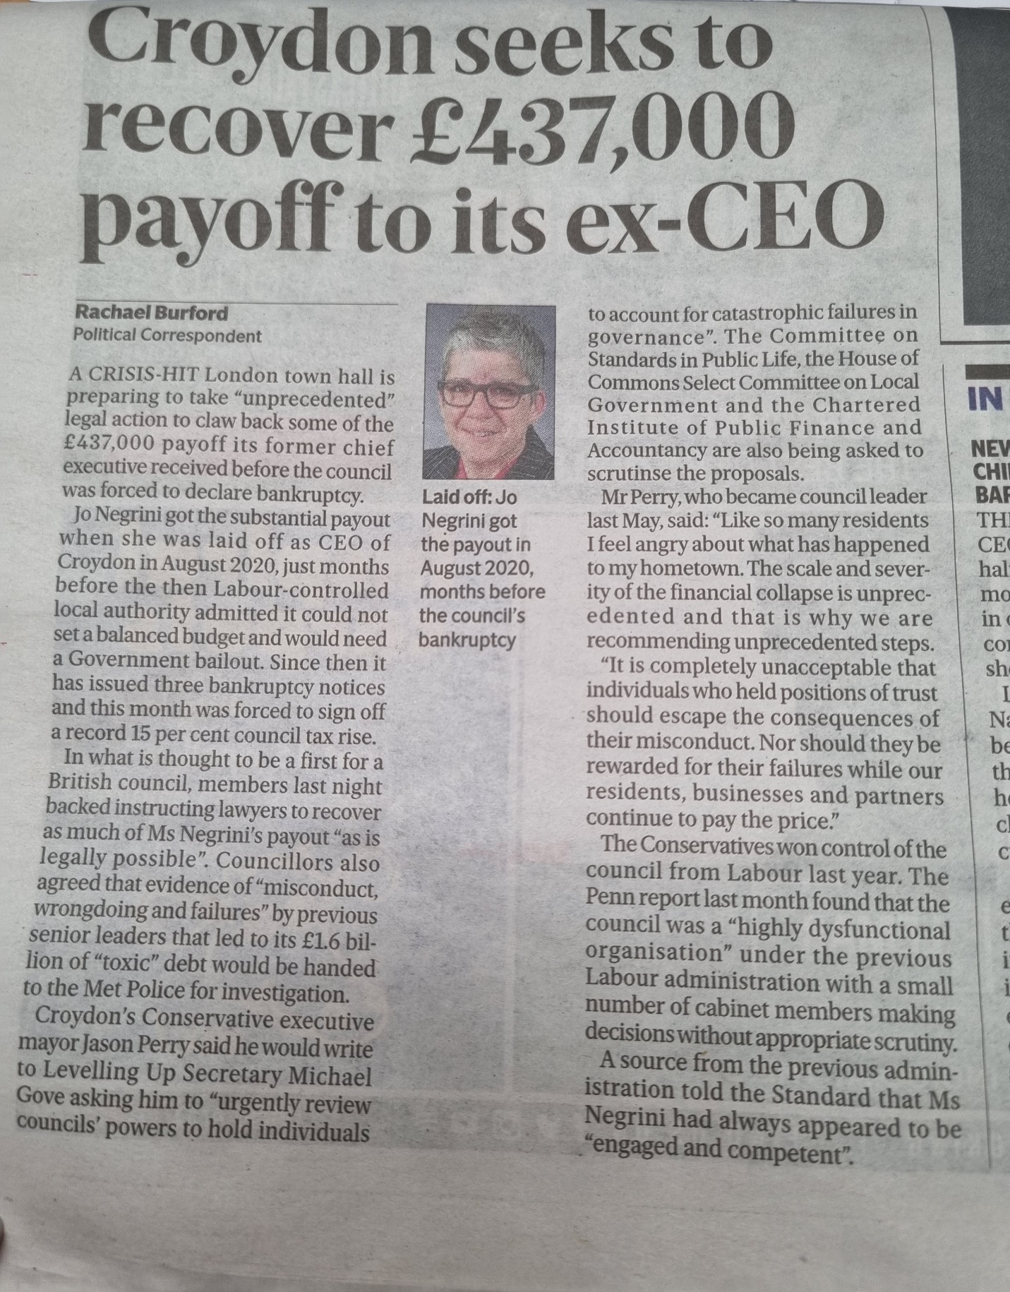

References
Andrews, R., and Ferry, L. (2023). Municipally Owned Corporations in England and Wales: A Tale of Two Countries. In Corporation in Local Government: Context, Evidence and Perspectives from 19 Countries (pp. 49-72). Cham: Springer International Publishing.
Brenner, E. (2022). Youth Knife Crime in London and Croydon. Contemporary Challenges: The Global Crime, Justice and Security Journal, 3, 118-136.
Herman, C. C., Agboola, C. K., Cummings, P., Degrads, N., Nabukeera, S., Bird, M., and Chatterjee, C. R. (2022). PART A. Order, 10, 3.
Impact, F. (2019). Croydon Council. AGENDA.
Little, M., Serber-Souza, S., Kebbe, M., Aveyard, P. N., and Jebb, S. A. (2021). A Natural Experiment Comparing the Effectiveness of the “Healthy Eagles” Child Weight Management Intervention in School Versus Community Settings. Nutrients, 13(11), 3912.
Quin, M., Carmichael, L., and Hopper, C. (2022). Implementing Health Impact Assessment policy on infrastructure development in the London Borough of Tower Hamlets. Cities & Health, 1-9.
Spencer, C., Griffin, B., and Floyd, M. (2019). Croydon safeguarding children board.
Usher, R. (2019). The Annual Audit Letter for the London Borough of Croydon-Year ended 31 March 2019. Sage.

