Type 2 Hypervisor Platform Based Virtualised Network

Dominik Tomasz Kania
Computing (Computer Networks and Cybersecurity)
University of Wales Trinity Saint David
Swansea, Wales
1702026@student.uwtsd.ac.uk

Table of Contents
Worksheet 1 – Practical Tasks 3
Task 1: VM Creation and OS Installation 3
Task 2: Virtual Network Configurations 8
Worksheet 1 – Observational Tasks 14
Hypervisors Architectures 14
Type 1: Native or Bare Metal Hypervisor 15
Type 2: Hosted Hypervisor 17
Subnet Mask 19
Cloud Computing 19
Terminology 21

Worksheet 1 – Practical Tasks

Task 1: VM Creation and OS Installation
To create Virtual Machine, VirtualBox or another virtualization tool has to be installed. In this task, VirtualBox was used to create 4 Virtual Machines and install operating system on each machine as shown in Figure 1. The Virtual Machine in computing is the virtualization of a computer system. Virtual Machines are architectures that provide functionality similar to that of a real computer. They are used to test software in a secure, sandboxed environment and to install programmes that are not supported by the main operating system.
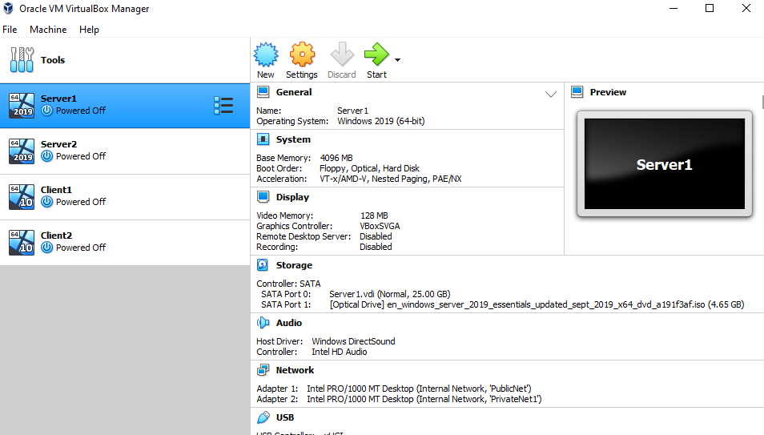
- Virtual Machine creation.

Installing operating system on each machine requires downloading disc image (ISO file) that is used in installation process. After downloading ISO file, settings have to be changed, and downloaded copy of Windows has to be added as a disk file as shown in Figure 2 for Windows 10 and Figure 3 for Windows Server 2019. This step is required to install the correct ISO file, since the settings value is empty by default.
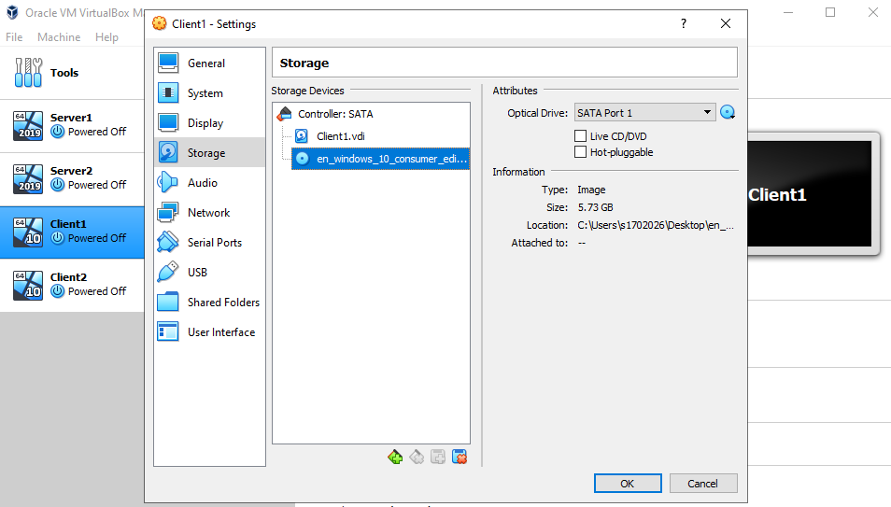
- Windows 10 ISO file.
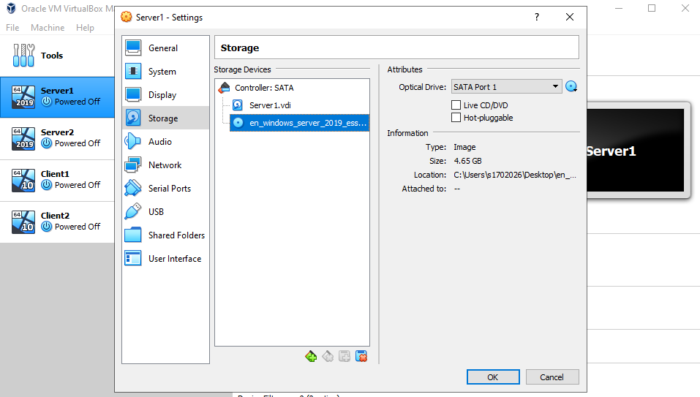
- Windows Server 2019 ISO file.
It is advised to optimise Virtual Box as running Virtual Machine borrows resources from physical host, and it can have a negative impact on the performance. There are number of ways to optimise Type 2 Hypervisor programs, such as:
- Upgrading an old-style Hard Disk Drive (HDD) to a Solid-State Drive (SSD) is advised as Virtual Box makes heavy use of the disk.
- Allocating more memory will increase the speed as Virtual Machines are allocated with the minimum amount of memory as default as shown in Figure 4.
- Installing Guests Additions in Virtual Box as shown in Figure 5, speeds up the display as default graphics driver is very slow.
- To maximise performance, increasing video memory to at least 128 MB is advised as shown in Figure 6.
- Allocating more CPUs to the Virtual Machine will increase performance and enabling PAE/NX as shown in Figure 7, will determine whether the PAE and NX capabilities of the host CPU will be exposed to the Virtual Machine.
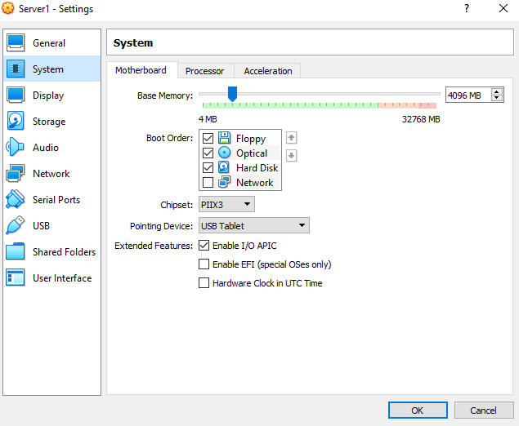
- Memory allocation.
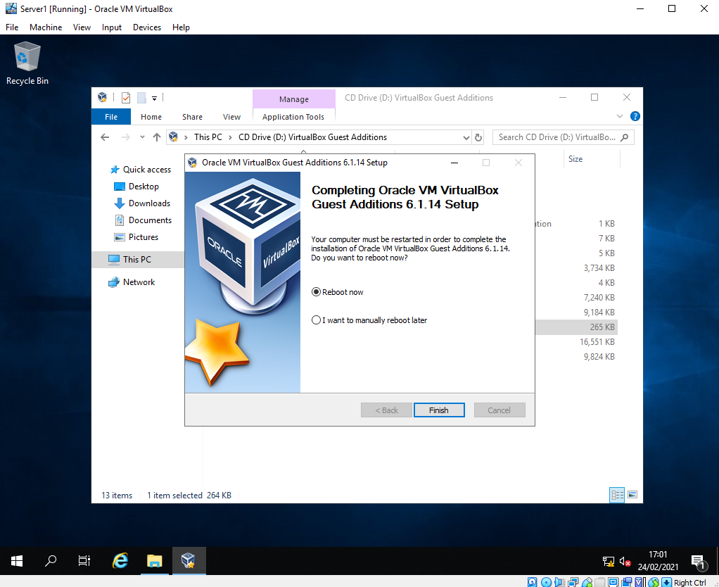
- Guest Additions installation.
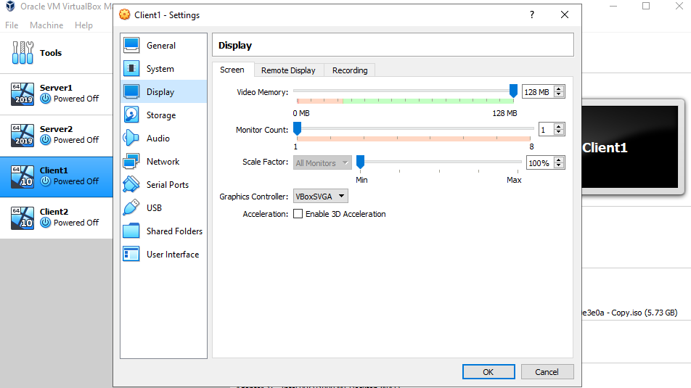
- Video memory allocation.
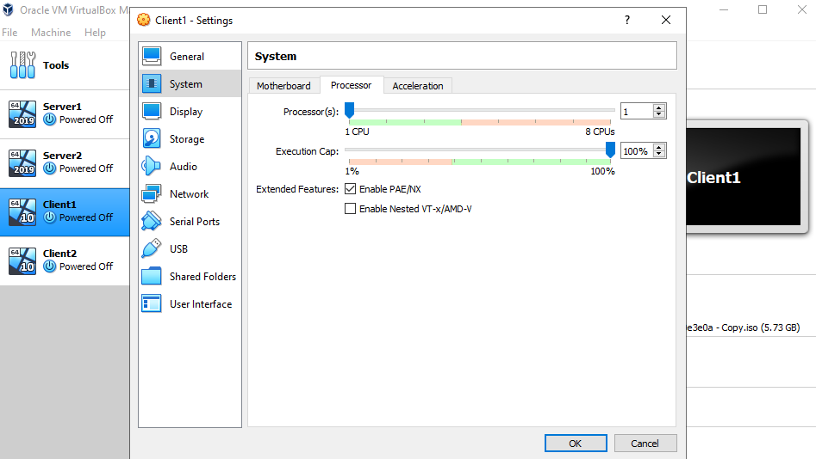
- PAE/NX and CPUs allocation.

Task 2: Virtual Network Configurations
To create a Virtual Switch and form a Local Area Networks (LANs) called PublicNet and PrivateNet, trial network configuration was used as shown in Figure 8.
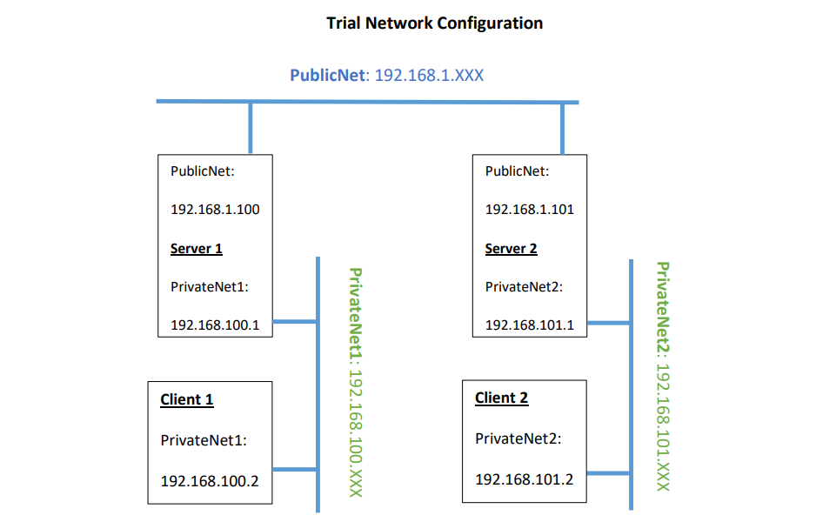
- Trial network configuration.
Network adapters for each server and client need to be set up with the correct network names, IP addresses and subnet masks as shown in Table I.
- Network adapters configuration.
Name | Network Name | IP Address | Subnet Mask
Server 1 | PublicNet  PrivateNet1 | 192.168.1.100  192.168.100.1 | 255.255.255.0  255.255.255.0
Client 1 | PrivateNet1 | 192.168.100.2 | 255.255.255.0
Server 2 | PublicNet  PrivateNet2 | 192.168.1.101  192.168.101.1 | 255.255.255.0  255.255.255.0
Client 2 | PrivateNet2 | 192.168.101.2 | 255.255.255.0

Network adapters are devices that allow connectivity over a standard network connection by adding a single protocol stack. The configuration of the process where the protocol stack is implemented is supported by network adapters. Naming each adapter appropriately is required for this configuration before IP addresses can be assigned to the servers and clients. This is shown in Figure 9.
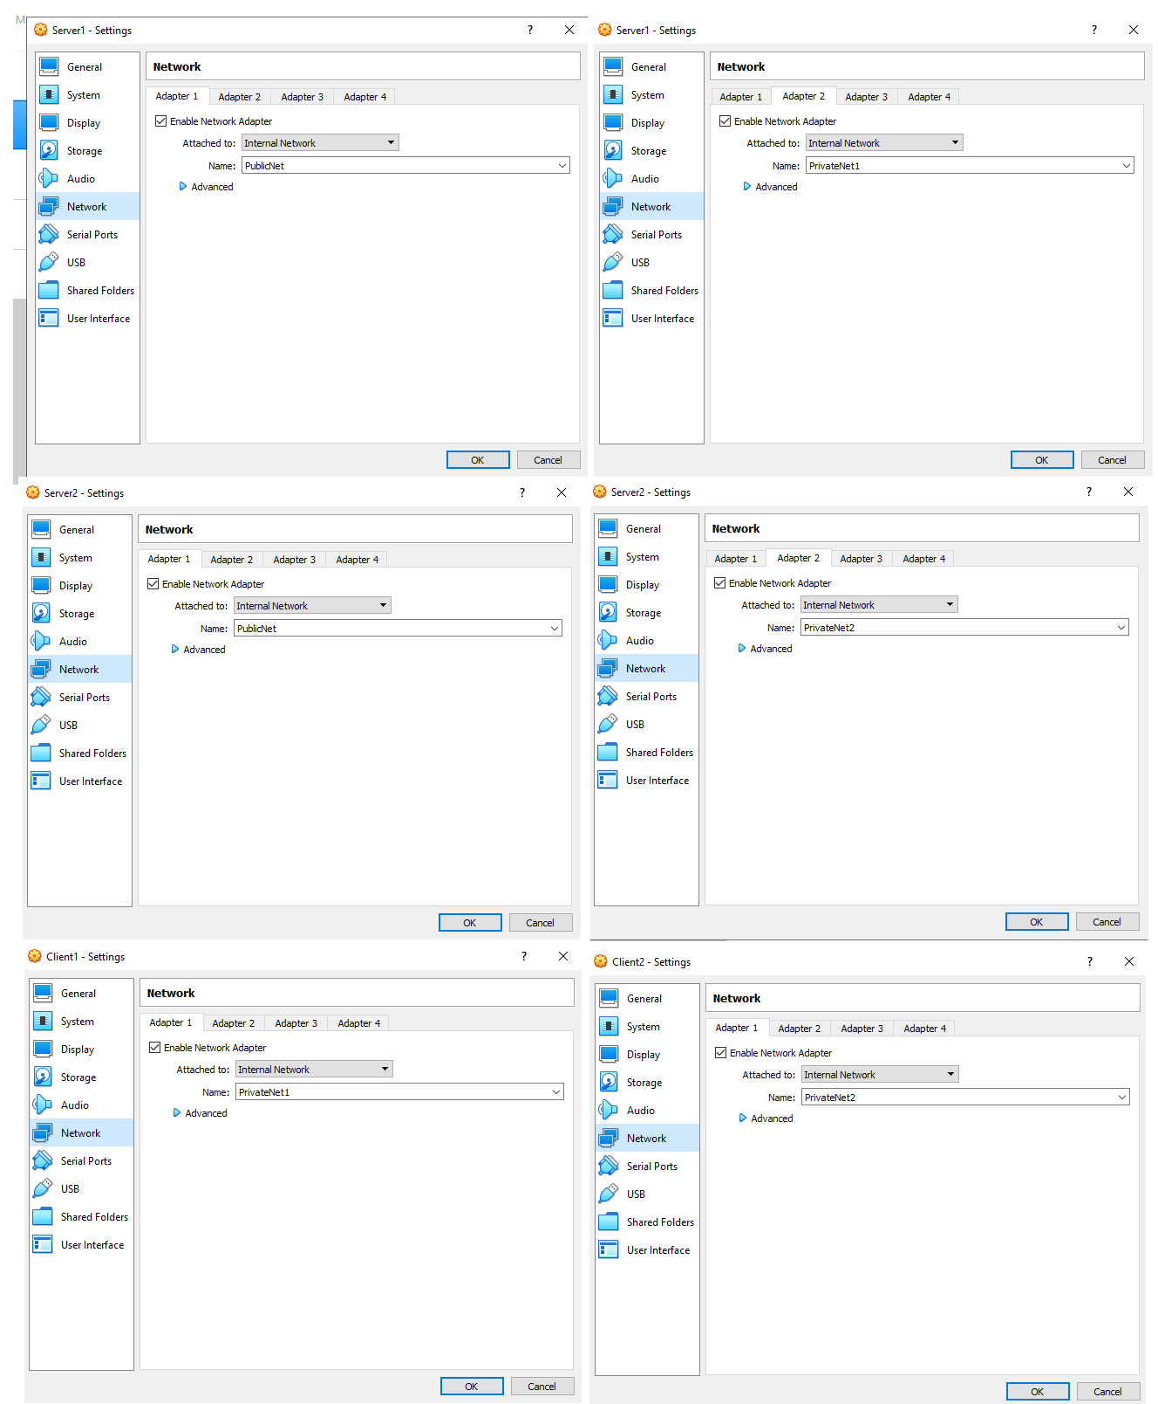
- Names of the adapters.
After naming each adapter appropriately, IP addresses and subnet masks can be assigned. Settings of each network must have required IP address for the Internet Protocol Version 4 (TCP/IPv4). These settings are located in the properties of each network as shown in Figures 10-12. The correct address is required in order to send packets in the internal networks.
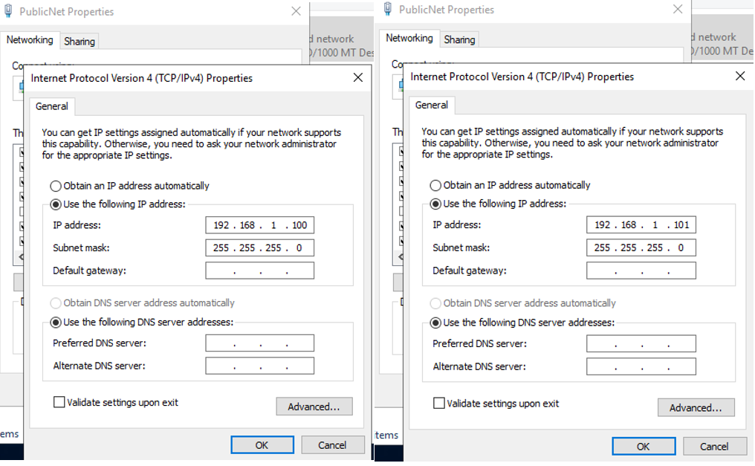
- PublicNet settings for the Server 1 and Server 2.

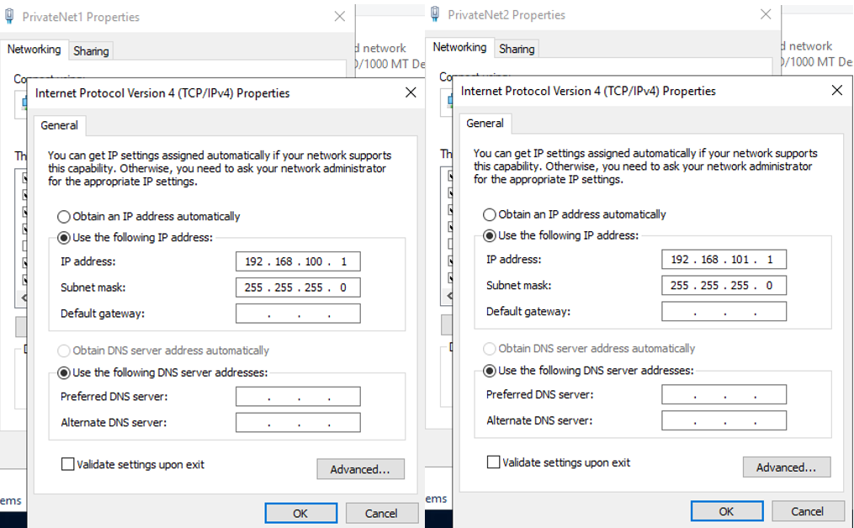
- PrivateNet1 and PrivateNet2 settings for the Server 1 and Server 2.
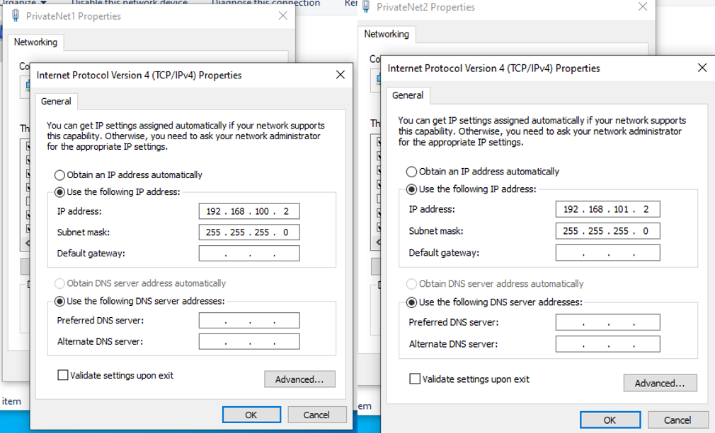
- PrivateNet1 and PrivateNet2 settings for the Client 1 and Client 2.

When everything is set up, connection between servers and clients can be verified. To do that, firewall on each Virtual Machine needs to be disabled (this is shown in Figure 13) as ICMP command (“ping”) is needed to demonstrate successful connectivity between the Virtual Machines. Firewall is a part of a computer system or network designed to limit unwanted access while allowing for communications based on pre-configured rules and policies. Firewalls deny ICMP protocols by default as it can be used by a potential intruder to perform reconnaissance against a target network.
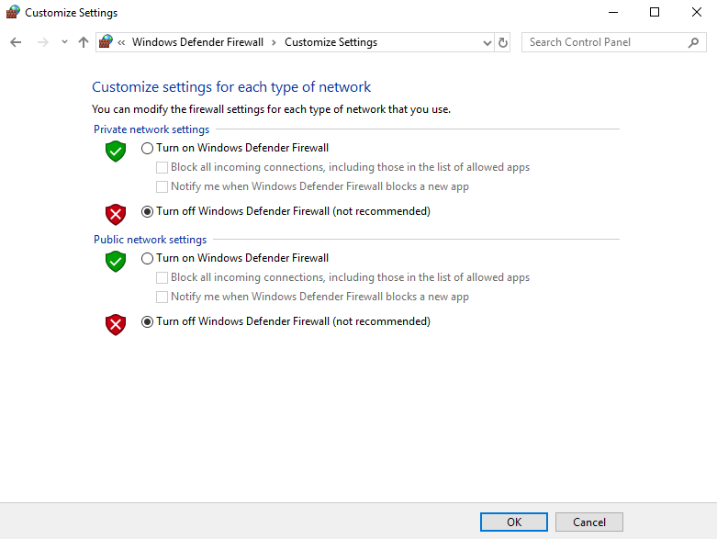
- Firewall settings.

Ping is a command-line tool that checks whether a networked device can be reached and can be accessed on almost any operating system with network access. With the firewall turned off on every Virtual Machine, “ping” command can be used to verify connectivity between servers and clients. To do that, two commands have to be used for the internal networks:
- Server 1 and Client 1: “ping 192.168.100.2” command is used to verify connectivity as shown in Figure 14.
- Server 2 and Client 2: “ping 192.168.101.2” command is used to verify connectivity as shown in Figure 15.
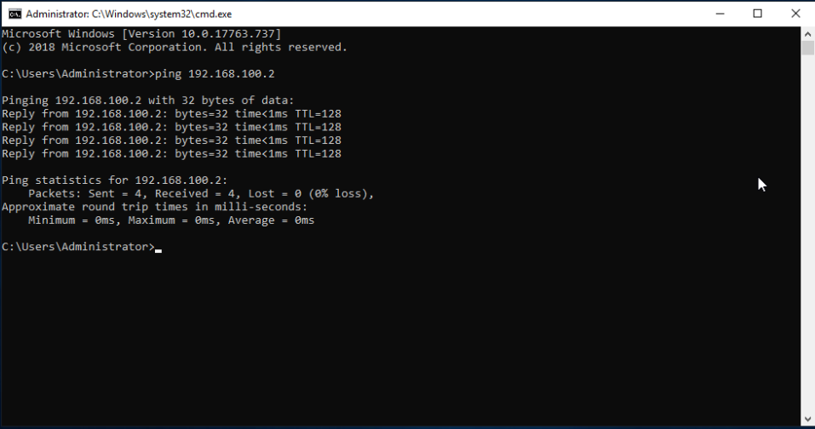
- Successful connectivity between the Server 1 and Client 1.
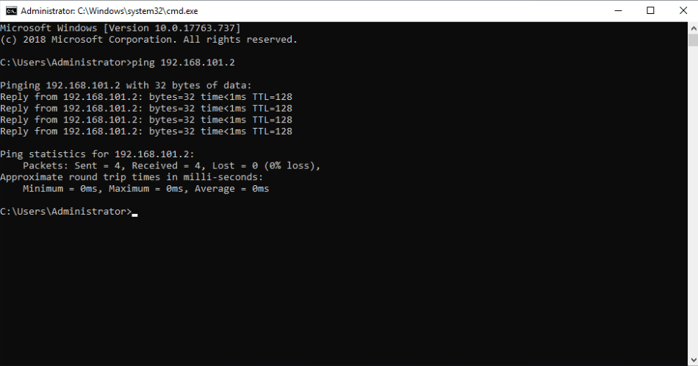
- Successful connectivity between the Server 2 and Client 2.

Worksheet 1 – Observational Tasks

Hypervisors Architectures
System Virtualization is a technique that enables multiple Virtual Machines (VMs) to share physical machine resources using a software layer called a Hypervisor or a Virtual Machine Monitor (VMM) [1]. Multiple Virtual Machines can run on a host computer, each with its own operating system and applications. They share the existing hardware of the host machine; nevertheless, with each method, this technique produces an illusion of operating on a different, autonomous physical machine. Important here is to provide an infrastructure that is strong enough to preclude bugs in a virtual system from modifying the Virtual Machine or host machine. Types of Hardware Virtualization include:
- Full Virtualization: In this form of virtualization, the complete appearance of actual hardware is virtualized to enable the software to operate without any alteration.
- Partial Virtualization: Not all host machine hardware is specifically replicated in this form of virtualization. This requires certain applications to be changed in the guest machine to run in a virtualized environment.
- Para-Virtualization: The para-virtualized method of hardware virtualization provides potential performance advantages when a host operating system is running in a virtualized environment with changes made to a guest that has been virtualized. It also organises access to hardware infrastructure with the support of a virtual machine.
In addition, a Hypervisor is a software that allows the actual machine's hardware to be used by multiple operating systems. It is located between the operating system of the host machine and the virtual environment [2] [3].
Hypervisor, as mentioned above, is a software that handles multiple operating systems or various instances of the same operating system on a single physical device or host machine. There are two main types of Hypervisors [3]:
- Type 1: Native or Bare Metal Hypervisor
- Type 2: Hosted Hypervisor

Type 1: Native or Bare Metal Hypervisor
Native or Bare Metal Hypervisor is an application that runs directly above the host computer hardware as shown in Figure 16. It also controls the operating systems that operate immediately above the hypervisor and the guest computer. This is because the operating system of the guest computer operates at a separate or independent stage, which is immediately above the hypervisor. There is no need to load an existing Operating System on this type of Hypervisor. Type 1 Hypervisors are known as the most effective and best-performing Hypervisors available for business computing with direct access to the existing hardware with no other applications, such as Operating Systems and drivers, to deal with for virtualization. Running directly on the physical hardware makes them extremely secure and the risk of attacks that exploit security weaknesses and bugs in Operating Systems is mitigated by virtualization when each visitor has its own Operating System [3]. This means that the attack on a one Virtual Machine is theoretically separated from that Virtual Machine and cannot be distributed to those operating on the same hardware [4]. Benefits and drawbacks of this type of Hypervisors are:
- Benefits:
  - Highly efficient due to direct access to physical hardware.
  - One operating system increases security as there is nothing between Hypervisor and CPU that a hacker could compromise.
  - Each Virtual Machine is an isolated environment.
  - Good scalability, since it does not rely on the underlying operating system and has the ability to directly assign resources.
- Drawbacks:
  - A separate management machine is required to handle various Virtual Machines and to monitor the host hardware.
  - More complicated setup as necessary hardware support is needed.
  - In most instances, the network switch has to be set up within the system memory.
  - Limited hardware support due to few device drivers built into the hypervisor.
Example vendors of Native or Bare Metal Hypervisor include VMware ESX and ESXi, Microsoft Hyper-V, Citrix Systems XenServer, KVM, and Oracle VM Server [5].
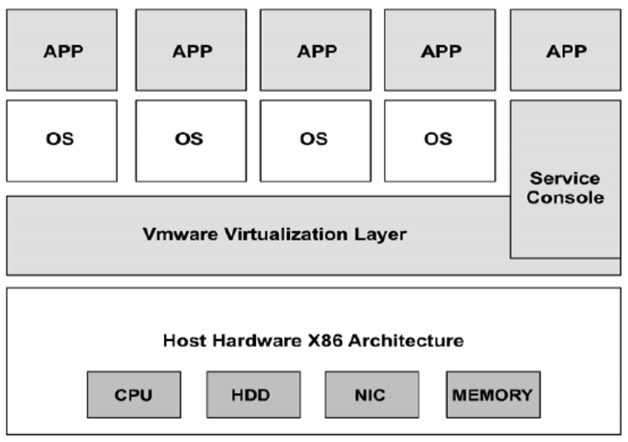
- Native or Bare Metal Hypervisor architecture. Source: Adapted from [3].

Type 2: Hosted Hypervisor
Type 2 Hypervisor does not operate explicitly on the hardware beneath it. Instead, it runs as an application in an operating system as shown in Figure 17. Any problem with the host operating system with this type of hypervisor would have an effect on the host operating system running on the hypervisor and would also have an impact on the hypervisor itself, even though the hypervisor running above the operating system might also be protected so that it would not be the host operating system. Type 2 Hypervisors seldom exist in server-based environments. Instead, they are sufficient for individual PC users who need to operate several operating systems. Examples include developers, technology malware researchers, and corporate consumers who need access to programs that are only accessible on other technology platforms. The downside to hosted hypervisors is that latency is higher than bare metal hypervisors [3]. This is because information must flow through the OS layer between the hardware and the hypervisor [4]. Benefits and drawbacks of this type of Hypervisors are:
- Benefits:
  - Fast and convenient access to an additional host operating system besides the primary one operating on the host machine.
  - Higher productivity of end-users due to various operating systems.
  - Wide variety of hardware supported, since there is extra layer of operating system.
  - Simple and quick installation process as there is no hardware support required.
- Drawbacks:
  - Need for connectivity to device, memory, and network services through a host operating system that has direct access to a physical computer.
  - Many failure points as anything that affects the performance of the primary operating system will affect both the host operating system and the virtual machine.
  - Latency issues related to the external layer of the operating system.
  - Potential security threats if a hacker exploits the host operating system, then it may affect any Virtual Machine.
Example vendors of Hosted Hypervisor include VMware Workstation, Server, Player and Fusion, Oracle VM VirtualBox, Microsoft Virtual PC, and Oracle Solaris Zones [6].
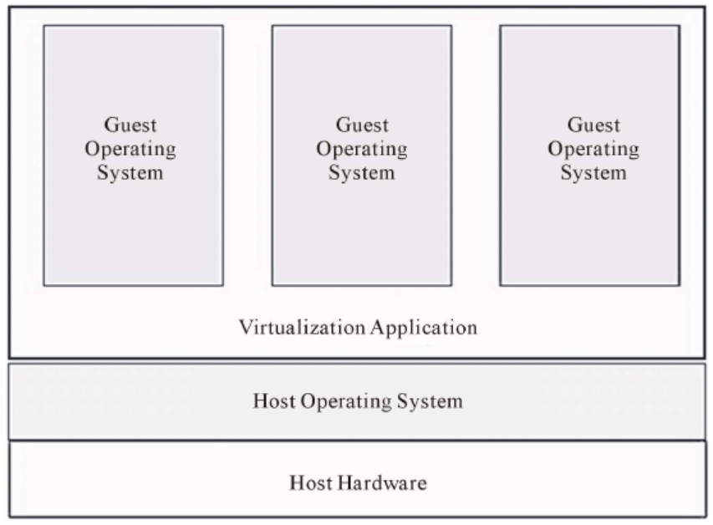
- Hosted Hypervisor architecture. Source: Adapted from [3].

Subnet Mask
The subnet mask is used to control the network process and subnetwork information is partitioned by a host or router in accordance with the corresponding IP address. It is a number that specifies the set of IP addresses accessible on a network. The number of valid IP addresses for a given network is constrained by a single subnet mask. Multiple subnet masks can organise a single network into smaller subnetworks. The significance of the subnet mask in IPv4 addressing is to decide whether a host is on a local subnet or a remote network (TCP/IP protocol uses a subnet mask to make this decision). Hosts can communicate directly with hosts on the same network, but they must communicate with a router in order to connect with hosts on other networks [7] [8].

Cloud Computing
Cloud computing is the on-demand, pay-as-you-go distribution of IT services over the Internet. It is focused on the leasing of computing services, storage and databases from various cloud vendors, rather than the acquisition and maintenance of physical data centres and servers. Organizations of various kinds, sizes and markets use the cloud for a wide range of uses [9], such as:
- Data storage and management by moving data over the Internet to an off-site cloud computing facility that can be accessed from any location and device.
- Product creation and testing is feasible with reduced technology development costs and time by leveraging cloud infrastructures that can be quickly scaled up or down.
- Big data analytics using machine learning and artificial intelligence.
- Streaming content with high-definition video and audio platforms and worldwide delivery.
- Customer-based mobile applications delivered on demand using software as a service (SaaS).
Cloud computing is a significant move away from the conventional way corporations thought of IT infrastructure. There are many advantages of cloud computing; however, new problems continue emerging due to economic development and expansion, although several concerns have not been fully taken into account. Some of the benefits and challenges of cloud computing are discussed below [10]:
- Benefits:
  - Reduced overhead cost of purchasing equipment and setting up and maintaining on-site data centres.
  - Ability to scale cloud infrastructures up or down by providing the correct amount of IT services.
  - Enhanced efficiency of resource management by adaptive resource planning.
  - Autonomous system managed transparently to users.
  - Independent user-centric interface that can be reached by well-established services and applications such as Web services and Web browsers.
- Drawbacks:
  - Businesses might save money on hardware and software; however, they could pay higher network bandwidth costs.
  - Companies have questions about their safety and data protection as opposed to conventional hosting providers.
  - Migration problems occur as data of companies is transferred from one cloud to another.
  - The price and reliability benefits of this approach also poses controversial regulatory concerns in the case of cloud storage stemming from distributing consumer data overseas.
  - The continuity of the service can be affected by unforeseen incidents such as power cuts.
Example vendors of Cloud Computing include Amazon Web Services (AWS), Microsoft Azure, Google Cloud Platform, VMware, Slack, Dropbox, Acquia, Salesforce, and IBM [9] [10] [11].

Terminology
There are number of different terminologies used in Task 1 and Task 2; however, the most relevant ones chosen for this report are:
- Firewall: A firewall is a component of a computer system or network intended to restrict unauthorised access while allowing permitted communications based on pre-configured rules and policies. Purpose of the firewall is to create a barrier between safe and regulated internal networks that can be trusted and insecure external networks such as the Internet [12].
- ICMP Ping: ICMP is part of the TCP/IP suite. Error and control messages are addressed by this protocol. Ping is one of the most commonly used ICMP messages. This command is typically used to detect network or host connection errors and to address typical TCP/IP networking issues. However, the ping order may also be used to trigger significant repercussions for the wireless network [13].
- Physical Address Extension (PAE): This processor capability enables x86 processors to use more than 4 GB of physical memory on compatible operating systems. It also allows 32-bit versions of Windows Server on x86-based platforms to reach up to 64 GB or 128 GB of raw memory, depending on the physical address size of the processor [14].
- No-eXecute (NX): Memory pages may be identified as non-executable using this processor function. The functionality enables the CPU to assist in the protection of the system against malicious malware attacks. The NX function stops malicious programme code from being run in open memory areas [15].
- Server Management: The method of managing and controlling servers for their optimum efficiency is known as server management. Hardware, programmes, security, and backups are all managed as part of server management. The key objectives of a successful server management approach are to reduce downtime for servers and create stable server environments.

- Comparison of functions for different systems.
Terminology | Microsoft Windows | Linux | macOS
Firewall | In this system firewall is preinstalled, since users do not have complete control over which ports are open. It is turned on by default for both types of network locations: private and public. Moreover, it is only appropriate for the security of the host on which it resides. | Linux does not require a firewall, since it does not open ports by default without user acknowledgment. The system firewall is not installed by default and needs to be downloaded and installed manually. The Linux Firewall functionality is supported by Netfilter and is ideal for enterprise security. | Although macOS comes with an integrated firewall, it is not turned on by default. Since the standard macOS system does not have such easily vulnerable services listening by default, it does not require a tagged firewall to protect it from attacks.
ICMP Ping | The payload in this ICMP packet is an incomplete Latin alphabet and the number of pings is set to 4 by default. The limited variety of parameters that can be set could be a disadvantage when it comes to troubleshooting the network. | Linux ICMP message sends out special characters and numbers as a payload. Continuously sending packets before they are interrupted is the key benefit of this method, and the range of parameters provides precise details. | Packet size in macOS is set to 56 bytes by default, and is sent continuously until interrupted, identical to Linux. Default limit for ping in this system is 4000 milliseconds, anything beyond that will cause request timeout.
Server Management | Windows servers use a graphical user interface that makes it simpler to control a server compared to a command-line server. Although Windows servers come at an expense, they frequently come with paid support, which may be necessary for a business. | Linux server is an open-source, command-line based software server that is more cost-effective and simpler to use than paid software. Due to the use of fewer resources, the system is more efficient and can be modified to satisfy the needs of the consumers. | This server is built on the Darwin open-source platform and complies with company guidelines and protocols. It has a graphical interface, comparable to Windows servers, and offers facilities including a mail transfer agent and a domain name server.

