

Celia McClelland
1813622
M4X01916 – Marketing Essentials
The importance of marketing information system, its effectiveness within the hospitality and tourism industry as a tool for marketing, information gathering and communication.
Lecturer: Oluwaseun Adegbite

M4X01916 – MARKETING ESSENTIALS
Introduction
This report will analyse the importance of marketing information system, and its effectiveness within centre parcs as a tool for marketing, information gathering and communication.
The marketing information system is an organised system which is designed by internal and external sources which collects marketing data. The information gathered is stored and analysed to meet the managers informational needs before being distributed ((Berenson, 1969)). In this case MIS is the best tool to be used, it is a computerized system which assists them in efficiently run their department with the tools available to them through this system.
Centre Parcs will be used as an exemplification in this report to illustrate the importance of the marketing information system and its effectiveness within the hospitality and tourism industry as a tool for marketing, information, gathering and community. Centre Parcs marketing scheme will be perceived to see how it consolidates with their marketing skills which has been influenced by both business and consumer purchaser. In conclusion, endorsement will be decided how the company's marketing strategy will be capable of expanding to auxiliary the needs of the target market. By considering both negative and positive responses from their customers. By meeting the individual's unique needs and knowing that their customers perceive as adding value to the company, which attributes to opportunities on improving the company
Discussion/Evaluation and Critical Analysis:
Firstly, the company has an advantage as the United Kingdom is the 5th most popular tourist attraction out of 136 countries (World Economic Forum ,2017). This statement shows that UK businesses use the pareto principle (listened to 20% of their clientele's feedback resulting to 80% profit. However environmental opportunities, threat, government decisions can affect a business) of broadening their business to international clientele.
Centre Parcs is the leading UK holiday attraction for short break holidays, it is open all year long with 3 segments which structures their success. I) traditional holiday centre ii) holiday park based on caravan and lodge accommodation iii) forest village. The target market for Centre Parcs is focused on a family friendly environment. Centre Parcs is a company that experiences both consumer and business purchasing.
The global completion in 2018/2019 marketing has a shift of trends. The marketing information system is required from knowing the pricing of their competitors to non-price factors as well as meeting their customer’s needs. By knowing the strength and weakness of the buisness of the marketing information system, can give assistance the proper information required for the effective completion. However, it is quite common that some companies don’t always get the right information required as the strategy is all wrong. (MIS best strategy)
Customer Relationship Management
Definition – By having organised system which purses the customers preferences and behaviours in order to adapt the worth proposition as closely as possible to each customer’s unique needs. By the company maintaining a long-term relationship with their customer, by interaction maturity the customer feels their feedback is adding value to the buisness. By customer value orientation the customer will be returning, if the customer has a problem, the company will need in ensure customer centricity. By having dynamic interaction, it needs to be customised to the individual’s needs.
Tom Write the new marketing director at Centre Parcs released a statement “There will also be an increasing emphasis on relationship marketing, and this will form a critical part of the marketing mix because so many of our clients are repeat customers (Marketing week ,1998)” Centre Parcs have been listening to both customers and staff feedback. The company has refurbished and improved their existing 5 sites. The employees feel supported and empowered to deliver a 5-star experience to their customers.

Marketing Information System
Definition – the marketing information system is designed to examine and evaluate information, which has been internal and external sources of an organisation. Appropriate marketing data delivers source for conclusions. Firstly, the product progress or enhancement, valuing, distribution, packaging, media variety, also elevation(Rowley, 2006).
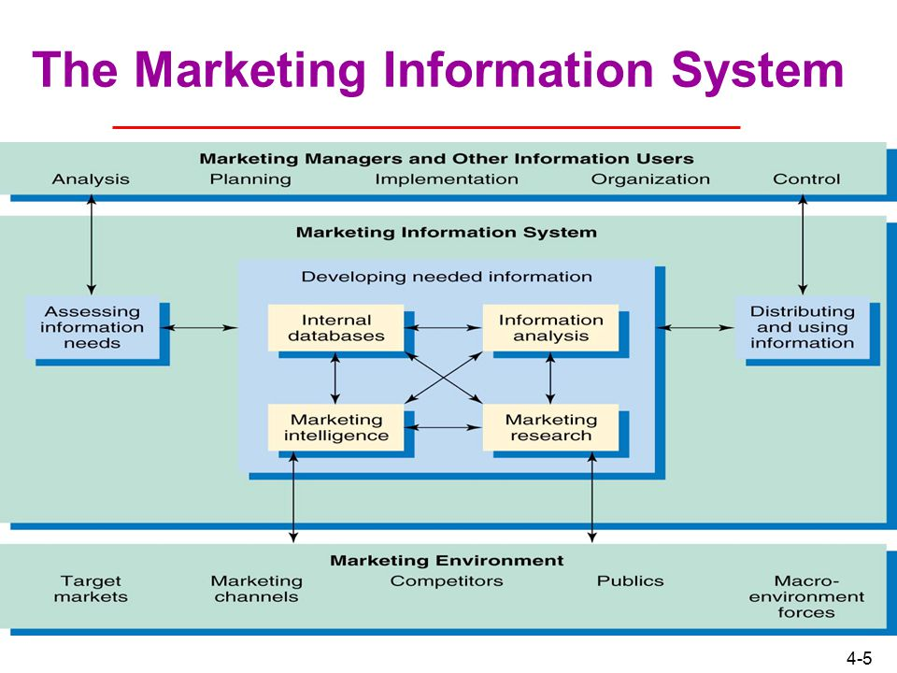
Three types of marketing information

(bing.com,2019)

Recurrent information | Monitoring information | Problem related
- Periodic data (weekly , monthly , quarterly or annual interval)  - It conclude of pertaining sales, sales markets and shares , customer awareness of brands and data relates to competitors | - External sources (journals & other publications)  - Extract relevant information from the sources to understand the changing trends, understanding the competitors’ activities | - Combination of primary and secondary data  - Adequate sample size of market research relating to marketing problems requested by the manager.

Marketing Research
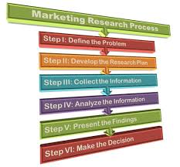
Definition -assembling information about the company’s position in the market. The company will recognise what their customers’ needs are. The research is either external or internal information which is briefed in a report. This research helps business have a wider variety of choice to make more informed decisions about the company’s marketing mix to meet the customers need (Chapman, 1989).

(bing.com,2010)

Marketing information system for Centre Parcs has guidelines to gather the correct information. The Internal records are the essential information about the actions of the organization. The most practical evidence is advanced by marketing information system by arranging & encapsulating schedules, orders, balance sheets into development that will be related with the preferences the managements obligation for the marketing mixes.
Marketing managers require environmental variables information in sequence to elevate and contrivance centre parcs marketing Plans. Centre Parcs requires the external sources & internal sources.
Centre Parcs have been promoting their business via television/ radio and social media, which is endorsing their status, by their target market recognising their brand. TV advertising has high costs; however, it is the most popular advertising strategy which reaches large audience. Centre parcs focus on generating there brand to meet their objective.
Radio is less expensive to advertise but can generate many customers. Business within the UK use radio to administer entertainment to their customers. Which gives Centre Parcs the opportunity to send their radio recording to nationwide radio stations which can broadcast the message to local communities. Which allows them to get timely messages to promote their business by mentioning their offers, as well as their aims. The company spends over 2 million pounds on advertising, using a range of methods including TV advertising, online advertising, public relations. Quarterly; January, April, June, September(Cngwenya, 2003)
Every business need to ‘spend money to make money’(Bamford- Niles, 2010) Centre Parcs has a revenue of £4403 million (2015/2016) the company has invested 95 million into refurbishing there 5 woodland villages (Centre Parcs 2017). As well as expanding their objectives to attract conference weekends to business purchasers. secondly purchasing there 6th village park in Ireland which brings them to the community.
Their main objective is to open their 6th site in Ireland, which is in the town outside of Ballymount. By doing their research (write it out market intelligence, do not be shy to use the right terminology) they have found out it is a popular tourist destination. By doing their research they have spoken to the local community stake holder. To maintain an invaluable relationship with the locals they will keep them updated on the progress of the site. By listening to the locals concerns they have come up with solutions, e.g. they have designed a public footpath, to go around the site to preserve the public routes, including a network of roads which allows the construction vehicles to use so they do not disrupt the town roads.
Markets structures can be defined in four broad categories, based on the number and size of competitors in the market. (Brassington.F, and Pettitt s 2006) . (Please delete the initials ‘F’ and ‘s’) By doing the research Centre Parcs competition is Butlins and Haven holiday resorts. However, they are more commercial parks as they are more for entertainment and excitement. Where Centre Parcs offer a woodland nature environment.

Conclusion:
In conclusion by Centre Parcs collecting data (online questionnaires) analyse (coming up with solution by the feedback they have received) produce (turning plans into action) sell (selling their site experience with offers, promotions). Using the information collected from sources (employees, market researchers, insight of their competitors, customers), they are generating and validating ligament customer and market insight. By promoting their buisness by advertising the demographic sales the managers are aware and know what experience sells seasonally Finally by using the primary data they are testing the target market on their attitudes, knowledge and preference so the company can find a solution to help expand the target markets visual image (help with descriptive research). However from analysing the data confirm , MIS is used as obtaining, sorting ,all information is expensive but for main bosses it helps them maintain relevant information both internal and external.

- Berenson, C. (1969). Marketing Information Systems. Journal of Marketing, 33(4), p.16. - World Economic Forum (2017). Travel & Tourism Competitiveness Index2017 edition. Available: http://reports.weforum.org/travel-and-tourism-competitiveness-report-2017/country-profiles/#economy=GBR. Last accessed 31 January 2019. - Bing.com. (2019). marketing information system - Bing. [online] Available at: https://www.bing.com/images/search?view=detailV2&id=22EB4FADD82ED6D9E9C6A50BC55A0C6F305CC2A7&thid=OIP.IsIKbzFMC9p_uLYHacD3fAHaFj&mediaurl=http%3A%2F%2Fslideplayer.com%2F4506477%2F15%2Fimages%2F5%2FThe%2BMarketing%2BInformation%2BSystem.jpg&exph=720&expw=960&q=marketing+information+system&selectedindex=0&ajaxhist=0&vt=0&eim=0 [Accessed 25 Feb. 2019].
- Marketing Week. (1998). Center Parcs in UK director hunt. Available: https://www.marketingweek.com/1998/06/04/center-parcs-in-uk-director-hunt-2/. Last accessed 31 January 2019. - Bing.com. (2019). marketing research process example - Bing. [online] Available at: https://www.bing.com/images/search?view=detailV2&id=9C6861121A5E4E5D866D68C331C43265CEF77EB9&thid=OIP.f8NHcllWjwIEk2aBFyTQaAHaG3&mediaurl=https%3A%2F%2Fbusinessjargons.com%2Fwp-content%2Fuploads%2F2015%2F09%2Fmarketing-research-process-final.jpg&exph=464&expw=500&q=marketing+research+process+example&selectedindex=19&cbir=sbi&ajaxhist=0&vt=0&eim=0 [Accessed 25 Feb. 2019].
- Rowley, J. (2006). Information Marketing. Aldershot, England: Ashgate, pp. p1-34.
- Cngwenya. (2013). CP Marketing & Advertising. Available: https://cparcsmarketing.wordpress.com/. Last accessed 02 January 2019.
- Bamford-Niles C. (2010). Advantages and Disadvantages of Marketing. Available: https://www.thecompanywarehouse.co.uk/blog/advantages-and-disadvantages-of-marketing. Last accessed 31 January 2019.
- centre parcs. (2017). annual review 2016/2017. Available: https://www.centerparcs.co.uk/content/dam/centerparcs/corporate-documents/annual-reviews/annual-review-2017.pdf. Last accessed 02 January 2019.
- Brassington F , Pettitt S (2006). Principles of Marketing. London: Pearson Education, 2006. p75. - Bibliography - Leonidas. C., Leonidou , and Marios, T., (2004). The Export Marketing Information System: An Integration of the Extant Knowledge. Journal of World Business. 39 (1), p12-36. - Chapman, R. (1989). Problem‐Definition in Marketing Research Studies. Journal of Consumer Marketing, 6(2), pp.51-59.

