Tamara Khoury
Student No. 1602243
4th Feb 2019

MBA Dissertation Proposal

The Influence of Talent Management in Enhancing Organisational Performance
In the Non-Profit Sector

SBMA7123D

Supervisor: Julie Thomas

Contents
1. Academic Focus and Research Rationale…………………………………….………3
1.1 Topic of Research/ Title………………………………………………………………3
1.2 Context/Background ……………………...………………………….………………3
1.3 Theories and Best Practices…………………………………………………………5
1.4 Justification ………………………………………………….……..………………....7
1.5 Research Aim and Objectives……………………………………………………….8
1.6 Research Question…………………………...……………………….……………..9
2. Research Philosophy………………….…………………………………………………9
3. Research Paradigm and Method…………………………………………………..… 10
4. Data Collection………………………………………………………………..…………10
5. Methods of Data Analysis……………………………………………………..……….11
6. Limitations of the study …………………………………………………………….…..11
7. Ethical Considerations……………………………………………………….……...….12
8. Resource and Time management ……………………………….…………..…….…12
9. Appendix/Gantt Chart ……...…………………………………………………….…….13
References………………………………………………………………………………….14

1. Academic Focus and Research Rationale

1.1 Topic of Research/ Title
The Influence of Talent Management (TM) in Enhancing Organisational Performance (OP), in the Non-profit Sector.
Case Study: The United Nations World Food Programme

1.2 Context/Background
Globalisation and the growing worldwide rivalry have made organisations more aware of the importance of having loyal, skilled and knowledgeable workers, which are the key to competitive advantage (Sheehan, 2012a). In this case, organisations need to develop strategies to attract, retain, develop and manage talent internationally, where Talent management (TM) has proven to be an imperative strategic issue (Armstrong 2016).
According to Armstrong & Taylor (2014), Talent is what individuals need to have in order to perform well in their roles. They make a positive change to the organisational performance (OP) through their direct contributions and they have the potential to make a significant input in the future (Tansley et al. 2007, p8). Therefore, TM goals are to find, obtain, retain, engage and develop those talented individuals (CIPD 2018).
In the humanitarian sector, where non-profit organisations are pressured to become more efficient and effective, introducing TM into the culture and budgets of non-profits is an essential step as they are not only competing with non-profits, but also with the private sector in the global arena. Thus, non-profits need to concentrate on the culture, growth and development. According to Chertavian (2013), most non-profits are able to attract talent by their purpose, but find it difficult to develop and keep talent. Therefore, non-profits need to have an attractive culture, great leaders, and sustained strategies for growth and development to respond to future demand in the global marketplace. Cheese et al (2008), argues that managing talent is all about “building a capability in putting the right talent in the right place at the right time” to allow the organisation to reach its present strategic goals and to be ready for the upcoming opportunities or challenges. However, to be prepared for the future, employees need to have the essential skills to function at a global level, as it is crucial to both the organisation’s performance and the development of personnel. According to McKinsey report (2018), performance management is all about aligning employees’ goals to the organisation’s objectives and therefore, organisations need to invest in coaching leaders of the organisation to achieve the desired outcomes (Hancock et al 2018, P4).
Leaders are accountable for the development and the recognition of talent as they work directly with personnel on performance matters, progress needs and potential successors. Hence, HR can deliver the tools and systems, but leaders need to correctly use those systems to attract, retain, develop and evaluate talent (Trudel 2011).TM is more than a trendy word, but it is a progressive method, which can increase the firm's performance, flexibility and gives its management the tools to plan for change and development (Sinclair 2014). However, management needs to understand that in order to have effective TM strategies; it needs to find ways to engage its employees and to give them the chance to influence the strategic process, where they become more responsible and highly motivated (CIPD 2018).
Having an inspiring and challenging vision, mission, and value statement can serve as an influential motivational instrument to form a committed and involved workforce, where employees understand the direction of the organisation, work together to move the mission/ purpose forward and share the responsibility for the success of the organisation (Stewart 2012). Although, this can be easier to achieve in the humanitarian sector with inspiring mission/vision statement (Chertavian 2013), however, keeping a global workforce engaged can be challenging with employees placed in various regions and often in hazardous locations. Therefore, it is essential to try to attract, develop and retain highly skilled and experienced employees and keeping them motivated by nurturing a culture of employee engagement ( CIPD 2015), where employees believe in the purpose of the mission, which can also enhance workers retention (Brown et al. 2016, Deloitte).

1.3 Theories and best practices:
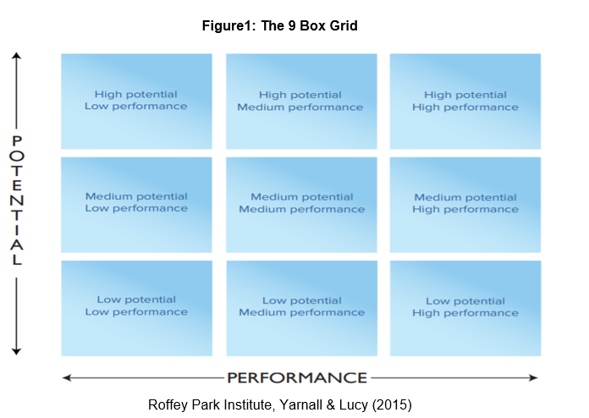
Talent can be defined by using different approaches; while the first approach takes account of all the people in the organisation, the other approach assesses talent on the basis of strength, competencies, giftedness, high potential, and high performance (Meyers et al 2013). In the non-profit sector, it is important to focus on the right talent that can make a difference to the organisation’s performance. Therefore, organisations need to find the appropriate tools and best practices to translate their views on talent based on the strategic direction and to link them to their performance. The study will use theories such as the “9 box grid” to identify talent within an organisation based on current performance and future potential. The 9 box grid below (Figure 1) has two dimensions to represent performance and potential. Normally, the horizontal dimension has three stages of performance and the vertical dimension has three stages of potential. This can help leaders of the organisation to make a decision based on where each staff member is located and therefore, assess the organisations’ talent to support future resource planning, training & development needs, and increase the focus on motivating and engaging talent within the organisation (Yarnall & Lucy 2015).

However, assessing the organisation’s talent is not enough to achieve the business goals. Therefore, organisations need to focus on maintaining a pool of talented individuals through a talent pipeline (Figure 2), where procedures of talent planning, resourcing and talent development can help the organisation to keep a flow of talent required to create a talent pool (Armstrong & Taylor 2014, p 266).
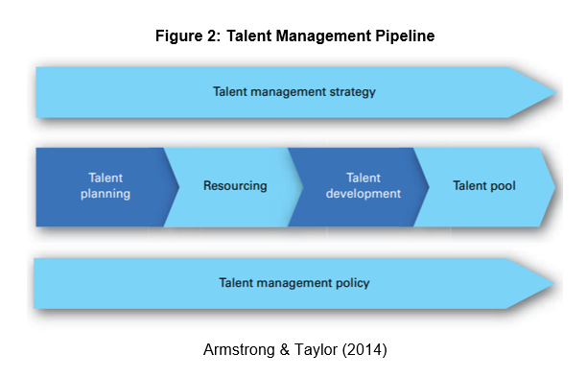
1.4 Justification
TM has been the centre of the literature of HR specialisations, including succession planning, human resources development and organisational development, where the majority of scholars highlighted the importance of talent as an obvious source of competitive advantage and critical for organisational success (Beechler & Woodward 2009; Iles, Chuai & Preece 2010; Sheehan, 2012a). Yet, only a small number of studies analysed the influence of TM on the organisation’s performance (Bethke-Langenegger 2012, Kehinde 2012), where it seems to be lacking empirical evidence of the connection between TM and organisational performance (OP) (Bethke-Langenegger 2012; GallardoGallardo, Dries & Gonzalez-Cruz 2013; Boudreau & Ramstad 2005). As scholars argued that evaluating and documenting, the effect of TM can be challenging due to the several methods that measure organisational performance (Bethke-Langenegger 2012) such as financial gains, operational success, customer satisfaction, employee satisfaction and retention (Tangen, 2005). On the other hand, most of the researches conducted on TM are related to the private or for-profit sector and only a few have touched on the topic of TM in the non-profit/ humanitarian sector. Therefore, we found a gap in the literature when it comes to emphasising on the importance of having TM strategies in the non- profit sector. Both Non-profit and for-profit organisations have acknowledged the fact that although evaluating TM can be challenging, but it is essential to ensure that the investment in talent is meeting the organisational objectives at any point in time (CIPD 2018). Therefore, the research will focus on the below:

1.5 Research Aim & Objectives:
Aim: To evaluate the importance of having TM strategies in the non-profit sector to enhance organisational performance.

Objectives:
- To assess the need to have TM strategies in the non-profit sector.
- To analyse the effectiveness of talent management strategies in the non-profit sector.
- To identify key elements of successful talent management strategies.
- To evaluate current practices in non-profit organisations (case study) in order to make recommendations to improve the TM strategies and enhance performance.

1.6 Research questions:
1. What are the effects of having TM strategies in the non-profit sector and why TM strategies are important for the success of organisations?
2. What are the challenges and opportunities of the current TM strategies in the non-profit sector and what are the TM strategies the organisation’s need to develop or adapt to add value and enhance organisational performance?

2. Research Philosophy:
The research philosophy is all about the development of knowledge by creating a system of assumptions and beliefs (Saunders et al. 2016, p124). There are five main research philosophies: positivism, pragmatism, interpretivism, post-modernism and critical realism. For the purpose of this study, the researcher assumes that to answer the research question and meet the research aim and objectives, adopting the interpretivist philosophy will be the most appropriate approach for the study and therefore, qualitative data will be collected through interviews. The interpretivist philosophy specifies that the researcher should know about the variances among human in relation to their roles as the social actors (Saunders et al., 2012, p.116). Therefore, this will help to generally understand the human experience in definite situations or settings. In addition to the positive impact, the qualitative approach can have on the research approach in terms of flexibility and interactively engaging with participants to discover their inner experiences and opinions about the subject (Maxwell 2012).

3. Research Paradigm and Method
The researcher would rely on a single case study research of the selected organisation (United Nations World Food Programme- UNWFP), where the primary data will be obtained from conducting interviews with key actors in the organisation. This could help the researcher to develop an in-depth analysis of the subject with a view to understanding the problem from the viewpoint of the contributors (Yin 2013). In addition, secondary data will be obtained from publications, textbooks, reports, books, websites, journals, manuals, case studies or any other related services.

4. Data Collection
The researcher will design a semi-structured questionnaire to use when conducting interviews (face to face or online) with key actors in the organisation, i.e. top management, department’s heads, executives and Human Resource Directors. This will help the researcher to find out their views about the overall trends in relation to the subject, in order to identify the main challenges facing non-profits when implementing TM strategies and policies. In addition, to reporting on selected contributors feedback as well as their expectations & experiences with regard to TM Practices. The researcher will also list out suggestions for overall improvement for organisational effective performance by providing TM processes that can be useful to the workforces and the organisations. According to Kvale (2009), a semi-structured interview offers evidence from the contributors’ own individual insights, this will provide us with more valid and consistent information related to our objectives, and therefore, it will reinforce the result and conclusion (Saunders et al 2012).
5. Methods of Data Analysis
The researcher will analyse the interviews and the outcomes using content analyses approach because it allows for quantitative analysis of initial qualitative data in the subject areas of HRM and Strategic Management (Duriau et al 2007). Then, the researcher will present a deep insight into the existing practices in the selected organisation. In addition, to covering the strong points and weak links of the TM strategies as well as core competencies of the organisation. The researcher will evaluate & assess the current organisational performance based on the contributors’ overall awareness, prospects & satisfaction or dissatisfaction as offered by the TM practices of the organisation.

6. Limitations of the study:
The researcher might face challenges such as difficulty in retrieving information from the contributors, proper sample size to use, data collection methods and approval to use the organisations as a case study.
There are also some limitations in relation to the use of a case study approach and how well the case study can be connected to a larger context. According to Stake (1995), that external rationality and generalizability are often questioned in single case studies, since sampling is often small and distinctive. The risk that any case study results have a slim chance to be of value for external use. Therefore, the researcher needs to consider presenting adequate evidence, from the observed information, reinforced by literature and theory within the study area.

7. Ethical Considerations:
The research will involve coordination and collaboration between different individuals with varied standards; therefore, it is ethical to conduct the study with a high degree of honesty, accountability, fairness and mutual respect. The researcher will adhere to the University’s ‘Research Ethics and Integrity Code of Practice and the selected organisation’s Ethical guidelines which are related to the data sharing policies, copyright, anonymity, protection and confidentiality rules (Bell & Bryman, 2007, Saunders et al, 2012). The researcher will also present the results in an unbiased, fair and objective manner; demonstrating transparency and open communication at all times.

8. Resource and Time management
Time management is vital when writing a dissertation. Therefore, it is essential to plan, schedule, and make goals to manage effectively the research project. According to Gritter (2011), planning ahead, prioritising tasks, setting goals, scheduling and using calendars are important in time management. However, external situations beyond our control could affect the timeline of submitting the research. Therefore, the researcher needs to make some contingency planning to deal with any emergencies or unplanned conditions. The researcher plans to submit the final project the first half of July (2019) with an intention to complete the project well in advance of the deadline.
The following Gantt-Chart displays the main activities with the related dates/ timelines.

9. Appendix:
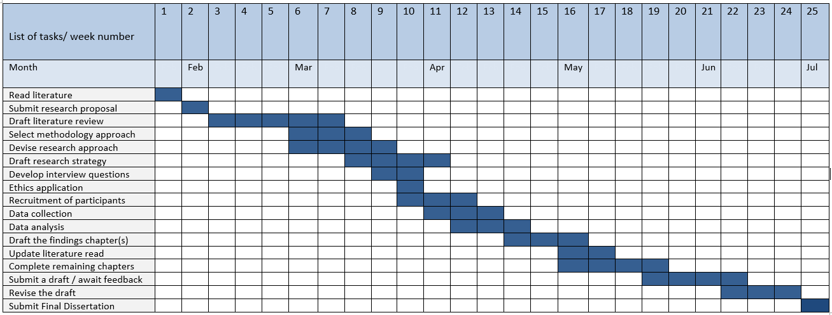
Gantt chart for the Dissertation

References:

Armstrong, M. &Taylor S. (2014), Armstrong’s Handbook of Human Resource Management Practice, 13th edition. (online.) Available at: https://otgo.tehran.ir/Portals/0/pdf/Armstrong%27s%20Handbook%20of%20Human%20Resource%20Management%20Practice_1.pdf (Accessed: 25th of February 2017).

Armstrong, M. (2016) Armstrong's Handbook of Strategic Human Resource Management. London: Kogan Page.

Bell, E. & Bryman, A. (2007). “The ethics of management research: an exploratory content analysis”, British Journal of Management. 18(1) 63-77.

Bethke-Langenegger, P. (2012). The differentiated workforce: Effects of categorization in talent management on workforce level. Unpublished working paper, No.18. Switzerland: Department of Business Administration, University of Zurich.

Brown D., Bersin J., Gosling W. and Sloan N.,(2016). Engagement. Deloitte Insight. (Online). Available at: https://www2.deloitte.com/insights/us/en/focus/human-capital-trends/2016/employee-engagement-and-retention.html (Accessed on the 9th Jan 2019).

Cappelli, P. (2008). Talent on demand: Managing talent in an age of uncertainty. Boston: Harvard Business Press.

Cappelli, P. (2009). What's old is new again: Managerial “talent”in an historical context. Research in Personnel and Human Resources Management,28, 179–218.

Cheese, P., Thomas, R.J. and Craig E. (2008). The Talent Powered Organisation: Strategies for Globalization, Talent Management and High Performance.Kogan Page.

Chertavian G., (2013), Nonprofits Need to Compete for Top Talent. (Online). Available at: https://hbr.org/2013/03/nonprofits-need-to-compete-for (Accessed on the 9th Dec 2018).

CIPD (2015) Employee engagement: an introduction factsheet CIPD. (Online) Available at: https://www.cipd.co.uk/knowledge/fundamentals/relations/engagement/factsheet (Accessed: 10th April 2017).

CIPD (2018), HRM and talent management – driving performance. (Online) Available at: https://www.cipd.co.uk/knowledge/fundamentals/hrmandtalentmanagement/engagement/factsheet (Accessed: 29th Jan 2019).

CIPD (2018), Talent management. (Online) Available at: https://www.cipd.co.uk/knowledge/fundamentals/relations/talentmanagement/factsheet (Accessed: 29th Jan 2019).

Chuai, X., Preece, D., & Iles, P. (2008). Is talent management just “old wine in new bottles”?: The case of multinational companies in Beijing. Management Research News,31(12), 901–911.

Collings, D. G., & Mellahi, K. (2009). Strategic talent management: A review and research agenda. Human Resource Management Review,19(4), 304–313.

Duriau, Reger, & Pfarrer, (2007).A Content Analysis of the Content Analysis Literature in Organisation Studies: Research Themes, Data Sources, and Methodological Refinements. Organisation Research Methods, 10: 5–34.

Gallardo-Gallardo et al. / Human Resource Management Review 23 (2013) 290–300

Gritter, E (2011), Time Management Tips for Dissertation Writing. (Online.) Available at: http://thesawh.org/wpcontent/uploads/2012/06/Gritter_Revised_Time_Management_Tips_SAWH_Toolkit_Submission.pdf(Accessed: 11th of December 2018).

Hancock B., Hioe E., and Schaninger B., (2018). The fairness factor in performance management. McKinsey Quarterly. (Online). Available at: https://www.mckinsey.com/~/media/McKinsey/Business%20Functions/Organisation/Our%20Insights/The%20fairness%20factor%20in%20performance%20management/The-fairness-factor-in-performance-management.ashx(Accessed on the 9th Jan 2019).

Iles, P., Chuai, X., & Preece, D. (2010). Talent management and HRM in multinational companies in Beijing: Definitions, differences and drivers. Journal of World Business,45(2), 179–189.

KEHINDE, J., PhD, ACA (2012), Talent Management: Effect on Organisational Performance. (online.) Available at: http://macrothink.org/journal/index.php/jmr/article/viewFile/937/1286. (Accessed: 27th of November 2018).

Kvale, S. (2009) “Doing Interviews”. Sage Publications Ltd.

Lockwood, Nancy. R. (2007). Leveraging employee engagement for competitive advantage: HR’s strategic Role. SHRM, Research Quarterly.

Maxwell, J. A. (2012). Qualitative research design: An interactive approach. London: Sage.

Saunders, M., Lewis, P. and Thornhill, A. (2012). Research Methods for Business Students (6th edition). Harlow: Pearson.

Saunders, M., Lewis, P. and Thornhill, A. (2016). Research Methods for Business Students (7th edition). Harlow: Pearson.

Schaufeli W.B., Bakker A.B. (2004), Job demands, job resources and relationshipwith burnout and engagement: a muli-sample study, “Journal of Organisational Behaviour”, Vol. 25, p. 293-315

Sheehan, M. (2012), Developing Managerial Talent: Exploring the link between management Talent and perceived Performance in Multinational Corporations (MNCs)’, European Journal of Training and Development, Vol.36,pp.66-85.

Sinclair C. (2014), Talent Management-Keeping the Right People on the Bus, (online). Available at: https://www.nonprofitkinect.org/article/4930-talent-management%E2%80%94keeping-the-right-people-on-the-bus (Accessed: 25th of February 2017).

Snell, S.A. and Dean Jr., J.W. (1992) ‘Integrated manufacturing and human resource management: a human capital perspective’, Academy of Management Journal, Vol. 35, No. 3, pp.467–504.

Soane, E. (2013) ‘Leadership and employee engagement’, in Truss, C., Delbridge, R., Alfes, K., Shantz, A.

Stake, R. (1995). The art of case study research. Thousand Oaks, CA: Sage.

Stewart L. (2012), Leaders and Employee Involvement- IA CEO. (Online). Available at: https://www.youtube.com/watch?v=UQWzz9VdiU4(Accessed: 11th March 2017)

Tangen, S. (2005). Demystifying productivity and performance. International Journal of Productivity and Performance Management, 54(1), 34-46.

Tansley, C., Turner, P., Carley, F., Harris, L., Sempik, A., Stewart, J., et al. (2007). Talent: Strategy, management, measurement. London: Chartered Institute of Personnel and Development (CIPD).

Taylor, S. (2014) Resourcing and Talent Management. London: Kogan Page

Trudel, N. (2011). Who is Responsible for Talent Management? (Online). Available at: http://www.employee-performance.com/blog/who-is-responsible-for-talent-management/ (Accessed on the 2nd of April 2017).

Yarnall J. and Lucy D. (2015), IS THE NINE BOX GRID ALL ABOUT BEING IN THE TOP RIGHT?
Executive Summary. (Online). Available at: https://www.roffeypark.com/wp-content/uploads2/Nine-Box-Grid-Exec-Summary-1.pdf (Accessed on the 9th Jan 2019).

Yin, R. K. (2013). Case Study Research: Design and Methods. 5th Edition. London: Sage Publications.

