Programs in C and Documentation
ACCA4017 – G Thomas

Isobel Sutcliffe – 1808257
1808257@student.uwstd.ac.uk

Contents
Section A 1
A1. What is a variable and why are they important in writing programs? 1
A2. Explain why the for-loop can also be referred to as a counting-loop and give an example of when you would use it. 1
A3. Explain what an array is, what their features are, and give an example of when you would use one. 2
Section B 3
B1. Exercise1 3
B2. Exercise 2 8
B3. Exercise 3 13
B4. Exercise 4 17
References 24

Section A
A1. What is a variable and why are they important in writing programs?
A variable could be looked at as a container which allows an item of data to be held, much like a box could contain a piece of jewellery. This item of data would then be determined by the user of the programme and/or the programmer themselves. [1]
When a variable is created it is given a name, chosen by the programmer, and this name acts like a label on the container, allowing the item contained, to be retrieved at any time by the use of its name. This is important in programming as it allows interaction between user and the programme that is being used. [1]
Variables within programming are important as they allow a degree of flexibility and can sometimes speed up an application if written into the programme correctly.
An example of this would be when using a financial programme to calculate VAT on an invoice that was being raised:
INVOICE AMOUNT £
£100.00
20%
VAT RATE %
£120.00
GROSS AMOUNT £
(INC VAT)
In the above example you would have the inputter/user putting the invoice amount into the “INVOICE AMOUNT £” container/box, this would be considered a variable container. There would be a constant container for the VAT as this rate rarely changes. Followed by another variable box that would house the equation that the programme would perform to calculate the GROSS AMOUNT.

A2. Explain why the for-loop can also be referred to as a counting-loop and give an example of when you would use it.

A loop is a bit of coding that allows the programmer to repeat steps automatically. One cycle through a loop piece of code is called a pass or iteration. [1]
There are a couple of different types of loops, that can be called up when programming. There is the While loop, which will continue to iterate until a certain condition is met. Or, there is the for-loop which will iterate through the loops repeating processes until it meets the number of iterations, that was set out in the code, i.e. if the loop is set to run three times, it will run three times, hence the term counting-loop, as it does count up or down the loops as required.
This type of loop could be very useful when displaying the 12 times table up to 20 * 12 as you could programme the computer to show you the results using a loop function 20 times.
for (int i = 1; i <= 20; i ++)

would be the start of your for loop and as you can see it start with i = 1, the i ++ is where the loop looks for the instruction to go up to the next number or down (i - -) and I will continue to go through the numbers:
i = 1
i = 2
. . .
. . .
. . .
Until i = 20
Where the loop instructions will stop because it has reached its limit.

A3. Explain what an array is, what their features are, and give an example of when you would use one.
An array variable can contain multiple items of data, the items contained within an array are called elements and are indexed from 0 to n-1, where n is the last counted value, i.e. [1, 2, 3] will be indexed as [0, 1, 2] where n is 3.
Rules around arrays include the need to express the size of the array and an array must be of the same type.
An array could be used to keep a score sheet of your team members in darts, for example:
PlayerNames[6]
PlayerScores[6]
The number 6 determines the size of the array, meaning that the array will have 6 players and 6 scores to keep track of.
In this example each element in PlayerName will be a character string, whilst each element in PlayerScore will be a integer and each element relates to a specific place in the array’s memory making it easier to grab the relevant piece of information when it is asked for by any programme.

Section B

B1. Exercise 1

- Problem Identification

- Define the variables (Character String, Number with decimal and a number without decimal)
- Ask the questions on the screen:

- What is your name?
- What is your height in metres (to two decimal places)?
- How old are you in years?

- Display the values on the screen.

- Your name is _______
- Your height is ___ cms
- You are __ years old.

- Annotated Code
#include <stdio.h>

void main()
{
char name[50]; // variables to contain the user input
float height; // variables to contain the user input
int age; // variables to contain the user input

printf("What is your name?\n"); // user is asked for their name
scanf("%s", &name); // user enters their name

printf("What is your height in cms?\n"); // user is asked for their height
scanf("%f", &height); // user enters their height

while (height <0 || height >= 300) // for height less than 0cms or more than 300cms go through loop
{
printf("Please check you cant be either the tallest of the shortest person in the world!!!!\n"); // returns message advising that the height may be wrong
printf("What is your height in cms?\n"); // user is asked for their height
scanf("%f", &height); // user enters their height
}

printf("How old are you?\n"); // user is asked to input their age
scanf("%d", &age); // user enters their age

while(age < 0 || age >= 120) // for age less than 0 or more than 120 g0 through loop
{
printf("Do you want to check your age, you are either the oldest person in the world or you are the youngest!!!\n"); // returns message advising that the age may be wrong
printf("How old are you?\n"); // user is asked to input their age
scanf("%d", &age); // user enters their age
}

printf("\nHi %s, you are %d and you are %.2f tall\n\n", name, age, height); // print the values inputted by the user to the screen

}

- Testing

3.1 Normal Values
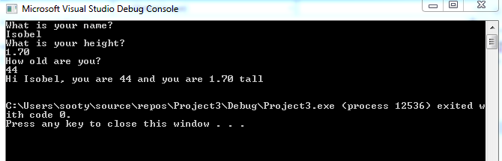

Result: Program runs as expected, returns correct values for Isobel with height 1.70 and 44 years old.

  - Negative Value in Height and Age
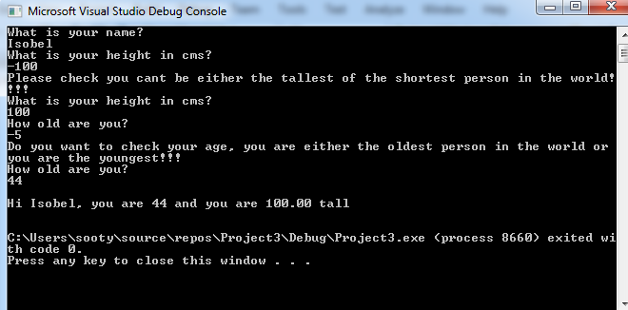

Result: Program runs as expected, notifying user of the negative values within height and age, allowing user to then correct.

  - Larger Than Expected Height and Age

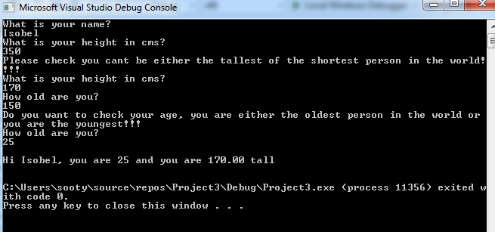

Result: Program runs as expected, notifying user of the high values within height and age, allowing user to then correct.

  - Number in Name

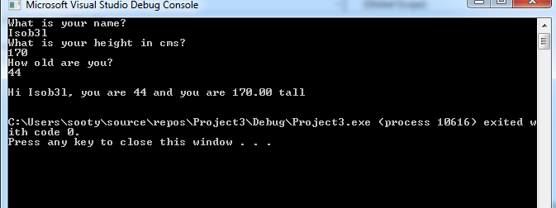

Result: Program runs as expected, as 3 in the name is an alphanumeric character, the system cannot currently pick it up as a possible error.

  - Character instead of number for Height and/or Age

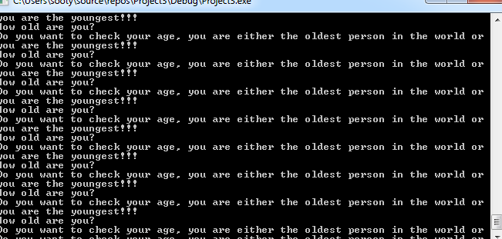

Result: Failed - not quite what was expected, used 3o0 for height, ran continuously until prompted to stop.

B2. Exercise 2

- Problem Identification

- What variables do you need to input:

  - radius of circle;
  - height of triangle;
  - base length of triangle.

- Some rules around checking if the triangle is contained within the circle:

- If the height of the triangle is equal to the diameter of the circle the triangle is unlikely to be in the circle, assume this to be the case and return error message.
- If the base of the triangle is equal to the diameter (2*radius), check if the height is less than or equal to the radius, if so assume it is and calculate otherwise return error message.

- Area of a circle needs to be calculated
- Area of a triangle needs to be calculated
- Storing the results of the area
- The resulting calculations of the circle area less the triangle area
- Will it always be a triangle?

- Annotated Code

# include <stdio.h>

void main()
{
float rad, height, base; //variables to contain the user input
float circlea, trianglea, result; //variables to contain resulting calcualtions
float PI = 3.14; // fixed variable declared

printf("What is the radius of the circle?\n");
scanf("%f", &rad); // user enters the radius of the circle

printf("What is the height of the triangle?\n");
scanf("%f", &height); // user enters the height of the triangle

printf("What is the base length of the triangle\n");
scanf("%f", &base); // user enters the base length of the triangle

if (height >= (2 * rad))
{
printf("As the height of the triangle is the same or higher than the diameter of the circle, it is assumed that the triangle is not contained within the circle");
//result if the triangle height is the same or higher than the diameter of the circle
}
else if (base <= (2 * rad) && height > rad)
{
printf("As the height of the triangle is the same or higher than the radius of the circle with the base being the same length as the diameter, it is assumed that the triangle is not contained within the circle");
//result if the triangle height is the same or higher than the diameter of the circle
}
else
{
circlea = (rad * rad) * PI; // calculate the area of the circle
trianglea = (height * base) / 2; // calculate the area of the triangle

result = circlea - trianglea; // result of subtracting the are of the triangle away from the area of the circle

printf("If you have a circle with a radius of %.2f that contained a triangle with height %.2f and base %.2f the resulting shaded area calculated would be %.2f\n\n", rad, height, base, result);
// print result of the area required
}
}

- Testing

  - Normal values for Radius of Circle, Height and base of Triangle (used 5)

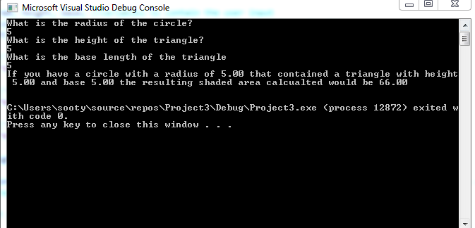

Result: Program runs as expected, returns the inputted values of 5, Circle area would have been 78.5, whilst the area of the triangle would have been 12.5, leaving an area of 78.5 – 12.5 = 66 around the triangle.

  - Normal Values for Radius of 5, with Triangle Height of 10, Base of 5

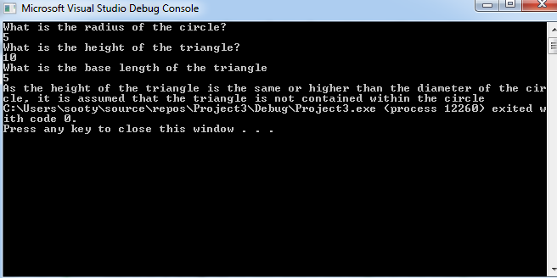

Result: Program runs as expected, returns error as height is equal to the diameter of the circle, suggesting that the triangle is not contained within the circle.
  - Normal Values for Radius of 5, with Triangle Height of 4, Base of 10

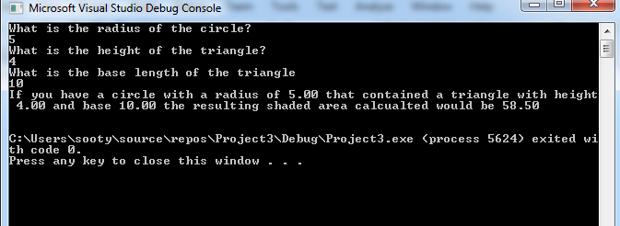

Result: Program runs as expected, height of triangle is less than the radius of the circle whilst the base is the same length as the diameter of the triangle, assumed shape is that the triangle is contained within the circle.

  - Normal Values for Radius of 5, with Triangle Height of 6, Base of 10

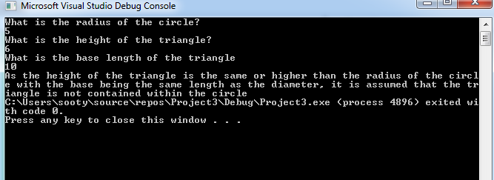

Result: Program runs as expected, returns error as height is equal or higher than the radius circle, whilst the base is the same length as the diameter of the circle, suggesting that the triangle is not contained within the circle.

  - Place 1o Instead of 10 into Radius of the Circle

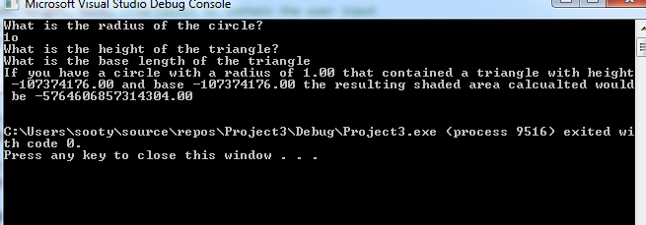

Result: Program failed – as it did not recognise the o as a 0, and did not allow the user to input for the triangle.

B3. Exercise 3

- Problem Identification

- Declare variables for 5 products (Do we allow the user to name them?)

Need a loop to iterate the question 5 times.

- Calculate total price of the 5 products
- Display total without VAT on the screen
- Calculate total price with VAT added on at 20%
- Display total with VAT on the screen.

- Annotated Code
#include <stdio.h>

void main()

{
float price, r1 = 0, r2; // variables to contain user input and results
int x; // variable container for the count

for (x = 1; x <= 5; x++) // Loop count with 5 iterations
{
printf("Can you please enter the price of your item?\n");
scanf("%f", &price); // user input request within the loop

r1 = price + r1; // running total for the requested prices
}

r2 = r1 * 1.2; // calculation for VAT to be applied to the total prices
printf("The total of your goods excluding VAT is %.2f,\n\n The total of your goods including VAT is %.2f.\n", r1, r2);
// screen print of total results excluding and including VAT
}

- Testing

  - Normal Positive Values

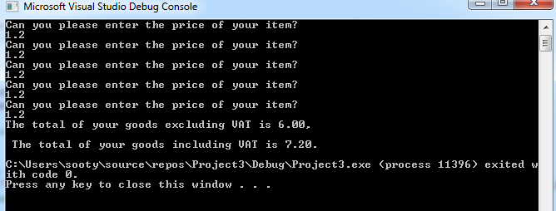

Result: Ran as expected, with a total and the total with VAT added correctly.

  - Normal Negative Values

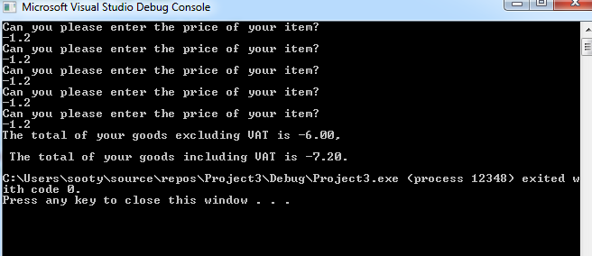

Result: Ran as expected with all negative values, calculated the total with and without VAT correctly.

  - Mixed normal Negative and Positive Values

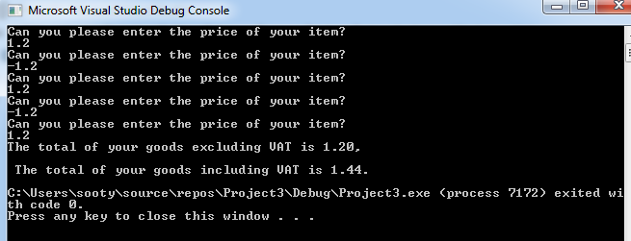

Result: Ran as expected with correctly calculated totals with and without VAT.

  - Using o instead 0 in One of the Values (1st value)

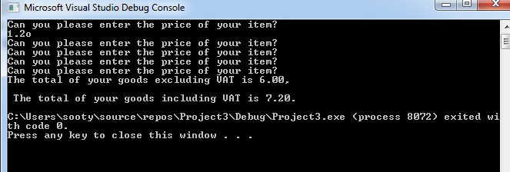

Result: Failed as it did not allow the user to enter any further values and assumed that 1.2 was for all 5 values.

  - Using E instead of 3 as a Value (5th value)

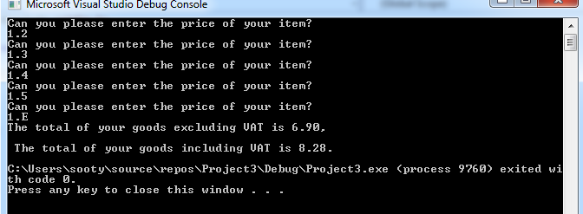

Result: Failed as it assumed that the final value was 1.5 and calculated the totals in that way.

B4. Exercise 4

- Problem Identification

- Determine whether player/user would like to play
- If NO, display message.
- If YES, continue with game.
- Define 3 random variables that can be displayed together.
- Numbers must range from 1 to 5 (lower number 1, upper number 5)
- Display the three variables to the user declaring if the user has:

- Won any points;
- Not won any points.

- Define and display the points values:

  - Three 5’s will be 2000 points;
  - Two 5’s in any of the three positions 100 points;
  - Three 4’s, 3’s, 2’s, 1’s will give the user 20 points.

- Keep a running total of the scores.
- Ask player if they wish to play again, repeat from 1, until player says NO

- Annotated Code
#include <stdio.h>
#include <stdlib.h>
#include <time.h>

void main()
{
int slot[3]; // declaring the number of values in the array
int low = 1; // the lowest number of range
int high = 5; // the highest number of range
srand(time(NULL)); // seed randomness in the choice
int i;
char answer; // answer to question about going again
int points = 0; // declare variable for cumulative points

printf("Would you like to play on the slot machine (Y OR N)?\n"); // Ask user if they would like to play
scanf(" %c", &answer); // user inputs their answer

while (answer == 'Y') // if the answer is Y then the game begins
{
for (i = 0; i < 3; i++) // for loop (count loop) to get the numbers for the array
{
slot[i] = rand() % (high - low + 1) + low; // choose random numbers for the array
}

printf("Your jackpot numbers are: "); // print the jackpot numbers to the player

for (i = 0; i < 3; i++)
{
printf("%d ", slot[i]); // jackpot numbers as declared in the for loop

}
if (slot[0] == slot[1] && slot[1] == slot[2] && slot[2] == 5) // stating all the elements must equal 5
{
printf("Congratulations, you have won 2000 points\n\n"); // if all elements do equal 5 return the statement that the jackpot of 2000 has been won
points = points + 2000; // add 2000 points to the players jackpot
}
else if (slot[0] == slot[1] && slot[1] == 5) // declare condition for this jackpot (2 * 5's)
{
printf("Congratulations, you have won 100 points\n\n"); // if any of the two elements equal 5 return the statement that the jackpot of 100 has been won
points = points + 100; // add 100 points to the players jackpot
}
else if (slot[1] == slot[2] && slot[2] == 5) // declare condition for this jackpot (2 * 5's)
{
printf("Congratulations, you have won 100 points\n\n"); // if any of the two elements equal 5 return the statement that the jackpot of 100 has been won
points = points + 100; // add 100 points to the players jackpot
}

else if (slot[0] == slot[2] && slot[0] == 5) // declare condition for this jackpot (2 * 5's)
{
printf("Congratulations, you have won 100 points\n\n"); // if any of the two elements equal 5 return the statement that the jackpot of 100 has been won
points = points + 100; // add 100 points to the players jackpot
}
else if (slot[0] == slot[1] && slot[1] == slot[2] && slot[2] == 4) // condition for this jackpot 3 * 4's
{
printf("Congratulations, you have won 20 points\n\n"); // if all of the elements are equal to 4 return the statement that the jack pot of 20 has been won
points = points + 20; // add 20 points to the players jackpot
}
else if (slot[0] == slot[1] && slot[1] == slot[2] && slot[2] == 3) // condition for this jackpot 3 * 3's
{
printf("Congratulations, you have won 20 points\n\n"); // if all of the elements are equal to 3 return the statement that the jack pot of 20 has been won
points = points + 20; // add 20 points to the players jackpot
}
else if (slot[0] == slot[1] && slot[1] == slot[2] && slot[2] == 2) // condition for this jackpot 3 * 2's
{
printf("Congratulations, you have won 20 points\n\n"); // if all of the elements are equal to 2 return the statement that the jack pot of 20 has been won
points = points + 20; // add 20 points to the players jackpot
}
else if (slot[0] == slot[1] && slot[1] == slot[2] && slot[2] == 1) // condition for this jackpot 3 * 1's
{
printf("Congratulations, you have won 20 points\n\n"); // if all of the elements are equal to 1 return the statement that the jack pot of 20 has been won
points = points + 20; // add 20 points to the players jackpot
}

else
{
printf("Sorry no luck today\n\n"); // if player has not met any of the conditions/cases above return statement
}

printf("Your new total is %d\n\n", points); // print cumulative total

printf("\n\n");

printf("Would you like to go again (Y OR N)?\n"); // ask if player would like to go again
scanf(" %c", &answer); // user inputs their answer
}
printf("Thank you for playing today\n\n"); // if answer to play is "N"
}
- Testing

  - Saying No to Playing

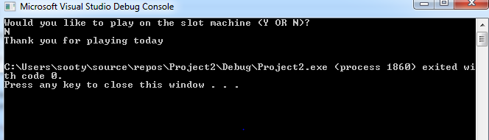

Result: As Expected – game ended.

  - Saying Yes to Playing with no Win

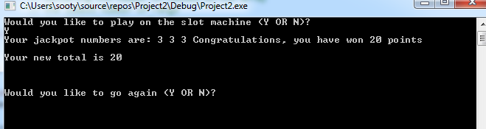

Result: As Expected – game played and then asked if you would like another go.

  - Saying Yes to Playing and Getting all 5’s and 2000 Points

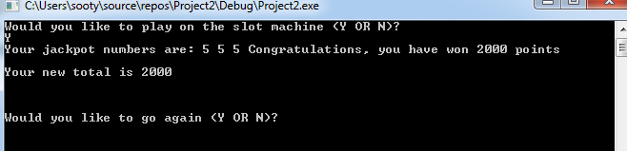

Result: As Expected – game played and player got all of the 5’s with 2000 points and asked to play again.

  - Saying Yes to Playing and Getting all the 4’s 20 Points

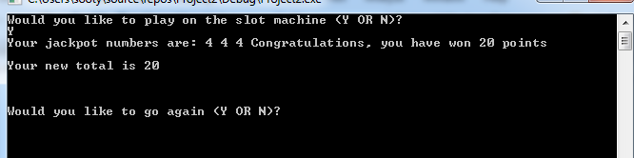

Result: As Expected – game played and player got all of the 4’s with 20 points and asked to play again.

  - Saying Yes to Playing and Getting all the 3’s 20 Points

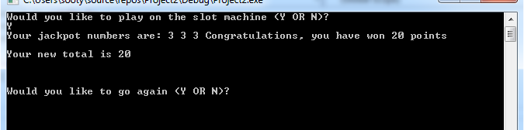

Result: As Expected – game played and player got all of the 3’s with 20 points and asked to play again.

  - Saying Yes to Playing and Getting all the 2’s 20 Points

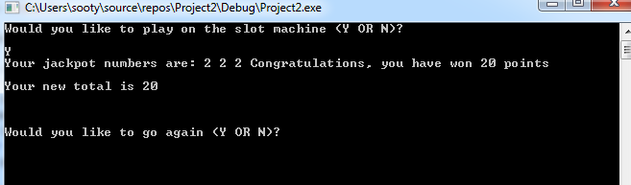

Result: As Expected – game played and player got all of the 2’s with 20 points and asked to play again.

  - Saying Yes to Playing and Getting all the 1’s and 20 Points

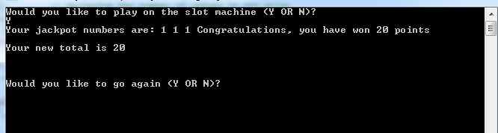

Result: As Expected – game played and player got all of the 1’s with 20 points and asked to play again.

  - Saying Yes to Playing and Getting 2 5’s and 100 Points

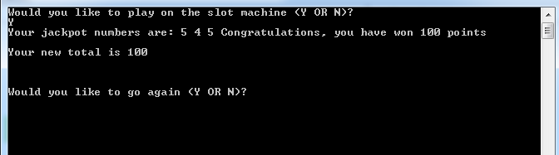
Result: As Expected – game played and the player got 2 fives and 100 points and asked to play again.

  - Saying yes to Playing and Getting Cumulative points as the Player Plays More

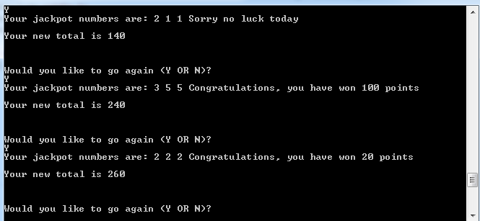

Results: As Expected – game played and cumulative total was added to as player played more games.

  - Saying Yes with lower case “y”

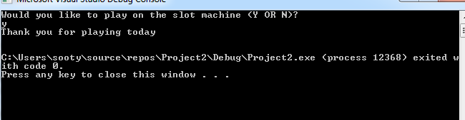

Result: Did not play as expected.

References

[1] | M. McGrath, Coding for Beginners, Leamington Spa: In Easy Steps, 2017.

