FINANCIAL MANAGEMENT
LCMB7002

Student Name: Janet Ogundayo
Student ID: 1918674
Lecturer: Dr Jay

Table of Contents
Introduction 3
Part (a) Company background: Tesco Plc. 4
Business model of Tesco Plc. 5
Recent events over the past five years 7
Part (b) Financial performance review 7
Current financial standpoint of the company 7
Calculation and critical evaluation of key financial ratios for the past 5 years (e.g. profitability, liquidity, gearing, efficiency ratios) 8
Profitability ratio 9
Liquidity ratio 12
Gearing ratio 13
Efficiency ratio 14
Recommendation on how to improve the financial management of the company 16
Part (c) Carrying out investment appraisal techniques to evaluate the projects: 17
Payback Period (PBP): 18
Net Present Value (NPV): 20
Accounting rate of return (ARR): 21
External factors to consider 22
Conclusion 22
References 24

Introduction
Finance is one of the core management functions of an organisation. The overall performance of an organisation largely depends on how well its finances are managed. By definition, financial management refers to the organisational functions involving “the planning, organizing, directing and controlling the financial activities of the enterprise” (Archer, Choate and Racette, 1983). This involves funding the operations and business functions, securing investments, making investment and capital decisions, recording financial transactions, auditing the company’s financial performance and conditions, etc. The financial management is therefore, a vital strategic function for an organisation. The competitive position of a company depends on the efficiency of performance, and the efficiency depends on the optimum use of the financial assets of the company (Block, Hirt and Danielsen, 2019). The report starts with a brief background of the company and its business model. The major recent events of the company that took place over the last five years have been explored in this part as well. Then the financial position of the company has been critically reviewed using key financial ratios. At the third part of this report, two investment opportunities have been evaluated for the company using capital budgeting methods. Thus, the report covers some of the basic aspects of financial management to help analyse the market position and the performance of the company. The report aims to inform the selected company’s position and performance, compared to its key competitors, in the respective industry. The selected company for this report is Tesco Plc, which is a UK based retailer and currently the largest supermarket chain in the country. The company’s shares are traded on London Stock Exchange. The relevant financial data of the company have been gathered from the company’s annual financial report titled “Annual Report and Financial Statements 2019”.

Part (a) Company background: Tesco Plc.
Tesco Plc trades as Tesco at London Stock Exchange. It is one of the oldest and currently the largest supermarket chain in the UK (Tesco Plc, 2020). The company represents the traditional image of the UK in many ways as it has been linked to British culture over the years. It is also currently the third largest retailer in terms of the gross revenues in the world scale. Tesco was founded in 1919 by Jack Cohen in Hackney, London. It had debuted as a chain of market stalls. In 1914, the company was officially named as Tesco. The first nation-wide market growth of the company took place from 1931 to 1939 (Tesco Plc, 2020). By then, there was 100 stores of the company across the country. The global expansion of the company started taking place in the 1990s. During this year, the company had expanded across 11 countries around the world. The company, however, started to expand its product line since 1960s. Up till 2000s, the company was known as the low cost and high-volume retailers in the UK. But later, the company had expanded its product ranges, and started to offer products of different price ranges (Tesco Plc, 2020).
The company operates in the retail sector. More specifically, Tesco mainly operates in the groceries, food items and household appliances market. The company’s product portfolio, however, is much diverse. The report will only focus on the supermarket business of Tesco, which is the core business of the company. The company competes with ASDA, Sainsbury, Waitrose, Aldi and Lidl in the retail market sector in the UK. It holds around 30% of the retail market share in the UK, and thus, acts as the industry leader (Bernard Marr, 2020).
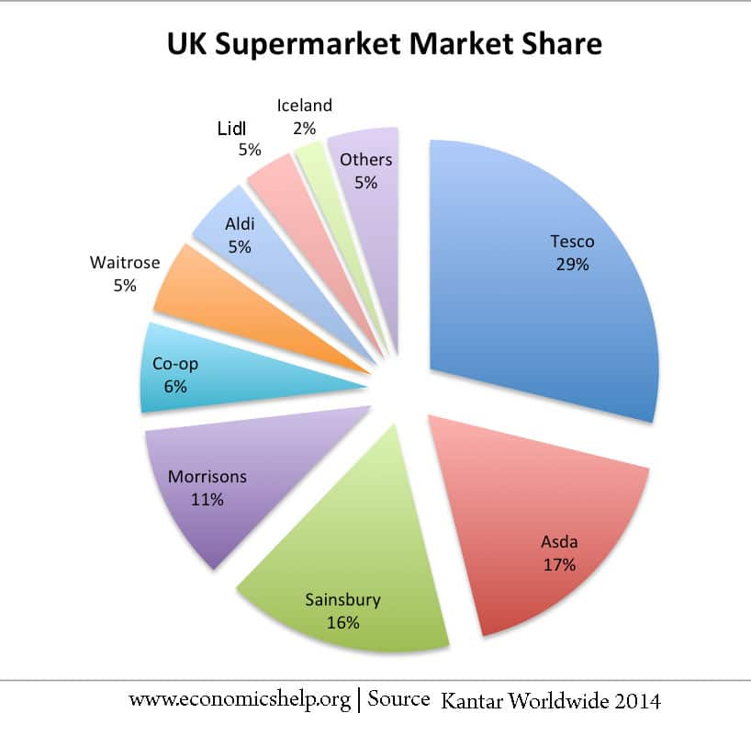
Figure: Market share of Tesco in the UK supermarket industry (Infront Analytics, 2020).

Business model of Tesco Plc.
Business model can be defined as “the plan for the successful operation of a business, identifying sources of revenue, the intended customer base, products, and details of financing” (Khan and Jain, 2007). Tesco’s business model would involve how the company operates its business successfully, how the sources of revenues are identified, and how the intended customer base is accessed communicated with (Financial Times, 2020). This also involves how the products are developed and the financing procedures are detailed.
The business model of Tesco is based and organised around the three pillars- the customers, the channels and the products. The business is organised in a customer centric market approach. As mentioned by Tesco, the business model is kept simple and transparent. The organisation focuses on the little things to make larger impacts and bigger differences (Correia et al., 2019).

Figure: Three pillars of Tesco’s business model (Correia et al., 2019)
The company keeps its customers at the core of the business model. The company listens to the customers and tries to determine what is important to them, based on their feedbacks and the patterns of their demands (Correia et al., 2019). The company, for example, conducts regular market researches to get insights on the expectations of the customers from their own accounts. The Tesco Product Team then creates the products and offers for the customers. The company offers a diverse range of products targeting a diverse group of market segments (Brigham and Houston, 2019). Thus, inclusivity is a core to its product assortment strategy. The company also maintains transparency and sustainability in its business model to respond to the popular market demands. For instance, the company pays fair prices to the suppliers and maintains positive business relations with them. Continuous efforts are made to determine the customers’ needs and to anticipate their demands. Then comes the use of different channels to distribute the products to the customers. Tesco being the largest market shareholder in the UK’s grocery industry, it is the most accessible retailer for the customers as well (Bernard Marr, 2020). The company makes huge amount of investments every year to upgrade its stores and supermarket outlets to make them more convenient and efficient to the customers.

Recent events over the past five years
Last year, the company’s former and the long serving CEO Dave Lewis had stepped down from his position in the organisation (Bernard Marr, 2020). This had paved the way for his successor Ken Murphy to take on the responsibilities. This will, however, bring less changes to the company’s culture and structure because Ken Murphy’s leadership style is very much resembling to that of the previous CEO’s style (Financial Morningstar, 2020).
Up till April 2020, the company was making strong profit performance. It was expected that the company would make 13% more profits this year compared to the previous year’s performance. However, that changed with the Covid 19 situation (Bernard Marr, 2020). The company, similar to any other business organisation, has experienced the negative impacts of the pandemic situation. Although, the company is likely to sustain because of its online sales channel, but the company’s financial analysts warned that the company might lose around £925 million by the end of this year due to the pandemic. The company has recently announced to strengthen its online distribution more to cope with the changes from the pandemic situation (Financial Morningstar, 2020).
Earlier this year, it was predicted that Brexit could make significant changes within the organisation with the increases in business overheads and wages (Bernard Marr, 2020). However, up till now, the company have not reported any significant changes due to the Brexit.
Tesco did not have any recent M&A to report. The last merger was in 2017 with the Booker Group. Therefore, the only relevant strategic changes in the company that took place recently, has been the change in leadership and the profit decline due to the pandemic (Bernard Marr, 2020).

Part (b) financial performance review

Current financial standpoint of the company
In 2015, the company’s market capital had grown to £18.1 billion. The company also got listed as an FTSE 100 Index constituent. Currently, Tesco operates across 6800 locations, manages a workforce of 450,000 employees, and has generated £63.911 billion in gross revenues last year (Infront Analytics, 2020). The company’s operating profits were £2.206 billion, and the net income was £1.320 billion. The stock prices of the company have been experiencing a decline since April of this year, mostly due to the pandemic situation. Currently the company’s assets are worth 12,668million GBP in total (Financial Morningstar, 2020).

Calculation and critical evaluation of key financial ratios for the past 5 years (e.g. profitability, liquidity, gearing, efficiency ratios)
The key financial ratios of the company have been calculated using the data gathered from the income statement and balance sheet of the company. Critical evaluation has been made on the company’s financial performance based on the findings of the ratio calculation (Correia et al., 2019). The company’s financial performance has been compared with the industry standards, and in comparison, to the closest competitor of the company, ASDA Plc (Brigham and Houston, 2019).
Income statement of the company for the year 2019-18
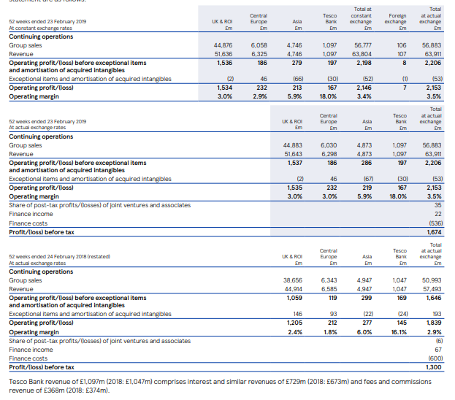
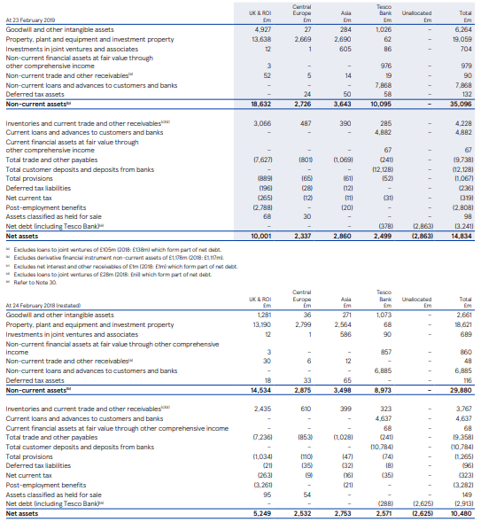
Figure: Tesco income statement 2019-18 (Tesco PLC, 2020)
Balance sheet for the year 2019-18
Figure: Tesco Balance sheet 2019 (Tesco PLC, 2020)

Profitability ratio
Measures the profitability performance of the company throughout the accounting year (Madura, 2019).
 | 2015 | 2016 | 2017 | 2018 | 2019
Return on equity  =Profit After tax / Net worth | -52.7 | 1.76 | -0.53 | 14.26 | 10.43
Returns on capital employed  = EBIT/Capital Employed | -23.54 | 2.45 | 1.67 | 7.88 | 7.45
Net profits margin  = Net income ÷ total sales | -9.22 | 0.25 | -0.07 | 2.1 | 2.07
Return on assets  = Net Income / Total Assets | -12.17 | 0.31 | -0.09 | 2.66 | 2.82
Table: Profitability ratio (Tesco PLC, 2020)

Figure: Profitability ratio (Tesco PLC, 2020)
Profitability ratio helps determine the profitability or profit performance of the company (Archer, Choate and Racette, 1983). Calculating Tesco’s profitability ratio using data from the company’s annual reports, it is evident that the company had maintained a significant growth in profit performance from 2015 to 2019. However, the company’s return on equity and the return on capital employed had declined in 2019 (Block, Hirt and Danielsen, 2019).
Return on equity: The recent decline in return on equity suggests that the company has been unable to increase the shareholders’ value in 2019 (Tesco PLC, 2020). In the industry context, a positive ROE would have been around 15% to 20%. The company came near to generating the industry standard in 2018, but failed to keep up in 2019 (Block, Hirt and Danielsen, 2019). But on a positive note, Tesco’s closest market competitor ASDA’s ROE was 9% in 2019, which is a 40% decline from the previous year (Financial Morningstar, 2020). This indicates that the company, despite underperforming in terms of the desired industry standards, did perform better compared to its closest market rival (Archer, Choate and Racette, 1983).
Return on capital employed: The company’s return on capital employed indicates how efficiently the company utilizes its capital for generating profits (Block, Hirt and Danielsen, 2019). The company’s financial reports indicate that it has been able to improve the ROCE in the last five years. In 2019, there has been a slight decline (Tesco PLC, 2020). There is no specific industry standard to measure ROCE.
The company should evaluate its ROCE with those of its competitors (Brigham and Houston, 2019). ASDA for example, had its ROCE at 5.9% in 2019, and 9% in 2018 (Financial Morningstar, 2020). Thus, it is evident that ASDA could not compete with the same level of efficiency as Tesco last year, but did manage to generate a competitively better ROCE in 2018.
Net profit margin: Net profit margin helps evaluate the capacity of the company to generate net profits. A good net profit margin is usually considered to be between 10% to 20% or higher (Brigham and Houston, 2019). It is evident from the company’s financial reports that they failed to generate an industry standard net profit margin in the last five years. This does send a bad signal to the investors (Tesco PLC, 2020). It also indicates the company’s inability to extract a healthy amount of profit which it could have used for investment and growth purpose (Correia et al., 2019). However, the economic does affect the net profit margins, and therefore, the factors of the business environment could be considered to further justify the net profit margins of the company (Johnson and Melicher, 1982).
Return on assets: Return on assets ratio indicates the company’s profitability in context of its assets (Johnson and Melicher, 1982). Usually a 5% ROA is considered industry standard. Again, looking at Tesco’s performance, it is evident that they have failed to generate a “good” ROA in the last five years (Tesco PLC, 2020). On the contrary, ASDA’s financial reports indicate a higher ROA in the last five years. In 2018, ASDA’s ROA was 5%, and in 2019, it was 3.8% (Financial Morningstar, 2020). Although, the company failed maintain a positive growth, but it did manage to generate more profits against its assets compared to Tesco Plc. This signals that Tesco needs to utilize its assets more efficiently to generate revenues. Currently the company is investing more on its assets, but these investments are not generating a positive return for the company. Measures need to be taken to adopt more effective asset management strategies (Financial Morningstar, 2020).

Liquidity ratio
Liquidity ratios are a group of financial metrics that help determine the company’s ability to pay off its current debts (Khan and Jain, 2007). These ratios also help determine the level of financial risks that a company is exposed to during any particular accounting year. The relevant liquidity ratios have been calculated for Tesco using the data from its financial reports (Madura, 2019).
 | 2015 | 2016 | 2017 | 2018 | 2019
Current Ratio  =Current assets/current liabilities | 0.6 | 0.75 | 0.79 | 0.71 | 0.61
Quick Ratio  = [Current Assets – Inventory – Prepaid expenses] / Current Liabilities | 0.42 | 0.59 | 0.64 | 0.55 | 0.48
Table: Liquidity ratio (Tesco PLC, 2020)

Figure: Liquidity ratio (Tesco PLC, 2020)
Current Ratio: The current ratio helps determine the company’s ability to pay its short-term liabilities that are due within a year (Brigham and Houston, 2019). The current assets are divided with the current liabilities of the company to determine this ratio. A good current ratio would be between 1.2 to 2 (Correia et al., 2019). This indicates that the company has twice the amount of current assets compared to its current liabilities. This is also the industry average. Looking at Tesco’s current ratio profile, it is evident that the company has less capabilities to pay off its current liabilities (Johnson and Melicher, 1982). Also, to make it worse, the company’s current ratio performance has declined over the years. This sends a very bad signal on the company’s performance (Tesco PLC, 2020). The company may soon find itself into a liquidity position from which it would be difficult to recover from. The management needs to employ more effective current assets management strategies (Khan and Jain, 2007). Also, comparing to ASDA’s current ratio in 2019 and 2018 respectively, the current ratios were 0.9 and 0.8. Thus, they managed to maintain higher liquidity performance compared to Tesco (Financial Morningstar, 2020).
Quick Ratio: Quick ratio is another measure for evaluating the company’s liquidity performance. Not all current assets of the company can be sold instantly (Brigham and Houston, 2019). The only current assets that a company can sell instantly are the cash and the bank balance. A company’s ability to pay off its current liabilities with its cash money shows the company’s liquidity status in a more critical way (Brigham and Houston, 2019). Tesco’s quick ratio for the year was 0.48, slightly lower than its current ratio. The previous year it was 0.55, and 0.64 the year before. It shows that the company is constantly losing its liquidity status. Soon, the company will run into cash deficit once they start to pay out their current liabilities. This may put the company’s financial position in a significant amount of risk in the coming years (Block, Hirt and Danielsen, 2019). However, looking at ASDA’s performance, their quick ratio was at 0.18%, which is far less than Tesco (Financial Morningstar, 2020). It does show that the industry has been underperforming in general. The company’s need to develop strategies to reduce their liabilities and increase cash inflows to maintain a healthy cash liquidity.

Gearing ratio
 | 2015 | 2016 | 2017 | 2018 | 2019
Debt/Equity | 1.51 | 1.24 | 1.47 | 0.68 | 0.38
Financial Leverage  = Total Debt / Shareholder's Equity | 6.25 | 5.09 | 7.12 | 4.28 | 3.3
Table: Gearing ratio
Debt/Equity: The debt-to-equity ratio is the financial ratio which indicates the relative proportion of the shareholders' equity and debt used for financing the purchase of the company's assets (Johnson and Melicher, 1982). This ratio helps measure whether the company’s operations are largely financed by equity or by debt. A higher debt to equity ratio sends a bad signal about a company. Usually, a good debt/equity ratio for Tesco in the context of its respective industry would be between 1 to 1.5 (Infront Analytics, 2020). A higher ratio will indicate that the company is unable to finance its operations from its own equity. At Tesco however, the debt to equity ratio was 0.38 and the year before it was 0.68.
Financial Leverage: Financial leverage is “the use of borrowed money (debt) to finance the purchase of assets” (Johnson and Melicher, 1982). This ratio is particularly important to determine the solvency of the company and the risks that it is exposed to. If the company continues to purchase assets with borrowed money, then the risks of the company going insolvent becomes higher. A good financial leverage in the context of Tesco is 0.5 or less (Infront Analytics, 2020). This indicates that the company is purchasing assets with own capital rather than borrowed funds (Financial Morningstar, 2020). Yet, Tesco’s financial leverage is much higher compared to the industry standards, which indicates the risks of insolvency. Although, it would be easier for the company to avoid such risks, but if plans are not met to reduce the financial leverage then the company could soon face sustainability issues.

Efficiency ratio
Efficiency ratio helps determine the efficiency of the performance of a company during an accounting year (Khan and Jain, 2007). Performance efficiency is required to perform competitively in the industry. The following ratios would help determine the areas in which efficiency should be increased.
 | 2015 | 2016 | 2017 | 2018 | 2019
Receivables turnover  = Net Credit Sales / Average Accounts Receivable | — | 219.49 | 56.74 | 38.88 | 40.94
Inventory turnover  Cost of Goods Sold ÷ Average Inventory | 19.71 | 19.15 | 22.41 | 23.73 | 24.49
Fixed assets turnover  = Net Sales / Average Fixed Assets | 2.77 | 2.84 | 3.11 | 3.14 | 3.4
Asset turnover  = Revenue / Average total assets | 1.32 | 1.24 | 1.24 | 1.27 | 1.36
Table: Efficiency ratio

Figure: Efficiency ratio
Receivables turnover: This ratio helps measure the company’s efficiency in collecting money from the account’s receivables (Madura, 2019). Faster turnover of the receivables indicate that the company is in a better position to collect money from the receivables so that the liquidity of the company is maintained and the accounts payables are paid regularly as well (Financial Morningstar, 2020).
Usually, in the context of the retail industry, a good receivables turnover would be 10. This means that the company will be able to gather money from the receivables a minimum of 10 times a year. A higher receivables turnover would be better (Infront Analytics, 2020). However, the company’s past performance should also be taken into account for this consideration. Tesco for instance, had better receivables turnover in 2016, which declined in the recent years. But the company still has a good turnover performance compared to industry standards (Financial Morningstar, 2020).
Inventory turnover: Inventory turnover ratio helps measure the company’s performance of them replacing the older inventories with new ones during a particular time period. A good inventory turnover would be 4 to 6 (Madura, 2019). However, in retail sector, higher the turnover, the better the company’s inventory performance. Higher inventory turnover indicates the company’s efficiency in managing the cycle of inventory flows. The company has maintained a good inventory turnover in the last five years. Compared to ASDA, whose inventory turnover was less than 10 in the last five years, Tesco proved its faster sales performance in the retail sector (Financial Morningstar, 2020).
Fixed assets turnover: Fixed assets turnover indicates a company’s ability to generate net sales against its fixed assets. In the context of the retail sector, a higher fixed assets turnover compared to the closest market rivals would indicate the company’s efficiency to perform more competitively (Madura, 2019). For instance, ASDA’s fixed assets turnover was 4.14, 4.21, 4.37, 4.55 and 4.39 in the last five years respectively (Financial Morningstar, 2020). Compared to Tesco, the company clearly had slight edge over the use of fixed assets to generate net sales. This is also a good indication that being the market leader, Tesco faces some hurdles against the competitors who manage to perform better with their less fixed assets (Tesco Plc, 2020). To improve this performance, the company needs to improve its online sales channels and reduce the number of physical stores.

Recommendation on how to improve the financial management of the company
Being a retail company that operates in a highly competitive industry, Tesco aims success by offering competitive value propositions at competitive retail prices and by adapting a customer-oriented business model (Block, Hirt and Danielsen, 2019). The company targets the middle class to upper class market segments in the UK. Thus, a diverse range of products are marketed by the company at different prices (Financial Times, 2020). Such a mix of product line or business strategy does have some impact on the financial performance of the company. This has been the case for Tesco as well. The company does have a good profitability which is evident from the ratio analysis, but the company’s liquidity performance and its leverage continues to suffer. It would be recommended for the company to conduct a business model analysis to determine the areas that are causing the liquidity issues.
At this current state of the business, it is important to reduce dependence on physical stores and expand more into the online distribution channels (Block, Hirt and Danielsen, 2019). This will help the company’s liquidity health and their financial leverage. Proper asset management strategies also need to be undertaken to improve the efficiency of using the assets and the overall performance in using these assets (Financial Times, 2020). Tesco needs to utilize its assets more efficiently to generate revenues. Currently the company is investing more on its assets, but these investments are not generating a positive return for the company. The company’s need to develop strategies to reduce their liabilities and increase cash inflows to maintain a healthy cash liquidity.
The finances of the business need to be managed more strategically. Since the company operates in a highly competitive industry, it needs to maintain an efficient cost structure. This is perhaps the most challenging task for the business (Financial Times, 2020). The company, for example, selects its suppliers based on cost efficiency focus. This puts less pressure on operational costs, and the company manages to finance other functions of the company proportionately (Block, Hirt and Danielsen, 2019). A substantial amount of investments is made on market communication strategies to ensure that the customer base is kept updated and new target customers are attracted towards the company.

Part (c) Carrying out investment appraisal techniques to evaluate the projects:
To maintain a competitive market performance, the company needs to identify and utilize the investment opportunities (Block, Hirt and Danielsen, 2019). Different capital budgeting methods are used for conducting the investment appraisal. In the given scenario, for instance, the company has identified two potentially profitable investment opportunities. Yet, to determine which one would serve the company’s objectives better, Tesco needs to apply NPV, ARR, and Payback Period techniques of capital budgeting.
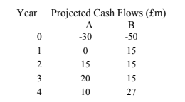
*Cost of capital 11.8%

Payback Period (PBP):
PBP helps determine the time it takes to recoup the initial investment amount. It is a popular capital budgeting method which the company can use alongside other methods to have a complete evaluation of the investment project (Block, Hirt and Danielsen, 2019).
Payback Period =Initial Investment/ Net Cash Flow per Period
However, the projects in question have uneven cash flows. Therefore, the Payback period needs to be calculated using an advanced formula as shown below.
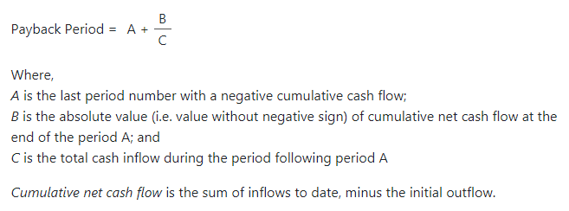
Payback Period of project A:
Year | Cash flow | Cash flow cumulative
0 | -30 | -30
1 | 0 | -30
2 | 15 | -15
3 | 20 | 5
4 | 10 | 15
PBP | 2.75 years

The project A’s PBP is 2.75 years
Payback Period of project B:
Year | Cash flow | Cash flow cumulative
0 | -50 | -30
1 | 15 | -35
2 | 15 | -20
3 | 15 | -5
4 | 27 | 22
PBP | 3.19 years

The project B’s PBP is 3.19 years.
It is evident that Project A has less payback period than project B, which indicates that project A would be more preferable option if the company’s primary focus is to recoup its initial investment.
Benefits
This method is very easy to calculate. Thus, the company does not need to spend much time in determining the attractiveness of an investment using this method (Brigham and Houston, 2019). However, evidences suggest that this method does not favour large companies or companies that aim to sustain performance and growth.
Demerits
Problem with this investment appraisal method is that it does not consider the time value of money. To actually evaluate the worth of an investment option, it is important to consider what the future returns will be worth in the present value (Brigham and Houston, 2019). Without taking account of that, the actual value of an investment cannot be determined in true sense. However, this method does complete the assessment when used alongside a different method (Johnson and Melicher, 1982).

Net Present Value (NPV):
According to Archer, Choate and Racette (1983), “Net present value (NPV) refers to the difference between the present value of cash inflows and the present value of cash outflows over a period of time”.
Project ‘A’ NPV:
= (-30) +(0/ (1+0.118)) +(15/ (1+0.118)²)) +(20/ (1+0.118)³) +(10/ (1+0.118)⁴)
=£2,713,648.26
Project ‘B’ NPV:
= (-50) +(15/ (1+0.118)) +(15/ (1+0.118)²)) +(15/ (1+0.118)³) +(27/ (1+0.118)⁴)
=£3,433,752.05
It is evident from the calculation of NPV that project B would be more profitable for the company compared to project A because it will generate more returns in the years to come.
Benefits
The reason that this finding should be considered more than the findings of PBP is that this method evaluates the time value of the company (Johnson and Melicher, 1982). It is also a better technique for management decision making because managers aim to increase the value of the company with the investments they make. Specifically, in the context of Tesco. NPV would be the method to consider to aid management decision (Khan and Jain, 2007).
Demerits
The only problem with this method is that it is difficult to calculate and if the company requires quick returns, then this method would be less preferable (Khan and Jain, 2007). But if the company actually wants to evaluate the worth of the company, then NPV would be the appraisal method to look up to.

Accounting rate of return (ARR):
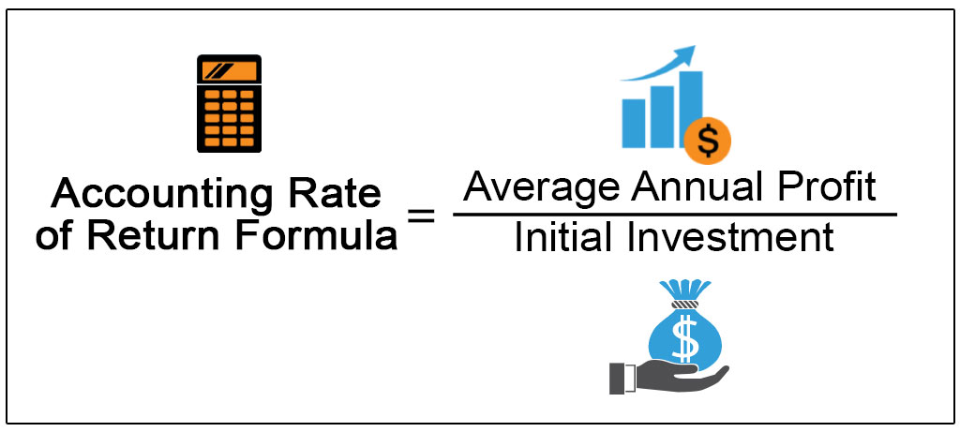
ARR calculates the average rate of return. It is usually an appraisal technique that complements the findings of other investment appraisal findings.

ARR of project A:
Average annual earnings= 45,000000/4= 1125,00,00
Initial investment= 30,000,000
ARR= 0.375
ARR of project B:
Average annual earnings= 72,000,000/4= 18000000
Initial investment= 50,000,000
ARR= 0.36
Project A will generate a 37.5% return from its investments, whereas, project B would generate 36% returns from the investments in the coming years. The gap between the projects is very less to prioritize the findings of ARR over the findings of NPV.
Advantages:
ARR is a simple to calculate technique and it provides a simplistic analysis of a capital budgeting option (Oberholzer, 2012). It also considers the concept of net earnings, which is an important factor to look at when appraising an investment option (Madura, 2019). It particularly satisfies the owners because they look at the profitability of the company.
Disadvantages:
ARR may give conflicting findings if compared to ROI which is a more acceptable technique for calculating the returns on investments (Oberholzer, 2012). This method does not consider the time value of money either. And finally, this method does not consider the impacts of external factors when determining the profitability. Thus, it is less preferable over NPV.

External factors to consider
The political stability, political changes, economic changes, social demand, technological disruptions, and legal frameworks need to consider before choosing a particular investment option. For instance, Brexit had significant impact on the business operations as it increased the costs of imports from EU (Tesco PLC, 2020). The current pandemic had affected almost all business operations so far, and deemed many projects unprofitable. The technology that is demandable today, may not have the same demand tomorrow. The management also needs to evaluate which alternative would be more sustainable and ethical as per market demands and expectations. Without taking consideration of these issues, the company would risk its investments because the impacts of external business environment are substantial to the performance of the investment, and may change the course of actions of the business (Brigham and Houston, 2019). Therefore, it is vital that the external factors are taken into consideration as well.

Conclusion
This report has explored some key areas of financial management. The data have been linked to those of the competitors to determine the competitive position of the company. Discussions have been made in reference to relevant theories and practices of financial management. Tesco’s performance has been linked to its key market competitor, ASDA, which is also a leading retail company in the UK with the closest market share compared to Tesco. Comparing the company’s data with those of its competitors will help determine Tesco’s market position. Findings of the report suggests that the company is currently in a less desired market condition in terms of liquidity, financial leverage and the other aspects of market performance. Between the currently available two investment options, the management should go with the findings of NPV and thus, accept project B for its greater return in future. However, whichever option is chosen, the impacts of external factors need to be forecasted as well.

References
Archer, S., Choate, G. and Racette, G., 1983. Financial Management. New York: Wiley.
Bernard Marr, 2020. Tesco: Measuring Customer Performance & Gaining Insights From The Clubcard Data. [online] Bernard Marr. Available at: <https://www.bernardmarr.com/default.asp?contentID=1057> [Accessed 2 July 2020].
Block, S., Hirt, G. and Danielsen, B., 2019 Foundations Of Financial Management.
Brigham, E. and Houston, J., 2019 Fundamentals Of Financial Management.
Correia, C., Flynn, D., Uliana, E., Wormald, M. and Dillon, J., 2019 Financial Management.
Financial Morningstar, 2020. Growth, Profitability, And Financial Ratios For Walmart Inc (WMT) From Morningstar.Com. [online] Financials.morningstar.com. Available at: <https://financials.morningstar.com/ratios/r.html?t=WMT> [Accessed 2 July 2020].
Financial Times, 2020. UK Retail Industry | Financial Times. [online] Ft.com. Available at: <https://www.ft.com/stream/21db2280-83f0-402b-a5d4-48a6affe7282> [Accessed 2 July 2020].
Infront Analytics, 2020. Tesco PLC: Financial Ratios (TSCO | GBR | Food Retailers & Wholesalers) - Infront Analytics. [online] Infrontanalytics.com. Available at: <https://www.infrontanalytics.com/fe-EN/01841EX/Tesco-PLC/financial-ratios> [Accessed 2 July 2020].
Johnson, R. and Melicher, R., 1982. Financial Management. Boston: Allyn and Bacon.
Khan, M. and Jain, P., 2007. Financial Management. New Delhi: Tata McGraw-Hill.
Kolb, R., 1996. Financial Management. Cambridge, Mass.: Blackwell Business.
Madura, J., 2019 International Financial Management.
Oberholzer, M., 2012. The relative importance of financial ratios in creating shareholders’ wealth. South African Journal of Economic and Management Sciences, 15(4), pp.416-428.
Tesco Plc, 2020. Annual Report And Financial Statements 2019. [online] Tescoplc.com. Available at: <https://www.tescoplc.com/media/476423/tesco_ar_2019.pdf> [Accessed 2 July 2020].
Tesco PLC, 2020. Financial Performance. [online] Tesco PLC. Available at: <https://www.tescoplc.com/investors/reports-results-and-presentations/financial-performance/> [Accessed 2 July 2020].

