 | APPENDIX GA28

MODERATION OF MARKED ASSESSMENT
This form is used to ensure that marked assessments have been through an internal and external review process. This form should be completed for each assessment for a particular module.

PARTNER (and taught location if relevant):
EXTERNAL EXAMINER NAME: | Lorraine Gearing
ASSESSMENT AUTHOR : | Beverley Holland
MODULE TITLE: | Databases and Application Development
MODULE CODE: | ACCA5026 |  |  | MODULE LEVEL: |  |  |  | 5
COMPONENT NO. (e.g. 1 of 2): |  |  |  | COMPONENT WEIGHTING  (e.g. 50% of the module): |  |  |  | 50%
ASSESSMENT PERIOD | ☐ Semester 1 | Semester 1 Re-sit |  |  | ☒ Semester 2 | Semester 2 Re-sit |  |  | Other, please state
TYPE OF ASSESSMENT: | ☒ Coursework |  | Examination |  |  |  | Practical
LANGUAGE OF ASSESSMENT: |  |  |  | TRANSLATION PROVIDED: |  |  |  | Yes/No
TURNITIN CHECK FOR UNFAIR PRACTICE: | Yes

Students listed in the sample below must be registered on a UWTSD award.
FOR COMPLETION BY INTERNAL MODERATOR
After moderation I am able to agree the marks of the sample as shown below.
Student Name or number | 1st Marker mark | Moderator/2nd Marker | Moderator/3rd Marker | Agreed Mark | Comment
Julian Milligan | 60 |  |  | 60 | A good assignment overall, student has concentrated on the SQL and has done this very well (as noted by first marker), needs to tighten up the other requirements of the assignment.
Brandon Gorman | 80 |  |  | 80 | A very good assignment overall, I have noticed same layout/numbering issues in other modules, will mention it to student in next review
Steve Moon | 51 |  |  | 51 | An unusually low mark for this student, however, I know he has been under great pressure at work due to Covid (NHS worker) The SQL is good, but the rest of the assignment feels rushed.
Ollie Bird | 83 |  |  | 83 | An excellent assignment and student is clearly highly technically competent.
Sharla Passariello | 70 |  |  | 70 | A very good assignment, pleased to see this student doing well despite the extreme work pressures she has had this year. Happy to support the mark awarded
Emily Stockdale | 60.5 |  |  | 60.5 | Another student I shall mention layout/numbering to at next review. Generally a good assignment overall however.

INTERNAL MODERATOR (or second marker) |  | Please |  | Comments
 |  | YES | NO | Comments
1 | Has agreement on the marks been reached?
2 | Does feedback identify opportunities for improved performance?
3 | Is feedback constructive?
4 | Is the feedback linked to the appropriate category/ classification of the assessment criteria?
5 | Is the feedback consistent across the sample?
6 | Is there mention of improvement to referencing and consideration of unfair practice, where relevant?
7 | Actions to complete  This box will expand as you type
8 | How was agreement between markers reached?  There was initial confusion on the part of the 2nd marker at the relationship between the marking grids and the mark awarded. The first marker revised the feedback sheets to provide further detail regarding the formula used for translation. 2nd marker was then able to see the process followed.  This box will expand as you type

INTERNAL MODERATOR (or third marker, only where required, i.e. where the first two markers have been unable to reach a resolution) |  | Please |  | Comments
 |  | YES | NO | Comments
1 | Has agreement on the marks been reached?
2 | Does feedback identify opportunities for improved performance?
3 | Is feedback constructive?
4 | Is the feedback linked to the appropriate category/ classification of the assessment criteria?
5 | Is the feedback consistent across the sample?
6 | Is there mention of improvement to referencing and consideration of unfair practice, where relevant?
7 | Actions to complete  This box will expand as you type
8 | How was agreement between markers reached?  This box will expand as you type

FOR COLLABORATIVE PROVISION ONLY

PARTNERSHIP TEAM LEADER |  | Please |  | Comments
 |  | YES | NO | Comments
1 | Has appropriate internal moderation taken place?
2 | Does feedback identify opportunities for improved performance?
3 | Is feedback constructive?
4 | Is the feedback linked to the appropriate category/ classification of the assessment criteria?
5 | Is the feedback consistent across the sample?
6 | Is there mention of improvement to referencing and consideration of unfair practice, where relevant?
7 | Actions to complete  This box will expand as you type

EXTERNAL EXAMINER REVIEW ONLY FOR THOSE MODULES / ASSESSMENT COMPONENTS detailed in the annual GA15 External Examiner Agreement

EXTERNAL EXAMINER |  | Please |  | Comments
 |  | YES | NO | Comments
1 | Has appropriate internal moderation taken place? |  |  | I note the comments re internal moderation
2 | Does feedback identify opportunities for improved performance? |  |  | As with semester 1 ass 2, the comments are very brief and do not pinpoint many specific areas for improvement
3 | Is feedback constructive?
4 | Is the feedback linked to the assessment criteria?
5 | Is the feedback consistent across the sample?
6 | Is there mention of improvement to referencing and consideration of unfair practice, where relevant?
7 | Actions to complete  This box will expand as you type

Signed (internal moderator):  Gaynor Thomas | Date: 9/6/21
Signed (Partnership Team Leader): | Date:
Signed (External Examiner):  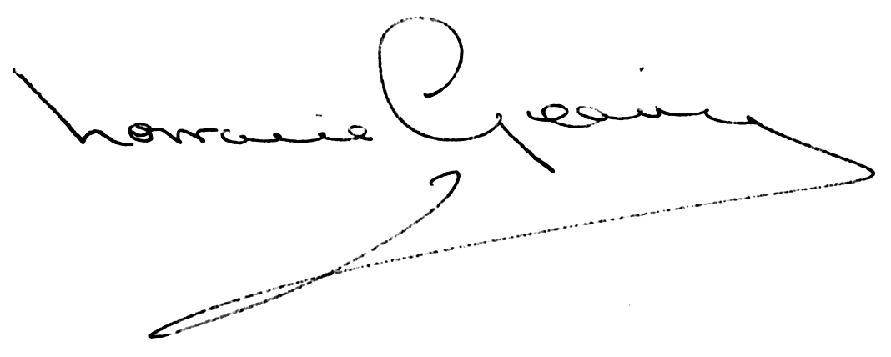 | Date: 30/6/21

UWTSD PROVISION: please submit the completed document to the appropriate Programme Director.
COLLABORATIVE PROVISION: please submit the completed document (or make available electronically) to the Partnership Team Leader. This must be in accord with specific arrangements for sharing electronic documents (e.g. via SharePoint or similar).

