

Developing and evaluating the usability and accessibility of a website by conducting a usability study

by
Kalan Jay Hughes

Supervisor: Gaynor Thomas

Project submitted as part of the requirements for the award of
MSc (Hons) Software Engineering

September 2023
DECLARATION

I, Kalan Jay Hughes declare that I am the sole author of this Project; that all references cited have been consulted; that I have conducted all work of which this is a record, and that the finished work lies within the prescribed word limits.

This work has not previously been accepted as part of any other degree submission.

Signed : Kalan Jay Hughes

Date : 15 September 2023

FORM OF CONSENT

I, Kalan Jay Hughes hereby consent that my Project, submitted in candidature for the MSc Software Engineering degree, if successful, may be made available for inter-library loan or photocopying (subject to the law of copyright), and that the title and abstract may be made available to outside organisations.

Signed : Kalan Jay Hughes

Date : 15 September 2023

Abstract

Website usability and accessibility stand as crucial factors in website design. Nevertheless, a staggering 98% of the world’s most visited one million websites fail to provide comprehensive accessibility [1]. This raises a significant problem, as it renders these websites unusable for people with disabilities, resulting in a detrimental impact on their overall user experience. This study aims to investigate whether enhancing website usability and accessibility can lead to an improved user experience. The findings of this research will shed light on the extent to which these two features influence the overall quality of website usage.
The overarching aim of the project was to develop a website that was based on requirements that were gathered from participants, and then carry out a usability study and questionnaire on participants to determine if the usability and accessibility of the website improved their user experience.
After the usability study and questionnaire were carried out, the results were evaluated. The results showed that all of the participants thought that the website had good usability and accessibility which improved their user experience. This is because all of the participants, regardless of whether they had a disability or not, rated the website's usability a nine or a ten, the accessibility of the website a nine or a ten, and their overall experience of the website a nine or a ten. This helped to prove the hypothesis which was ‘Does improved usability and accessibility of a website improve the user experience?’. A set of requirements was then created based on the results to help improve a website's user experience. The top methods a website can use to improve usability and accessibility are to ensure the website has easy navigation, that it is compatible with a variety of devices and browsers, and that the website works correctly with various accessibility assistive technologies.
In conclusion, having good usability and accessibility can help to improve the users’ experience when using the website. This means that websites should be more accessible to disabled users to ensure that they have a good experience with the website. Hopefully, this project can help to bring awareness to the importance of having good usability and accessibility on websites to ensure that everyone can use the website regardless of whether they have a disability or not.
One recommendation that could be made for future work is to have the disabled participants use the website during its development. This is so they can provide feedback on what to add or change which can help to make the website more accessible which you may not have thought of yourself. This is one way the project could be expanded upon in the future.

Table of Contents
Abstract 3
Chapter 1. Introduction 8
Chapter 2. Research & Review of Literature 11
2.1. Introduction 11
2.2. Research Papers 11
2.2.1. Evaluation of E-Commerce Website Research Paper 11
2.2.2. Assessing Ecommerce Websites: Usability and Accessibility Study 12
2.2.3. Assessing the Importance of an E-learning System’s Usability Design Characteristics 13
2.2.4. Signalling Effect of Website Usability on Repurchase Intention 14
2.2.5. Web Accessibility: Filtering Redundant and Irrelevant Information Improves Website Usability for Blind Users 15
2.2.6. Web Accessibility Investigation and Identification of Major Issues of Higher Education Websites with Statistical Measures: A Case Study of College Websites 15
2.2.7. The Relationship between Website Accessibility and Usability: An Examination of U.S County Government Online Portals 16
2.2.8. Accessibility, Usability, Quality Performance, and Readability Evaluation of University Websites of Turkey 17
2.2.9. Assessing the Usability, Accessibility and Mobile Readiness of e-government Websites: A Case Study in India 18
2.2.10. Framework for Accessibility Evaluation of Hospital Websites 19
2.3. Web Content Accessibility Guidelines (WCAG) 2.0 19
2.4. Adobe Accessibility Whitepaper 21
2.5. Literature Review Conclusion 22
Chapter 3. Research and Development Methodologies 23
3.1. Research Methodology Approach 23
3.2. Research Instruments 24
3.3. Development Methodology 25
3.4. Resources 26
3.5. Ethical Issues 27
3.6. Risks 28
3.7. Section Conclusion 28
Chapter 4. Design & Implementation 29
4.1. Survey Design 29
4.2. Survey Results 31
4.3. Existing Websites 37
4.3.1. University of Wales Trinity Saint David 38
4.3.2. Swansea University 39
4.3.3. University of South Wales 40
4.3.4. Cardiff University 41
4.4. Website Summary Table 42
4.5. Website Requirements 43
4.6. Design 45
4.6.1. Database Design 45
4.6.2. Website Design 46
4.7. Implementation 47
4.7.1. Database Implementation 47
4.7.2. Key Issues That Need To Be Addressed 50
4.7.3. Website Implementation 50
4.7.4. How The Requirements Were Met 55
Chapter 5. Results and Evaluation 57
5.1. Usability Study Example 58
5.2. Questionnaire Example 59
5.3. Visual Disability Results Evaluation 60
5.4. Physical Disability Results Evaluation 61
5.5. No Disability Results Evaluation 62
5.6. Results Conclusion 63
5.7. User Experience Requirements 65
Chapter 6. Conclusion and Recommendations 66
6.1. Suggestions for Future Work 66
Chapter 7. Reflection 68
References 70
Appendices 75
Usability Study and Questionnaire Results 75
Blank Usability Study & Questionnaire: 75
Participant 1: 77
Participant 2: 79
Participant 3: 81
Participant 4: 83
Participant 5: 85
Participant 6: 87
Participant 7: 89
Participant 8: 91
Participant 9: 93
Participant 10: 95
Participant 11: 97
Participant 12: 99
Participant 13: 101
Participant 14: 103
Participant 15: 105

Chapter 1. Introduction

The following project that is being carried out is about developing and evaluating the usability and accessibility of a website by conducting a usability study. The reason why this project is being carried out is because a lot of websites do not consider usability and accessibility when developing a website. This has resulted in over 98% of the world’s top one million websites not offering full accessibility [1]. This is a big problem as it means that people with disabilities are likely to be unable to use a website due to it not being accessible. 71% of people with disabilities who visit a website will leave the website if it is not accessible [1]. This shows that to ensure that people with disabilities have a good experience with the website, it needs to have good usability and accessibility which are two of the most important aspects when developing a website. The purpose of this project is to carry out a usability study on a website that will be developed to see how big of an impact the usability and accessibility of the website have on the user’s experience. The goal of this project is to bring awareness to the importance of usability and accessibility when developing websites which could result in future websites being developed with usability and accessibility in mind.
Navigating and using websites is a simple task that most people would not consider to be an issue. However, many people would consider it to be an extremely difficult and frustrating task [2]. Inaccessible websites have been described as making people feel “more disabled” [2]. This is the complete opposite way that you would want people to feel when using a website. This shows how important and necessary it is to make sure that websites have good usability and accessibility for all people regardless of whether they are disabled or not. This project is worth doing as it can help to make websites more inclusive for people with disabilities. This is because the project can help bring awareness to website usability and accessibility which may result in future websites having better usability and accessibility which would be more inclusive for people with disabilities.

The project that is being carried out has one overarching aim and five objectives. The aim and objectives are listed below as well as the project's hypothesis.
Hypothesis:
Does improved usability and accessibility of a website improve the user experience?
Aim:
To develop a website that is based on requirements that have been gathered from a survey and to carry out a usability study on the website to determine whether the usability and accessibility of the website had improved the users’ experience.

Objectives:
- Carry out research to gain a better understanding of what is required for a website to have good usability and accessibility.
- Conduct a survey on a group of participants to gather the requirements for the website.
- Develop the website based on the requirements from the survey.
- Conduct a usability study and a questionnaire on participants.
- Evaluate the results of the usability study and questionnaire to test the hypothesis.
By completing the aim and objectives, it will help to ensure that the project is on track to achieve the desired outcome which is to see if the usability and accessibility of a website can improve the users’ experience. This will help to test the hypothesis which will result in finding out if the usability and accessibility of a website can improve the users’ experience.

The structure of the following report will be as follows. There will be a literature review chapter that contains information about research that has been carried out in this area of topic. There will then be a methodology chapter that talks about the types of research and development methodologies that are going to be used. It is going to contain information about the resources that will be used to carry out the project, and it will address any risks or ethical issues that the project may encounter and how they will be dealt with. The next chapter is the design and implementation chapter. This chapter will contain a section that discusses the design and the results of the survey that is going to be carried out on participants to gather the requirements for the website that will be developed. There will be a chapter that displays the requirements that have been gathered for the website. There will then be a design section that talks about the design of the database and website based on the requirements that have been gathered. Finally, there will be an implementation section that shows the implementation of the database and website based on the designs that were created. There will then be an evaluation chapter. This chapter will show the usability study and questionnaire that will be carried out on participants after the website and database have been completed. Usability and accessibility testing is important in website development as it can help to show the developers if the website has good usability and accessibility. This section will also evaluate the results of the usability study and questionnaire of all of the participants to determine whether the website has good usability and accessibility. There will then be a conclusion and recommendations chapter that summarises the project and talks about any avenues for future work that could be carried out in the topic area. There will also be a reflection chapter that talks about what the author learned during the development of the project and what they could have done differently. Finally, there will be a references chapter that contains all of the references that were used in the creation of the project. An appendix will be below the references chapter which contains each participant’s usability study and questionnaire results. This concludes the introduction chapter. The following chapter will contain the literature review.

Chapter 2. Research & Review of Literature

2.1. Introduction

This section of the project is going to contain information about the research and the review of literature that has been carried out. The first section will contain information about a variety of research papers that have been carried out in this area of study. They will be evaluated to see what they have done, how the papers will be able to help with the project, and how the project that is being carried out can contribute to the papers that have already been carried out. The second section will contain information about the web content accessibility guidelines. This is to help get an idea of the requirements that will be needed for the website that is going to be developed. The third section will contain information about Adobe's accessibility whitepaper. This is to help see what accessibility guidelines existing companies are using.

2.2. Research Papers

2.2.1. Evaluation of E-Commerce Website Research Paper

The first paper that is under evaluation is an evaluation of e-commerce websites’ accessibility and usability [3]. This particular research focuses on a comprehensive study of an e-commerce website, consisting of four distinct phases. Initially, the researchers employed the ‘SortSite’ tool to assess the website’s accessibility and usability. Subsequently, a manual evaluation was conducted to validate detected errors, and effective solutions were presented. The third phase engaged three usability specialists, who conducted a heuristic evaluation of the website. Finally, user tests involving visually impaired individuals were carried out to ascertain the website’s adherence to accessibility and usability guidelines. The accessibility assessment was based on the WCAG 2.0 accessibility standards.
Upon completion of the study, a satisfaction questionnaire was administered to gather users’ opinions on the website’s usability and accessibility. Surprisingly, 85% of respondents admitted to experiencing a lack of enjoyment during their browsing experience. This is a noteworthy aspect, as it indicates that poor usability might lead to users disengaging and potentially never returning to the website. Equally significant, 85% of participants expressed feeling “lost” while navigating the site, further highlighting its usability issues. The visual representation of the overall site rating, presented through a pie chart, revealed that a majority of users considered the site to be “reasonable” or “weak”, emphasising the crucial role of usability and accessibility in shaping users’ perception of the website.
Overall, this research paper offers a valuable resource for the project’s development, brimming with insightful information. It furnishes details on the tests conducted, participant demographics, and test outcomes. By incorporating this information, the ongoing project can ensure that its own tests effectively contribute to the existing body of knowledge. Notably, the project can build upon this research by conducting its study on a website tailor-made based on participants’ requirements, rather than evaluating an already established website, as done in the research paper. This adaptation is likely to produce more relevant and applicable results for the project’s objectives.

2.2.2. Assessing Ecommerce Websites: Usability and Accessibility Study

The second paper under evaluation is an assessment of e-commerce websites [4]. The primary aim of this study was to evaluate the usability and accessibility of e-commerce websites in Pakistan based on WCAG 2.0 accessibility standards. The researchers employed the Heuristics approach and used a System Usability Scale for conducting the usability testing. Their evaluation of usability was based on the criteria derived from the Web Content Accessibility Guidelines. Additionally, the paper presents valuable recommendations to enhance the usability and accessibility of these websites.
Following the completion of the usability study, the researchers presented their findings. The results revealed that 40% of the reported errors fell under the category of “Perceivable”, indicating difficulties in perceiving the information displayed on the websites. Most frequently, violations were observed in the guidelines that emphasised the provision of equivalent text alternatives for all non-text content on web pages. This omission is crucial, especially for visually impaired individuals who heavily rely on text alternatives for buttons, images, graphs, and other visual elements.
Overall, this research paper offers a wealth of beneficial information. Its recommendations hold significant potential for improving the usability and accessibility of websites. Integrating these recommendations into the ongoing project’s website development process will ensure a more user-friendly and accessible platform. In this regard, the project adopts an approach inspired by this research paper, engaging participants to gauge the website’s usability and accessibility through their feedback and opinions. This constructive input will prove invaluable in fine-tuning and enhancing the project’s final outcome.

2.2.3. Assessing the Importance of an E-learning System’s Usability Design Characteristics

The third paper to be evaluated focuses on the significance of usability design characteristics in an E-learning system, based on students’ preferences [5]. The main objective of this study is to explore the relative importance of design criteria developed for evaluating the usability of an e-learning system from a student’s perspective. The researchers formulated a set of usability principles that significantly influenced the students’ learning process. These usability principles were used as the benchmark for the tests that were carried out. Subsequently, they conducted a study to identify the most crucial usability design characteristics from the student's point of view and evaluated the e-learning system’s usability based on these attributes. The evaluation was based on the perception of 181 learners.
Upon analysing the results, the researchers determined the key dimensions of usability. Information quality emerged as the most vital dimension, followed by navigation as the second most crucial aspect. System learnability and visual design were ranked third and fourth, respectively. On the other hand, instructional assessment and system interactivity were found to be the least important design categories. These findings provide valuable insights for designers and evaluators, enabling them to enhance the usability of the e-learning system.
On the whole, this research paper offers a plethora of useful information that can contribute to the project’s development. Notably, it presents students’ perspectives on the most significant dimensions of usability. Incorporating these results into the ongoing website development will ensure the website possesses good usability. The project being developed takes a step further by building the website based on participants’ views of what constitutes good usability and accessibility, while the website in the research paper had already been created.

2.2.4. Signalling Effect of Website Usability on Repurchase Intention

The fourth paper that is being evaluated explores the signalling effect of website usability on repurchase intention [6]. In this paper, the authors present a model rooted in the signalling theory and expectation confirmation model to understand the influence. This model was used as the benchmark for the tests that were carried out. The primary objective was to investigate whether the model suggests that a signal can influence a shopper’s expectation, which in turn determines their repurchase intention. To empirically test the model, the researchers collected pre-purchase and post-purchase data through a two-stage survey. The collected data was then subjected to analysis using structural equation modelling.
Based on the results, the study revealed that signalling extends beyond the pre-purchase stage of the initial transaction and significantly influences users’ repurchase intention. The findings highlight the importance for online sellers to transmit realistic signals, as this plays a pivotal role in attracting returning customers. In essence, website usability demonstrates a long-term impact on both new and returning customers.
Overall, this research paper serves as a valuable resource for the project’s development, providing diverse information on how website usability can profoundly affect the behaviour of both potential and returning customers.

2.2.5. Web Accessibility: Filtering Redundant and Irrelevant Information Improves Website Usability for Blind Users

The fifth paper that is being evaluated delves into the enhancement of website usability for blind users through filtering redundant and irrelevant information [7]. The study aimed to assess how efficiently individuals with blindness could perform tasks on websites that employed such filtering techniques. To investigate this, three experiments were conducted, involving seventy-six participants with blindness. These participants were tasked with performing various assignments on websites that filtered out irrelevant and redundant information. The researchers evaluated the participants’ cognitive load using the dual-task paradigm and the NASA-RTLX questionnaire which was the benchmark used for the evaluation.
From their findings, it became evident that filtering or eliminating irrelevant and redundant information significantly improved the participants’ cognitive load, satisfaction, and overall performance. These results underscore the potential for enhancing the usability and accessibility of websites by employing such filtering strategies.
Overall, this research paper holds substantial value for the project’s development. It furnishes crucial insights into enhancing usability and accessibility for individuals with blindness on the website being created. Furthermore, the paper provides comprehensive details about their experimental approach, which can be instrumental in ensuring the validity of the project’s study and its gathered results.

2.2.6. Web Accessibility Investigation and Identification of Major Issues of Higher Education Websites with Statistical Measures: A Case Study of College Websites

The next paper that is being evaluated focuses on a web accessibility investigation, specifically identifying critical issues on higher education websites [8]. The paper’s primary goal was to present a comprehensive accessibility analysis of higher education websites based on the WCAG 2.0 accessibility standards. To achieve this, the researchers employed two accessibility evaluation tools called the web accessibility test and the accessibility engine. In their case study, they meticulously scrutinised forty-four websites to conduct the web accessibility evaluation process.
Based on their meticulous research, they unearthed several key issues prevalent on the websites, namely colour contrast, form labels, captions, and marquee elements. Resolving these issues is crucial to enhance overall accessibility. The study underscores that achieving a stellar user experience necessitates websites to embody both superior usability and accessibility.
Overall, this research paper holds immense significance for the project’s development. It provides valuable insights into avoiding major issues during website development and offers guidance on mitigating these challenges. By incorporating these findings, the project can ensure the website’s exceptional usability and accessibility, ultimately leading to an enhanced user experience.

2.2.7. The Relationship between Website Accessibility and Usability: An Examination of U.S County Government Online Portals

The seventh paper that is being evaluated focuses on examining U.S. County government portals [9]. The primary goal of this research paper was to carry out a study to provide a potential solution to incentivise the government to adopt a higher accessibility standard on websites. To achieve this goal, three hundred and forty-two government online portals were selected by a stratified sampling method. An automated tool was used to evaluate the homepages of the websites to see if they complied with the WCAG 2.0 accessibility standards. They then used an eighteen-item heuristic checklist based on prior work to assess the usability of the websites.
After carrying out the study, the results revealed that most county government websites did not implement the WCAG 2.0 standard. They found that even the websites with the highest accessibility score only partially implemented the standard at best. Only 30% of the websites at best partially applied the standard set out which they found to be “far from satisfactory”.
Overall, this research paper has provided a variety of information that can be useful in the development of the website. It provides information about all of the rules that the websites violated. These rules can be applied to the website being developed to ensure that it complies with the WCAG 2.0 standard. This can result in the website having good usability and accessibility which can help to improve the users' experience when navigating the website.

2.2.8. Accessibility, Usability, Quality Performance, and Readability Evaluation of University Websites of Turkey

The next paper that is going to be evaluated looks at university websites in Turkey to see if they meet WCAG 2.0 accessibility criteria by looking at the websites' accessibility, usability, quality performance, and readability [10]. To carry out this evaluation, they used an instrument called AChecker for accessibility testing. They used it to test each homepage against the WCAG 2.0 standards. The home pages were visually and manually inspected for usability testing. For the quality performance test, they used a tool called Web Page Analyzer. They calculated the readability of the home pages by using the Online-Utility.org tool.
After carrying out the tests, they analysed the results. They found that only ten out of one hundred and ten state university websites satisfied all three conformance levels. They found that the most frequently violated WCAG 2.0 checkpoint was “missing appropriate Alt Text”. 69% of the websites contained this error. When it came to usability, they found that the most frequently met principle was “Audio or video autoplay”. They found that there were severe problems that were detected concerning the guidelines for hyperlinked text conventions. None of the websites met the requirements that “All text links are blue”, “All text links change colour after being clicked”, and “All text links are underlined”.
Overall, this research paper has provided results which can help to ensure that the website that is being developed meets the requirements for the WCAG 2.0 accessibility criteria. By complying with the WCAG 2.0 criteria, the usability and accessibility of the website will be improved which can help improve the users’ experience. One way that the project being developed improves upon this research paper is by carrying out tests on a website being developed instead of already existing websites.

2.2.9. Assessing the Usability, Accessibility and Mobile Readiness of e-government Websites: A Case Study in India

The ninth research paper that is going to be evaluated investigates the usability, accessibility, and mobile readiness of Indian government websites [11]. The main goal of the paper was to see if Indian e-government websites complied with the WCAG 2.0 accessibility guidelines. To test the usability of the websites, they used a variety of online tools. To test the readability of the websites, they used the webFX tool. To test the accessibility of the websites, they used an automated evaluation tool called TAW.
After carrying out the tests, they gathered the results. They found that only eleven out of the one hundred and sixty-four websites had no broken links. This means that the remaining 93.4% of the websites had broken links which is very bad for usability. They found that the majority of the websites had an average readability score of twelve, which indicated that even people with primary education could understand the content of the websites which is very good. In terms of accessibility, they found that 92% of websites failed at checkpoint 1.1.1 due to the lack of text alternatives for non-text elements like images, videos, speech, and animation. 31% of the websites failed to provide a distraction-free web accessibility environment to the user.
Overall, this research paper is very useful as it provides a lot of information that can be applied to the website that is being developed. This is because it provides information on the types of usability and accessibility features that websites are missing which can be implemented on the website being developed to ensure that it has good usability and accessibility which can help to improve the users’ experience.

2.2.10. Framework for Accessibility Evaluation of Hospital Websites

The final research paper that is being evaluated is a framework for accessibility evaluation of hospital websites [12]. The main goal of this paper was to provide a framework in the evaluation process to help in the evaluation of the websites proposed by the World Wide Web Consortium. There were two stages in the evaluation of the e-health websites. The first stage applies standard Webometrics rating criteria, which focuses on research results and other indicators that better reflect the overall quality of health institutions around the world. The second stage performs the evaluation against WCAG 2.0 standards to evaluate the accessibility of the website and to ensure the quality of the procedures.
After carrying out the tests, the results were analysed. They found that 54.5% of the hospital websites have fewer than 10 errors. The evaluation shows that the errors that were presented are related to the lack of alternative text in the images, the lack of labels on the forms, as well as empty or broken links. Most of the errors found on the evaluated websites are related to the “Level A: 4.1.2” attribute. This is related to the “href” when the link is not built correctly. This shows that it is necessary to ensure that all links have a valid “href”.
Overall, this research paper contains a variety of information that can be used to help with the development of the website. This is because it contains a variety of different figures which show the errors that the websites make and the guidelines which they fail to follow. By ensuring that the website being developed does not contain any of these errors, it will improve the usability and accessibility of the website which can help to improve the users’ experience.

2.3. Web Content Accessibility Guidelines (WCAG) 2.0

This section of the literature review is going to look at the Web Content Accessibility Guidelines [13]. This is to help formulate the requirements for the website that is being developed to ensure that it adheres to the guidelines set out in the WCAG 2.0.
There are four main areas in the WCAG 2.0 guidelines. The first area is ‘Perceivable’. This area contains all of the guidelines that need to be followed to ensure that information and user interface components are presentable to users in ways that they can perceive. One example of a guideline in this area is ‘1.1 Non-text Content’. This guideline states that all non-text content that is presented to the user must have a text alternative that serves the equivalent purpose. This is to make sure that people who are visually impaired are still able to understand the content that is being displayed on the website. This guideline can help to ensure that the website is accessible to people who have visual disabilities.
The second area is ‘Operable’. This area contains all of the guidelines that need to be followed to ensure that the user interface components and navigation are operable. One example of a guideline in this area is ‘2.1. Keyboard Accessible’. This guideline states that all functionality of the content is operable through a keyboard. This is so that people who are unable to use a mouse can navigate and use the website with just a keyboard. This guideline can help to ensure that the website is accessible to people who have physical disabilities.
The third area is ‘Understandable’. This area contains all the guidelines that need to be followed to ensure that the information and operation of the user interface are understandable. An example of a guideline in this area is ‘3.1 Readable’. This guideline states that all text content must be readable and understandable. This is because people with disabilities experience text in a variety of different ways, so the text on the website must be written and displayed in a way that makes it readable for all users regardless of disabilities. This guideline can help to ensure that the website is accessible for people who have trouble reading text.
The final area is ‘Robust’. This area contains all of the guidelines that need to be followed to ensure that all of the content can be interpreted reliably by a wide variety of users, including assistive technologies. An example of a guideline in this area is ‘4.1 Compatible’. This guideline states that compatibility must be maximised with current and future user agents, including assistive technologies. This is because technology changes quickly, so websites must keep up-to-date with new technologies to ensure that they are compatible with the websites. This guideline can help to ensure that users who use technologies to browse websites can do so without any compatibility issues.
In conclusion, the Web Content Accessibility Guidelines can help immensely with the development of the website as they contain a variety of different guidelines, and it shows how these guidelines can be implemented to ensure that the website being developed has good usability and accessibility which can help to improve the users’ experience when using the website.

2.4. Adobe Accessibility Whitepaper

This section of the literature review is going to look at Adobe’s accessibility whitepaper [14]. This is to help gather information on the types of accessibility standards and regulations existing companies enforce on their websites. These accessibility standards and regulations could be implemented into the website being developed to help improve its usability and accessibility which will improve the users’ experience when using the website.
The whitepaper talks about the three categories of disability that call for specific attention. These are visual, auditory, and mobility. The paper provides information about the different types of disabilities that people can have in these three categories. This can help to get an idea of the different types of disabilities that need to be considered when developing the website.
The paper then talks about ways that the users navigate. It mentions screen readers and keyboard shortcuts in particular. These two things are important to take into consideration as screen readers are useful for helping visually impaired people navigate websites. Keyboard shortcuts are also useful for people who have physical disabilities as it allows them to more easily navigate websites. These methods of navigation could potentially be implemented into the website being developed to help improve its usability and accessibility.
The whitepaper mentions support for closed captioning. This is something that needs to be taken into consideration for the website being developed. This is because if the website is going to contain any videos, it is important that it has closed captioning so that people with auditory disabilities will be able to understand what the video is talking about. Including closed captions can help to improve the usability and accessibility for users with auditory disabilities which can improve the users’ experience when using the website.
The paper also talks about customisable displays, contrast, and colour schemes. This is something that should be taken into consideration for the website being developed. This is because users who have a visual disability like colour blindness may have trouble viewing the website. Allowing them to change the display, contrast, and colour scheme of the website could help to make navigation easier for them. This would improve the usability and accessibility of the website which will improve the users’ experience.
In conclusion, Adobe’s accessibility whitepaper contains a variety of useful information that could be applied to the website being developed to ensure that it has good usability and accessibility which will improve the users’ experience when using the website.

2.5. Literature Review Conclusion

In conclusion, the literature review that has been carried out has helped with the development of the project. This is because the research papers contain information that can be used to ensure that the project is carried out to the best of its abilities. The papers contained information about a variety of different usability and accessibility testing approaches which can be implemented into the project being developed. Some of these approaches are testing for readability, testing the navigation, testing against the WCAG 2.0 standards, testing with screen readers, and testing for any errors. Some of the most crucial approaches that websites should carry out are testing against the WCAG 2.0 standards, testing the navigation, testing for any errors, and testing accessibility assistive technologies. The Web Content Accessibility Guidelines and Adobe’s Accessibility Whitepaper contained a variety of useful information about usability and accessibility. This information can be applied to the website being developed to ensure that it has good usability and accessibility. This concludes the literature review.

Chapter 3. Research and Development Methodologies

The methodology section holds significant importance as it encompasses all the information detailing how the project will be executed. Within this section, you will find comprehensive details about the research methodology approach and the instruments to be utilised. Furthermore, it will delve into the chosen development methodology and outline the required resources. Lastly, ethical concerns and potential risks will be discussed.

3.1. Research Methodology Approach

There are three primary types of research methodologies. These are qualitative, quantitative, and mixed methods [15].
The qualitative methodology is employed when gathering and analysing written or spoken words and text [15]. This approach is particularly useful for studying perceptions of events, individuals, and other subjects [15]. Data in qualitative research is typically obtained through interviews, observations, and focus groups [15].
On the other hand, the quantitative methodology is utilised for collecting, measuring, and analysing numerical data from a large number of participants [15]. This method relies on factual information and statistics to validate the researcher’s intended objectives [15]. Data in quantitative research is acquired through questionnaires, surveys, tests, databases, and records [15].
The mixed methodology is a blend of qualitative and quantitative approaches [15]. This amalgamation of methodologies offers more realistic and intriguing results, particularly suited to address specific aspects or discoveries [15].
The research methodology that is going to be employed in the development of this project is a mixed methodology. The rationale for choosing this methodology lies in the project’s objective to gather and analyse both written or spoken words and text, which fall under qualitative data. Simultaneously, data from participants will be collected, measured, and analysed through surveys, questionnaires, and tests, constituting quantitative data. Consequently, this project incorporates both qualitative and quantitative methods, making a mixed methodology the most suitable choice, being a harmonious integration of both approaches.

3.2. Research Instruments

This section will discuss the research instruments to be utilised in this project. Research instruments are the tools that are employed for data collection and analysis [16]. Several different research instruments exist, such as interviews, questionnaires, surveys, and checklists [16].
The first research instrument to be employed in this project is a survey [16]. The survey aims to gauge people’s preferences regarding functions and features they would like to see on a website, with a focus on improving its usability and accessibility. Microsoft Forms will be used to create the survey as it automatically creates graphs for each question which makes it easier to visualise the results. Analysing the survey results will reveal the participants’ desired elements, which will then be translated into requirements for the development of the website. By incorporating these requirements into the website design, it is expected to better cater to the users’ needs in terms of usability and accessibility. The survey is chosen as the data collection method due to its cost-effectiveness, efficiency, and ease of gathering information from individuals [16]. Additionally, surveys can be conducted anonymously, encouraging participants to express their opinions freely [16]. This survey serves as the initial research instrument in this project.
The second research instrument is a usability study [17]. The study will be conducted after the completion of the website. Participants will be given various identical tasks to perform on the website, and their completion times will be measured, additionally, participants will be asked to provide feedback upon completing the tasks. The main objective of the usability study is to assess the website’s usability and accessibility. This usability study marks the second research instrument in the project.
The third research instrument to be employed is a questionnaire [17]. After completing the usability study, participants will be given a questionnaire that explores their overall experience with the website. Once all participants have filled out the questionnaire, the results will be analysed to evaluate the website’s usability and accessibility and to assess if these aspects have positively impacted the users’ experience.
The participants that fill in the survey will not be the same participants that will carry out the usability study. The participants that carry out the usability study will be the same participants who will fill out the questionnaire after completing the usability study. These three research instruments constitute the primary tools to be employed in this project for data collection and analysis.

3.3. Development Methodology

There are four primary types of development methodologies. These are Agile, DevOps, Waterfall, and RAD [18].
The first development methodology to be discussed is Agile. Agile methodology can effectively reduce costs and bugs by developing software in iterative cycles [18]. Its strength lies in its adaptability to changing requirements [18].
Next is the DevOps methodology, which aids in lowering the failure rate of new releases [18]. It also contributes to faster time-to-market and improved customer satisfaction [18].
The third methodology is the Waterfall, which represents the most traditional software development approach [18]. It compromises five distinct phases which are requirements, design, implementation, testing, and maintenance. Each phase must be completed before progressing to the next, ensuring a clear and manageable development process [18].
The final methodology is Rapid Application Development (RAD) [18]. RAD encompasses four phases which are requirements, user design, construction, and cutover [18]. It proves beneficial for time-sensitive projects of small to medium size [18].
For the development of this project, the chosen methodology is the Waterfall. This decision aligns with the project’s approach, starting with gathering website requirements from the participants, followed by the design, implementation, testing, and deployment phases. These sequential stages match the five-step structure of the Waterfall methodology, making it the most suitable approach for this project.

3.4. Resources

This section outlines all the essential resources required to execute the project successfully.
The only piece of hardware that is needed is a personal computer, which will serve as the primary tool for developing the website to be used in the project. Additionally, the computer will utilised for conducting the survey, usability study, and questionnaire.
The first piece of software that will be needed is Notepad++ [19]. This is a free source code editor that supports various programming languages. Notepad++ will be employed to create the website for the project.
The second piece of software that will be needed is MySQL [20]. This is going to be used to develop the database that will store the data that the user enters while on the website.
The final piece of software that will be needed is XAMPP [21]. XAMPP will be used to create a local web server which is what the website and database will run on.
Three programming languages will be used in the development of the website. These are HTML, PHP, and JavaScript. HTML is being used as it is a language that can be used to easily develop websites which will be beneficial for the project. PHP is being used as it will allow for the website to be linked to a database which stores data that the users enter on the website. JavaScript is being used as it is a versatile scripting language for client-side interactivity which will be useful for when the user enters data on the website. These are the three programming languages that will be used to develop the website.
Another resource that is necessary for the project is literature, which includes books, journals, and research papers. These resources are vital for conducting in-depth research and facilitating the development process.
The final critical resource is participants. Participants are essential for the survey, usability study, and questionnaire. Their involvement is crucial in assessing the website’s usability and accessibility and providing valuable insights into the project. Approximately 25 participants will be needed for the survey. This is so a wide variety of results are collected. 15 participants will be needed for the usability study and questionnaire so that there is enough data that can be evaluated to draw conclusions to help test the hypothesis.
In summary, these resources are all fundamental components which are necessary for the successful implementation of the project.

3.5. Ethical Issues

This section will address the ethical issues confronting the project.
The first ethical concern pertains to obtaining consent [22]. As part of the project, participants will engage in a survey, usability study, and questionnaire. To safeguard against any lack of consent, all participants will be explicitly asked for their consent before proceeding with these activities.
The second ethical issue is related to transparency of intent [22]. As participants’ data will be collected, they must be informed about the purpose of data usage. To mitigate this ethical concern, all participants will receive clear explanations regarding the intended use of their data before any data collection takes place.
The third ethical challenge involves anonymity and confidentiality [22]. To ensure anonymity, participants will have the option to remain anonymous during the data collection process. To uphold confidentiality, all collected data will be securely stored on a single computer. This measure is implemented to prevent unauthorised access and potential breaches that could compromise data confidentiality.
These are the ethical issues the project faces, along with the measures taken to prevent them.

3.6. Risks

This section will address the risks confronting the project.
The primary risk the project faces is the potential unavailability of the intended software for website creation. To mitigate this risk, an alternative software option can be considered, ensuring that the website development process can proceed smoothly.
The second risk is the possibility of insufficient participants for the survey, usability study, and questionnaire. To prevent this risk, additional efforts can be made to reach out to a broader pool of individuals, including friends, family, and peers.
These are the two risks that the project faces, along with the corresponding preventative measures to minimise their impact.

3.7. Section Conclusion

In conclusion, the methodology section has discussed the research methodology and the research instruments that will be used to carry out the project. It has also discussed the development methodology and resources that will be used to create the website. Finally, the ethical issues and risks were discussed, and solutions were provided that can be used to avoid them. This concludes the research and development methodologies section of the project.

Chapter 4. Design & Implementation

4.1. Survey Design

To gather the requirements for the website that is going to be developed, a survey is going to be carried out on participants to find out what types of features they would like to see and would not like to see on the website that is being developed.
Question 1 – What is your gender?
This question will be able to show if certain genders have an effect on the requirements.
Question 2 – What is your age?
This question will be able to show if certain age groups have certain requirements.
Question 3 – What device do you most commonly use to browse websites?
This question will show what devices the website needs to be compatible with.
Question 4 – What web browser do you most commonly use to browse websites?
This question will show what browsers the website needs to be compatible with.
Question 5 – What is something that you like to see on websites?
This question will show what things should be included on the website.
Question 6 – What is something that you do not like to see on websites?
This question will show what things should not be included on the website.
Question 7 – What is the first thing that grabs your attention when using a new website?
This question will show what needs to be included on the website to grab the users’ attention.
Question 8 – How much text do you like to see on a website?
This question will show how much text the website should include to appease the users.

Question 9 – How much images do you like to see on a website?
This question will show how many images the website should include to appease the users.
Question 10 – How much colour do you like to see on a website?
This question will show how much colour should be included on the website to appease the users.
Question 11 – What is one thing a website could do or include that would get you to leave the website?
This question will show what the website should not do or include to prevent people from leaving the website.
Question 12 – What is one thing a website could do or include to improve the user experience?
This question will show what the website should do or include to improve the user experience.
Question 13 – Do you prefer a website to have one page or multiple pages?
This question will show if the website should have a one-page layout or a multiple-page layout.

Before sending the survey to a large variety of people, it was sent to a small group of people as a pilot survey. This step was taken to gather feedback and identify potential issues or areas where questions might need adjustments. Fortunately, the recipients of the pilot survey provided feedback, stating that they encountered no difficulties while completing it. As a result, no changes were necessary for the main survey.
With the successful pilot survey and nor required modifications, the main survey was subsequently sent out to a diverse range of individuals. By reaching out to a wider audience, a broader spectrum of responses would be obtained, which would prove valuable in the development of the website.

4.2. Survey Results

After all of the individuals had filled in the survey, the results were analysed. This section will discuss the results for each question to help gather the requirements for the website that will be created.
Question 1 – What is your gender?
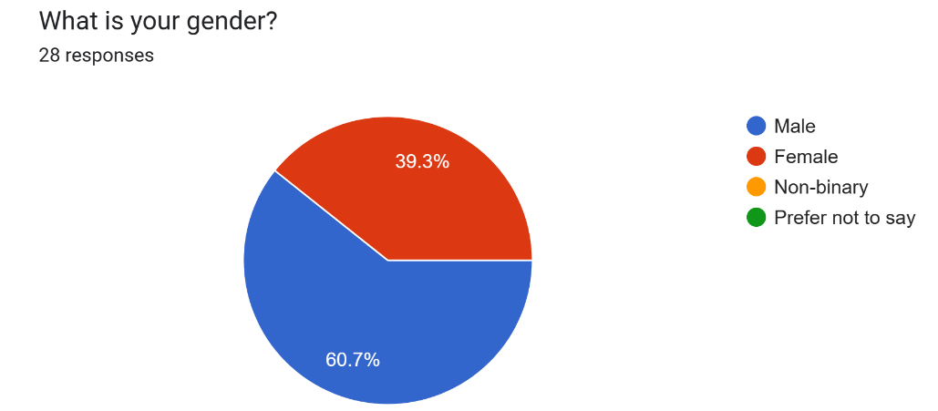
Out of the 28 responses to the survey, 17 of them were male and the remaining 11 were female. This is a good balance of genders which can help to identify if any gender has certain requirements for the website being developed.

Question 2 – What is your age?
No individuals were under the age of 18. 12 of the individuals were between the ages of 18 and 25 which was the highest amount. 3 of the individuals were between the ages of 26 and 35. 2 of the individuals were between the ages of 36 and 45. 4 of the individuals were between the ages of 46 and 55. 3 of the individuals were between the ages of 56 and 65. Finally, 4 of the individuals were over 65. This shows that there is a wide range of ages which can help to identify if certain age groups have certain requirements.
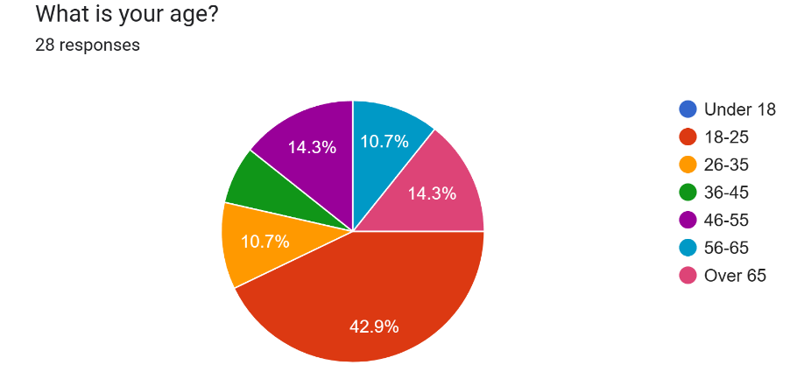
Question 3 – What device do you most commonly use to browse websites?
14 people said that they browse websites on their phones which had the highest results. 10 people said that they use a PC/Laptop. Finally, 4 people said that they use a tablet. This shows that people use a variety of devices to browse websites which means that the website being developed needs to work on a phone, PC/Laptop, and tablets.
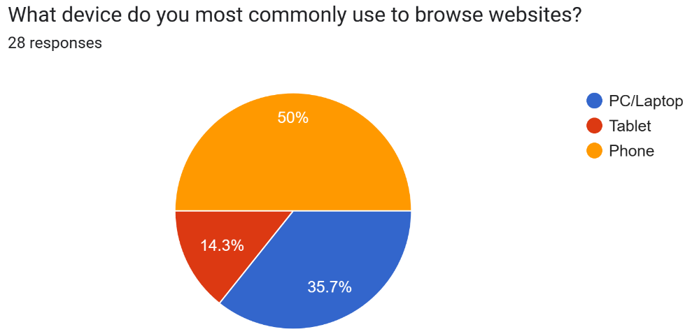

Question 4 – What web browser do you most commonly use to browse websites?
13 people said they use Safari to browse websites which had the highest results. 1 person said they use Samsung Internet. 6 people use Google Chrome. 1 person uses Mozilla Firefox. 5 people said they use Microsoft Edge. Finally, 2 people said they use Opera. This shows that the website being developed needs to be compatible with a variety of browsers such as Safari, Google Chrome, and Microsoft Edge.
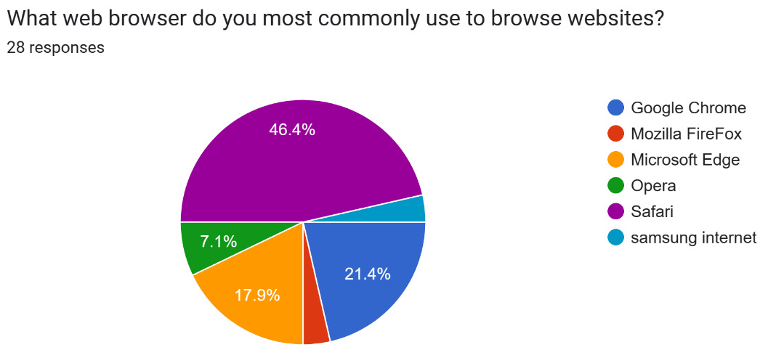

Question 5 – What is something that you like to see on websites?
There were 28 responses to this question with a variety of answers. Some of the most common answers were a simple layout, images, good accessibility, and a navigation bar. This means that the website that is being developed should contain these features.
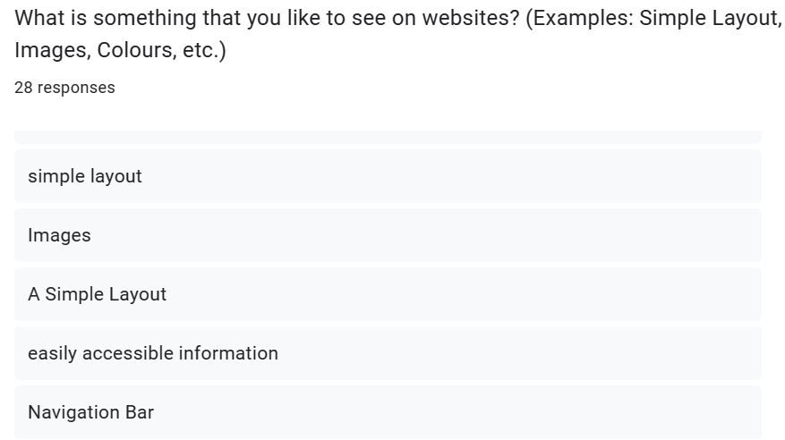

Question 6 – What is something that you do not like to see on websites?
There were 28 responses to this question with a variety of different answers. Some of the most common answers were difficult navigation, confusing layout, an abundance of text, and a bad colour scheme. This means that the website that is being developed should ensure that these things are avoided.
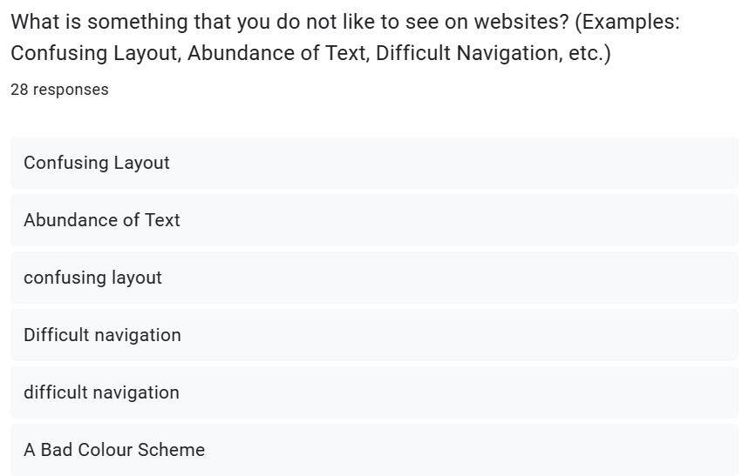

Question 7 – What is the first thing that grabs your attention when using a new website?
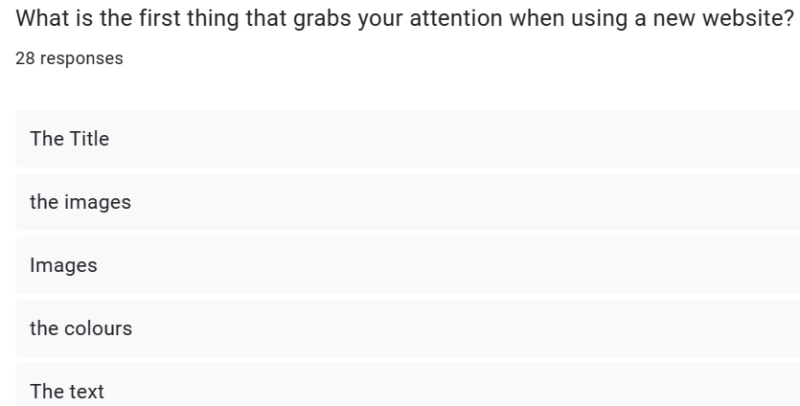
There were 28 responses to this question with a variety of different answers. Some of the most common answers were the title, the images, the colours, and the logo. This means that the website that is being developed should include these things to grab the users’ attention.

Question 8 – How much text do like to see on a website?
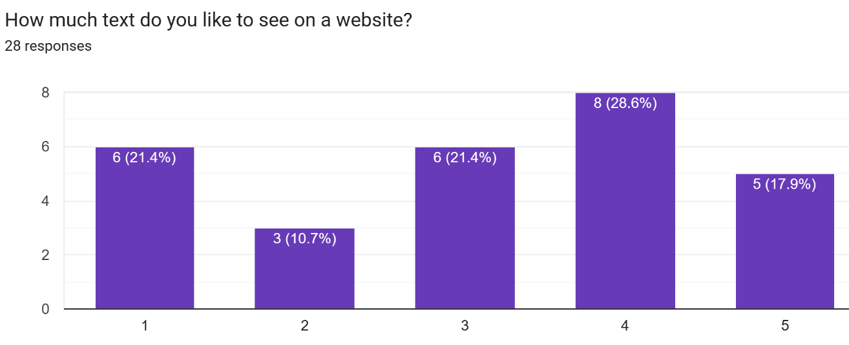
This question used a scale of 1 to 5 with 1 being not a lot of text and 5 being a lot of text. 6 people chose 1, 3 people chose 2, 6 people chose 3, 8 people chose 4 which was the highest answer, and 5 people chose 5. These answers will be taken into consideration to see how much text will be used on the website that is being developed.
Question 9 – How much images do you like to see on a website?
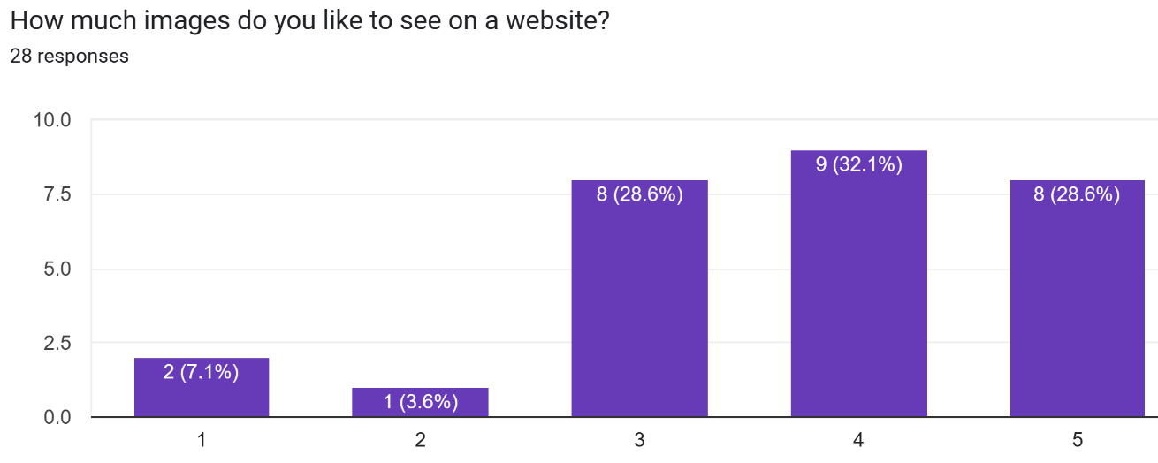
This question used a scale of 1 to 5 with 1 being not a lot of images and 5 being a lot of images. 2 people chose 1, 1 person chose 2, 8 people chose 3, 9 people chose 4 which was the highest answer, and 8 people chose 5. These answers will be taken into consideration to see how many images will be used on the website that is being developed.

Question 10 – How much colour do you like to see on a website?
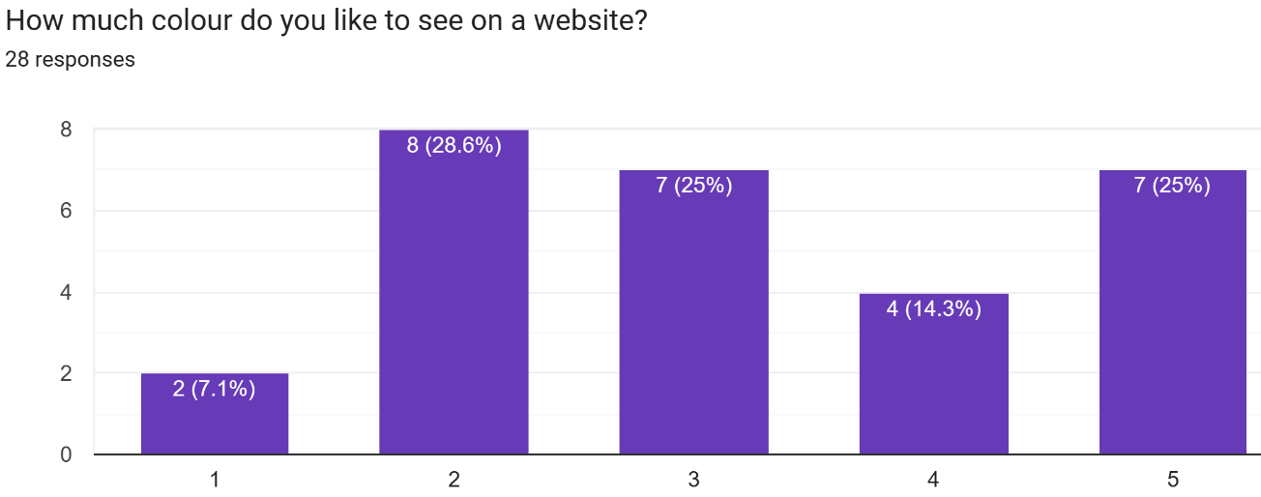
This question used a scale of 1 to 5 with 1 being not a lot of colour and 5 being a lot of colour. 2 people chose 1, 8 people chose 2 which was the highest answer, 7 people chose 3, 4 people chose 4, and 7 people chose 5. These answers will be taken into consideration to see how much colour will be used on the website that is being developed.

Question 11 – What is one thing a website could do or include that would get you to leave the website?
There were 28 responses to this question with a variety of different answers. Some of the most common answers were having a bad layout, bad colours, advertisements, and small text. This means that the website that is being developed should avoid these things to ensure that the user does not leave the website.
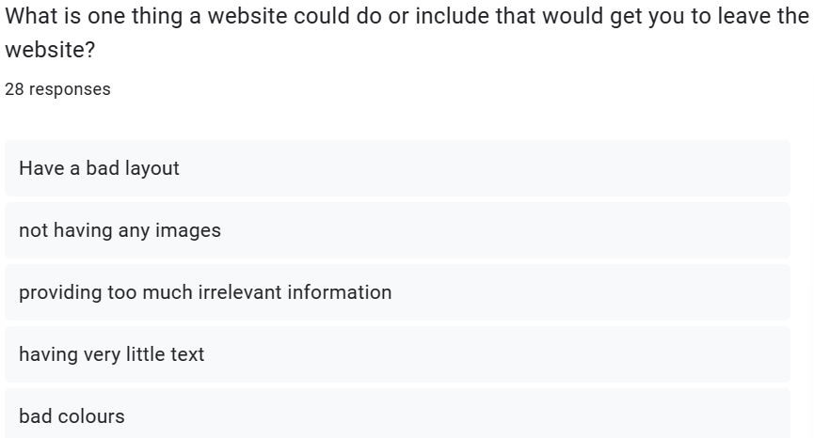

Question 12 – What is one thing a website could do or include to improve the user experience?
There were 28 responses to this question with a variety of different answers. Some of the most common answers were having a good colour scheme, easy navigation, and mobile compatibility. This means that the website that is being developed should include these things to improve the user experience.

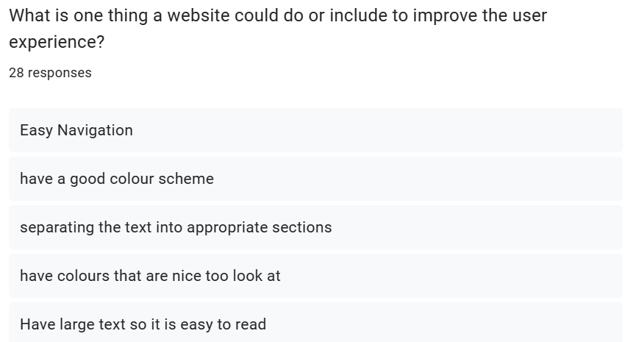

Question 13 – Do you prefer a website to have one page or multiple pages?
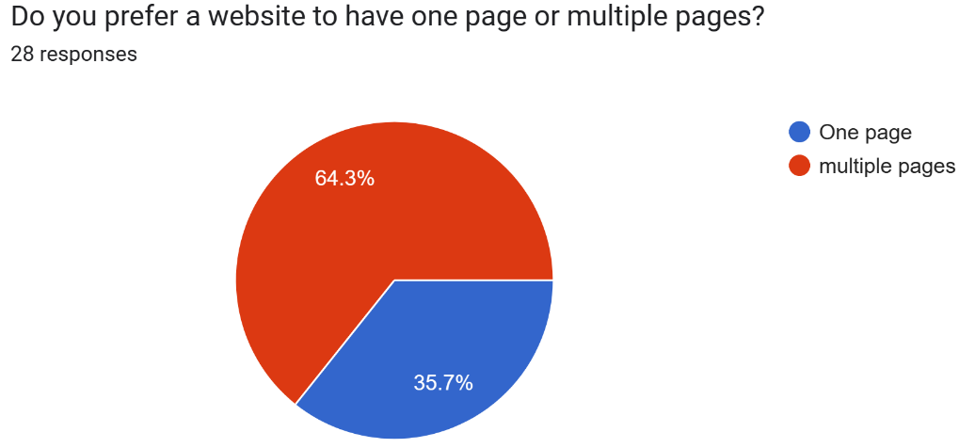
18 people said that they prefer a website to have multiple pages which was the highest answer. 10 people said that they prefer a website to have one page. The website that is being developed will have multiple pages as it was the highest answer.

In conclusion, the results that have been gathered from this survey will help to create the requirements for the website that is being developed. By implementing these requirements, the website will have good usability and accessibility which can help to improve the users’ experience.

4.3. Existing Websites

This section of the design and implementation chapter is going to look at some existing University websites to find out what usability and accessibility features they do and do not include. The features that will be concentrated on are the navigation menu, alt text, usable forms, browser and mobile consistency, colour scheme, and keyboard-only navigation to limit the scope of the project. This is to help get an idea of the features that need to be included on the website being developed to ensure that it has good usability and accessibility to help improve the users’ experience. The websites that will be looked at will be limited to University websites due to the scope of the project.

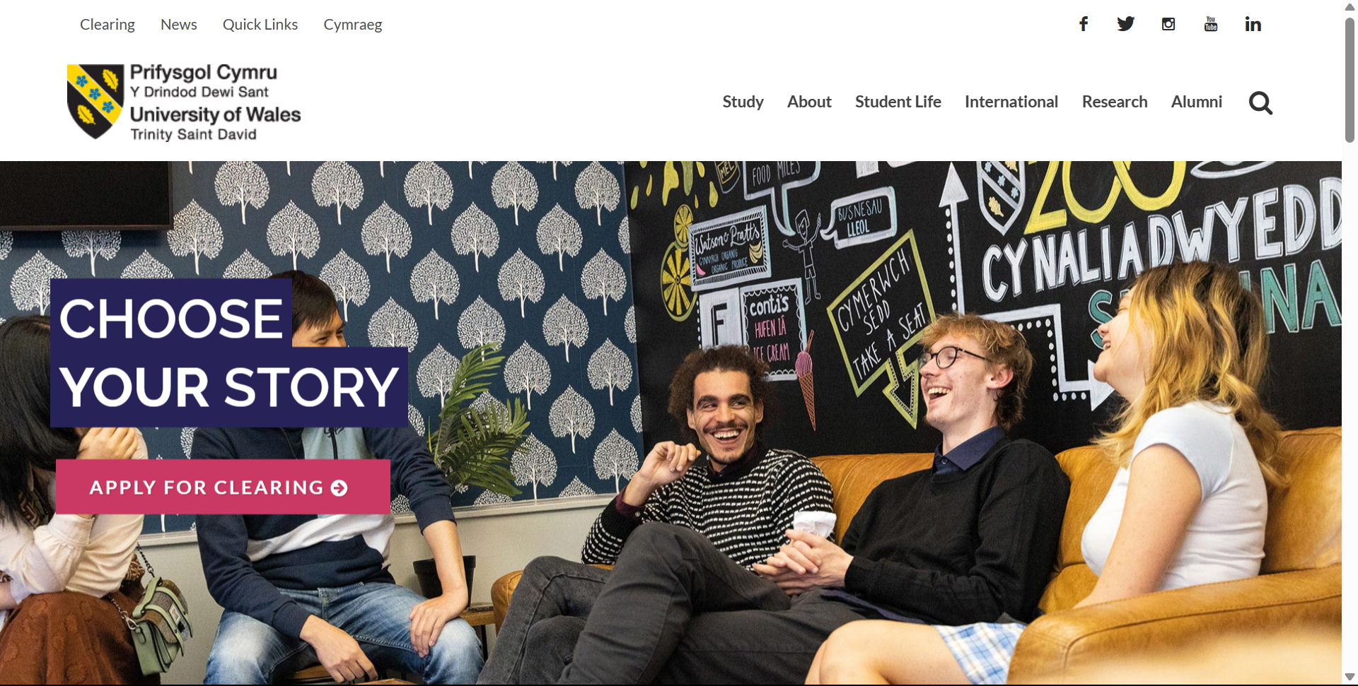
4.3.1. University of Wales Trinity Saint David
The first website that will be looked at is the University of Wales Trinity Saint David [23]. This website contains a variety of information, from courses to campuses to useful resources. This website has good usability. This is because it has a good layout which provides the user with information in a way that makes it easy for them to understand. It also contains a navigation menu which can help the user navigate the website which is good for the website’s usability. The website also has good accessibility. This is because the website can be navigated by only using a keyboard. This is good for users with physical disabilities which prevents them from using a mouse. The website also contains alt text on the images which is good for users who are browsing the website with visual disabilities. The website is also compatible with a variety of different browsers which means that the user will get the same experience regardless of the browser they are using. The website is also compatible with mobiles which means that the user can view the website on their mobile phone without experiencing any issues. The website also contains forms that the user can fill in with any questions that they have. This is good for the user experience as any questions that they have can be answered with direct contact.
In conclusion, this website can help with the development of the website as it contains a variety of different features that can be implemented into the website being built to help improve its usability and accessibility which will improve the users’ experience.

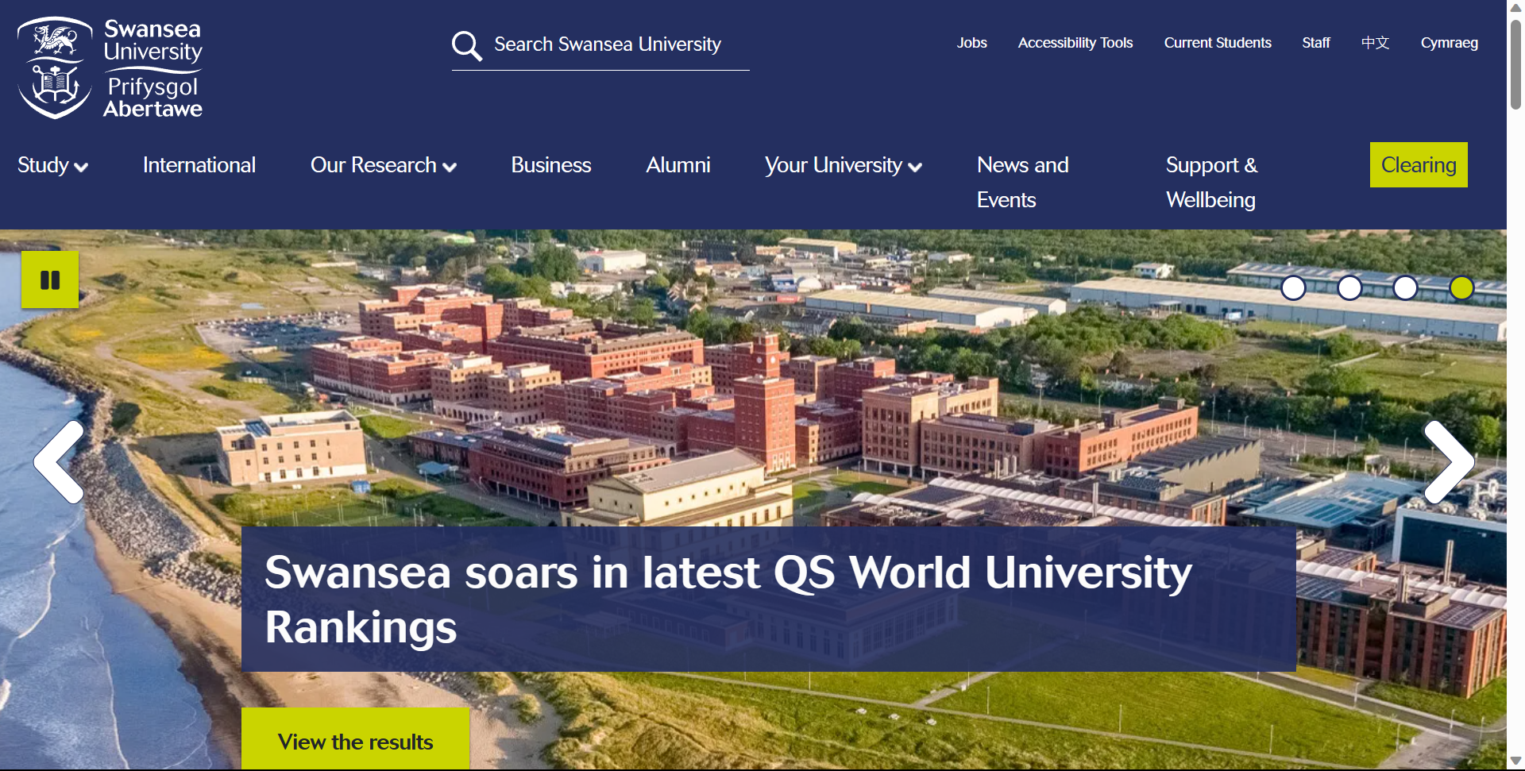
4.3.2. Swansea University

The second website that will be evaluated is Swansea University [24]. This website contains information about courses, accommodation, student life, and much more. The website has a good layout which is good for usability as it means that the user should have no issues navigating the website. The website also contains a navigation menu which can help the user easily navigate the website which is good for usability. The website uses alternative text on its images which is good for accessibility as it means that visually impaired users who use screen readers will be able to understand what the image is displaying. The website allows for keyboard-only navigation which is good for users with physical disabilities and improves the website accessibility. The website is compatible with multiple different browsers and mobile phones. This is good for usability as users will get the same experience on the website regardless of browser or device which is good for the users’ experience. The website also contains usable forms that the user can use to make any enquiries. This is good for the user experience because if the user has any questions, they can be answered without the user having to search for the information.
In conclusion, this website contains a variety of different information and features that can be implemented into the website that is being developed to help improve its usability, accessibility, and user experience.

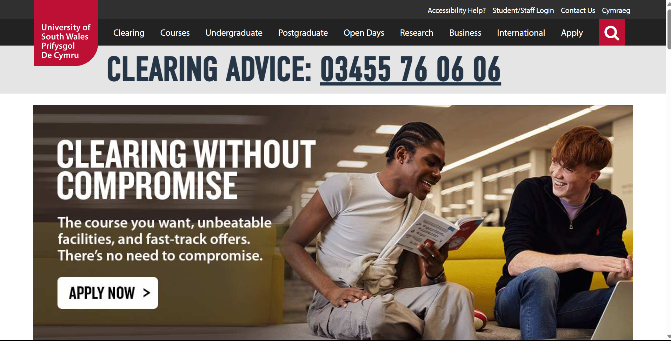
4.3.3. University of South Wales

The third website that is going to be evaluated is the University of South Wales [25]. This website contains a variety of information such as clearing advice, open days, apprenticeships, and much more. The website has a good layout with a good colour scheme which is good for usability as it can help to make navigation easier for the user. The website also contains a navigation menu which can help the user easily navigate between pages which is also good for usability. The website features alternative text on its images which is good usability for visually impaired users. The website can be navigated with only a keyboard which is good for physically disabled users. Both of these features are good for accessibility. The website can be used on a variety of different browsers and devices which is good for usability as the user will have the same experience regardless of the device or browser they are using which is good for the users’ experience. The website also contains usable forms which allow the user to make enquiries. This is good for the users’ experience because if they have any questions, they can easily ask them without any hassle.
In conclusion, this website is good as it offers a variety of features which are good for usability and accessibility. By implementing these features onto the website that is being developed, the website will have good usability and accessibility which could improve the users’ experience.

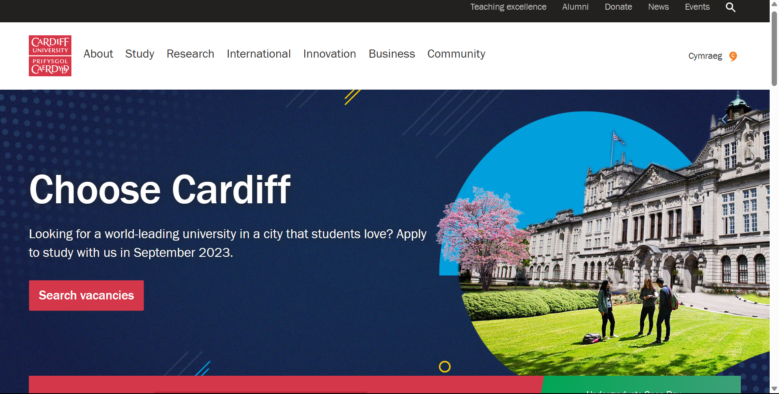
4.3.4. Cardiff University

The final website that is going to be evaluated is Cardiff University [26]. This website contains a variety of information such as vacancies, clearing advice, course information, and much more. The website has a good layout and a good colour scheme which can help to make navigation easier for the user which is good for usability. The website also contains a navigation menu which can help the user navigate between pages quickly which is also good for usability. The website allows for the user to navigate it with only a keyboard which is good for physically disabled users. The images on the website contain alternative text which is good for visually impaired users. Both of these features are good for accessibility. The website supports a variety of different browsers and devices which means that the user can view it on whatever device and browser that they want which is good for usability. The website also contains usable forms which allow the users to ask any questions which is good for the users’ experience.
In conclusion, this website includes a variety of different features which are good for usability and accessibility. These features can be implemented on the website being developed to ensure that it has good usability and accessibility which can result in a better user experience.

4.4. Website Summary Table

This section is going to contain a summary table which compares each website to see what features they have and do not have. This can help to identify which features are most common and which features are least common to determine which features should be included on the website being developed.
 | Website Features
Website Name | Navigation Menu | Alt Text | Usable Forms | Browser Consistency | Mobile Compatibility | Good Contrasting Colour Scheme | Keyboard Only Navigation
www.uwtsd.ac.uk | YES | YES | YES | YES | YES | YES | YES
www.swansea.ac.uk | YES | YES | YES | YES | YES | YES | YES
www.southwales.ac.uk | YES | YES | YES | YES | YES | YES | YES
www.cardiff.ac.uk | YES | YES | YES | YES | YES | YES | YES

As the summary table above shows, all four websites contain all seven website features that are listed in the table. This means that the seven features that are listed are important features that all websites should include. This helps with the development of the website because it means that the website should include all seven of these features to improve its usability and accessibility which can help to improve the users’ experience.

4.5. Website Requirements

This section is going to contain the requirements for the website that have been gathered from the literature review, the survey that was carried out, and the existing websites that were looked at.
- The website needs to be compatible with PCs/laptops, phones, and tablets.
This is so users can access the website regardless of their device without running into any problems.
- The website needs to be compatible with a variety of different browsers.
This is so the users can access the website regardless of the browser that they are using without running into any problems.
- The website needs to be appropriate for all age groups.
This is due to the survey encompassing different age groups, necessitating the website to be appropriate for all of its users.
- The website should not have a cramped layout.
The survey findings indicated that it is advisable to avoid excessive text on the screen, as users have expressed their preferences against it.
- The website needs to contain images.
The survey findings indicated that users would like to see images on the website. This can help to make their experience better.
- The website must contain a usable form that the user can fill in.
This is to test whether users can fill in a form using assistive technologies such as a screen reader or keyboard-only navigation.
- The database needs to store the data that the user enters on the website.
This is to ensure that the website and database work correctly with each other. This would make the website experience more complete.
- The website needs to display the courses and modules that are stored in the database.
This is to ensure that the website and database work correctly together. This would make the website experience more complete.
- The website needs to have good usability.
This means that the website should feature a well-organised layout, user-friendly navigation, and a visually appealing colour scheme to ensure that the user has a good experience with the website.
- The website needs to have good accessibility.
This means that the website should feature alternative text for all of the images, keyboard-only navigation, usable with a screen reader, readable text size, and more to ensure that the user has a good experience with the website.
- The website must contain a contact page.
This is because the existing websites that were looked at all contained a contact page. The contact page needs to contain contact information for the University and an interactive Google Map that shows the location of the University.
- The website must have multiple pages.
This is because the survey indicated that people prefer a website to have multiple pages. It would also help to get a better idea of what the users' opinions are on the website navigation.
These are all of the requirements that have been created for the website that is being developed.

4.6. Design

Once the requirements had been gathered, the designs for the database and website could be created. The website would contain a form that the user could fill in if they had any questions that they wanted to ask the University. The form details would then be stored in the database. The database would also contain the courses and modules that the University offers to students. These courses and modules would be displayed on the website. This meant that the database needed to store details about the user, the users’ questions, modules, and courses. Once it decided on what the database would be storing, an entity relationship diagram was created to see what tables and fields would be needed to store the necessary data. The entity relationship diagram for the database that is going to be created can be found below.

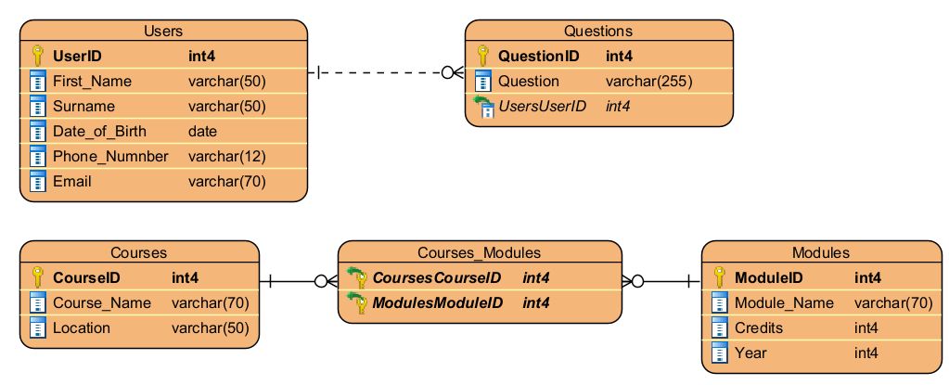
4.6.1. Database Design

The entity relationship diagram that was created contains five tables. The first table is the ‘Users’ table. This table will store all of the users’ details after they fill in the form on the website. This table is linked to the ‘Questions’ table.
The second table is the ‘Questions’ table. This table will store the users’ questions after they fill in the form on the website.
The third table is the ‘Courses’ table. This table will store all of the information about the available courses. This table is linked to the ‘Courses_Modules’ table.
The fourth table is the ‘Modules’ table. This table will store all of the information about all of the available modules. This table is also linked to the ‘Courses_Modules’ table.
The final table is the ‘Courses_Modules’ table. This table will contain all of the courses and it will show all of the modules that each course contains.
Once the database had been designed and the entity relationship diagram had been created, the implementation of the database could then be carried out.

4.6.2. Website Design

This section is going to discuss the design for the website that is being created. After the database had been designed, the design for the website could be constructed. The website design would be based on the requirements that have been gathered from the survey and literature review that have been carried out. This is to ensure that the website meets the users’ needs which can help to ensure that the website has good usability and accessibility which could improve the users’ experience when using the website.
The website will be for the University of Wales Trinity Saint David. It will contain information about the courses and modules that they have to offer. Users will be able to fill in a form with any questions that they have.
The first page on the website will be the ‘Home’ page. This page will contain information about what the website contains. It will also contain a navigation menu at the top of the page so that users can navigate between pages. There will be images on the page and a footer which contains some additional information. The navigation menu and the footer will be on every page of the website.
The second page on the website will be the ‘Campuses’ page. This page will contain information about the different campuses that are available for students to study at. There will also be images of the campuses on this page.
The third page on the website will be the ‘Departments’ page. This page will contain information about four different departments that are available to study at the University. These departments are Computing, Business and Management, Art and Design, and Health and Social Care. There will be an image for each department that the user can click which will take them to a sub-page for that specific department. There will be a sub-page for all four of the departments which will contain information about each of the departments and the courses and modules that are available for each department. The courses and modules will be pulled from the database that is being created alongside the website.
The fourth page on the website will be the ‘Contact’ page. This page will contain contact information for the University. There will be an interactive Google Map that shows the location of the University.
Finally, the fifth page on the website will be the ‘Enquiry’ page. There will be a usable form that the user can fill in with any questions that they want to ask. These questions and user details will be stored in the database that is being created alongside the website.
Once the design of the website had been created, the website could then be implemented.

4.7. Implementation

This section is going to talk about the implementation of the website and database after the designs of the website and database had been carried out.

4.7.1. Database Implementation

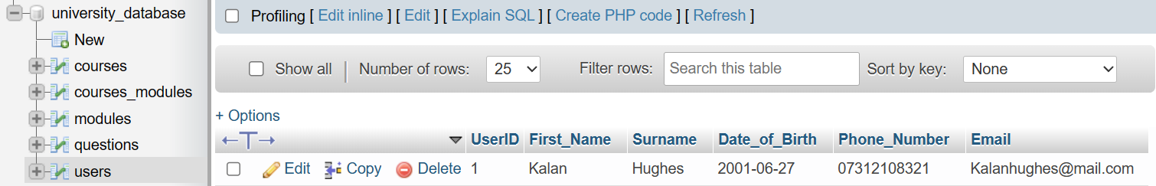
This section is going to talk about the implementation of the database that was created for the University website. Implementing the database was a relatively simple process. This is because the entity relationship diagram was used to help with the creation. The first step of the implementation was to create the ‘users’ table. This table has 6 different fields which are used to store the customers’ details. The primary key on this table is the ‘UserID’. When the user enters their details on the website, they are stored in this table once they submit the enquiry form.
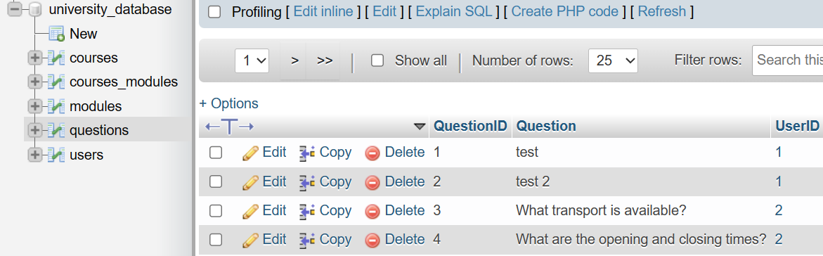
The second table that was implemented was the ‘questions’ table. This table has three different fields that store the questions that the users ask when they fill in the enquiry form. The primary key on this table is the ‘QuestionID’. When the user enters their details on the website, their details are stored in the ‘users’ table and their questions are stored in the ‘questions’ table. If the users' details already exist in the ‘users’ table, only their question is inserted into the database. This is to prevent duplicate details from being inserted into the database.

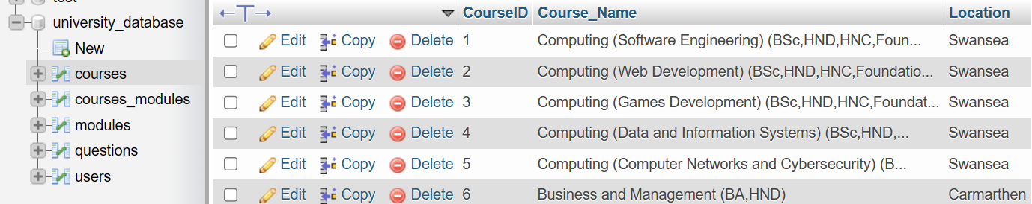
The third table that was implemented was the ‘courses’ table. This table has three different fields that store all of the information about the courses that are displayed on the website. The primary key on this table is the ‘CourseID’.

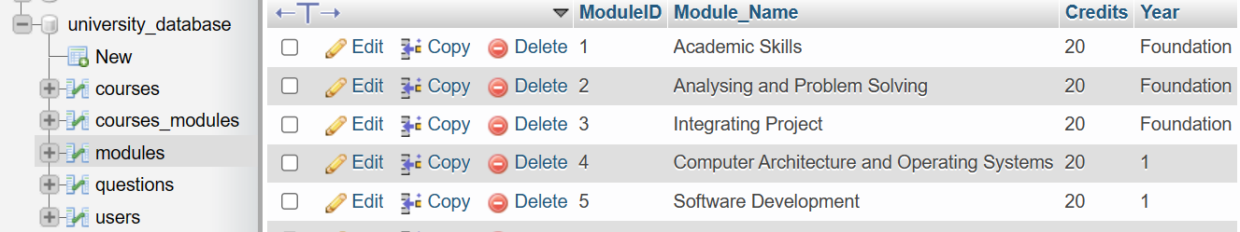
The fourth table that was implemented was the ‘modules’ table. This table has four different fields that store information about all of the modules that are displayed on the website. The primary key on this table is the ‘ModuleID’.
The final table that was implemented was the ‘courses_modules’ table. This table is a junction table between the ‘courses’ table and the ‘modules’ table. The purpose of this table is to show all of the modules contained within each course. This table has two primary keys. The first primary key is the ‘CourseID’ from the ‘courses’ table. The second primary key is the ‘ModuleID’ from the ‘Modules’ table. This table is used to display each course and its modules on the website.
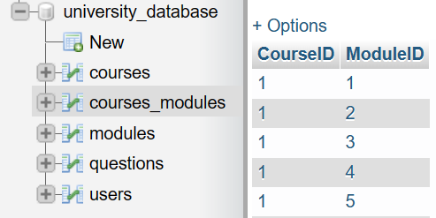

Once all of the tables had been implemented and data had been added to the ‘courses’, ‘modules’, and ‘courses_modules’ tables, the database was complete. This meant that the implementation of the website could commence.

4.7.2. Key Issues That Need To Be Addressed

This section is going to focus on the key issues that need to be addressed within the website implementation. The first issue that needs to be addressed is screen-reader navigation. This is because the whole website needs to be usable with a screen reader so that visually impaired users can get the whole website experience. The second key issue that needs to be addressed is keyboard-only navigation. This is because the whole website needs to be usable with only a keyboard so that physically impaired users can get the same experience when using the website as everyone else. The third key issue that needs to be addressed is compatibility. This is because the website needs to be compatible with a variety of devices and browsers so that every user gets the same experience with the website regardless of how they access it. Another key issue that needs to be addressed is usability. This is because the whole website needs to have good usability so that the users have a good experience with the website. This means that the website has to have a good layout and easy navigation to ensure that the website has good usability. The final key issue that needs to be addressed is making sure that the website is age-appropriate. This is to make sure that the users have a good experience with the website regardless of their age. These are some of the key issues that need to be addressed with the website that is going to be implemented.

4.7.3. Website Implementation

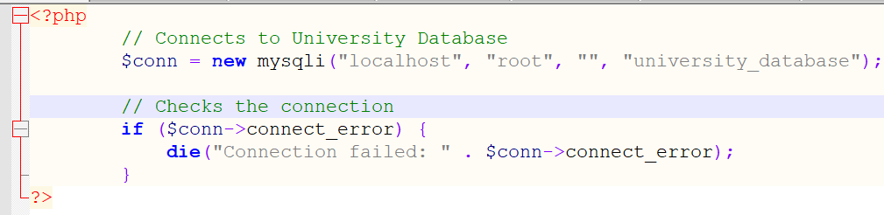
This section is going to talk about the implementation of the website that has been created. The first step of implementing the website was to create a file called ‘conninfo.php’. This file allows the website to connect to the database. This would allow information that is stored in the database to be displayed on the website. It would also allow for data that is entered on the website to be stored in the database.
Once the ‘conninfo.php’ file had been created, it was time to start implementing the website based on the website design that was previously created. The website took some inspiration from the existing UWTSD web pages [27], [28], [29], [30]. The first page of the website that was implemented was the ‘Home Page’. This page contains a header, navigation bar, and a footer. All of these things can be found on each page of the website to ensure that the website has a consistent design. The colour scheme is also the same on every page. By keeping the same layout and colour scheme, the user will become familiar with the design of the website which would be good for their experience. The ‘Home Page’ contains information about the content that can be found on the different pages of the website.
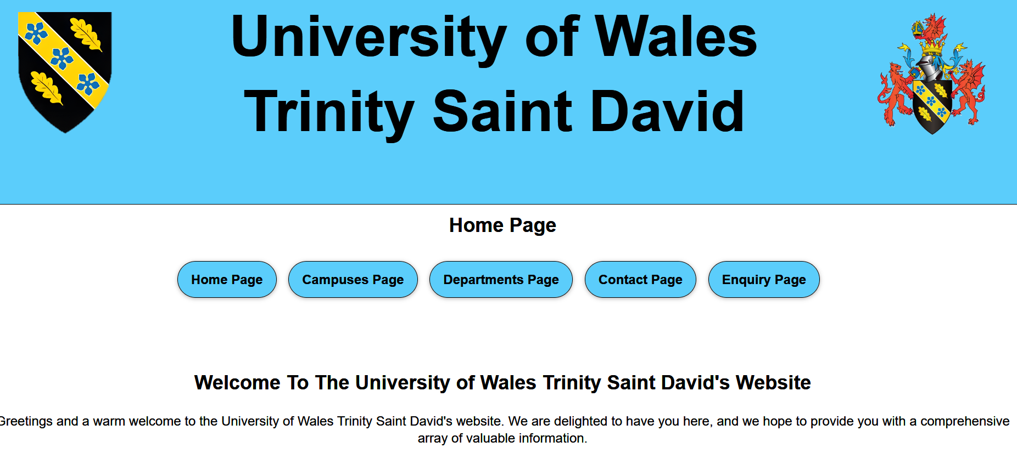

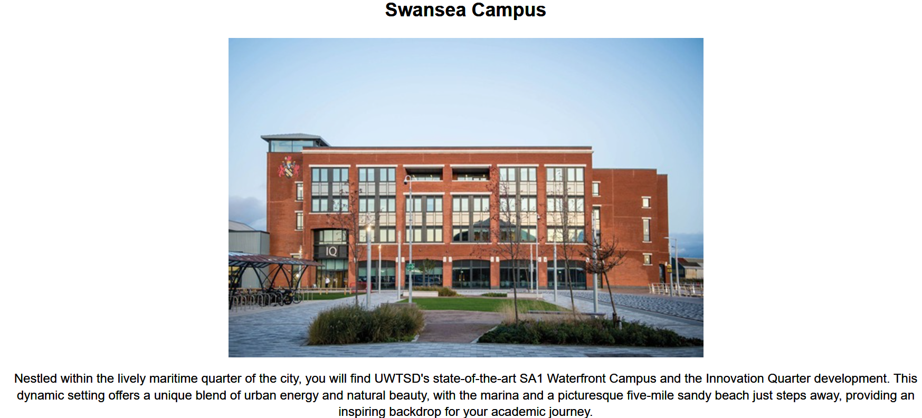
The second page that was implemented was the ‘Campuses Page’. This page contains information about four different campuses that are available to study at. Each campus has an image and a description that talks about the campus.
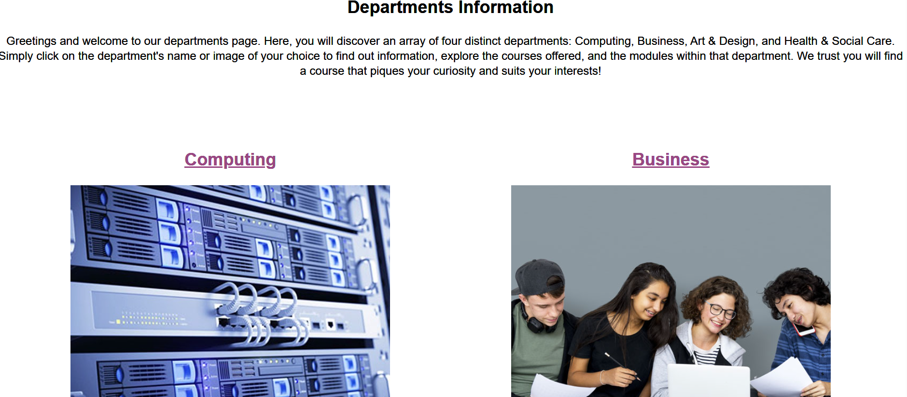
The third page that was implemented was the ‘Departments Page’. This page contains four different departments that are available to study. These departments are ‘Computing’, ‘Business’, ‘Art & Design’, and ‘Health & Social Care’. Each department has a title and an image that can be clicked which will take the user to a subpage about that specific department.

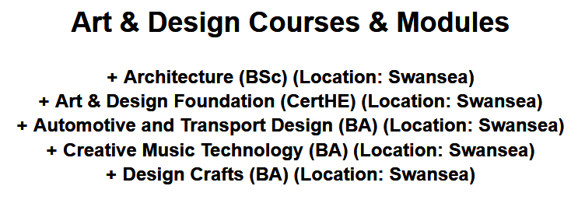
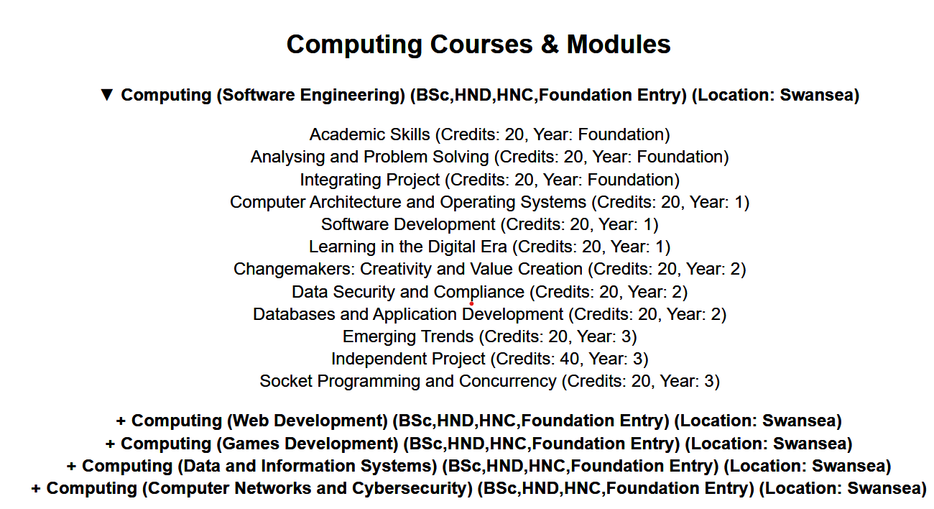
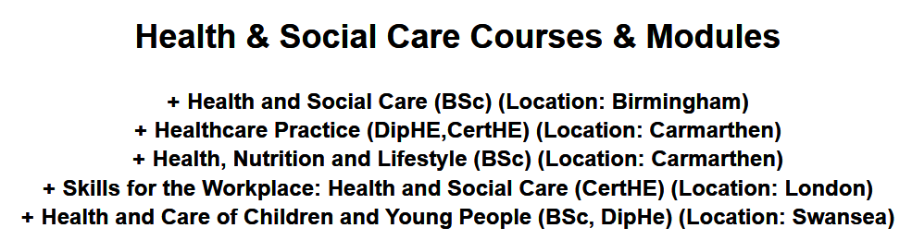
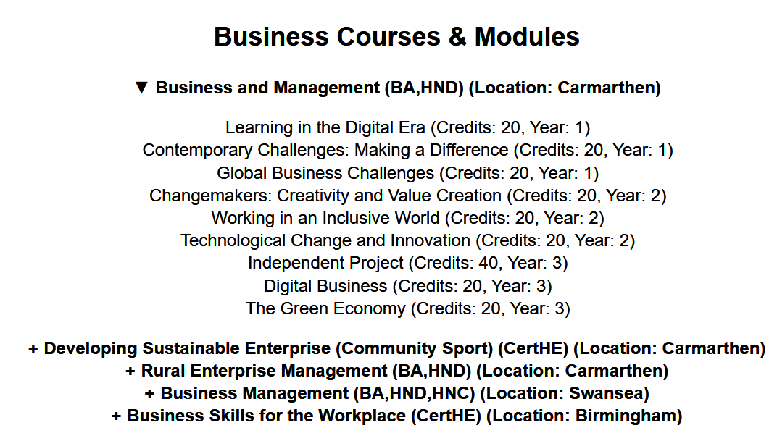
The next pages that were implemented were the departments' subpages. When a department was clicked on the ‘Departments Page’, the user would be taken to a subpage for that specific department. The subpage would contain information about the department, and it would contain a section with all of the courses that are available within the department. Clicking on the course would expand it to show all of the modules that are available within the course. The courses and modules that are displayed on the pages are pulled from the database.
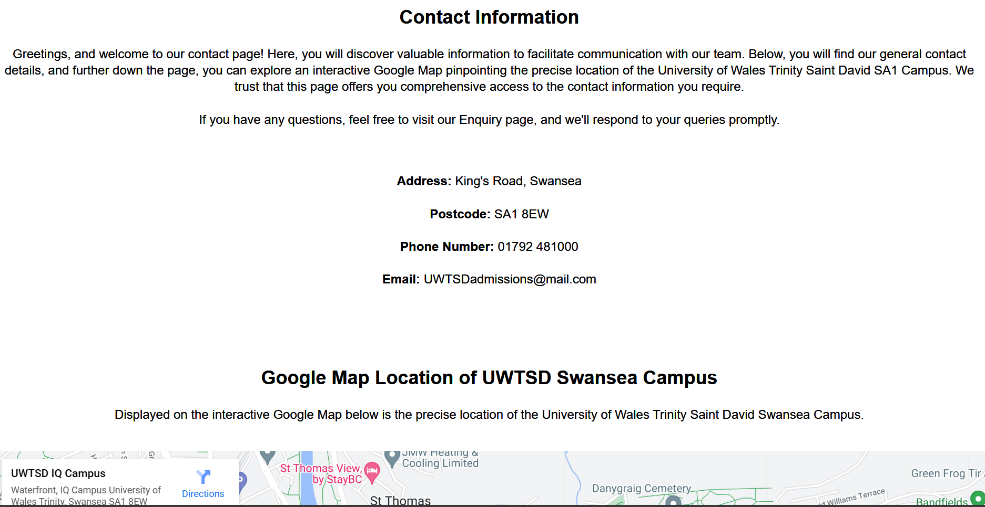
The next page that was implemented was the ‘Contact Page’. This page contains contact information for the University. It also contains an embedded interactive Google Map that shows the location of the University of Wales Trinity Saint David SA1 Campus [31].

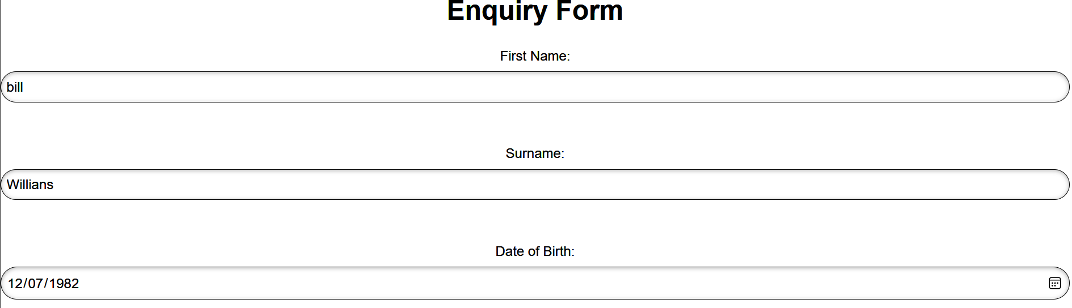
The next page that was implemented was the ‘Enquiry Page’. This page contains information about any enquiries that the user may have. It also contains an enquiry form that the user can fill in with any questions that they have. When they click the submit button, the information that they entered on the form is inserted into the database.

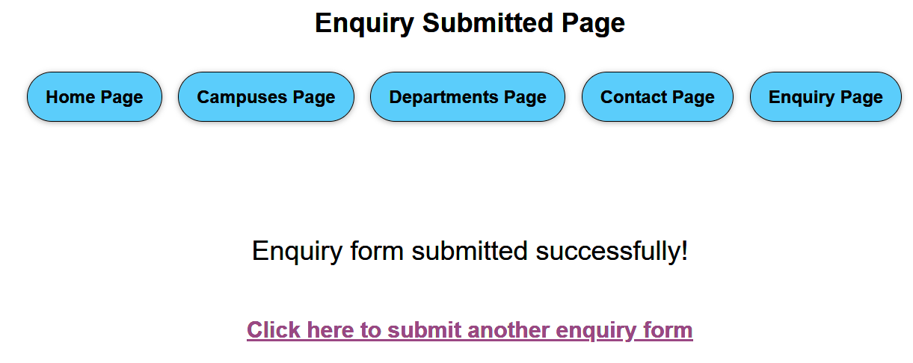
The final page that was implemented was the ‘Enquiry Submitted Page’. This page is displayed after the user clicks the button to submit their enquiry form. It lets them know that their enquiry form was submitted, and it contains a button that takes them back to the enquiry form so that they can submit another enquiry form.

These were all of the pages that were implemented for the website that was developed. After all of the pages had been implemented, the website needed to be tested to ensure that everything worked correctly. The first test that was carried out was functional testing. This consisted of three parts. The first part was unit testing [32]. Unit testing was used to test the individual components of the website to make sure that they all worked correctly. After the unit testing was carried out, the integration testing was carried out [33]. The integration testing was used to test the individual components as a group to make sure that they worked together correctly without any issues. After the integration testing was carried out, the system testing was carried out [34]. This was to test the whole system to make sure that everything worked correctly which it did. This concluded the functional testing of the website.
After the functional testing was carried out, the usability of the website was tested. This was to make sure that the users could use the website without having any issues. This means that things such as the buttons, form, and navigation were tested to make sure that they all worked correctly which they did.
After the usability of the website was tested, the accessibility was tested. This was to make sure that users could use the website without having any accessibility issues. This meant that things such as screen readers, keyboard-only navigation, and the colour scheme were tested to make sure that they all worked correctly which they did.
After the accessibility was tested, the compatibility of the website was tested. This was to make sure that the website worked correctly on different devices and browsers. This was to prevent the user from running into any issues depending on the device or browser that they were using. There were no compatibility issues found during the testing.
Finally, the database was tested to ensure that the data that was stored in the database was being displayed on the website correctly and any data that was entered on the website was being stored in the database correctly. This was to ensure that the courses and modules were being displayed on the website and also to ensure that the enquiry forms were being stored in the database. There were no issues with the database.
This concludes all of the types of testing that were carried out on the website and database to ensure that they worked correctly. Once all of the testing had been carried out, the implementation of the website and database had been completed. This meant that the usability study could now commence. This concludes the chapter that discussed the design and implementation of the website and the database that was created for this project.

4.7.4. How The Requirements Were Met

This section is going to discuss how all of the requirements were met when implementing the website. The first two requirements needed the website to be compatible with a variety of devices and browsers. These requirements were met as the website is responsive which means that it works on a variety of devices and browsers. The third requirement needed the website to be appropriate for all age groups. This requirement was met as the website has a simple layout that is appropriate for all ages. The fourth requirement said that the website should not have a cramped layout. This requirement was met as the website did not have a cramped layout. The fifth requirement said that the website should have images. This requirement was met as the website had images. The sixth requirement said that the website must contain a usable form that the user can fill in. This requirement was met as the website contained an enquiry form that the user could fill in. The seventh requirement said that the database needs to store data that the user enters on the website. This requirement was met as the data stores the information that the user enters in the enquiry form. The eighth requirement said that the website needs to display courses and modules that are stored on the database. This requirement was met as the website does display courses and modules that are stored in the database. The ninth requirement said that the website needs good usability. This requirement was met as the website contains a simple layout and easy navigation which provides good usability. The tenth requirement said that the website needs good accessibility. This requirement was met as the website can be navigated with a screen reader and keyboard only. The website also has an appropriate text size and font which helps with the accessibility. The eleventh requirement said that the website must have a contact page. This requirement was met as the website has a contact page. The final requirement said that the website needs multiple pages. This requirement was met as the website has a variety of different pages. This is how all of the requirements were met during the implementation of the website.

Chapter 5. Results and Evaluation

After the website and database had been implemented, the usability study could be carried out. The purpose of the usability study is to see if the website that was developed based on the requirements gathered had good usability and accessibility. By carrying out the usability study, the results would help to see if the hypothesis could be proven true. The hypothesis asks the question ‘Does improved usability and accessibility of a website improve the user experience?’. To help test this hypothesis, a usability study and questionnaire would be carried out on fifteen participants. There will be three separate groups that the participants will be split into. Five of the participants will have visual disabilities so they will use a screen reader to carry out the usability study. Five of the participants will have physical disabilities which means that they will use a keyboard only to carry out the usability study. Finally, the remaining five participants will not have any disabilities. However, two of these participants will use a keyboard only to complete the usability study. The reason why the third group of participants will not have any disabilities is so that they can be compared with participants who do have disabilities to see how their experience differs when completing the tasks in the usability study. After all of the participants carry out the usability study, they will be given a questionnaire to fill in so that their experience with the website can be evaluated to test the hypothesis. An example of the usability study and questionnaire can be found below. All of the participants’ usability study and questionnaire results can be found in the appendix.

5.1. Usability Study Example

Participant: 1
Gender: Male
Age: 72
Disability: Visual
Assistive Technology: Screen Reader
Tasks | Time To Complete | Comment
Task 1: Use the interactive Google Map on the contact page to find how many stars the UWTSD IQ Campus is rated. | 2 minutes 59 seconds | No problems were encountered.
Task 2: Find out the year and month the London Campus expanded to a second location called ‘Holborn Circus’. | 5 minutes 41 seconds | No issues. Took some time to navigate through the campus information.
Task 3: Display the modules for the ‘Web Development’ course. | 3 minutes 48 seconds | The task took the user quite some time to complete.
Task 4: Find the phone number for the University. | 1 minute 30 seconds | Easy to complete as I previously used the contact page.
Task 5: Submit two enquiry forms. | 6 minutes 18 seconds | No issues were encountered. Took some time to fill in the form.

Above is an example of an example of the usability study that was carried out on a participant. The top of the usability study shows the participants' number, gender, age, disability, and assistive technology that was used to browse the website. This is to help see if there were any similarities or differences depending on the participant's gender, age, disability, or assistive technology used. The participants were given five tasks to complete. The tasks required the participant to navigate every page on the website which would help to ensure that they get the full experience of the website before they give their opinion on it. The participants would be timed to see how long it took them to complete each task. This is so the time it takes them to complete a task can be compared to other participants. Finally, the participant would be asked for a comment after each task to see their thoughts on the task. This is to help see if they experienced any difficulties or problems when carrying out the tasks. After the participants carried out the usability study, they filled in a questionnaire. The questionnaire that this participant filled in can be found below.

5.2. Questionnaire Example

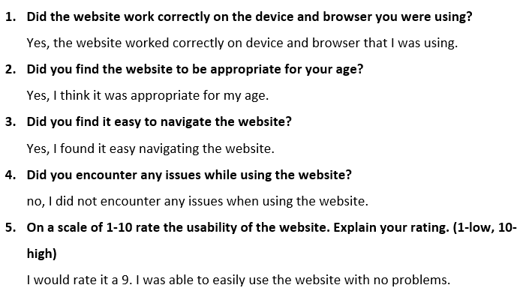

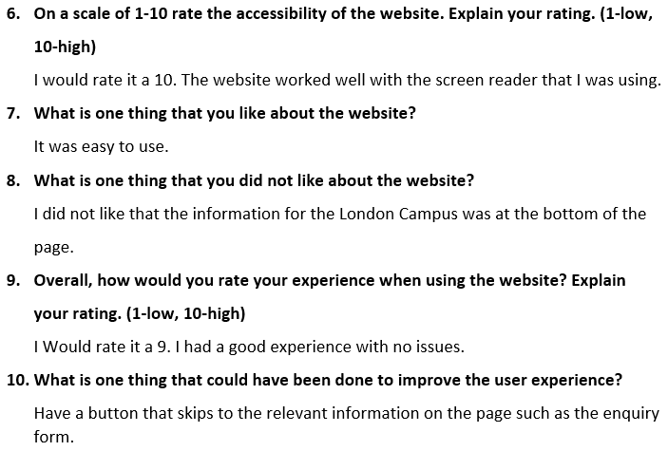

Above is an example of the questionnaire that all of the participants fill in after they carry out the tasks in the usability study. The questionnaire contains 10 questions that are about the website and the users' experience with the website. This questionnaire can help to see what each participant thought of the website. This can help to see if the usability and accessibility of the website improved the users’ experience which can help to test the hypothesis.
After all of the fifteen participants completed the usability study and questionnaire, the results were evaluated to see if the usability and accessibility improved the users' experience. The results for the three groups of participants can be found below.

5.3. Visual Disability Results Evaluation

This section is going to evaluate the results of the first group of participants which was the group with visual disabilities who used screen readers to carry out the usability study tasks. The screen reader that all five participants used was the NVDA screen reader to help keep the results consistent [35].
All five of the participants who used screen readers were able to complete their tasks with no problems or encountering any issues. Task one took an average of two minutes and seventeen seconds to complete. Task two took an average of four minutes and forty-eight seconds to complete. Task three took an average of three minutes and eighteen seconds to complete. Two of the participants took quite some time to complete task three as it took them nearly four minutes to complete it. One correlation between the two participants is that they were both the oldest participants in the group which could be the reason why this task took them a while to complete. Task four took an average of forty-two seconds to complete. Finally, task five took an average of five minutes and twenty-four seconds to complete. The last three participants took a similar amount of time to complete the tasks except the first two participants who took a while to complete task three. They all found the navigation to be easy with the screen reader which is good. They all rated the usability and accessibility highly, with most participants rating it a 10. The participants had a positive experience with the website, with most participants rating their overall experience with the website a 10. Some areas that the users liked about the website were the ease of navigation, the layout, and the fact that there were no issues with the website. The participants did have some suggestions for improvements. These included adding a button to skip to the relevant information, a slideshow or gallery of images, a frequently asked questions section, and an option to automatically display the modules for the courses. All of the participants found the website to be appropriate for their age. All of the participants said that the screen readers worked well with the website.
This evaluation suggests that the website was well-designed in terms of usability and accessibility for people with visual disabilities who use screen readers which is good for improving the users’ experience with the website.

5.4. Physical Disability Results Evaluation

This section is going to evaluate the results of the second group of participants which was the group with physical disabilities who used only a keyboard to carry out the usability study tasks.
All five of the participants who used a keyboard-only to complete the usability study tasks did so quickly and efficiently without any problems. Task one took an average of twenty-three seconds to complete. Task two took an average of one minute and fifteen seconds to complete. Task three took an average of one minute and fourteen seconds to complete. Task four took an average of eighteen seconds to complete. Finally, task five took an average of two minutes and six seconds to complete. All five of the participants took a similar amount of time to complete the tasks. All participants found the website easy to use and navigate with only a keyboard. All of the participants rated the usability and accessibility of the website highly, with most participants rating it a 10. They all found the website to be appropriate to their age. Some areas of the website that the participants liked were the layout, the navigation, and the ease of access to the information. The participants did have some suggestions for improvement. These were the ability to view the modules without having to click the course, and more course-related details. Overall, participants had a good experience with the website, with the rating averaging around nine or ten.
This evaluation suggests that the website was well-designed in terms of usability and accessibility for people with physical disabilities who use keyboard-only for navigation which is good for improving the users’ experience with the website.

5.5. No Disability Results Evaluation

This section is going to evaluate the results of the final group of participants which was the group with no disabilities. Three of the participants did not use any assistive technology. However, two of the participants only used a keyboard to carry out the usability study tasks. This is to see what people with no disabilities thought of the accessibility of the website.
All of the participants found the website to be highly user-friendly. They were all able to complete the tasks quickly and effectively. Task one took an average of seventeen seconds to complete. Task two took an average of forty-three seconds to complete. Task three took an average of thirty-seven seconds to complete. Task four took an average of twelve seconds to complete. Finally, task five took an average of one minute and thirty-two seconds to complete. All five of the participants took a similar amount of time to complete the tasks. All of the participants were able to navigate the website with or without any assistive technology. All of the participants thought that the website had good usability and accessibility. They also all found the website to be appropriate for their age. Some areas of the website that the participants liked were the simplistic design, the layout, the ease of navigation, and the clickable images. One suggestion for improvement that one of the participants had was for more pages and departments on the website. Another participant suggested adding videos. Overall, participants in this group had an overwhelmingly positive experience with the website, with ratings averaging around ten.
This evaluation suggests that the website was well-designed in terms of usability and accessibility for people with no disabilities or people who use a keyboard only for navigation which is good for improving the users’ experience with the website.

5.6. Results Conclusion

After evaluating the three different groups of participants. The first conclusion is that the website has good usability and accessibility. This is because all participants, whether they had a disability or not, were able to complete their tasks with no problems. Another conclusion is that the website is age-appropriate. This is because the participants had a wide age range and they all thought that the website was appropriate. The third conclusion is that the website is compatible with assistive technologies. This is because participants who used screen readers or keyboard-only navigation reported that the website worked well with assistive tools. Another conclusion that can be made is that the website has a good layout, and the design is intuitive and user-friendly. This is because the time it took to complete the tasks was consistent among all the participants. The last conclusion that can be made is that the website provided a good user experience. This is because all of the participants rated the overall website experience a nine or a ten.
The results have also determined that the requirements that were gathered when designing the website were all met. This is because the website was compatible with a variety of devices and browsers. It was also appropriate for all age groups. The website did not have a cramped layout and it contained images. There was a form that the user could fill in and the data was then stored in a database. The website displayed the courses and modules that were stored in the database. The results also show that the website had good usability and accessibility. The website also contained multiple pages, with one of them being a contact page. This shows that all of the requirements were met which makes the website a success.
The results can also help to prove the hypothesis which was ‘Does improved usability and accessibility of a website improve the user experience?’. This is because the results show that all of the participants found that the usability and accessibility of the website were good, with the participants rating the usability and accessibility of the website an average of nine and ten. The results then show that all of the participants found the user experience to be overwhelmingly good with all of the participants rating the user experience an average of nine and ten. This shows that the usability and accessibility of a website do improve the user experience. This means that for a website to have a good user experience, it must have good usability and accessibility.
The results back up the research that was done in the literature review. This is because the literature review was carried out to find out what things websites should include to improve the usability and accessibility of the website. The research was implemented into the website that was developed and the results show that the website has good usability and accessibility which backs up all of the research that was done in the literature review.
All of the objectives that were created for the project were met. This is because research was carried out to gain a better understanding of what is required for a website to have good usability and accessibility. A survey was also carried out on a group of participants to gather the requirements for the website. The website was then developed based on the requirements from the survey. A usability study and questionnaire were then carried out on participants. Finally, the results of the usability study and questionnaire were evaluated to test the hypothesis.
The overarching aim of the project was also met. This is because the aim of the project was to develop a website that is based on requirements that are gathered from a survey and to carry out a usability study on the website to determine whether the usability and accessibility of the website had improved the users’ experience. All of the aspects of this aim were met which means that the overarching aim and all of the objectives were met.
Overall, the results that were gathered from the usability study and questionnaire were expected. This is because the results show that the good usability and accessibility of the website helped to improve the users’ experience of the website which was the expected outcome.
If the project were to be carried out again, one thing that would be done differently is to work with the disabled participants throughout the development of the website to get their input on what could be done differently to the website during development. This would help to ensure that the website has even more accessibility features that may not have been included without constant input from the disabled participants.

5.7. User Experience Requirements

After carrying out the usability study and questionnaire and evaluating the results, a set of requirements have been developed to help improve the usability and accessibility of a website which would improve the users’ experience when using the website. These requirements can be found below.
- Make sure the website works correctly with screen readers (alt text, labels).
- Make sure that the website can be used with only a keyboard.
- Make sure that the website works on a variety of different devices and browsers.
- Make sure that the colour scheme is good for people who are colourblind.
- Make sure that all of the text is a legible size and font.
- Make sure that the website is age-appropriate for the target demographic.
- Make sure that the website has a good layout (Not crammed).
- Make sure that the navigation is simple to understand.
- Make sure that any forms are accessible (Screen readers, Keyboard-only).
- Use headings and subheadings to easily distinguish content.
By implementing these requirements into the website being developed, it can help to improve the usability and accessibility of the website which will improve the users’ experience. It is important to note that there are a lot more requirements that are not listed above that can help to improve the usability and accessibility of a website.

Chapter 6. Conclusion and Recommendations

In conclusion, the project that was carried out was successful for a variety of different reasons. This is because the introduction chapter helped to develop the hypothesis for the project which was proven true after evaluating the results. The introduction also developed an overarching aim and objectives for the project, which were all met after completing the evaluation chapter. The literature review chapter helped to research what things a website should include to improve its usability and accessibility. This was successful as the results show that the website that was created had good usability and accessibility which shows that the literature review was a success. The methodology section helped to find out what ways that data would be collected, the ethical risks, the resources needed, and much more. This was a success as the project followed the structure of the methodology section which helped to make sure that the project went smoothly which it did. The design and implementation section was a success. This is because the survey helped to gather the requirements for the website. The design section helped to get an idea of what the website and database needed to look like. The implementation section used the requirements and designs that were created to implement the database and website successfully. The evaluation section was also a success. This is because a usability study and questionnaire were carried out on participants to find out if the usability and accessibility of the website improved the users’ experience. The results were then evaluated to test the hypothesis. The hypothesis was proven true as the website's good usability and accessibility helped to improve the users’ experience. In conclusion, the hypothesis was proven to be true, and all of the aims and objectives were met.

6.1. Suggestions for Future Work

This section is going to provide some suggestions for future work in this area. One thing that could have been done differently is having the disabled participants use the website during development so they could provide constant feedback. This would be a benefit because it would help the website have better usability and accessibility as the disabled participants may recommend some features that the developers would not have thought of by themself. This is one suggestion for any future work in this area. Another suggestion for future work in this area is to expand on the disabilities that are tested. For example, some people with physical disabilities rely on voice recognition software to use websites. This means that a website could be created that tests if physically disabled people can complete tasks with voice recognition software. This could help to improve the usability and accessibility for people who rely on voice recognition software which would improve the user experience. One benefit of implementing these suggestions is that it would help to improve the user experience for disabled people who use websites. One benefit of the work that has been carried out is that it can help to bring awareness to the usability and accessibility of websites. Hopefully, the work carried out and any future work can help to make websites more accessible to disabled users.

Chapter 7. Reflection

Looking back at the project, I am very happy with how it turned out. There are a lot of things that I have learned during the development of the project. One thing I have learned is how difficult it can be for people with disabilities to navigate websites due to the lack of usability and accessibility options for them. I hope that this project will be able to bring awareness to this to try and make websites more accessible for disabled users in the future.
One skill that I have learned during the development of this project is how to work under pressure. This is because I did not have as much time to carry out this project as I did with my undergraduate project. This put a lot of pressure on me to make sure that I was able to get it done by the deadline. I was able to allocate my time correctly which allowed me to get the project done by the deadline. This leads into the next skill that I built upon which was time management. This project helped me to develop my time management skills because there were a lot of different components to the project that needed to be completed by a certain date or before I could move on to the next task. This required me to manage my time to make sure that I got all of the components done in time in the correct order to maximise my efficiency and the time that I spent working on the project. An additional skill that I learned during the creation of this project is problem-solving. This is because I had problems with XAMPP as it would not start MySQL which meant that I could not load my database. This required me to research how to solve the problem which I managed to do which helped develop my problem-solving skills. The final skill that I have learned during the project is how to analyse and evaluate results. This is because I had to analyse and evaluate the survey carried out to gather the requirements for the website being developed. I also had to analyse and evaluate the usability study and questionnaire that was carried out on the participants to see if the results proved the hypothesis. These are some of the skills that I have learned during the project which can help me in any future work that I carry out.
One skill that I have improved upon is my communication skills. This is because I already had communication skills from carrying out my previous project, but this project helped me to develop my communication skills as I had to communicate with all of the participants. This helped to improve my communication skills. Another skill that I have improved upon is my organisational skills. This is a skill that I already had but this project helped me to improve upon this skill as there were a lot of areas within the project which I had to organise to make sure that I got everything done in the correct order so that I could move on to the next area. The final skill that this project helped me improve upon is adaptability. This is because it was a skill that I already had, but the project required me to be adaptable as some of the participants had to reschedule the date that they were supposed to carry out their usability study and questionnaire. This meant that I had to adapt to this by seeing if any other participants were free during that time to help me maximise my efficiency and to make sure that I was not wasting crucial time. These are some of the skills that I have improved upon during this project.
I achieved everything that I set out to achieve after completing the project. This is because I wanted to create a survey to gather requirements for the website. I then wanted to develop the website and database and test it on participants to see if the usability and accessibility of the website impacted the user experience. I was able to achieve all of this, and I found from the results that improved usability and accessibility do impact the user experience.
One thing that I could have done differently which could have made the project better is having the disabled participants use the website during its development. This is because I could get their feedback on what I could change or add to the website to make it more accessible. This would have helped me include accessibility features that I would not have been able to think of by myself. If I were to expand upon this project in the future, this is one thing that I would do differently.
Overall, I have learned many skills throughout the project, and I achieved everything that I set out to achieve. The knowledge that I have gained from this project can help me in any future work that I undertake in this area. This concludes the reflection chapter of the project.

References

[1] | “The Ultimate List of Web Accessibility and ADA Statistics,” 20 April 2021. [Online]. Available: https://web.archive.org/web/20230321135509/https://www.crownpeak.com/blog/accessibility-ada/the-ultimate-list-of-web-accessibility-and-ada-statistics. [Accessed 3 April 2023].
[2] | Scope, “Frustrated: The ‘F’ word of inaccessibility,” 10 February 2020. [Online]. Available: https://business.scope.org.uk/article/frustrated-the-f-word-of-website-inaccessibility-for-disabled-consumers. [Accessed 3 April 2023].
[3] | Ramiro Gonc¸alve, Tania Rocha, et al., “Evaluation of e-commerce websites accessibility and usability: an e-commerce platform analysis with the inclusion of blind users,” p. 567, 5 July 2017.
[4] | Soomaiya Hamid, et al., “Assessing Ecommerce Websites: Usability and Accessibility Study,” November 2020. [Online]. Available: https://www.researchgate.net/profile/Soomaiya-Hamid/publication/346424847_Assessing_Ecommerce_Websites_Usability_and_Accessibility_Study/links/5fce5710299bf188d4fedd26/Assessing-Ecommerce-Websites-Usability-and-Accessibility-Study.pdf. [Accessed 9 April 2023].
[5] | Ahmed Alshehri, et al., “Assessing the Relative Importance of an E-learning system’s Usability Design Characteristics Based on Students' Preferences,” European Journal of Educational Research, 9 July 2019. [Online]. Available: https://files.eric.ed.gov/fulltext/EJ1222289.pdf. [Accessed 9 April 2023].
[6] | L. G. Pee, J. J. Jiang, G. Klein, “Signaling Effect of Website Usability on Repurchase Intention,” International Journal of Information Management, 2018. [Online]. Available: https://personal.ntu.edu.sg/peelg/publications/Signaling%20Effect%20of%20Website%20Usability%20on%20Repurchase%20Intention.pdf. [Accessed 9 April 2023].
[7] | Stéphanie Girauda, Pierre Thérouanne, Dirk D. Steiner, “Web accessibility: Filtering redundant and irrelevant information improves website usability for blind users,” International Journal of Human-Computer Studies, 15 March 2018. [Online]. Available: https://hal.science/hal-01731012/file/Giraud,%20Th%c3%a9rouanne%20&%20Steiner%20(2018)%20IJHCS%20-%20Web%20accessibility%20%5bpostprint%5d.pdf. [Accessed 9 April 2023].
[8] | Abid Ismail, K.S. Kuppusamy, “web accessibility investigation and identification of major issues of higher education websites with statistical measures: A case study of college websites,” 1 April 2019. [Online]. Available: https://reader.elsevier.com/reader/sd/pii/S1319157818312394?token=000D441E56A5C4AABAD5470BDA6B15AB9740A24CD5AF92F3C90C11B4A93BB1FDFBAFCE914A2737EF297BC800AA5466A3&originRegion=eu-west-1&originCreation=20230421063845. [Accessed 10 April 2023].
[9] | Y. Bai, “The Relationship between Website Accessibility and Usability: An Examination of U.S County Government Online Portals,” vol. 17, no. 1, 1 April 2019.
[10] | Y. Akgul, “Accessibility, usability, quality performance, and readability evaluation of university websites of Turkey: a comparative study of state and private universities,” Universal Access in the Information Society, vol. 20, pp. 157-170, 7 April 2020.
[11] | Gaurav Agrawal, Devendra Kumar, Mayank Singh, “Assessing the usability, accessibility, and mobile readiness of e-government websites: a case study in india,” Universal Access in the Information Society, vol. 21, pp. 737-748, 22 March 2021.
[12] | Patricia Acosta-Vargas, Tania Acosta, Sergio Luján-Mora, “Framework for Accessibility Evaluation of Hospital Websites,” 2018 International Conference on eDemocracy & eGovernment (ICEDEG), 7 June 2018.
[13] | “Web Content Accessibility Guidelines (WCAG) 2.0,” 11 December 2008. [Online]. Available: https://www.w3.org/TR/WCAG20/. [Accessed 12 July 2023].
[14] | A. Connect, “Accessibility Whitepaper,” 2020. [Online]. Available: https://www.adobe.com/content/dam/cc/us/en/products/adobe-connect/customer-success/pdfs/connect-accessibility-whitepaper.pdf. [Accessed 13 July 2023].
[15] | F. Pamplona, “What is Methodology in Research and How Can We Write it?,” 3 August 2022. [Online]. Available: https://mindthegraph.com/blog/what-is-methodology-in-research/#:~:text=The%20three%20types%20of%20methodology,%2C%20quantitative%2C%20and%20mixed%20methods.. [Accessed 17 July 2023].
[16] | “Research Instrument,” [Online]. Available: https://www.studysmarter.co.uk/explanations/marketing/marketing-information-management/research-instrument/#:~:text=Popular%20research%20instruments%20are%20interviews,focus%20groups%2C%20and%20secondary%20data.. [Accessed 6 April 2023].
[17] | “Understanding the Top 9 UX Research Methods & Techniques,” [Online]. Available: https://maze.co/guides/ux-research/ux-research-methods/#:~:text=UX%20researchers%20employ%20different%20research,%2C%20field%20studies%2C%20and%20more.. [Accessed 6 April 2023].
[18] | S. E. Team, “Top 4 software development methodologies,” 28 March 2017. [Online]. Available: https://www.synopsys.com/blogs/software-security/top-4-software-development-methodologies/. [Accessed 6 April 2023].
[19] | D. Ho, “What is Notepad++,” [Online]. Available: https://notepad-plus-plus.org/. [Accessed 6 April 2023].
[20] | “Bringing MySQL to the web,” [Online]. Available: https://www.phpmyadmin.net/. [Accessed 18 July 2023].
[21] | “What is xampp?,” [Online]. Available: https://localhosts.mobi/xampp. [Accessed 18 July 2023].
[22] | “Ethical Issues In Data Collection,” [Online]. Available: https://www.studysmarter.co.uk/explanations/english/research-and-composition/ethical-issues-in-data-collection/. [Accessed 7 April 2023].
[23] | “University of Wales Trinity Saint David,” [Online]. Available: https://www.uwtsd.ac.uk/. [Accessed 15 July 2023].
[24] | “Swansea University,” [Online]. Available: https://www.swansea.ac.uk/. [Accessed 15 July 2023].
[25] | “University of South Wales,” [Online]. Available: https://www.southwales.ac.uk/. [Accessed 15 July 2023].
[26] | “Cardiff University,” [Online]. Available: https://www.cardiff.ac.uk/. [Accessed 15 July 2023].
[27] | “Our Campus,” [Online]. Available: https://www.uwtsdlondon.ac.uk/our-campus/. [Accessed 23 August 2023].
[28] | “Swansea Campus,” [Online]. Available: https://www.uwtsd.ac.uk/swansea/. [Accessed 23 August 2023].
[29] | “Birmingham Campus,” [Online]. Available: https://www.uwtsd.ac.uk/birmingham/. [Accessed 23 August 2023].
[30] | “Why Carmarthen?,” [Online]. Available: https://www.uwtsd.ac.uk/carmarthen/why-carmarthen/. [Accessed 23 August 2023].
[31] | “UWTSD IQ Campus,” [Online]. Available: https://www.google.com/maps/place/UWTSD+IQ+Campus/@51.6170062,-3.926211,17z/data=!3m1!4b1!4m6!3m5!1s0x486e8aaccfb90259:0x4015ee97ec5dce33!8m2!3d51.6170062!4d-3.926211!16s%2Fg%2F11f2rvw2tz?entry=ttu. [Accessed 23 August 2023].
[32] | T. Contributor, “Unit Testing,” May 2023. [Online]. Available: https://www.techtarget.com/searchsoftwarequality/definition/unit-testing#:~:text=Unit%20testing%20is%20a%20software,tests%20during%20the%20development%20process.. [Accessed 23 August 2023].
[33] | M. Narang, “Integration Testing: Real-life Example,” 28 June 2023. [Online]. Available: https://www.shiksha.com/online-courses/articles/integration-testingreal-life-example/. [Accessed 23 August 2023].
[34] | Kinza Yasar, Ryan Black, “system testing,” March 2023. [Online]. Available: https://www.techtarget.com/searchsoftwarequality/definition/system-testing#:~:text=System%20testing%2C%20also%20referred%20to,full%2C%20integrated%20system%20or%20application.. [Accessed 23 August 2023].
[35] | “DOWNLOAD and experience NVDA TODAY,” [Online]. Available: https://www.nvaccess.org/download/. [Accessed 28 August 2023].

Appendices

Usability Study and Questionnaire Results

Blank Usability Study & Questionnaire:
Participant:
Gender:
Age:
Disability:
Assistive Technology:
Tasks | Time To Complete | Comment
Task 1: Use the interactive Google Map on the contact page to find how many stars the UWTSD IQ Campus is rated.
Task 2: Find out the year and month the London Campus expanded to a second location called ‘Holborn Circus’.
Task 3: Display the modules for the ‘Web Development’ course.
Task 4: Find the phone number for the University.
Task 5: Submit two enquiry forms.

- Did the website work correctly on the device and browser you were using?
- Did you find the website to be appropriate for your age?
- Did you find it easy to navigate the website?
- Did you encounter any issues while using the website?
- On a scale of 1-10 rate the usability of the website. Explain your rating. (1-low, 10-high)
- On a scale of 1-10 rate the accessibility of the website. Explain your rating. (1-low, 10-high)
- What is one thing that you like about the website?
- What is one thing that you did not like about the website?
- Overall, how would you rate your experience when using the website? Explain your rating. (1-low, 10-high)
- What is one thing that could have been done to improve the user experience?

Participant 1:
Participant: 1
Gender: Male
Age: 72
Disability: Visual
Assistive Technology: Screen Reader
Tasks | Time To Complete | Comment
Task 1: Use the interactive Google Map on the contact page to find how many stars the UWTSD IQ Campus is rated. | 2 minutes 59 seconds | No problems were encountered.
Task 2: Find out the year and month the London Campus expanded to a second location called ‘Holborn Circus’. | 5 minutes 41 seconds | No issues. Took some time to navigate through the campus information.
Task 3: Display the modules for the ‘Web Development’ course. | 3 minutes 48 seconds | The task took the user quite some time to complete.
Task 4: Find the phone number for the University. | 1 minute 30 seconds | Easy to complete as I previously used the contact page.
Task 5: Submit two enquiry forms. | 6 minutes 18 seconds | No issues were encountered. Took some time to fill in the form.

- Did the website work correctly on the device and browser you were using?
Yes, the website worked correctly on the device and browser that I was using.
- Did you find the website to be appropriate for your age?
Yes, I think it was appropriate for my age.
- Did you find it easy to navigate the website?
Yes, I found it easy to navigate the website.
- Did you encounter any issues while using the website?
no, I did not encounter any issues when using the website.
- On a scale of 1-10 rate the usability of the website. Explain your rating. (1-low, 10-high)
I would rate it a 9. I was able to easily use the website with no problems.
- On a scale of 1-10 rate the accessibility of the website. Explain your rating. (1-low, 10-high)
I would rate it a 10. The website worked well with the screen reader that I was using.
- What is one thing that you like about the website?
It was easy to use.
- What is one thing that you did not like about the website?
I did not like that the information for the London Campus was at the bottom of the page.
- Overall, how would you rate your experience when using the website? Explain your rating. (1-low, 10-high)
I Would rate it a 9. I had a good experience with no issues.
- What is one thing that could have been done to improve the user experience?
Have a button that skips to relevant information on the page such as the enquiry form.

Participant 2:
Participant: 2
Gender: Male
Age: 68
Disability: Visual
Assistive Technology: Screen Reader
Tasks | Time To Complete | Comment
Task 1: Use the interactive Google Map on the contact page to find how many stars the UWTSD IQ Campus is rated. | 2 minutes 32 seconds | Simple task.
Task 2: Find out the year and month the London Campus expanded to a second location called ‘Holborn Circus’. | 5 minutes 19 seconds | Another simple task. No difficulty.
Task 3: Display the modules for the ‘Web Development’ course. | 3 minutes 34 seconds | It took some time for the user to complete this task.
Task 4: Find the phone number for the University. | 58 seconds | No problems.
Task 5: Submit two enquiry forms. | 5 minutes 46 seconds | No problems filling in the form.

- Did the website work correctly on the device and browser you were using?
The website did work correctly.
- Did you find the website to be appropriate for your age?
Yes.
- Did you find it easy to navigate the website?
Yes, there were no problems navigating.
- Did you encounter any issues while using the website?
There were no issues.
- On a scale of 1-10 rate the usability of the website. Explain your rating. (1-low, 10-high)
10 as it was easy to use and there were no problems.
- On a scale of 1-10 rate the accessibility of the website. Explain your rating. (1-low, 10-high)
10 as the screen reader worked well with the images and the form.
- What is one thing that you like about the website?
The layout was easy to understand.
- What is one thing that you did not like about the website?
I did not like that the courses had to be clicked to view the modules.
- Overall, how would you rate your experience when using the website? Explain your rating. (1-low, 10-high)
10 as the website was easy to understand and navigate.
- What is one thing that could have been done to improve the user experience?
Automatically display the modules without having to click the course.

Participant 3:
Participant: 3
Gender: Female
Age: 61
Disability: Visual
Assistive Technology: Screen Reader
Tasks | Time To Complete | Comment
Task 1: Use the interactive Google Map on the contact page to find how many stars the UWTSD IQ Campus is rated. | 1 minute 56 seconds | Nice and easy.
Task 2: Find out the year and month the London Campus expanded to a second location called ‘Holborn Circus’. | 4 minutes 48 seconds | This task was also nice and easy
Task 3: Display the modules for the ‘Web Development’ course. | 3 minutes 6 seconds | No difficulty completing it
Task 4: Find the phone number for the University. | 34 seconds | The information is well laid out.
Task 5: Submit two enquiry forms. | 5 minutes 4 seconds | The form was easy to understand and fill in.

- Did the website work correctly on the device and browser you were using?
Yes, it did.
- Did you find the website to be appropriate for your age?
Yes, I think it was.
- Did you find it easy to navigate the website?
Yes, the navigation was very easy to understand.
- Did you encounter any issues while using the website?
I did not encounter any issues.
- On a scale of 1-10 rate the usability of the website. Explain your rating. (1-low, 10-high)
I would give it a 10 as it was very easy to use, and the information was easy to comprehend.
- On a scale of 1-10 rate the accessibility of the website. Explain your rating. (1-low, 10-high)
I would also give this a 10 because the screen reader worked correctly.
- What is one thing that you like about the website?
The information was easy to access and comprehend.
- What is one thing that you did not like about the website?
There was not anything that I disliked.
- Overall, how would you rate your experience when using the website? Explain your rating. (1-low, 10-high)
I would give it a 10 because it was easy to use, the information was easy to understand, and there were no issues.
- What is one thing that could have been done to improve the user experience?
I would have liked to see a slideshow of images or a gallery.

Participant 4:
Participant: 4
Gender: Male
Age: 55
Disability: Visual
Assistive Technology: Screen Reader
Tasks | Time To Complete | Comment
Task 1: Use the interactive Google Map on the contact page to find how many stars the UWTSD IQ Campus is rated. | 1 minute 33 seconds | No problems or issues.
Task 2: Find out the year and month the London Campus expanded to a second location called ‘Holborn Circus’. | 4 minutes 21 seconds | No problems or issues.
Task 3: Display the modules for the ‘Web Development’ course. | 2 minutes 48 seconds | No Problems or issues.
Task 4: Find the phone number for the University. | 18 seconds | No problems or issues.
Task 5: Submit two enquiry forms. | 4 minutes 43 seconds | No problems or issues.

- Did the website work correctly on the device and browser you were using?
It worked fine.
- Did you find the website to be appropriate for your age?
Yes, I do.
- Did you find it easy to navigate the website?
Yes, I found it easy.
- Did you encounter any issues while using the website?
No there were no problems or issues.
- On a scale of 1-10 rate the usability of the website. Explain your rating. (1-low, 10-high)
I will give it a 10 as I had no problems or issues when using the website.
- On a scale of 1-10 rate the accessibility of the website. Explain your rating. (1-low, 10-high)
I will give it a 10 as I had no problems or issues getting the screen reader to work with the website.
- What is one thing that you like about the website?
There were no problems or issues that stopped me from using it.
- What is one thing that you did not like about the website?
I cannot think of anything that I disliked.
- Overall, how would you rate your experience when using the website? Explain your rating. (1-low, 10-high)
I will give it a 10 as the website did not have any problems or issues which gave me a good experience.
- What is one thing that could have been done to improve the user experience?
Maybe the website could have had some videos.

Participant 5:
Participant: 5
Gender: Female
Age: 52
Disability: Visual
Assistive Technology: Screen Reader
Tasks | Time To Complete | Comment
Task 1: Use the interactive Google Map on the contact page to find how many stars the UWTSD IQ Campus is rated. | 1 minute 27 seconds | The task was easy.
Task 2: Find out the year and month the London Campus expanded to a second location called ‘Holborn Circus’. | 3 minutes 55 seconds | The task was also easy.
Task 3: Display the modules for the ‘Web Development’ course. | 2 minutes 13 seconds | Found it easy to complete.
Task 4: Find the phone number for the University. | 32 seconds | This task was also easy.
Task 5: Submit two enquiry forms. | 4 minutes 12 seconds | This task was also easy like the previous ones.

- Did the website work correctly on the device and browser you were using?
Yes, I found that it worked correctly.
- Did you find the website to be appropriate for your age?
Yes, I found the website to be appropriate for my age.
- Did you find it easy to navigate the website?
Yes, I found it easy to navigate the website.
- Did you encounter any issues while using the website?
No, I did not find any issues when using the website.
- On a scale of 1-10 rate the usability of the website. Explain your rating. (1-low, 10-high)
I would rate it a 10. I had no problems with the website, and everything appeared to work correctly.
- On a scale of 1-10 rate the accessibility of the website. Explain your rating. (1-low, 10-high)
I would rate it a 10. I found that the screen reader worked well with the website.
- What is one thing that you like about the website?
I like the design of the website.
- What is one thing that you did not like about the website?
I did not like that the enquiry form text boxes spanned the whole width of the page.
- Overall, how would you rate your experience when using the website? Explain your rating. (1-low, 10-high)
I would rate it a 10. Everything worked correctly and I had no issues with the website.
- What is one thing that could have been done to improve the user experience?
I think a frequently asked questions section would have been nice.

Participant 6:
Participant: 6
Gender: Female
Age: 49
Disability: Physical
Assistive Technology: Keyboard-only Navigation
Tasks | Time To Complete | Comment
Task 1: Use the interactive Google Map on the contact page to find how many stars the UWTSD IQ Campus is rated. | 17 seconds | No problem completing the task.
Task 2: Find out the year and month the London Campus expanded to a second location called ‘Holborn Circus’. | 57 seconds | No problem completing the task.
Task 3: Display the modules for the ‘Web Development’ course. | 46 seconds | No problems completing this task either.
Task 4: Find the phone number for the University. | 11 seconds | The task was easy, there were no problems.
Task 5: Submit two enquiry forms. | 1 minute 47 seconds | The task was also easy, there were no problems.

- Did the website work correctly on the device and browser you were using?
Yes, the website worked correctly.
- Did you find the website to be appropriate for your age?
Yes, I do think that the website was appropriate.
- Did you find it easy to navigate the website?
Yes, the navigation was easy.
- Did you encounter any issues while using the website?
I did not run into any issues.
- On a scale of 1-10 rate the usability of the website. Explain your rating. (1-low, 10-high)
I would give it a 10 as the website was well laid out and the navigation was good.
- On a scale of 1-10 rate the accessibility of the website. Explain your rating. (1-low, 10-high)
I would give it a 10 as I was able to navigate the whole website with only a keyboard.
- What is one thing that you like about the website?
I like how easy it was to navigate.
- What is one thing that you did not like about the website?
I did not like that the courses had to be clicked to view their modules.
- Overall, how would you rate your experience when using the website? Explain your rating. (1-low, 10-high)
I would give it a 9 as it had a good layout and good navigation with room for improvement.
- What is one thing that could have been done to improve the user experience?
Remove the need to click the courses to view their modules.

Participant 7:
Participant: 7
Gender: Male
Age: 46
Disability: Physical
Assistive Technology: Keyboard-only Navigation
Tasks | Time To Complete | Comment
Task 1: Use the interactive Google Map on the contact page to find how many stars the UWTSD IQ Campus is rated. | 15 seconds | It was simple.
Task 2: Find out the year and month the London Campus expanded to a second location called ‘Holborn Circus’. | 51 seconds | It was simple as well.
Task 3: Display the modules for the ‘Web Development’ course. | 40 seconds | This was another simple task.
Task 4: Find the phone number for the University. | 8 seconds | This task was the easiest so far.
Task 5: Submit two enquiry forms. | 1 minute 24 seconds | This task was simple, although it took the longest to complete.

- Did the website work correctly on the device and browser you were using?
The website did work correctly on the browser and device I was using.
- Did you find the website to be appropriate for your age?
I think that the website was appropriate for my age.
- Did you find it easy to navigate the website?
The navigation was simple and easy to understand.
- Did you encounter any issues while using the website?
No issues were encountered during my use of the website.
- On a scale of 1-10 rate the usability of the website. Explain your rating. (1-low, 10-high)
The usability was a 10 as the website had a good layout, good colours, and good navigation.
- On a scale of 1-10 rate the accessibility of the website. Explain your rating. (1-low, 10-high)
I would rate the accessibility a 10 as the website worked well while only using a keyboard.
- What is one thing that you like about the website?
I liked the simplistic design of the website as the colours and layout were easy to understand.
- What is one thing that you did not like about the website?
I cannot think of anything that I did not like about the website.
- Overall, how would you rate your experience when using the website? Explain your rating. (1-low, 10-high)
I would rate my overall experience a 10 as I think that the website had good usability and accessibility and I had no problems.
- What is one thing that could have been done to improve the user experience?
I cannot think of anything that could have been done differently to improve my already good experience.

Participant 8:
Participant: 8
Gender: Male
Age: 65
Disability: Physical
Assistive Technology: Keyboard-only Navigation
Tasks | Time To Complete | Comment
Task 1: Use the interactive Google Map on the contact page to find how many stars the UWTSD IQ Campus is rated. | 25 seconds | The task was no problem to complete.
Task 2: Find out the year and month the London Campus expanded to a second location called ‘Holborn Circus’. | 1 minute 19 seconds | No problems completing the task.
Task 3: Display the modules for the ‘Web Development’ course. | 1 minute 16 seconds | There were no problems completing this task.
Task 4: Find the phone number for the University. | 20 seconds | This task was no problem.
Task 5: Submit two enquiry forms. | 2 minutes 1 seconds | This task was also not a problem to complete.

- Did the website work correctly on the device and browser you were using?
Yes
- Did you find the website to be appropriate for your age?
Yes
- Did you find it easy to navigate the website?
Yes
- Did you encounter any issues while using the website?
No
- On a scale of 1-10 rate the usability of the website. Explain your rating. (1-low, 10-high)
10. There were no problems with the usability.
- On a scale of 1-10 rate the accessibility of the website. Explain your rating. (1-low, 10-high)
10. The website worked with only a keyboard.
- What is one thing that you like about the website?
I liked that it was easy to understand the information.
- What is one thing that you did not like about the website?
There is not anything that I disliked.
- Overall, how would you rate your experience when using the website? Explain your rating. (1-low, 10-high)
10. I had a good experience with the website.
- What is one thing that could have been done to improve the user experience?
There is not anything that comes to mind.

Participant 9:
Participant: 9
Gender: Female
Age: 67
Disability: Physical
Assistive Technology: Keyboard-only Navigation
Tasks | Time To Complete | Comment
Task 1: Use the interactive Google Map on the contact page to find how many stars the UWTSD IQ Campus is rated. | 32 seconds | No trouble getting the task done.
Task 2: Find out the year and month the London Campus expanded to a second location called ‘Holborn Circus’. | 1 minute 41 seconds | No trouble getting this task done.
Task 3: Display the modules for the ‘Web Development’ course. | 1 minute 52 seconds | No trouble getting this task done.
Task 4: Find the phone number for the University. | 28 seconds | No trouble getting this task done either.
Task 5: Submit two enquiry forms. | 2 minutes 40 seconds | No trouble with this task.

- Did the website work correctly on the device and browser you were using?
Yes, the website worked.
- Did you find the website to be appropriate for your age?
Yes, I think it was.
- Did you find it easy to navigate the website?
Yes, it was easy.
- Did you encounter any issues while using the website?
No, there were no issues while using the website.
- On a scale of 1-10 rate the usability of the website. Explain your rating. (1-low, 10-high)
I would rate it a 9 as I liked that all of the information was easy to access.
- On a scale of 1-10 rate the accessibility of the website. Explain your rating. (1-low, 10-high)
I would rate it a 10 as it worked well with the keyboard.
- What is one thing that you like about the website?
I liked that all of the information was easily accessible.
- What is one thing that you did not like about the website?
I do not think that there was anything that I disliked about the website.
- Overall, how would you rate your experience when using the website? Explain your rating. (1-low, 10-high)
Overall, I would rate it a 10 as I liked how the information was easily accessible and I was able to use only a keyboard.
- What is one thing that could have been done to improve the user experience?
I cannot think of anything that could be done to improve the experience.

Participant 10:
Participant: 10
Gender: Female
Age: 61
Disability: Physical
Assistive Technology: Keyboard-only Navigation
Tasks | Time To Complete | Comment
Task 1: Use the interactive Google Map on the contact page to find how many stars the UWTSD IQ Campus is rated. | 27 seconds | Completed it with ease.
Task 2: Find out the year and month the London Campus expanded to a second location called ‘Holborn Circus’. | 1 minute 29 seconds | No problems, completed easily.
Task 3: Display the modules for the ‘Web Development’ course. | 1 minute 35 seconds | No problems with this task, completed with ease.
Task 4: Find the phone number for the University. | 22 seconds | No problems, easily completed.
Task 5: Submit two enquiry forms. | 2 minutes 31 seconds | Easily completed with no problems.

- Did the website work correctly on the device and browser you were using?
Yes, it worked with no problems.
- Did you find the website to be appropriate for your age?
Yes, it was appropriate.
- Did you find it easy to navigate the website?
Yes, I navigated the website with no problems.
- Did you encounter any issues while using the website?
I had no problems with the website.
- On a scale of 1-10 rate the usability of the website. Explain your rating. (1-low, 10-high)
I will give it a 10 because it was easy to use and there were no problems with the website.
- On a scale of 1-10 rate the accessibility of the website. Explain your rating. (1-low, 10-high)
I will give it a 10 because there were no problems using the website with only a keyboard.
- What is one thing that you like about the website?
I like the colour scheme.
- What is one thing that you did not like about the website?
I would have liked to see some more information about the courses.
- Overall, how would you rate your experience when using the website? Explain your rating. (1-low, 10-high)
I will give it a 10 because there were no problems while using the website and I was able to use the website and complete the tasks with ease.
- What is one thing that could have been done to improve the user experience?
Include more information about the courses.

Participant 11:
Participant: 11
Gender: Male
Age: 19
Disability: None
Assistive Technology: None
Tasks | Time To Complete | Comment
Task 1: Use the interactive Google Map on the contact page to find how many stars the UWTSD IQ Campus is rated. | 7 seconds | It was really easy.
Task 2: Find out the year and month the London Campus expanded to a second location called ‘Holborn Circus’. | 26 seconds | This was also really easy.
Task 3: Display the modules for the ‘Web Development’ course. | 16 seconds | Another easy task.
Task 4: Find the phone number for the University. | 5 seconds | Extremely easy to do.
Task 5: Submit two enquiry forms. | 1 minute 10 seconds | Easy task, no problems completing it.

- Did the website work correctly on the device and browser you were using?
Yes, everything worked correctly.
- Did you find the website to be appropriate for your age?
Yes, I think that it is appropriate for my age.
- Did you find it easy to navigate the website?
The navigation was extremely easy.
- Did you encounter any issues while using the website?
I did not encounter any issues when using the website to complete the tasks.
- On a scale of 1-10 rate the usability of the website. Explain your rating. (1-low, 10-high)
I would rate it a 10 because it was easy to navigate and find all of the information that I was looking for.
- On a scale of 1-10 rate the accessibility of the website. Explain your rating. (1-low, 10-high)
I would rate it a 10 because when I was filling in the form, I was able to do it with only the keyboard. This is because the tab button would take me to the next input.
- What is one thing that you like about the website?
I like the simplistic design of the website.
- What is one thing that you did not like about the website?
I would have liked to see some videos on the website.
- Overall, how would you rate your experience when using the website? Explain your rating. (1-low, 10-high)
I would rate it a 10 because it was really easy to use and navigate. I also had no issues carrying out any of the tasks.
- What is one thing that could have been done to improve the user experience?
Include some videos for each department.

Participant 12:
Participant: 12
Gender: Male
Age: 26
Disability: None
Assistive Technology: Keyboard
Tasks | Time To Complete | Comment
Task 1: Use the interactive Google Map on the contact page to find how many stars the UWTSD IQ Campus is rated. | 10 seconds | Easy to do with a keyboard.
Task 2: Find out the year and month the London Campus expanded to a second location called ‘Holborn Circus’. | 32 seconds | Easy to do with a keyboard.
Task 3: Display the modules for the ‘Web Development’ course. | 21 seconds | This was also easy to do with a keyboard.
Task 4: Find the phone number for the University. | 9 seconds | Easy to do with a keyboard.
Task 5: Submit two enquiry forms. | 1 minute 25 seconds | Simple to fill in the form with the keyboard.

- Did the website work correctly on the device and browser you were using?
Yes, I found that it all worked correctly.
- Did you find the website to be appropriate for your age?
Yes, the website was appropriate for my age.
- Did you find it easy to navigate the website?
The navigation was simple to do with only a keyboard.
- Did you encounter any issues while using the website?
There were no issues that were encountered when using the website with only a keyboard.
- On a scale of 1-10 rate the usability of the website. Explain your rating. (1-low, 10-high)
I would give it a 10 because it was laid out in a way that was easy to navigate.
- On a scale of 1-10 rate the accessibility of the website. Explain your rating. (1-low, 10-high)
I would give it a 10 because I was able to use a keyboard to complete all of the tasks with no problems.
- What is one thing that you like about the website?
I like that it can be navigated with only a keyboard.
- What is one thing that you did not like about the website?
There was not anything that I disliked about it.
- Overall, how would you rate your experience when using the website? Explain your rating. (1-low, 10-high)
I would give it a 10 because I had no problems using the website with only a keyboard and I completed all of the tasks with ease.
- What is one thing that could have been done to improve the user experience?
There was nothing that could be done to improve the experience.

Participant 13:
Participant: 13
Gender: Female
Age: 22
Disability: None
Assistive Technology: Keyboard
Tasks | Time To Complete | Comment
Task 1: Use the interactive Google Map on the contact page to find how many stars the UWTSD IQ Campus is rated. | 10 seconds | No problems doing the task with a keyboard.
Task 2: Find out the year and month the London Campus expanded to a second location called ‘Holborn Circus’. | 35 seconds | No problems completing the task with a keyboard.
Task 3: Display the modules for the ‘Web Development’ course. | 27 seconds | No problems completing this task with a keyboard either.
Task 4: Find the phone number for the University. | 10 seconds | No problems completing the task with a keyboard.
Task 5: Submit two enquiry forms. | 1 minute 40 seconds | It was easy to fill in the forms with only a keyboard.

- Did the website work correctly on the device and browser you were using?
Yes, it did.
- Did you find the website to be appropriate for your age?
Yes, I think it is.
- Did you find it easy to navigate the website?
Yes, it was easy despite only using the keyboard.
- Did you encounter any issues while using the website?
No, there were not any issues.
- On a scale of 1-10 rate the usability of the website. Explain your rating. (1-low, 10-high)
I would rate it a 10. It had a nice layout that was easy to navigate through.
- On a scale of 1-10 rate the accessibility of the website. Explain your rating. (1-low, 10-high)
I would rate it a 10. It was easy to use with only a keyboard.
- What is one thing that you like about the website?
I like the simplistic colours used on the website.
- What is one thing that you did not like about the website?
There was not much to dislike about the website.
- Overall, how would you rate your experience when using the website? Explain your rating. (1-low, 10-high)
I would rate it a 10. It was easy to use and to complete the tasks with only the keyboard.
- What is one thing that could have been done to improve the user experience?
I do not think there was anything that could be done.

Participant 14:
Participant: 14
Gender: Female
Age: 42
Disability: None
Assistive Technology: None
Tasks | Time To Complete | Comment
Task 1: Use the interactive Google Map on the contact page to find how many stars the UWTSD IQ Campus is rated. | 8 seconds | No problem, it was easy.
Task 2: Find out the year and month the London Campus expanded to a second location called ‘Holborn Circus’. | 21 seconds | No problems, it was also easy.
Task 3: Display the modules for the ‘Web Development’ course. | 25 seconds | Easy to do.
Task 4: Find the phone number for the University. | 6 seconds | No problems here either.
Task 5: Submit two enquiry forms. | 1 minute 29 seconds | No problems filling in the form.

- Did the website work correctly on the device and browser you were using?
Yes, the website worked on the device and browser.
- Did you find the website to be appropriate for your age?
Yes, I think the website was age-appropriate.
- Did you find it easy to navigate the website?
The navigation was simple.
- Did you encounter any issues while using the website?
There were no issues encountered.
- On a scale of 1-10 rate the usability of the website. Explain your rating. (1-low, 10-high)
10 because it was easy to use the website.
- On a scale of 1-10 rate the accessibility of the website. Explain your rating. (1-low, 10-high)
10 because I was able to use the keyboard to go up and down the page.
- What is one thing that you like about the website?
I like that the department images were clickable.
- What is one thing that you did not like about the website?
I cannot think of anything that I did not like.
- Overall, how would you rate your experience when using the website? Explain your rating. (1-low, 10-high)
10 because the tasks were easy to complete, and the website was nice to use.
- What is one thing that could have been done to improve the user experience?
I think that the experience was good as it is.

Participant 15:
Participant: 15
Gender: Male
Age: 46
Disability: None
Assistive Technology: None
Tasks | Time To Complete | Comment
Task 1: Use the interactive Google Map on the contact page to find how many stars the UWTSD IQ Campus is rated. | 11 seconds | It was simple to do.
Task 2: Find out the year and month the London Campus expanded to a second location called ‘Holborn Circus’. | 28 seconds | This task was also simple to do.
Task 3: Display the modules for the ‘Web Development’ course. | 32 seconds | This was easy to do.
Task 4: Find the phone number for the University. | 7 seconds | Simple task.
Task 5: Submit two enquiry forms. | 1 minute 48 seconds | Filling in the form was simple to do.

- Did the website work correctly on the device and browser you were using?
Yes, the website worked correctly.
- Did you find the website to be appropriate for your age?
Yes, I do think that it was appropriate for my age.
- Did you find it easy to navigate the website?
Yes, the website navigation was easy to do.
- Did you encounter any issues while using the website?
No, I did not encounter any issues while using the website.
- On a scale of 1-10 rate the usability of the website. Explain your rating. (1-low, 10-high)
I will rate it a 10 because the website navigation was easy, and the design of the website was simple to use.
- On a scale of 1-10 rate the accessibility of the website. Explain your rating. (1-low, 10-high)
I will rate it a 10 because each section has a large heading which makes it easy to see what each section is at a glance.
- What is one thing that you like about the website?
I like the way the pages were formatted.
- What is one thing that you did not like about the website?
I would have liked to see some more pages.
- Overall, how would you rate your experience when using the website? Explain your rating. (1-low, 10-high)
I will rate it a 10 because all of the tasks were easy to do, and the website was well designed.
- What is one thing that could have been done to improve the user experience?
I think the experience could have been improved if there were more pages and departments.

