DS 1 Template

Screenshot/Photo 1
[Insert Photo/Screenshot below]

I use facebook to connect with others for posting pictures, use marketplace to buy few thins

Screenshot/Photo 2
[Insert Photo/Screenshot below]

I use this app for my prescription and communicate with my doctors online

Screenshot/Photo 3
[Insert Photo/Screenshot below]
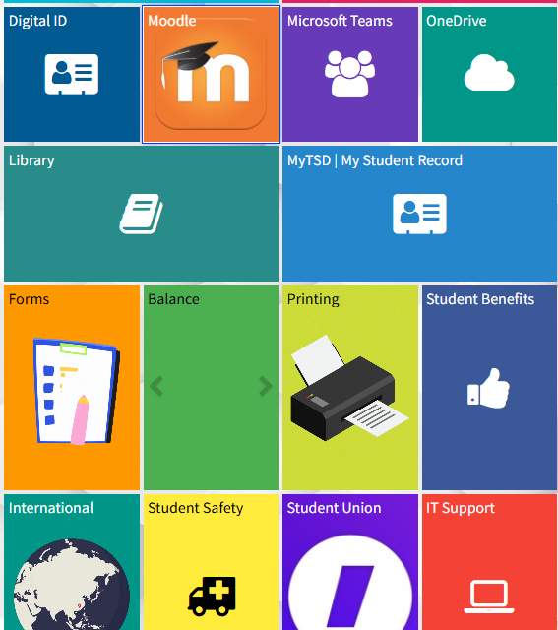
I use this dashboard for my university and complete my work, this makes it easy for me to access all the information I need

Screenshot/Photo 4
[Insert Photo/Screenshot below]

I listen to Srilankan music and news in Tamil and information for adverts and any radio adverts. I listen in my car

