University of Wales Trinity Saint David
School of Engineering
Manufacturing processes and defects
Materials and Introduction to Processing
ACMA4000
Morgan Daniel Evans
2222959
05/02/2024

Contents
1 Abstract 1
2 Forming 2
4 Casting 4
5 Miscellaneous 7
6 Conclusion 8
7 References 1

Abstract

There are many forms of manufacturing, these being categorized into forming, casting and miscellaneous. These types of manufacturing can be used dependant on the part that needs to be made, some processes can create different types of features under better conditions dependant on the part. It can also be dependent on how many parts need to be made as some processes are cheaper to create but can only be used for one off and others are more expensive and can be repeated numerous amounts of times.

Forming

Hot Rolling is the process where metal is heated up to recrystallization temperature to where it can be plastically deformed but is not molten, it needs to be that the material is soft but not liquid and then it is pushed through two rolling cylinder (Thorat, 2024). It is widely used throughout industry as a way of altering the thickness and surface area of large quantities of material instead of using slower or more expensive ways of doing but it also creates no waste products. Materials that are usually put through the hot rolling process are magnesium, copper, steel, aluminium and various alloys.

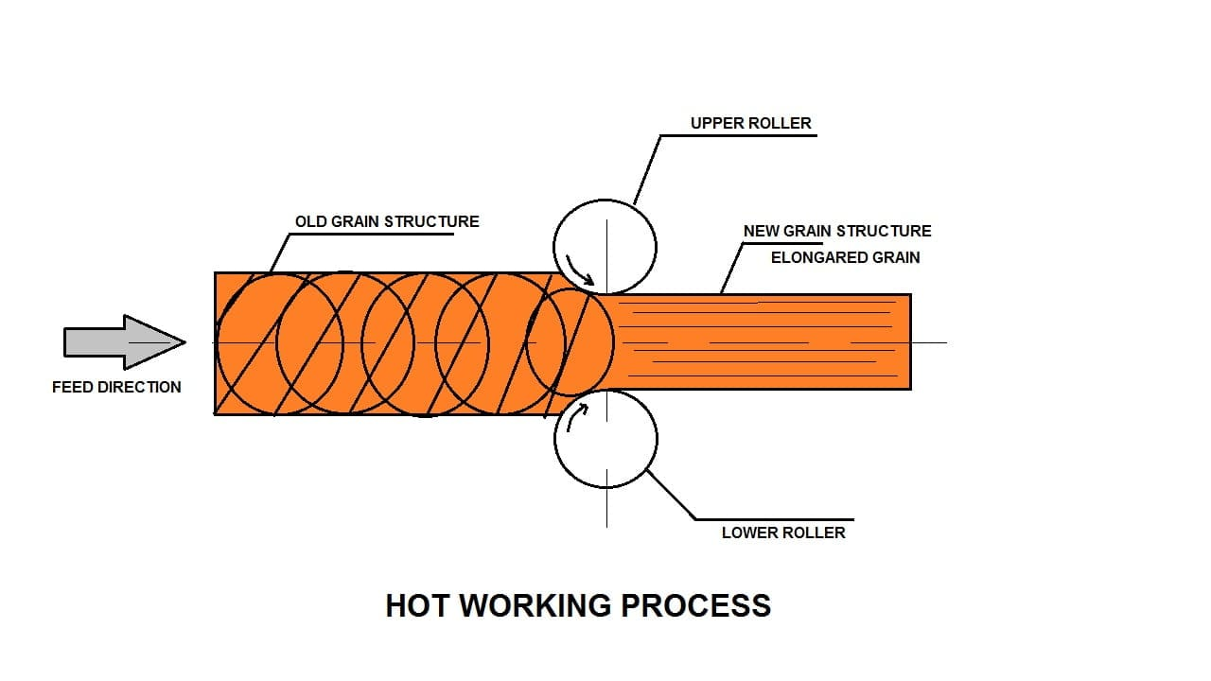

(Kumar, 2021)

Typically, hot rolling is ideally used for making structural I-beams, C-channel and tubular sections, usually made of steel. (Ghosh, 2011). The advantages of using hot rolling are it can become tougher and more ductile due to reduction in grain separation, it can make it better suited for wear and tear (Advantages and Disadvantages of Hot Rolling, 2023). It can also make the material better for welding. The disadvantages of hot rolling are it can be very inaccurate due to quick oxidisation of the surface causing really poor surface are which is not very flat. This process isn’t very energy efficient and can be very expensive due to the large force needed to push the material through the rollers (Advantages and Disadvantages of Hot Rolling, 2023). When hot rolling ultra-low carbon medium manganese steel 115°C, during the cool process between 115°C and 900°C there is a recrystallization where the grain size is reduced from 40µm to 20µm (Shaoxia Yu, 2018).

 (Nwachukwu & Oluwole, 2017)
From the figure above you can see that hot rolling has increased the tensile strength of the steel as most steels range from about 400-550MPa, this shows drastic change in the tensile strength as the results show a range of experiments done on the same grade of steel and the new tensile strength is ranging from about 507 MPa to 637.5 MPA, which is a massive increase from most standard steels and is probably due to the reduction in grain separation. Defects that may occur in hot rolling are oxidisation in material surface creating a rougher surface finish which usually occurs when the material isn`t hot enough, Scars which are raised metal sheet which are quite scaly that leave weakness in the material surface and also blisters which are bulges in the material surface that may cause cracks if crushed which will again weaken the material. One of the prevention methods of stopping oxidisation is heating the material to the specific temperature recommended, prevention methods for scars would be to clean the billet thoroughly before rolling and prevention methods for blisters would be to avoid keeping the material in the furnace too long (Shane, 2024).

Casting

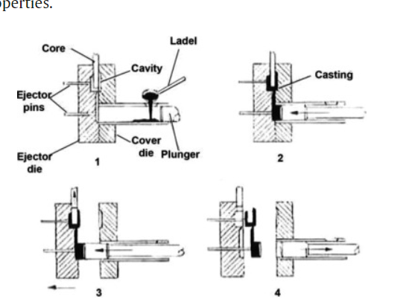 (Graf, 2021)
In the process of high pressure die casting, a die is used with a cavity of whatever shape the user wants created but generally the mould has to be put on order for a specific shape and this can take multiple weeks or months to be manufactured and sent to the customer not to mention expensive, then is attached to a machine capable of injecting molten metal at a high velocity, then the die is closed and the molten metal is injected in whilst a ram/plunger is used to create high pressure within the chamber, this pressure is maintained for a short period as the internal water passages are opened for cooling. After the material is cooled the pressure is released and the die is opened and the parted is released from the die by the ejector pins (Mallick, 2010). High pressure die casting is typically used for automotive components such as combustion engines (Fan, Wang, Wang, & Weiler, 2023). But it can be used for a large range of parts but the larger or more complex the part is the more expensive it will be to manufacture. The advantages of using high pressure die casting are that it is efficient as it allows for quicker filling of the moulds, it has extremely good surface finish no need for secondary machining and it is cost effective as it produces no waste with its precision of the process (What is High Pressure Die Casting Advantages and Disadvantages?, 2019). The disadvantages of high pressure die casting are that it is not suitable for metals with a high melting point, there is a limit to how big the component can be and creating or purchasing the dies can take quite a while which is why it is only suitable for mass production (High-Pressure Casting: Definition, Importance, How It Works, Applications, and Advantages, 2023).
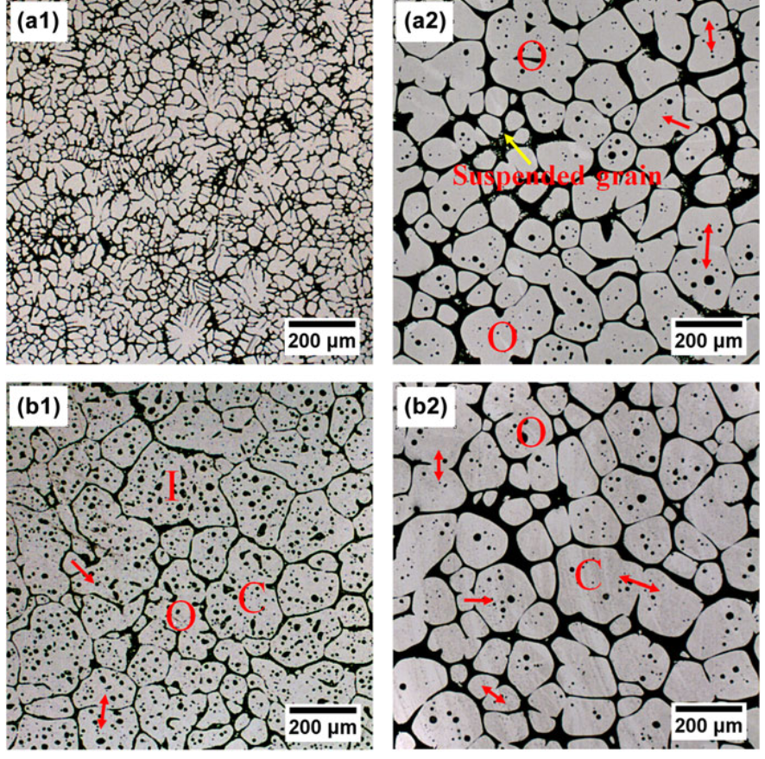 (Wang, 2016)
As you can see in the figure above the microstructure of aluminium after high pressure die casting is very different, the grain separation is much larger resulting in strength being much lower, but could result in the tensile strength being greater than previous.
 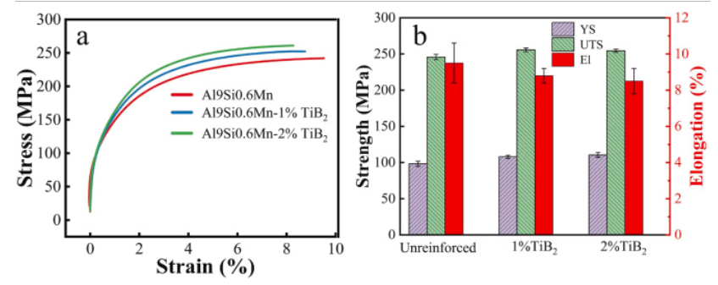 (Hu, et al., 2023)
From the figure above you can see that the affects of high pressure die casting on aluminium, both yield strength and ultimate tensile strength have increased but not drastically whereas the elongation has been reduced by a significant amount, around 2% to be exact. Common defects that may occure withing high pressure die casting are porositry which is basically gas bubbles entering the material in molten form during the cooling process, shinkage porosity which is when there is uneven shinking withing the material creating holes or porosity (Die Casting Defects: Types, Causes, and How to Prevent Them, 2022) and the last defect is cold shuts which occurs when the flow of molten material solidifyies too quickly resulting in the material not forming the shape of the cavity within the die.To prevent porosity you should use the correct temperature, pressure and shot speed to then eliminate any air pockets forming within the material (Porosity in Die Casting: How to Prevent Them, 2022).A method to prevent shrinkage porosity is to use a simulation software that will demonstrate how the molten material will behave under the different pressures, speeds and temperature (Fagani, 2017). Cold shuts can beprevented by improving the gating systems, increasing the temperature of the molten material or improving the permeability of the mold to allow for less cold air to enter the cavity (Top Four Common Defects in High-Pressure Die Casting Operations, 2021).

Miscellaneous
Machining comes in various different forms, there is milling and turning and this has in recent years been advanced by CNC machining which is a highly accurate machining technology which is controlled by a computer running on what is called G-code which is the operating language. These machines come in various different forms such as 3-axis, 4-axis and 5axis becoming more expensive the more with the 5 axis especially. But with this investment in a 5-axis machine you get a more efficient machining process and the ability to machine more complex parts. There are two different ways of programming these types of machines and these are by using the console connected to the machine but is very limited on creating complex parts. Another way of programming these machines is by the various different software packages that allow you to creating various different tool paths using a set variety of machining strategies. By creating these toolpaths when the programme is finished you can post out the programme onto a network or USB and the computer will generate these toolpaths into G-code which is why this is a very efficient method for complex parts. CNC machines creates parts by using various different tools such as drills, end mills, chamfer tools etc, inserted into a spindle where the machine will spin the tool at very high speeds and the feed the tool into the material cutting it into the desired part that user wants.
 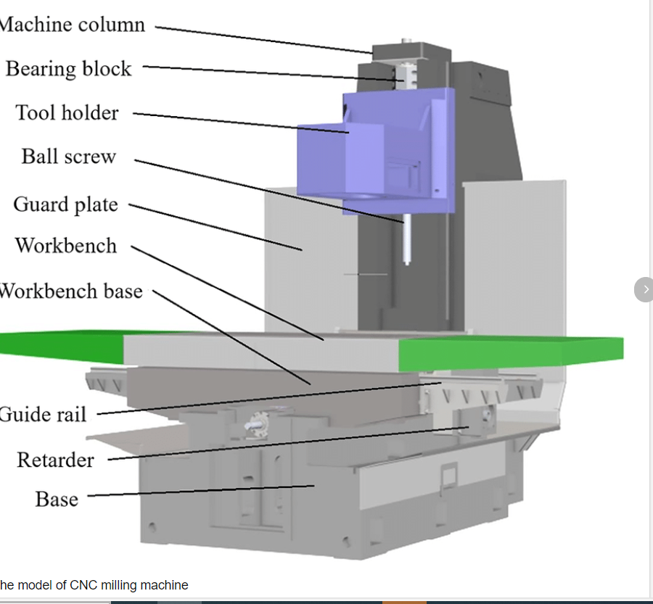 (Yi, Hu, Zhang, & Sun, 2020)

Cnc milling is used in a vast array of industries such as motor vehicle, aerospace, oil and gas and heavy industry. There are many advantages of using CNC machines such as there is a very small margin for human error, it`s very accurate as it is controlled by a computer, it has very good surface finishing but this is very dependant on the user as there are a variety of different speeds and feeds that create different types of surface finishing another advantage is and this is a very new concepts up and coming in industry where the machines are being operated by robots and can go days without any human input . The disadvantages of CNC milling are it`s very expensive to buy and run the machines and the complex the machine the more expensive, there are size limitation on these machines and all limitations are based on what machine you have and the last disadvantage would that there is to some degree marginal human error as most machines are run and programmed by humans but this is only really an issue when proving out programmes which for safety reason need a human operator. The microstructure of steel when machined is generally only affected near where the surface of the material has been machines, but the only real affect is that the hardness of the material becomes signifigantly larger, this is also the case with steel that has corroded (Bissey-Breton, Vignal, Herbst, & Coudert, 2016). Generally it is the same sort of princible with ultimate tensile strength where it is increased near the surface of machining but not drastically as this is only a small percentage of the overall mass of material. A defect that may occure during CNC machining would a witness mark where the tool starts and ends in the same place leaving a mark that is very noticable, another defect would be took breakages which more times than not results in a scrapped part as the tool can be difficult to extract from the part or it has caused extensive damage to the part and probably one of the most common defects that occurs in CNC machining is chattering which is from the tool vibrating whilst cutting material resulting in an uneven cut giving very poor finish. To prevent a witness mark from occuring you would add an overlap to the toolpath so that the tool doesn`t start and end in the same position resulting in a better finish. To prevent or reduce the amount of tool breakage calculations can be made to find the tool life of the tool so that the tool can be efficiently used but then replaced after the tool has exceeded it`s use without breaking, but also using different grading of tooling to suit the material will drastically help and using the maximum diameter tools that can machine the parts will increase the tool life. To prevent chattering from happening whilst machining you will have to alter the speeds and feeds of the tool as different materials have different parameters due to tensile strength, there are a wide range of resources available online to guide the user with suitable feeds and speeds.

Conclusion
As you can see above, there is a variety of different way to manufacture parts all having their specific need, all have benefits and drawbacks and it is entirely upto the user’s needs on which one they will you, but as you can also see there are a variety of counter measures that can be made to fully utilise any of these processes to have a high standard part ready for your workshop or customer.

References

Bibliography
Advantages and Disadvantages of Hot Rolling. (2023). The Piping Mart.
Bissey-Breton, S., Vignal, V., Herbst, F., & Coudert, J. B. (2016). Influence of Machining on the Microstructure, Mechanical Properties and Corrosion Behaviour of a Low Carbon Martensitic Stainless Steel. Science Direct.
Die Casting Defects: Types, Causes, and How to Prevent Them. (2022). Rapid Direct.
Fagani, M. (2017). Shrinkage porosity: causes and remedies. Bruschi.
Fan, S., Wang, X., Wang, G. G., & Weiler, J. P. (2023). Applications of High-Pressure Die-Casting (HPDC) Magnesium Alloys in Industry. intechopen.
Ghosh, S. (2011). Hot Rolling Process. Mech Guru.
Graf, A. (2021). Materials, Design and Manufacturing for Lightweight Vehicles (Second Edition). Science Direct .
High-Pressure Casting: Definition, Importance, How It Works, Applications, and Advantages. (2023). xometry.
Hu, C., Zhu, H., Wang, Y., Xia, C., Geng, J., Chen, D., . . . Wang, H. (2023). Microstructure features and mechanical properties of non-heat treated HPDC Al9Si0.6Mn–TiB2 alloys. Science Direct.
Kumar, E. A. (2021). Hot Working: Definition, Methods, Working Process, Advantages, Disadvantages, Application. The Mechanical Engineering .
Mallick, J. (2010). Materials, Design and Manufacturing for Lightweight Vehicles. Woodhead Publishing.
Messite, N. (2022). 6 Ways to Use a High Pass Filter When Mixing. iZotope Contributor.
Nwachukwu, P., & Oluwole, L. (2017). Effects of rolling process parameters on the mechanical properties of hot-rolled St60Mn steel. Research gate.
Porosity in Die Casting: How to Prevent Them. (2022). Rapid Direct.
Scholberg, K. (2017). Why do low and high-pass filters differ so much when they have the same components? webhome.phy.duke.edu.
Shane. (2024). Common Hot-Rolled Steel Defects You Shouldn’t Ignore. Machinemfg.
Shaoxia Yu, L. D. (2018). Effect of hot rolling temperature on the microstructure and mechanical properties of ultra-low carbon medium manganese steel. Science direct.
Thorat, S. (2024). What is Hot Rolling – Advantages and Disadvantages. learnmech.com.
Top Four Common Defects in High-Pressure Die Casting Operations. (2021). Dycast Specialties.
Wang, J. (2016). Alloy development and reheating process exploration of Al–Si casting alloys with globular grains for thixoforming. research gate.
What is High Pressure Die Casting Advantages and Disadvantages? (2019). Teamsworld.
Yi, G., Hu, H., Zhang, S., & Sun, L. (2020). Composition modeling for manufacturing resource cloud service. research gate.
Yu, S., Du, L., Hu, J., & Misra, R. D. (2018). Effect of hot rolling temperature on the microstructure and mechanical properties of ultra-low carbon medium manganese steel. Science direct.

