Assignment 2

Quality Management in Construction

Project Planning
ACBA5001

Prepared for

Dr. Deborah Hughes
and
Rachel Cook

Completed by

Benjamin Davies (2012775)

Completed on

05/04/2022

Table of Contents
1.0 | Introduction | Page 3
2.0 | Management Procedure | Page 3-6
3.0 | Quality Management Procedure | Page 7-9
4.0 | Conclusions | Page 10
5.0 | References | Page 11

- Introduction

I have been employed by a local construction company who are tendering a project outside the UWTSD IQ building in SA1, Swansea. The university has concerns over the current management of the project, specifically the quality management and assurance sector. This is due to complaints from students about a previous project which brought into question the quality of the building when in use. Due to these complaints, I have been instructed to produce a report to reassure the university. Within this report I will first begin with a report on the management procedure which will evaluate how I will manage the various parties on site, I will also provide a flow chart to elaborate on this. Next then I will define a quality management system which will focus on client satisfaction and continuous improvement that will reduce problems progressively. I will produce and explain international standards that will explain the quality management system, I will also create my own process map which will include the processes of my construction company, I will also explain the procedure for QA to improve quality standards in construction, and I will make a flow chart to describe after sales procedures. (UWTSD, 2022)

2.0 Management Procedure

Quality management in construction is the policies, processes and procedures put in place to improve an organisation’s ability to deliver quality to its customers, whether those customers are clients, contractors or subcontractors on a consistent and constantly improving basis. Construction companies want to deliver quality on every phase of work and on every project, and the key to doing so is establishing these with internal and external principles and guidelines which result in quality. There are many objectives in quality management which we can take to achieve quality, the first would be to minimise the defect on asset delivery and handover, also to identify and solve defects and issues before your customers do which will safeguard your company’s reputation.
A site manager is responsible for ensuring that projects are managed with quality and are completed on time and within budget. Site managers will start work often just before construction, site managers will take responsibility for an entire project and key tasks which they are responsible for include:

- Supervising and overseeing the direction in which the project is going while constantly ensuring that the client’s specifications are met while reviewing progress and liaising with quantity surveyors to monitor costs.
- Meeting with the client and other construction professionals and more often than not members of the public
- Coordinating and supervising construction workers
- Selecting which tools and materials will be used on site
- Conducting safety inspections and ensuring consistent site safety
- Preparing site reports, and checking designs and drawings
- Maintaining quality control procedures
- Preventing site problems
- Assessing and addressing any risks
- Negotiating contracts and securing permits and licences
(Jones, 2022)

Communication within a construction project is the key in the success if a construction project, construction consists of many different things. These include different roles, tasks and ways to collaborate throughout the tenure of the project. To make sure that this all comes together smoothly, clear and effectively with quality, communication is key, If there are any miscommunications or wrong meetings or briefings during planning then the communication between the contractor to subcontractors, architect to the builders, etc will be full of incorrect then projects, tasks and activities stand the chance of being completed incorrectly. To avoid this happening the most efficient way to communicate is to organise workers on site. for this to happen efficiently I’ve developed a list which ranks them through the importance of their roles and jobs and in order of who they report to, this has been created through a chart. As site manager on this project, I decided to organise them as follows –

I feel this is the most efficient way that a site should be organised to ensure quality control to be at maximum efficiency. The decisions that must be made by site managers are the most important decisions on site as they are the most important worker on the site as decision making is the most important component of a manager’s role. It plays the most important role in the planning process during every step. When the site managers plan, they decide on many matters as what goals their company will pursue, what resources they will use, and who will perform each required task. They must manage decisions in a way that can be done correctly to ensure no risks or mistakes are made within the assurance of quality control. I organised how this must be done within a flow chart that I created below –

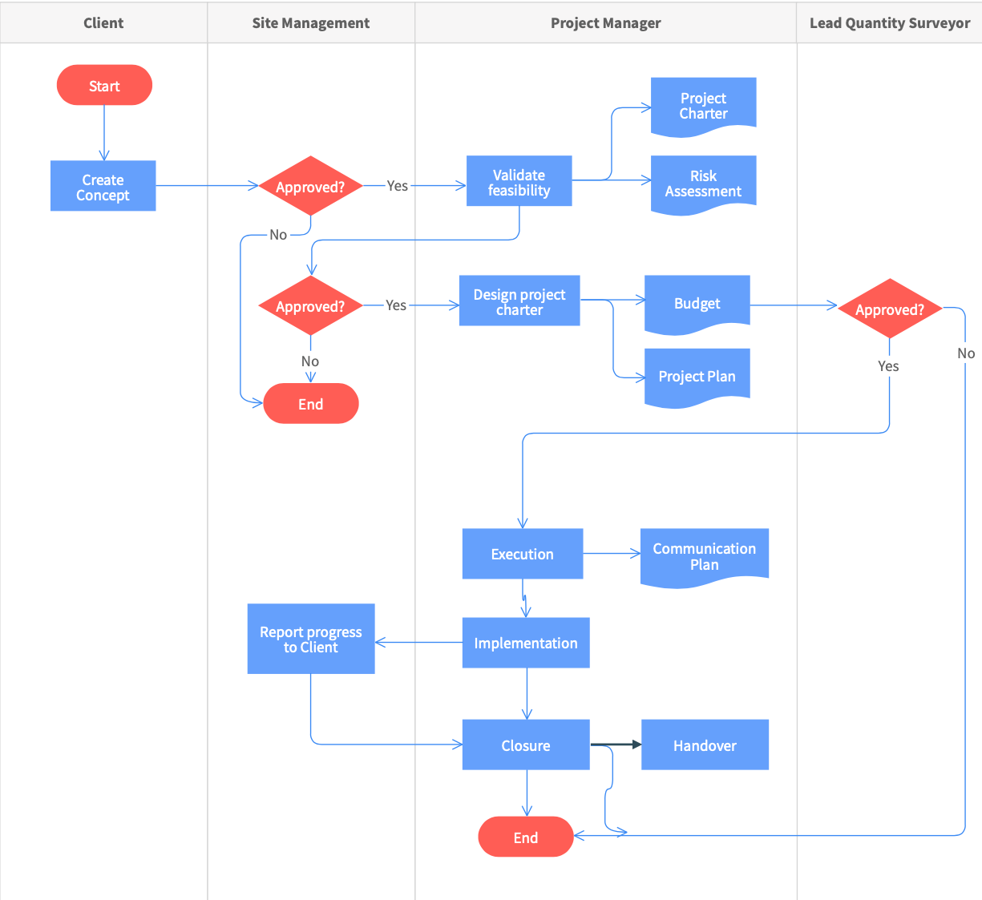

3.0 Quality Management Procedure

Quality control is the part of quality management that ensures that the client needs are met and comply with requirements. It is a work method that facilitates measurements of quality and compares them with established international standards and analyses the differences between the results obtained and the desired results in order to make decisions which will correct any differences.

Quality assurance is a set of planned and systematic actions that ensure that the companies services comply with clients set requirements. It involves checking all stages of the project to avoid mistakes as in the case of quality control but also checking the quality in a planned and constant way through every single step of construction. It is the development of work that prevents errors being made

International standards bridge the gap between companies. They allow mutual understanding of the quality between companies and clients, facilitating and allowing greater communication and even improving the economy in the process. Clear Quality break down the ins and outs of how ISOs benefit you, in this case the ISO 9000 standards are the general international standards to follow to assure quality control, they consist of four basic interdependent standards supported with guides, technical reports and specifications, these are,
- ISO 9000: Quality management.
- ISO 9001: Quality management systems - Requirements.
- ISO 9004: Managing for the sustained success of an organization - A quality management approach.
- ISO 19011: Guidelines on internal and external audits of quality management systems.

ISO 9001 is the international standard that outlines the requirements for a quality management system, it can be utilised by any company or business, irrespective of size and industry. Companies can only be certified under the ISO 9001 standard as it is the standard that certifies the efficiency of a quality management system in the most efficient way.

Construction companies use ISO 9001 to ensure that the service they provide meet customer and regulatory requirements. Independent, third-party certification helps demonstrate that you are meeting your stakeholders’ needs and that your QMS follows a robust framework that focuses on continuous improvement and effective risk management.

The construction industry has seen an erosion of efficiency with limited improvement compared to other industries over the past 50 years and the implementation of ISO 9001 integrates the use of continuous improvement which will allow for the elimination of poor effiency and poor quality as the site manager will constantly make sure that the continuous improvement will be implemented by every worker every step of the project

The benefits include the fact that it is a system which will satisfy the client as its committed to meeting the requirements that the client requires, it has a drive for constant improvement as a certified ISO 9001 QMS will provide you a clear understanding of how a company operates and allows to identify improvements such as risk management, customer focus and productivity. It defines quality management into a list of 7 principles which are

- Engagement of people
- Client focus
- Leadership
- Process Approach
- Improvement
- Evidence based decision making
- Relationship Management

This is the system in quality management which is best suited to appeal to the needs of the client and will improve the company at a constant rate.

ISO 9004 promotes the use of leadership through management, it believes that top management through leadership should
- Promote the adoption of the mission, vision, values and culture in a way that is concise and easy to understand, to achieve unity of purpose.
- Create an internal environment in which people are engaged and committed to the achievement of the organisation’s objectives
- Encourage and support managements at appropriate levels to promote and maintain the unity of purpose and direction as established by the top management. (ISO,2022)

To maintain Quality Assurance there should be steps in place to do so as our project won’t be a success if our client isn’t satisfied. Construction quality control is majorly important because it improves client happiness. A satisfied client is one who will use your company and work with you again, and even give high recommendations to other companies and customers.

Doing high quality work means less reworking. Needing to go back on steps and reworking shows that the work should have been done right the first time, doing it right first time will greatly reduce costs. This is also a way to keep the morale and happiness of your crew high at all times, which in turn means they’ll work more efficiently.
The most important point is that construction quality control leads to a successful construction project. Everything that we do in construction project management improves on the quality of our work. Focusing the majority of our time on quality means fewer problems and far less changes, while also saving time and money. (Buma, 2021)

After Sales service is a big part of assuring quality control, the new Homes Quality Board in 2021, defines the definition of after-sales service as: 'the service provided by the Developer to resolve any Emergency Issues, Snags, Defects or Complaints during the first two years following Legal Completion. (Anon, 2021) ' Here is a flow chart that I created explaining the process of the after sales service.

4.0 Conclusion

In conclusion I think we can gather that there are many responsibilities a site manager must follow and standards that they must implement to assure the highest quality of project possible, like the comprehensive list of ISO 9000 international standards list which gives us an in-depth detailed view on what standards that the site manager must follow to ensure that the project is completed with quality and care during the whole duration and during every step of the project, we could also see how important communication is and how important a QA/QC supervisor is within a project, and we also learned how we can implement these aspects of the role into our construction project which will help ensure client satisfaction and allows for continuous improvement which as we saw in ISO 9001 is crucially important within a construction project.

5.0 References

(UWTSD, 2022) Assignment 2 Brief

(Jones,2022) Jones, K., 2022. 4 Keys To Effective Construction Project Management. [online] Constructconnect.com. Available at https://www.constructconnect.com/blog/4-keys-effective-construction-project-management].

(ISO,2022) advisera.com. (n.d.). ISO 9004: Guidance on making your QMS more successful. [online] Available at: https://advisera.com/9001academy/knowledgebase/iso-9004/

(Buma,2021) Ryan Buma, 2021, Construction Quality Control: Essential Tips for Managing Quality. [online] Available at https://www.projectmanager.com/blog/construction-quality-control

(Anon, 2021) www.designingbuildings.co.uk. (n.d.). After-sales service. [online] Available at: https://www.designingbuildings.co.uk/wiki/After-sales_service

