Student name – Owen Evans
Student number – 2121421
Date – 25/04/2022

Introduction to Web and Database Concepts

HTML & CSS Web Development

Contents
1. Introduction 3
2. Requirements 3
3. Implementation 3
3.1 Screenshots of Completed Site 3
3.1.1 Home Page (Gaming Site) 4
3.1.2 News Page 5
3.1.3 Reviews Page 6
3.1.4 Guides/Walkthroughs Page 7
3.1.5 Forum/FAQ Page (form in Appendix B) 8
3.1.6 About Page 9
3.1.7 Contact Page (form in Appendix B) 10
3.2 Validation 10
3.2.1 HTML 11
3.2.2 CSS 13
4. Evaluation 13
4.1 Website Usability Research 13
4.1.1 Website Usability for Website 14
4.2 Search Engine Optimisation (SEO) Research 14
4.2.1 Search Engine Optimisation (SEO) for Website 15
4.3 Accessibility Research 15
4.3.1 Accessibility for Website 16
5. Conclusion 17
6. References 17
7. Bibliography 19
8. Appendices 20
8.1 Appendix A – HTML and CSS code 20
8.1.1 CSS Code 20
8.1.2 Gaming Site HTML Code (Homepage) 24
8.1.3 News Page HTML Code 28
8.1.4 Reviews Page HTML Code 39
8.1.5 Guides and Walkthroughs Page HTML Code 48
8.1.6 Forum and FAQ HTML Code 52
8.1.7 About US HTML Code 57
8.1.8 Contact and Donate HTML Code 60
8.2 Appendix B - Formspree 64

Introduction

This report contains different areas that discuss the created site named, ‘Owen’s Gaming Site’. The websites layout was based off the ‘Umbrella Code’ [1]. The report will be split into 3 main sections as explained below.
Requirements that cover the purpose, subject matter, and the intended audience of the site.
An implementation section which shows screenshots of parts of each page of the website, with validation for the coding and how any errors were fixed.
An evaluation that uses research studies to provide definitions of usability, search engine optimisation (SEO) and accessibility when related to web development, with explanations of each regarding the created site and recommendations to improve for future projects.

Requirements

The website was created due to personal interest in gaming and so was an obvious choice when deciding a subject matter to create a site around. The purpose for the site was to share news and information regarding games, both new and older.
Gaming is one of the most popular hobbies around the world with a Curry’s survey showing that over half of the UK (52%) play games in their free time with sports games being the most popular genre and 1 in 10 spending up to £200 a year [2].
Over the Covid period, especially at the start, gaming grew massively as people were having to stay inside more and so needing something as a pastime. Trade body UKIE published its UK Consumer Games Market Valuation for 2021 and reported a record value of £7.16 billion [3].
The intended target audience for the site is generalised, as in the target is simply gamers who can be of any age. This is due to some content being for 18+ games, but there is also content for people under 18 and so that is why the general gaming community is the target audience, rather than an age range.

Implementation

Screenshots of Completed Site

The screenshots show sections of a page. 3rd party forms were used to store user inputs for the forums and contact pages (Appendix B).

Home Page (Gaming Site)

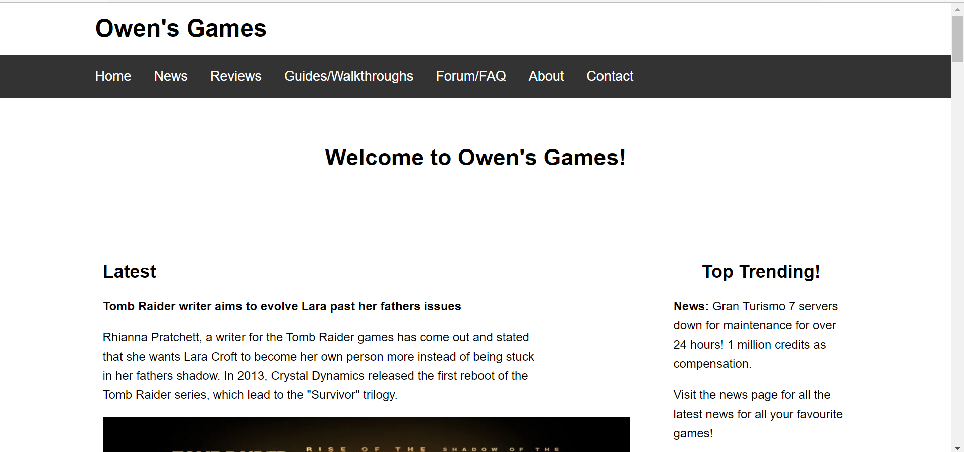
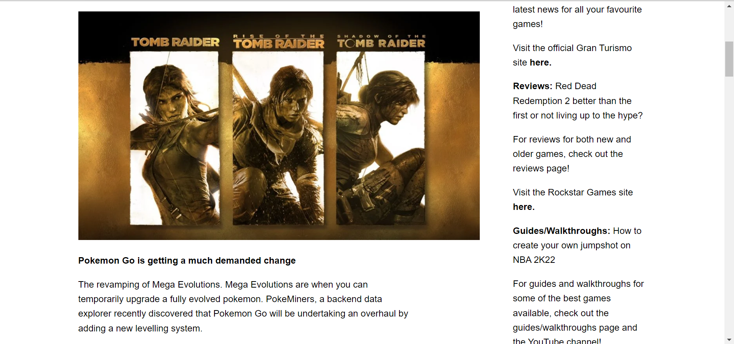
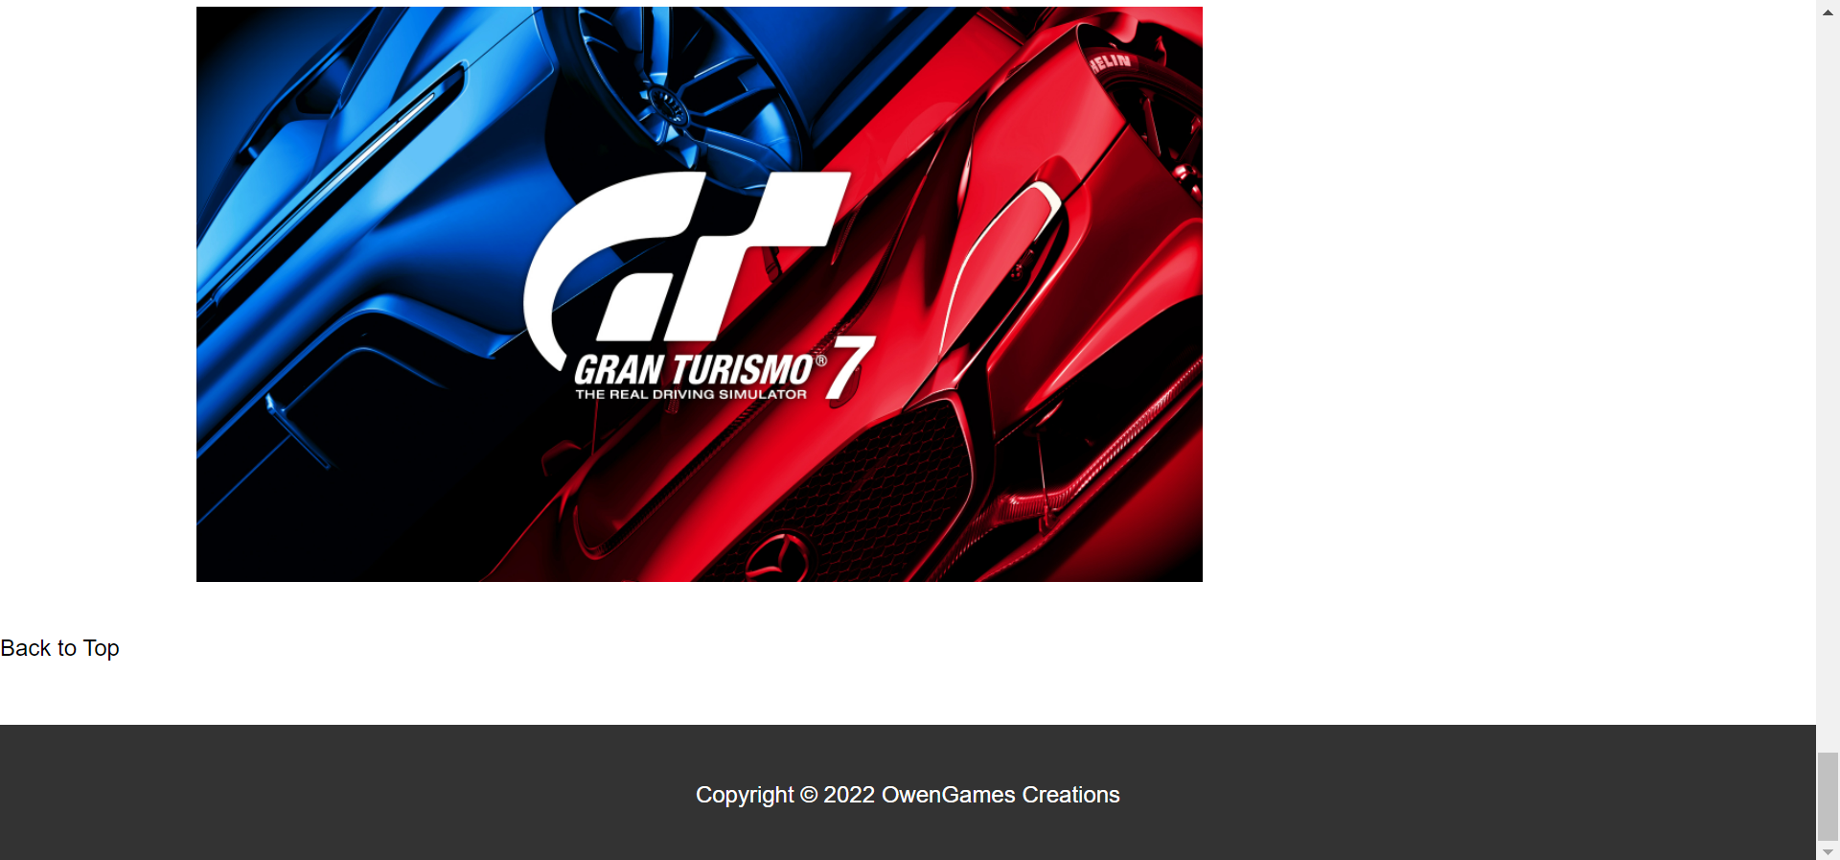

News Page

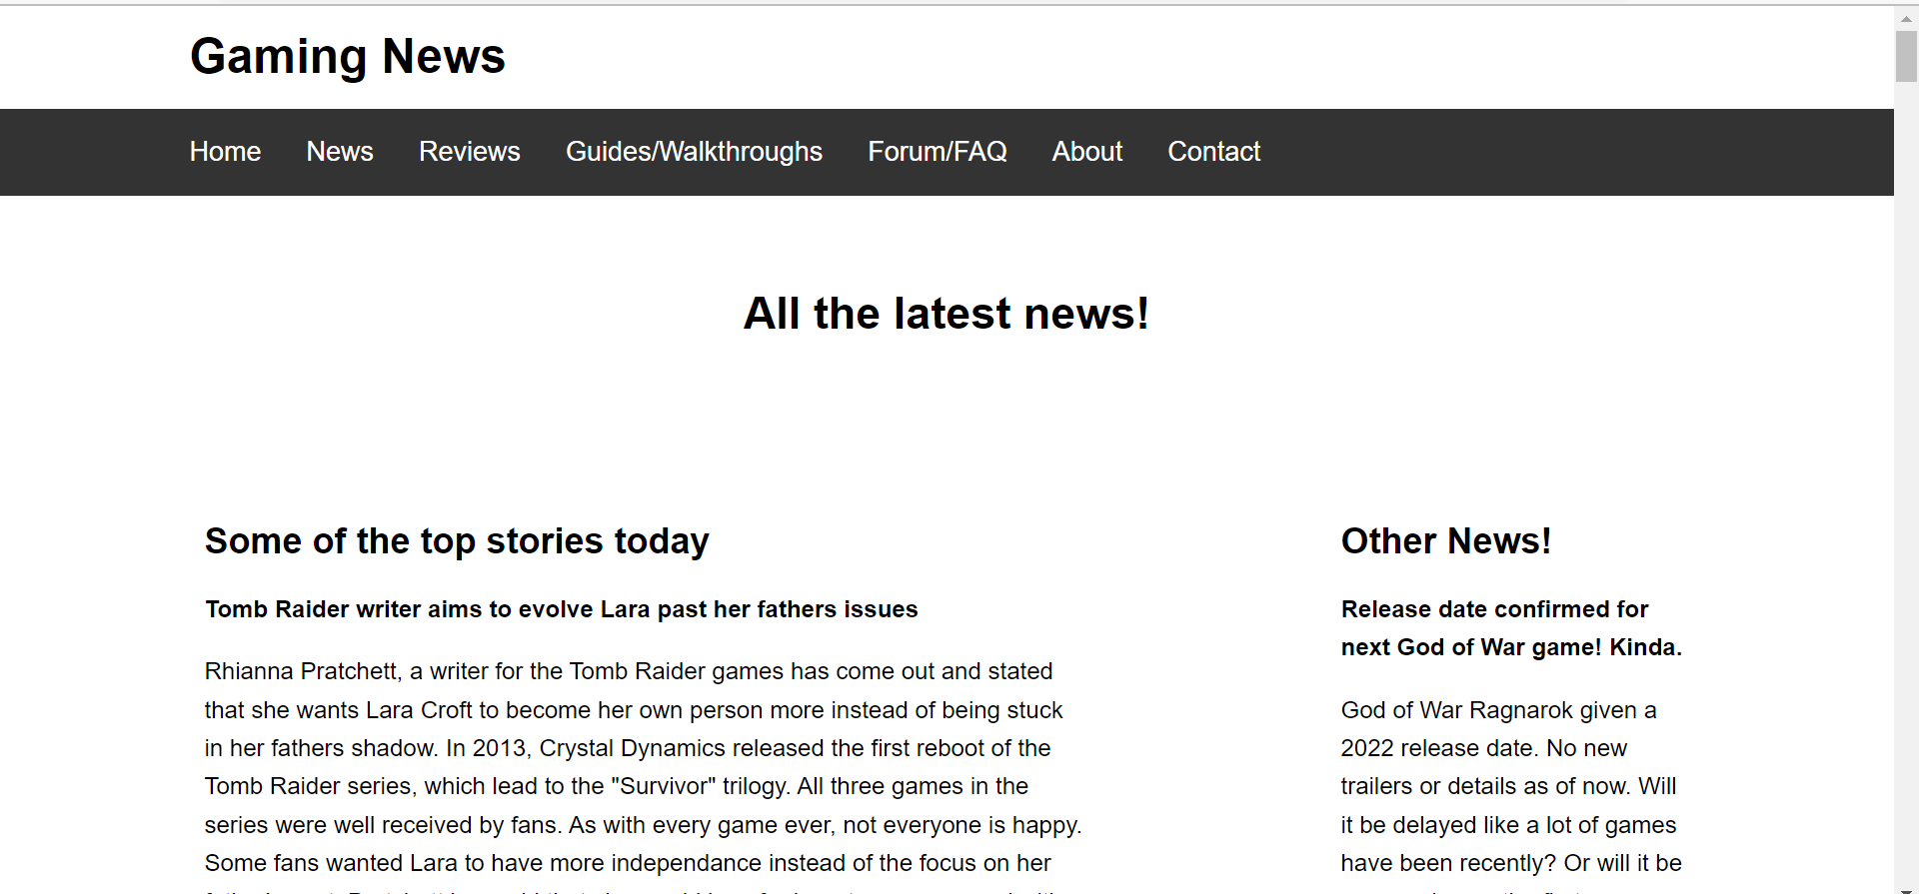
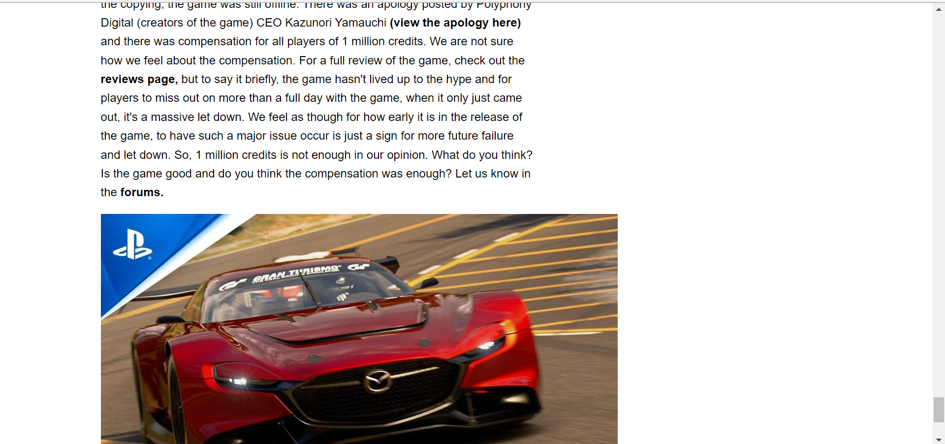

Reviews Page

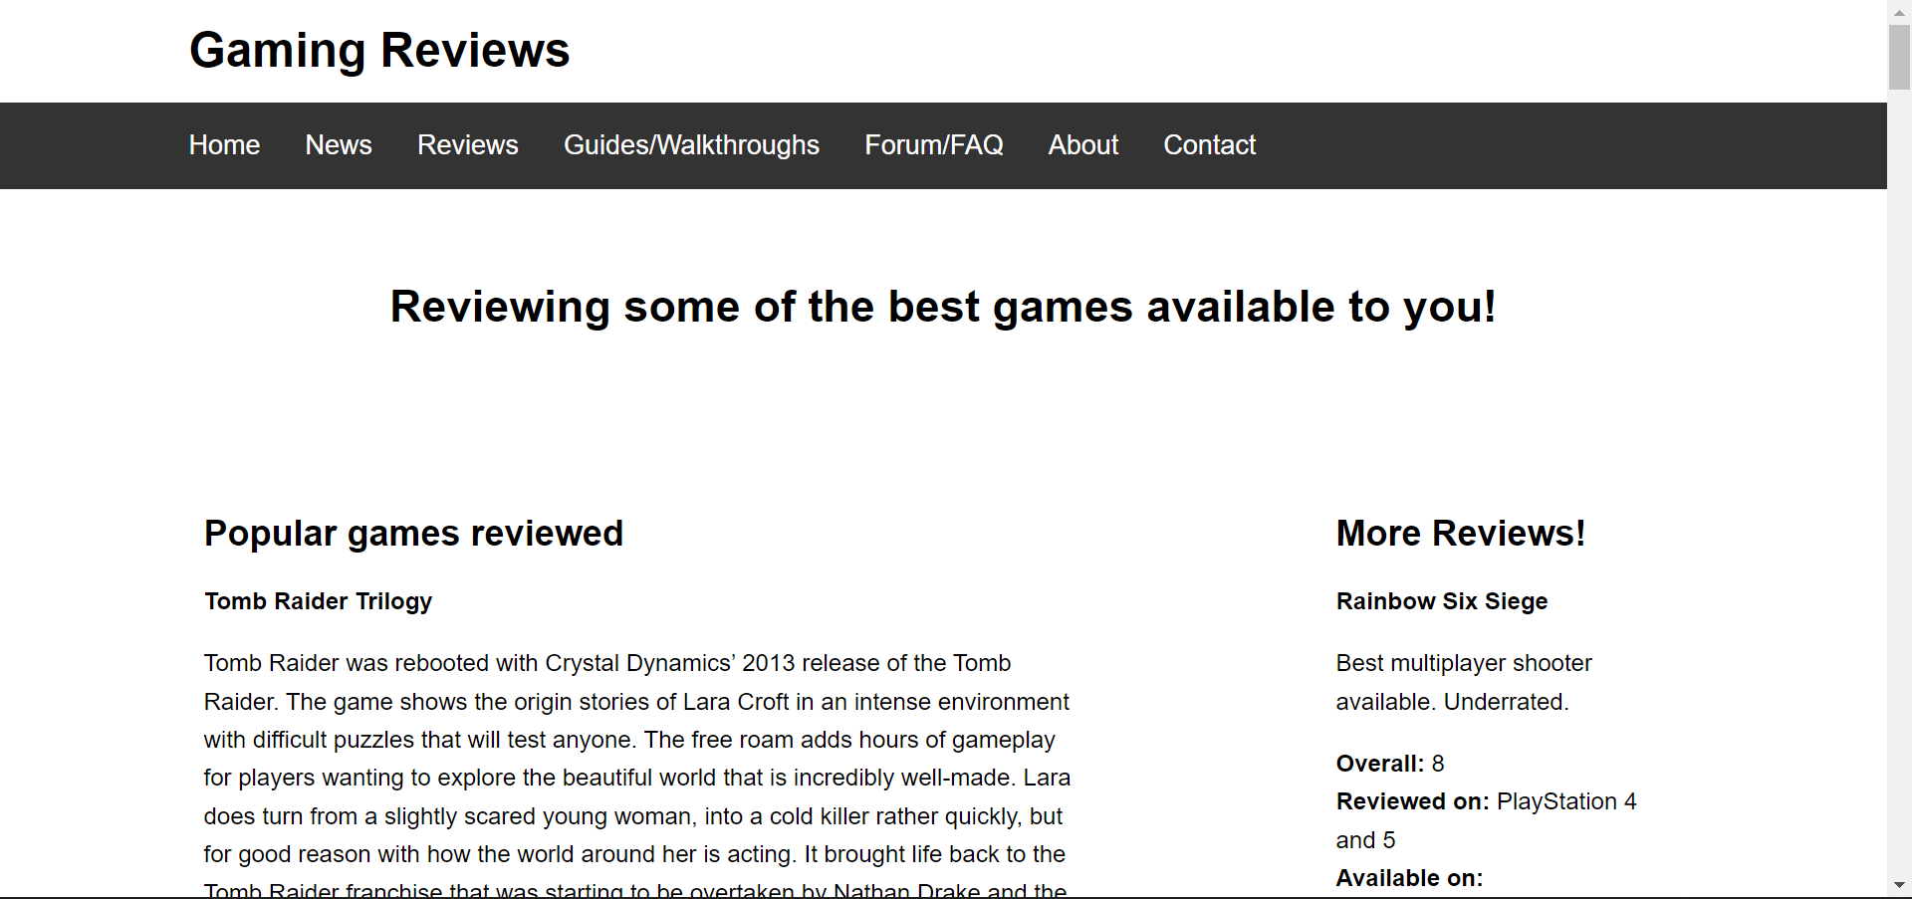
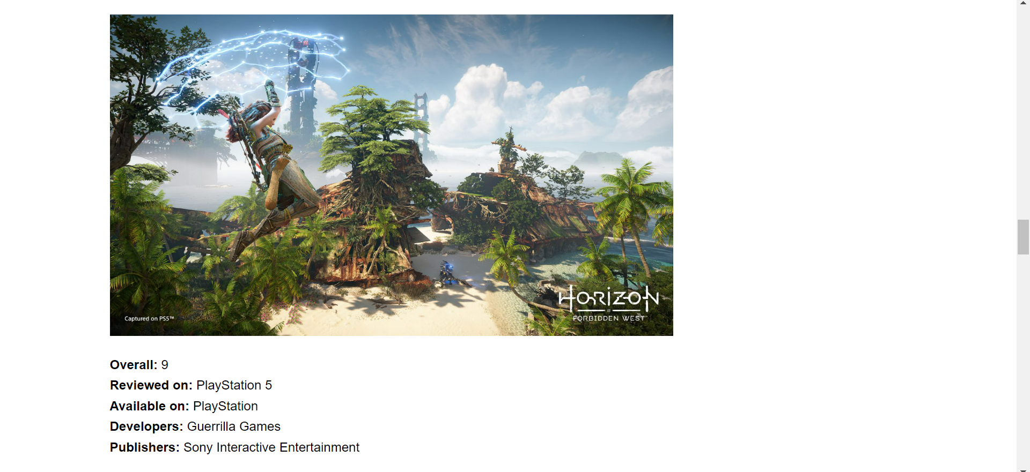

Guides/Walkthroughs Page

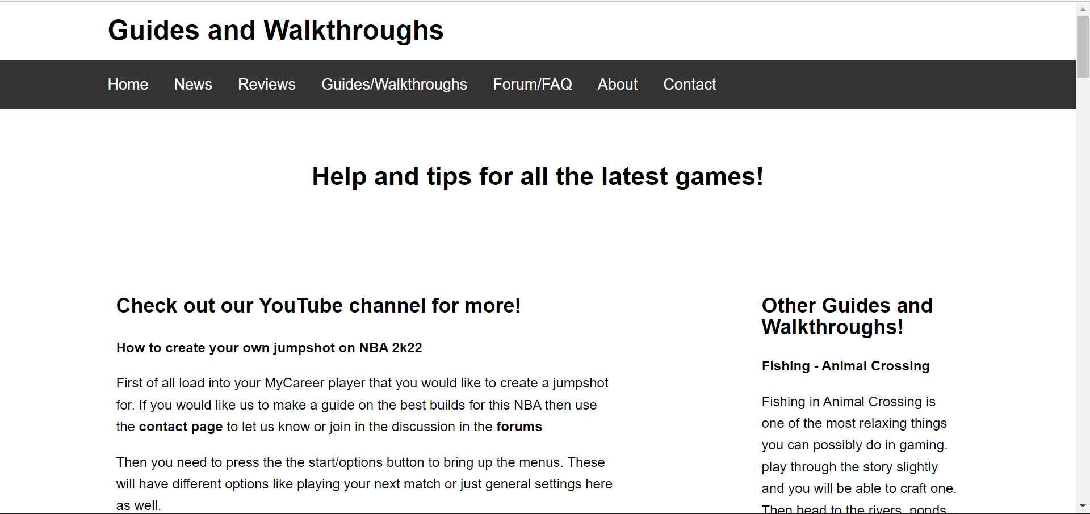
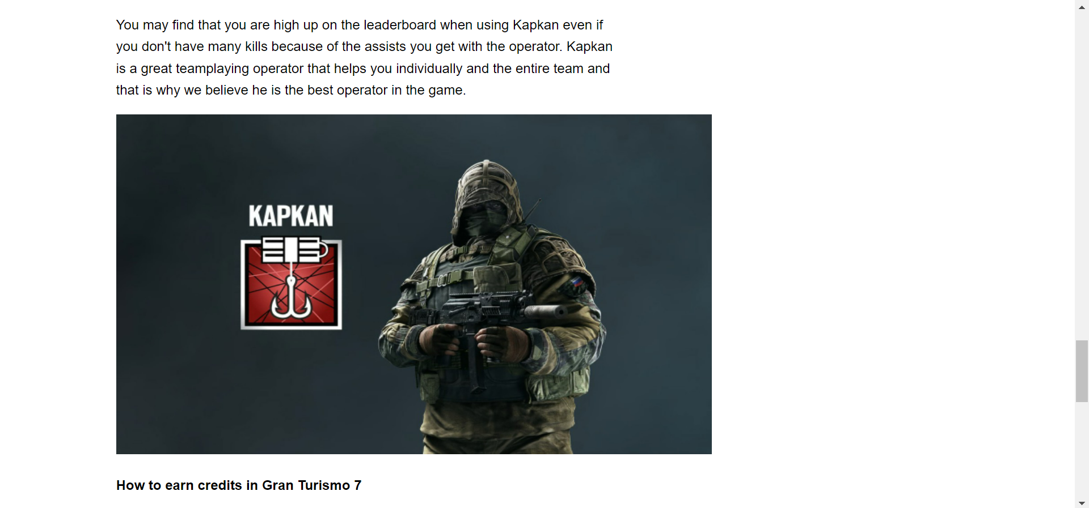

Forum/FAQ Page (form in Appendix B)

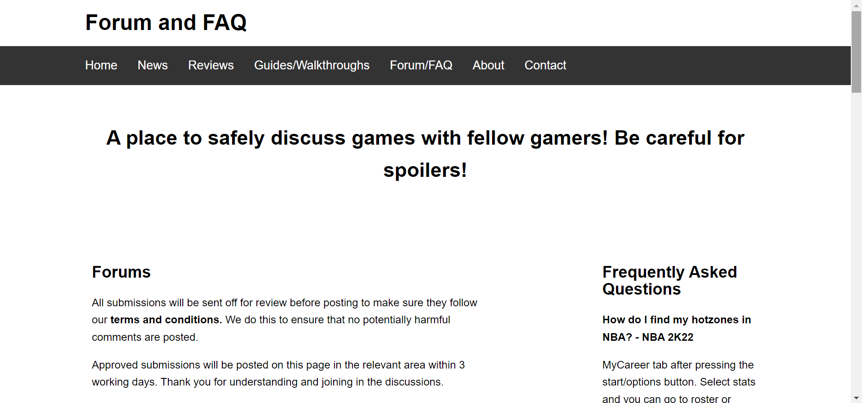
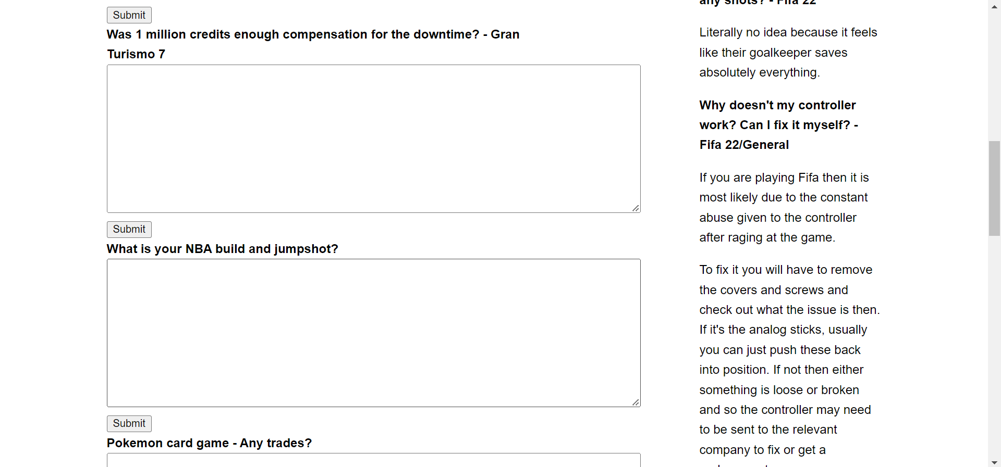

About Page

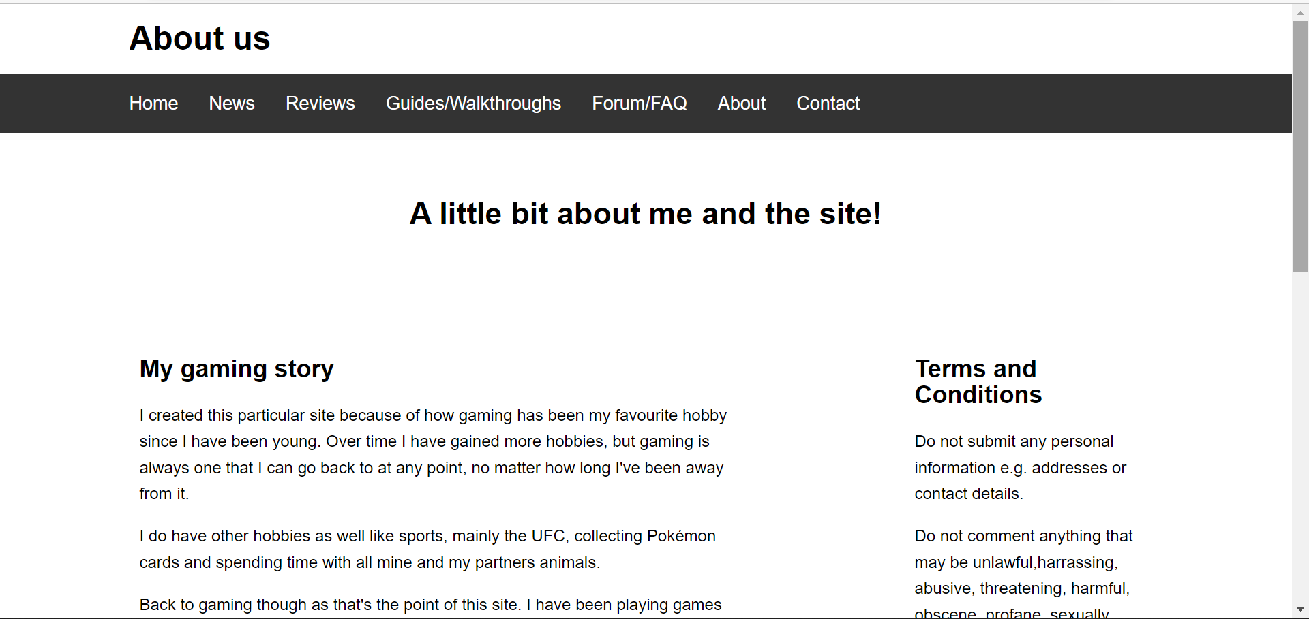
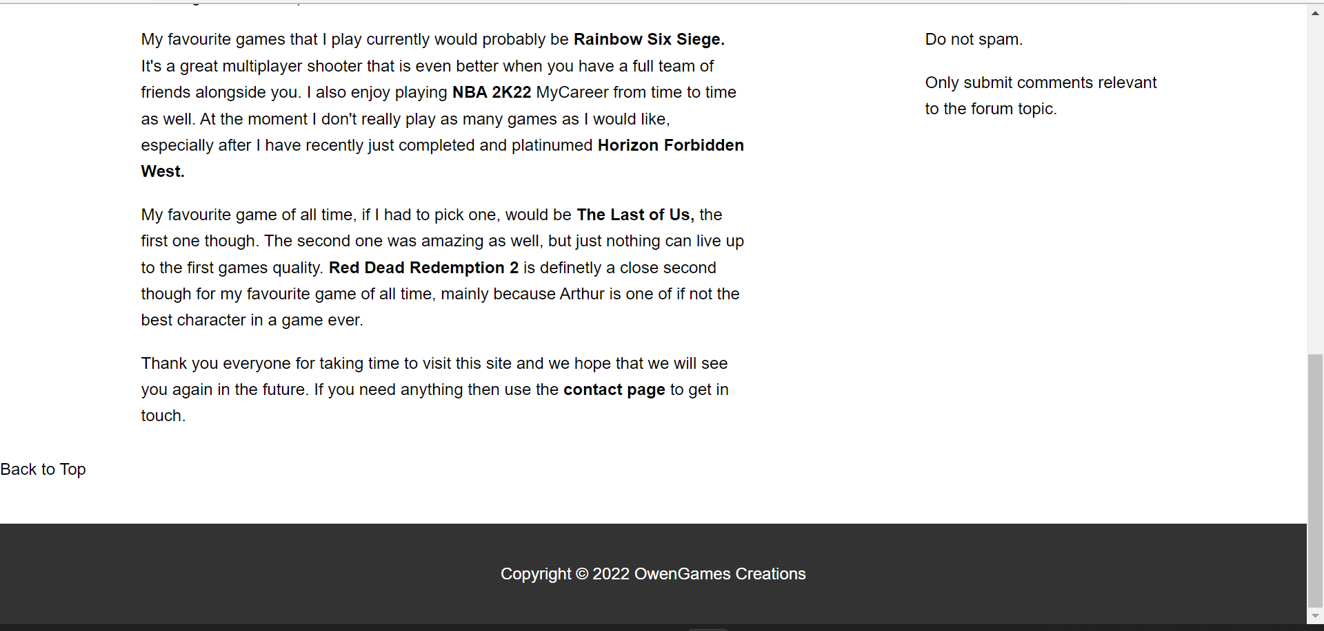

Contact Page (form in Appendix B)

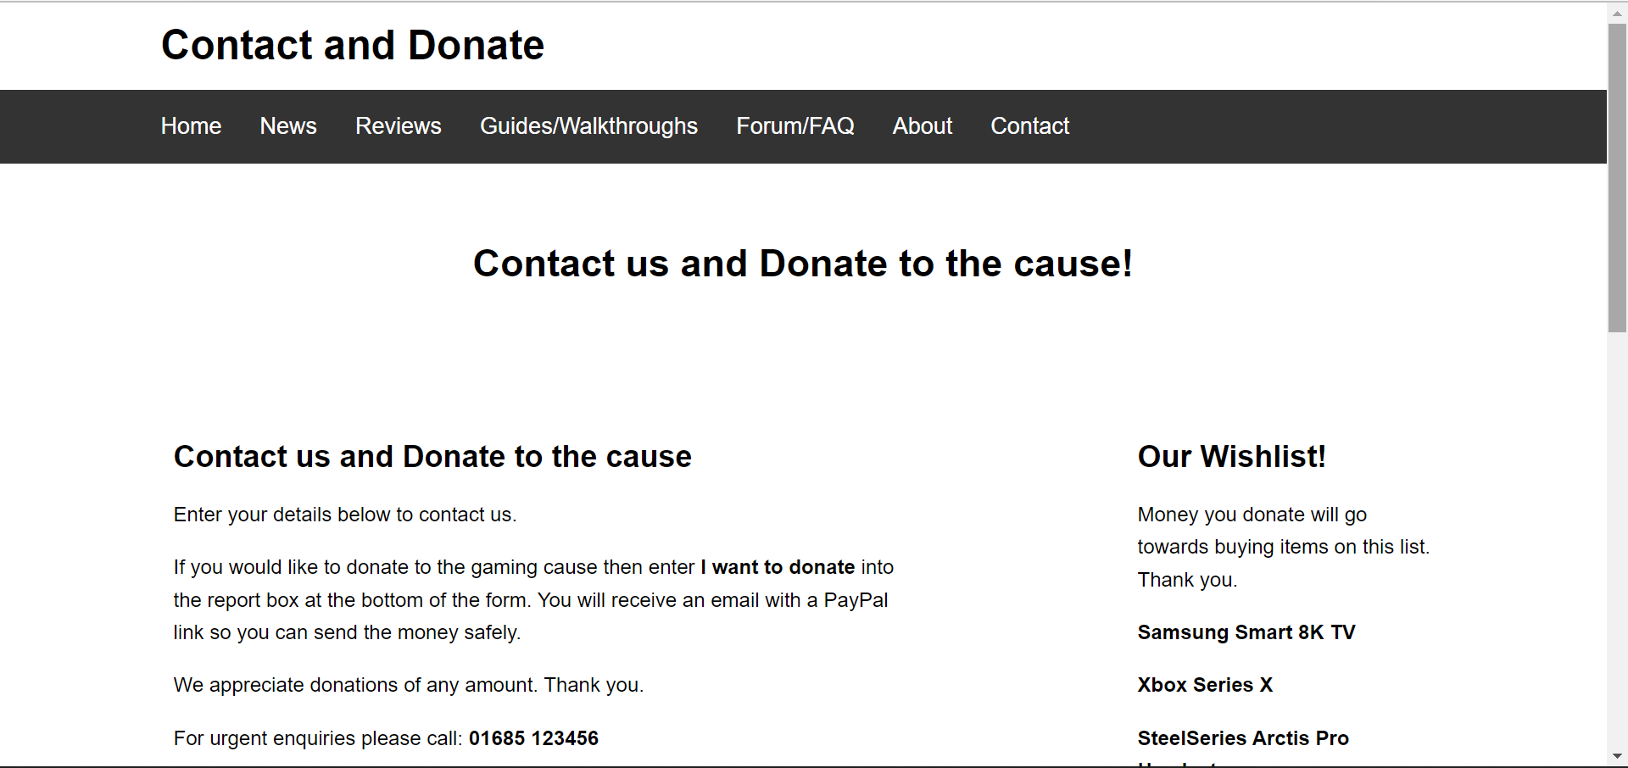
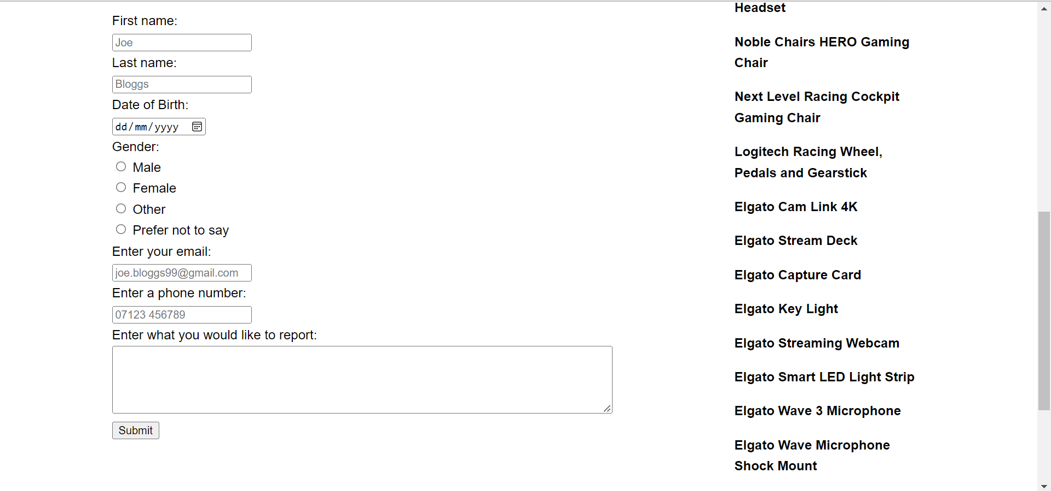

Validation

Validation is checking your website against a standard created by the World Wide Web Consortium (W3C). Validation shares a similar purpose as proof reading, but more precise. This process helps a creator make their website code as clean as possible, which will aid with compatibility, web accessibility and SEO.
Compatibility is important so that a websites design renders correctly in different browsers. Validation ensures this and therefore makes a site more compatible and better overall. Search engines read through cleaner code easier, which allows more information to be extracted and for a site to be more authoritative. This increases its search engine position. Finally, accessibility of a site means that it also caters for users with a disability. Validating a site doesn’t mean a site will be completely accessible, but it does help improve accessibility which overall leads to a better website [4].

HTML

Validation was only required and completed for the home page. Validation was completed through the W3C Markup Validation Service (Bibliography). Through validation 16 errors and 2 warnings were found. There were some errors that occurred on multiple occasions, as shown below. Screenshots of the errors picked up by the validation service are shown below.
Warnings
- The code and website are written in English, so the warning was to state this within the code. The code now reads <html lang=”en”.
- Warning 2 suggested that the h1 element should only be used for the top-level heading. This was suggested due to the code, <h1> Welcome to Owen’s Games! </h1>. This warning wasn’t acted upon as changing to h2 and so on affects the CSS element of the showcase, meaning the site did not look as intended after this change.
Errors
- Errors 1, 10, 11, 13, 14, 15 and 16 were all errors relating to an illegal character in path segment. This error was a space is not allowed. For example, href="Gaming CSS.css". The error is due to the file names created for the website. The file names are being used to link web pages. This error was not changed.
- Error 2 states that there is no p element in scope but there is a p end tag. The error is relating to the code, <p id="pageTop"><h1>Owen's Games</h1></p>. The code was changed to <p id="pageTop"></p><h1>Owen's Games</h1>. This change fixed the error.
- Errors 3, 4, 5, 6, 7, 8 and 9 were all relating to element ‘a’ not being allowed with element ul in the context that it is. An example of the error in code is, <a href='gaming site.html' > Home </a>. The code was changed to, <li><a href='gaming site.html' > Home </a></li>. This fixed the error.
- Error 12 is relating to the center element being obsolete and should be located within the CSS code. The code that showed the error is, <center><h2>Top Trending!</h2></center>. Attempts to fix the error, changed the sidebar in a way that goes against the intentional designs of the site.
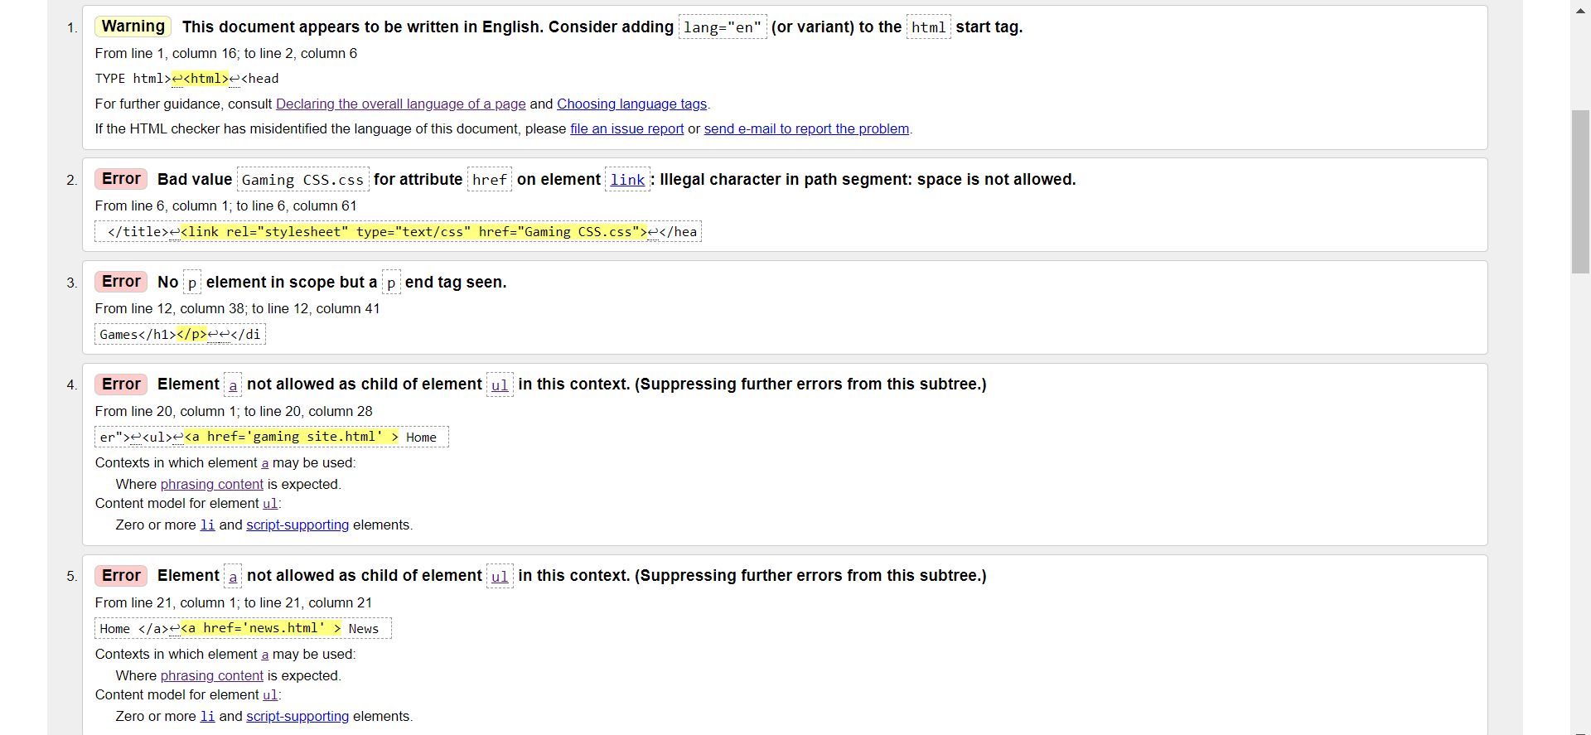
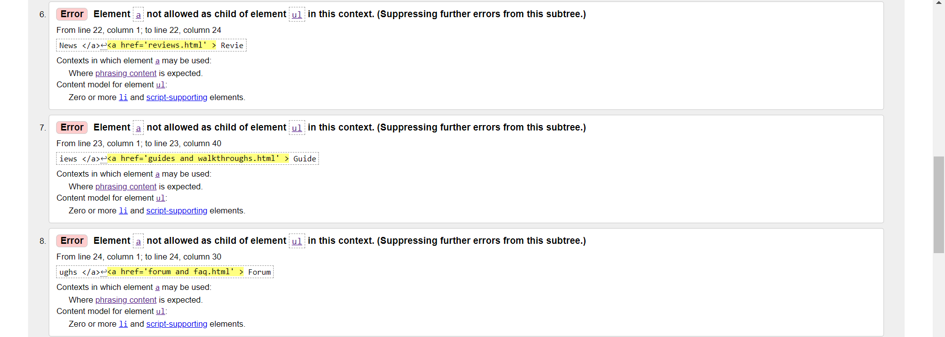
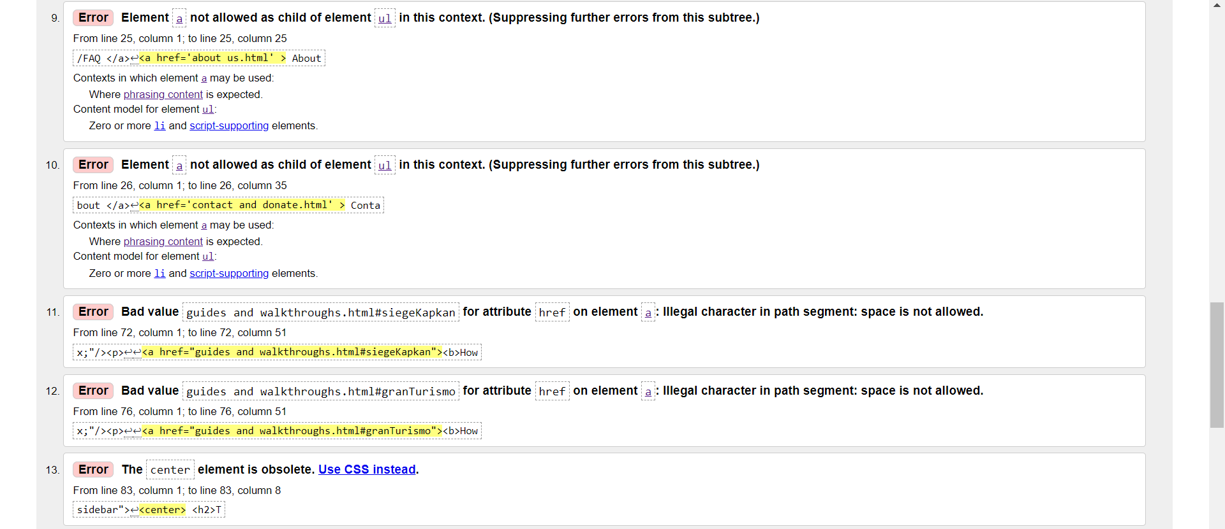
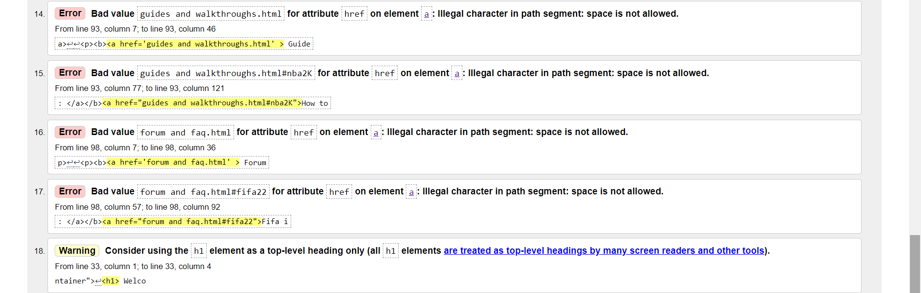

CSS

The main CSS is used for all pages of the website. After validating through the W3C Validation Service (Bibliography), no errors were found, so an icon was awarded as proof. The image below shows the validation services results.
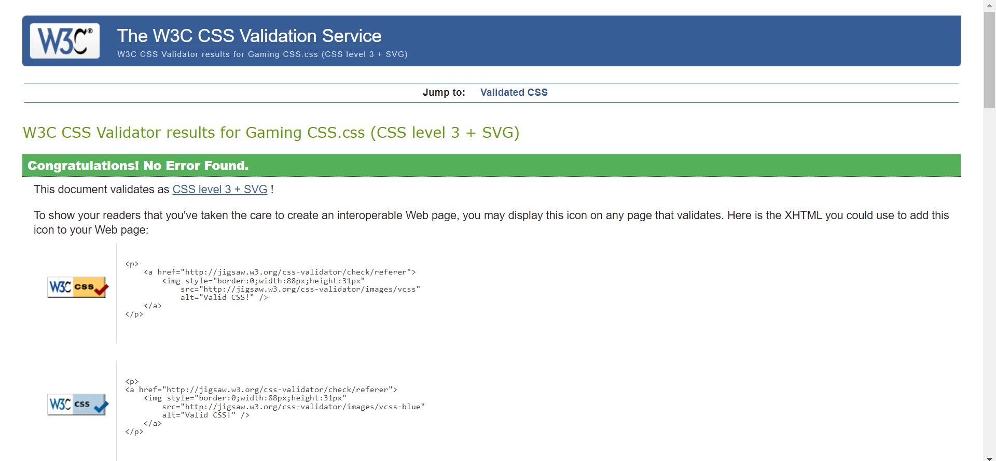

Evaluation

When analysing a website there are three main points that help show its quality. Website usability, accessibility, and SEO. This section will discuss each of these points with a relevant research study used for further information. The research will be used to evaluate the site and discuss how each point is incorporated. Recommendations for improvement will also be provided.

Website Usability Research

Website usability is the ‘feel’ of a website and the ease of which it can be used by anyone trying to access the site [5]. The International Organisation for Standardisation officially defines the term in ISO 9241-11 as “the extent to which a product can be used by specified users to achieve specified goals with effectiveness, efficiency and satisfaction in a specified context of use” [6].
A study conducted by T. Chiew and S. Salim shows a usability criterion which can be split into four categories, breaking down each point on how to evaluate a site. Category 1, content, organisation, and readability. A website must contain interesting and up-to-date information, that is easily read and well organised, without having to scroll to either side to access any information. Category 2, navigation, and links. A website should have a standard links menu throughout the site that allows a user to easily know where they are. Links should allow a user to navigate around the site with ease. Category 3, user interface design. A website should have an attractive and comfortable design that does not have features containing blinking text and looping animations. A consistent feel that makes sense with little web advertisements to get in the way is essential. Category 4, performance, and effectiveness. A website should not have a long wait time to open a page and it responds to any user actions as expected. It should be clear what links have been visited and provide useful messages when a user is unsure on how to proceed [7]. In summary the study provided useful tips on how to create a website that provides the best possible experience for a user.

Website Usability for Website

The content on each page is well organised and easily readable with up-to-date information regarding gaming. Headings clearly show what a user is about to read, with the same fonts used throughout. However, some areas of the site contain too much information and so this would need shortening in the future [8].
For the navigation, there are multiple links that will take you to different pages, back to the top of a page, or specific sections depending on the story you select. Also, there are links to third party sites that are relevant to the stories. The site does not make it clear if you have used a link or not, which is an error that would need correcting for future projects. The main purpose of navigation on a website is to help users [9]. The website has useful links throughout the site, but some could be seen as less relevant than others and so cut out.
The website has the same design throughout all pages, with no advertisements. The user interface is responsive and upon scrolling or clicking any links, the site acts almost instantly [10]. The website design and interface are simple and could possibly be improved to add more colour and overall be made even simpler with the addition of more pages that would contain a specific story instead of just everything on one page. This would allow for more detailed information without having too much in one place.
Website performance and effectiveness is difficult to judge without having the site uploaded online, as the site would need to be receiving traffic to be able to gain insight on the overall performance, including the average time on the site and average page visits [11].

Search Engine Optimisation (SEO) Research

Research conducted by J. Zilincan, using Google’s SEO Starter Guide (2010) defined SEO as “a series of modifications and techniques, which make it easier for search engines to crawl, index, and understand the content of a website”. SEO is generally split into two groups, on-page, and off-page. On-page includes elements controllable by the website’s creator, such as the contents, titles, headings, domain name, internal links, speed of page and data structure. Off-page includes elements outside of the creator’s control. These elements are influenced by others like visitors of the site, or other publishers. The correct mix of both groups help a website get a higher ranking on search results pages [12].

Search Engine Optimisation (SEO) for Website

Using the above research study and information sourced from Single Grain contributors that provide SEO techniques for driving more traffic [13], techniques used within the created site include:
- The websites content was up-to-date and relevant to gaming. Up-to-date and popular content will allow the site to appear higher in the search rankings. More research could have been conducted into the most popular stories to further improve this area.
- The site contains links:
  - At the top of the site that take you to other pages.
  - Throughout the content to other pages.
  - At the bottom of a page that will take you back to the top.
  - To other sites that are relevant to the content.
- Key words are used throughout for content optimisation and for the most part there is an appropriate word count. The content throughout the site is interesting and relevant, but some sections are debatably too large.
- Images used to break up the text making the paragraphs seem shorter and the information easier to read. This will help traffic on the site if uploaded as more users would be inclined to stay on the page and read the stories. The images could be better quality and better positioned in future projects.
- There is plenty of ‘white space’ on the site that stops pages from becoming overcrowded.
- Forums page used to get user input on different topics. This allows users to visit the site and discuss with others, which was created with the aim to bring users back and increase the sites traffic. A recommendation for this section would be to make the users input print on the site after being entered.
- Although there are no uploads, a YouTube channel was created to allow the website to upload videos relevant to any content posted.
- An about us page that gives insight into why the site was created. This page intends to get users to start trusting the site more as they know it is created by someone that has similar interests.

Accessibility Research

Web accessibility can be defined as “making a website navigable and tractable by various user categories especially those who have disabilities and normally face obstacles when interacting with the web”. According to W3C, web accessibility allows those with disabilities to still perform actions, like simply browsing a site. Research undertaken by H. Abuaddous, M. Zalisham and N. Basir argues that there should be legislation enforced instead of just voluntary guidelines so that there is a responsibility on creators to create a website that is more accessible for those with disabilities [14].
The Web Content Accessibility Guidelines (WCAG) were created to help creators make websites more accessible. WCAG 2.0 set principles that are known by an acronym POUR. Perceivable. A user can identify content and elements of a page through their sense. This can be visually, sound or touch. Operable. Successfully being able to use any interactive elements of a site. This usually is through voice recognition, keyboards, and screen readers. Understandable. The content should be comprehendible with a consistent format and design. Robust. Content can be interpreted by a variety of users, therefore allowing them to choose the technology they need to be able to interact with the site [15].
WCAG 2.1 is the current version, published in 2018 and WCAG 2.2 is in draft and is set for publishing in September 2022. This takes the accessibility requirements of WCAG 2.0 and includes additional requirements [16][17].

Accessibility for Website

WCAG 2.1 carries on with the WCAG 2.0 requirements with some additions and so still uses the POUR acronym, with a conformance model used to show if a site meets the requirements and needs of webs users. These principles have different levels, level A is the minimum for a website to meet a requirement. Then level AA and level AAA as the top tier [18]. Below is a brief evaluation of the site using each area of POUR.
Perceivable
- The created site contains only text with no alternatives provided (assistive technology may work but is not tested). This is something that would need improvement in the future.
- The site is best viewed at 100% zoom. If zooming in or out, image sizes change and block text. Changing orientation also has a similar effect. This is something that would need adjusting for future projects.
- Content sequence is readable and makes sense
- Limited colours to avoid issues. White space to avoid overcrowding pages.

Operable
- A keyboard can be used to scroll up and down the site, but a mouse is needed for clicking any links.
- User has as much time as needed to view content. However, there are no timeouts for inactivity.
- The web page contains no flashing images or blinking text to avoid seizures.
- Headings used throughout to describe topics and location on a page. Easily understandable links to get to other sections.
Understandable
- Language is programmed in code to avoid confusion.
- Content does not require an advanced reading level.
- Navigation is consistent throughout with the navigation bar always in the same location and a back to top link at the bottom of each page.
- Input error messages on the forums and contact page are not included, but some guidance is provided with either a question or an example in the input box. For future projects, these pages would need improving.
Robust
- No testing for the usage of assistive technology undertaken.
- HTML markup language used to create website with correct tags used (view code in Appendix A and validation in section 3.2).
Conformance
This website would not reach level AAA, but the minimum level (level A) would be met for most requirements that are needed.

Conclusion

Overall, the website was a success as it portrays a popular topic in gaming and so if uploaded online, should receive adequate amounts of traffic, but as mentioned, improvements are needed if it was wanting to compete with the larger, more well-known sites that cover the same topic and target audience.
However, there is obviously room for improvement and so further research into creating websites is needed, so that the design can be improved, along with researching WCAG in more depth, so that the site can meet the accessibility requirements.

References

[1] G. Jones, "Umbrella Code", Moodle.uwtsd.ac.uk, 2022. (Online). Available: https://moodle.uwtsd.ac.uk/mod/page/view.php?id=409405. (Accessed: 30- Apr- 2022).
[2] Currys, "Britain’s gaming habits and tastes", Techtalk, 2020. (Online). Available: https://techtalk.currys.co.uk/gaming/Britains-gaming-habits-and-tastes. (Accessed: 26- Apr- 2022).
[3] T. Ivan, "UK games industry reports record £7.16bn in 2021", VGC, 2022. (Online). Available: https://www.videogameschronicle.com/news/uk-games-industry-reports-record-7-16bn-in-2021/. (Accessed: 26- Apr- 2022).
[4] Planning Optimising Launching Reviewing, "What makes a good website and why is validation important?", PoLR. (Online). Available: https://www.polr.co.uk/web-design-glasgow/what-is-accessible-web-design/. (Accessed: 27- Apr- 2022).
[5] E. Visser and M. Weideman, "An empirical study on website usability elements and how they affect search engine optimisation", South African Journal of Information Management, vol. 13, no. 1, pp. 1-2, 2011. Available: https://journals.co.za/doi/10.10520/EJC46350. (Accessed 30 April 2022).
[6] International Organisation for Standardisation, "ISO 9241-11:2018(en) Ergonomics of human-system interaction — Part 11: Usability: Definitions and concepts", Iso.org, 2018. (Online). Available: https://www.iso.org/obp/ui/#iso:std:iso:9241:-11:ed-2:v1:en. (Accessed: 30- Apr- 2022).
[7] T. K. Chiew and S. S. Salim, "WEBUSE: Website Usability Evaluation Tool", Malaysian Journal of Computer Science, vol. 16, no. 1, pp. 47-57, 2003. Available: https://ejournal.um.edu.my/index.php/MJCS/article/view/6118/. (Accessed 26 April 2022).
[8] Yale University, "Readability | Usability & Web Accessibility", Usability.yale.edu. (Online). Available: https://usability.yale.edu/web-accessibility/articles/readability. (Accessed: 30- Apr- 2022).
[9] B. Arriola, "How to Improve Your Website Navigation: 7 Essential Best Practices", Search Engine Journal, 2019. (Online). Available: https://www.searchenginejournal.com/technical-seo/website-navigation/#close. (Accessed: 30- Apr- 2022).
[10] M. Ellis, "Web design, web development, UI and UX: What’s the difference and which do you need?", 99designs, 2018. (Online). Available: https://99designs.co.uk/blog/web-digital/web-design-development-ui-ux-difference. (Accessed: 30- Apr- 2022).
[11] Webolutions Company, "10 Key Metrics to Determine Your Website's Effectiveness", Webolutions Marketing Agency - Best Web Design and Development Company Denver, CO. (Online). Available: https://webolutions.com/10-key-metrics-effective-website/. (Accessed: 30- Apr- 2022).
[12] J. Zilincan, "Search Engine Optimization", CBU International Conference Proceedings, vol. 3, pp. 506-510, 2015. Available: https://www.proquest.com/docview/1909314154?pq-origsite=gscholar&fromopenview=true. (Accessed 26 April 2022).
[13] I. Kreimer, E. Dopson and R. Prior, "Effective SEO Techniques that Work in 2019 & Beyond", Single Grain, 2022. (Online). Available: https://www.singlegrain.com/seo/effective-seo-techniques-that-work/. (Accessed: 28- Apr- 2022).
[14] H. Abuaddous, M. Zalisham and N. Basir, "Web Accessibility Challenges", International Journal of Advanced Computer Science and Applications, vol. 7, no. 10, pp. 172-180, 2016. Available: https://www.researchgate.net/publication/309660088_Web_Accessibility_Challenges. (Accessed 26 April 2022).
[15] The University of New York, "Accessibility Toolkit for Open Educational Resources (OER): Accessibility Principles", Guides.cuny.edu, 2020. (Online). Available: https://guides.cuny.edu/accessibility/whyitmatters#. (Accessed: 26- Apr- 2022).
[16] Siteimprove, "WCAG compliance checker - Free instant WCAG 2.0 check", Siteimprove. (Online). Available: https://www.siteimprove.com/glossary/wcag-compliance-checker. (Accessed: 30- Apr- 2022).
[17] W3C, "What’s New in WCAG 2.2 Working Draft", Web Accessibility Initiative (WAI), 2022. (Online). Available: https://www.w3.org/WAI/standards-guidelines/wcag/new-in-22/. (Accessed: 30- Apr- 2022).
[18] W3C, "Web Content Accessibility Guidelines (WCAG) 2.1", W3.org, 2018. (Online). Available: https://www.w3.org/TR/WCAG21/. (Accessed: 30- Apr- 2022).

Bibliography

https://validator.w3.org/
https://jigsaw.w3.org/css-validator/
https://gamerant.com/tomb-raider-writer-wants-lara-evolve-past-father/
https://gamerant.com/tomb-raider-best-things-about-each-survival-trilogy-game/
https://www.techradar.com/news/pokemon-go-is-getting-a-change-that-fans-have-been-demanding-for-years
https://www.pcgamer.com/where-is-xur-today-destiny-2/
https://www.ign.com/articles/video-game-release-dates-ps4-ps5-xbox-one-series-x-nintendo-switch
https://metro.co.uk/2022/04/08/football-manager-2022-free-this-weekend-on-pc-and-xbox-16433475/
https://www.parliament.uk/get-involved/have-your-say/forum-terms-and-conditions/
Tomb Raider: Definitive Survivor Trilogy is coming to Xbox | VGC (videogameschronicle.com)
TOMB RAIDER TRILOGY | That's Lara on Stadia! - TOMB RAIDER FRANCE
Pokemon GO Backgrounds Free download - PixelsTalk.Net
Pokémon GO: Mega Evolution, Explained (cbr.com)
Xur Exotic Merchant - Destiny 2 Wiki Guide - IGN
Video Game Release Dates - Every Game Confirmed For 2020/2021 (thegamer.com)
1920x1080 Horizon Forbidden West 1080P Laptop Full HD Wallpaper, HD Games 4K Wallpapers, Images, Photos and Background - Wallpapers Den
Horizon Forbidden West Flying neither Confirmed nor Denied by Dev; Beta Milestone Reached (wccftech.com)
How To Know Which Version of Horizon: Forbidden West to Get (gamerant.com)
Last of Us wallpaper ·① Download free beautiful High Resolution wallpapers for desktop and mobile devices in any resolution: desktop, Android, iPhone, iPad 1920x1080, 2560x1440, 320x480, 1920x1200 etc. WallpaperTag
The Last Of Us Part II Wallpapers - Wallpaper Cave
Wallpaper Ubisoft, Tom Clancy's Rainbow Six Siege, Kapkan images for desktop, section игры - download (goodfon.com)
1920x1080 Gran Turismo 7 PS5 Laptop Full HD 1080P HD 4k Wallpapers, Images, Backgrounds, Photos and Pictures (hdqwalls.com)
Gran Turismo 7 Features in New Official PS5 Launch Trailer – GTPlanet
EGS_FootballManager2022_SportsInteractive_S1_2560x1440-b8b3816a89feb951b3c37da921ee57cd (2560×1440) (epicgames.com)
EvKXjnmXUAAPCPS.jpg (1920×1080) (dotesports.com)
Pokemon-Legends-Arceus-Scrn26022021.jpg (1920×1080) (switch-brasil.com)
pokemon-legends-arceus.jpg (2001×1271) (nme.com)
ghost-of-tsushima-2020_a21naGyUmZqaraWkpJRobWllrWdpZWU.jpg (3840×2400) (wallpapersden.com)
red-dead-redemption-2-game-poster-2018_a2dobmyUmZqaraWkpJRqZmdlrWdtbWU.jpg (5120×2880) (wallpapersden.com)
R.8d9190d316089eef86804aed20f5fdfb (1920×1080) (bing.com)
gran-turismo-7-release-date-2021.jpg (1920×1080) (rectifygaming.com)
horizon-forbidden-west-screenshot-01-disclaimer-02oct20.jpg (2400×1350) (videogameschronicle.com)

Appendices

Appendix A – HTML and CSS code

CSS Code

body{
background-color:white;
color:black;
font-family:Arial, Helvetica, san-serif;
font-size:16px;
line-height:1.6em;
margin:0;
}

.container{
width:80%;
margin:auto;
overflow:hidden;
}

#main-header{
background-color:white;
color:black;
}

#navbar{
background-color:#333;
color:#fff;
}

#navbar ul{
padding:0;
list-style:none;
}

#navbar li{
display:inline;
}

#navbar a{
font-size:18px;
padding-right:25px;
color:white;
}

a{
color:black;
text-decoration:none;
}

a:hover{
color:cadetblue;
}

#main-footer{
background-color:#333;
color:#fff;
text-align:center;
padding:20px;
margin-top:40px;
}

#main{
float:left;
width:60%;
padding:10px;
box-sizing:border-box;
}

#sidebar{
float:right;
width:25%;
background-color:white;
color:black;
padding:10px;
box-sizing:border-box;
}

#showcase{
background-color:white;
background-size:1200px;
opacity:1.0;
background-position:center right;
min-height:100px;
margin-bottom:30px;
text-align:center;
}

#showcase h1{
color:black;
font-size:30px;
line-height:1.6;
padding:30px;
}

@media (max-width:600px) {
#main{
width:100%;
float:none;
}

#sidebar{
width:100%;
float:none;
}

#navbar li{
display:block;
}

}

Gaming Site HTML Code (Homepage)

<!DOCTYPE html>
<html lang="en">
<head>
<meta charset="utf-8" />
<title> Owen's Games </title>
<link rel="stylesheet" type="text/css" href="Gaming CSS.css">
</head>

<body>
<header id="main-header">
<div class="container">
<p id="pageTop"></p><h1>Owen's Games</h1>

</div>
</header>

<nav id="navbar">
<div class="container">
<ul>
<li><a href='gaming site.html' > Home </a></li>
<li><a href='news.html' > News </a><li>
<li><a href='reviews.html' > Reviews </a></li>
<li><a href='guides and walkthroughs.html' > Guides/Walkthroughs </a></li>
<li><a href='forum and faq.html' > Forum/FAQ </a></li>
<li><a href='about us.html' > About </a></li>
<li><a href='contact and donate.html' > Contact </a></li>
</ul>
</div>
</nav>

<section id="showcase">
<div class="container">
<h1> Welcome to Owen's Games! </h1>
</div>
</section>

<div class="container">
<section id="main">
<h2>Latest</h2>
<a href="news.html#tombRaider"><b>Tomb Raider writer aims to evolve Lara past her fathers issues</b></a>
<p>Rhianna Pratchett, a writer for the Tomb Raider games has come out and stated that she wants Lara Croft to become her own person more instead of being stuck in her fathers shadow.
In 2013, Crystal Dynamics released the first reboot of the Tomb Raider series, which lead to the "Survivor" trilogy.<p>
<p><img src="LaraCroftx3.jpg" alt="Lara Croft" style="width:700px;height:400px;"/><p>

<a href="news.html#pokemonGo"><b>Pokemon Go is getting a much demanded change</b></a>
<p>The revamping of Mega Evolutions. Mega Evolutions are when you can temporarily upgrade a fully evolved pokemon. PokeMiners, a backend data explorer recently discovered
that Pokemon Go will be undertaking an overhaul by adding a new levelling system.<p>
<p><img src="PokemonGO.jpg" alt="Pokemon GO" style="width:700px;height:400px;"/><p>

<a href="news.html#destinyXur"><b>Destiny 2: Where is Xur and what does he have available?</b></a>
<p>Xur arrives at 5pm on a Friday and leaves on a Tuesday when the game resets. Xur is no longer bugged now after an update. The bug fixed the issue
where the stats shown in Xur's inventory were not actually the stats on the received item.<p>
<p><img src="Xur.jpg" alt="Xur" style="width:700px;height:400px;"/><p>

<a href="news.html#gameRelease"><b>Video game releases of 2022: What is coming out soon</b></a>
<p>PlayStation, Xbox and Nintento all have games releasing in April and throughout the year with a lot of these titles also coming to PC gamers as well. <p>
<p><img src="Games2022.jpg.jpg" alt="Games2022" style="width:700px;height:400px;"/><p>

<a href="news.html#freeFootball"><b>Free weekend for Football Manager 2022 - Where to download</b></a>
<p>One of the top rated football managment games available is free for Xbox and PC for the weekend and is on sale for £26,79 until April 21st<p>
<p><img src="footballmanager.jpg" alt="FM2022" style="width:700px;height:400px;"/><p>

<a href="reviews.html#horizon2"><b>Horizon Forbidden West - Review</b></a>
<p>Horizon truly shows the power of the PlayStation 5. The graphics of the world and the character designs and movements look as real as a game can get. The game brought back some of the fan favourite characters from the first game, obviously with Aloy being the main hero of the story again.
The setting is stunning, just like the first game and in our opinion even better.<p>
<p><img src="horizon2.jpg" alt="HorizonFW" style="width:700px;height:400px;"/><p>

<a href="reviews.html#lastofUs"><b>The Last of Us - Review</b></a>
<p>The first game was and possibly still is the greatest story game of all time and it actually has a half decent multiplayer mode to it as well.<p>
<p><img src="joel&ellie.jpg" alt="Joel and Ellie" style="width:700px;height:400px;"/><p>

<a href="guides and walkthroughs.html#siegeKapkan"><b>How to use Kapkan - The best operator is Siege</b></a>
<p>Kapkan has had a major buff since the game first came out and even before buffs he was an amazing operator to use and in our opinion, he is the best.<p>
<p><img src="kapkan.jpg" alt="Kapkan" style="width:700px;height:400px;"/><p>

<a href="guides and walkthroughs.html#granTurismo"><b>How to earn credits in Gran Turismo 7</b></a>
<p>Credits are what allow you to upgrade your cars and buy new ones and so they are very valuable for players in game.<p>
<p><img src="gt7.jpg" alt="GT7" style="width:700px;height:400px;"/><p>

</section>

<aside id="sidebar">
<center><h2>Top Trending!</h2></center>

<p><b><a href='news.html' > News: </a></b><a href="news.html#turismoServers">Gran Turismo 7 servers down for maintenance for over 24 hours! 1 million credits as compensation.</a><p>
<p>Visit the news page for all the latest news for all your favourite games! <p>
<p>Visit the official Gran Turismo site <a href='https://www.gran-turismo.com/gb/' ><b>here.</b></a>

<p><b><a href='reviews.html' > Reviews: </a></b><a href="reviews.html#redDead">Red Dead Redemption 2 better than the first or not living up to the hype?</a><p>
<p> For reviews for both new and older games, check out the reviews page!<p>
<p>Visit the Rockstar Games site <a href=https://www.rockstargames.com/reddeadredemption2/><b>here.</b></a>

<p><b><a href='guides and walkthroughs.html' > Guides/Walkthroughs: </a></b><a href="guides and walkthroughs.html#nba2K">How to create your own jumpshot on NBA 2K22</a><p>
<p>For guides and walkthroughs for some of the best games available, check out the guides/walkthroughs page and the
<a href=https://www.youtube.com/channel/UCIx3pknxEU6g3oIp99fn6xQ/featured > YouTube channel! </a><p>
<p>Visit the official NBA 2K site <a href=https://nba.2k.com/ ><b>here.</b></a><p>

<p><b><a href='forum and faq.html' > Forum/FAQ: </a></b><a href="forum and faq.html#fifa22">Fifa is a dead franchise in need of change, do you agree?</a><p>
<p>For more discussions and answers to your questions, check out the Forum/FAQ page!<p>
<p>Visit the official EA Fifa site <a href=https://www.ea.com/en-gb/games/fifa/fifa-22 ><b>here.</b></a>

</aside>

</div>

<a href="#pageTop">Back to Top</a>

<footer id="main-footer">
<p> Copyright &copy; 2022 OwenGames Creations </p>
</footer>

</html>

News Page HTML Code

<!DOCTYPE html>
<html>
<head>
<meta charset="utf-8" />
<title> Gaming News </title>
<link rel="stylesheet" type="text/css" href="Gaming CSS.css">
</head>

<body>
<header id="main-header">
<div class="container">
<p id="pageTop"><h1>Gaming News</h1></p>
</div>
</header>

<nav id="navbar">
<div class="container">
<ul>
<a href='gaming site.html' > Home </a>
<a href='news.html' > News </a>
<a href='reviews.html' > Reviews </a>
<a href='guides and walkthroughs.html' > Guides/Walkthroughs </a>
<a href='forum and faq.html' > Forum/FAQ </a>
<a href='about us.html' > About </a>
<a href='contact and donate.html' > Contact </a>
</ul>
</div>
</nav>

<section id="showcase">
<div class="container">
<h1> All the latest news! </h1>
</div>
</section>

<div class="container">
<section id="main">
<h2>Some of the top stories today</h2>
<section id="tombRaider"><b>Tomb Raider writer aims to evolve Lara past her fathers issues</b></section>
<p>Rhianna Pratchett, a writer for the Tomb Raider games has come out and stated that she wants Lara Croft to become her own person more instead of being stuck in her fathers shadow.
In 2013, Crystal Dynamics released the first reboot of the Tomb Raider series, which lead to the "Survivor" trilogy. All three games in the series were well received by fans.
As with every game ever, not everyone is happy. Some fans wanted Lara to have more independance instead of the focus on her father's past. Pratchett has said
that she would love for Lara to move on and with a new Tomb Raider game being announced recently, maybe Pratchett and fans of the game will get their wish.
Even though Lara's father is a vital character in her developing into the Tomb Raider, delving more into other characters into more detail could be a way for fans
to see other sides of Lara that they are yet to have witnessed, or at least witnessed only a little of. One side of Lara that fans have statd they would like to see more from,
that we got to witness in the final game of the trilogy, the Shadow of the Tomb Raider (2018), is the darker side that was more brutal. The trilogy has
been a success with new abilities learnt through out, new weapons and weapon upgrades, horror elements and stealth that made the game much more tense,
simple things like the weather and possibly, for us at least, some of the best parts of the trilogy were down to the amazing puzzles and NPC interactions that
added collectibles and missions that extended the game for hours, if a player was wanting to explore all aspects of the game. The Tomb Raider reboot was a success
and we can't wait to hear more about the next releases. When the time comes be sure to check out the site for all the latest updates and if you would like to read how
we reviewed the trilogy then check out the reviews page.<p>
<p><img src="LaraCroftx3.jpg" alt="Lara Croft" style="width:700px;height:400px;"/><p>

<section id="pokemonGo"><b>Pokemon Go is getting a much demanded change</b></section>
<p>The revamping of Mega Evolutions. Mega Evolutions are when you can temporarily upgrade a fully evolved pokemon. PokeMiners, a backend data explorer recently discovered
that Pokemon Go will be undertaking an overhaul by adding a new levelling system. The datamine has suggested that the temporary evolutions will be upgradable through tiers.
These tiers will unlock perks, XP, ability buffs, candy and possibly more. Also revealed is a free Mega Evolution icon item that posssibly allows you to upgrade an evolutionary tier
without any cost. The Mega Evolution system was launched back in 2020 and has since received complaints from fans. At the moment, players can activate one of the temporary
evolutions by collecting enough Mega Energy which is earned through Raid Battles. The problem players have with this process is that the Raids require other players to join you
and they earn you very little energy. If you have evolved a Pokemon, you can have them as your buddy Pokemon. After all this hassle, the Mega Evolutions only last a few hours, so players
do not think it is actually worth the time. Players will be hoping that the leaks are true as they will not be wanting to grind for nothing like they feel they have been.
The leaks mentioned here may or may not be true as these are only rumours, but as soon as the Pokemon Go developer Niantic
offically announce the update, then we will report on the issue again. <a href='https://www.pokemon.com/uk/app/pokemon-go/' ><b> Click here </b></a>to download the game from the official site <p>
<p><img src="PokemonGO.jpg" alt="Pokemon GO" style="width:700px;height:400px;"/><p>

<section id="destinyXur"><b>Destiny 2: Where is Xur and what does he have available?</b></section>
<p>Xur arrives at 5pm on a Friday and leaves on a Tuesday when the game resets. Xur is no longer bugged now after an update. The bug fixed the issue
where the stats shown in Xur's inventory were not actually the stats on the received item. To find Xur this week head over to the Widning Cove in the EDZ. From spawn, head forward and he is up on the cliffs
by a crashed ship. The first item in his store is the Aeon Swift exotic Hunter gauntlets. This gear item has become a meta item in Nightfalls recently due to the customisable options available to fit all
playstyles. The Warlock item is Sunbracers, an exotic gloves item that are more useful in lower level areas where melee kills are easier as they will allow
players to set everything alight, but in higher level areas these become a lot less useful. The final piece of exotic armour, the Ursa Furiosa boots is for the titan class.
These boots are best for endgame contents like the Raids and Nightfalls as they enable your team to withstand more DPS. The final exotic item in the store is the exotic kinetic hand cannon, Crimson,
useful for both PvE and PvP as it holds an instant healing effect on kills. As always Xur has some legendary items with him as well and so if you want to buy any of those items or
any of the exotics mentioned then head to Xur with all your shards.<p>
<p><img src="Xur.jpg" alt="Xur" style="width:700px;height:400px;"/><p>

<section id="gameRelease"><b>Video game releases of 2022: What is coming out soon</b></section>
<p>PlayStation, Xbox and Nintento all have games releasing in April and throughout the year with a lot of these titles also coming to PC gamers as well. Below is a list of the games announced and rumoured so far. The platform for these games are either not included, unknown or yet to be announced fully.
<b>Note:</b> Some games are not officailly announced and so some dates are just rumours and predictions. The games below are undoubtedly not the only games going to be released over the next year and years, more will probably be announced
and when they are, we will be sure to update the list, so keep checking every so often. If any dates are incorrect then we apologise and would appreciate if you used the <a href='contact and donate.html' ><b> contact page</b></a> to let us know.<p>
<p><img src="Games2022.jpg.jpg" alt="Games2022" style="width:700px;height:400px;"/><p>
<p>
<dt><b>April 2022</b></dt>
<dd>Terrorbane - April 1</dd>
<dd>LEGO Star Wars: The Skywalker Saga - April 5</dd>
<dd>MLB: The Show 22 - April 5 </dd>
<dd>Chrono Cross: The Radical Dreamers Edition - April 7 </dd>
<dd>Slipstream - April 7 </dd>
<dd>The House of the Dead: Remake - April 7 </dd>
<dd>Godfall: Ultimate Edition - April 7 </dd>
<dd>DREAMVIBE - April 8 </dd>
<dd>13 Sentinels: Aegis Rim - April 12 </dd>
<dd>Tormented Souls - April 14 </dd>
<dd>Road 96 - April 14 </dd>
<dd>Star Wars: Force Unleashed - April 20</dd>
<dd>The Serpent Rogue - April 26 </dd>
<dd>Zombie Army 4: Dead War - April 26 </dd>
<dd>Nintendo Switch Sports - April 29 </dd>

<dt><b>May 2022</b></dt>
<dd>Salt and Sacrifice - May 10 </dd>
<dd>Evil Dead: The Game - May 13</dd>
<dd>Sniper Elite 5 - May 26 </dd>
<dd>Pac-Man Museum+ - May 27 </dd>

<dt><b>June 2022</b></dt>
<dd>The Quarry - June 10 </dd>
<dd>Mario Strikers: Battle League Football - June 10</dd>
<dd>Fire Emblem Warriors: Three Hopes - June 24</dd>
<dd>Cuphead: The Delicious Last Course (DLC) - June 30</dd>
<dd>LEGO Brawls - June 2022</dd>

<dt><b>July 2022</b></dt>
<dd>Klonoa Phantasy Reverie Series - July 8 </dd>
<dd>Live A Live - July 22 </dd>

<dt><b>August 2022</b></dt>
<dd>Two Point Campus - August 9 </dd>
<dd>Saints Row - August 23</dd>

<dt><b>September 2022</b></dt>
<dd>Xenoblade Chronicles 3 - September 2022</dd>

<dt><b>October 2022</b></dt>
<dd>Forspoken - October 11</dd>
<dd>Gotham Knights - October 25</dd>

<dt><b>November 2022</b></dt>
<dd>Starfield - November 11</dd>

<dt><b>December 2022</b></dt>
<dd>STALKER 2: Heart of Chernobyl - April 28</dd>

<dt><b>To Be Announced (TBA)</b></dt>
<dd>Abandoned – TBA </dd>
<dd>Advance Wars 1+2: Re-Boot Camp - TBA </dd>
<dd>Alan Wake 2 – 2023 </dd>
<dd>Among Us VR – TBA</dd>
<dd>Ancestors: The Humankind Odyssey – TBA</dd>
<dd>ARC Raiders – 2022</dd>
<dd>Ark 2 – TBA</dd>
<dd>As Dusk Falls – TBA</dd>
<dd>Atomic Heart – TBA</dd>
<dd>Avatar: Frontiers of Pandora – 2022</dd>
<dd>Avowed – TBA</dd>
<dd>Babylon's Fall – TBA</dd>
<dd>Bayonetta 3 - 2022</dd>
<dd>Bright Memory Infinite – TBA</dd>
<dd>Contraband – TBA</dd>
<dd>Crimson Desert – TBA</dd>
<dd>Dead Space - Early 2023</dd> </dd>
<dd>Deathverse: Let it Die – 2022</dd>
<dd>Digimon Survive – 2022</dd>
<dd>The DioField Chronicle – 2022</dd>
<dd>Disney Speedstorm - Summer 2022</dd>
<dd>Dune: Spice Wars - 2022</dd>
<dd>Eiyuden Chronicle: Hundred Heroes – 2023</dd>
<dd>Eiyuden Chronicle Rising - 2022</dd>
<dd>Evil West – TBA</dd>
<dd>Everwild - TBA</dd>
<dd>ExoMecha - TBA</dd>
<dd>Exoprimal – 2023</dd>
<dd>The Expanse: A Telltale Series – TBA</dd>
<dd>Fable - TBA</dd>
<dd>Front Mission 1st: Remake - Summer 2022</dd>
<dd>Front Mission 2 Remake – TBA</dd>
<dd>Final Fantasy XVI – TBA</dd>
<dd>GetsuFumaDen: Undying Moon – 2022</dd>
<dd>GigaBash – 2022</dd>
<dd>God of War: Ragnarok – 2022</dd>
<dd>Goodbye Volcano High – TBA</dd>
<dd>Grid Legends – 2022</dd>
<dd>Gundam Evolution – 2022</dd>
<dd>Hello Neighbor 2 - TBA</dd>
<dd>Hogwarts Legacy - Holiday 2022</dd>
<dd>Homeworld 3 - Q4 2022</dd>
<dd>Jojo's Bizarre Adventure: All Star Battle R – 2022</dd>
<dd>The Legend of Zelda: Breath of the Wild 2 - Spring 2023 </dd>
<dd>Life is Strange: Remastered Collection – TBA</dd>
<dd>Little Devil Inside - TBA</dd>
<dd>The Lord of the Rings: Gollum - 2022</dd>
<dd>Mario + Rabbids Sparks of Hope – 2022</dd>
<dd>Marvel's Midnight Suns - 2nd half 2022</dd>
<dd>Marvel's Spider-Man 2 - 2023</dd>
<dd>Marvel's Wolverine - TB</dd>
<dd>Metal Hellsinger - 2022</dd>
<dd>Metal Slug Tactics – 2022</dd>
<dd>Monster Hunter Rise - Sunbreak (DLC) - Summer 2022</dd>
<dd>Neon White – TBA</dd>
<dd>Nightingale - 2022</dd>
<dd>No Man's Sky - Summer 2022</dd>
<dd>One Piece Odyssey - 2022</dd>
<dd>Open Roads - 2022</dd>
<dd>The Outer Wilds – TBA</dd>
<dd>The Outer Worlds 2 - TBA</dd>
<dd>Oxenfree 2: Lost Signals - 2022</dd>
<dd>Party Animals - 2022</dd>
<dd>Perfect Dark - TBA</dd>
<dd>Phantasy Star Online 2: New Genesis - TBA</dd>
<dd>Pillars of Eternity II: Deadfire - TBA </dd>
<dd>Portal: Companion Collection - 2022</dd>
<dd>A Plague Tale: Requiem – 2022</dd>
<dd>Planet of Lana - 2022</dd>
<dd>Pragmata - 2023</dd>
<dd>Prince of Persia: The Sands of Time Remake - TBA </dd>
<dd>Project Eve – TBA</dd>
<dd>Redfall - Summer 2022</dd>
<dd>Replaced - TBA</dd>
<dd>Resident Evil Re:Verse – 2022</dd>
<dd>Scorn - TBA</dd>
<dd>SD Gundam Battle Alliance – 2022</dd>
<dd>Season – TBA</dd>
<dd>Second Extinction - TBA</dd>
<dd>Senua's Saga: Hellblade II - TBA</dd>
<dd>Shadowrun Trilogy – 2022</dd>
<dd>Shovel Knight Showdown - TBA</dd>
<dd>Six Days in Fallujah - Q4 2022</dd>
<dd>Slime Rancher 2 - 2022</dd>
<dd>Skul: The Hero Slayer – TBA</dd>
<dd>Somerville - 2022</dd>
<dd>Sonic Frontiers - Holiday 2022</dd>
<dd>Splatoon 3 - Summer 2022</dd>
<dd>Star Ocean: The Divine Force - 2022</dd>
<dd>Star Trek: Resurgence - Spring 2022</dd>
<dd>Star Wars: Hunters – 2022</dd>
<dd>Star Wars: Knights of the Old Republic Remake – TBA</dd>
<dd>State of Decay 3 – TBA</dd>
<dd>Stranger of Paradise Final Fantasy Origin - 2022</dd>
<dd>Steelrising - TBA</dd>
<dd>Stray - TBA</dd>
<dd>Suicide Squad: Kill the Justice League - Spring 2023</dd>
<dd>Synced: Off-Planet - 2022</dd>
<dd>System Shock Remastered - TBA</dd>
<dd>Taiko no Tatsujin: Rhythm Festival – 2022</dd>
<dd>Tchia - Spring 2022</dd>
<dd>Teenage Mutant Ninja Turtles: The Cowabunga Collection - 2022</dd>
<dd>Teenage Mutant Ninja Turtles: Shredder's Revenge - 2022</dd>
<dd>Texas Chainsaw Massacre – TBA</dd>
<dd>Thirsty Suitors - TBA</dd>
<dd>Trek to Yomi – 2022</dd>
<dd>Uncharted: Legacy of Thieves Collection - Early 2022</dd>
<dd>Valkyrie Elysium - 2022</dd>
<dd>Vampire: The Masquerade - Bloodlines 2 - TBA </dd>
<dd>Vampire: The Masquerade - Bloodhunt – 2022</dd>
<dd>Warhammer 40,000: Dark Tide - TBA</dd>
<dd>Warhammer 40,000: Space Marine 2 - TBA</dd>
<dd>We Are OFK - 2022</dd>
<p>
<section id="freeFootball"><b>Free weekend for Football Manager 2022 - Where to download</b></section>
<p>One of the top rated football managment games available is free for Xbox and PC for the weekend and is on sale for £26,79 until April 21st. The game can be downloaded via Steam or the Epic Games Store
and if you play Xbox then you can download the PC or console version on the Xbox store. For the Xbox players out there, you will need to be a Xbox Live Gold Subscriber, but the game is slightly cheaper, priced at £20.09
while on sale. You will find the free trial in the 'Get For Free' or 'Play For Free' sections on the relevant store. Sports Interactive, the creators of the popular sports game,
announced the free weekend and sale on their <a href='https://twitter.com/FootballManager/status/1512067672636203011' ><b> Twitter </b></a> and <a href='https://www.footballmanager.com/news/football-manager-2022-try-free-now' ><b> website. </b></a>
This offer is for some reason not available for the players using mobile or Nintento Switch versions of the game, but hopefully Sports Interactive will do another sale in the future that includes all players.
<p><img src="footballmanager.jpg" alt="FM2022" style="width:700px;height:400px;"/><p>

<section id="turismoServers"><b>Gran Turismo 7 servers down for over 24 hours. 1 million credits as compensation.</b></section>
<p>The game went down for a scheduled maintenance, which was later extended after there was an issue found in the 1.07 patch. Eventually after over 24 hours of players not being able to play the single player or multiplayer elements
of the game, the 1.08 patch was released. However, this still didn't end the wait as after the 354MB download was complete, you had to wait for it to copy and all PlayStation players know how long that takes. Some players found that even
after the copying, the game was still offline. There was an apology posted by Polyphony Digital (creators of the game) CEO
Kazunori Yamauchi <a href='https://www.gran-turismo.com/us/gt7/news/00_3802725.html' ><b> (view the apology here) </b></a> and there was compensation for all players of 1 million credits. We are not sure how we feel about the compensation.
For a full review of the game, check out the </a></b><a href="reviews.html#turismoReview"><b> reviews page, </b></a>
but to say it briefly, the game hasn't lived up to the hype and for players to miss out on more than a full day with the game, when it only just came out, it's a massive let down. We feel
as though for how early it is in the release of the game, to have such a major issue occur is just a sign for more future failure and let down. So, 1 million credits is not enough in our opinion. What do you think? Is the game good and do you think the compensation was enough?
Let us know in the</a></b><a href="forum and faq.html#turismoForum"><b> forums.</b></a><p>
<p><img src="gt7car.jpg" alt="GT7 Car" style="width:700px;height:400px;"/><p>

</section>

<aside id="sidebar">
<h2>Other News!</h2>
<p><b>Release date confirmed for next God of War game! Kinda.</b><p>
<p>God of War Ragnarok given a 2022 release date. No new trailers or details as of now. Will it be delayed like a lot of games have been recently? Or will it be as amazing as the first game was? We can't wait to find out more.<p>
<p><b>Fifa 23? Or are EA going to be changing the name?</b><p>
<p>EA the creators of the popular Fifa franchise have discussed moving away from their footballing partners Fifa, but how would this impact the game? Would there still be licensing for all the teams and players?
As of right now, nobody fully knows what is going to happen with the franchise and with Fifa 22 soon to be coming to an end, that is concering.<P>
<p><b>The next Assassin's Creed game, where will it be?</b><p>
<p>The much loved franchise has received some critic over the years for many different reasons, recently it's due to straying from the actual assassin gameplay that got people into the franchise. Games like Odyessey and Valhalla, they may be
good games in some peoples opinions, but they aren't really what the franchise was known for. Maybe the next game in the series will go back to its roots or maybe they'll stray even further away.<p>

</aside>

</div>

<a href="#pageTop">Back to Top</a>

<footer id="main-footer">
<p> Copyright &copy; 2022 OwenGames Creations </p>
</footer>

</html>

Reviews Page HTML Code

<!DOCTYPE html>
<html>
<head>
<meta charset="utf-8" />
<title> Owen's Gaming Reviews </title>
<link rel="stylesheet" type="text/css" href="Gaming CSS.css">
</head>

<body>
<header id="main-header">
<div class="container">
<p id="pageTop"><h1>Gaming Reviews</h1></p>
</div>
</header>

<nav id="navbar">
<div class="container">
<ul>
<a href='gaming site.html' > Home </a>
<a href='news.html' > News </a>
<a href='reviews.html' > Reviews </a>
<a href='guides and walkthroughs.html' > Guides/Walkthroughs </a>
<a href='forum and faq.html' > Forum/FAQ </a>
<a href='about us.html' > About </a>
<a href='contact and donate.html' > Contact </a>
</ul>
</div>
</nav>

<section id="showcase">
<div class="container">
<h1> Reviewing some of the best games available to you! </h1>
</div>
</section>

<div class="container">
<section id="main">
<h2>Popular games reviewed</h2>
<p><b>Tomb Raider Trilogy</b><p>
<P>Tomb Raider was rebooted with Crystal Dynamics’ 2013 release of the Tomb Raider. The game shows the origin stories of Lara Croft in an intense environment with difficult puzzles that will test anyone.
The free roam adds hours of gameplay for players wanting to explore the beautiful world that is incredibly well-made. Lara does turn from a slightly scared young woman, into a cold killer rather quickly, but for good reason with how the world around her is acting. It brought life back to the
Tomb Raider franchise that was starting to be overtaken by Nathan Drake and the Uncharted franchise, but with this first release being so well made, Lara jumped right back to the top of the list of best action-adventure heroes. The game has it all, emotional moments, scary, tense, action and puzzling.
If you haven’t had a chance to play this game then we would definitely recommend it.<p>
<p>The 2015 release of Rise of the Tomb Raider had a lot to live up to and it absolutely smashed it. Again, the game has it all, just this time even more of it. Lara once again cemented herself as the top action-adventure hero and overall, one of, if not the best gaming character of all time.
The second game in the trilogy takes everything that made the first game so good and just improves on it in every way possible.<P>
<P>2018 brought a close to the Lara Croft origin story trilogy. The story, like the games before it brought you close to the side characters throughout and made you emotional when something happens to them.
The setting is once again one of the best in gaming and the game keeps improving and adding even more for players to challenge themselves with.
The game brought the end to this trilogy in a fantastic fashion, and we are so happy that a new game has been announced so we get to explore the world of the Tomb Raider again.<p>
<p>One thing that brings these games down is the poor multiplayer mode. Obviously, the story mode is the main part of the game, but with how today is for gamers, it seems as though everyone wants a multiplayer mode. For us personally, completely binning the multiplayer and adding more attention to the story mode would be the best way forward.
The story does feel as though you are just trying to live up to your father’s name and he was famous and an important character in Lara’s origin story, however, it did feel as though on times he was the main character in a way and so we hope this changes with future releases.<p>
<p><img src="TombRaiderx3.jpg" alt="Tomb Raider" style="width:700px;height:400px;"/><p>
<dt><b>Overall: </b>Tomb Raider - 9</dt>
<dt><b>Overall: </b>Rise of the Tomb Raider - 9</dt>
<dt><b>Overall: </b>Shadow of the Tomb Raider - 9</dt>
<dt><b>Reviewed on: </b>PlayStation 4</dt>
<dt><b>Available on: </b>PlayStattion/Xbox/PC</dt>
<dt><b>Developers: </b>Crystal Dynamics and Eidos Montreal</dt>
<dt><b>Publishers: </b>Square Enix</dt>

<p><section id="turismoReview"><b>Gran Turismo 7</b></section><p>
<p>Gran Turismo 7 celebrates the 25th birthday of the series and it does it in a stunning way. The graphics of the game are some of the best that you can possibly see currently. The gameplay makes you feel as though you are actually driving the car, with all cars feeling different in their own ways.
There is plenty to do in the game with the online races where you can challenge your friends or others to races on tons of different tracks with set rules or custom if you want to play around more. The single player element has plenty to do with the missions, the addition of the café giving challenges to players to complete, mainly in the races.
The customisation and stores available within the game add even more for a player to jump into by being able to basically complete change the specifications of your car to fit the styles needed for races.<p>
<p>The game is amazing, but there have been some problems. The servers, people, us included are not happy with the fact that when the servers are down for maintenance that the single player is also unavailable. The rewards are decent, but could be better for the longer races, but with the microtransactions being around, it seems like the rewards may not change enough.
Overall, the game is great for those that love the world of cars and racing. If you are more of a casual player then the game may be slightly overwhelming and to put it bluntly, just boring.<p>
<p><img src="gt7race.jpg" alt="Gran Turismo" style="width:700px;height:400px;"/><p>
<dt><b>Overall: </b>7.5</dt>
<dt><b>Reviewed on: </b>PlayStation 5</dt>
<dt><b>Available on: </b>PlayStation </dt>
<dt><b>Developers: </b>Polyphony Digital</dt>
<dt><b>Publishers: </b>Sony Interactive Entertainment</dt>

<p><section id="horizon2"><b>Horizon Forbidden West</b></section><p>
<p>Horizon truly shows the power of the PlayStation 5. The graphics of the world and the character designs and movements look as real as a game can get. The game brought back some of the fan favourite characters from the first game, obviously with Aloy being the main hero of the story again.
The setting is stunning, just like the first game and in our opinion even better. The combat was once again amazing and the overall gameplay makes this one of the games of the year and at this moment, it is leading the race. The game has a lot of free roam opportunity with the side quests, errands and all the other missions and collectibles that can be found while exploring.<p>
<p>The main story was longer than the first game, but the addition of characters that are extremely futuristic does take away some of the tribal nature of the game and we feel as though it was not the greatest addition to an amazing story. The story made sense, but a bit more backstory into characters, especially the main villains this time around would have added a lot to the game,
this was another thing the first was lacking in for the most part.<p>
<p>The gameplay is what makes Horizon one of the best games available and if you haven’t played the first game then we would highly recommend playing that before the first game as it helps a lot with the story. We gave the first game in the series; Horizon Zero Dawn a strong 9 and this game follows suit.
The ending clearly sets us up for a third game in the series and we are excited for it, we just hope that the game includes more backstory to characters.<p>
<p><img src="horizon2.jpg" alt="HorizonFW" style="width:700px;height:400px;"/><p>
<dt><b>Overall: </b>9</dt>
<dt><b>Reviewed on: </b>PlayStation 5</dt>
<dt><b>Available on: </b>PlayStation </dt>
<dt><b>Developers: </b>Guerrilla Games</dt>
<dt><b>Publishers: </b>Sony Interactive Entertainment</dt>

<p><b>Pokémon Legends: Arceus</b><p>
<p>A different style to a massive franchise. The game had a different playstyle than every other before it and it feels amazing. The open world element makes this quite possibly the best Pokémon game released yet. If you are a fan of Pokémon, then this is a must buy game. If you are not a fan of Pokémon, then play the game anyways and you will become a fan. This is one of the must have games for the Switch.
The story doesn’t live up to the free roam standards, but the Pokédex makes this game re-playable for hours on end.<p>
<p><img src="pokemonarceus.jpg" alt="Pokemon Arceus" style="width:700px;height:400px;"/><p>
<dt><b>Overall: </b>9</dt>
<dt><b>Reviewed on: </b>Nintendo Switch</dt>
<dt><b>Available on: </b>Nintendo Switch </dt>
<dt><b>Developers: </b>Game Freak</dt>
<dt><b>Publishers: </b>Nintendo and The Pokémon Company</dt>

<p><section id="lastofUs"><b>The Last of Us</b></section><p>
<p>The first game was and possibly still is the greatest story game of all time and it actually has a half decent multiplayer mode to it as well. The game starts instantly with heartbreak that somehow even when you don’t know the characters at all, still makes you feel sad and sorry for them.
Joel and Ellie are two of the best characters in a game and we cannot wait for the show, even though we aren’t sure about the casting choices. The game is dark and gruelling throughout, but again, also tugs at your heart strings with the different side characters involved that come and go and the relationship formed between the two main characters.<p>
<p>It will take a lot for a game to ever reach this level of mastery again.<p>
<p><img src="joel&ellie.jpg" alt="Joel and Ellie" style="width:700px;height:400px;"/><p>
<p><b>The Last of Us Part 2</b><p>
<p>In many people’s opinion, the game didn’t need a sequel, but the game was still welcomed with open arms by fans. It did not disappoint, well it did, but it shouldn’t. It disappointed people as it didn’t go as expected.<p>
<p>The first game showed that there was potential for a lot of heartbreak, but not many players expecting such a major moment to occur so early into the second game. It caught everyone off guard, and it introduced a new character Abby that, even though definitely had her reasons for doing what she did, was still hated by near enough everyone. I guess you could say that is great writing because most villains you should hate.
Playing as the villain for a lot of the game was both good to learn backstory, but also annoying for some after what had happened. Nobody wants to play as a character they hate. We feel as though some of the missions that you have to play as Abby are some of the best in the game.<p>
<p>The game did not disappoint. It lived up to the hype.<p>
<p><img src="tlou2.jpg" alt="Last of Us 2" style="width:700px;height:400px;"/><p>
<dt><b>Overall: </b>The Last of Us - 10</dt>
<dt><b>Overall: </b>The Last of Us Part 2 - 10</dt>
<dt><b>Reviewed on: </b>PlayStation 3 and 4</dt>
<dt><b>Available on: </b>PlayStattion</dt>
<dt><b>Developers: </b>Naughty Dog Software</dt>
<dt><b>Publishers: </b>Sony Computer Entertainment</dt>

<p><section id="redDead"><b>Red Dead Redemption 2</b></section><p>
<p>In our opinion this rivals Last of Us as the best story of all time and we could argue that it tops it.
Arthur is the best character and his journey was one of the greatest things we have witnessed.<p>
<p>Obviously the first game was amazing as well and in the second game, which is a prequel, we meet some characters that players will recognise already and so the game gives great
backstory into what happened to the group.<p>
<p>The game was ahead of its time and with technology advancing the way it has, it is obvious that the overall graphics of the prequel would be
so much better. The setting, the character models and just everything about this game is perfection. The graphics are superb. The characters are some of the best in gaming history and the
story is probably one of the saddest you'll ever play through on times.
<p>If we could give games higher than a 10, then this may be one of the few that would break the scales.<p>
<p><img src="redDead2.jpg" alt="Red Dead 2" style="width:700px;height:400px;"/><p>
<dt><b>Overall: </b>10</dt>
<dt><b>Reviewed on: </b>PlayStation 4</dt>
<dt><b>Available on: </b>PlayStation/Xbox/PC</dt>
<dt><b>Developers: </b>Rockstar</dt>

</section>

<aside id="sidebar">
<h2>More Reviews!</h2>
<p><b>Rainbow Six Siege</b><p>
<p>Best multiplayer shooter available. Underrated.<p>
<dt><b>Overall: </b>8</dt>
<dt><b>Reviewed on: </b>PlayStation 4 and 5</dt>
<dt><b>Available on: </b>PlayStation/Xbox/PC</dt>
<dt><b>Developers: </b>Ubisoft Montreal</dt>
<dt><b>Publishers: </b>Ubisoft</dt>

<p><b>The Forest</b><p>
<p>Scary all the way through. Amazing with friends.<p>
<dt><b>Overall: </b>8.5</dt>
<dt><b>Reviewed on: </b>PlayStation 4</dt>
<dt><b>Available on: </b>PlayStation/Xbox/PC</dt>
<dt><b>Developers: </b>Endnight Games</dt>
<dt><b>Publishers: </b>Endnight Games and Rabbit Bay Games</dt>

<p><b>Fifa 22</b><p>
<p>A popular game that just absolutely sucks. The gameplay is awful and it is one of the most unrewarding games you could possibly play.
The only mode that is cared about is Ultimate Team and so everything else is poorly executed.<p>
<dt><b>Overall: </b>4</dt>
<dt><b>Reviewed on: </b>PlayStation 5</dt>
<dt><b>Available on: </b>PlayStation/Xbox/PC</dt>
<dt><b>Developers: </b>Electronic Arts (EA)</dt>

<p><b>Marvel’s Spider-Man</b><p>
<p>This and the Miles Morales game both show how amazing a superhero game can be. The setting is amazing, and the story is superb.
One of the best game series’ available currently. The DLCs are great and hopefully are touched on again within the next game.<p>
<dt><b>Overall: </b>9.5</dt>
<dt><b>Reviewed on: </b>PlayStation 4 and 5</dt>
<dt><b>Available on: </b>PlayStation</dt>
<dt><b>Developers: </b>Insomniac Games</dt>
<dt><b>Publishers: </b>Sony Interactive Entertainment </dt>

<p><b>Legend of Zelda: Breath of the Wild</b><p>
<p>One of the best Switch games available. An expansive open world, with a great story. Carried on the amazing legacy of the Zelda franchise in the best possible way.<p>
<dt><b>Overall: </b>9</dt>
<dt><b>Reviewed on: </b>Nintendo Switch</dt>
<dt><b>Available on: </b>Nintendo Switch and Wii U</dt>
<dt><b>Developers: </b>Nintendo Entertainment</dt>

<p><b>Telltale’s The Walking Dead</b><p>
<p>A game that breaks heart and tests your decision making. One of the best stories in a game with some amazing characters that you truly care about after playing.<p>
<dt><b>Overall: </b>9</dt>
<dt><b>Reviewed on: </b>PlayStation 4 and 5</dt>
<dt><b>Available on: </b>PlayStation/Xbox/PC/Switch</dt>
<dt><b>Developers: </b>Telltale Games and Skybound Entertainment</dt>

<p><b>Skyrim</b><p>
<p>A timeless game that has released multiple versions of the game with the addition of three DLCs. For a game that was brought out in 2011, it still is amazing to explore.<p>
<dt><b>Overall: </b>10</dt>
<dt><b>Reviewed on: </b>Xbox 360 and PlayStation 4 and 5</dt>
<dt><b>Available on: </b>PlayStation/Xbox/PC/Switch</dt>
<dt><b>Developers: </b>Bethesda Game Studios</dt>

<p><b>Ghost of Tsushima</b><p>
<p>One of the best games of all time. Amazing story and just perfect in near enough every way.
The addition of multiplayer could have been a good idea but was done poorly. More DLC or just more focus on a second game would be a better option.<p>
<dt><b>Overall: </b>9.5</dt>
<dt><b>Reviewed on: </b>PlayStation 4</dt>
<dt><b>Available on: </b>PlayStation</dt>
<dt><b>Developers: </b>Sucker Punch Productions</dt>
<dt><b>Publishers: </b>Sony Interactive Entertainment</dt>

</aside>

</div>

<a href="#pageTop">Back to Top</a>

<footer id="main-footer">
<p> Copyright &copy; 2022 OwenGames Creations </p>
</footer>

</html>

Guides and Walkthroughs Page HTML Code

<!DOCTYPE html>
<html>
<head>
<meta charset="utf-8" />
<title> Owen's Gaming Guides and Walkthroughs </title>
<link rel="stylesheet" type="text/css" href="Gaming CSS.css">
</head>

<body>
<header id="main-header">
<div class="container">
<p id="pageTop"><h1>Guides and Walkthroughs</h1></p>
</div>
</header>

<nav id="navbar">
<div class="container">
<ul>
<a href='gaming site.html' > Home </a>
<a href='news.html' > News </a>
<a href='reviews.html' > Reviews </a>
<a href='guides and walkthroughs.html' > Guides/Walkthroughs </a>
<a href='forum and faq.html' > Forum/FAQ </a>
<a href='about us.html' > About </a>
<a href='contact and donate.html' > Contact </a>
</ul>
</div>
</nav>

<section id="showcase">
<div class="container">
<h1> Help and tips for all the latest games! </h1>
</div>
</section>

<div class="container">
<section id="main">
<h2>Check out our <a href=https://www.youtube.com/channel/UCIx3pknxEU6g3oIp99fn6xQ/featured > YouTube channel for more! </a><p></h2>
<p><section id="nba2K"><b><b>How to create your own jumpshot on NBA 2k22</b></b></section><p>
<p>First of all load into your MyCareer player that you would like to create a jumpshot for. If you would like us to make a guide on the best builds for this NBA then use the<a href='contact and donate.html' ><b> contact page </b></a>
to let us know or join in the discussion in the<a href="forum and faq.html#nbaJumpshot"><b> forums</b></a><p>
<p>Then you need to press the the start/options button to bring up the menus. These will have different options like playing your next match or just general settings here as well.<p>
<p>Go across to the MyPlayer option and select Animations. This will bring up all the animations for your jumpshot, free throws, dunks and dribble moves.<p>
<p>Select Jumpshot Creator. Here you have the option to design your own shot. The base and then release 1 and 2. Different people will like different things for these. Some say base shot 98 is the best. Some will say the Steph Curry base.
This will depend on what you prefer as different bases have different speeds and windows for greening shots or hittinh the slightlies.<p>
<p>Currently when we play with our PF build we use Jumpshot 3 with Kobe Bryant as release 1 and then Klay Thompson as release 3. We put the release speed up fully to make it as fast as possible, but you may want to try different speeds
and there is a 40/60 split, with Kobe being the 40 and Klay the 60. There wasn't too much reasoning behind that other than Klay has a slightly faster release and a nicer arc in our opinions.<p>
<p>Once the jumpshot is created make sure to save and then when you go back to where you can see all your animations, select jumpshot at the very top in the first column, and choose the jumpshot you created.<p>
<p><img src="nba.jpg" alt="NBA 2k22" style="width:700px;height:400px;"/><p>

<p><b>Shock and remove trial - Horizon Forbidden West</b><p>
<p>The shock and remove trial in Horizon is part of the highest level hunting grounds found out in the wilds. It is the first trial in that hunting ground, but also, in our opinion the most difficult.<p>
<p>First of all, the hunting grounds is called the Raintrace and it is southwest of Fall's Edge village and northeast of Thornmarsh village. When there, as usual speak to the grounds keeper there.<p>
<p>For this trial make sure you have a weapon that uses Purgewater ammo, this is so that you can inflict the drenched state on the Tremortusk. This removes its strengths so that you can inflict the Shock state.<p>
<p>After you have inflicted the drenched state using the Purgewater ammo, switch to Shock ammo to inflict the shocked state. This may take a while, but you need to do this before the drenched state ends.<p>
<p>Once the Tremortusk is shocked you need to switch to ammo that has good tear damage. This will remove the tusks for the quest. You will be able to remove both tusks during one shocked state if your weapons are powerful enough.<p>
<p>There are issues with this quest though, the Tremortusk can fall into the ground and so you won't be able to remove the tusks and then you'll have to repeat the whole process again, which more than likely will stop you getting full stripes.<p>
<p>There are also three Clawstriders roaming around the grounds. You may be lucky enough that they are far enough away from you so you can complete the quest in time. They only have melee attacks and so they need
to be close enough to do anything anyways and if you have the explosive spike thrower, then you will easily defeat the three.<p>
<p>Once the two tusks are removed you can go back to the grounds keeper and hand in the quest.<p>
<p><img src="horizonAloy.jpg" alt="Horizon" style="width:700px;height:400px;"/><p>

<p><section id="siegeKapkan"><b>How to use Kapkan - The best operator is Siege</b></section><p>
<p>Kapkan has had a major buff since the game first came out and even before buffs he was an amazing operator to use and in our opinion, he is the best.<p>
<p>To use him is quite simple. A lot of people would use his 5 entry denials on just the objective area. While this can be a good tactic if you are playing against people that rush the objective, it's not always the best tactic against smarter players.
We are not saying avoid the objective rooms, but if you put 1 or 2 on main entrances to the objective and the other 3 or 4 scattered around on some hallways and main entrances then there is more chance that the enemies will trigger
the entry denials. When they are triggered you'll get some points and also it can help the team. If you remember where you placed the entry denials and listen out when they are triggered, you will be able
to update the team on the enemies position.<p>
<p>Having an entry denial on the main entrance to the objective can then be useful for if the enemies rush at the end of the round, they'll get hurt which makes it easier for you or a team mate to get the kill.<p>
<p>You may find that you are high up on the leaderboard when using Kapkan even if you don't have many kills because of the assists you get with the operator. Kapkan is a great teamplaying operator that helps you individually
and the entire team and that is why we believe he is the best operator in the game.<p>
<p><img src="kapkan.jpg" alt="Kapkan" style="width:700px;height:400px;"/><p>

<p><section id="granTurismo"><b>How to earn credits in Gran Turismo 7</b></section><p>
<p>Credits are what allow you to upgrade your cars and buy new ones and so they are very valuable for players in game. You can buy them through micro transactions, but we recommend against that.<p>
<p>To earn credits complete the cafe challenges, these mainly include races that reward you quite well for finishing in the top 3. Try for a clean race and you recieve a 50% bonus on top as well.<p>
<p>Completing challenges sometimes gives you ticekts for the roulette and usually you are rewarded with credits here, but they are often small amounts.<p>
<p>If you have friends that play the game then race against each other, it's fun and also a great way to gain credits.<p>
<p><img src="gt7.jpg" alt="GT7" style="width:700px;height:400px;"/><p>

</section>

<aside id="sidebar">
<h2>Other Guides and Walkthroughs!</h2>
<p><b>Fishing - Animal Crossing</b><p>
<p>Fishing in Animal Crossing is one of the most relaxing things you can possibly do in gaming. play through the story slightly and you will be able to craft one. Then head to the
rivers, ponds and ocean to catch as much as possible.<p>
<p>Overtime you'll get a better rod or cooler looking ones and also its worth noting that different fish will show depending on the time of day and different months of the year.<p>

<p><b>How to find shiny Pokémon in Pokémon Legends: Arceus</b><p>
<p>Finding a shiny Pokémon is difficult, there isn't really a set way to find them, but keep a look out for the Space Rifts and Outbreaks as these are your best bets for
coming across a shiny.<p>
<p>These also contain higher level Pokémon so be prepeared for more difficult battles and catches. It is worth it if you are able as these Pokémon will jump straight into
most teams.<p>

<p><b>How to earn coins in Fifa 22</b><p>
<p>If you play Fifa you know that is not rewarding. Playing Rivals and Champs is the best way to earn coins if you can handle the toxic community and awful gameplay.
If you can't handle that, give away your wins in Champs and you'll still get some coins and players.<p>
<p>Avoid Fifa Points as they are not worth the money. Don't fund EA, they don't care about their customers and won't help you if have account issues.
Our account was hacked and we were told to just change our password, no compensation at all. Buy coins on sites like <a href=https://www.u7buy.com/ ><b> U7Buy </b></a>and you will be able to
buy all the best players and complete the latest SBCs.<p>

</aside>

</div>

<a href="#pageTop">Back to Top</a>

<footer id="main-footer">
<p> Copyright &copy; 2022 OwenGames Creations </p>
</footer>

</html>

Forum and FAQ HTML Code

<!DOCTYPE html>
<html>
<head>
<meta charset="utf-8" />
<title> Forum and FAQ </title>
<link rel="stylesheet" type="text/css" href="Gaming CSS.css">
</head>

<body>
<header id="main-header">
<div class="container">
<p id="pageTop"><h1>Forum and FAQ</h1></p>
</div>
</header>

<nav id="navbar">
<div class="container">
<ul>
<a href='gaming site.html' > Home </a>
<a href='news.html' > News </a>
<a href='reviews.html' > Reviews </a>
<a href='guides and walkthroughs.html' > Guides/Walkthroughs </a>
<a href='forum and faq.html' > Forum/FAQ </a>
<a href='about us.html' > About </a>
<a href='contact and donate.html' > Contact </a>
</ul>
</div>
</nav>

<section id="showcase">
<div class="container">
<h1> A place to safely discuss games with fellow gamers! Be careful for spoilers!</h1>
</div>
</section>

<div class="container">
<section id="main">
<h2>Forums</h2>
<p>All submissions will be sent off for review before posting to make sure they follow our <a href="about us.html#termCondition"><b> terms and conditions.</b></a>
We do this to ensure that no potentially harmful comments are posted.<p>
<p>Approved submissions will be posted on this page in the relevant area within 3 working days. Thank you for understanding and joining in the discussions.<p>

<form action="https://formspree.io/f/xknyqqob" method="post">

<section id="fifa22"></section>
<label for="fifaForum"><b>Fifa is a dead franchise in need of change, do you agree?</b></label><br>
<textarea name="fifaForum" cols="90" rows="12"></textarea><br>
<button type="submit">Submit</button><br>

<section id="turismoForum"></section>
<label for="gT7"><b>Was 1 million credits enough compensation for the downtime? - Gran Turismo 7</b></label><br>
<textarea name="gt7" cols="90" rows="12"></textarea><br>
<button type="submit">Submit</button><br>

<section id="nbaJumpshot"></section>
<label for="nbaBuild"><b>What is your NBA build and jumpshot?</b></label><br>
<textarea name="nbaBuild" cols="90" rows="12"></textarea><br>
<button type="submit">Submit</button><br>

<label for="pokeMon"><b>Pokemon card game - Any trades?</b></label><br>
<textarea name="pokeMon" cols="90" rows="12"></textarea><br>
<button type="submit">Submit</button><br>

<label for="favGame"><b>What is your favourite game of all time?</b></label><br>
<textarea name="favGame" cols="90" rows="12"></textarea><br>
<button type="submit">Submit</button><br>

<label for="hypeGame"><b>What game release are you most excited for?</b></label><br>
<textarea name="hypeGame" cols="90" rows="12"></textarea><br>
<button type="submit">Submit</button><br>

<label for="heroVillain"><b>Who is your favourite gaming hero and villain (don't have to be from the same game)?</b></label><br>
<textarea name="heroVillain" cols="90" rows="12"></textarea><br>
<button type="submit">Submit</button><br>

<label for="1stVS2nd"><b>Do game sequels live up to the hype of the first?</b></label><br>
<textarea name="1stVS2nd" cols="90" rows="12"></textarea><br>
<button type="submit">Submit</button><br>

</form>

</section>

<aside id="sidebar">
<h2>Frequently Asked Questions</h2>
<p><b>How do I find my hotzones in NBA? - NBA 2K22</b><p>
<p>MyCareer tab after pressing the start/options button. Select stats and you can go to roster or player stats.
When hoovering over your name press R3/RightStick. Press R2/RT until you get to the Hot Zones section. This will show you the Hot Zones for the season.<p>

<p><b>Why can't my goalkeeper save any shots? - Fifa 22</b><p>
<p>Literally no idea because it feels like their goalkeeper saves absolutely everything.<p>

<p><b>Why doesn't my controller work? Can I fix it myself? - Fifa 22/General</b><p>
<p>If you are playing Fifa then it is most likely due to the constant abuse given to the controller after raging at the game.<p>
<p>To fix it you will have to remove the covers and screws and check out what the issue is then. If it's the analog sticks, usually you can just push these back into position.
If not then either something is loose or broken and so the controller may need to be sent to the relevant company to fix or get a replacement.<p>

<p><b>Why do people spawn peak? - Siege</b><p>
<p>It's for getting quick kills, but it is usually done by try hard players that want to end a game quick instead of letting people have fun.<p>

<p><b>Can you invite the whole party to a game? - PlayStation</b><p>
<p>Did you know you can invite the whole party to a game? It's really easy to do as well. When on a game and you go to invite someone as normal, you get the option
to select a group, scroll down to the party you would like to invite. Select that and the whole party get an invite they can join.<p>

<p><b>What's a trap? - Dead by Daylight</b><p>
<p>What a perfect trap! A trap is just something players can do to catch a killer out or for a killer to catch another player.<p>

<p><b>Where's Thatcher coming? - Siege</b><p>
<p>Window.<p>

<p><b>Who is getting banned? - Siege</b><p>
<p>Jackal, Thatcher, Cav and Clash. Clash recently is being replaced by Kaid.<p>

</aside>

</div>

<a href="#pageTop">Back to Top</a>

<footer id="main-footer">
<p> Copyright &copy; 2022 OwenGames Creations </p>
</footer>

</html>

About US HTML Code

<!DOCTYPE html>
<html>
<head>
<meta charset="utf-8" />
<title> About us </title>
<link rel="stylesheet" type="text/css" href="Gaming CSS.css">
</head>

<body>
<header id="main-header">
<div class="container">
<p id="pageTop"><h1> About us </h1><p>
</div>
</header>

<nav id="navbar">
<div class="container">
<ul>
<a href='gaming site.html' > Home </a>
<a href='news.html' > News </a>
<a href='reviews.html' > Reviews </a>
<a href='guides and walkthroughs.html' > Guides/Walkthroughs </a>
<a href='forum and faq.html' > Forum/FAQ </a>
<a href='about us.html' > About </a>
<a href='contact and donate.html' > Contact </a>
</ul>
</div>
</nav>

<section id="showcase">
<div class="container">
<h1> A little bit about me and the site! </h1>
</div>
</section>

<div class="container">
<section id="main">
<h2>My gaming story</h2>
<p>I created this particular site because of how gaming has been my favourite hobby since I have been young. Over time I have gained more hobbies,
but gaming is always one that I can go back to at any point, no matter how long I've been away from it.<p>
<p>I do have other hobbies as well like sports, mainly the UFC, collecting Pokémon cards and spending time with all mine and my partners animals.<p>
<p>Back to gaming though as that's the point of this site. I have been playing games for as long as I can remember and had consoles like the Nintendo GameBoy and PlayStation 2.
Now I am playing a variety of different games on my PlayStation 5, pretty much daily.<p>
<p>My favourite consoles currently are obviously the PlayStation 5 and also the Nintendo Switch. I don't play the Switch enough anymore, but what really got me into playing it was
Animal Crossing and the Pokémon games (Sword and Shield and Legends: Arceus).<p>
<p>My favourite games that I play currently would probably be <a href=https://www.ubisoft.com/en-gb/game/rainbow-six/siege ><b>Rainbow Six Siege. </b></a> It's a great multiplayer shooter
that is even better when you have a full team of friends alongside you. I also enjoy playing <a href=https://nba.2k.com/ ><b>NBA 2K22 </b></a>MyCareer from time to time as well.
At the moment I don't really play as many games as I would like, especially after I have recently just completed and platinumed <a href=https://www.guerrilla-games.com/games><b>Horizon Forbidden West.</b></a><p>
<p>My favourite game of all time, if I had to pick one, would be <a href=https://www.naughtydog.com/><b>The Last of Us,</b></a> the first one though. The second one was amazing as well,
but just nothing can live up to the first games quality. <a href=https://www.rockstargames.com/reddeadredemption2/><b>Red Dead Redemption 2</b></a> is definetly a close second though for my favourite
game of all time, mainly because Arthur is one of if not the best character in a game ever.<p>
<p>Thank you everyone for taking time to visit this site and we hope that we will see you again in the future. If you need anything then use the <a href='contact and donate.html' ><b>contact page</b></a> to get in touch.<p>

</section>

<aside id="sidebar">
<section id="termCondtion"></section>
<h2>Terms and Conditions</h2>

<p>Do not submit any personal information e.g. addresses or contact details.<p>
<p>Do not comment anything that may be unlawful,harrassing, abusive, threatening, harmful, obscene, profane, sexually orientated or racially offensive.<p>
<p>Do not swear or use offensive language.<p>
<p>Do not post adverts or promotions for products or services.<p>
<p>Do not spam.<p>
<p>Only submit comments relevant to the forum topic.<P>

</aside>

</div>

<a href="#pageTop">Back to Top</a>

<footer id="main-footer">
<p> Copyright &copy; 2022 OwenGames Creations </p>
</footer>

</html>

Contact and Donate HTML Code

<!DOCTYPE html>
<html>
<head>
<meta charset="utf-8" />
<title> Contact Us and Donate </title>
<link rel="stylesheet" type="text/css" href="Gaming CSS.css">
</head>

<body>
<header id="main-header">
<div class="container">
<p id="pageTop"><h1> Contact and Donate </h1><p>
</div>
</header>

<nav id="navbar">
<div class="container">
<ul>
<a href='gaming site.html' > Home </a>
<a href='news.html' > News </a>
<a href='reviews.html' > Reviews </a>
<a href='guides and walkthroughs.html' > Guides/Walkthroughs </a>
<a href='forum and faq.html' > Forum/FAQ </a>
<a href='about us.html' > About </a>
<a href='contact and donate.html' > Contact </a>
</ul>
</div>
</nav>

<section id="showcase">
<div class="container">
<h1> Contact us and Donate to the cause! </h1>
</div>
</section>

<div class="container">
<section id="main">
<h2>Contact us and Donate to the cause</h2>
<p>Enter your details below to contact us.<p>
<p>If you would like to donate to the gaming cause then enter <b>I want to donate</b> into the report box at the bottom of the form.
You will receive an email with a PayPal link so you can send the money safely.<p>
<p>We appreciate donations of any amount. Thank you.<p>
<p>For urgent enquiries please call: <b>01685 123456</b><p>

<form action="https://formspree.io/f/xeqnrreo" method="post">

<label for="fname">First name:</label><br>
<input type="text" id="fName" name="fName" placeholder="Joe" required><br>

<label for="lname">Last name:</label><br>
<input type="text" id="lName" name="lName" placeholder="Bloggs" required><br>

<label for="dob">Date of Birth:</label><br>
<input type="date" id="dob" name="dob" required><br>

<label for="gender">Gender:</label><br>
<input type="radio" id="male" name="gender" value="Male" required>
<label for="male">Male</label><br>

<input type="radio" id="female" name="gender" value="Female" required>
<label for="css">Female</label><br>

<input type="radio" id="other" name="gender" value="Other" required>
<label for="other">Other</label><br>

<input type="radio" id="no" name="gender" value="Prefer not to say" required>
<label for="no">Prefer not to say</label><br>

<label for="email">Enter your email:</label><br>
<input type="email" id="email" name="email" placeholder="joe.bloggs99@gmail.com" required><br>

<label for="phone">Enter a phone number:</label><br>
<input type="tel" id="phone" name="phone" placeholder="07123 456789" required><br>

<label for="report">Enter what you would like to report:</label><br>
<textarea rows="5" cols="80" id="report" required>
</textarea><br>

<button type="submit">Submit</button>

</form>
</section>

<aside id="sidebar">
<h2>Our Wishlist!</h2>
<p>Money you donate will go towards buying items on this list. Thank you.<p>
<p><a href=https://www.currys.co.uk/products/samsung-qe55qn700atxxu-55-smart-8k-hdr-neo-qled-tv-with-bixby-alexa-and-google-assistant-10229459.html><b>Samsung Smart 8K TV</a><p>
<p><a href=https://www.currys.co.uk/products/microsoft-xbox-series-x-seagate-1-tb-expansion-hard-drive-and-3-month-game-pass-ultimate-bundle-10231438.html>Xbox Series X</a><p>
<p><a href=https://www.currys.co.uk/products/steelseries-arctis-pro-wireless-7.1-gaming-headset-black-10180084.html>SteelSeries Arctis Pro Headset</a><p>
<p><a href=https://www.currys.co.uk/products/noblechairs-hero-real-leather-gaming-chair-black-10192599.html>Noble Chairs HERO Gaming Chair</a><p>
<p><a href=https://www.currys.co.uk/products/next-level-racing-nlrs009-gttrack-simulator-cockpit-gaming-chair-matt-black-10215264.html>Next Level Racing Cockpit Gaming Chair</a><p>
<p><a href=https://www.currys.co.uk/products/logitech-g923-xbox-and-pc-racing-wheel-pedals-and-driving-force-shifter-bundle-10226796.html>Logitech Racing Wheel, Pedals and Gearstick</a><p>
<p><a href=https://www.currys.co.uk/products/elgato-cam-link-4k-10192040.html>Elgato Cam Link 4K</a><p>
<p><a href=https://www.currys.co.uk/products/elgato-stream-deck-xl-10194985.html>Elgato Stream Deck</a><p>
<p><a href=https://www.currys.co.uk/products/elgato-4k60-pro-mk.2-game-capture-card-10199629.html>Elgato Capture Card</a><p>
<p><a href=https://www.currys.co.uk/products/elgato-key-light-10190376.html>Elgato Key Light</a><p>
<p><a href=https://www.currys.co.uk/products/elgato-facecam-full-hd-streaming-webcam-10227185.html>Elgato Streaming Webcam</a><p>
<p><a href=https://www.currys.co.uk/products/elgato-smart-led-light-strip-10227164.html>Elgato Smart LED Light Strip</a><p>
<p><a href=https://www.currys.co.uk/products/elgato-wave3-premium-microphone-and-digital-mixing-solution-10210659.html>Elgato Wave 3 Microphone</a><p>
<p><a href=https://www.currys.co.uk/products/elgato-wave-microphone-shock-mount-10211793.html>Elgato Wave Microphone Shock Mount</a><p>
<p><a href=https://www.currys.co.uk/products/elgato-wave-pop-filter-10210733.html>Elgato Wave Pop Filter</a></b><p>
</aside>

</div>

<a href="#pageTop">Back to Top</a>

<footer id="main-footer">
<p> Copyright &copy; 2022 OwenGames Creations </p>
</footer>

</html>

Appendix B - Formspree



