Module: Marketing Fundamentals

Assignment title
Blogging to communicate

Student ID: 2114508

Student name:Ralitsa Georgieva

Contents
Company introduction 3
Marketing mix process and strategy 4
Segmentation, Targeting and Positioning 6
Blog 1 7
Blog 2 8
Blog 3 9
Blog 4 10
Blog 5 11
How to feel fresh and full with energy consistent? 11
Blog 6 13
Exercises and sport matters 13
Conclusion 15
Reference list 16

Company introduction

Boots was founded in 1849 by John Boot. After his father died in 1860, Jesse Boot, then 10, assisted his mother in running the family's medicinal herbs shop in Nottingham, which was consolidated as Boot and Co. Ltd in 1883 and later became Boots Pure Drug Company Ltd in 1888.
Boots is the top medical, cosmetic and beauty retailer in UK with only one serious main competitor named Superdrug PLC. Boots provide large range of health care, medics and cosmetic products and currently operate with 2,200 stores, 550 Boots Opticians practices, and 533 Boots Hearingcare locations. 85% of the UK population is within 10 minutes of a Boots store. We employ around 51,000 Boots UK team members (Girard,2013).
Figure 1
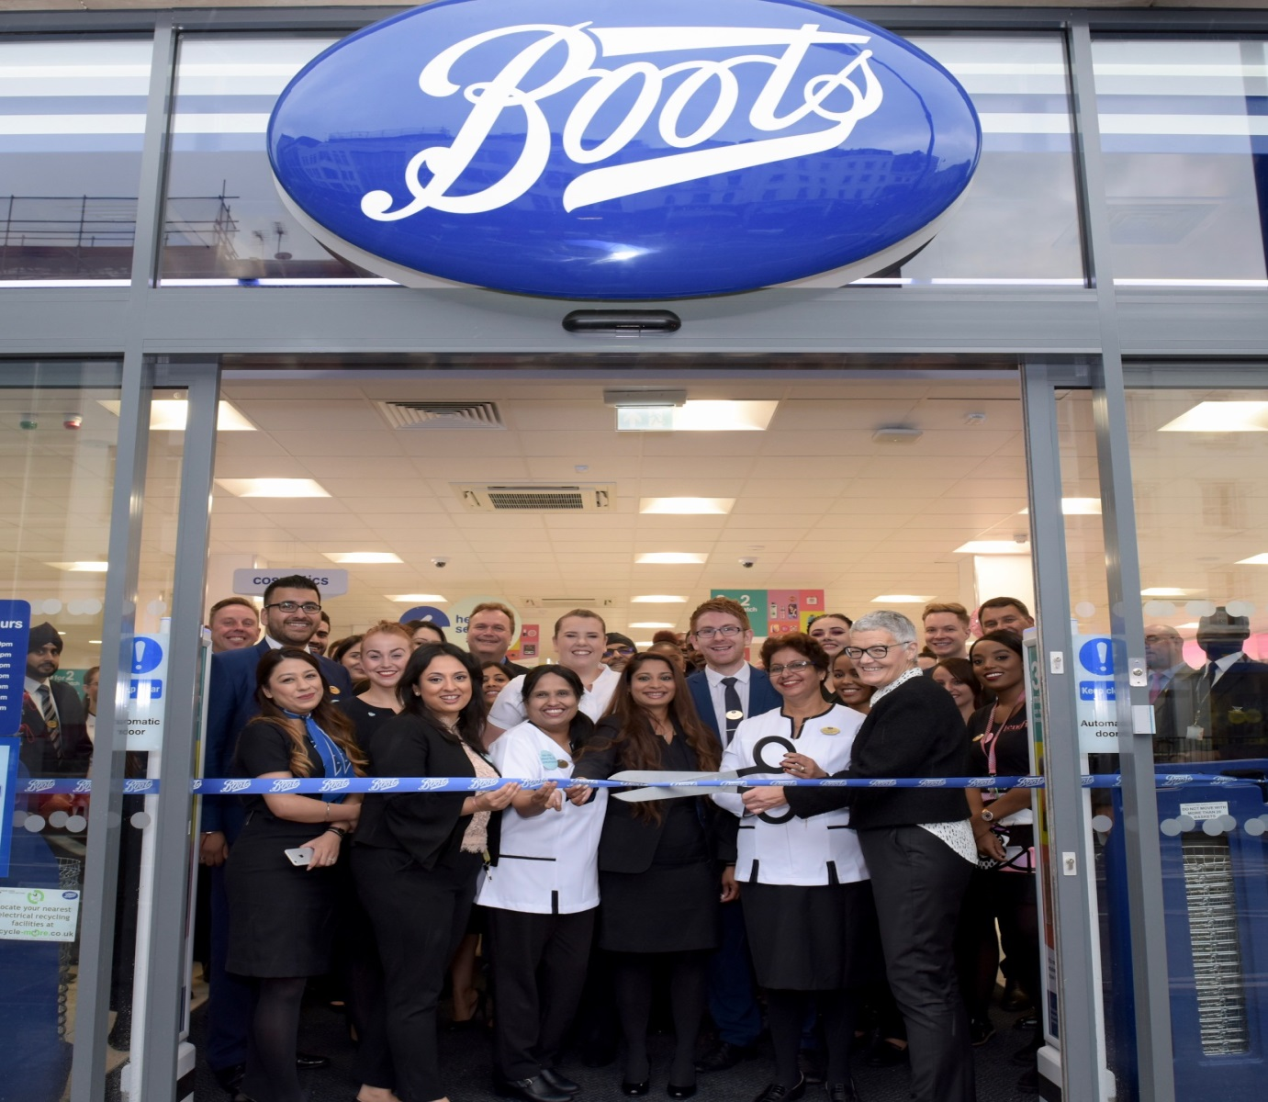
(Prokubovskaya,2016).

Marketing mix process and strategy

Marketing mix include four main elements which are product, price, promotion and place.
Product within the Boots are large range of medicines, health products, fitness products, medical services, beauty products and all this contribute for the company top market position and success.
Prices within the Boots stores and online products are very competitive within the UK market, because they offer discounts, great promotions, collecting points and many others. All this keeping the customer engaged and loyal to the company for long terms (Prokubovskaya,2016).
Promotion is one of the main factors for the customer footfall in the stores and online sales. The company offers buy one get second free, buy one get second half price, buy item and get free gift all this are very attractive for the customers shopping and savings.
Place normal place of the Boots stores are the high street top locations close to station or bus stops and this gives high opportunities for the customers shopping in store. Apart from this the online option for orders and deliveries is very effective and productive customer option for more easy shopping nowadays this way of purchases increasing as trend (Prokubovskaya,2016).

Figure 2
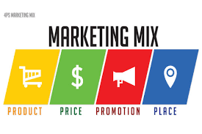
(Prokubovskaya,2016).

Segmentation, Targeting and Positioning

Figure 3
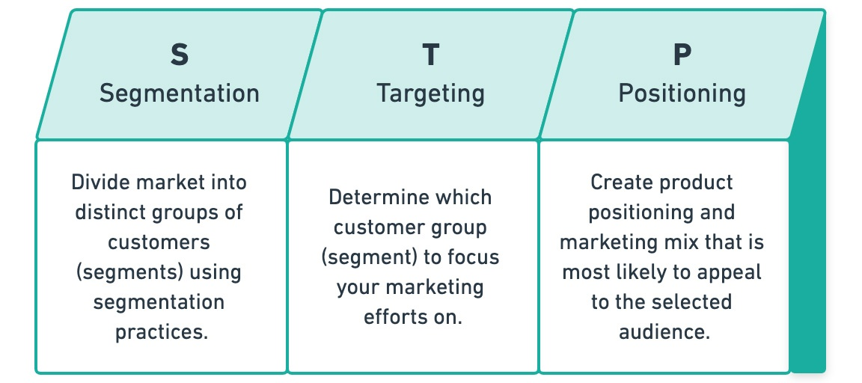
(Lim,2021).
Market segmentation has long been recognized as a necessity because it is much simpler and more convenient to target a subset of the industry rather than the audience effectively. Contemporary marketing techniques further target people to ensure that the right statement gets to the right individuals (Goi,2009).
Targeting representing that there is need of targeting specific group of people which have higher possibilities and demand to be interested from the company products or services so this way the company can have better performance and sales in short and long terms.
Positioning is the last step, but very important as this means creating product or service as per the demands and needs of the selected target group. The positioning showing the importance of the firstly analyze the target group needs and then selecting the right product for this demands (Lim,2021).

Blog 1
What is the best mascara for my eye?
Figure 4
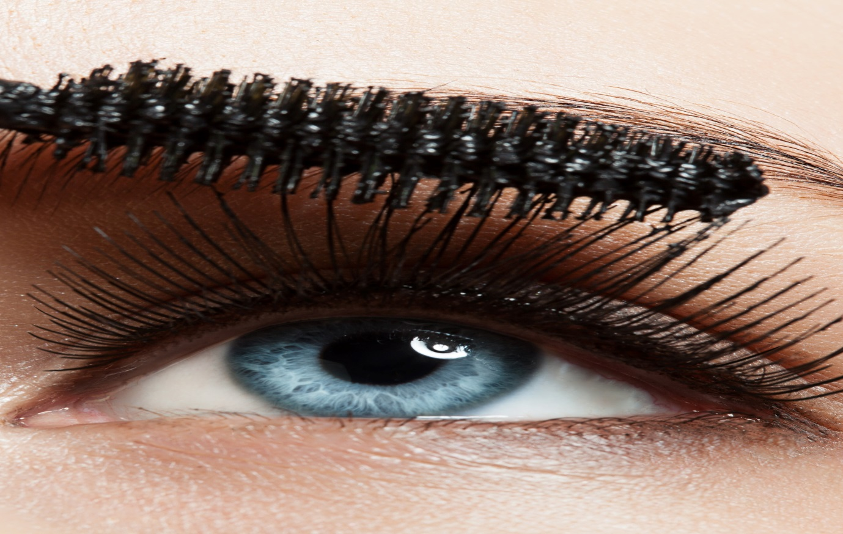
(Goi,2009).
The woman eye is one of the most important details of the beauty look and this is the reason why is so important to choose the proper and good mascara for your best look and beauty (Goi,2009).
It's difficult to know which mascara methodology is best when there are plenty to choose from. You can relax knowing that the perfect one for you exists. You'll never want to let it go once you've found it. Continue reading to learn how to select the best mascara for you.
Boots offering large range of mascaras for you and you will receive high level of service; also you give a try in store and check how you would look with different mascaras and brands for your eyelashes (Goi,2009).
Go Beauty and find your best look! – This is our message to the target group.

Blog 2

Be healthy and take care for your health
Figure 5

(Lim,2021).
Boots targeting the group of people which want to focus over their healthy life and prevention of any sickness and not only as people with good health feels much happier.
Boots offer large range of health care products and medics services which will take care for your condition, healthy life and feeling comfort in your daily tasks (Lim,2021).
Using health care products will give you more energy and healthier life so you can take care for your family and duties with best possible way.
You can firstly check your condition and metrics using our pharmacy services and then based over the results you can purchase what you need to become in best possible shape and form of your life (Lim,2021).
Be Health, Stay Health! – is the logo of our campaign.

Blog 3

Taking care for your pregnancy and your child

Figure 6

(Prokubovskaya,2016).
In Boots we do care for your child and your pregnancy as we have large assortment of vitamins and health products which targeting to ensure that you and your child will be maximum healthy and confident for life time moments and memories.
When you get pregnant but until you're 12 weeks pregnant, you should take a 400 microgram folic acid tablet each day. Folic acid can effectively deter genetic diseases, such as spina bifida, in children.
If you didn't take folic acid prior to actually getting pregnant, you should begin as soon as you learn you're expecting.
Consume folate (the natural form of folic acid)-rich green leafy vegetables, as well as folic acid-fortified breakfast cereals and fat spreads.
In ours stores and online can be easily find many different brands with multivitamins and minerals which you need from the test you are pregnant up to the moment of the birth and in the next 12 years of the child life with best quality and effectiveness (Prokubovskaya,2016).

Blog 4

How to take care for your skin?
Figure 7

(Lee,2000).

In Boots you can first make consultation about what is your type of skin and then you can select and see the different options how you can make your skin to looks better and you to feel confident and comfortable with your skin feeling.
As we can see from the figure below there is four types of skin and is important to know which type is your skin. There is dry, oily, combination and normal types skin and in our stores we have best products for support and help your skin type (Lee,2000).
Figure 8 Types of skin
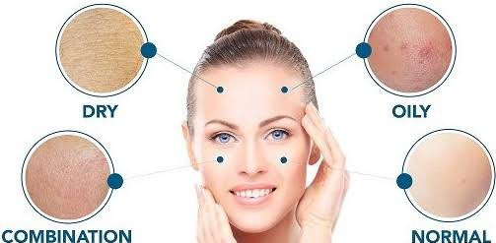
(Lee,2000).

Blog 5

How to feel fresh and full with energy consistent?

Figure 9

(Boudi,2020).
Feeling confident, full with energy, health and successful is depending of your body vitamins and minerals in our stores we can take care for your best health and energy with large assortment of vitamins which will impact your life positive way.
Our consultants can give you the best advice for your great condition and improvement so you can feel energized every day and achieving your goals with more positive mindset and happiness (Boudi,2020).

Blog 6

Exercises and sport matters

Figure 10

(Prokubovskaya,2016).

It is proven that people who do exercise and training daily or even weekly feels better, more confident and with better success in their life and work. Every type of sport need right nutrition and vitamins so your body can handle the movements, lifting, running and all involved activities (Prokubovskaya,2016).
Your body needs enough vitamins and elements in order to be strong, with good immune system and less risk for your body. It is proven that vitamins are important element of your sport and healthy life and you need then to recover from your trainings (Boudi,2020).

Blog 7

How to support our Immune system during winter?
Figure 11

(Išoraitė,2014).

Nowadays with many cold and flu issues and with the covid19 disease is very important for every person to be sure that he has the highest possible immunity system especially during the winter period.
Here is Boots you can visit your local store or order online the best solutions and mix between immunity boosters like vitamin C, B12, B5, calcium, vitamin D and many more which will take care for your immunity levels with months. This will protects you from sickness like cold and flu and your body will be able to respond much stronger to any diseases (Išoraitė,2014).

Conclusion

Marketing is essential because it assists you in selling your products or services. The simple truth of any business is to make profit, and marketing is a major application area for accomplishing that goal. According to Creativs, many companies would not survive without marketing even though goal is to maximize sales. With the above blogs we can see perfect examples how Boots successfully using the marketing mix for achieving the sales targets and customer engagements. It is delivering results to the company due to the consistent company stability and results in short and long terms of time.

Reference list
Ambler, T., 2008. Marketing and the bottom line: assessing marketing performance. In Performance management (pp. 137-148). Palgrave Macmillan, London.
Anitsal, I., Anitsal, M.M. and Girard, T., 2013. Retail mission statements: Top 100 global retailers. Academy of Strategic Management Journal, 12(1), p.1.
Constantinides, E., 2006. The marketing mix revisited: towards the 21st century marketing. Journal of marketing management, 22(3-4), pp.407-438.
Edwards, S. and Shackley, M., 1992. Measuring the effectiveness of retail window display as an element of the marketing mix. International Journal of advertising, 11(3), pp.193-202.
Ghezali, F. and Boudi, A., 2020. The moderating effect of information technology capabilities on the relationship between marketing mix and corporate entrepreneurship. PSU Research Review.
Goi, C.L., 2009. A review of marketing mix: 4Ps or more. International journal of marketing studies, 1(1), pp.2-15.
Išoraitė, M., 2014. ENTREPRENEURSHIP AND SUSTAINABILITY ISSUES. ENTREPRENEURSHIP AND SUSTAINABILITY ISSUES 3 (2), p.173.
Išoraitė, M., 2016. Marketing mix theoretical aspects. International Journal of Research-Granthaalayah, 4(6), pp.25-37.
Lim, W.M., 2021. A marketing mix typology for integrated care: the 10 Ps. Journal of Strategic Marketing, 29(5), pp.453-469.
Pogorelova, E., Yakhneeva, I., Agafonova, A. and Prokubovskaya, A., 2016. Marketing Mix for E-commerce. International journal of environmental & science education, 11(14), pp.6744-6759.
Schmidt, R.A. and Pioch, E.A., 2004. Community pharmacies under pressure: issues of deregulation and competition. International journal of retail & distribution management.
Yoo, B., Donthu, N. and Lee, S., 2000. An examination of selected marketing mix elements and brand equity. Journal of the academy of marketing science, 28(2), pp.195-211.
Zherdetska, L., Diatlova, Y., Diatlova, V., Derkach, J., Goncharenko, A. and Zos-Kior, M., 2021. Digital banking in the marketing mix and human resource management: improving the approach to the assessment as an innovative component. Laplage em Revista, 7(3A), pp.111-119.

