Is there a significant association between gender and university course choices?

Abstract

It has been found that a person's gender can give indications of what a preferred choice of study at universities could be. Using qualitative data from thirty-two undergraduate students, this study analyses if there is a significant association between gender and a chosen university course. Literature has been written which outlines various reasoning for the correlation of gender and a chosen university course. Radford & Holdstock (2006) identified the segregation within academic fields and specifically looked at gender dominance within certain academic fields; computing predominantly dominated by males and psychology by females. Cheryan et al., (2017) stated a lack of balance within the sector of STEM fields in U.S universities with a particular decreased number of women obtaining a degree in computer science. Whilst Johnson et al., (2020) found females to have an increasingly higher percentage within the undergraduate study of psychology causing a gender imbalance. This study aimed to specifically look at psychology and computing to investigate a significant association between gender and university course. The findings concluded that there was no significant association and previous literature-based hypothesis was therefore rejected.

Introduction

Within research it has been found that a person’s gender can give an indication towards a chosen higher educational course of study. Segregation within academic fields in relation to gender is an apparent constant, with gender dominance over different chosen curriculums also identified (Radford & Holstock, 2006). Research conducted by Radford & Holdstock (2006) investigated the difference in gender and higher educational aims of computing and psychology students with research to particular dominance within each field. Computing as a higher educational course study is excessively male dominated whilst psychology female dominance has risen over the years due to its prominent humanistic qualities (Radford & Holstock, 2006).

It is suggested that in computing both men and women had similar attributes and thought processes on the subject, with female computing students deviating from the norm and displaying gender characteristics suited to the male dominated association (Durndell et al., 1990; Radford & Holstock, 2006). The study found that for the gender variable alone, the dominated courses had various factors of explanation that also included personality traits, cognitive abilities, and social interests (Radford & Holstock, 2006). However, it was also found that similarities regardless of gender when concerning educational aims in both computing and psychology presented similarities, thus generalising the overall outcome of achievement in any chosen field of study in both males and females (Radford & Holstock, 2006).

Cheryan et al., (2017) studied the lack of gender balance of students in certain STEM fields within the compounds of U.S universities. Computer science was one of those fields which lacked female students at an undergraduate level. In fact, there has been a decrease in the number of women who obtain a degree qualification within this field over the last 30 years, with an approximate 20% resulted decline by the mid 2000’s (Cheryan et al., 2017). A concept also found in statistics from UCCA (1998, as cited in Durndell et al.,1990) where female admissions for computing saw decreasing figures between 1979 and 1987 predicting a shortfall of qualified people overall for this chosen profession. Although there was found to be a correlation in females with advanced foundational backgrounds and the higher probability of chosen STEM subjects (Mcmaster, 2017).

Reasons for such findings suggested demand for computer scientists is not being met through U.S training and lack of appeal. National science foundation (2010, as cited in Cheryan et al., 2017) produces a figure showing the difference in gender concerning computer science but states that the number is considerably higher due to the number of males who intended to undertake computer science as a major compared to females. Further investigation looked at masculine culture, underrepresentation, gender gaps in self-efficacy, stereotypes, and lack of early educational experience as reasons for the imbalance in gender and certain STEM fields (Cheryan et al., 2017). Differences in choice of STEM subjects concerning gender has also been suggested to be associated with social conditioning along with environments which are gender based (Gasteen, 2019)

Johnson et al., (2020) on the British psychological society (BPS) discusses an imbalance within the field of psychology. Female undergraduate students for psychology contribute to the rate of 80%, with universities from the Russell group institutions reporting higher figures (Johnson et al., 2020). A fact reiterated by Boysen et al., (2022) who found that women were predominant within the study and the professional workplace of psychology with definitive femininity associations towards the field. With this being a general trend across other countries, strategies are being investigated to change this precedent and promote gender balance (Johnson et al., 2020).

There is research which suggests that there are other components which contribute to a person’s chosen university course such as history of family and socio-economic backgrounds as well as ethnicity (Mcmaster, 2017), and, even though there are other associating factors that can influence a person’s chosen academic subject at university level, it is clear due to relative literature, that an association is apparent between gender and a chosen university course. This study will look specifically at a relation between gender (male and female) and university course (psychology and computing). It’s hypothesised that males would prefer to study a computing course and females would prefer to study a psychology course.

Method

Participants

In total there were 32 participants, all being undergraduate students: 17 females and 15 males.

Participants were recruited via opportunity sampling; participants took part during a module workshop – one psychology class and one computing class.

Ages ranged between 18 and 43 (M = 25.91, SD = 6.12).

Design

This study included categorical variables. Due to this, a chi- square test for independence was used to explore the association between those variables. Gender, male and female, was the first variable with the second variable being university course, psychology, and computing.

Materials

The participants were asked to record their gender and provide which university course, psychology, or computing, they were currently studying on Qualtrics. Age was also collected as a demographic, but it is not included in the overall study.

Procedure

Data collection was conducted during a module workshop. One psychology module lead introduced the study during a scheduled class and one module lead from the discipline of computing did the same. Participants were given a brief verbal description of what the study would consist of during their workshops. All participants were informed that consent would be required, and all three questions were asked to be completed contained on Qualtrics. Once both classes had completed data collection, the data was summarised by the researcher into one excel document ready to distribute for analysis.

Results

A Chi² for independence was calculated to explore the association between a chosen university course and an individual's gender. The formula used to calculate this is as follows:

X² (1, N = 32) = 3.14, p > .05.

This calculation reveals that there was no significant association between a chosen university course and an individual's gender. Therefore, the hypothesis that males would favour studying a computing course and females would favour studying a psychology course must be rejected.

Discussion

It was expected that males would prefer to study a computing university course and females would prefer to study a psychology university course due to the related literature found that indicates higher percentage rates of women within the chosen field of psychology and the research into male domination within computing. It was hypothesised that this study would produce similar results. However, the findings showed that there was no significant association between a chosen university course and a person’s gender given that the chi² is more than the p .05, and therefore, the hypothesis must be rejected.

Previous literature that was discussed gave clear indication that there would be an association between gender and a chosen university course. Johnson et al., (2020) and Boysen et al., (2022) both identified a gender imbalance within the field of psychology, with predominantly more females than males both within the study of and the profession. Radford & Holdstock (2006) investigated both computing and psychology courses regarding gender where the same dominant associations occurred; females dominated psychology and males dominated computing. Cheryan et al., (2017) also identified an imbalance within STEM fields of study where males were the controlling proportions. Whilst the results from this study remain rejected, there is a question as to why this has occurred.

This study was based online via Qualtrics making it easily accessible for participants to complete. And given there were only two questions, the study is simple for the participants understand and accurately answer. However, it could have been too simplistic to accumulate the most accurate and diverse results where greater possible aspects could have been explored. It is also noted that only 32 participants supplied data collection, results may have differed if there were more participants from a wider range of universities.

Even though age was collected as a demographic, this could have been added to the analysis of data to identify if there is a significant change of perspective on an association between a younger and mature student on chosen university courses. A mature student could have different, more situational reasons for re-entering higher education compared to a younger student. Situations like unemployment, divorce and life experience are all life changing events that can encourage the need for an educational satisfaction concerning personal development or to improve current family life (Dawson & Boulton, 2000, as cited in Gill et al., 2015) This could influence a chosen undergraduate course, depending on which life turning event an individual has experienced or would want to achieve, with question on stereotypical gendered role motivation (Marks et al., 2003, as cited in Gill et al., 2015).

It is also important to mention that today the construct of gender is becoming more diverse and as such, there could possibly be a need for further investigation as to what classifies gender when it comes to associating it with a chosen academic field, and question if research is just associating the stereotypical aspects of gender with a chosen course as reasons why it’s studied or the gender itself. As was found within the literature, female students who studied computing attained aspects against the norm and instead contributed towards masculine characteristics (Durndell et al., 1990; Radford & Holstock, 2006).

Boysen et al., (2022) identified that there is imbalance within the psychology field where women were dominant in both university and professional settings. It found that there was a link between the association of femininity and psychology with less masculine associations. Aspects suggesting perception on the study of psychology is also affected by stereotypical gendered role assignments. (Boysen et al., 2022) Further in-depth questions could be included within data collection to help attain this and explore the concepts of masculinity and femininity regardless of assigned gender in relation to their chosen course of study.

References
Boysen, G., Chicosky, R. L., Rose, F. R., & Delmore, E. E. (2022). Evidence for a gender stereotype about psychology and its effect on perceptions of men’s and women’s fit in the field. The Journal of Social Psychology, 162(4), 485–503. https://doi.org/10.1080/00224545.2021.1921682
Cheryan, s., Ziegler, S. A., Montoya, A. K.., & Jiang, L. (2017). Why Are Some STEM Fields More Gender Balanced Than Others? Psychological Bulletin, 143(1), 1–35. https://doi.org/10.1037/bul0000052
Durndell, A.., Siann, G., & Glissov, P. (1990). Gender Differences and Computing in Course Choice at Entry into Higher Education. British Educational Research Journal, 16(2), 149–162. https://doi.org/10.1080/0141192900160204
Gasteen. A. (2019). Gender and STEM Subject Choice. International Journal of Population Data Science, 4(3). https://doi.org/10.23889/ijpds.v4i3.1328
Gill, B., Hayes, S., & Senior, C. (2015). The effects of family support and gender on mature student engagement in higher education. Frontiers in Psychology, 6, 156–156. https://doi.org/10.3389/fpsyg.2015.00156
Johnson, J., Madill, A., Koutsopoulou, G., Brown, C., & Harris, R. (2020, 07 24). Tackling gender imbalance in psychology. Retrieved from The British Psychological Society: https://www.bps.org.uk/psychologist/tackling-gender-imbalance-psychology
Mcmaster. C. (2017). Who studies STEM subjects at A level and degree in England? An investigation into the intersections between students’ family background, gender and ethnicity in determining choice. British Educational Research Journal, 43(3), 528–553. https://doi.org/10.1002/berj.3270
Radford, J., & Holdstock, L. (2006). Gender differences in higher education aims between computing and psychology students. Research in Science & Technological Education, 163-176 http://dx.doi.org/10.1080/0263514950130206.

Appendices

Consent form, data collection form and debrief.
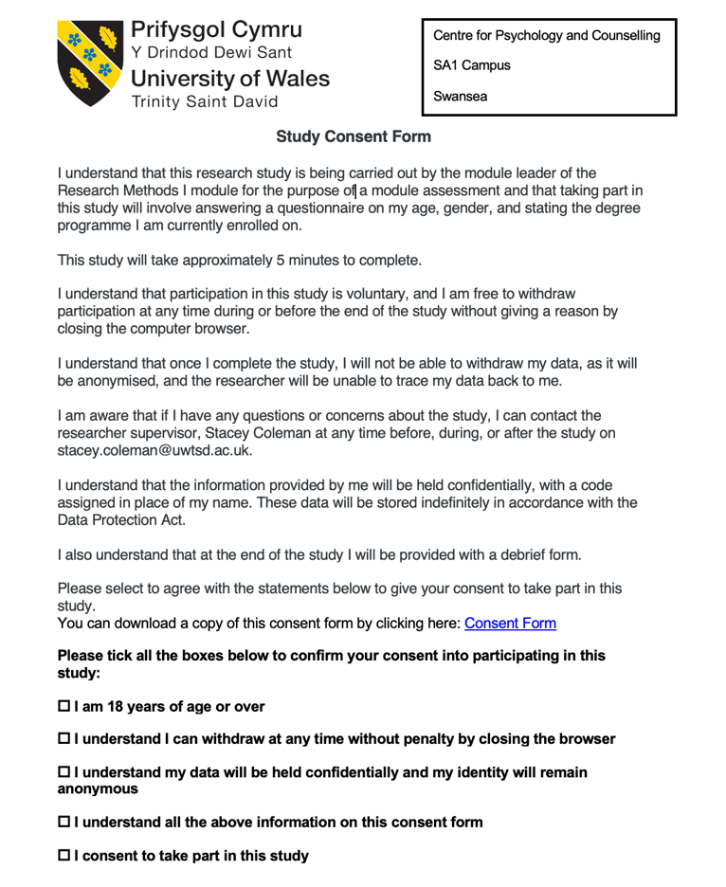

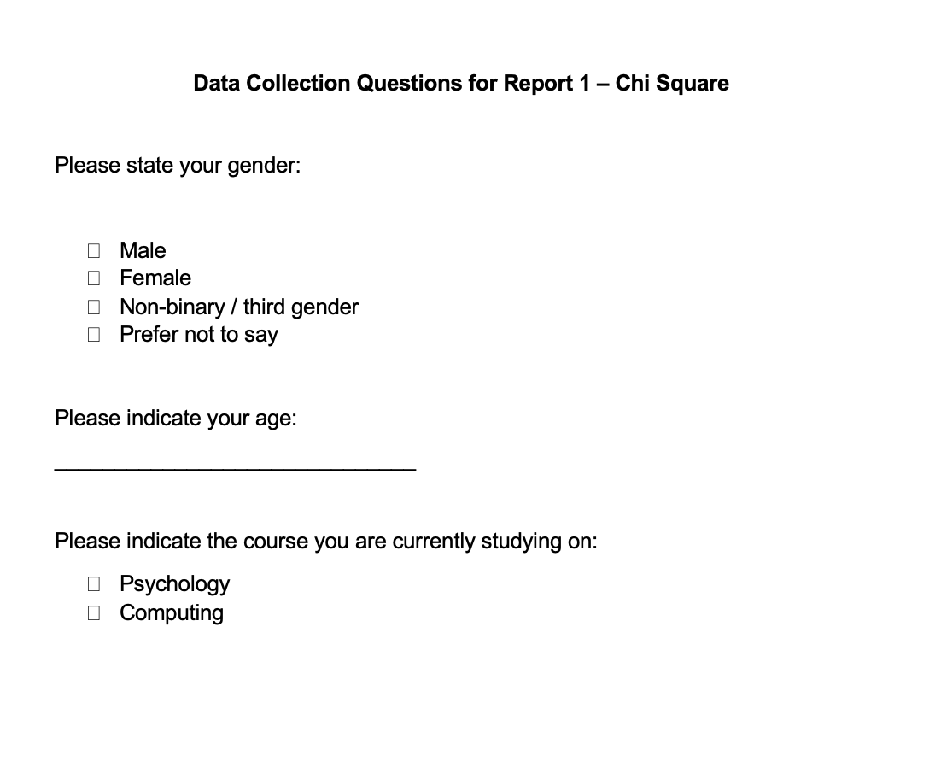

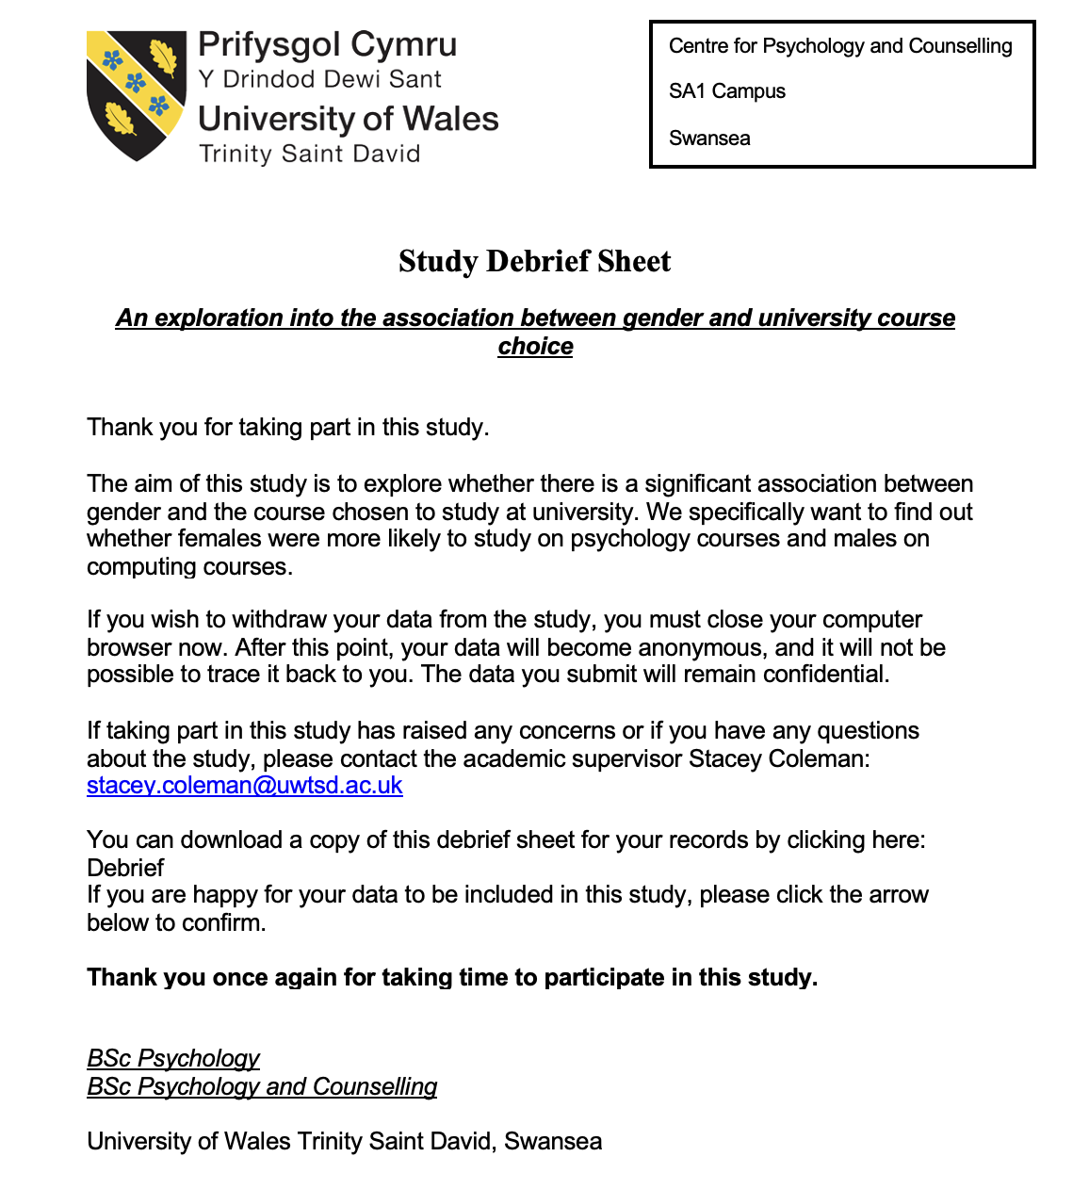

Data table
Gender | Age | University Course
Male | 22 | Computing
Male | 19 | Computing
Female | 21 | Computing
Male | 43 | Psychology
Female | 24 | Computing
Male | 26 | Computing
Female | 18 | Psychology
Female | 29 | Psychology
Female | 21 | Computing
Female | 31 | Psychology
Male | 27 | Computing
Female | 33 | Psychology
Male | 25 | Computing
Male | 31 | Psychology
Female | 29 | Computing
Male | 19 | Psychology
Female | 23 | Psychology
Female | 21 | Psychology
Female | 25 | Psychology
Male | 30 | Psychology
Male | 20 | Computing
Male | 27 | Psychology
Female | 41 | Psychology
Female | 19 | Computing
Male | 24 | Computing
Female | 28 | Psychology
Female | 22 | Psychology
Male | 22 | Computing
Male | 20 | Computing
Female | 27 | Psychology
Female | 35 | Computing
Male | 27 | Computing

Table of results

GENDER | UNIVERSITY COURSE |  | TOTAL
 | COMPUTING | PSYCHOLOGY
MALE | ¹ 10 | ² 5 | 15
FEMALE | ³ 6 | ⁴ 11 | 17
TOTAL | 16 | 16 | 32

Calculation of results
Formula: -
(Row total) x (Column total) / Grand total

- 16 x 15 / 32 = 7.5
- 16 x 15 / 32 = 7.5
- 16 x 17 / 32 = 8.5
- 16 x 17 / 32 = 8.5

Observed (O) and expected (E) frequencies table: -

 | Observed | Expected
1 | 10 | 7.5
2 | 5 | 7.5
3 | 6 | 8.5
4 | 11 | 8.5

Calculation of Chi² :-
Chi² = Σ (O – E)² / E
- (10 – 7.5)² / 7.5 = 2.5² / 7.5 = 6.25 / 7.5 = 0.83
- (5 – 7.5)² / 7.5 = -2.5² / 7.5 = 6.25 / 7.5 = 0.83
- (6 – 8.5)² / 8.5 = -2.5² / 8.5 = 6.25 / 8.5 = 0.74
- (11 – 8.5)² / 8.5 = 2.5² / 8.5 = 6.25 / 8.5 = 0.74
Chi² = 0.83 + 0.83 + 0.74 + 0.74 = 3.14
∴ Chi² = 3.14

Degree of freedom: -
2 x Variables – V1 = Gender and V2 = University course
2 x Categories – Male/Female and Computing/Psychology
DF formula and calculations: -
(V1 – 1) x (V2 – 1) = (2 – 1) x (2 – 1) = 1 x 1 = 1
∴ The degree of freedom = 1

