University of Wales Trinity Saint David

R E P O R T

ACCA4022
Computer Architecture & Operating System

Computer Systems and Components Specifications

Student: Victor Moroi

Student no.: 2021926

Lecturer(s): Dr. Terry Walcott
Dr. Anupam Mazumdar
Mr. Sadeque Imam

April 2021
Table of Contents
Introduction 3
ACRONYMS 3
SCENARIO 1 4
1.1 Specification and Justification 4
1.2 Summary 6
Scenario 2 6
2.1 Specification and Justification 6
2.2 Additional Storage 9
2.3 The summary 9
Conclusion 9
Bibliography 9

Introduction

Today, a computer is a versatile tool not only for consumption but also for creating content in any form. The author was given to do the tasks of producing a computer hardware shopping list with their specifications per two scenarios. Both scenarios have different requirements.

The first scenario is about an elderly person who needs a simple PC with low costs. The user does not intend to play the games and would like to use it to perform word-processing functions, viewing content on YouTube, internet usage, send and receiving emails. As an additional option, the person would also like to make online video calls to be in touch with his family abroad.

The second scenario is about a graduate user who intend to start up a company in producing and editing 4K video content in high-demand desktop. Furthermore, the user will store many big size files and will need to have an additional storage drive, such as a NAS drive. Also need to introduce a surround sound monitoring system with SPDIF input.

ACRONYMS

CPU – Central Processing Unit
DVD-I – Digital Versatile Disc International
GPU – Graphics Processing Unit
HDD – Hard Disk Drive
HDMI – High-Definition Multimedia Interface
HDR – High Dynamic Range
IPS – In-Plane Switching
NAS – Network Attached Storage
PCIe – Peripheral Component Interconnect express
RAID – Redundant Array of Independents Disks
RAM – Random Access Memory
RGB – Red Green Blue
SPDIF – Sony/Phillips Digital Interface
SSD – Solid State Drive
TDP – Thermal Design Power
UHD – Ultra High Definition
VGA – Video Graphics Array (640 by 480 pixels)

SCENARIO 1

1.1 Specification and Justification

CPU:
APU on socket AM4 - AMD Athlon 200GE £52
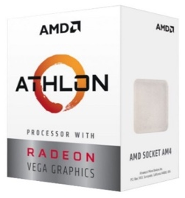
As the basis of the computer, the Athlon 200GE is a dual-core processor with simultaneous multi-threading that always runs at 3.2 GHz. Also features 35W TDP for low-priced, low-power usage.
This is an excellent processor for watching videos of good quality, surfing the Internet, simple games if anyone wants it. The most important thing is that the processor is cold, and a boxed cooler will be enough to cool it. The processor has an excellent combination of value, performance, functionality and he already receive a cooler, a video card, and a processor.

MOTHERBOARD:
ASRock A320M-HDV R4.0 Micro ATX £43
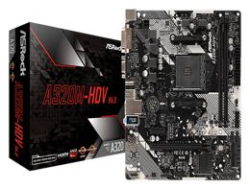
The choice fell on this motherboard because it supports an AM4 socket without looking for unnecessary functions, this is a simple motherboard that supports up to 32 GB of RAM. It is also compatible with Athlon chipsets. Moreover, it can output video via HDMI, VGA, and DVI-D. Also, via HDMI, you can output an image to a TV, it comes in handy.

RAM:
Samsung 4GB 2666MHz DDR4 RAM (2x 4GB) £46

The choice is the simplest "Samsung" to overclock the memory a little, since the built-in core will use part of the RAM. For this scenario can even use DDR3, but since "ASRock" requires DDR4, I will use the interface compatible with it. For minimal comfort, we need two 4 GB memory sticks.

SSD:
Samsung 860 EVO MZ-76E250B £40
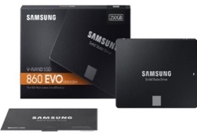
The suggest is an SSD referring to what low-quality hard drives are now producing. An excellent option is the Samsung MZ-76E250BW. Yes, a little expensive, but one such SSD will be enough for an elderly user for all the needs for the rest of his life. And it is all completely silent and starts up in seconds.

PSU:
Builder 500W ATX PSU Power Supply 12cm £20
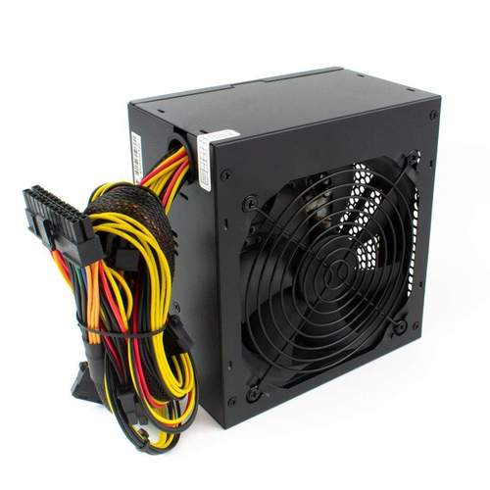
Ideal for these budget builds this PSU comes with a 70% efficiency and a sleeve bearing 12cm fan that offers a quiet operation with excellent cooling. The power supply has a power of 500W.

CASE:
Deepcool MATREXX 30 Tempered Glass MicroATX PC Case £30
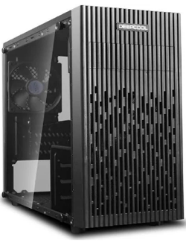
Perfect for users with limited space. This case is small-sized, with an internal logical structure that maximizes compatibility.
The structure (dimensions 420 x 201 x 365mm) is compatible with M-ATX and ITX motherboards. The case is fitted with 120 mm radiator/fan in the front, and comes with a pre-installed 120 mm black fan in the rear. The case guarantees the performance and aesthetic needs.

Monitor:
SAMSUNG S24F356 Full HD 24" LED Monitor £120
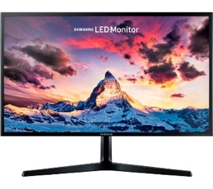
The display of the device is a key consideration when building a PC for elderly users. The minimum diagonal must be at least 16 inches or more. Needs to be with anti-reflective coating and with a resolution from 1366x768 to 1400x900. Is not necessary to be taken a higher resolution - the interface and layout of the sites will be too small.
For the scenario, was chosen this 24 inches Full HD (1920 x 1080p) monitor, with HDMI and VGA inputs. Is optimized for viewing comfort through Eye Saver mode which reduces blue light emissions — which stimulate the retina more than other colour wavelengths. This module reduces eye fatigue and provides a more comfortable viewing experience.

Keyboard:
Geemarc Telecom KBSV3_WH £25

This keyboard offers an ideal solution for those who find using a keyboard with small keys and text difficult. The bold, black characters on the white keys make it easier to read - especially those with less-than-perfect vision. The large print makes it easier to spot each letter and can increase the typing speed.

Mouse:
Logitech M100 Wired USB Mouse, 3-Buttons £12


Models with additional keys should be discarded - a standard set is enough. The wired model was chosen. Wireless models require charging or changing batteries which can be a difficulty for the elderly user. In addition, the chance of breaking the constant load wire is extremely small.

Camera web:
Logitech C270 HD Webcam £25
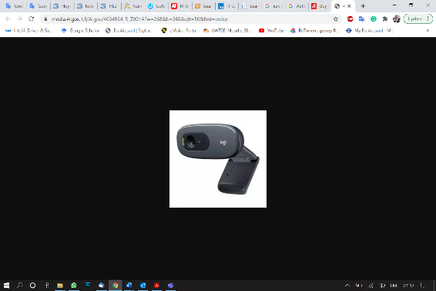
This webcam is giving a sharp and smooth video calling (720p/30fps) in a widescreen format. Has automatic light correction that will show the user vibrant and natural colours. Also, the built-in noise-reducing mic makes sure that voice comes across clearly, even if is busy surroundings

_____________________________
Total: £413

1.2 Summary

Choosing a computer for an elderly user is a responsible thing. This configuration would be optimal and cost-effective. As the budget was not mentioned, it is just over £400, maybe for an elderly user it is a bit expensive but considering the resources of the applications that grow every year, this configuration will maintain its performance to comfortably use in the future.

Scenario 2

2.1 Specification and Justification

CPU:
Intel Core i7-9700K 3.6Ghz 8 Core CPU, 8 Thread, 4.9GHz Turbo £180
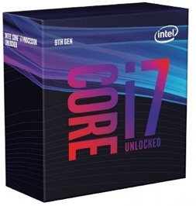
One of the main components for editing video materials is still the central processor.
Most video editors nowadays are multi-threaded, so a multi-core processor can improve the performance of the computer.
This modern Intel processor has 8 cores and will be enough for a graduate who wants the highest possible performance for processing 4K video. CPU has High-performance UHD graphics with a Frequency of 3.60 GHz (Turbo Mode 4.90GHz) and 12MB of cache.

MOTHERBOARD:
MSI MPG Z390 Gaming Edge AC ATX Motherboard £230
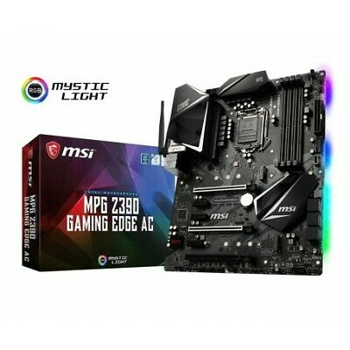
The Z390 motherboard is a high-end board capable of strong performance and overclocking. Two M.2 slots enable the use of high-speed SSD drives and the onboard audio is the high-performance Realtek ALC1220P. This can provide a high-definition sound. Also, at the rear is included SPDIF. This version of the board includes onboard 433Mbps Wi-Fi via the Intel 9462 wireless adapter and integrated with a Bluetooth 5.0.
Supports all types of RAID for SATA and RAID 0 and RAID 1 for M.2 storage devices.

GRAPHIC CARD (GPU):
NVidia GeForce RTX 3060 Ti 8GB £481
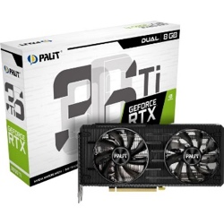
A powerful graphics subsystem is indispensable. In general, the best option is to be no less than 6GB to avoid crashes with a lack of video memory.
The Nvidia RTX series provides the user with superfast GDDR6 memory which is necessary for 4K video editing. When working with such videos, it is extremely important that the video card supports multiple displays. In this choice, the user can connect up to 4 displays depending on the complexity of his work.

RAM:
32GB Kingston HyperX Fury DDR4 PC4-25600 3200MHz DIMM RAM (2x 32GB) £456

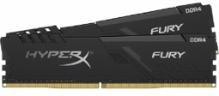
FURY DDR4 memory automatically overclocks to the highest frequency published, up to 3200MHz, to deliver instant top-level performance for motherboards with Intel’s chipset. It is a small investment for premium components that complement Intel’s 8-core processors for faster video editing and 3D rendering.

PRIMARY STORAGE DRIVE:
WD Blue 3D NAND Internal SSD 2.5 Inch SATA - 1 TB, Blue - High Performance £83
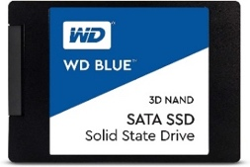
WD Blue solid-state drive delivers fast performance, optimizes storage, and delivers fast transfer speeds with industry-leading reliability. Optimised to run multiple tasks in parallel, WD Blue SSDs make it easy to run multiple demanding applications at the same time.

SECONDARY STORAGE DRIVE:
Seagate BarraCuda 4TB 3.5" SATA HDD/Hard Disk Drive £75

A very versatile hard drive that gives the most out of system storage. Here the user can store all his work from simple documents to the big format of 4K video files.

CPU COOLING:
Builder 500W ATX PSU Power Supply 12cm £80

Fitted with two fans provide powerful cooling with fans that run from 600 RPM to 1700 RPM, making it easy to minimize airflow and does not let the temperature rise even if the CPU is running at full capacity.

PSU:
CORSAIR CV650 ATX PSU - 650 W £55
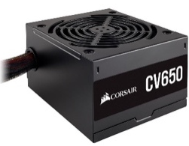
A reliable power supply unit suitable for larger towers with a number of components. The thermally controlled 120 mm fan is built to have little or no detectable noise during operation, so the user can work and watch the video without distraction.

CASE:
Be Quiet! Pure Base 600 Black Case £73
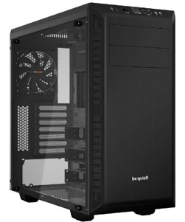
The Pure Base 600 case is smart usability features, whisper-quiet operation thanks to two pre-installed 2 fans. Is perfectly compatible with the ATX motherboard. Optimised for liquid cooling with three specially designed areas of up to 360mm to add water cooling radiators.

Monitor:
LG UHD 27UL850 27 Inch Monitor 4K HDR 400 IPS £440
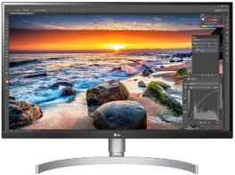
Video editing monitor starts with the display size, the more the better. The choice was for this HDR 27-inch monitor that has a resolution of 3840 x 2160p and an IPS panel which gives an editor to see as many elements of the work screen.

Keyboard:
Logitech Craft £158

This keyboard is one of the first choices for beginner’s editors.
Complete Creative Control. The creative input dial on this wireless keyboard adapts to any application that is being used, providing instant access to the tool that is needed when it is needed.

Mouse:
Logitech MX Master Wireless Mouse £48
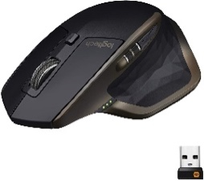
One of the best mouse models that offers comfort, control and customization with advanced features. The precision wheel automatically switches from click to ultra-fast scrolling.

_____________________________
Total: £2359

2.2 Additional Storage

NAS:
QNAP TS-832PX 8-Bay Enclosure (4GB RAM) £790
Seagate Iron Wolf Pro 8TB SATA Hard Drive (NAS) x2 £358
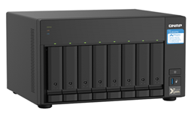
Large volumes of data and information can be stored apart from the computer and also retrieved whenever required. This option can offer Network Attached Storage (NAS) which is usually attached to the computer through ethernet port.
This NAS system does not come with drives. The author included two 8TB drives designed for NAS.
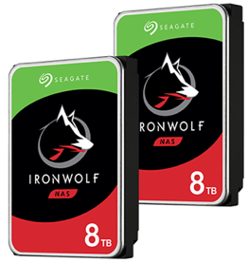
There are many different types of RAID (0, 1, 5, 6, 10, etc.) that offered different benefits. The best option for this NAS is to run on RAID 1 technology. Reduced storage capacity, since the same data has to be stored twice, your overall storage capacity is halved. However, this level is most suited for mission-critical applications, because when one drive fails, the other will automatically take over. Since both the drives contain identical data, there will be no impact on the loss of information from them.

2.3 The summary

The main goal of such a computer is to reach an easy level in use, so as not to cause difficulties and misunderstanding to the user which he practically does not need. The components of the system will meet or exceed the minimum requirements provided by the scenario. By purchasing this system, the user will be satisfied with the results.

Conclusion

The computer is versatile in nature. It can perform different types of tasks with the same ease. At one moment you can use the computer to prepare a Word document and at the next moment, you may play music or print a document. Moreover, you can create or watch, and edit the video in high resolution and even play the favourite game. Computers have several limitations too. The computer can only perform tasks that it has been programmed to do.

Bibliography

[1] | A. Clements, Principles of computer hardware, Oxford University Press, 2006.
[2] | M. Mano, Computer system architecture, Prentice-Hall of India, 2003.
[3] | Wang, P. Shuangbao and R. Ledley, Computer architecture and security: Fundamentals of designing secure computer systems, John Wiley & Sons, 2012.
[4] | K. Park, D. Lee, Y. Woo, G. Lee, J. Lee and D. Ki, “Reliability and performance enhancement technique for SSD array storage system using RAID mechanism,” IEEE Xplore, 2009. [Online]. Available: https://ieeexplore.ieee.org/abstract/document/5341269. [Accessed 27 04 2021].
[5] | J. L. Hennessy and D. A. Patterson, Computer architecture: a quantitative approach, Elsevier, 2011.
[6] | I. Englander and W. Wong, The architecture of computer hardware, systems software, and networking: An information technology approach, John Wiley & Sons, 2021.
[7] | D. Vadala, Managing RAID on LINUX: Fast, Scalable, Reliable Data Storage, O'Reilly Media, Inc., 2002.
[8] | P. M. Chen, E. K. Lee, G. A. Gibson, R. H. Katz and D. A. Patterson, “RAID: high-performance, reliable secondary storage,” ACM Computing Surveys, pp. 145-185, 1994.
[9] | G. A. Gibson and R. Van Meter, “Network attached storage architecture,” Communications of the ACM, vol. 43, no. 11, pp. 37-45, 2000.

