

Title: Understanding the importance of Stakeholder Engagement in the successful commencement and completion of the project of TestCard UK
Student name : Ana Capatina
Student ID : 2408124
Programme: BA (Hons) Leadership and Management Skills for the Workplace
Module: Understanding and Engaging Stakeholders
Module code: LCLM5001
Module Leaders: Alastair Moyes, Nishi Ramsurrun
Internal Verifier: Md Kalam, Samuel Ofori
University name: University of Wales
Word Count: 4056

Executive Summary
A smartwatch health device is highly popularised at present to meet the health consciousness trends. The report has explored the initiative of TestCard UK to launch a new wearable health device reflecting its commitment to digital healthcare innovation. The purpose of the report is to explore the current business position of TestCard, review the readiness of the organisation and its ability to manage stakeholder engagement. Using models like SWOT, PESTLE, RACI, 4C and others, the analysis highlights strengths in brand reputation, weaknesses in high implementation costs, and regulatory compliance. The report significantly emphasises the respective importance of continuous stakeholder engagement in the wearable health device project of TestCard. The recommendations that are initiated involve the implementation of the structured feedback loops to focus on capturing the insights of the post-launch. It also highlighted the maintenance of regular updates with the influential stakeholders and further investing in stakeholder relationship management. Involvement of cross-functional training will help in enhancing collaboration and also a significant engagement with the sustainability practices that will strengthen the overall brand reputation. Continuous stakeholder interaction is beneficial for the launch, which is essential for sustaining the overall performance of the product.

Table of Contents
1. Introduction 3
2. An appraisal of the company 4
2.1 SWOT analysis 4
2.1 PESTLE Analysis 5
2.3 SMART objective 6
3. Key internal and external stakeholders 7
3.1 RACI matrix 7
3.2 Internal Stakeholders 8
3.3 External Stakeholders 8
3.4. Stakeholder map 9
3.5 Stakeholders matrix 9
3.6. Engagement plan 10
3.7 Communication plan 10
4. Explanation of the roles and responsibilities of the key stakeholders 11
4.1 Application of 4C model 11
4.2 Roles and responsibilities of internal stakeholders 13
4.3 Roles and responsibilities of External stakeholders 14
5. Impact of stakeholders' engagement and recommendations for future 15
5.1 Impact of stakeholder engagement on business performance 15
5.2 Theory and model 16
5.3 Recommendations 17
6. Conclusion 18
References 20
AI Declaration 24

1. Introduction
TestCard Ltd is a digital health technology company based in the United Kingdom, headquartered in York, the United Kingdom and founded in 2017. The firm focuses on at-home diagnostic testing kits with the aid of a smartphone application, which lets users take fast and precise diagnostic tests on their urinary tract infections, glucose and pregnancy. TestCard embraces preventive healthcare, affordable healthcare, and medical-grade medication tests to provide feedback through digital innovation. Being acknowledged long enough in the global community in terms of its user-focused design and data precision, TestCard is a newly emerged leader in the UK healthcare technological industry, which is facilitating the advancement of digital diagnostics all over the world (Testcard, 2025). The organisation focuses on the activities related to preventive healthcare, significant clinical excellence and also the digital health innovation. TestCard mainly focuses on integrating technology in the healthcare services, which are considered digital tools to monitor health, enhancing patient engagement and also improving the service efficiency. It mainly considered aligning with the increasing demand for different personalised healthcare solutions, specifically for the wearable health technologies that mainly empower individuals to track their virtual health metrics. The current project mainly includes launching a new wearable health device that is capable of monitoring the heart rate, oxygen saturation and also the sleep pattern.

2. An appraisal of the company

2.1 SWOT analysis
Strengths: It is identified that TestCard has a strong brand reputation not only in the UK but also internationally (Testcard, 2025). The high reputation of TestCard ensures credibility and customer trust in its product launches. The organisation has a strong customer base, including customers from care providers, health insurance and others. This is the strength of TestCard.
Weaknesses: Limited wearable tech experience is identified as one of the weaknesses for TestCard. Developing an effective wearable health device is associated with high costs in its R&D initiatives. This is another weakness that reflects on TestCard.
Opportunities: The global wearable market was more than 534 million units in 2024 (IDC, 2025). This creates a high opportunity for TestCard to meet market trends and strengthen its business.
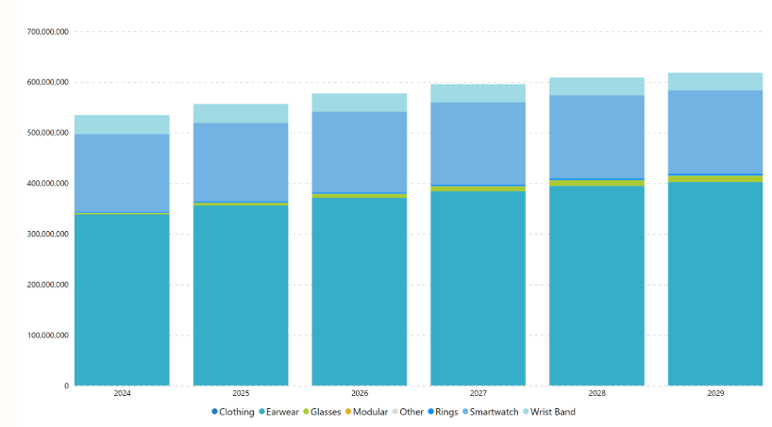
Figure 1: Worldwide wearables demand
(Source: IDC, 2025)
Threats: The strict data privacy regulations in the UK create threats for TestCard. For example, a lack of compliance with the GDPR regulations will cause high penalties (Cohen et al., 2020, p.1267). The high competition in the worldwide wearable market has also created a threat for TestCard.

2.1 PESTLE Analysis
Political: The Medicines and Healthcare Regulatory Agency enforces medical device regulation in the UK. These are the political factors that ensure healthcare organisations must comply with this regulation.
Economical: At present, there is an increasing consumer spending on health and wellness technologies (Callaghan et al., 2021). This creates a favourable environment for the wearable devices of TestCard. The rising affordability of digital health products also enhances the market potential.
Social: That is a growing health-conscious population in the UK. It is identified that 86% of the population in the UK recognised the net importance of fitness (Adamson, 2025). This creates a favourable environment for TestCard to launch wearable health devices.
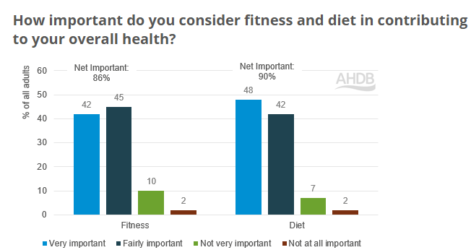
Figure 2: Health-consciousness among UK People
(Source: Adamson, 2025)
Technological: Technological advancements improve the efficiency of the tech products. TestCard needs to use updated AI, sensors, IoT and others in their wearable device.
Legal: Strict compliance with GDPR and other data protection regulations is highly required to ensure user privacy and build trust (Cohen et al., 2020). Operating businesses in the UK, TestCard needs to comply with data protection regulations to protect customer-related personal information and build trust.
Environmental: Using eco-friendly and sustainable materials in production helps meet corporate social responsibility commitments. TestCard is also committed to sustainability, and for that, this environmental consideration is needed within the business.

2.3 SMART objective
SMART Criteria | Objective
Specific | Launch a wearable health device that accurately monitors heart rate, oxygen levels, and sleep patterns to provide real-time health insights for consumers.
Measurable | Achieve at least 100,000 device sales within the first year of launch, tracking adoption rates and customer feedback for performance evaluation.
Achievable | Leverage established TestCard healthcare network, marketing expertise, and strategic technology partnerships to ensure product development and market readiness.
Relevant | Aligns with the mission of TestCard to enhance personal health management through innovative and accessible digital health solutions.
Time-bound | Within six months for a timely market launch.
Table 1: SMART Objectives
(Source: Self-created)

3. Key internal and external stakeholders
Stakeholder theory highlights the importance of stakeholder engagement for businesses as well as projects. The theory defines that stakeholders are the individuals or groups who can influence or are influenced by the project outcomes (Marcon Nora et al., 2023). For the successful delivery of the selected project for TestCard UK, it is highly important to identify and engage the right stakeholders. In the context of the project, the stakeholders can be categorised as internal and external stakeholders.

3.1 RACI matrix
Task / Activity | Product Dev | R&D | Marketing & Sales | IT & Analytics | Customer Service | Suppliers | Regulatory Bodies | Investors | Tech Partners
Design & Development | R | A | C | C | I | C | I | I | C
Feasibility & Testing | C | R/A | I | C | I | I | C | I | C
Marketing & Launch | I | I | R/A | C | I | I | I | C | C
Data Management | I | I | C | R/A | C | I | I | I | C
Regulatory Compliance | I | C | I | C | I | I | R/A | I | I
Customer Support | I | I | I | C | R/A | I | I | I | C
Supplier Coordination | C | C | I | I | I | R/A | I | I | C

Table 2: RACI matrix
(Source: Self-created)

3.2 Internal Stakeholders
The product development team is one of the crucial internal stakeholders for this project. They are the ones who will design and develop the smartwatch health device and make it compliant with the health monitoring requirements and also the functional requirements.
The internal stakeholders of the research and development team perform the feasibility, prototypes and testing as well. Their technical knowledge will be essential in making the gadget safe, reliable and competitive. Internal stakeholders of the project also include the marketing and sales departments. They work out launch campaigns, strategies of price and distribution channels. Internal stakeholders include the customer service team as well, where enquiry feedback and support will be provided after the launch.

3.3 External Stakeholders
The suppliers of valuable technology components are the external stakeholders for this project. They will be provided with critical hardware for device production. Regulatory bodies are also the external stakeholders for this project. For example, the National Healthcare Service and Medicines and Healthcare Regulatory Agency are the regulatory bodies that focus on ensuring compliance with medical device regulations as well as safety standards (MHRA, 2025). Customers are the end users and are also the external stakeholders for the project. For example, the high level of engagement and adoption rate of the ultimate users of the device is highly essential. Investors, who will provide financial support and expect high returns, are also external stakeholders. Strategic technology partners are also the external stakeholders for the project. For example, strategic technology partners will help in app integration, implement AI features and develop software.

3.4. Stakeholder map
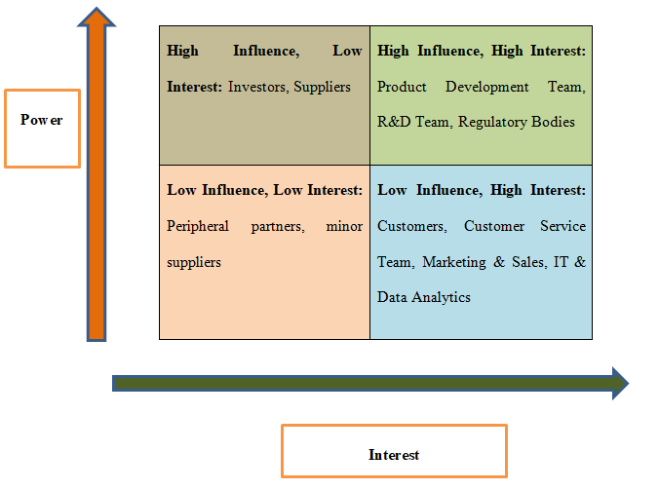
Figure 3: Stakeholder Mapping
(Source: Self-created)

3.5 Stakeholders matrix
Stakeholder Group | Influence | Interest | Engagement Strategy
Executive Leadership/Board | High | High | Active consultation, frequent briefings
Product Development Team | High | High | Collaborative workshops, agile updates
Regulatory Bodies (MHRA/NHS) | High | Medium | Formal reporting, compliance reviews
Marketing & Sales Team | Medium | High | Weekly progress meetings, dashboards
Patients/End-users | Low | High | Surveys, pilot testing, and feedback sessions
Suppliers & Distributors | Medium | Medium | Monthly reports, operational coordination
Table 3: Stakeholders matrix
(Source: Self-created)
Stakeholder Matrix significantly focuses on mapping of the stakeholders that are mainly based on the interest and influence, which also enables prioritisation for the engagement strategies (Styk and Bogacz, 2022, p.183). The Matrix focuses on ensuring a significant engagement of resources that are allocated for the stakeholders proactively.

3.6. Engagement plan
An engagement plan helps in outlining how the stakeholders focus on involvement throughout the respective project (Hollmann et al., 2022). For the case of TestCard UK, executive leadership will include a regular project review and also the approval for the strategic decisions. The engagement plan for the product development team can focus on including agile sprint meetings and prototyping of workshops. For the case of regulatory bodies, inclusion of compliance submission, audits and approval can be one of the important engagement plans. For the patient or the end users, inclusion of pilot testing, feedback collection and different co-design sessions can be beneficial. For the marketing and sales department, the campaign planning meeting and the product launch briefing can be one of the important engagement plans.

3.7 Communication plan
Stakeholder Group | Communication Type | Frequency | Responsible Person
Executive Leadership/Board | Progress reports, presentations | Bi-weekly | Project Manager
Product Development Team | Agile updates, workshops | Weekly | Project Manager/Tech Lead
Regulatory Bodies | Formal submissions, compliance reports | Monthly | Regulatory Lead
Patients/End-users | Surveys, pilot updates | Monthly | Marketing Team
Marketing & Sales Team | Dashboards, briefings | Weekly | Marketing Manager
Suppliers & Distributors | Operational updates | Monthly | Supply Chain Manager
Table 4: Communication plan
(Source: Self-created)
A communication plan helps in specifying different information that needs to be shared with different stakeholders (Ellis et al., 1991, p.48). The above communication plan provides detailed information regarding the process of communication with the considered stakeholders.

4. Explanation of the roles and responsibilities of the key stakeholders

4.1 Application of 4C model
As the project manager of TestCard UK for its smartwatch health device launch, the primary responsibility is to focus on ensuring that all the stakeholders are effectively engaged to achieve the objective of the project within the next 6-month timeline. Stakeholder engagement helps in informing the stakeholders and also focuses on studying significant participation, aligning the expectations and further mitigation of risk and conflicts (Kujala et al., 2022, p.1186). The process of significant engagement of the stakeholders within a structured plan, systematic communication and proactive management can be done with the help of the 4C model.
Communication: Effective communication can be considered to be one of the important elements for stakeholder engagement. Effective and open communication helps ensure that all the parties are significantly informed, and the expectations are properly aligned, along with misunderstandings that are minimised (Bahrain et al., 2023, p.1491). Executive leadership significantly requires concise and higher-level progress that mainly focuses on highlighting important risks, milestones and also the decisions needed. The product development benefited from the frequent, detailed updates and also the involvement of interactive workshops to focus on facilitating rapid problem-solving. Patience and the end users whose feedback is considered to be critical for the respective product design will be further engaged with the help of a survey, significant pilot testing and also structuring of feedback sessions. Communication channels will be significantly diversified, including emails and the project dashboards for the routine updates, meetings for different strategic discussions and also the involvement of collaborative platforms that help in dealing with the task tracking and technical collaboration (Mammadova and Abdullayeva, 2025, p.201). The feedback loop helps in ensuring that stakeholder voices are properly addressed, ask different questions and contribute their insights.
Coordination: Coordination includes aligning different efforts of the stakeholders to ensure efficient workflow and also avoiding any kind of duplication or conflicts (Ganeshu et al., 2024, p.16). It helps in establishing the central project schedule with an environment of clear milestones and deliverables, focusing on the accessibility of the stakeholders. Regular coordination meetings with the internal team include addressing the potential bottleneck. For the case of external elements, coordination with the regulatory authorities, different suppliers and the health care providers is observed to be essential for meeting the compliance requirements and also ensuring the timely procurement of different materials. Coordination mechanisms such as the involvement of project calendars, different task allocation tools and also the integrated reporting system help in facilitating better accountability, transparency and the real-time monitoring of the entire progress (Ellis et al., 1991, p.52). The structured approach focuses on the stakeholders working towards the common objective and also minimises the risk of management.
Cooperation: In the successful completion of a project, cooperation is considered to be essential. Cooperation refers to the working together of the stakeholders for achieving the shared goals and also respecting individuals for the responsibilities and significant constraints. For the context of the smartwatch device launch, fostering cooperation by clarification of significant roles and responsibilities with the RACI Matrix will provide a significant definition for the activities within the project task. Cooperation also requires the involvement of creating a supportive environment for the stakeholders where they are further encouraged for significant participation and the recognition of their contribution (Nonet et al., 2022, p.182). Organising a cross-functional workshop for the stakeholders can help in solving the problem, sharing of expertise and also focusing on innovative solutions.
Collaboration: Collaboration significantly represents a higher level of engagement with the stakeholders. Through collaboration between different parties, actively co-create different solutions, sharing important knowledge and also making some joint decisions (Mason et al., 2024, p.399). For this project, significant collaboration is considered to be critical for the integration of insights from different diverse stakeholders, such as the involvement of combining the clinical feedback from the NHS trust with the inclusion of consumer preferences for redefining the device features. Collaborative tools will also include the shared documentation of the platforms and the codesign sessions that will help contribute to the real-time decision-making process.
The 4C model focuses on supporting conflict management. Communication helps in ensuring significant clarity and reducing misunderstanding (Adham, 2023, p.154). It focuses on including coordination and aligns with the schedules and the resources, cooperation focuses on building better trust and responsibility, and collaboration considers joint resolution for the disputes. The risk register and the stakeholder feedback mechanism can be used to focus on proactively identifying different sources of conflicts. Escalation protocols and the involvement of mediation processes can be beneficial for addressing the disagreement quickly, ensuring that the project remains on the timeline, and managing a positive stakeholder relationship.

4.2 Roles and responsibilities of internal stakeholders
Internal Stakeholder | Role | Responsibilities
Product Development Team | Design & development (Dribble, 2022) | Design the wearable device, ensure it meets health-monitoring and functional requirements, collaborate with R&D, and oversee quality assurance.
R&D Team | Technical feasibility & prototyping | Conduct feasibility studies, develop prototypes, test device functionality, ensure safety, reliability, and technical compliance.
Marketing & Sales | Promotion & distribution | Develop marketing campaigns, create pricing strategies, plan distribution channels, conduct market research, and identify target customers (Marcon Nora et al., 2023, p.682).
IT & Data Analytics | Data management & integration | Collect, store, and analyse device data, integrate with apps and platforms, ensure secure handling of sensitive health information, and provide analytics for product improvement.
Customer Service | Post-launch support | Manage customer inquiries, complaints, and feedback, ensure high customer satisfaction, and provide insights to inform product enhancements.

Table 5: Roles and responsibilities of internal stakeholders
(Source: Self-created)

4.3 Roles and responsibilities of External stakeholders
External Stakeholder | Role | Responsibilities
Suppliers | Hardware & technology provision | Suppliers are critical for providing high-quality wearable components required for the production of devices. Their responsibilities include timely delivery of materials, ensuring components meet technical and quality standards, and supporting the production process to avoid delays (Zaidi, 2025). They also maintain supply chain reliability and communicate any issues that could impact project timelines.
Regulatory Bodies (MHRA, NHS) | Compliance & approval | Regulatory bodies ensure that the device complies with UK medical device regulations and safety standards (MHRA, 2025). Their responsibilities include reviewing all documentation, assessing safety and efficacy, granting approvals for market release, and monitoring ongoing compliance to prevent legal or ethical violations. They play a high-influence role in enabling market entry.
Customers / End-users | Product adoption & feedback | Customers are the ultimate users whose adoption determines the success of the product. Their responsibilities include engaging with the device, reporting usability issues, providing feedback on functionality, and contributing insights for iterative improvements. High engagement ensures better design refinement and satisfaction.
Investors | Funding & oversight | Investors provide the financial resources necessary for development, marketing, and launch (Hollmann et al., 2022). They are responsible for monitoring project progress, evaluating return on investment, approving major budget allocations, and influencing strategic decisions that affect project scope and resource allocation.
Strategic Technology Partners | Software & AI integration | Support app integration, implement AI features, develop software functionalities, and ensure compatibility with the digital health ecosystem of TestCard.

Table 6: Roles and responsibilities of External stakeholders
(Source: Self-created)

5. Impact of stakeholders' engagement and recommendations for future
Effective stakeholder engagement is essential for successfully completing a project (OnIndus, 2024). Engaging stakeholders strategically ensures that their resources, experiences and influence are utilised to achieve the targeted project goals, while reducing risk, as well as maximising benefits. In this section, the impact of effective engagement of stakeholders will be highlighted along with key recommendations for the future.

5.1 Impact of stakeholder engagement on business performance
Quality improvements and market readiness:
Engaging internal stakeholders such as the research and development and product development teams helps in effectively improving the product quality as well as ensuring market readiness. A regular collaboration between engineers, data analytics and product designs is effective for iterative testing, rapid identification of design flows, and improvements within the project on time. Effective engagement of external stakeholders, such as users, is helpful in providing feedback related to comfort, functionality and usability (McKinsey & Company, 2020). Based on this insight into end users, the appropriate adjustment within the wearable device can happen. Integration of stakeholder insights at the early stage of the product development process, such as in the wearable device manufacturing process, helps ensure an appropriate product that meets customer expectations.
Enhanced end users' trust and adoption
Stakeholder engagement with end users helped in fostering a sense of inclusion and ownership (Ashcroft, 2017). For example, through survey focus groups and beta testing, customer engagement ensured this project. Customers who feel heard are more likely to adopt the product and also provide positive feedback. This strengthens the brand loyalty of TestCard. Ensuring transparent communication on product features, their impacts, and data privacy measures helps in creating trust among targeted users. This is highly important for TestCard, as trust directly influences market adoption, as well as successful launch.
Strong Regulatory Compliance:
The other impact of stakeholder engagement is strong compliance with regulations (Christopher et al., 2013). The regulatory bodies, such as MHRA and NHS, help this project meet their medical device standards as well as meet legal requirements. Throughout the product development process of TestCard, the involvement of MHRA and NHS helped the organisation to create a wearable device that incorporates feedback, submit accurate documentation and also be free from any compliance issues. Engagement of regulatory bodies at early stages helps in reducing delays in product development and also requires regulatory requirements that support the safety and quality of the product.
Project-related risk reduction
Stakeholder engagement in the project helps in identifying potential risks at early stages (Global Infrastructure Hub, 2023). For example, inclusion of a research development team, product development team, regulatory bodies, suppliers and others at the early stage helped in identifying technical, financial or operational risks in projects of TestCard. Regular coordination with suppliers helps in the timely delivery of the essential components for creating the device. Regulatory authorities such as the NHS and others are helped in providing industrial standards. This reduces delays as well as the cost overall in this project.
These are some key impacts of effective stakeholder engagement on the wearable device project of TestCard.

5.2 Theory and model
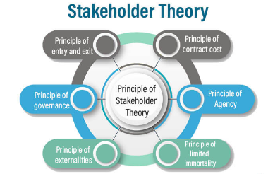
Figure 4: Stakeholder theory
(Source: Thakur, 2022)
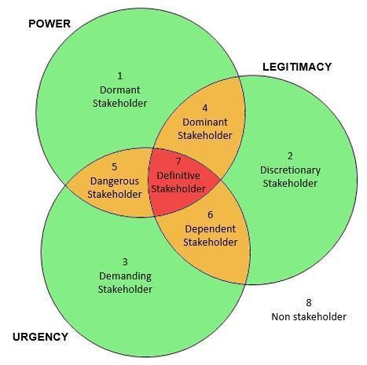
Figure 5: Salience Model
(Source: Morphy, 2019)
Important theories and models can be considered for the stakeholders that help in dealing with better conflict management and also understanding of the working process within the project. Stakeholder theory significantly provides one of the foundations for understanding the names of the stakeholders and their expectations (Awa et al., 2024, p.9). The Salience Model helps in the classification of the stakeholders by their respective power, legitimacy and urgency, providing significant guidance for prioritising the engagement strategy (Kapiriri and Razavi, 2021, p.1029). 4C's model that includes communication, coordination, cooperation and collaboration significantly supports the overall conflict resolution and aligns with the diverse needs of the stakeholder group. Integrating all these can be beneficial to ensure a better stakeholder engagement at TestCard UK in a more systematic, proactive and aligned way for the respective project success.

5.3 Recommendations
- One of the suggestions regarding how stakeholder engagement can be conducted in the future in this project is the implementation of a continuous feedback loop to the users (Dugbartey and Kehinde, 2025, p.1243). To make sure, for example, there should be a structured system of gathering constant feedback from device users that takes place after lunch. It will assist in collecting customer feedback and development of features of the devices, resolution of usability challenges and projection of future requirements.
- The other strategic suggestion is the retention of frequent executive reports and meetings with the stakeholders. With high-influence stakeholders, such as regulatory bodies, top management and investors, TestCard needs to continuously communicate. This will help in identifying essential updates in devices and allow for productive problem-solving.
- The other strategic recommendation for future stakeholder engagement is to invest in stakeholder relationship management software. For example, utilising digital tools to track interaction, concern and feedback of stakeholders is recommended (Boreal, 2025). This will help improve efficiency as well as ensure accountability.
- Fostering cross-functional training is also another recommendation for future stakeholder engagement (Dugbartey and Kehinde, 2025). For example, providing training sessions that bring together marketing, customer service and product development will improve collaboration and reduce knowledge silos.
- TestCard should align stakeholder engagement with sustainability practices. For example, using eco-friendly materials and green supply chain management at TestCard will help in enhancing brand reputation and also appeal to ethically-conscious consumers.
- Monitoring engagement effectiveness is also another strategic recommendation. For example, implementation of KPIs, such as response time, satisfaction rating and others, will ensure continuous improvement and measurable value for the engagement strategy.
The overall recommendation highlighted that stakeholder engagement should not end at the launch of the product, but a continuous interaction with customers, regulators and other stakeholders is needed to sustain the product performance and facilitate future innovation.

6. Conclusion
Reflecting on the overall discussion, it can be concluded that in the current healthcare technology landscape, where regulatory compliance, customer trust and innovation are crucial, engaging stakeholders strategically will ensure that their insights, experience and knowledge are fully harnessed. This process is associated with improvement in product development as well as reducing the risk of delays, addressing customer satisfaction and also complying with regulatory requirements. With the help of systematic instruments and models, e.g., of SWOT and PEST analysis, the present stance of the strategic strategies of TestCard is outlined. The strong brand name and requirement of health products provide an advantage to TestCard health devices, where difficulties arise due to high competition, implementation costs and others. The RACI matrix and stakeholder mapping helped in elucidating accountability, the level of influence and interest of the stakeholders. It also identified the need to maintain open communication on this project. Going forward, the 4C model, including communication, coordination, cooperation, and collaboration, proved to be a key mechanism in conflict management alongside the establishment of strong and trust-based relations in a project. All these are ways of developing a holistic system of matching project goals and the expectations of the stakeholders. The overall discussion also highlighted that participation of stakeholders does not only enable instant lunch, but would also have long run advantages to TestCard. In particular, the collaboration with regulators, clients, and partners will help the company in the sphere of innovation, sustainability, compliance, and the possibility to sustain relations with the suppliers and other participants available. Transparency and trust in the innovation-based growth policy of TestCard are also beneficial to the investors. The study also highlighted that stakeholder engagement is highly essential for post-launch. It will help the organisation to stay competitive within the market by upgrading features on its wearable health device. It will directly sustain the reputation, customer trust and competitive advantage of TestCard. In general, stakeholder engagement is not only a one-time event but a continuous process that would guarantee project success and make TestCard one of the major companies in the wearable health devices market.

References
Adamson, V. (2025). Consumer attitudes show health is all about balance | AHDB. [online] Ahdb.org.uk. Available at: https://ahdb.org.uk/news/consumer-insight-consumer-attitudes-show-health-is-all-about-balance. (Accessed: 21 Sep 2025)
Adham, T.K.I. (2023). ‘Conflict resolution in team: Analyzing the of conflicts and best skills for resolution.’ Scholars Journal of Engineering and Technology, 11(08), pp.152-162.
Ashcroft, J. (2017) The relational lens: understanding, measuring, and managing stakeholder relationships. Cambridge: Cambridge University Press. Available at: https://www-cambridge-org.ezproxy.uwtsd.ac.uk/core/books/relational-lens/value-and-importance-of-relationships/718C31032061BDFA3F480BA2A53F45D4#CN-bp-1 (Accessed 23 Sep 2025)
Awa, H.O., Etim, W. and Ogbonda, E. (2024). ‘Stakeholders, stakeholder theory and corporate social responsibility (CSR).’ International Journal of Corporate Social Responsibility, 9(1), pp.1-11.
Bahrain, N.K., Sakrani, S.R. and Maidin, A. (2023). ‘Communication barriers in work environment: understanding impact and challenges.’ International Journal of Academic Research in Business and Social Sciences, 13(11), pp.1489-1503.
Boreal (2025). Stakeholder Engagement. [online] Boréalis. Available at: https://www.boreal-is.com/modules/stakeholder-engagement/. (Accessed 23 Sep 2025)
Callaghan, S., Lösch, M., Pione, A. and Teichner, W., (2021). ‘Feeling good: The future of the $1.5 trillion wellness market.’ URL: https://www. mckinsey. com/industries/consumer-packaged-goods/our-insights/feeling-good-the-future-of-the-1-5-trillion-wellness-market
Christopher, M., Payne, A., and Ballantyne, D. (2013). Relationship Marketing: Creating Stakeholder Value. Saint Louis: Taylor and Francis
Cohen, I.G., Gerke, S. and Kramer, D.B. (2020). ‘Ethical and legal implications of remote monitoring of medical devices.’ The Milbank Quarterly, 98(4), pp.1257-1289.
Dribble (2022). Dribbble - Discover the World’s Top Designers & Creative Professionals. [online] dribbble.com. Available at: https://dribbble.com/resources/career/product-team-roles. (Accessed 26 Sep 2025)
Dugbartey, A.N. and Kehinde, O., (2025). ‘Optimizing project delivery through agile methodologies: Balancing speed, collaboration and stakeholder engagement.’ World J. Adv. Res. Rev, 25, pp.1237-1257.
Ellis, C.A., Gibbs, S.J. and Rein, G.L. (1991). ‘Groupware: Some issues and experiences.’ Communications of the ACM, 34(1), pp.38–58.
Ganeshu, P., Fernando, T., Therrien, M.C. and Keraminiyage, K. (2024). ‘Inter-organisational collaboration structures and features to facilitate stakeholder collaboration.’Administrative Sciences, 14(2), pp.1-25.
Global Infrastructure Hub (2023). Stakeholder Identification, Engagement and Empowerment. [online] inclusiveinfra.gihub.org. Available at: https://inclusiveinfra.gihub.org/action-areas/stakeholder-identification-engagement-and-empowerment/. (Accessed 25 Sep 2025)
Hollmann, S., Regierer, B., Bechis, J., Tobin, L. and D’Elia, D. (2022). ‘Ten simple rules on how to develop a stakeholder engagement plan.’ PLoS Computational Biology, 18(10), pp.1-520.
IDC (2025). IDC - Wearable Devices Market Insights. [online] IDC. Available at: https://www.idc.com/promo/wearablevendor/. (Accessed 20 Sep 2025)
Kapiriri, L. and Razavi, S.D. (2021). ‘Salient stakeholders: Using the salience stakeholder model to assess stakeholders’ influence in healthcare priority setting.’ Health Policy OPEN, 2, pp.1-1048.
Kujala, J., Sachs, S., Leinonen, H., Heikkinen, A. and Laude, D. (2022). ‘Stakeholder engagement: Past, present, and future.’ Business & Society, 61(5), pp.1136-1196.
Mammadova, F. and Abdullayeva, N. (2025). ‘The role of communication and collaboration in business management.’ JEL Classification, 45, pp. 196-210.
Marcon Nora, G.A., Alberton, A. and Ayala, D.H.F. (2023). ‘Stakeholder theory and actor‐network theory: The stakeholder engagement in energy transitions.’ Business Strategy and the Environment, 32(1), pp.673-685.
Mason, M.C., Iacuzzi, S., Zamparo, G. and Garlatti, A. (2024). ‘How do stakeholders co-create value in a service ecosystem? Insight from mega-events.’ Management Decision, 62(13), pp.398-425.
McKinsey & Company (2020). Factors for external stakeholder engagement | McKinsey. [online] www.mckinsey.com. Available at: https://www.mckinsey.com/capabilities/strategy-and-corporate-finance/our-insights/the-pivotal-factors-for-effective-external-engagement. (Accessed 21 Sep 2025)
MHRA (2025). Medicines and Healthcare products Regulatory Agency. [online] GOV.UK. Available at: https://www.gov.uk/government/organisations/medicines-and-healthcare-products-regulatory-agency. (Accessed 22 Sep 2025)
Morphy, T. (2019). Stakeholder Salience. [online] Stakeholdermap.com. Available at: https://www.stakeholdermap.com/stakeholder-analysis/stakeholder-salience.html (Accessed 25 Sep. 2025).
Nonet, G.A.H., Gössling, T., Van Tulder, R. and Bryson, J.M. (2022). ‘Multi-stakeholder engagement for the sustainable development goals: introduction to the special issue.’ Journal of Business Ethics, 180(4), pp.1-945.
OnIndus (2024). Why Stakeholder Engagement is Crucial for Project Success? - OnIndus. [online] OnIndus. Available at: https://www.onindus.com/importance-of-stakeholder-engagement-in-project-management/. (Accessed 24 Sep 2025)
Styk, K. and Bogacz, P. (2022). ‘A method for stakeholder mapping in connection with the implementation of a development project.’ Energies, 15(4), pp.1-1592.
Thakur, M. (2022). Stakeholder Theory | Top 6 Principles of Stakeholder Theory with Example. [online] EDUCBA. Available at: https://www.educba.com/stakeholder-theory/ (Accessed 26 Sep. 2025).
Testcard, (2025). The future of diagnostic testing is digital. Available at:https://www.testcard.com/ (Accessed 26 Sep. 2025).
Zaidi, Z. (2025). Supplier’s responsibilities: Overview, definition, and example. [online] Cobrief. Available at: https://www.cobrief.app/resources/legal-glossary/suppliers-responsibilities-overview-definition-and-example/. (Accessed 23 Sep 2025).

